East west university
Department of Computer Science and Engineering
Simple Book Shop Management Program
CSE 103: Mini Project Specification [FALL-2022]
Course Instructor: Dr. Md. Hasanul Ferdaus
Section: 11 Group No: 02
Group Member: 1. Ahasan Abir Kafi (228)

2. Wasifa Motahara Raisa (103)
3.Mostakim Midhat (099)

Date :31/12/2022

Show Welcome Message()

Program should simply display “Welcome to simple book management system “.
printf is a function available (pre defined) in C library which is used to print the specified content in Monitor.
Here it prints the String literal "Welcome to simple book management system".



Show Menu Options ()

Below is a menu driven program using switch case.
unsigned is doubled the size of signed as it only considers positive values.
%d is the format specifier for unsigned integer.

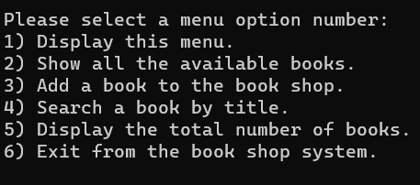
Next

Show Books()
- A switch statement allows a variable to be tested for equality against a list of values. Each value is called a case, and the variable being switched on is checked for each switch case. The expression used in a switch statement must have an integral or enumerated type, or be of a class type in which the class has a single conversion function to an integral or enumerated type.
- The constant-expression for a case must be the same data type as the variable in the switch, and it must be a constant or a literal.
- When the variable being switched on is equal to a case, the statements following that case will execute until a break statement is reached.
- When a break statement is reached, the switch terminates, and the flow of control jumps to the next line following the switch statement.

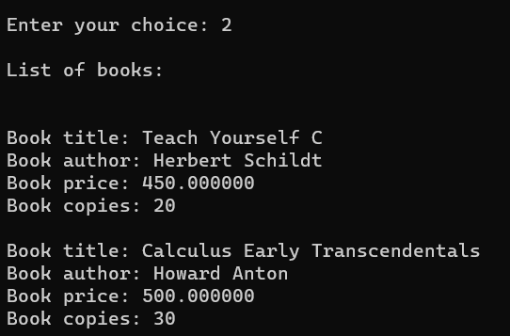

Add book()
- It’s also a switch case statement. This function will run in case statement. The constant-expression for a case must be the same data type as the variable in the switch, and it must be a constant or a literal.
- When the variable being switched on is equal to a case, the statements following that case will execute until a break statement is reached.

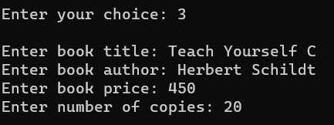

Main()
The iteration is implemented using a do while loop. We need to initiate the iteration in order to have multiple inputs and give out their corresponding outputs. In other words, we can say that we use a do while loop for iterating many times when we want to give input many times, one after another, so that all the information of the books present in the library can be somehow known.
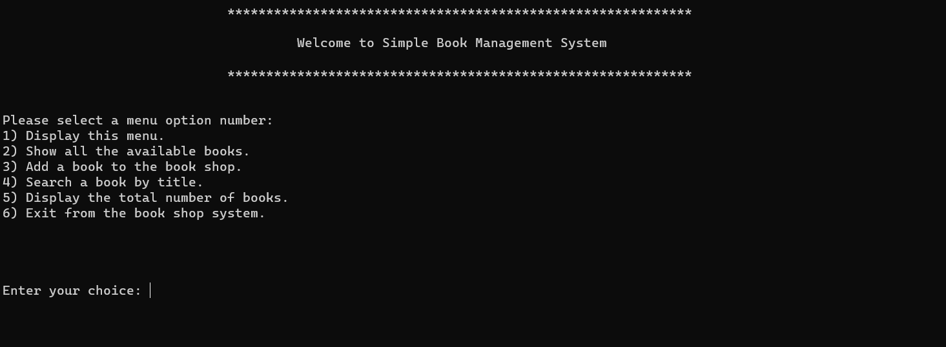

Show Goodbye Message()
When the user enters option 6, the program should terminate after showing the goodbye message
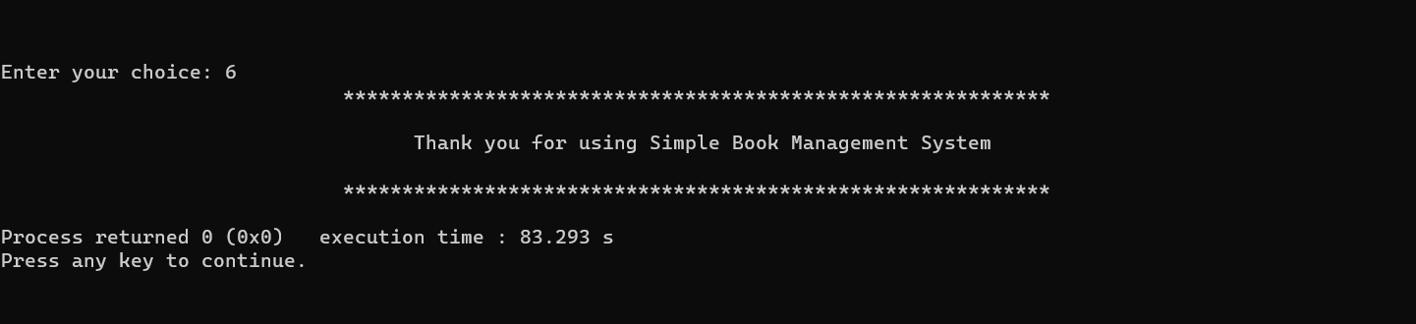

Conclusion

The concept of storing or recording the details of books embedded within the user's system is known as Library Management System. It details the type of books, the list of books, etc. Only a person with the login credentials can access the Library Management System. That person can perform many operations like adding the book details, removing the book details, displaying the book details, modifying the book details, etc.
We must use the Library Management System in order to have secured storage of book details contained within the Library (probably ). This feature is generally enabled in order to protect the data, which is highly confidential. This is one of the simplest Management systems built within the system using the C programming language.
The Library Management System overviews the concept of storing and generating all the data or records of the book contained within the library. This can be known as a general database which stores the data of the book details. It helps in searching the details by reducing time consumption. Not only protects the details of the books in the library but also saves all the data up to date without missing any. This is the major benefit of the Library Management System.

Thank You

