Project Log Book

Group Members:
Wasif Aleem 8786
Owais Sarwar 9523
Tahoor Bin Toufiq 9150
Muhammad Zubair 8498
Azib Ali 9348
Entry Date | Work Done
January 7th, 2021 | Discussed the basic plan to build the prototype for HMS in class, noting down all constraints to be taken care of. Furthermore, we decided our next group meeting would be on January 15th, 2021.
January 15th, 2021 | Meeting at Wasif” s Place: We discussed about the project objective. Using the Software Management Plan template printed from the web site, we stepped through each section and discussed what was required and what resources were available to us. We also discussed how this prototype should be flexible for other countries. There was constant reference to the "Hospital Management System" and other related articles.
January 16th, 2021 | Finished a rough draft prototype and set it up on the online account.
January 19th, 2021 | members checked the document of the Software Project Management Plan, and she made some correction marking the corrections in red.
January 20th, 2021 | The mistakes were corrected on the web site, and email was sent to management to check the document for any more mistakes
January 20th, 2021 | The document was checked by the management and few more mistakes were found. These mistakes were corrected and put on the web.
January 22th, 2021 | Meeting: We discussed the Reservation System in more detail and added more information to the SPMP document.
January 25th, 2021 | Management checked the document of the Software Project Management Plan, and she made some corrections.
January 27th, 2021 | The mistakes were corrected on the web site, and email was sent to management to check the document for any more mistakes.
January 29th, 2021 | Meeting: We discussed parts 3 and 4 of the Software Project Management Plan in more detail and decided to update some information in the SPMP document. The different parts of the document were divided between the team for updates.
February 3th, 2021 | Finished updating the rough draft prototype and set it up on the online account. Sent all team members email with link to latest copy of the document.
February 4th, 2021 | Management checked the document of the Software Project Management Plan. The mistakes were corrected on the web site. The latest version of the document is available online.

Last Updated on February 5th, 2021
Software Requirements Specification
For
Hospital Management System

Wasif Aleem 8786
Owais Sarwar 9523
Tahoor Bin Toufiq 9150
Muhammad Zubair 8498
Azib Ali 9348
February 04, 2021
Version | Changes Made | Date
1.0 | First Pass for Review | 4/2/2021
1.2 | Second Pass for Review | 5/3/2021
1.3 | Third Pass for Review | 5/4/2021
1.4 | HMS Review Version | 5/05/2020

Table of Contents
1. Introduction
2. The General Description
3. Specific Requirements
4. Supporting Information
1. Introduction

1.1 Purpose

This document describes the software requirements and features for the Hospital Management System (HMS).

1.2 Scope In

The CRM is requesting proposals to build a prototype of the Hospital Management System (HMS) for their current system. This new ARRS needs to be scalable enough so that it can accommodate the increase in reservations by the people in Pakistan.
The system will be designed to provide an electronic version of the hospital managing system in Pakistan. The system will have a user-friendly graphical interface and will be more cost effective compared to the current non-electronic version of the reservation system.
The objectives of this development effort are:
- To provide existing users with a new environment in which to make appointment for doctors.
- To provide an avenue for customers to get their appointments in a more convenient way.
- To regain control of the HMS to avoid rush and wastage of time.
- To implement a prototype of a scaled down version of the final system to test the solution and further develop requirements.
- To collect statistics in a more efficient manner for future development and construction.
- To increase efficiency of system.
1.3 Scope Out

The following features will not be the part of this Project:

1.4 Definitions, Acronyms, and Abbreviations.

CASE – Computer Aided Software Engineering
CITS – China International Travel Agency
HMS - Hospital Management system
PP - Project Plan
SDD - Software Design Description
SRS - Software Requirement Specification
SDS – Software Design Specification
SPMP - Software Project Management Plan
GUI – Graphical User Interface
QAM – Quality Assurance Manager
PDM – Project Development Manager
PMP – Project Management Professional
TBD – To be determined
UML – Unified Modeling Language

1.5 Overview

Chapter 2 of the SRS is a brief description of the characteristics of the software to be built, its functions, its users, its constraints and its dependencies.

Chapter 3 is about specific requirements, such as functional requirements, external interface requirements, performance requirements, and also design constraints and quality characteristics.

Finally, chapter 4 includes all the supporting information, such as the Table of Contents, the Appendices, and the Index.

2. The General Description

This section describes the general factors that affect the product and its requirements. This section consists of five subsections that follow. This section does not state specific requirements. Each of the subsections makes those requirements easier to understand, it does not specify design or express specific requirements. Such detail is provided in section 3.

2.1 Product Perspective

This application allows a user’s to make an appointment, as appointment created it will store on database and the appointment will be shown to the specific doctor to whom appointment has been made. The doctor can give his service to the patient at the specific time interfaces is presented in Figure 2.1.

Figure 2.1 Overview/Architecture Diagram of the ARRS
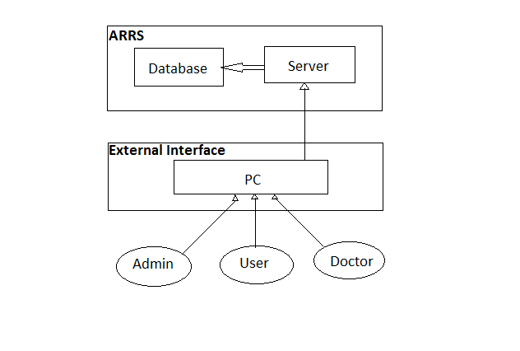
Figure 2.1

Functions of System Components:

Database:
• Stores data
• Creates reports
• Provides access to data
• Updates information

Server:
• Provides access to the database
• Authenticates users
• Processes appointments
• Performs backups
• Produces reports

External Interfaces:

Personal Computers
• Users (patients, Doctors, Admin) may use personal computers to obtain a remote access to the server and the reservation database via the Internet.

Computer Hardware and Peripheral Equipment to be used:
• PC which include CPUs, monitors, keyboards, and mice
• Network
• Terminals

2.2 Product Functions
This section provides a summary of the functions that the software will perform.
2.2.1 Function Relationships
Figure 2.2 to 2.6 depict the relationships among the functions to be implemented by the system.
Figure 2.2 ARRS General Function Relationship/Higher Level Use case Diagram
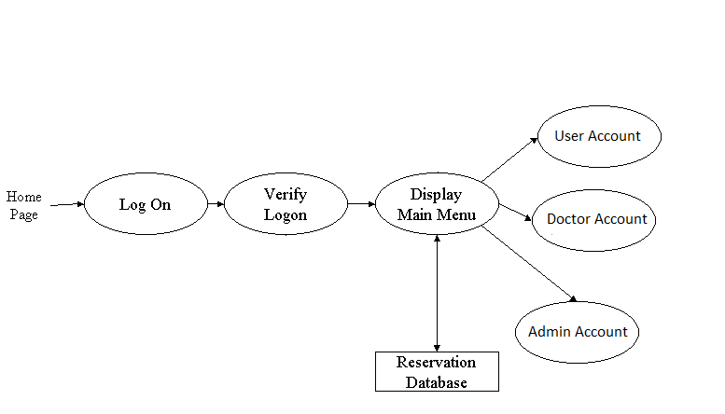

2.2.2 Function Descriptions (Functional Requirement Listings)

2.2.2.1 Login Function

Description: This function ensures that only authorized users gain access to the Reservation databases. An authorized user is a user who has an account on the system. Users include patients, doctors, and Administration. The user must type a valid username and password to gain access.

2.2.2 Module 1: User

Description: This function allows the user to view his appointment history
His profile or to make an appointment.

2.2.3 Module 2: Doctor

Description: This function allows the Doctor to [Make | View] an appointment or edit profile.

2.2.4 Module 3: Admin

Description: This function allows the admin to [View | Delete | Create] doctor, can [View] users as well.

2.3 User Characteristics
The main users of the system will be the people making appointments and the administration that access the reports generated by the system. The users are not required to have knowledge in the computer field. The graphical interface provides an easy way of using the HMS system with minimum of training.

2.4 General Constraints
The constraints for the project are:
- The functional prototype should be available after 30 days upon the arrival of the management team to China. This may prove to be a serious time constraint on the development of a successful prototype.
- Team members are restricted from bringing their own equipment, and insufficient equipment supply may hinder project development.
- Team members are restricted to bringing only the analysts of the team to Pakistan. This might affect the project development if more people are needed or the required skills are not available.
- The majority of the population does not have or have a limited access to the Internet.
2.5 Assumptions and Dependencies or Business Logic
The assumptions for the project are:
- Doctors have some specific specialization
- Reservation can be made up to one month before a particular trip.
- Seats are assigned during reservation.
- Phone reservation involves tickets being purchased within 24 hours after making the reservation. Otherwise, the reservation will be cancelled.
- Patient appointment lists will be available to doctor.
- Each doctors have their own fees.
- Network connection will always remain established.

<ADD OOAD REPORT DIAGRAMS HERE>

3. Specific Requirements

This section of the SRS contains design requirements for the Automated Railway Reservation System.

3.1 Functional Requirements

3.1.1 Log In Function

- Description: This function ensures that only authorized users gain access to the Reservation databases. An authorized user is a user who has an account on the system. Users include passengers, train officials, and CRM ministry officials. The user must type a valid username and password to gain access.

- Usage Scenario/ Use case Description/ Specification:

Description | Allows access to online ARRS
Inputs | Username, password
Source | - User inputs username and password  - Press Login Button

Alternate case
Outputs | Successful login; unsuccessful login
Destination | None
Precondition | Authorized User
Post Condition | No change to Passenger Accounts Database
Side Effects | Failures and successful logins are sent to Reservation Database

- Flow of Event or Data Flow Diagram for Login
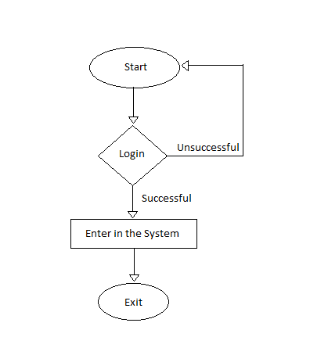

    - Module 1 complete CRUD Make a Reservation Function

- Description: This function allows the user to [make | drop | view] a appointments for a particular doctor on a particular date. If the user does not already have a reservation, then a new appointment is created. If the user already has a previous reservation, a new appointment is added to the list of appointment history.

- Usage Scenario/ Use case Description/ Specification:

Description | [ make | drop | view] a reservation to the user’s account
Inputs | Doctor, Appointment date & time.
Source | - User select doctor, appointment date and time  - Press Button …

Alternate Case
Outputs | Added | Deleted | Viewed reservation
Destination | Computer screen  Appointment database
Precondition | Valid information; Doctors available; user does not have another appointment at the same time
Post Condition | appointment added to users account
Side Effects | User’s current reservations adjusted  Doctor appointments updated

- Use case Diagram:

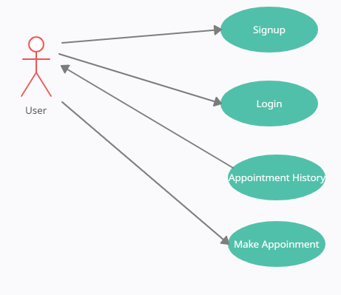

- Flow of Event or Data Flow Diagram:
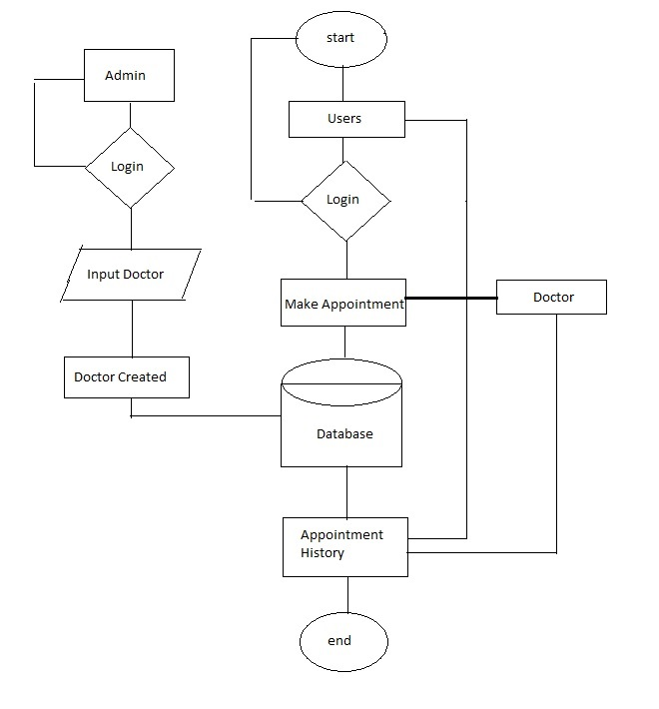

- Sequence Diagram:
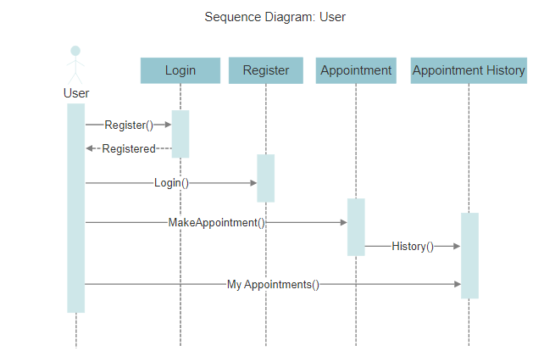

- Collaboration Diagram:
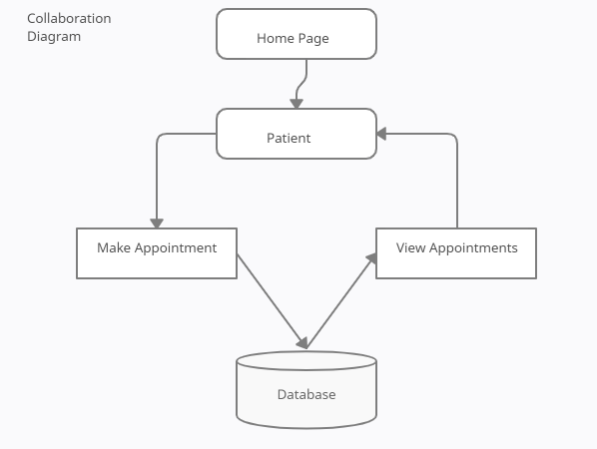

- Activity Diagram:
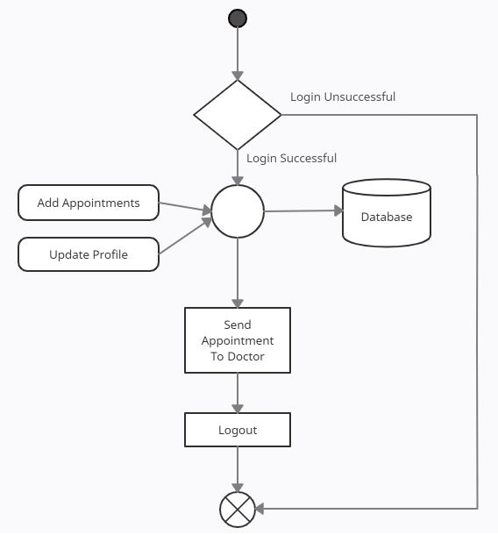

- State Chart Diagram:
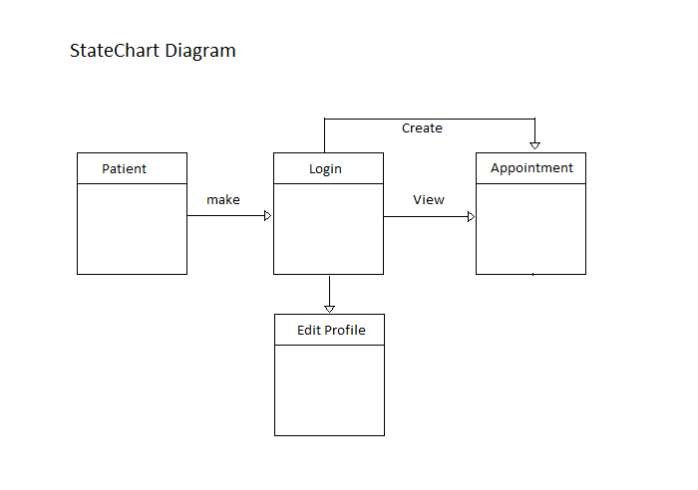

- Class Diagram:
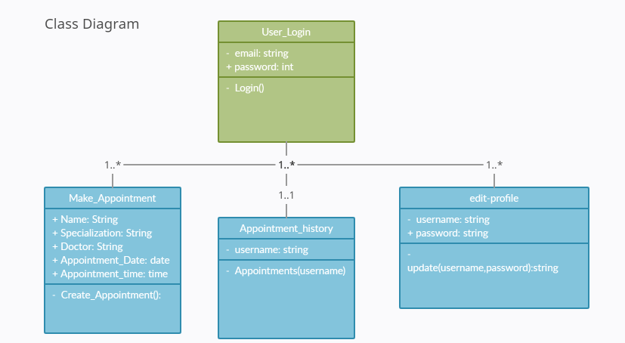

    - Module 3 complete CRUD Make a Reservation Function
- Description: This function allows the doctor to [make | view] a appointments for him on a particular date. Doctor can create a new appointment and a new appointment is added to the list of appointment history

- Usage Scenario/ Use case Description/ Specification:

Description | [ make | view | update] a appointment to the user’s account
Inputs | User and doctor information
Source | - Doctor can edit the users medical history.  - Press Button …

Alternate Case
Outputs | Added | Viewed | Modified appointment
Destination | Computer screen  Reservation database  Doctors Account database
Precondition | Valid information no more than two appointments at the same time
Post Condition | appointment added to users account
Side Effects | User’s medical history updates.

- Use case Diagram:
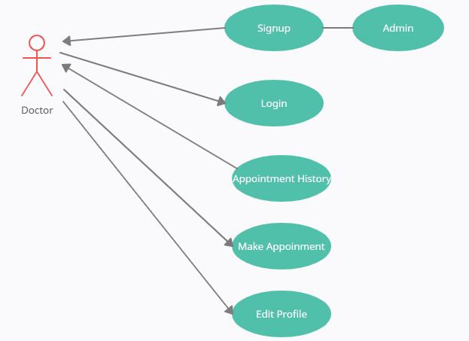

- Flow of Event or Data Flow Diagram:
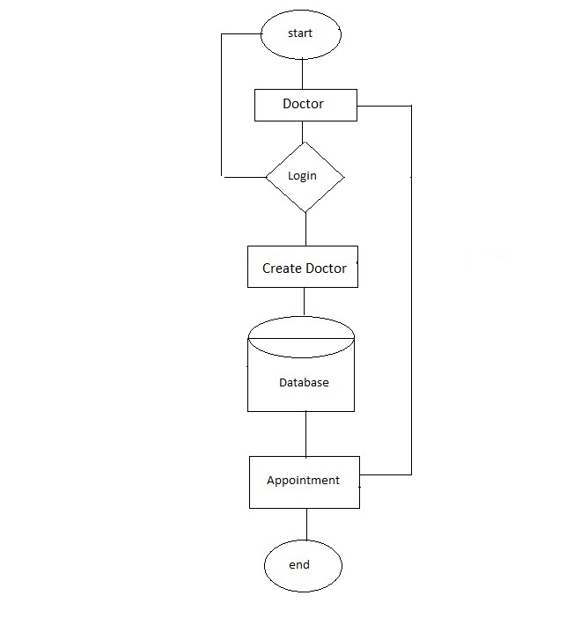

- Sequence Diagram:
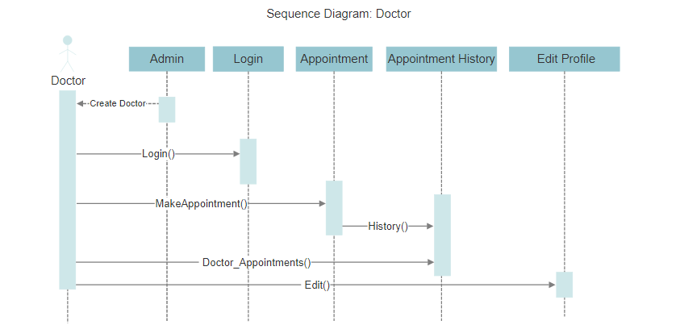

- Collaboration Diagram:
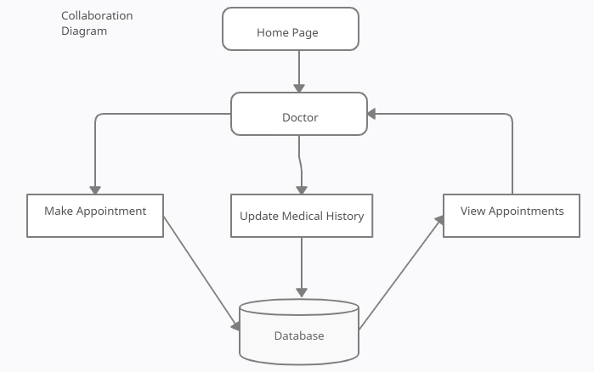

- Activity Diagram:
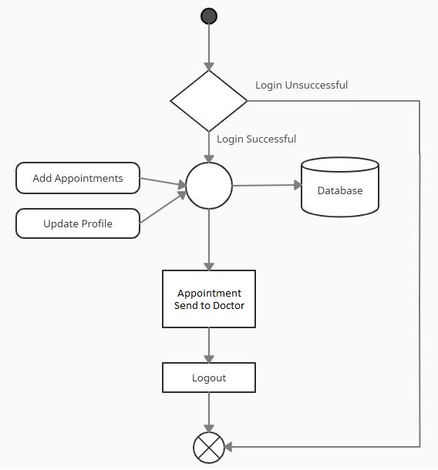

- State Chart Diagram:
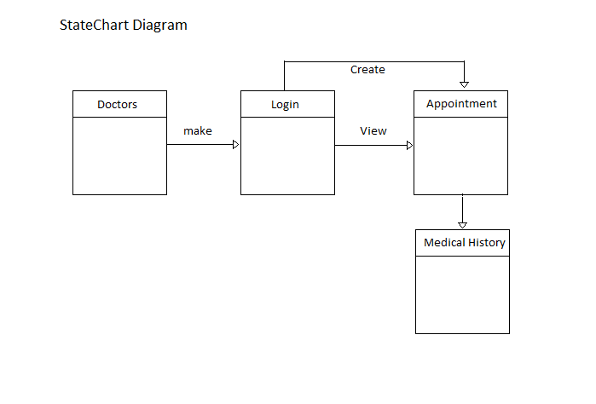

- Class Diagram
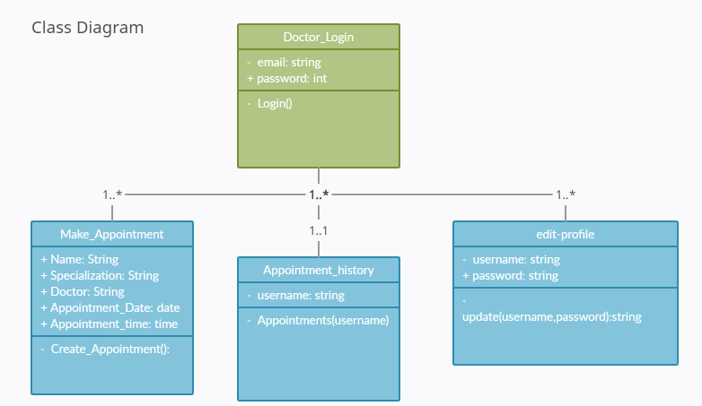

    - Module 4 complete CRUD Make a Reservation Function
- Description: This function allows the admin to [make | drop | view] an appointment for a particular doctor on a particular date. Admin can see user’s appointment list, doctors and users list. Admin can also create doctors and his specialization

- Usage Scenario/ Use case Description/ Specification:

Description | [ make | drop | view | update] to the user and admin profiles
Inputs | Doctor information and specialization
Source | - inputs doctor info  - Press Button …

Alternate Case
Outputs | Added | Deleted | Viewed | Modified a doctor.
Destination | Computer screen  Reservation database  User Account database
Precondition | Valid information no same user ids
Post Condition | Doctor added to the list
Side Effects | Doctors account created

- Use case Diagram:
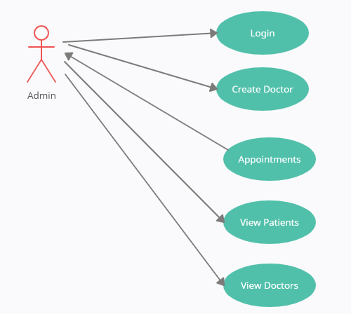

- Flow of Event or Data Flow Diagram:

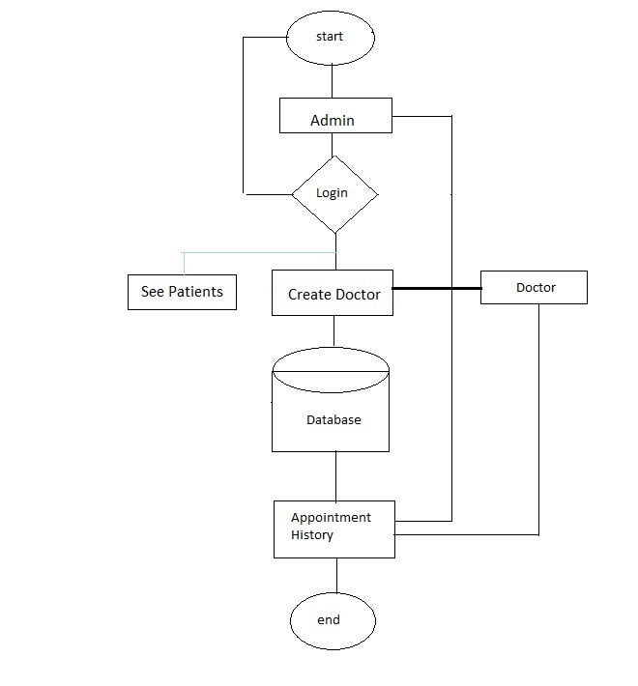

- Sequence Diagram:
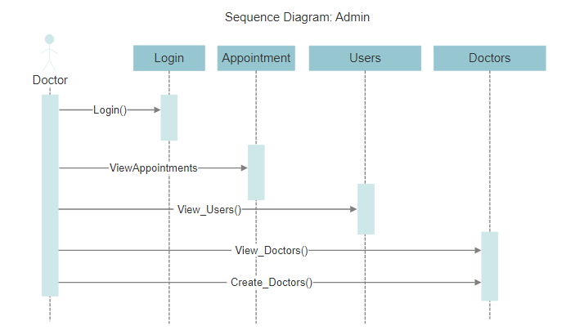

- Collaboration Diagram:
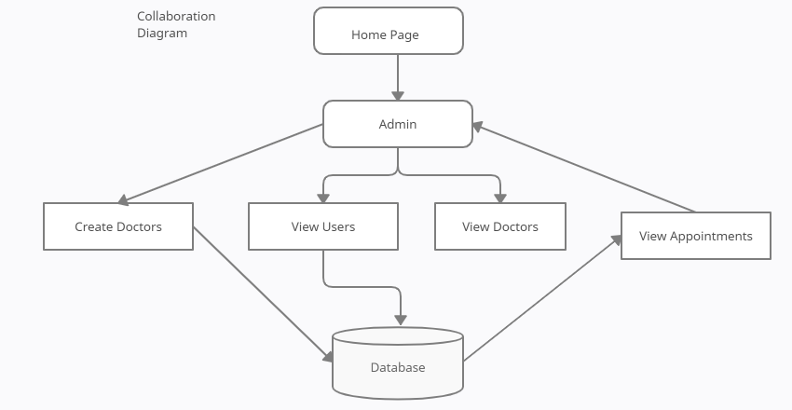

- Activity Diagram:
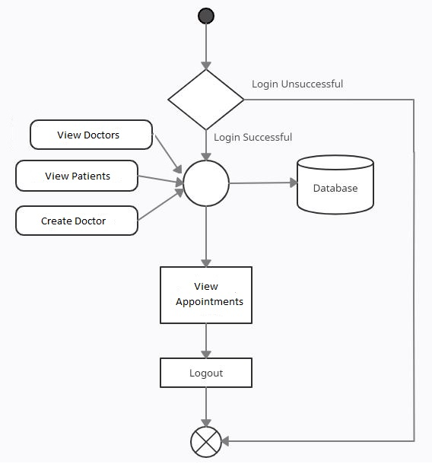

- State Chart Diagram:
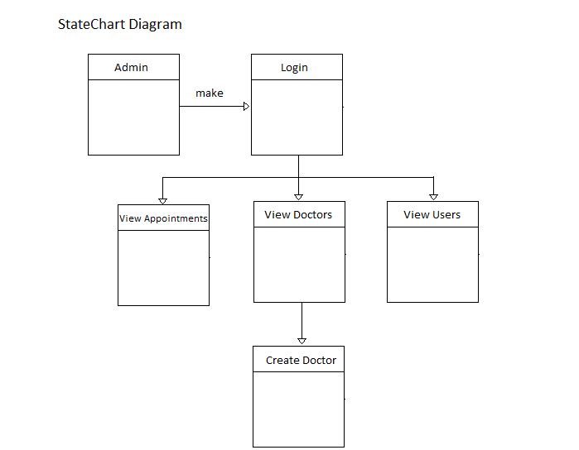

- Class Diagram
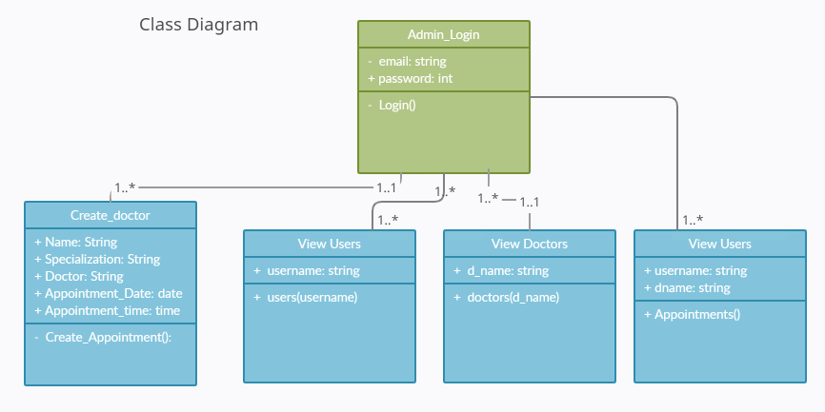

3.2. External Interface Requirements
3.2.1 User Interfaces
The user interfaces are divided into three major components. The first if the user is a patient and wanted to book appointment, second if user is a Doctor and third if user is from administration.

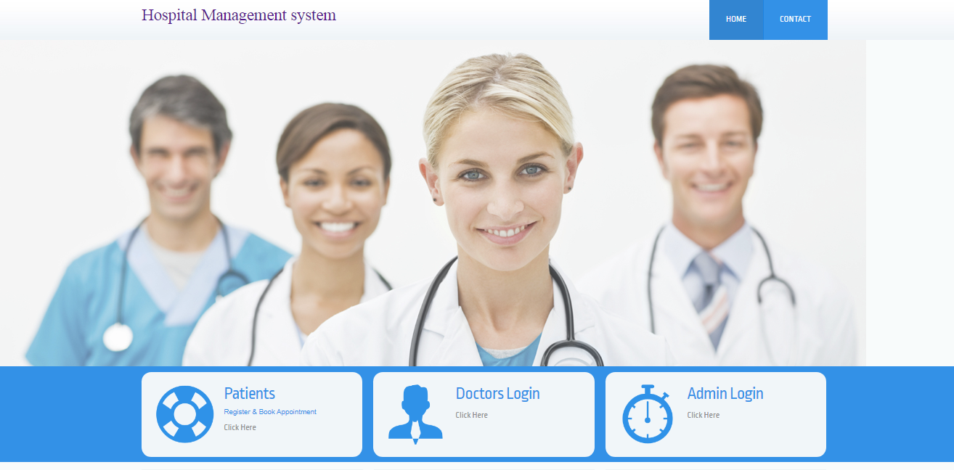

Selecting any one of the functionality will take user in to different interface. Selecting patient will take him to patients interface, selecting doctor will take him to doctor’s interface and admin will take in to admin interface.

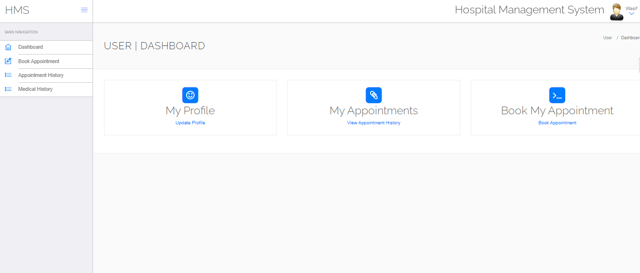

The user can select any of the four functionalities. For the sake of this demonstration, if the user clicks on the Book my appointment another page will open where user can fill required information and .The three buttons allow the user to navigate through the interfaces. For instance, the back button will take the user to the above page, and the logout button will take to home page. Display Available the picture below illustrates the Make Appointment function.

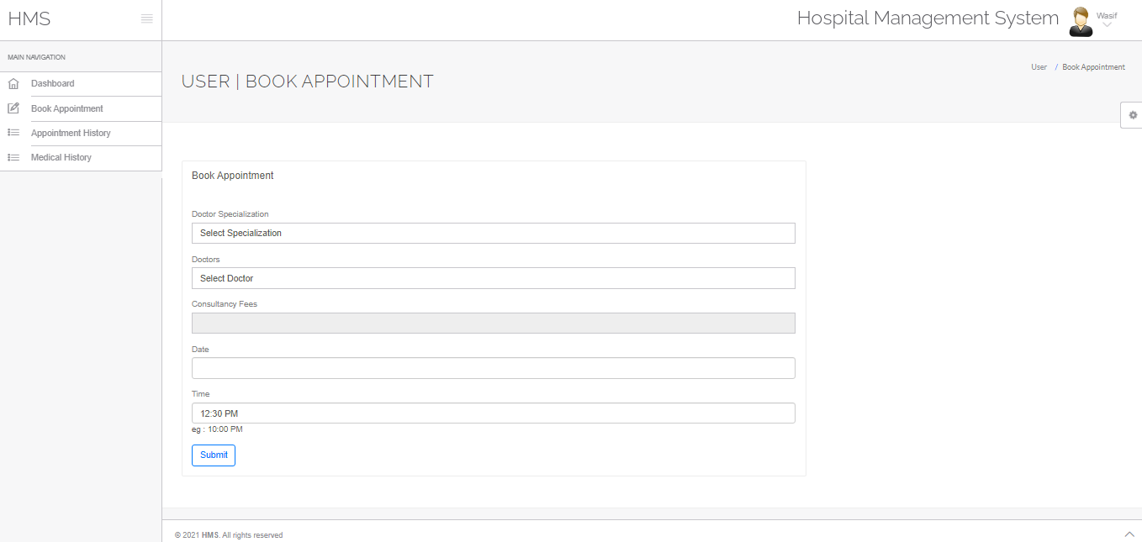

The Display below shows function displays all the appointment of the user has made. The doctor name with his specialization, fees date and time was mentioned active showing the appointment is in future. The user can cancel any appointment with cancel button

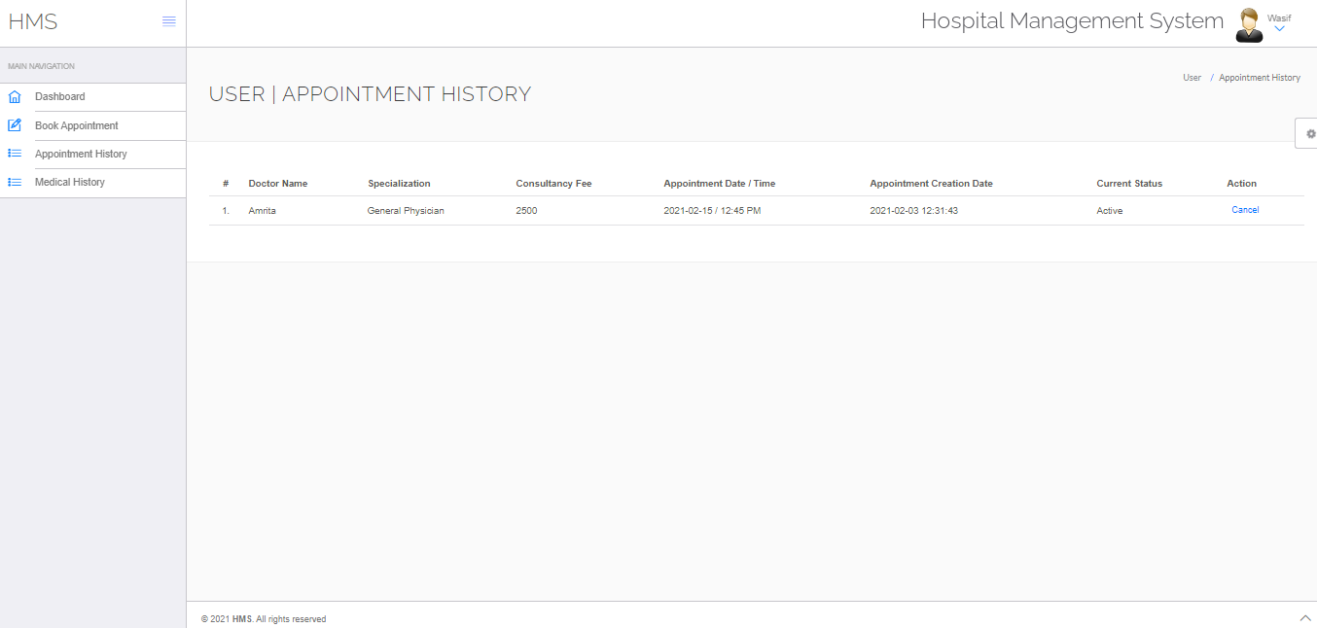

The user can cancel any appointment with cancel button. This page showing only appointment of the current person.

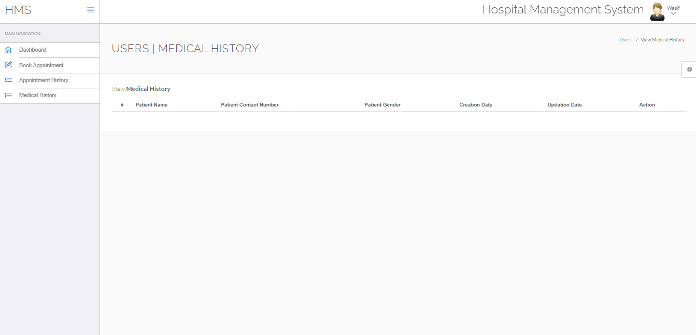

The above illustration shows the medical history maintained by the doctor. Therefore, the HMS interface is able to access all four functionalities as shown in the main menu (first diagram). Once the HMS selects the Reports function, a list of five reports is displayed as linked list. This is shown in the diagram below:

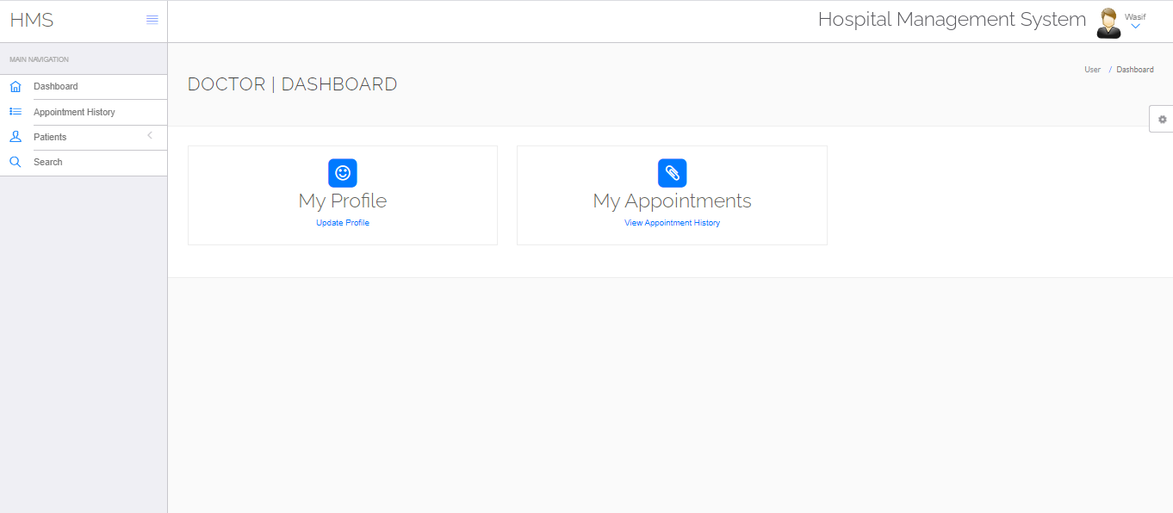

The above Diagram shows the doctors panel wher doctor can change his profile and can check appointments made to him.

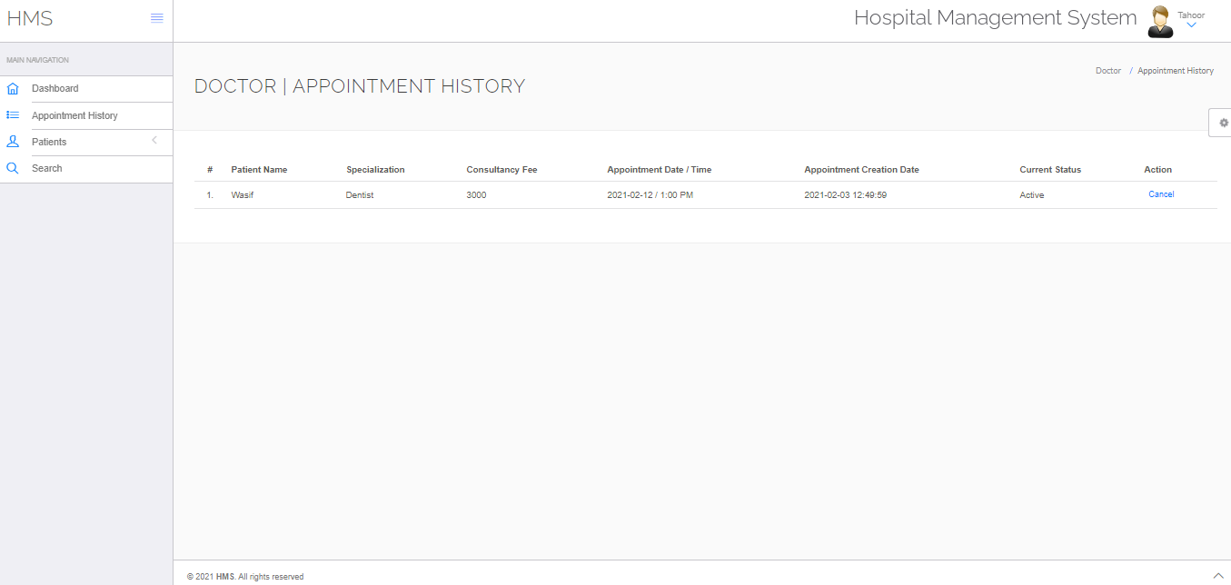

The doctors can see the appointments made to him doctor can cancel the appointment as well as doctor could himself can made appointment of a person didn’t have access to the system.

3.2.2 Hardware Interfaces
The website needs a system with proper internet connectivity

3.2.3 Software Interfaces
The application can be run on any browser, the website needs a server to local host the application on browser, the database has been created using MySQL on phpmyadmin the website built in php.

Information about the products used for the HMS:

(1) Name: phpmyadmin
(2) Mnemonic: The phpmyadmin project
(3) Version Number: 5.0.4
(4) Source: The phpmyadmin project

(1) Name: Windows 8
(2) Mnemonic: windows
(3) Version Number: 8
(4) Source: Microsoft

(1) Name: Google Chrome
(2) Mnemonic: chrome
(3) Version Number: 40
(4) Source: Google

(1) Name: Wamp
(2) Mnemonic: Wamp Server
(3) Version Number: 1.3.14
(4) Source: Romain Bourdon

3.3 Performance Requirements
The following sections list the performance requirements for the system.

3.3.1 User Requirements

User Requirements | Description of Requirement For Design Environment
Location(s) and Number(s) of Users | Pakistan
Expected Growth in Number of Users
After 1 Year | 50%
After 2 Years | 100%
After 3 Years | 200%
User Expectation
Interactivity | User expect that it provides a very easy to use graphical user interface
Reliability | For some applications, reliability must be 100% during the application session
Adaptability | Network must adapt to user additions, deletions and changes
Security | Encryption software would be used for Credit Card transactions
Cost / Funding | Less than $250K

3.3.2 Application Requirements

Since no specified service is indicated, then we have listed the applications as best – efforts. This may change as we learn more about the application.

The communication package is determined to be burst in nature, with small data sizes and frequent transmissions. We can consider this application to be interactive-burst, while the database transaction-processing application is described by the CRM as transferring large amounts of data (initial estimates are 1 MB/transaction), we have listed this application as interactive-bulk.

Categorizing  Applications | Best-Efforts | Application  Locations
Communication | 100 Kb/s | Karachi
Database Access | 400 Kb/s | All Locations
Database Transaction processing | 1.5 Mb/s | All Locations

3.3.3 Host Requirements

 | Type of Host or  Equipment | Numbers and  Locations
Host A | PC | Guangzhou (10), Nanjing(7), Shanghai(10)
Host B | Database Server | Shanghai
Host C | Application Server | Nanjing

3.4.1 Standards Compliance
There are no design constraints that can be imposed by other standards limitations.

3.4.2 Software Limitations
• must be able to run Internet Explorer or Google Chrome to access the system.
• must have cell-phone web based capability to access the system from a mobile phone.

3.4.3 Hardware Limitations
• Input/Output: One or two-button mouse, keyboard, cell-phone, or touch screen required.
• Network card required at thin-client terminals to make communication with server possible.

3.5 Quality Characteristics
There are a number of quality characteristics that apply to the ARRS software system.

3.5.1 Portability
The ARRS system will be developed using PHP, HTML and CSS so that it can be accessed from any type of system using just a regular web browser. It will also be available to users that have web access on their computers. The system will be tested on all types of hardware before being released to ensure that is it compliant with this requirement.

3.5.2 Reliability

The system should be capable of processing the appointments within a given time frame with no errors and the system should be available and operational all the time. During the development of the prototype for the count, the system will be tested in its actual environment to ensure that it can handle the load of reservations that occur during a regular workday.

3.5.3 Usability
The system will be developed so that it is an easy to use system that requires the least amount of user input possible. Every input will be validated. The user should only have general computer use knowledge. Error messages will be displayed if the user enters an invalid value or tries to access a function without the required permissions. An easy and well-structured user manual will be provided to the HMS and the system will include descriptive help for all operations allowed.
3.5.4 Correctness
The system will be considered correct if the required processing done within the time without errors and any kind of bugs, and the system would generate a message if there is a problem from the user side.
3.5.5 Flexibility
The ARRS system should be developed in such a way that it is easily customizable. If new functions are required by CRM, there will be little effort required to update the system to support new cities or new transactions.
3.5.6 Security

The ARRS system should not compromise the customer information at any time. The user information will never be sold to other parties and will be kept secure at all times. Users will be authenticated to ensure that no unauthorized users gain access to private information.

3.5.7 Maintainability

The HMS source code will be kept well structure and documented so that it is easier to maintain and extend the system. All changes to the system shall be documented for future updates.

3.6 Other Requirements

Certain requirements may, due to the nature of the software, the user organization, etc., be placed in separate categories such as those below.

3.6.1 Data Base

The databases will automatically be maintained when the information processed. One is the normal Database, and another is the user logs. These databases will be created with phpmyadmin and MySQL language. The following are the requirements for these databases that are to be developed as part of the product. They include:

Reservation Database
Types of information | Information of the users, doctors, doctor specialization, appointments, messages and user and doctors’ logs.
Frequency of use | Depends on the passenger demand, which may reach 1,000 per day during peak periods
Accessing capabilities | The database should allow access to at least 1,000 people at once; the users will have a general access to the information about the train schedule, and a secure access to the reports (available only to CRM officials) using a username and a password
Data element and file descriptions | To be determined
Relationship of data elements, records and files | To be determined
Static and dynamic organization | To be determined
Retention requirements for data | Train schedule information will be available as long as the train for a particular route is in use and at least one year after the train has been cancelled. The reports information will be available at least for 5 years

3.6.2 Operations
The normal operations required by the user can be viewed as the following:
User-initiated Operations:
These operations include the login operation, which is initiated by the users. Also, the process of becoming a new user is in this category. Building, changing, and viewing itineraries, as well as paying for the itinerary are all initiated by the users. The user initiates the report generation activity, as well as changing train schedules.
Interactive Operations and Unattended Operations:
The users initiate all the operations mentioned above, and almost all of them are somehow interactive. Displaying the train schedule is non-interactive. The report display is a non-interactive operation, although selecting the desired reports will require user input.
Data Processing Support Functions:
The user account data is used to create new accounts, as well as to validate user id's during login functions. For building itineraries, user input, user account data, and train schedule data are used, and processed. User data along with final results of user interaction (whether the user purchased a trip, number of tickets bought, etc.) are collected, and used for report generation purposes. Administrative users' inputs are collected in order to modify and present schedules.
Backup and Recovery Operations:
Both databases used (passenger account database and reservations database) are production databases. The main operation used for the backup and recovery is Oracle's built-in cold backup, which is also known as the "archive mode". Depending on the customer's needs and budget, additional redundancy can be added using systems like RAID 5 and tape backup.
3.6.3 Site Adaptation Requirements
There are no site adaptation requirements for this project.

4. Supporting Information.
There is no supporting information required for this project.

