VENDOR PERFORMANCE ANALYSIS
Retail & Wholesale Industry

An End-to-End Data Analytics Project
Tools Used: SQL Server | Python | Power BI
Prepared by: Wasif Ehsan | May 2026

1. Executive Summary

This report presents a comprehensive vendor performance analysis for a retail and wholesale business. The analysis integrates data from multiple sources including purchase records, sales transactions, vendor invoices, and pricing data to evaluate vendor efficiency, profitability, and inventory management.

The primary objective is to identify underperforming brands, evaluate vendor contribution to sales and profit, assess bulk purchasing impact, and provide actionable recommendations to optimize profitability.

Key findings at a glance:
- Total of 119 vendors analyzed across all product categories
- Overall gross profit margin stands at 30.49% with $136.8M gross profit
- Top 10 vendors contribute 64.72% of total purchases — indicating high vendor dependency
- Bulk purchasing reduces unit cost by 74% — a significant operational advantage
- $3.66 Million in capital is locked in unsold inventory requiring immediate attention
- 193 brands identified with high margins but low sales — prime candidates for promotion

2. Business Problem

Effective inventory and sales management are critical for optimizing profitability in the retail and wholesale industry. The business faces three core challenges:

- Inefficient pricing — some brands are priced too high, reducing sales volume despite strong margins
- Poor inventory turnover — capital is locked in slow-moving stock, increasing holding costs
- Vendor dependency — over-reliance on a small number of vendors creates supply chain risk

Goals of this analysis:
- Identify underperforming brands requiring promotional and pricing adjustments
- Determine top vendors contributing to sales and gross profit
- Analyze the impact of bulk purchasing on unit cost
- Assess inventory turnover to reduce holding cost and improve efficiency
- Investigate profitability variance between high and low performing vendors

3. Data Overview

The dataset covers the full year 2024 and includes six tables stored in SQL Server (VendorPerformanceDB):

Table Name | Records | Description
purchases | 2,372,474 | Purchase transactions by vendor and store
sales | 12,825,363 | Sales transactions with price and quantity
vendor_invoice | 5,543 | Invoice details including freight costs
purchase_prices | 12,261 | Reference prices per brand
begin_inventory | 206,529 | Opening inventory (not used in analysis)
end_inventory | 224,489 | Closing inventory (not used in analysis)

Tables used for final analysis: purchases, sales, vendor_invoice, and purchase_prices. Begin and end inventory tables were excluded as they do not directly relate to the vendor performance business problem.

3.1 Final Aggregated Table
An aggregated summary table (vendor_sales_summary) was created by joining the four relevant tables. New features engineered:
- gross_profit = total_sales_dollars - total_purchase_dollars
- profit_margin = (gross_profit / total_sales_dollars) x 100
- stock_turnover = total_sales_quantity / total_purchase_quantity
- sales_to_purchase_ratio = total_sales_dollars / total_purchase_dollars

After filtering for valid records (gross_profit > 0, profit_margin > 0, sales_quantity > 0), the final dataset contains 8,565 records across 119 vendors.

4. Key Performance Metrics

$448.8M  Total Sales | $312.0M  Total Purchases | $136.8M  Gross Profit | 30.49%  Profit Margin

119  Total Vendors | $3.66M  Unsold Inventory | $67.99M  Top Vendor Sales | $7.96M  Top Brand Sales

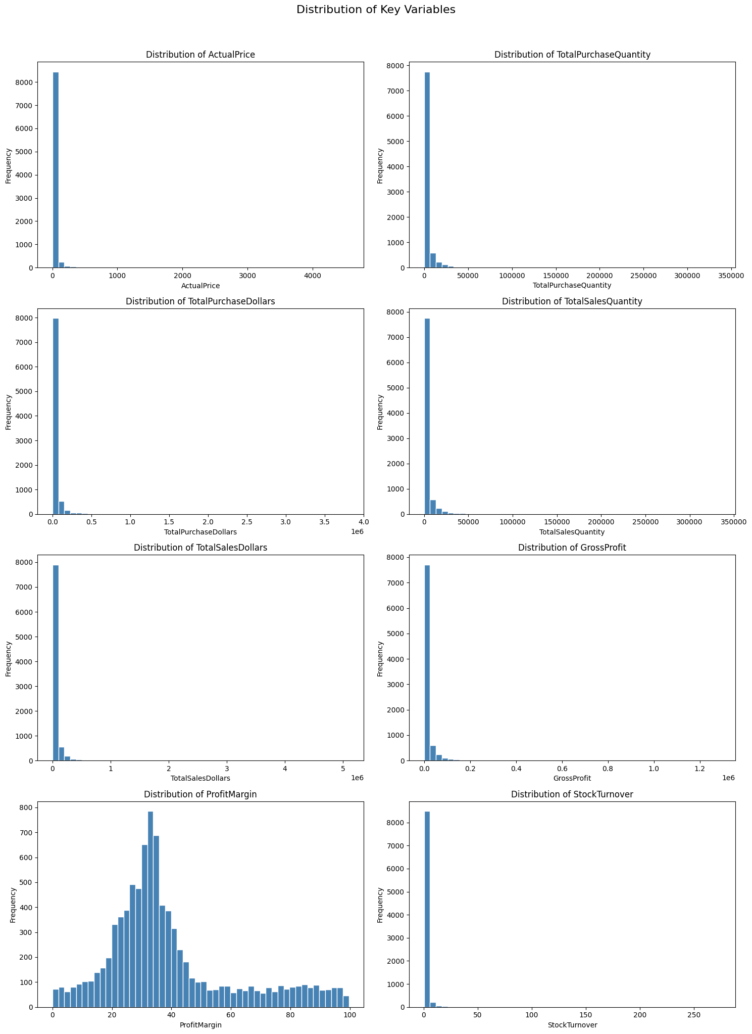
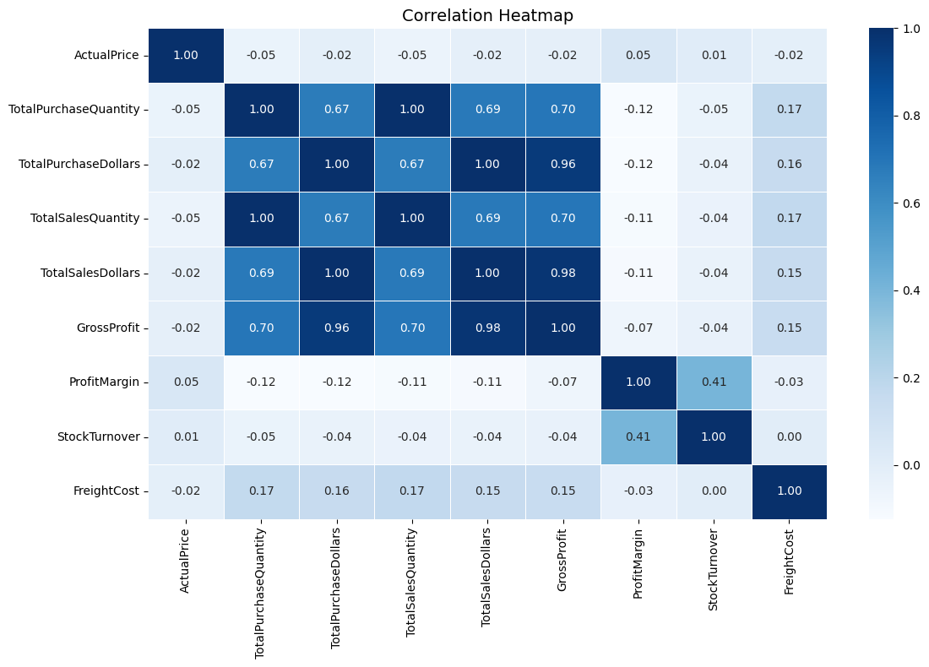

5. Research Questions & Findings

RQ1: Brands Needing Promotional Adjustments
Objective: Identify brands with low sales but high profit margins that need promotional support or pricing adjustments.

Finding:
- 193 brands identified with low sales (below $577) but high profit margin (above 65%)
- These brands are profitable per unit but lack market visibility
- They represent a significant missed revenue opportunity
Recommendation:
- Run sponsored promotions and targeted ads for these brands
- Reduce pricing slightly to boost sales volume
- Offer bundle deals to increase purchase frequency
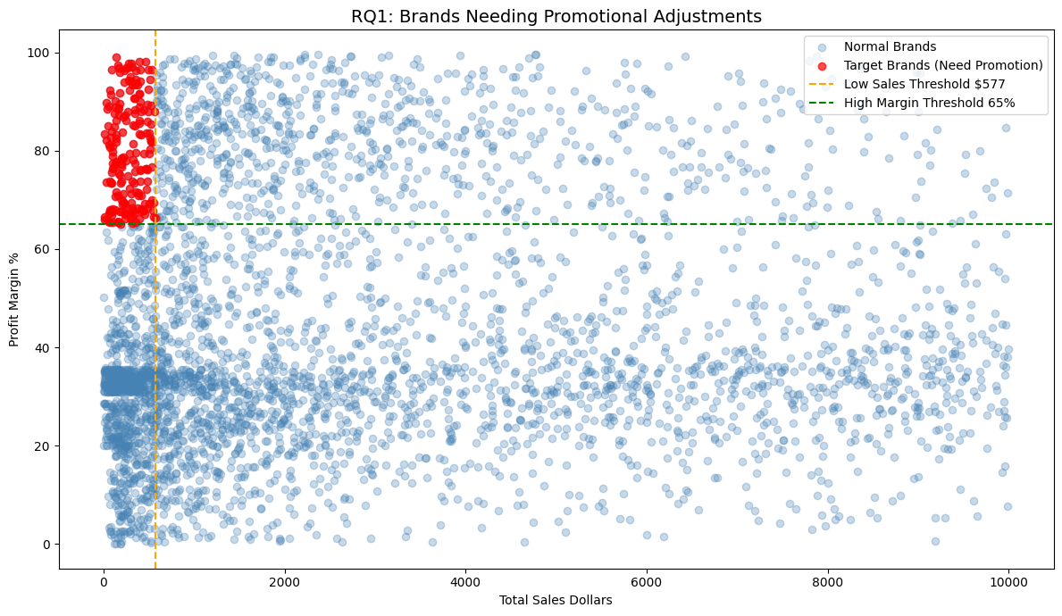

RQ2: Top Vendors and Brands by Sales
Objective: Identify the top vendors and brands driving the most revenue.

Top 10 Vendors by Sales:
Vendor Name | Total Sales
DIAGEO NORTH AMERICA INC | $67.99M
MARTIGNETTI COMPANIES | $39.33M
PERNOD RICARD USA | $32.06M
JIM BEAM BRANDS COMPANY | $31.42M
BACARDI USA INC | $24.85M
CONSTELLATION BRANDS INC | $24.22M
E & J GALLO WINERY | $18.40M
BROWN-FORMAN CORP | $18.25M
ULTRA BEVERAGE COMPANY LLP | $16.50M
M S WALKER INC | $14.71M

Top 10 Brands by Sales:
Brand Name | Total Sales
Jack Daniels No 7 Black | $7.96M
Tito's Handmade Vodka | $7.40M
Grey Goose Vodka | $7.21M
Capt Morgan Spiced Rum | $6.36M
Absolut 80 Proof | $6.24M
Jameson Irish Whiskey | $5.72M
Ketel One Vodka | $5.07M
Baileys Irish Cream | $4.15M
Kahlua | $3.60M
Tanqueray | $3.46M

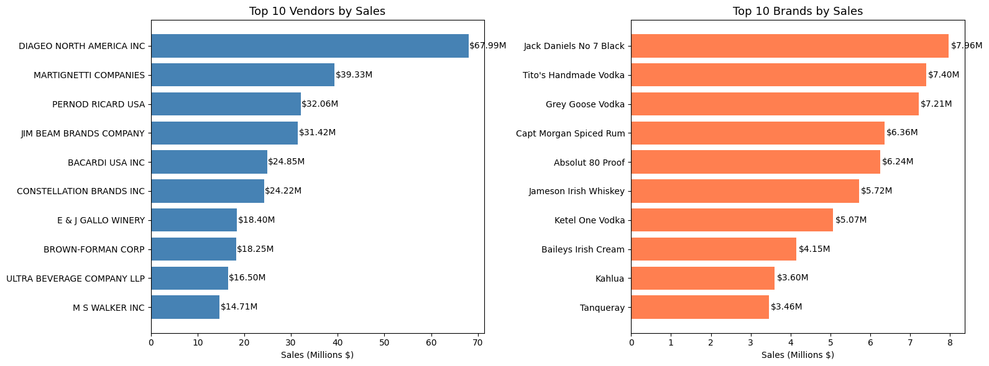

Recommendation:
- Strengthen relationships with top 3 vendors — Diageo, Martignetti, and Pernod Ricard
- Increase stock of top performing brands especially Jack Daniels and Tito's Vodka
- Vodka, Whiskey, and Rum dominate sales — prioritize these categories

RQ3: Vendor Purchase Contribution
Objective: Assess how purchases are distributed across vendors to identify dependency risk.
Finding:
Vendor Name | Purchase Contribution
DIAGEO NORTH AMERICA INC | 16.06%
MARTIGNETTI COMPANIES | 8.17%
PERNOD RICARD USA | 7.65%
JIM BEAM BRANDS COMPANY | 7.53%
BACARDI USA INC | 5.59%
CONSTELLATION BRANDS INC | 4.90%
BROWN-FORMAN CORP | 4.24%
E & J GALLO WINERY | 3.87%
ULTRA BEVERAGE COMPANY LLP | 3.58%
M S WALKER INC | 3.13%

- Top 10 vendors contribute 64.72% of total purchases
- Remaining 109 vendors contribute only 35.28%
- High concentration risk — business is heavily dependent on a few vendors
Recommendation:
- Diversify vendor portfolio to reduce dependency on top 10 vendors
- Develop relationships with mid-tier vendors to distribute risk
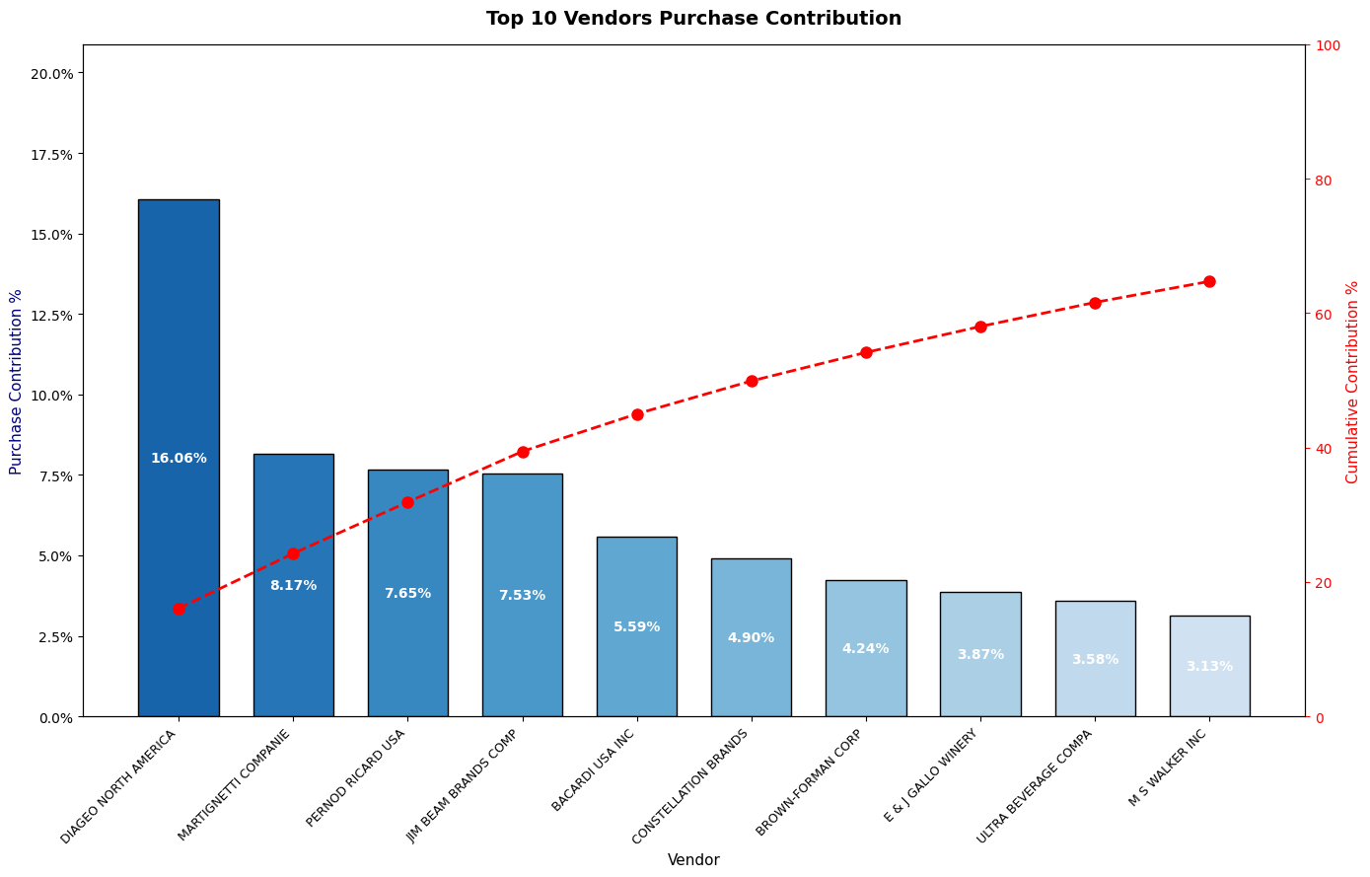

RQ4: Impact of Bulk Purchasing on Unit Cost
Objective: Analyze how order size affects the unit purchase price.

Finding:
Order Size | Average Unit Cost | Reduction vs Small
Small Orders | $41.38 | Baseline
Medium Orders | $15.42 | -63%
Large Orders | $10.74 | -74%

- 74% price reduction achieved from small to large orders
- Bulk purchasing strategy is clearly effective and should be reinforced

Recommendation:
- Encourage vendors to purchase in bulk through volume discount incentives
- Negotiate long-term bulk contracts with top vendors
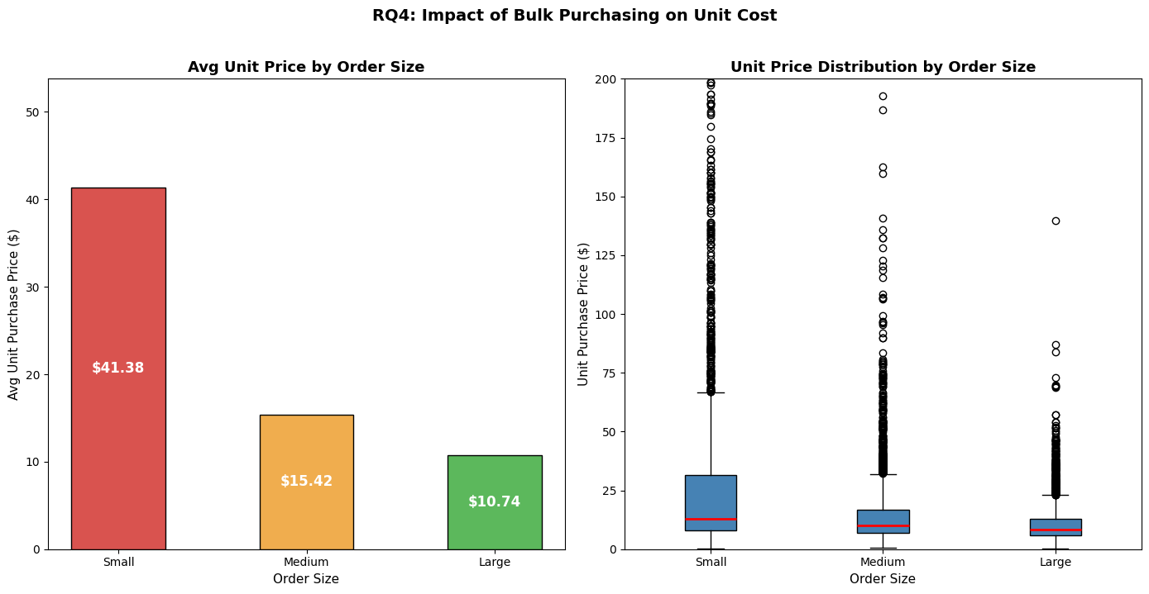

RQ5: Vendors with Low Inventory Turnover
Objective: Identify vendors with stock turnover below 1.0 indicating slow-moving inventory.

Finding:
- Vendors with stock turnover below 1.0 identified as underperformers
- ALISA CARR BEVERAGES has the lowest turnover at 0.615
- All flagged vendors are significantly below the target turnover of 1.0
- Low turnover means more stock is being purchased than sold

Recommendation:
- Advise these vendors to reduce purchase quantities
- Launch clearance sales for slow-moving products
- Revise storage and ordering strategies for these vendors
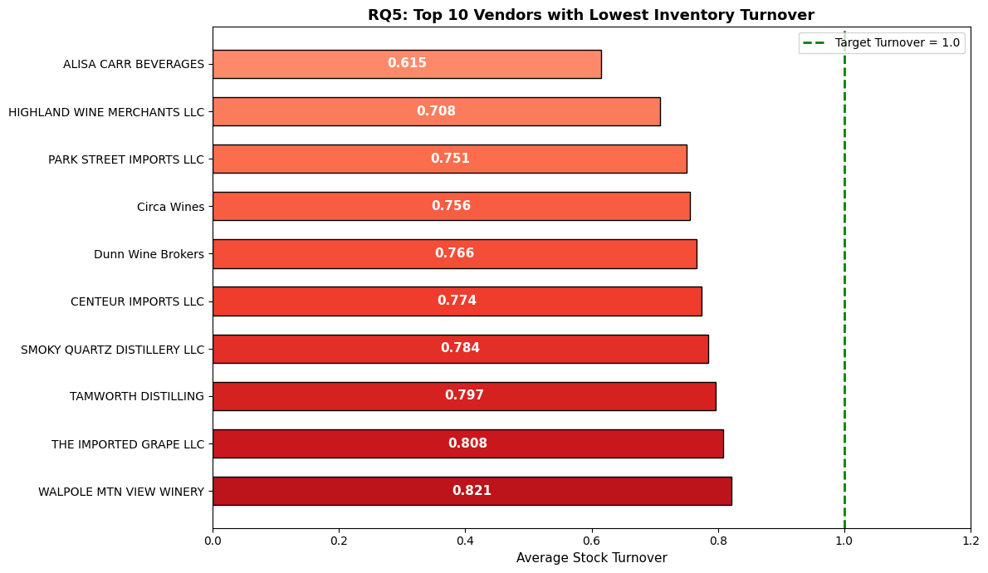RQ6: Capital Locked in Unsold Inventory
Objective: Quantify the capital tied up in unsold stock.

Finding:
- Total $3.66 Million capital is locked in unsold inventory
- DIAGEO has the highest unsold inventory value at $984K
- Top 3 vendors (DIAGEO, JIM BEAM, PERNOD RICARD) account for $2.39M of unsold stock
- This represents a significant operational inefficiency

Recommendation:
- Launch clearance sales for slow-moving products immediately
- Reduce future purchase quantities for high-inventory vendors
- Negotiate return policies with top vendors to reduce holding risk

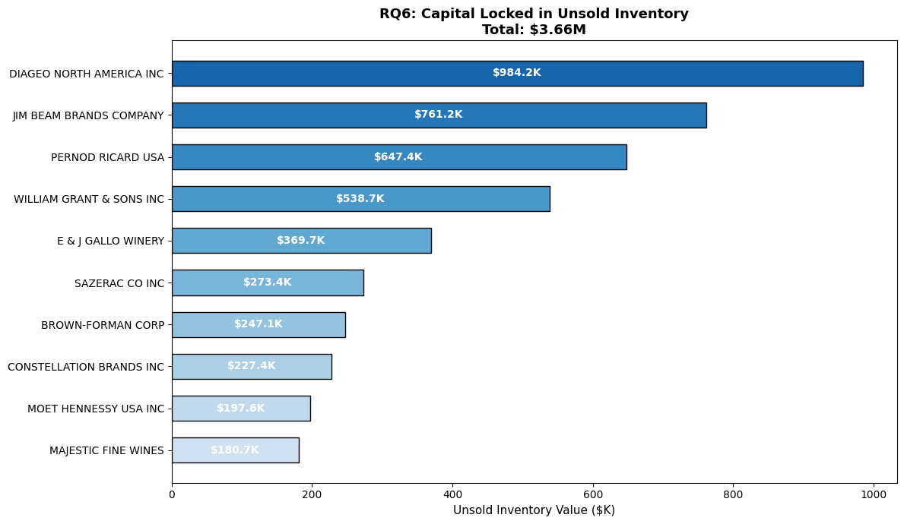RQ7 & RQ8: Statistical Analysis of Profit Margins
Objective: Compare profit margins between top and low performing vendors using statistical methods.

RQ7 — Confidence Intervals (95%):
Vendor Group | Profit Margin CI (95%)
Top Performing Vendors | 30.89% to 31.74%
Low Performing Vendors | 40.65% to 42.74%

- Counterintuitively, low performing vendors have HIGHER profit margins
- This suggests low performers sell premium/niche products in low volumes
- High volume vendors sacrifice margin for scale

RQ8 — Hypothesis Testing:
Test | Result
H0 (Null Hypothesis) | No significant difference in profit margins
H1 (Alternative) | Significant difference exists
T-Statistic | -17.9851
P-Value | 0.000000
Conclusion | REJECT H0 — Difference is statistically significant

Recommendation:
- Top vendors should explore selective price adjustments to improve margins
- Low volume vendors should focus on increasing sales through better marketing and distribution
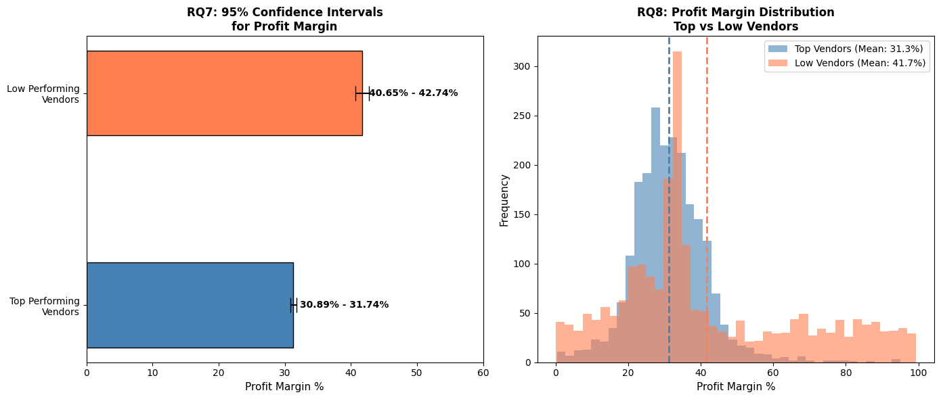

6. Strategic Recommendations

# | Recommendation | Priority
1 | Re-evaluate pricing for 193 low-selling, high-margin brands to boost sales volume | High
2 | Diversify vendor partnerships to reduce dependency on top 10 vendors (currently 64.72%) | High
3 | Leverage bulk purchasing advantages — 74% cost reduction from small to large orders | Medium
4 | Optimize slow-moving inventory through clearance sales and revised ordering strategies | High
5 | Enhance marketing and distribution for low-performing vendors to grow sales volume | Medium
6 | Negotiate return policies with top vendors to reduce $3.66M locked in unsold stock | Medium

7. Conclusion

This analysis reveals a business with strong overall performance — $448.8M in sales and a 30.49% profit margin — but with several areas requiring strategic attention.

The key concern is vendor concentration risk, where 64.72% of purchases come from just 10 vendors. Combined with $3.66M locked in unsold inventory and 193 high-margin brands that are underperforming in sales, there is a clear opportunity to improve both revenue and operational efficiency.

The statistical analysis confirms that the difference in profit margins between top and low performing vendors is not by chance — it reflects a fundamental difference in business strategy between high-volume, lower-margin vendors and low-volume, premium-margin vendors.

Implementing the six strategic recommendations outlined in this report will position the business for sustainable profitability, reduced operational risk, and improved vendor relationships.

End of Report
Vendor Performance Analysis | Wasif | May 2026

