1. What is View?

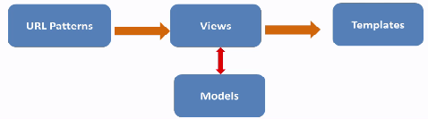View is a python function that take web request and return a response to it. This flow how view process works

1. What is URL dispatcher

It design and create elegant URL schemes, it do mapping between URL patterns (regx) and python functions view.