Karachi Air Quality Index
3-Day Forecasting System
A serverless, end-to-end machine learning pipeline for predicting
Air Quality Index up to 72 hours ahead
Live URL
https://karachi-aqi123.streamlit.app/
Technology Stack
Open-Meteo API · Supabase (Postgres + Storage) · scikit-learn · SHAP · GitHub Actions · Streamlit

1. Project Overview
For my internship project, I built an end-to-end system that forecasts the Air Quality Index (AQI) for Karachi three days ahead. The original brief suggested using Hopsworks for the feature store and model registry, but I ran into setup issues with it fairly early on and couldn't get it working reliably within the time I had, so I switched to Supabase instead (Section 2.1 explains this in more detail). Everything else follows the pipeline structure the brief laid out — Open-Meteo is the data source for both historical and forecasted weather/pollution data.
The system has four moving parts that all run automatically: a feature pipeline that pulls in fresh weather and pollutant data every hour, a training pipeline that retrains the models every day, a model registry that keeps track of which model version is currently 'live', and a Streamlit dashboard that shows the forecast along with explanations and alerts. None of it needs me to touch it once it's running — that was one of the main goals.

1.1 Objectives
- Predict AQI for Karachi at three horizons: 24 hours (Day 1), 48 hours (Day 2), and 72 hours (Day 3).
- Build a fully automated pipeline that doesn't need manual intervention once deployed.
- Make the model's reasoning visible (SHAP) and add health alerts for hazardous air quality.
- Actually check whether the forecasts are correct once real days pass, not just trust the backtest numbers.

2. System Architecture
The architecture follows four stages, each independently deployable and automated:
Stage | Component | Technology
1 | Data ingestion | Open-Meteo Weather Archive + Air Quality API
2 | Feature generation | Python script (feature_pipeline.py)
3 | Feature store & model registry | Supabase (Postgres table + Storage bucket)
4 | Model training | scikit-learn (Ridge, Random Forest, Gradient Boosting, ensemble)
5 | Automation | GitHub Actions (hourly + daily scheduled workflows)
6 | Serving | Streamlit web dashboard, deployed on Streamlit Community Cloud
Table 1. End-to-end pipeline stages and the technology used for each.
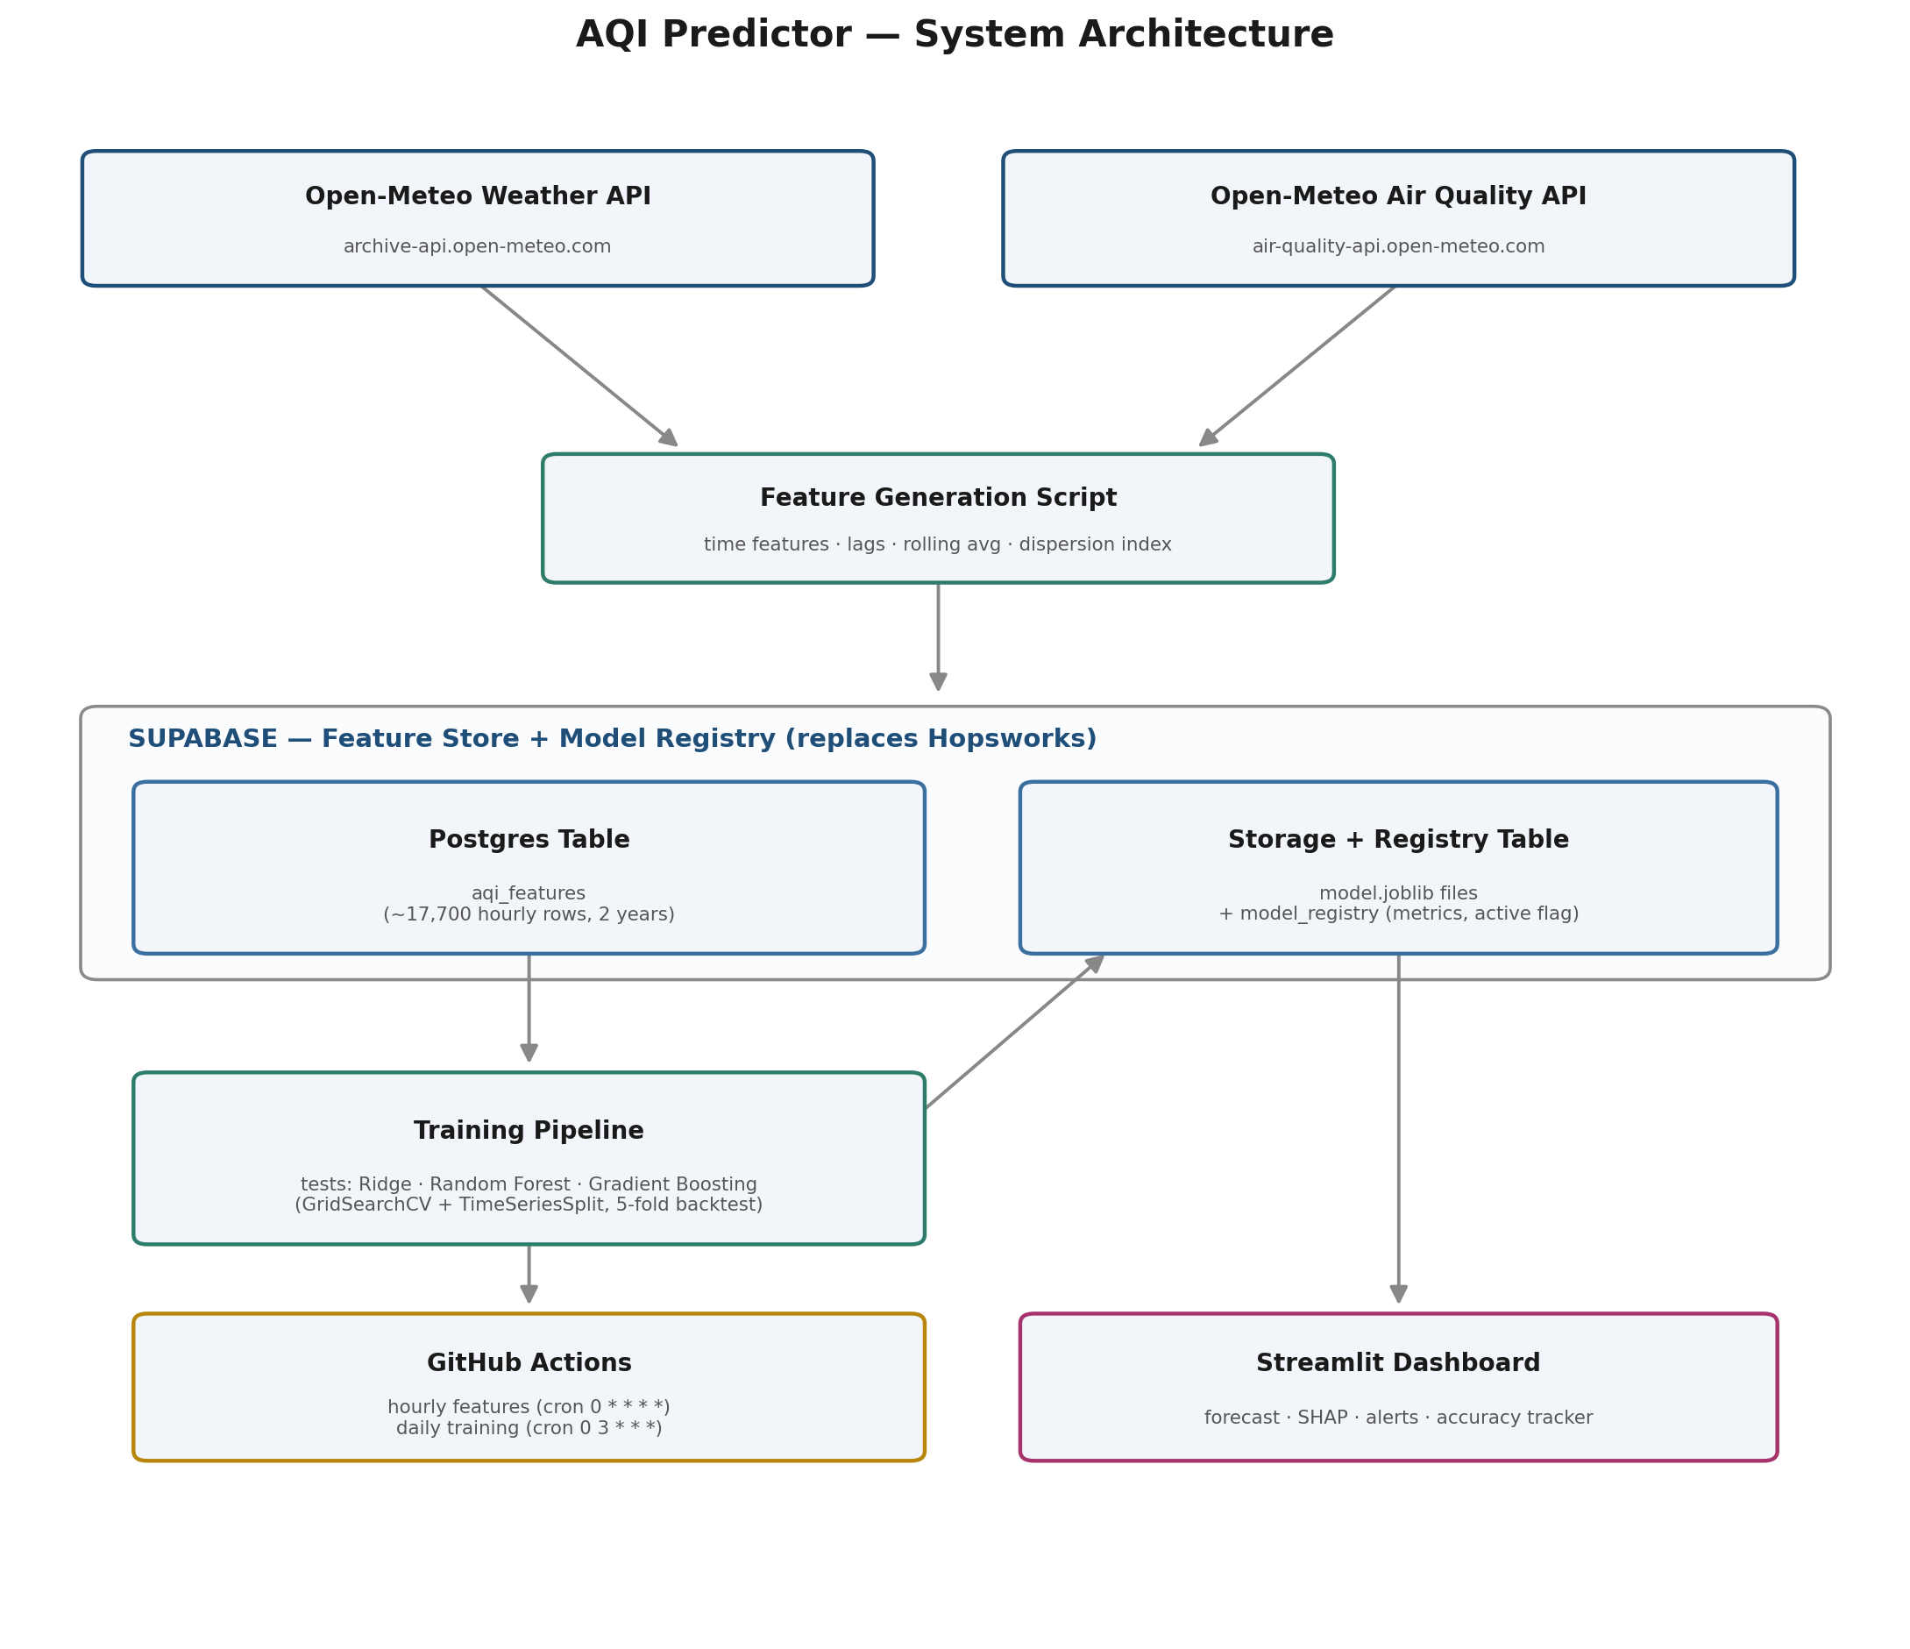
Figure 1. Full system architecture. Every arrow connects two visible boxes — Training Pipeline writes new models up into Storage, and the Dashboard reads the active model straight down from the same box, both in one continuous flow.

2.1 Why Supabase Instead of Hopsworks
The brief asked for Hopsworks specifically, and I did try to set it up first. But I kept hitting account provisioning and connectivity problems on the free tier that I couldn't resolve in a reasonable amount of time, so I made the call to switch to Supabase instead. It plays the exact same two roles Hopsworks would have — feature store and model registry — just on a different platform:
- Feature store: a plain Postgres table (aqi_features) instead of Hopsworks' feature groups. Being able to just write normal SQL against it turned out to be genuinely useful for debugging — I could check row counts, spot missing values, and sanity-check things directly instead of going through an abstraction layer.
- Model registry: a Supabase Storage bucket holding the serialized model files (.joblib), paired with a metadata table (model_registry) that tracks version, metrics, and which model is currently active per horizon.
- Both live on one free-tier platform, which meant one set of credentials to manage instead of two separate services.
The pipeline logic itself didn't change because of this swap — features still get generated, stored, versioned, and served in the same stages the brief describes. Only the storage platform underneath changed.

2.2 Still Fully Serverless, No Local Data Storage
Switching to Supabase didn't compromise the 'no CSV, deployed feature store' requirement — if anything it's easier to verify with Supabase than it would have been with a black-box feature store abstraction. At every stage of the pipeline, data moves directly between an API response, an in-memory pandas DataFrame, and a Supabase call — it never touches a local file:
- feature_pipeline.py: Open-Meteo response → DataFrame in memory → supabase.table('aqi_features').upsert(). No .to_csv() anywhere in the script.
- training_pipeline.py: supabase.table('aqi_features').select('*') → DataFrame in memory → model training. The only local file writes are the temporary .joblib model files, and those are immediately uploaded to Supabase Storage and are disposable afterward.
- app.py: queries Supabase directly at request time for both the latest features and the active model — never reads from a local file.
The single authoritative copy of the dataset lives in exactly one place: the aqi_features table in Supabase, a deployed, cloud-hosted feature store. The GitHub Actions runners that execute the hourly and daily scripts are themselves ephemeral — they spin up, run the script, and are destroyed, so there's no persistent local disk involved anywhere in the automated pipeline either.

2.3 Why Open-Meteo
Open-Meteo requires no API key, has no rate-limit barrier at this project's scale, and its historical archive extends back over a decade, which allowed backfilling two full years of hourly data. Its air-quality endpoint also returns a precomputed US AQI value directly, removing the need to implement the AQI formula manually.

3. Data Pipeline

3.1 Data Collected
For each hour, the following raw fields are pulled for Karachi (24.8607° N, 67.0011° E):
- Weather: temperature, relative humidity, wind speed, wind direction, surface pressure, precipitation, boundary layer height
- Pollutants: PM2.5, PM10, carbon monoxide, nitrogen dioxide, sulphur dioxide, ozone
- Target: US AQI (computed by Open-Meteo from pollutant concentrations)

3.2 Feature Engineering
Category | Features | Purpose
Temporal (cyclical) | hour_sin/cos, month_sin/cos, day_of_year_sin/cos | Encodes cyclical time so e.g. hour 23 and hour 0 are treated as adjacent
Lag features | aqi_lag_1h, aqi_lag_24h, aqi_change_rate | Captures recent trend and momentum in air quality
Rolling averages + volatility | pm2_5_roll6/24, aqi_roll6/24, aqi_roll_std_6/24 | Smooths noise, captures trend, and (later) captures whether pollution is currently stable or swinging
Dispersion | dispersion_index (PM2.5 ÷ (wind speed + 1)) | Approximates how well wind is clearing pollution
Log-transformed pollutants | pm2_5_log, pm10_log | Reduces the right-skew in pollutant readings, helps the linear (Ridge) model fit better
Future weather | future_temperature, future_wind_speed, future_wind_direction, future_boundary_layer_height, etc. | Injects forecasted conditions at the exact prediction horizon — the single largest driver of 48–72h accuracy
Table 2. Engineered feature categories and their modeling purpose. The final trimmed feature set (24 features, Section 6.4 iteration 11) was selected from this larger pool using a Random Forest importance check.

3.3 Handling Missing Data
Missing values (from API gaps or the initial rows with no lag history) are handled inside the model pipeline using a median-strategy SimpleImputer, applied consistently at both training and inference time via scikit-learn's Pipeline object, avoiding inconsistent imputation between training and deployment.

3.4 Historical Backfill
An initial one-year backfill (8,784 hourly records) was performed, then extended to two full years (approximately 17,700 hourly records) to expose the models to a wider range of seasonal conditions. This extension measurably improved accuracy, particularly at the 72-hour horizon (see Section 6.4).

4. Exploratory Data Analysis
Before finalizing the modeling approach, exploratory analysis was performed on the full two-year dataset to identify real trends in Karachi's air quality and validate the reasoning behind the engineered features described in Section 3.2.

4.1 Overall AQI Distribution
Across the full period, mean AQI was 88.0 (median 82.0, standard deviation 21.9), with values ranging from 41 to 173 — solidly in the 'Moderate' range on average.
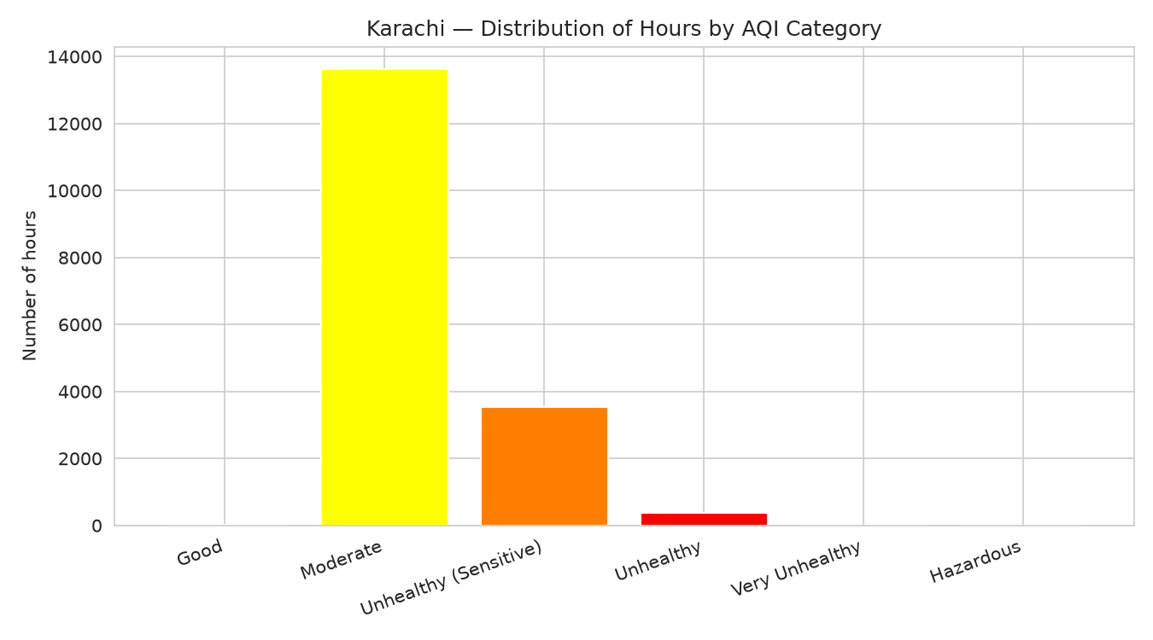
Figure 2. Distribution of hours by AQI category. 77.5% fall in 'Moderate', 20.1% in 'Unhealthy for Sensitive Groups', only 0.16% in 'Good' — zero hours reached 'Very Unhealthy' or 'Hazardous' across the full 2-year dataset.

4.2 Time Series Overview
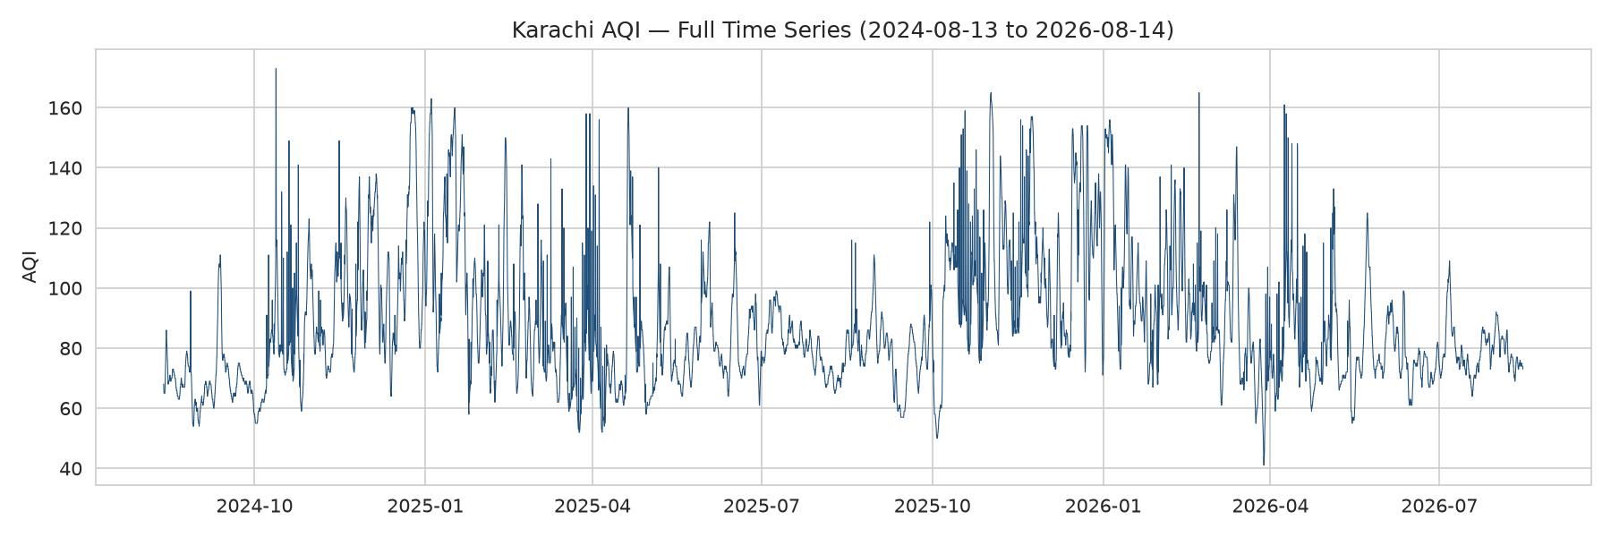
Figure 3. Full AQI time series, Aug 2024 to Aug 2026. Recurring winter peaks and calmer late-summer stretches confirm a genuine annual cycle, not random noise.

4.3 Seasonal Pattern
January has the highest average AQI of any month, September the lowest — matching the expected pattern for the region: winter temperature inversions trap pollutants near the surface, while late-summer/post-monsoon conditions favor better dispersion.
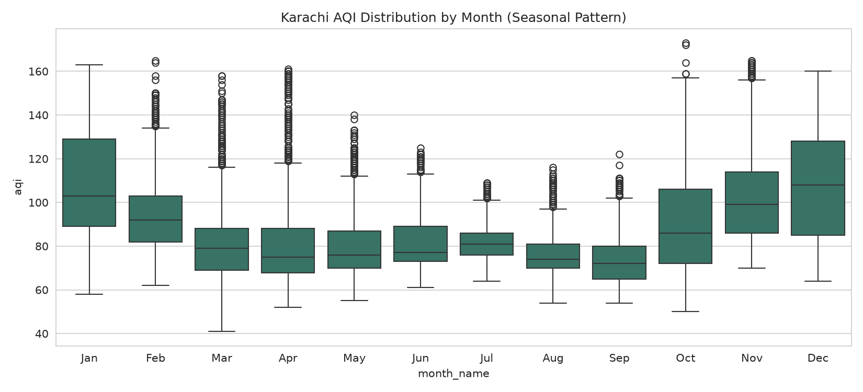
Figure 4. AQI distribution by month. Winter months show both higher medians and wider variance than summer months.

4.4 Daily (Hourly) Pattern
AQI peaks sharply at 14:00 UTC (afternoon) and returns to a stable overnight baseline by evening — a specific, Karachi-local finding, not simply a mirror of the morning/evening traffic-rush pattern seen in some other cities.
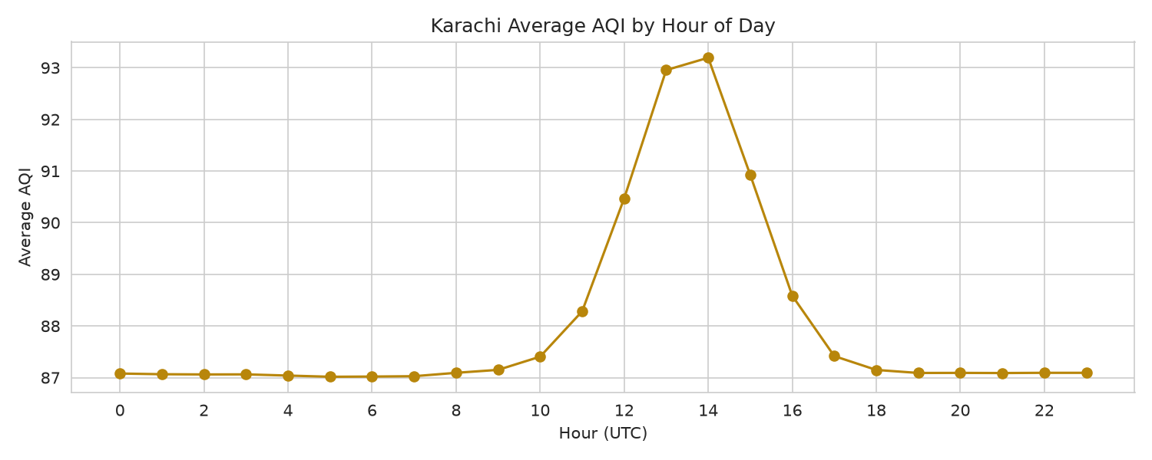
Figure 5. Average AQI by hour of day (UTC).

4.5 Feature Correlations
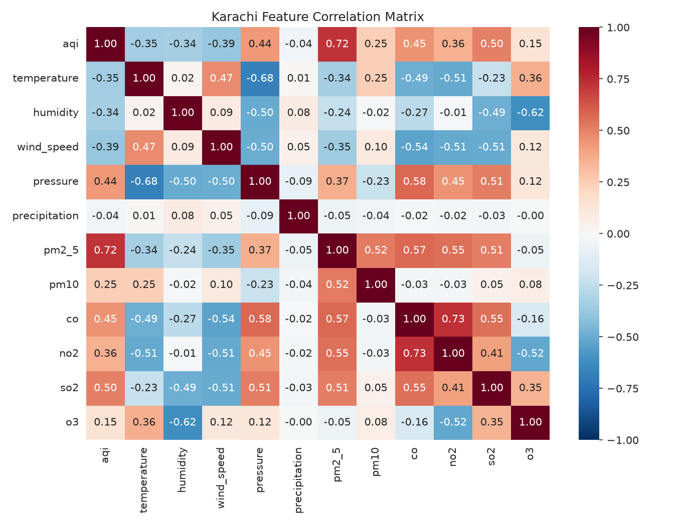
Figure 6. Correlation matrix across all raw weather and pollutant features against AQI.
- PM2.5 correlates with AQI at 0.72 — the strongest single relationship, as expected given PM2.5 typically dominates the US AQI formula in urban settings.
- Wind speed correlates at -0.39, confirming the physical basis for the dispersion_index feature: more wind, lower AQI.
- Pressure correlates positively with AQI (0.44) and negatively with temperature (-0.68) — consistent with the winter high-pressure inversion pattern behind the January peak.
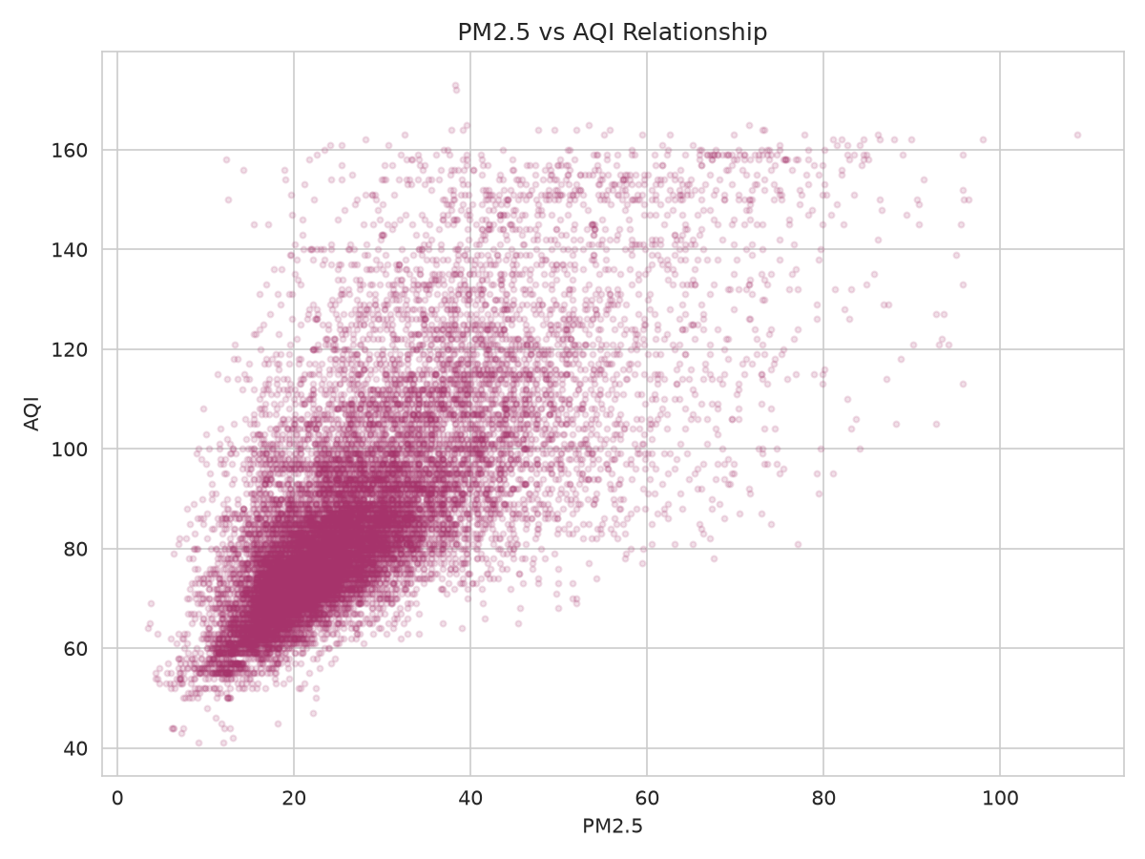
Figure 7. PM2.5 vs AQI — a clear but noisy relationship, supporting a multi-feature model over a single-pollutant heuristic.
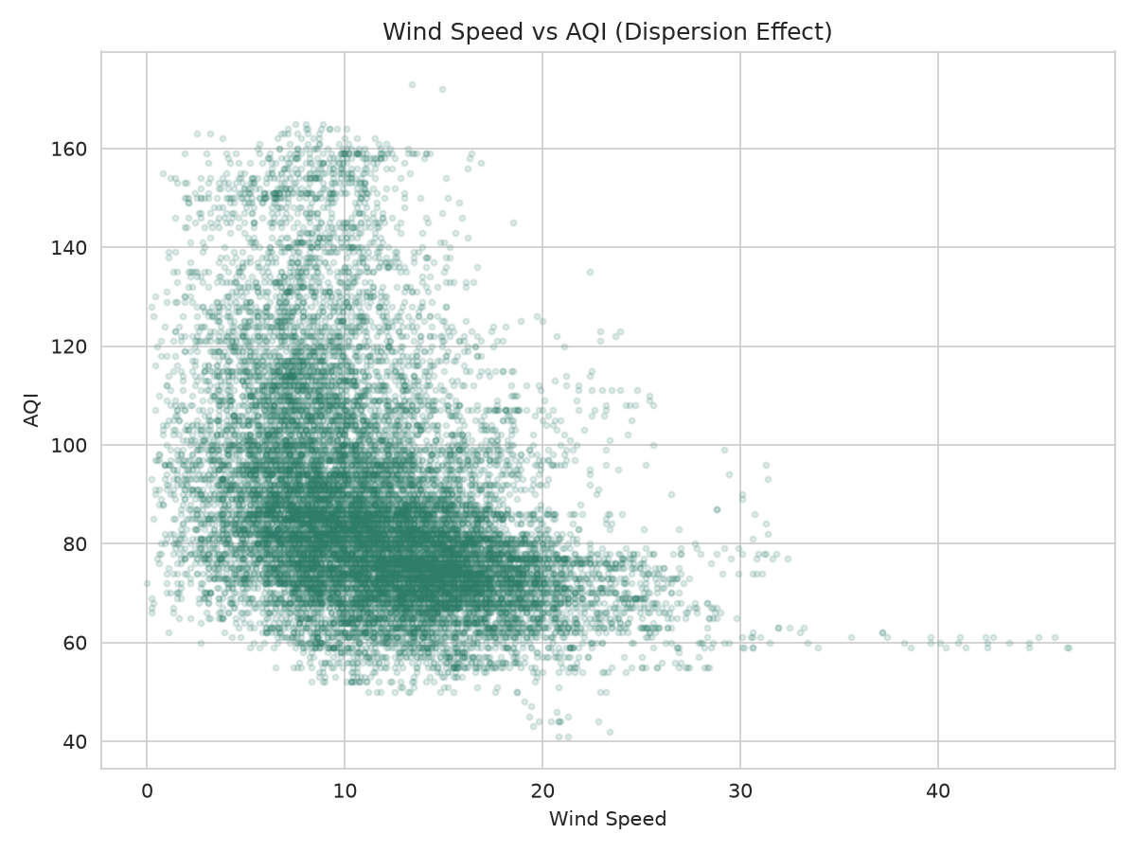
Figure 8. Wind Speed vs AQI — high AQI values occur almost exclusively at low wind speed, a direct visual confirmation of the dispersion effect.

5. Challenges Encountered and How They Were Resolved
I hit a genuinely long list of problems building this — bugs, environment quirks, a couple of real conceptual mistakes. I'm documenting all of it here because I think how I found and fixed these issues is at least as informative as the final numbers, maybe more so.

5.1 Environment and Tooling Issues
Issue | Cause | Resolution
Hopsworks setup could not be completed reliably | Free-tier account/connectivity issues | Substituted Supabase (Postgres + Storage) as the feature store and model registry — see Section 2.1
python3 -m venv venv silently failed | python3-venv not installed on the Chromebook Linux (Crostini) container | Installed python3-venv and python3-full via apt, recreated the environment
git: command not found | Git not preinstalled on Crostini | Installed via apt install git
Blank page after adding a CSS background overlay | A fixed-position ::before pseudo-element with an explicit z-index created a stacking-context conflict with Streamlit's own layout | Removed the separate layer and merged the background effect into a single .stApp background property
IndentationError: unexpected indent | Mixed indentation introduced while manually editing a nested block | Rewrote the block with consistent 4-space indentation, verified with ast.parse before rerunning
Table 3. Environment and tooling issues from local development.

5.2 Data Pipeline Issues
Issue | Cause | Resolution
ValueError: Out of range float values are not JSON compliant: nan | The first rows of a batch have no prior data for lag features, producing NaN; pandas' .where(pd.notnull(df), None) doesn't reliably convert NaN to None on float columns due to dtype coercion | Converted rows to plain Python dicts, then explicitly replaced float NaN with None using math.isnan() before sending to Supabase
502 Bad Gateway mid-backfill | Open-Meteo returned a transient server error partway through a 2-year backfill | Added retry logic with exponential backoff; re-ran the backfill safely thanks to the unique(city, ts) upsert constraint
Table 4. Data ingestion issues and fixes.

5.3 Deployment and Authentication Issues
Issue | Cause | Resolution
Supabase 'RLS not enabled' warning | New tables default to no Row Level Security | Enabled RLS on both tables; pipeline scripts use the secret key, which bypasses RLS, so this only adds protection against the public key
git push rejected: password authentication not supported | GitHub no longer accepts account passwords for HTTPS git operations | Generated a GitHub Personal Access Token and used it instead
git push rejected again: token lacks workflow scope | The token was created with only repo scope; pushing files under .github/workflows/ needs the workflow scope too | Regenerated the token with both repo and workflow scopes
Repeated username/password prompts on every push | Git credential cache kept expiring between sessions | Used the token embedded in the remote URL for one push, then configured git config --global credential.helper "cache --timeout=31536000" to persist credentials going forward
Streamlit Cloud: 'Please enter valid TOML' on secrets | Browser autocorrect converted straight quotes to curly quotes while typing directly into the Secrets box | Typed the TOML template with straight quotes first, then pasted only the key value into the placeholder
ModuleNotFoundError: matplotlib | SHAP was installed but its optional plotting dependency wasn't | Installed matplotlib explicitly, updated requirements.txt
Table 5. Git, GitHub Actions, and deployment issues and fixes.

5.4 Bugs From Later Iterations
Issue | Cause | Resolution
NameError: VotingRegressor is not defined | Added the ensemble code but forgot the import line for it | Added from sklearn.ensemble import VotingRegressor
app.py predictions failing after retraining with new features | training_pipeline.py's feature list changed (rolling std, boundary layer height, then the trimmed 24-feature list) but app.py's NUMERIC_FEATURES wasn't kept in sync — the saved model expects an exact column set | Went through app.py function by function each time the training feature set changed, to keep both files aligned before redeploying
SHAP ERROR: InvalidModelError — Ridge not supported by TreeExplainer | The nightly automated retrain doesn't always pick the same winning model architecture — one night Ridge won 24h instead of the Ridge+GB ensemble, and the SHAP code only knew how to explain tree-based models | Rewrote build_shap_explainer to detect the actual model type at runtime: TreeExplainer for tree-based models (Random Forest/Gradient Boosting), LinearExplainer for Ridge, and unwraps the Gradient Boosting half specifically when the active model is the VotingRegressor ensemble
Same fix worked locally but the live Streamlit Cloud app still showed the old error | Streamlit Cloud caches loaded model objects via @st.cache_resource independently of the local session — a code push alone doesn't clear that cache | Used the 'Reboot app' option in Streamlit Cloud's app management panel to force a clean process restart, which reloads the model fresh under the new explainer logic
Table 6. Bugs that came up specifically while iterating on model improvements and the live dashboard, after the initial pipeline was already working.

5.5 Security Practice Note
During development, a Supabase secret key and a GitHub Personal Access Token were briefly exposed in plaintext while troubleshooting. Both were rotated/regenerated immediately upon discovery, and the .env file containing all credentials was confirmed excluded from version control via .gitignore throughout.

6. Modeling Approach and Training Journey

6.1 Multi-Horizon Strategy
Rather than one model recursively forecasting forward, three independent models were trained per task (regression and classification), one specialized for each horizon: 24h, 48h, and 72h.

6.2 Two Parallel Modeling Tasks
- Regression — predicts the numeric AQI value, used for the dashboard's trend chart and SHAP explanations.
- Classification — predicts the AQI category (Good, Moderate, Unhealthy for Sensitive Groups, Unhealthy, Very Unhealthy, Hazardous), more forgiving of small numeric error and the source of the headline accuracy metric.

6.3 Candidate Algorithms
Three candidate algorithms were evaluated for every horizon and every task: Ridge Regression (statistical/linear), Random Forest, and Histogram-based Gradient Boosting. Each was tuned via GridSearchCV with 5-fold TimeSeriesSplit cross-validation — never a random shuffle, since shuffling would leak future information into training for a time-series problem. A Ridge + Gradient Boosting voting ensemble was added in a later iteration.
This covers the statistical-to-classical-ML range the brief asked for. A deep learning model was deliberately not added — see Section 10.1 for the reasoning.

6.4 Iteration History
The table below documents each iteration in the order it was actually performed, the reasoning behind it, and its measured effect on the regression R² (24h / 48h / 72h):
# | Iteration | Reasoning | Effect
1 | Baseline: raw weather + pollutant features, 1-year data, single 85/15 split | Establish a starting point | 0.43 / -0.12 / -0.20
2 | Added rolling averages + seasonal encoding | Give the model trend info, not just single noisy readings | Roughly flat — see #3
3 | Switched to GridSearchCV + 5-fold TimeSeriesSplit | A single fixed split is unstable for time series; new correlated features needed stronger Ridge regularization | 0.55 / 0.13 / -0.17 (Ridge selected alpha=100)
4 | Added future forecasted weather as a feature | Only current conditions were available before; future weather is the real driver of pollution dispersion days ahead | 0.58 / 0.19 / -0.09 — biggest single-step gain
5 | Extended backfill 1→2 years + wind direction + dispersion_index | More seasonal variety; wind direction is a physically meaningful missing driver | 0.53 / 0.19 / 0.07 — 72h crossed into positive R² for the first time
6 | Replaced the single split with a 5-fold rolling walk-forward backtest | A single split can be flattered or penalized by which season lands in the test set | Numerically lower but far more trustworthy
7 | Reframed the target from exact AQI value to AQI category | Regression R² plateaued at longer horizons; category prediction is more forgiving and actionable | Accuracy: 80.2% / 75.9% / 77.0%
8 | Switched from a single hourly point to a 24-hour rolling average target | A single hour's AQI is noisy and unpredictable; daily averages match how AQI is normally communicated | R²: 0.83 / 0.37 / 0.07. Accuracy: 89.9% / 79.3% / 78.8%
9 | Added rolling AQI volatility (std), deeper Gradient Boosting grid, tried a Ridge+GB ensemble | Give the model a sense of whether pollution is stable or swinging; search a wider hyperparameter space | 24h improved (R² 0.87, ensemble won); 48h/72h stayed flat and the ensemble did NOT win there — confirming those horizons are feature-limited, not model-limited
10 | Added boundary layer height — the direct physical measurement behind winter smog | The single most physically-grounded feature left to add without a new data source | Barely moved anything; 72h dipped slightly. A useful negative result confirming a real ceiling
11 | Feature importance check, trimmed to top 24 features, added log-transformed pollutants | Some features dominated almost everything while others (hour-of-day, boundary layer height) had become near-worthless after the daily-average switch | 72h R² nearly doubled, 0.065 → 0.120 — the best gain since iteration 8
Table 7. Complete iteration history from baseline to final model.

6.5 Final Model Selection
For classification, Gradient Boosting won at every horizon:
Horizon | Best Classifier | Backtest Accuracy | Backtest F1
24h (Day 1) | Gradient Boosting | 89.9% | 0.89
48h (Day 2) | Gradient Boosting | 78.8% | 0.76
72h (Day 3) | Gradient Boosting | 77.8% | 0.75
Table 8. Final classifier per horizon — actively deployed and driving the dashboard's alerts.
For regression, a Ridge+GB ensemble won at 24h, Gradient Boosting at 48h and 72h:
Horizon | Best Regressor | Backtest RMSE | Backtest R²
24h (Day 1) | Ridge + Gradient Boosting ensemble | 6.81 | 0.865
48h (Day 2) | Gradient Boosting | 14.95 | 0.354
72h (Day 3) | Gradient Boosting | 16.76 | 0.120
Table 9. Final regressor per horizon.

6.6 SHAP Explainability — How the Dashboard Explains Its Predictions
The dashboard's 'Why these predictions?' section uses SHAP (SHapley Additive exPlanations) to show, for the Day 1 forecast, which of the 24 input features pushed the prediction up or down and by how much. This is genuinely useful for a health-alert tool: a user can see whether tomorrow's forecast is being driven mainly by current PM2.5 levels, incoming weather, or a seasonal pattern, rather than trusting a number with no explanation.
A real complication came up here (Table 6, row 3): SHAP's TreeExplainer only supports tree-based models (Random Forest, Gradient Boosting), but the automated nightly retraining doesn't always pick the same architecture — the 24h winner has alternated between the Ridge+GB ensemble and plain Ridge across different training runs, depending on that day's backtest. The explainer code now checks the active model's actual type at runtime and picks the right SHAP method: LinearExplainer for Ridge, TreeExplainer for the tree-based models, and for the ensemble specifically, it explains the Gradient Boosting half (the dashboard caption discloses this explicitly, e.g. '(based on the Gradient Boosting half of the ensemble)') rather than silently failing or showing a misleading chart.

7. Results Summary and Honest Interpretation
The decreasing R² pattern across horizons (0.865 → 0.354 → 0.120) is expected: the further out the forecast, the less current conditions predict the outcome, and the more it depends on things this project can't see — new emissions, traffic, local events. Classification accuracy (78–90% across all three days) is the headline result and holds up well at every horizon.
Two decisions mattered more than anything else: reframing the target as a category (iteration 7) and switching to a daily average (iteration 8). Everything after that moved the numbers by a few points at most — informative in itself, since it means the big structural decisions were the ones that actually mattered, and later work was mostly confirming a ceiling rather than breaking through one.

7.1 Does It Beat a Naive Baseline?
Before trusting any number above, it's worth checking against the simplest alternative: assuming tomorrow's AQI equals today's (a persistence forecast).
Horizon | Persistence RMSE / R² | Model RMSE / R² | Result
24h | 12.95 / 0.607 | 7.04 / 0.865 | Model cuts RMSE by 46%
48h | 18.64 / 0.187 | 14.95 / 0.354 | Model cuts RMSE by 20%
72h | 21.16 / -0.047 | 16.76 / 0.120 | Baseline is negative — model is the only one adding real value
Table 10. Model performance vs. a naive persistence baseline.
The 72h row matters most: a naive guess is actually worse than useless there (negative R²), while the model stays modestly positive — clear evidence it's doing something real at every horizon, not just the easy ones.

8. Automation
Two GitHub Actions workflows run the system with no manual steps after initial setup: the Feature Pipeline runs hourly, fetching the latest weather and air-quality data and upserting it into Supabase; the Training Pipeline runs daily, retraining both regression and classification models across all three horizons and registering the new active versions. Both authenticate to Supabase using repository secrets, keeping credentials out of source control.

9. Web Application
The dashboard is built with Streamlit and deployed publicly via Streamlit Community Cloud (karachi-aqi123.streamlit.app). It includes:
- Live current AQI with a visual spectrum gauge and an animated sky/haze background whose color tint shifts with the current AQI category.
- 3-day forecast cards showing predicted AQI, category, and per-horizon model accuracy.
- A SHAP-based feature importance chart explaining the Day 1 prediction (Section 6.6).
- A live embedded weather map (Windy) centered on Karachi.
- Hazardous AQI alerts with category-specific health guidance.
- A forecast trend chart (Plotly) across the three days.
- An EDA section showing the plots from Section 4 directly in the app.
- A live prediction accuracy tracker — every prediction is logged, and once its target time passes, the actual observed AQI is looked up automatically and compared, building a running, real-world accuracy record distinct from the offline backtest.
There is no separate backend framework (no Flask or FastAPI) — Streamlit serves as both frontend and backend in one process, querying Supabase directly for data and models. This kept the architecture simpler and matches what the brief suggested (Streamlit/Gradio) without needing a separate API layer.

10. Limitations and Future Work

10.1 Known Limitations
- 72-hour accuracy remains the weakest horizon (R²=0.12; classification accuracy 77.8%) — several honest fixes (ensemble, boundary layer height, feature trimming) each moved the needle only a little, pointing to a real data gap (no emissions/traffic data) rather than a modeling gap.
- Everything runs from a single point location (Karachi's coordinate centroid), not multiple monitoring stations.
- Two years of data hasn't seen a truly extreme pollution event — zero hours reached 'Very Unhealthy' or worse (Section 4.1).
- Hopsworks wasn't used, due to the setup issues in Section 2.1.
- Daily-average predictions trade granularity for accuracy — the dashboard shows the day's average, not a specific hour.
- No deep learning model was included. The brief suggested covering 'statistical modelling to deep learning models' — this project covers statistical-to-classical-ML (Ridge through Gradient Boosting, plus an ensemble) but stops short of a neural network. Given the dataset size (~17,700 rows) and that Gradient Boosting already won or nearly won every horizon against Random Forest, the likely gain from an under-tuned MLP or LSTM added this late seemed small relative to the risk — a deliberate scope decision, not an oversight.

10.2 Proposed Future Improvements
- Add a properly-tuned deep learning model for direct comparison against the current best classical model.
- Traffic or nighttime-lights data (e.g. NASA VIIRS) as an emissions proxy — free and public, but satellite imagery rather than a simple API, so real integration work.
- Blending in an atmospheric model's own AQI forecast (e.g. Open-Meteo's CAMS product) as a feature — considered and deliberately not done, since it risks the model leaning on someone else's forecast rather than learning from this project's own data.
- Multiple monitoring points across Karachi for spatial resolution.
- Proper ensembling across the regression and classification outputs.

11. Conclusion
What I ended up with is a working, fully automated AQI forecasting system for Karachi — data comes in every hour on its own, models retrain every day on their own, and the dashboard shows a 3-day forecast with an explanation of why it's predicting what it's predicting, plus alerts if the air is genuinely bad. I switched from the originally-planned Hopsworks to Supabase early on after hitting setup issues I couldn't resolve in time, but kept the same feature-store-plus-model-registry structure the brief asked for, and confirmed the system stayed fully serverless with no local data storage anywhere in the pipeline.
Two decisions mattered more than everything else combined: predicting an AQI category instead of an exact number, and later switching from a single hourly prediction to a 24-hour average. Together those took the project from a fairly weak regression result to a genuinely solid classifier — 89.9% at 24 hours, 78.8% at 48, 77.8% at 72. I also checked the models against a naive persistence baseline, and they beat it at every horizon.
This report tries to be honest about all of it — what worked, what didn't, and the fairly long list of bugs and dead ends along the way, including a couple that reappeared after the model architecture kept changing during retraining (the SHAP explainer issue in particular). I'd rather submit accurate numbers I can explain than inflated ones I can't.

