**NATIONAL UNIVERSITY OF SCIENCES AND TECHNOLOGY**

**Fundamentals of Programming**

**ASSIGNMENT #1**

**Course Instructor:** Dr Khawaja Fahad Iqbal

**Lab Instructor:** Muhammad Affan

**Student Name:** Sayed Wasi Hyder Shah

**CMS ID:** 454424

**DATE:**

**20-11-2023**

**Q1: Write a C++ program to display factors of a number using for loops.**

#include<iostream>

using namespace std;

int main()

{

int i,num;

cout<<"Enter a number: ";

cin>>num;

cout<<"The factors of "<<num<<" are: ";

for(i=1;i<=num;i++)

{

if(num%i==0)

{

cout<<i<<" ";

}

}

return 0;

}

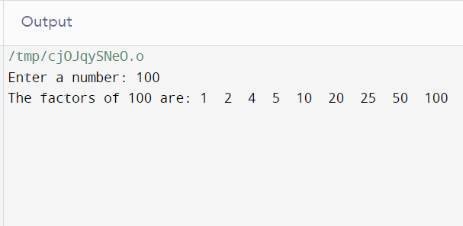

**Q2: Write output to the following code.**

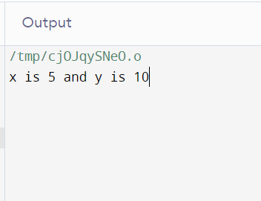

**Q3: Write a C++ program, take an integer value from user and check if it’s greater than 10 and less than equal to 20. Print 1 if yes and print 0 if no. Use appropriate datatype for output.**

**#include<iostream>**

**using namespace std;**

int main()

{

bool result;

int num;

cout<<"Enter an Integer: ";

cin>>num;

result=(num>10 && num<=20);

if(result)

{

cout<<"1";

}

else

{

cout<<"0";

}

return 0;

}

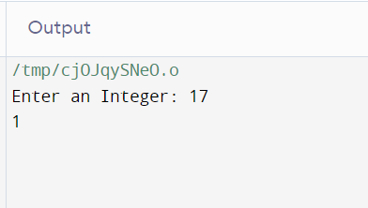

**Q4: Write a C++ program that uses a while loop to find the largest prime number less than a given positive integer N. Your program should take the value of N as input from the user and then find the largest prime number less than or equal to N. You are not allowed to use any library or pre-existing functions to check for prime numbers.**

#include<iostream>

using namespace std;

int main()

{

int N,i,a;

cout<<"Enter a number: ";

cin>>N;

a=N-1;

while(a>1)

{

i=2;

while(i<a)

{

if(a%i==0)

{

break;

}

++i;

}

if(i==a)

{

cout<<"Greatest Prime number before "<<N<<" is "<<a<<endl;

return 0;

}

--a;

}

cout<<"No Prime numbers found :(";

return 0;

}

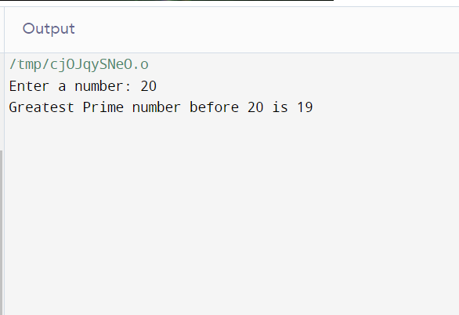

**Q5: Write a C++ program, take two string as input from user and check if both strings are equal or not. If they are equal make them unequal by rotating string. e.g., Hello is turned into olleH etc.**

#include<iostream>

#include<string>

using namespace std;

int main() {

string str1, str2;

cout << "Enter the first string: ";

cin >> str1;

cout << "Enter the second string: ";

cin >> str2;

if (str1 == str2) {

for (size_t i = 0, j = str1.length() - 1; i < j; ++i, --j) {

swap(str1[i], str1[j]);

}

cout << "After reversing the first string, the strings are now unequal:" << endl;

cout << "String 1: " << str1 << endl;

cout << "String 2: " << str2 << endl;

} else {

cout << "The strings are already unequal." << endl;

}

return 0;

}

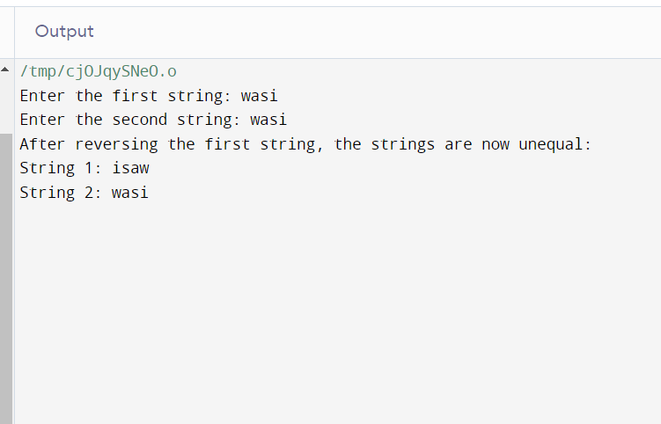

**Q6: Perform division in C++ without / using for loops. You can use / only to display the final results. Your dividend must be greater than divisor.**

#include<iostream>

using namespace std;

int main()

{

int dividend,divisor,quotient=0,remainder,a,b;

cout<<"Enter Dividend: ";

cin>>dividend;

cout<<"Enter Divisor: ";

cin>>divisor;

a=dividend;

b=divisor;

remainder=a%b;

cout<<dividend<<"/"<<divisor<<" = ";

for(int i=0;dividend>=divisor;i++)

{

dividend-=divisor;

quotient++;

}

cout<<quotient<<endl;

cout<<"Remainder= "<<remainder;

return 0;

}

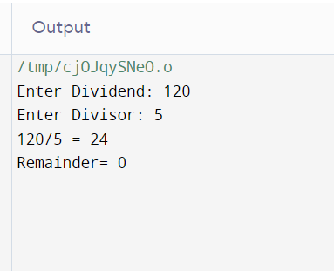

**Q7:**  **Write a C++program for a string which may contain lowercase and uppercase characters. The task is to remove all duplicate characters from the string and find the resultant string.**

#include <iostream>

#include <string>

using namespace std;

int main() {

string a;

int l;

cout << "Input the string text: ";

getline(cin, a);

l = a.length();

for (int i = 0; i < l; i++) {

for (int j = i + 1; j < l;) {

if (tolower(a[i]) == tolower(a[j])) {

a.erase(j, 1);

l = a.length();

} else {

j++;

}

}

}

cout << a;

return 0;

}

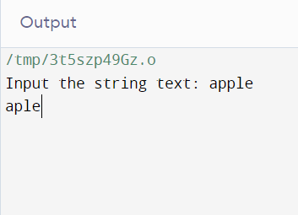

**Q8: Suppose an integer array a[5] = {1,2,3,4,5}. Add more elements to it and display them in C++.**

#include <iostream>

using namespace std;

int main() {

const int maxSize = 50;

int arr[maxSize] = {1, 2, 3, 4, 5};

cout << "Enter digits into the array. Enter 0 to stop input and display the array.\n";

int input;

int currentIndex = 5;

do {

cin >> input;

if (input != 0) {

arr[currentIndex++] = input;

if (currentIndex >= maxSize) {

cout << "Array is full. Exiting input loop.\n";

break;

}

}

} while (input != 0);

cout << "The current values stored in the array are:\n";

for (int i = 0; i < maxSize && arr[i] != 0; i++) {

cout << arr[i] << endl;

}

return 0;

}

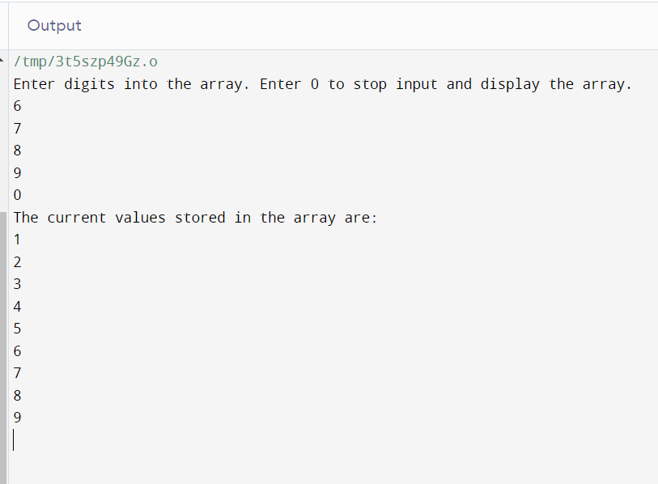

**Q9: Given an integer array and an integer X. Find if there’s a triplet in the array which sums up to the given integer X.**

#include <iostream>

using namespace std;

int main() {

int length;

cout << "Enter the length of the input array: ";

cin >> length;

int a[length];

cout << "Enter the values in the array: ";

for (int i = 0; i < length; i++) {

cin >> a[i];

}

int num;

cout << "Enter a number: ";

cin >> num;

int j, k, l;

bool value = false;

for (j = 0; j < length; j++) {

for (k = j + 1; k < length; k++) {

for (l = k + 1; l < length; l++) {

if (a[j] + a[k] + a[l] == num) {

value = true;

goto endLoop;

}

}

}

if (value) {

break;

}

}

endLoop:

if (value) {

cout << num << " is the sum of " << a[j] << " (Array." << j + 1 << ") , "

<< a[k] << " (Array." << k + 1 << ") & "

<< a[l] << " (Array." << l + 1 << ")";

} else {

cout << "No such combination found.";

}

return 0;

}

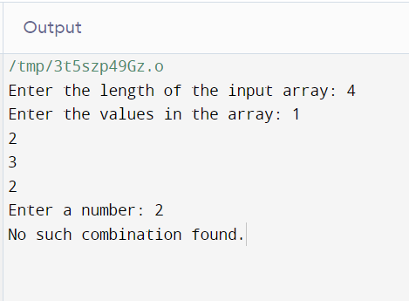

**Q10: Implement Bubble Sort on an array of 6 integers.**

#include <iostream>

using namespace std;

int main() {

int a[6];

cout << "Enter 6 integers into the array: \n";

for (int i = 0; i <= 5; i++) {

cin >> a[i];

}

for (int j = 0; j <= 5; j++) {

for (int k = 0; k <= 5; k++) {

if (a[k] > a[k + 1]) {

swap(a[k], a[k + 1]);

}

}

}

cout << "The sorted values are: \n";

for (int l = 0; l <= 5; l++) {

cout << a[l] << "\n";

}

return 0;

}

