**NATIONAL UNIVERSITY OF SCIENCES AND TECHNOLOGY**

**Fundamentals of Programming**

**LAB TASK (MANUAL 10)**

**Course Instructor:** Dr Khawaja Fahad Iqbal

**Lab Instructor:** Muhammad Affan

**Student Name:** Sayed Wasi Hyder Shah

**CMS ID:** 454424

**DATE:**

**20-12-2023**

**TASK 1**

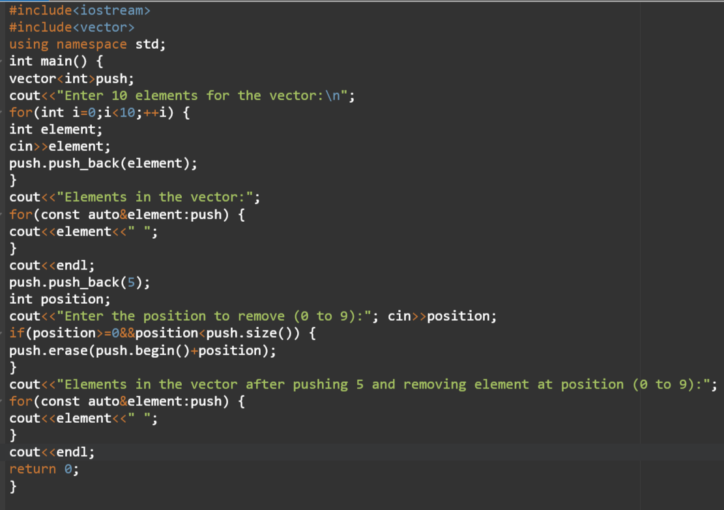

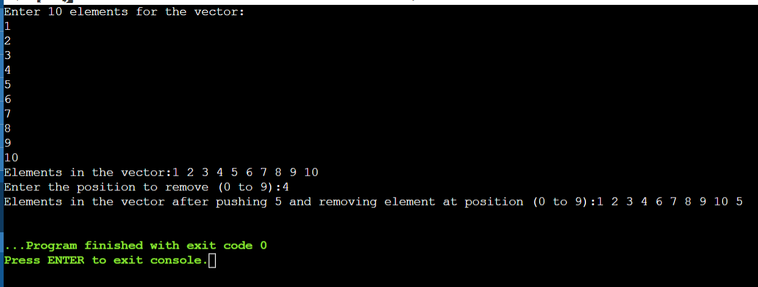

**TASK 2**

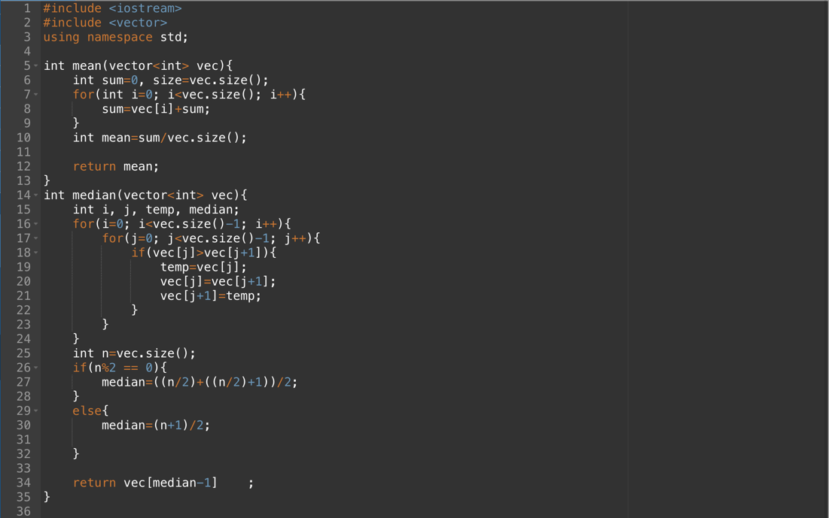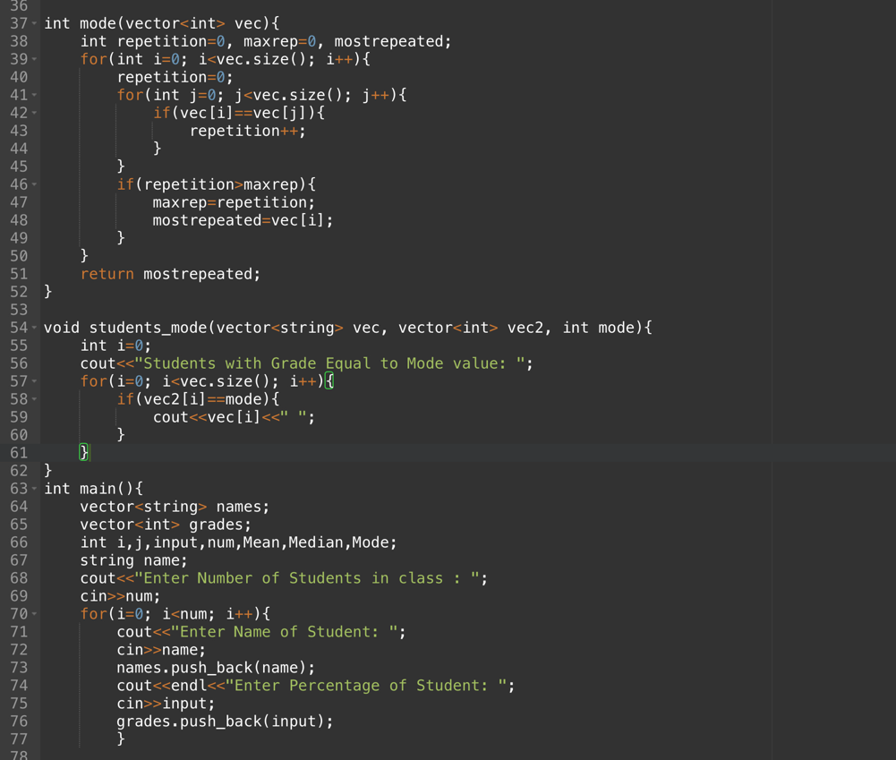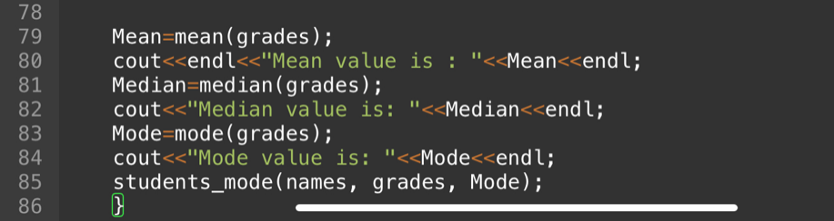

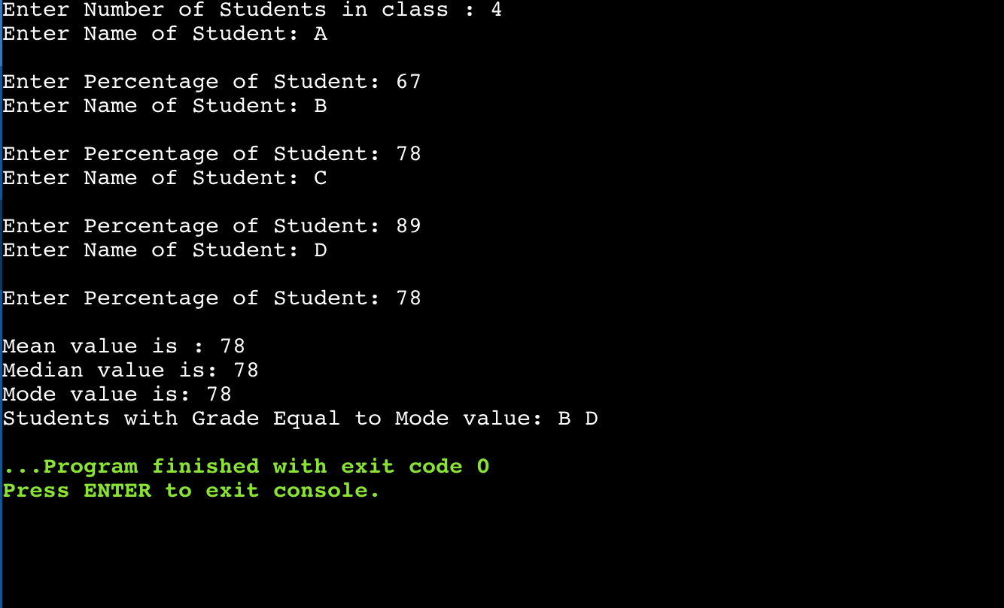

**TASK 3**

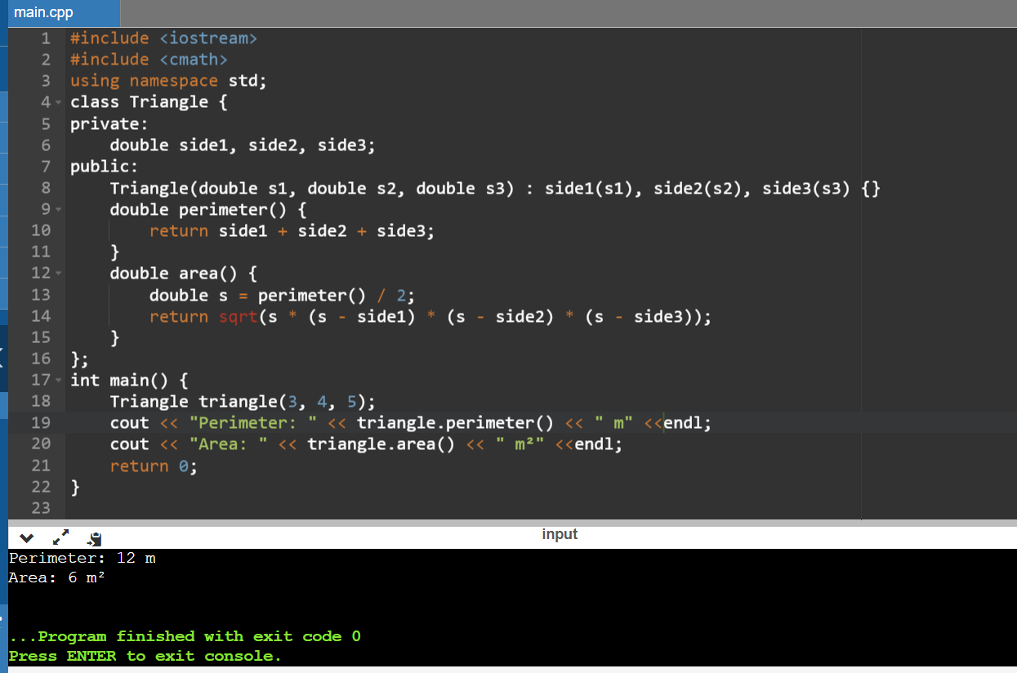

**TASK 4**



