**NATIONAL UNIVERSITY OF SCIENCES AND TECHNOLOGY**



**Fundamentals of Programming**

**ASSIGNMENT #02**

**Course Instructor:** Dr Khawaja Fahad Iqbal

**Lab Instructor:** Muhammad Affan

**Student Name:** Sayed Wasi Hyder Shah

**CMS ID:** 454424

**DATE:**

**11-10-2023**

**TASK 1:**

**Code**

**Output**

**Explanation:** In this program firstly, we must declare a variable for taking score of Student as input then using if statement, we must define criteria for grading and lastly show the grade of student by checking the criteria in which the input score falls.

**TASK 2:**

**Code**

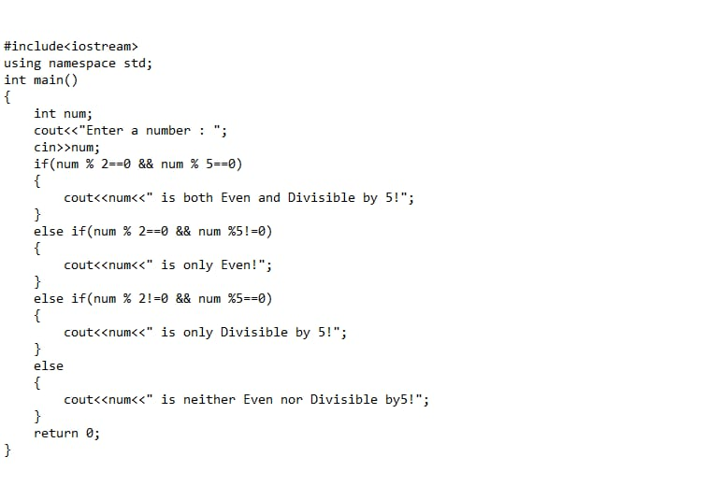

**Output**

**Explanation:** In this program at first, we must declare a variable that takes a number input by user. Then by using if statement we must define the condition that input number must meet. Here and operator and Modulus function are used to check if the input number Even and Divisible by 5 or not.

**TASK 3:**

**Code**

**Output**

**Explanation:** In this program again, we must declare a variable first that takes a year as input by user. Then using if statement, Modulus function and OR and AND operators we must define the condition for a year to be a leap year.

**TASK 4:**

**Code**

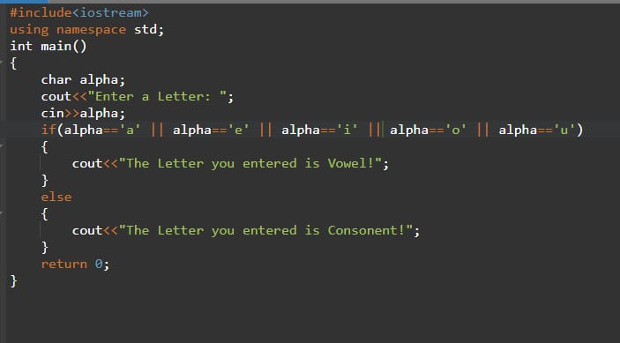

**Output**

**Explanation:** In this program initially, we must declare a character that takes a letter as input by user. Then using if statement and OR operator we must define the condition that input letter must meet in order to be a vowel.

**TASK 5:**

**Code**

**Output**

**Explanation:** In this program we must declare two variables that take attendance and GPA of student as input by user. Then in if statement we must define the criteria in which the student has to fall to be eligible for scholarship. Here, AND operator is used to check the condition.