**NATIONAL UNIVERSITY OF SCIENCES AND TECHNOLOGY**



**Fundamentals of Programming**

**ASSIGNMENT #04**

**Course Instructor:** Dr Khawaja Fahad Iqbal

**Lab Instructor:** Muhammad Affan

**Student Name:** Sayed Wasi Hyder Shah

**CMS ID:** 454424

**DATE:**

**24-10-2023**

**Task 1**

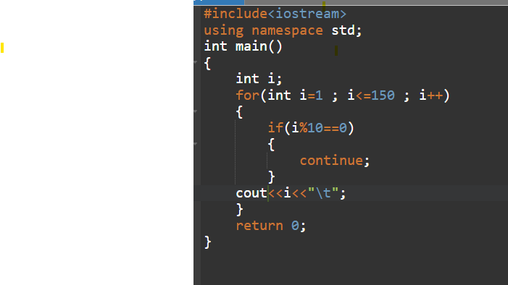



**Task 2**

**Task 3**



