**Lab Manual 4**

SAYED WASI HYDER SHAH

(454424)

**FOP**

Task 1

#include<iostream>

using namespace std;

int main()

{

int sum,i;

for(int i=1; i<=10; i++)

{

sum=sum+i;

}

cout<<"Sum of first 10 Natural Numbers is: "<<sum;

return 0;

}

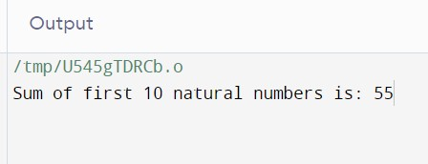

**Task 2**

#include<iostream>

using namespace std;

int main()

{

int num,i,prod;

cout<<"Enter a number: ";

cin>>num;

for(int i=1; i<=10; i++)

{

prod=num*i;

cout<<num<<" x "<<i<<" = "<<prod<<endl;

}

return 0;

}

**Task 3**

#include<iostream>

using namespace std;

int main()

{

int num;

int prod=1;

cout<<"Enter a number: ";

cin>>num;

for(int i=1; i<=num; i++)

{

prod=prod*i;

}

cout<<"Factorial of "<<num<<" = "<<prod;

return 0;

}

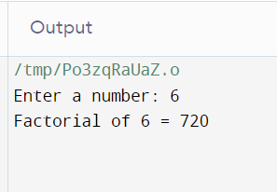

**Task 4**

#include<iostream>

using namespace std;

int main()

{

int a1,a2,end,sum=0;

cout<<"Enter first term: ";

cin>>a1;

cout<<"Enter second term: ";

cin>>a2;

cout<<"Enter the last term: ";

cin>>end;

cout<<a1;

cout<<"\t"<<a2;

do

{

sum=a1+a2;

cout<<"\t"<< sum;

a1=a2;

a2=sum;

}

while(sum<end);

return 0;

}

