**NATIONAL UNIVERSITY OF SCIENCES AND TECHNOLOGY**

**Fundamentals of Programming**

**LAB TASK (MANUAL 8)**

**Course Instructor:** Dr Khawaja Fahad Iqbal

**Lab Instructor:** Muhammad Affan

**Student Name:** Sayed Wasi Hyder Shah

**CMS ID:** 454424

**DATE:**

**30-11-2023**

**Task 1**

**TASK 2**

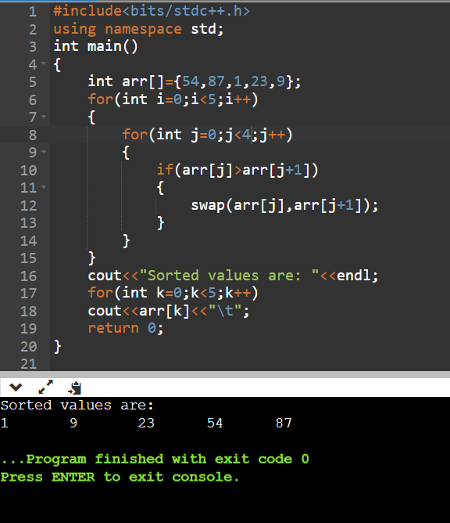

**Task 3**

