

Islamic University of Technology

Project Report

Course Name: Microcontroller-Based System Design Lab
Course Code: EEE 4706
Project Topic: Bluetooth interfacing with Microcontroller

Wasik Billah Ibn Rashid (190021335)

Objective

This project aims to develop a Bluetooth interface with an 8051 microcontroller assembly language. This project incorporates an interface connecting the Microcontroller and Bluetooth. All additional functionalities are programmed in assembly language, and the chosen hardware for implementation is the 8051 microcontrollers.
The Bluetooth modules allow for wireless data transmission and reception between two devices. Communication through smartphones to other devices is commonly used in home automation and new technologies. It is primarily applicable for controlling other devices.
The Bluetooth connection between the Microcontroller and Bluetooth module gives the power to control something remotely. Also, it helps to send data from one device to another device.

Required Components

Components | Cost (Tk)
Microcontroller Development Board | 7000
Jumper wires | 7000
DC Motor | 7000
Relay | 7000
Buzzer | 7000
Bluetooth Module HC-05 | 450
Total | 7450

Circuit Diagram

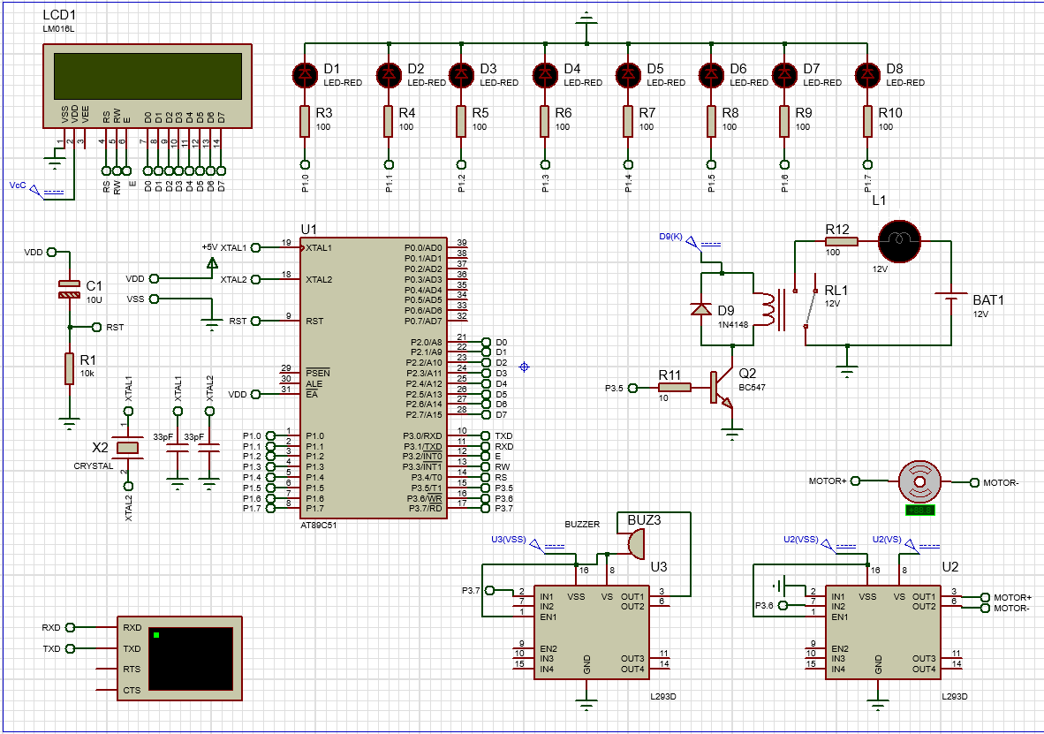

Mandatory Features

1. Control all 8 LEDs via Bluetooth and send out Morse code from Bluetooth device using any one of the LEDs. Display the coded message on the LCD.
2. Use two relays to connect and control two lights using Bluetooth.
3. Send an encrypted message from a Bluetooth device and display the decrypted message on the LCD.

Additional features

1. Display Morse code on the LCD when alphabets are sent from a smartphone.
2. Turn on the Buzzer accordingly when Morse code is sent from the smartphone to the Microcontroller.
3. Jump to the next line automatically when the 1st line of LCD is filled up.
4. Two-way communication: Retrieve data from Bluetooth and display it on the connected mobile phone. Additionally, we can transmit data from the phone to the Microcontroller and display it on the LCD monitor.
5. Motor control via Bluetooth: A motor can be controlled through a Bluetooth device. Using this Motor, we can move any other device.
6. Control the Buzzer: Wirelessly control the Buzzer.

Working Principle

For Bluetooth interfacing, a virtual terminal was used in Proteus. At first, we initialized the serial port communication. Here, Timer mode-2 was taken to use 8-bit auto-reload. Then, the TH1 register was given a 0FDH value for 9600 baud rates as the crystal frequency is 11.0592MHz. The SBUF register is used with the Bluetooth HC05 module to facilitate serial communication. The data from the Bluetooth goes into 8051 through the RX line. In the Microcontroller, the data was kept in the SBUF register. Then, the flag register TI is raised, and the data is moved from SBUF to A register. That is how the input was taken from the HC-05 Bluetooth module. After displaying the input in the LCD, the TI flag register was cleared, and the next input could be taken from the HC-05 module. In the hardware, we used the code and burned it into the Microcontroller. We sent our data from a smart smartphone through the HC-05 Bluetooth module. The RX and TX pins of HC-05 were connected with the Microcontroller's TX and RX pins, respectively. Microcontroller for transmission and receiving. The following symbols have to be sent from the smartphone to perform the mentioned tasks:
Turn On LEDS: 1 to 8
Turn Off LEDS: ! to *

Turn On Relay: 9
Turn Off Relay: (

Turn On Motor: +
Turn Off Motor: =

Turn on the Buzzer: "
Turn off Buzzer: :

Show MORSE Code: A to Z

Go back to taking new input: ,

Start encryption: <; A will be shown as B, B as C, and Z as A.
Stop encryption : >

Start Morse decrypt:?
Print Morse decrypt letter : )
Stop Morse decrypt: /
The given flowchart shows the workflow of this project.

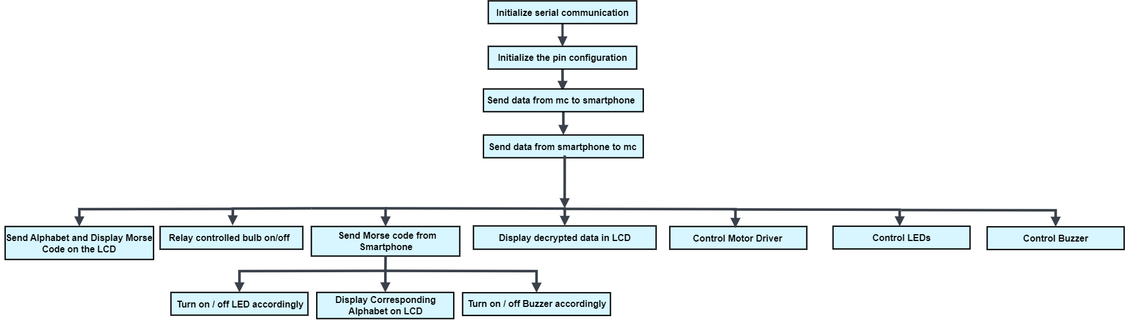

Code

ORG 00H
; INITIALIZE SERIAL COMMUNICATION
MOV TMOD,#20H ;Timer 1, mode 2 ; 0010 0000 ; 8 bit auto reload
MOV TH1,#0FDH ;9600 baud rate
MOV SCON,#50H; 8 bit data,1 stop bit, 1 start bit, REN enabled ; 0101 0000
CLR T1 ; Clear Timer 1 register
SETB TR1 ;start timer 1

;PIN CONFIGURATION
LED_1 BIT P1.0 ; the buffer port is port 1.
LED_2 BIT P1.1
LED_3 BIT P1.2
LED_4 BIT P1.3
LED_5 BIT P1.4
LED_6 BIT P1.5
LED_7 BIT P1.6
LED_8 BIT P1.7
LED_RELAY BIT P3.5
MOTOR BIT P3.6
BUZZER BIT P3.7

CLR LED_1
CLR LED_2
CLR LED_3
CLR LED_4
CLR LED_5
CLR LED_6
CLR LED_7
CLR LED_8
SETB LED_RELAY
CLR MOTOR

RS EQU P3.4
RW EQU P3.3
ENBL EQU P3.2

;SEND DATA FROM MICROCONTROLLER TO SMARTPHONE
MOV DPTR, #MYDATA
GO:
CLR A
MOVC A,@A+DPTR
JZ LCD ; LCD Subroutine
ACALL SEND
SJMP GO

SEND:
MOV SBUF, A
INC DPTR
HERE: JNB TI, HERE ;wait for the last bit to transfer
CLR TI ;clear TI for the next INPUT
RET

;MAKING THE LCD READY FOR DISPLAYING DATA FROM SMARTPHONE

; LCD Sub routine
LCD:
MOV SP,#70H ; 112D of ROM
MOV PSW,#00H

MOV A,#38H ;LCD 2 lines,5 by 7 matrix
LCALL COMMAND ;call command subroutine
LCALL DELAY ;give LCD some time

MOV A,#0EH ;display on, cursor on
LCALL COMMAND
LCALL DELAY

WELCOME:
MOV 32H, #16
LCALL CLEAR_LCD

MOV A,#06H ;shift cursor right
LCALL COMMAND
LCALL DELAY

MOV A,#80H ;force cursor to begin at 1st line
LCALL COMMAND
LCALL DELAY

;DISPLAY WELCOME MESSAGE
LCALL DELAY
; Display the MYDATA string
MOV DPTR, #MYDATA ; Load the address of the string
LOOP_1 : CLR A
MOVC A,@A+DPTR
JZ FINISH
LCALL DISPLAY
LCALL DELAY
INC DPTR
LJMP LOOP_1

FINISH:
LJMP SMARTPHONE

MSG_A: DB ".-",0
MSG_B: DB "-...",0
MSg_C: DB "-.-.",0
MSG_D: DB "-..", 0
MSG_E: DB ".", 0
MSG_F: DB "..-.", 0
MSG_G: DB "--.", 0
MSG_H: DB "....", 0
MSG_I: DB "..", 0
MSG_J: DB ".---", 0
MSG_K: DB "-.-", 0
MSG_L: DB ".-..", 0
MSG_M: DB "--", 0
MSG_N: DB "-.", 0
MSG_O: DB "---", 0
MSG_P: DB ".--.", 0
MSG_Q: DB "--.-", 0
MSG_R: DB ".-.", 0
MSG_S: DB "...", 0
MSG_T: DB "-", 0
MSG_U: DB "..-", 0
MSG_V: DB "...-", 0
MSG_W: DB ".--", 0
MSG_X: DB "-..-", 0
MSG_Y: DB "-.--", 0
MSG_Z: DB "--..", 0

MYDATA: DB "Group 03, Bluetooth Interfacing",0 ; this data is shown from virtual terminal

;COMMAND FROM THE SMARTPHONE
SMARTPHONE:
MOV A, "H"
LCALL TRANS

TRANS:
MOV SBUF, A

MOV 32H, #16
LCALL CLEAR_LCD

INPUT_NEW:
LCALL GENERAL_INPUT

MOV A, SBUF ;save incoming byte in A
CJNE A,#'1', LED_1_OFF
SETB LED_1;turn on the LED
LJMP INPUT_NEW ;print the INPUT_NEW_NEWacter pressed

LED_1_OFF:
MOV A,SBUF
CJNE A,#'2', LED_2_OFF
SETB LED_2 ;turn ofF the LED
LJMP INPUT_NEW

LED_2_OFF:
MOV A,SBUF
CJNE A,#'3', LED_3_OFF
SETB LED_3
LJMP INPUT_NEW

LED_3_OFF :
MOV A,SBUF
CJNE A,#'4', LED_4_OFF
SETB LED_4
LJMP INPUT_NEW

LED_4_OFF:
MOV A,SBUF
CJNE A,#'5',LED_5_OFF
SETB LED_5
LJMP INPUT_NEW

LED_5_OFF:
MOV A,SBUF
CJNE A,#'6',LED_6_OFF
SETB LED_6
LJMP INPUT_NEW

LED_6_OFF:
MOV A,SBUF
CJNE A,#'7',LED_7_OFF
SETB LED_7
LJMP INPUT_NEW

LED_7_OFF:
MOV A,SBUF
CJNE A,#'8',LED_8_OFF
SETB LED_8
LJMP INPUT_NEW

LED_8_OFF:
MOV A,SBUF
CJNE A,#'!',TURN_ON_RELAY
CLR LED_1
LJMP INPUT_NEW

TURN_ON_RELAY:
MOV A,SBUF
CJNE A,#'9',TURN_OFF_RELAY
CLR LED_RELAY
LJMP INPUT_NEW

TURN_OFF_RELAY:
MOV A,SBUF
CJNE A,#'(', NOT_TURN_OFF_RELAY
SETB LED_RELAY
LJMP INPUT_NEW

NOT_TURN_OFF_RELAY: ; TURN ON MOTOR
MOV A,SBUF
CJNE A,#'+', NOT_TURN_ON_MOTOR
SETB MOTOR
LJMP INPUT_NEW

NOT_TURN_ON_MOTOR: ; TURN OFF MOTOR
MOV A,SBUF
CJNE A,#'=', NOT_TURN_OFF_MOTOR
CLR MOTOR
LJMP INPUT_NEW

NOT_TURN_OFF_MOTOR:
MOV A,SBUF
CJNE A, #'"' , NOT_TURN_ON_BUZZER
CLR BUZZER
LJMP INPUT_NEW

NOT_TURN_ON_BUZZER:
MOV A, SBUF
CJNE A, #':' , NOT_TURN_OFF_BUZZER
SETB BUZZER
LJMP INPUT_NEW

NOT_TURN_OFF_BUZZER:

LED_1_ON:
MOV A, SBUF
CJNE A,#'@',LED_2_ON
CLR LED_2
LJMP INPUT_NEW

LED_2_ON:
MOV A, SBUF
CJNE A,#'#',LED_3_ON
CLR LED_3
LJMP INPUT_NEW

LED_3_ON:
MOV A, SBUF
CJNE A,#'$',LED_4_ON
CLR LED_4
LJMP INPUT_NEW

LED_4_ON:
MOV A, SBUF
CJNE A,#'%',LED_5_ON
CLR LED_5
LJMP INPUT_NEW

LED_5_ON:
MOV A, SBUF
CJNE A,#'^',LED_6_ON
CLR LED_6
LJMP INPUT_NEW

LED_6_ON:
MOV A, SBUF
CJNE A,#'&',LED_7_ON
CLR LED_7
LJMP INPUT_NEW

LED_7_ON:
MOV A, SBUF
CJNE A,#'*',CHECK_A
CLR LED_8
LJMP INPUT_NEW

CHECK_A:
MOV A, SBUF
CJNE A,#'A' , NOT_A ; Jump if not equal to "A"
MOV DPTR, #MSG_A
LJMP DISPLAY_MORSE ; Display Morse code for "A"

NOT_A:
MOV A, SBUF
CJNE A, #'B', NOT_B
MOV DPTR, #MSG_B
LJMP DISPLAY_MORSE

NOT_B:
MOV A, SBUF
CJNE A, #'C', NOT_C
MOV DPTR, #MSG_C
LJMP DISPLAY_MORSE

NOT_C:
MOV A, SBUF
CJNE A, #'D', NOT_D
MOV DPTR, #MSG_D
LJMP DISPLAY_MORSE

NOT_D:
MOV A, SBUF
CJNE A, #'E', NOT_E
MOV DPTR, #MSG_E
LJMP DISPLAY_MORSE

NOT_E:
MOV A, SBUF
CJNE A, #'F', NOT_F
MOV DPTR, #MSG_F
LJMP DISPLAY_MORSE

NOT_F:
MOV A, SBUF
CJNE A, #'G', NOT_G
MOV DPTR, #MSG_G
LJMP DISPLAY_MORSE

NOT_G:
MOV A, SBUF
CJNE A, #'H', NOT_H
MOV DPTR, #MSG_H
LJMP DISPLAY_MORSE

NOT_H:
MOV A, SBUF
CJNE A, #'I', NOT_I
MOV DPTR, #MSG_I
LJMP DISPLAY_MORSE

NOT_I:
MOV A, SBUF
CJNE A, #'J', NOT_J
MOV DPTR, #MSG_J
LJMP DISPLAY_MORSE

NOT_J:
MOV A, SBUF
CJNE A, #'K', NOT_K
MOV DPTR, #MSG_K
LJMP DISPLAY_MORSE

NOT_K:
MOV A, SBUF
CJNE A, #'L', NOT_L
MOV DPTR, #MSG_L
LJMP DISPLAY_MORSE

NOT_L:
MOV A, SBUF
CJNE A, #'M', NOT_M
MOV DPTR, #MSG_M
LJMP DISPLAY_MORSE

NOT_M:
MOV A, SBUF
CJNE A, #'N', NOT_N
MOV DPTR, #MSG_N
LJMP DISPLAY_MORSE

NOT_N:
MOV A, SBUF
CJNE A, #'O', NOT_O
MOV DPTR, #MSG_O
LJMP DISPLAY_MORSE

NOT_O:
MOV A, SBUF
CJNE A, #'P', NOT_P
MOV DPTR, #MSG_P
LJMP DISPLAY_MORSE

NOT_P:
MOV A, SBUF
CJNE A, #'Q', NOT_Q
MOV DPTR, #MSG_Q
LJMP DISPLAY_MORSE

NOT_Q:
MOV A, SBUF
CJNE A, #'R', NOT_R
MOV DPTR, #MSG_R
LJMP DISPLAY_MORSE

NOT_R:
MOV A, SBUF
CJNE A, #'S', NOT_S
MOV DPTR, #MSG_S
LJMP DISPLAY_MORSE

NOT_S:
MOV A, SBUF
CJNE A, #'T', NOT_T
MOV DPTR, #MSG_T
LJMP DISPLAY_MORSE

NOT_T:
MOV A, SBUF
CJNE A, #'U', NOT_U
MOV DPTR, #MSG_U
LJMP DISPLAY_MORSE

NOT_U:
MOV A, SBUF
CJNE A, #'V', NOT_V
MOV DPTR, #MSG_V
LJMP DISPLAY_MORSE

NOT_V:
MOV A, SBUF
CJNE A, #'W', NOT_W
MOV DPTR, #MSG_W
LJMP DISPLAY_MORSE

NOT_W:
MOV A, SBUF
CJNE A, #'X', NOT_X
MOV DPTR, #MSG_X
LJMP DISPLAY_MORSE

NOT_X:
MOV A, SBUF
CJNE A, #'Y', NOT_Y
MOV DPTR, #MSG_Y
LJMP DISPLAY_MORSE

NOT_Y:
MOV A, SBUF
CJNE A, #'Z', NOT_Z
MOV DPTR, #MSG_Z
LJMP DISPLAY_MORSE

DISPLAY_MORSE:
LOOP_MORSE: CLR A
MOVC A,@A+DPTR
JNZ NOT_ZERO_MORSE
ZERO_MORSE : LJMP INPUT_NEW
NOT_ZERO_MORSE:
LCALL DISPLAY
LCALL DELAY
INC DPTR
LJMP LOOP_MORSE

NOT_Z:
MOV A, SBUF
CJNE A, #'<', NOT_ENCRYPTION
LJMP ENCRYPTION

NOT_ENCRYPTION:
MOV A, SBUF
CJNE A, #'?', NOT_MORSE_DECRYPT
LJMP MORSE_DECRYPT

NOT_MORSE_DECRYPT:
MOV A, SBUF
CJNE A, #',' , NOT_NEW_INPUT
LJMP SMARTPHONE

NOT_NEW_INPUT:
LJMP SMARTPHONE

ENCRYPTION:
MOV 32H, #16
LCALL CLEAR_LCD

ENCRYPTION_INPUT:
LCALL GENERAL_INPUT

MOV A, SBUF
CJNE A, #'Z', NOT_Z_ENCRYPTION
MOV A, #'A' ; EQUAL TO Z
LCALL DISPLAY
LCALL DELAY
LJMP ENCRYPTION_INPUT

NOT_Z_ENCRYPTION:
MOV A, SBUF
CJNE A, #'>', CONTINUE_ENCRYPTION
LJMP WELCOME ; STOP ENCRYPTION AND GO BACK TO MAIN INPUT SUBROUTINE

CONTINUE_ENCRYPTION:
ADD A, #1
LCALL DISPLAY
LCALL DELAY
LJMP ENCRYPTION_INPUT

MORSE_DECRYPT:
MOV 32H, #16
;SETB LED_1
LCALL CLEAR_LCD

INPUT_NEW_MORSE:
MOV R0 , #0
MOV R2 , #0
MOV R6 , #0
MOV R7 , #0

MOV R5 , #1 ;COUNTER

MORSE_DECRYPT_INPUT:
LCALL GENERAL_INPUT

MOV A, SBUF
CJNE A, #'/', NOT_STOP_MORSE_DECRYPT
LJMP WELCOME

NOT_STOP_MORSE_DECRYPT:
MOV A, SBUF
CJNE A, #')' , CONTINUE_MORSE_DECRYPT
LJMP DISPLAY_MORSE_DECRYPT

CONTINUE_MORSE_DECRYPT:
MOV A, SBUF

CJNE R5 , #1 , NOT_1 ; if R5=1, store the input in R0
SJMP COUNTER_1

NOT_1:
CJNE R5 , #2 , NOT_2 ; if R5=2, store the input in R6
SJMP COUNTER_2

NOT_2:
CJNE R5 , #3 , NOT_3
SJMP COUNTER_3

NOT_3:
CJNE R5 , #4 , NOT_4
SJMP COUNTER_4

NOT_4:
LJMP WELCOME

COUNTER_1:
MOV R0 , A
INC R5
LJMP MORSE_DECRYPT_INPUT

COUNTER_2:
MOV R6 , A
INC R5
LJMP MORSE_DECRYPT_INPUT

COUNTER_3:
MOV R2, A
INC R5
LJMP MORSE_DECRYPT_INPUT

COUNTER_4:
MOV R7 , A
LJMP MORSE_DECRYPT_INPUT

DISPLAY_MORSE_DECRYPT:
;CHECK FOR A
CJNE R0, #'.' , NOT_MORSE_DECRYPT_A
CJNE R6, #'-' , NOT_MORSE_DECRYPT_A
CJNE R2, #0 , NOT_MORSE_DECRYPT_A
CJNE R7, #0 , NOT_MORSE_DECRYPT_A
LJMP MORSE_DECRYPT_A

;CHECK FOR B
NOT_MORSE_DECRYPT_A:
CJNE R0, #'-' , NOT_MORSE_DECRYPT_B
CJNE R6, #'.' , NOT_MORSE_DECRYPT_B
CJNE R2, #'.' , NOT_MORSE_DECRYPT_B
CJNE R7, #'.' , NOT_MORSE_DECRYPT_B
LJMP MORSE_DECRYPT_B

; CHECK FOR C
NOT_MORSE_DECRYPT_B:
CJNE R0, #'-' , NOT_MORSE_DECRYPT_C
CJNE R6, #'.' , NOT_MORSE_DECRYPT_C
CJNE R2, #'-' , NOT_MORSE_DECRYPT_C
CJNE R7, #'.' , NOT_MORSE_DECRYPT_C
LJMP MORSE_DECRYPT_C

; CHECK FOR D
NOT_MORSE_DECRYPT_C:
CJNE R0, #'-' , NOT_MORSE_DECRYPT_D
CJNE R6, #'.' , NOT_MORSE_DECRYPT_D
CJNE R2, #'.' , NOT_MORSE_DECRYPT_D
CJNE R7, #0 , NOT_MORSE_DECRYPT_D
LJMP MORSE_DECRYPT_D

; CHECK FOR E
NOT_MORSE_DECRYPT_D:
CJNE R0, #'.' , NOT_MORSE_DECRYPT_E
CJNE R6, #0 , NOT_MORSE_DECRYPT_E
CJNE R2, #0 , NOT_MORSE_DECRYPT_E
CJNE R7, #0 , NOT_MORSE_DECRYPT_E
LJMP MORSE_DECRYPT_E

; CHECK FOR F
NOT_MORSE_DECRYPT_E:
CJNE R0, #'.' , NOT_MORSE_DECRYPT_F
CJNE R6, #'.' , NOT_MORSE_DECRYPT_F
CJNE R2, #'-' , NOT_MORSE_DECRYPT_F
CJNE R7, #'.' , NOT_MORSE_DECRYPT_F
LJMP MORSE_DECRYPT_F

; CHECK FOR G
NOT_MORSE_DECRYPT_F:
CJNE R0, #'-' , NOT_MORSE_DECRYPT_G
CJNE R6, #'-' , NOT_MORSE_DECRYPT_G
CJNE R2, #'.' , NOT_MORSE_DECRYPT_G
CJNE R7, #0 , NOT_MORSE_DECRYPT_G
LJMP MORSE_DECRYPT_G

; CHECK FOR H
NOT_MORSE_DECRYPT_G:
CJNE R0, #'.' , NOT_MORSE_DECRYPT_H
CJNE R6, #'.' , NOT_MORSE_DECRYPT_H
CJNE R2, #'.' , NOT_MORSE_DECRYPT_H
CJNE R7, #'.' , NOT_MORSE_DECRYPT_H
LJMP MORSE_DECRYPT_H

; CHECK FOR I
NOT_MORSE_DECRYPT_H:
CJNE R0, #'.' , NOT_MORSE_DECRYPT_I
CJNE R6, #'.' , NOT_MORSE_DECRYPT_I
CJNE R2, #0 , NOT_MORSE_DECRYPT_I
CJNE R7, #0 , NOT_MORSE_DECRYPT_I
LJMP MORSE_DECRYPT_I

; CHECK FOR J
NOT_MORSE_DECRYPT_I:
CJNE R0, #'.' , NOT_MORSE_DECRYPT_J
CJNE R6, #'-' , NOT_MORSE_DECRYPT_J
CJNE R2, #'-' , NOT_MORSE_DECRYPT_J
CJNE R7, #'-' , NOT_MORSE_DECRYPT_J
LJMP MORSE_DECRYPT_J

; CHECK FOR K
NOT_MORSE_DECRYPT_J:
CJNE R0, #'-' , NOT_MORSE_DECRYPT_K
CJNE R6, #'.' , NOT_MORSE_DECRYPT_K
CJNE R2, #'-' , NOT_MORSE_DECRYPT_K
CJNE R7, #0 , NOT_MORSE_DECRYPT_K
LJMP MORSE_DECRYPT_K

; CHECK FOR L
NOT_MORSE_DECRYPT_K:
CJNE R0, #'.' , NOT_MORSE_DECRYPT_L
CJNE R6, #'-' , NOT_MORSE_DECRYPT_L
CJNE R2, #'.' , NOT_MORSE_DECRYPT_L
CJNE R7, #'.' , NOT_MORSE_DECRYPT_L
LJMP MORSE_DECRYPT_L

; CHECK FOR M
NOT_MORSE_DECRYPT_L:
CJNE R0, #'-' , NOT_MORSE_DECRYPT_M
CJNE R6, #'-' , NOT_MORSE_DECRYPT_M
CJNE R2, #0 , NOT_MORSE_DECRYPT_M
CJNE R7, #0 , NOT_MORSE_DECRYPT_M
LJMP MORSE_DECRYPT_M

; CHECK FOR N
NOT_MORSE_DECRYPT_M:
CJNE R0, #'-' , NOT_MORSE_DECRYPT_N
CJNE R6, #'.' , NOT_MORSE_DECRYPT_N
CJNE R2, #0 , NOT_MORSE_DECRYPT_N
CJNE R7, #0 , NOT_MORSE_DECRYPT_N
LJMP MORSE_DECRYPT_N

; CHECK FOR O
NOT_MORSE_DECRYPT_N:
CJNE R0, #'-' , NOT_MORSE_DECRYPT_O
CJNE R6, #'-' , NOT_MORSE_DECRYPT_O
CJNE R2, #'-' , NOT_MORSE_DECRYPT_O
CJNE R7, #0 , NOT_MORSE_DECRYPT_O
LJMP MORSE_DECRYPT_O

; CHECK FOR P
NOT_MORSE_DECRYPT_O:
CJNE R0, #'.' , NOT_MORSE_DECRYPT_P
CJNE R6, #'-' , NOT_MORSE_DECRYPT_P
CJNE R2, #'-' , NOT_MORSE_DECRYPT_P
CJNE R7, #'.' , NOT_MORSE_DECRYPT_P
LJMP MORSE_DECRYPT_P

; CHECK FOR Q
NOT_MORSE_DECRYPT_P:
CJNE R0, #'-' , NOT_MORSE_DECRYPT_Q
CJNE R6, #'-' , NOT_MORSE_DECRYPT_Q
CJNE R2, #'.' , NOT_MORSE_DECRYPT_Q
CJNE R7, #'-' , NOT_MORSE_DECRYPT_Q
LJMP MORSE_DECRYPT_Q

; CHECK FOR R
NOT_MORSE_DECRYPT_Q:
CJNE R0, #'.' , NOT_MORSE_DECRYPT_R
CJNE R6, #'-' , NOT_MORSE_DECRYPT_R
CJNE R2, #'.' , NOT_MORSE_DECRYPT_R
CJNE R7, #0 , NOT_MORSE_DECRYPT_R
LJMP MORSE_DECRYPT_R

; CHECK FOR S
NOT_MORSE_DECRYPT_R:
CJNE R0, #'.' , NOT_MORSE_DECRYPT_S
CJNE R6, #'.' , NOT_MORSE_DECRYPT_S
CJNE R2, #'.' , NOT_MORSE_DECRYPT_S
CJNE R7, #0 , NOT_MORSE_DECRYPT_S
LJMP MORSE_DECRYPT_S

; CHECK FOR T
NOT_MORSE_DECRYPT_S:
CJNE R0, #'-' , NOT_MORSE_DECRYPT_T
CJNE R6, #0 , NOT_MORSE_DECRYPT_T
CJNE R2, #0 , NOT_MORSE_DECRYPT_T
CJNE R7, #0 , NOT_MORSE_DECRYPT_T
LJMP MORSE_DECRYPT_T

; CHECK FOR U
NOT_MORSE_DECRYPT_T:
CJNE R0, #'.' , NOT_MORSE_DECRYPT_U
CJNE R6, #'.' , NOT_MORSE_DECRYPT_U
CJNE R2, #'-' , NOT_MORSE_DECRYPT_U
CJNE R7, #0 , NOT_MORSE_DECRYPT_U
LJMP MORSE_DECRYPT_U

; CHECK FOR V
NOT_MORSE_DECRYPT_U:
CJNE R0, #'.' , NOT_MORSE_DECRYPT_V
CJNE R6, #'.' , NOT_MORSE_DECRYPT_V
CJNE R2, #'.' , NOT_MORSE_DECRYPT_V
CJNE R7, #'-' , NOT_MORSE_DECRYPT_V
LJMP MORSE_DECRYPT_V

; CHECK FOR W
NOT_MORSE_DECRYPT_V:
CJNE R0, #'.' , NOT_MORSE_DECRYPT_W
CJNE R6, #'-' , NOT_MORSE_DECRYPT_W
CJNE R2, #'-' , NOT_MORSE_DECRYPT_W
CJNE R7, #0 , NOT_MORSE_DECRYPT_W
LJMP MORSE_DECRYPT_W

; CHECK FOR X
NOT_MORSE_DECRYPT_W:
CJNE R0, #'-' , NOT_MORSE_DECRYPT_X
CJNE R6, #'.' , NOT_MORSE_DECRYPT_X
CJNE R2, #'.' , NOT_MORSE_DECRYPT_X
CJNE R7, #'-' , NOT_MORSE_DECRYPT_X
LJMP MORSE_DECRYPT_X

; CHECK FOR Y
NOT_MORSE_DECRYPT_X:
CJNE R0, #'-' , NOT_MORSE_DECRYPT_Y
CJNE R6, #'.' , NOT_MORSE_DECRYPT_Y
CJNE R2, #'-' , NOT_MORSE_DECRYPT_Y
CJNE R7, #'-' , NOT_MORSE_DECRYPT_Y
LJMP MORSE_DECRYPT_Y

; CHECK FOR Z
NOT_MORSE_DECRYPT_Y:
CJNE R0, #'-' , NOT_MORSE_DECRYPT_Z
CJNE R6, #'-' , NOT_MORSE_DECRYPT_Z
CJNE R2, #'.' , NOT_MORSE_DECRYPT_Z
CJNE R7, #'.' , NOT_MORSE_DECRYPT_Z
LJMP MORSE_DECRYPT_Z

NOT_MORSE_DECRYPT_Z:
LJMP INPUT_NEW_MORSE

MORSE_DECRYPT_A:
MOV A, #'A'
LJMP MORSE_LED

MORSE_DECRYPT_B:
MOV A, #'B'
LJMP MORSE_LED

MORSE_DECRYPT_C:
MOV A, #'C'
LJMP MORSE_LED

MORSE_DECRYPT_D:
MOV A, #'D'
LJMP MORSE_LED

MORSE_DECRYPT_E:
MOV A, #'E'
LJMP MORSE_LED

MORSE_DECRYPT_F:
MOV A, #'F'
LJMP MORSE_LED

MORSE_DECRYPT_G:
MOV A, #'G'
LJMP MORSE_LED

MORSE_DECRYPT_H:
MOV A, #'H'
LJMP MORSE_LED

MORSE_DECRYPT_I:
MOV A, #'I'
LJMP MORSE_LED

MORSE_DECRYPT_J:
MOV A, #'J'
LJMP MORSE_LED

MORSE_DECRYPT_K:
MOV A, #'K'
LJMP MORSE_LED

MORSE_DECRYPT_L:
MOV A, #'L'
LJMP MORSE_LED

MORSE_DECRYPT_M:
MOV A, #'M'
LJMP MORSE_LED

MORSE_DECRYPT_N:
MOV A, #'N'
LJMP MORSE_LED

MORSE_DECRYPT_O:
MOV A, #'O'
LJMP MORSE_LED

MORSE_DECRYPT_P:
MOV A, #'P'
LJMP MORSE_LED

MORSE_DECRYPT_Q:
MOV A, #'Q'
LJMP MORSE_LED

MORSE_DECRYPT_R:
MOV A, #'R'
LJMP MORSE_LED

MORSE_DECRYPT_S:
MOV A, #'S'
LJMP MORSE_LED

MORSE_DECRYPT_T:
MOV A, #'T'
LJMP MORSE_LED

MORSE_DECRYPT_U:
MOV A, #'U'
LJMP MORSE_LED

MORSE_DECRYPT_V:
MOV A, #'V'
LJMP MORSE_LED

MORSE_DECRYPT_W:
MOV A, #'W'
LJMP MORSE_LED

MORSE_DECRYPT_X:
MOV A, #'X'
LJMP MORSE_LED

MORSE_DECRYPT_Y:
MOV A, #'Y'
LJMP MORSE_LED

MORSE_DECRYPT_Z:
MOV A, #'Z'
LJMP MORSE_LED

MORSE_LED:
LCALL DISPLAY
LCALL DELAY
CHECK_R0:
CJNE R0, #'-' , R0_NOT_DASH
LJMP R0_DASH

R0_NOT_DASH:
CJNE R0, #'.' , R0_NOT_DOT
LJMP R0_DOT

R0_NOT_DOT:
CJNE R0, #'0' , R0_NOT_ZERO
LJMP R0_ZERO

R0_NOT_ZERO:
LJMP INPUT_NEW_MORSE

R0_DASH:
LCALL DASH
LJMP CHECK_R6
R0_DOT:
LCALL DOT
LJMP CHECK_R6
R0_ZERO:
LJMP INPUT_NEW_MORSE

CHECK_R6:
CJNE R6, #'-' , R6_NOT_DASH
LJMP R6_DASH

R6_NOT_DASH:
CJNE R6, #'.' , R6_NOT_DOT
LJMP R6_DOT

R6_NOT_DOT:
CJNE R6, #'0' , R6_NOT_ZERO
LJMP R6_ZERO

R6_NOT_ZERO:
LJMP INPUT_NEW_MORSE

R6_DASH:
LCALL DASH
LJMP CHECK_R2
R6_DOT:
LCALL DOT
LJMP CHECK_R2
R6_ZERO:
LJMP INPUT_NEW_MORSE

CHECK_R2:
CJNE R2, #'-' , R2_NOT_DASH
LJMP R2_DASH

R2_NOT_DASH:
CJNE R2, #'.' , R2_NOT_DOT
LJMP R2_DOT

R2_NOT_DOT:
CJNE R2, #'0' , R2_NOT_ZERO
LJMP R2_ZERO

R2_NOT_ZERO:
LJMP INPUT_NEW_MORSE

R2_DASH:
LCALL DASH
LJMP CHECK_R7
R2_DOT:
LCALL DOT
LJMP CHECK_R7
R2_ZERO:
LJMP INPUT_NEW_MORSE

CHECK_R7:
CJNE R7, #'-' , R7_NOT_DASH
LJMP R7_DASH

R7_NOT_DASH:
CJNE R7, #'.' , R7_NOT_DOT
LJMP R7_DOT

R7_NOT_DOT:
CJNE R7, #'0' , R7_NOT_ZERO
LJMP R7_ZERO

R7_NOT_ZERO:
LJMP INPUT_NEW_MORSE

R7_DASH:
LCALL DASH
LJMP INPUT_NEW_MORSE
R7_DOT:
LCALL DOT
LJMP INPUT_NEW_MORSE
R7_ZERO:
LJMP INPUT_NEW_MORSE

CLEAR_LCD:
LCALL DELAY
MOV A,#01H ;clear lcd
LCALL COMMAND
LCALL DELAY
RET

GENERAL_INPUT:
ACALL DELAY
CLR A
CLR RI ;get ready to receive data
WAIT_INPUT: JNB RI, WAIT_INPUT ;wait for the INPUT_NEW to come in
RET

COMMAND:
LCALL READY
MOV P2,A
CLR RS ;control reg is selected, send command to LCD controller
CLR RW ;write to LCD
SETB ENBL
LCALL DELAY
CLR ENBL ;H to L pulse
RET

DISPLAY:
LCALL READY
MOV P2,A
SETB RS ;data register is selected, RS=1 send data to LCD
CLR RW ;write to LCD
SETB ENBL
LCALL DELAY
CLR ENBL ;H to L pulse
DJNZ 32H, SAME_LINE
LJMP NEW_LINE

NEW_LINE:
LCALL DELAY
MOV A,#0C0H ;2ND LINE
LCALL COMMAND
LCALL DELAY
SAME_LINE:
RET

;COMMAND and DISPLAY subroutine is same except the RS pin

READY:
SETB P2.7
CLR RS ;control reg is selected, send command to LCD controller
SETB RW ;reading from LCD

WAIT:
CLR ENBL ; disables communication with the LCD temporarily
ACALL DELAY ;L to H pulse
SETB ENBL
JB P2.7,WAIT ;checks the busy flag
RET

DASH:
SETB LED_1
CLR BUZZER
LCALL DELAY
LCALL DELAY
LCALL DELAY
LCALL DELAY
LCALL DELAY
LCALL DELAY
CLR LED_1
SETB BUZZER
LCALL DELAY
RET

DOT:
SETB LED_1
CLR BUZZER
LCALL DELAY
LCALL DELAY
CLR LED_1
SETB BUZZER
LCALL DELAY
RET

DELAY:
MOV R1,#1
AGAIN_3:
MOV R3,#220
AGAIN_2:
MOV R4,#220 ; delay
AGAIN:
DJNZ R4, AGAIN
DJNZ R3, AGAIN_2
DJNZ R1, AGAIN_3
RET

EXIT_2: SJMP EXIT_2

END

Hardware Implementation

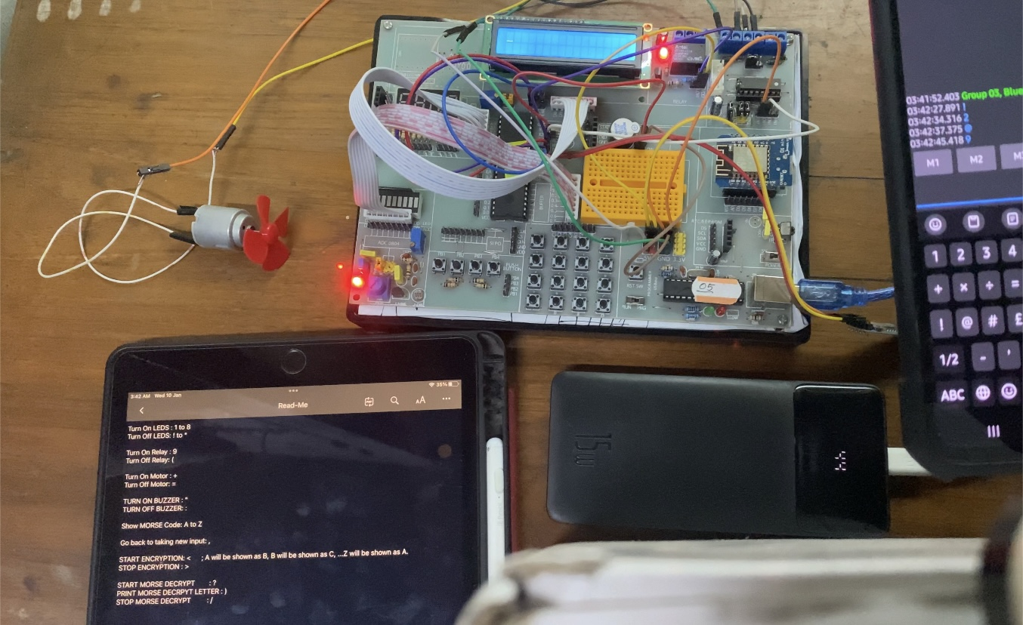

Video Demonstration
https://iutdhaka-my.sharepoint.com/:f:/g/personal/wasikbillah_iut-dhaka_edu/Ek9FEO7103tKtd-ibCEePaMBv0jdrJ3xidin6IIt1EDzHQ?e=Yetp1E
N.B. Please copy and paste the link in any browser, preferably in a desktop browser.

Problems Faced

- The HC05 module in Proteus software was not working as expected. So, a virtual terminal was used.
- Debugging required LEDs to be turned on and off at potential places of the code. This required many trial and error consuming a lot of time.

Conclusion

The objective of the project on Bluetooth interfacing has been implemented here. With three mandatory features, six other new features were also included. In completing this project, the knowledge of Bluetooth communication using a serial port of interfacing Bluetooth module was gained and learned. The project is done in both hardware and software. Proteus 8.16 Professional was used to build the circuit for the software part. Hardware was implemented using a Microcontroller, LCD monitor, HC-05 Bluetooth module, Relay, Motor, and Buzzer.

