

Islamic University of Technology

Project Report

Single-Phase H-Bridge Inverter with PI-Based RMS Voltage Control

Course Name : Control System Engineering I Lab
Course Code : EEE 4606

Name : Wasik Billah Ibn Rashid
Student ID : 190021335
Section : C1
Department : EEE

1. Overview
In this project we built a controller circuit that controls a single-phase full-bridge inverter with an LC filter. The inverter takes a DC voltage and turns it into an AC sine wave. The LC filter removes the high-frequency switching part so that the output is a clean sine wave. Our main goal is to control the RMS value of the output voltage so that it stays at the value we ask for. The project is done in MATLAB Simulink.
The whole system can be seen as a chain: the DC source feeds the H-bridge, the H-bridge feeds the LC filter, and the filter feeds the load. The gate signals of the H-bridge come from two comparators that compare a sine wave with a triangular carrier wave. A PI controller changes the amplitude of that sine wave so that the output RMS voltage matches the reference.
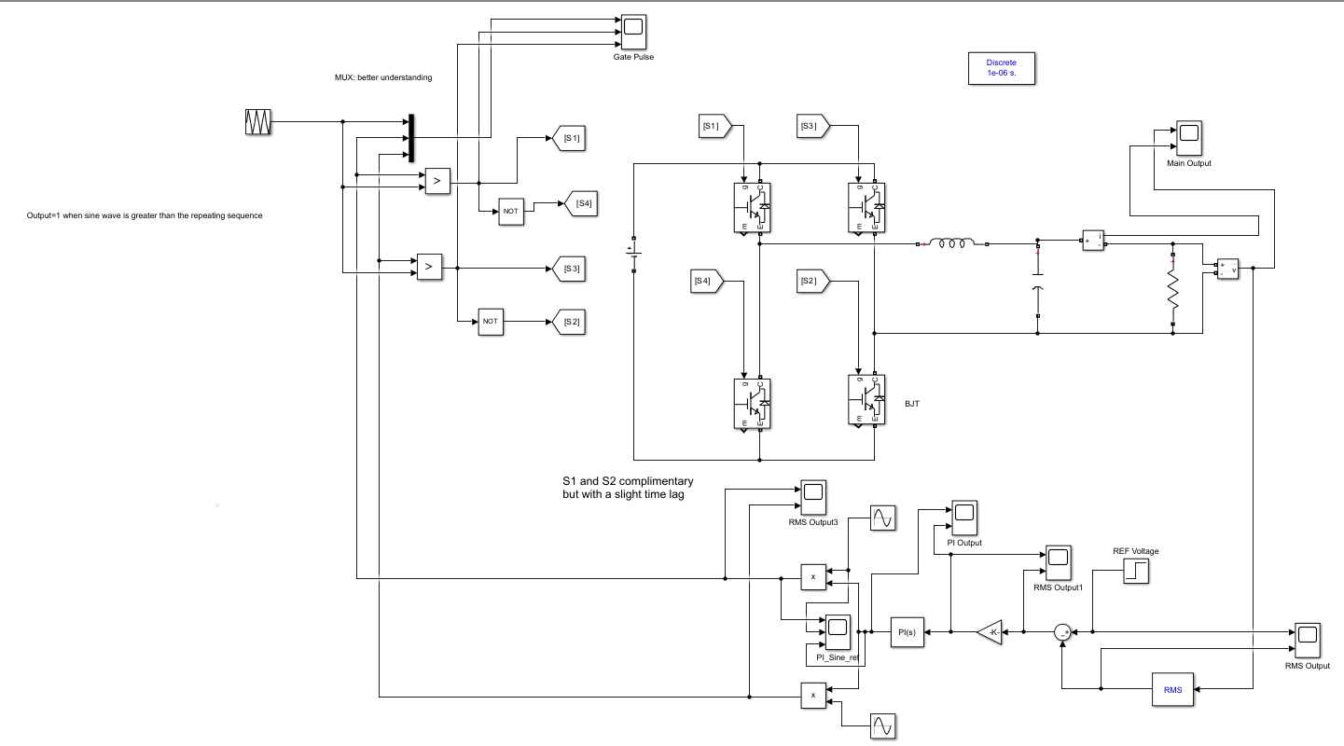
Fig: Schematic diagram of the Project

2. Values Used in the Project
These are the values taken from the Simulink model.
Part | Parameter | Value
DC voltage source | Voltage | 200 V
Switches (4) | Resistance | 1 mΩ
Reference sine waves (2) | Amplitude / frequency / phase | 0.85 / 60 Hz / 0° and 180°
Triangular carrier | Frequency / amplitude | 5 kHz / ±1
Inductor L | Inductance | 2 mH
Capacitor C | Capacitance | 20 µF
Load R | Resistance | 14.4 Ω
Reference voltage | Before / after the step at t = 1 s | 100 V / 120 V (RMS)
RMS block | Frequency / initial value | 60 Hz / 120 V
Gain block | Gain | 1/100
PI controller | Kp / Ki | 2 / 200
Solver | Fixed step (also powergui sample time) | 1 µs (1e-6 s)
Simulation | Stop time | 2 s

3. How the Circuit Works

3.1 The DC voltage source
The DC voltage source is 200 V. This is the largest voltage the output can reach. If the output were a full-size sine wave with a peak of 200 V, its RMS value would be 200 / 1.414 ≈ 141 V. So 141 V RMS is the most this circuit can give. We want 120 V RMS (peak 170 V), which is lower than 141 V.

3.2 The four switches and how they are turned on
We have four switches (IGBT/Diode blocks in Simulink): S1, S2, S3 and S4. S1 and S2 are turned on at the same time. In the next half cycle S3 and S4 are turned on together. The switches on the same leg are complementary: whenever S1 is on, S4 is off, and whenever S3 is on, S2 is off. That means S1 and S4 are complementary, and S3 and S2 are complementary. This is done with NOT gates.
Now, the duration for which S1 and S2 stay on depends on how long the reference sine wave remains greater than the triangular carrier wave. A comparator (the “>” block) gives 1 when the sine is greater than the carrier and 0 when it is smaller. This is called sinusoidal PWM. When the sine wave is high, the pulses are wide, and when the sine wave is near zero, the pulses are narrow.
When S1 and S2 are on, current flows from the voltage source through S1, then through the inductor, across the capacitor and through the load, and returns through S2. When S3 and S4 are on, the current flows through the load in the opposite direction. This is how we get an alternating voltage from a DC source.

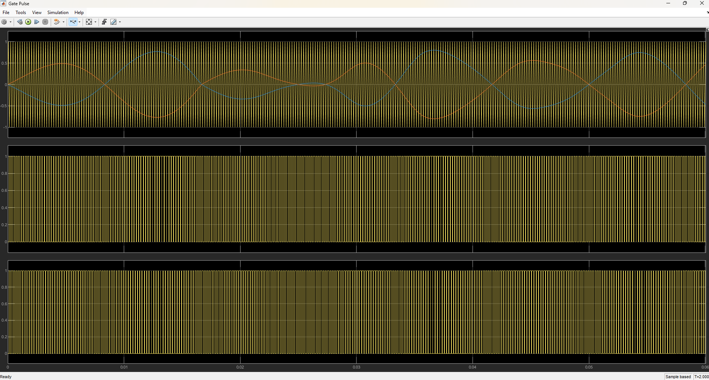
Figure 1: Gate pulse scope
1. The two reference sine waves and the triangular carrier.
2. Output of the comparator 1
3. Output of the comparator 2

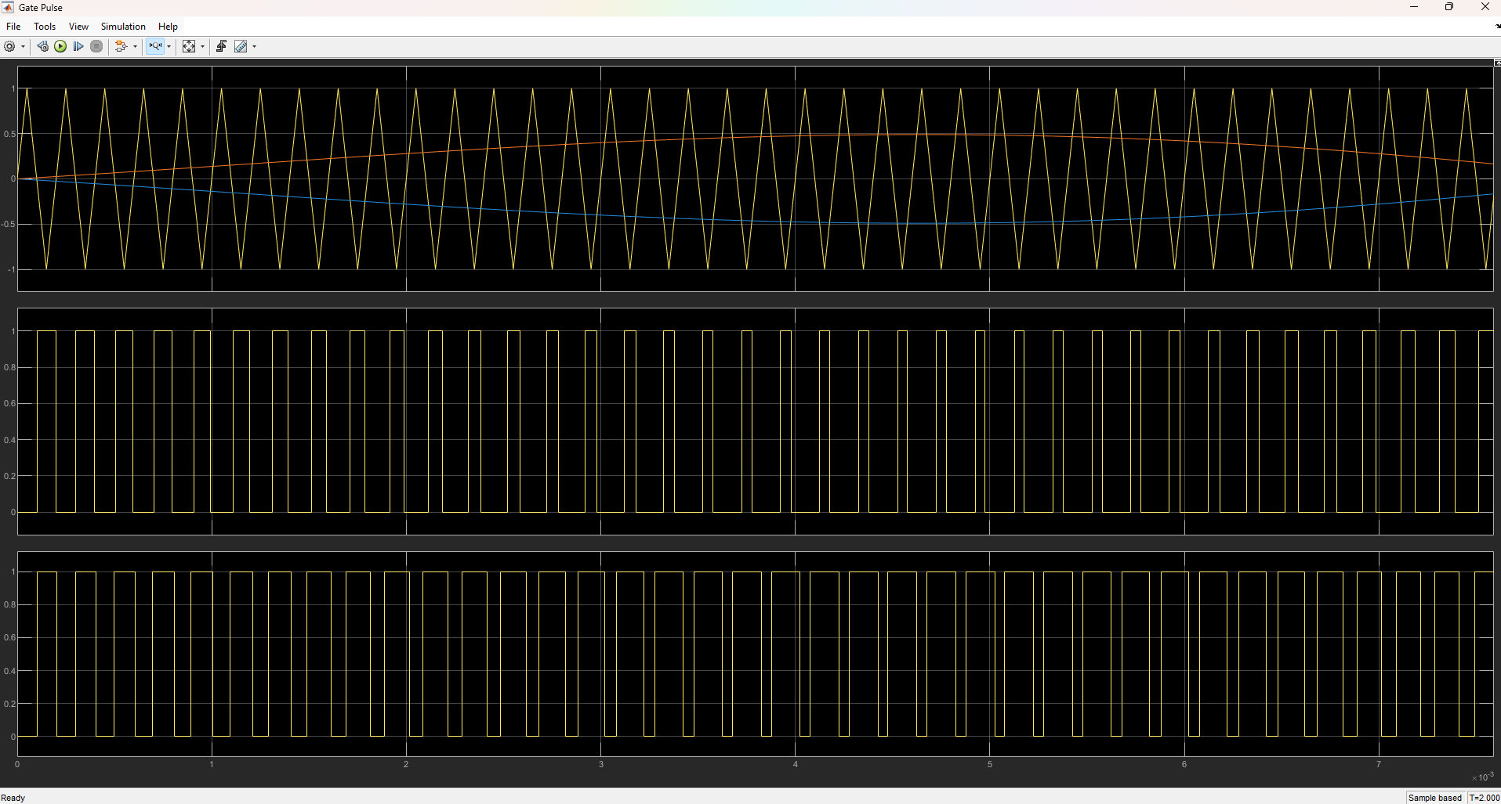
Figure 2: Gate pulse scope, zoomed in
1. The two reference sine waves and the triangular carrier.
2. Output of the comparator 1
3. Output of the comparator 2

In the zoomed picture we can see the pulse width follow the sine wave. Where the sine is above the carrier the pulse is 1, and the pulses get wider as the sine gets higher.

3.3 Function of the Inductor
The voltage across an inductor is v = L (di/dt). L is a constant, and di/dt is the rate of change of the current. An inductor opposes any fast change of current. Its impedance is Z = jωL, so the higher the frequency, the higher the impedance. This means the inductor blocks the high-frequency components of the current that come through the switches, and lets the slow 60 Hz current pass easily. During each pulse the voltage is applied to the inductor and the current rises along a straight line (a constant di/dt). During the off time it falls along a straight line. When we put many pulses of different widths together, the current follows the average, and that average is a sinusoidal wave.

3.4 Function of the Capacitor
For a capacitor, the current is i = C (dv/dt). If the voltage tries to change quickly, the capacitor opposes it. So the capacitor removes the little ripples that are left at the output of the inductor.
The impedance of a capacitor is Z = 1/(jωC), which becomes very small at high frequency. So all the high-frequency components pass through the capacitor and not through the load, and the low-frequency 60 Hz part goes to the load. In other words, the capacitor acts like a shunt across the load for high frequencies.
Together, the 2 mH inductor and the 20 µF capacitor make a low-pass filter with a cutoff frequency of
fc = 1 / (2π√(LC)) = 1 / (2π√(2 mH × 20 µF)) ≈ 796 Hz
This is much higher than 60 Hz (so the wanted signal passes) and much lower than 5 kHz and 10 kHz (so the switching signal is removed).
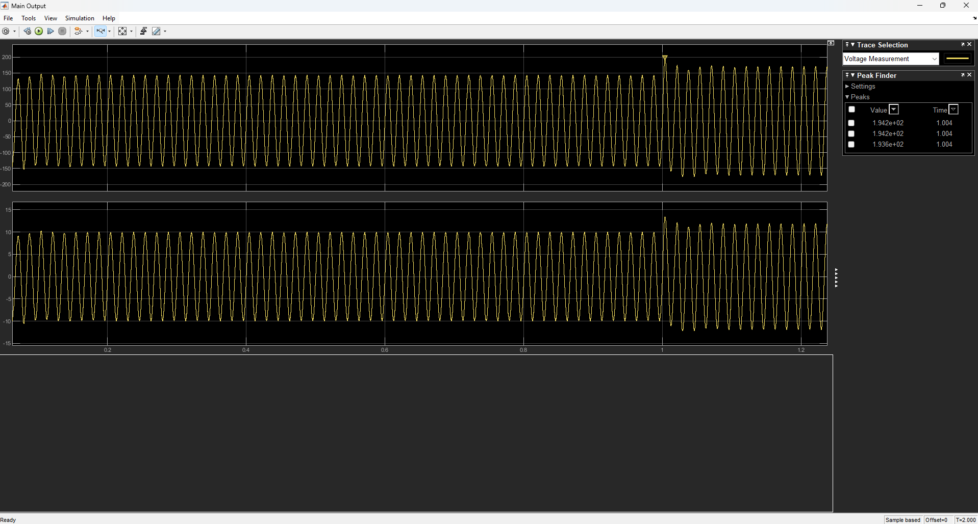
Figure 3: Main Output, full simulation
1. Output voltage
2. Output current

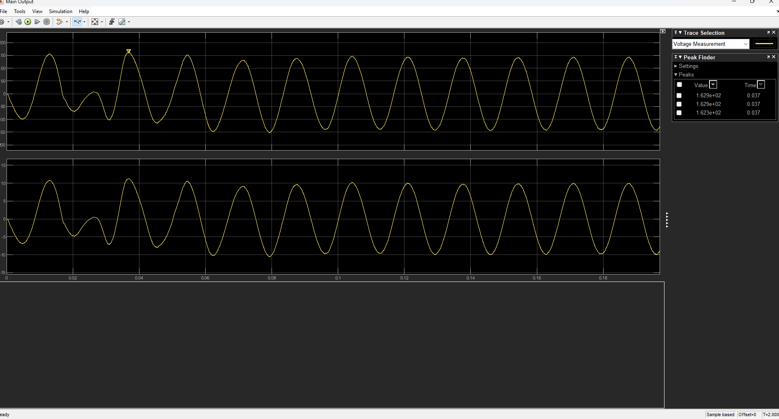
Figure 4: Main Output, start-up
1. Output voltage
2. Output current

Figure 3 shows the output voltage and current. Before t = 1 s the voltage peak is about 145 V (about 100 V RMS) and the current peak is about 10 A. After the reference steps to 120 V at t = 1 s, the voltage peak goes to about 170 V (120 V RMS) and the current peak goes to about 12 A. The current is in phase with the voltage because the load is a resistor (170 V / 14.4 Ω ≈ 11.8 A). Right after the step there is a short overshoot (peak about 194 V), and then it settles. Figure 4 shows the start-up: the first few cycles are distorted while the controller finds the right amplitude, then the waveform becomes a clean sine wave after about 0.1 s.

3.5 The feedback loop: RMS, sum block, gain and PI controller
The output of the load is measured and its RMS value is found with an RMS block. This RMS value is compared with the reference voltage, which is 120 V (keep in mind that this is an RMS value). If we gave the bridge a full-size signal we would get a high voltage, but we want exactly 120 V, so we need a controller to bring it to the correct value.
The first block is a sum block (a junction that subtracts the two signals). It finds the difference between the reference voltage and the RMS value of the output. This difference is the error signal.
e = Vref − Vout,rms
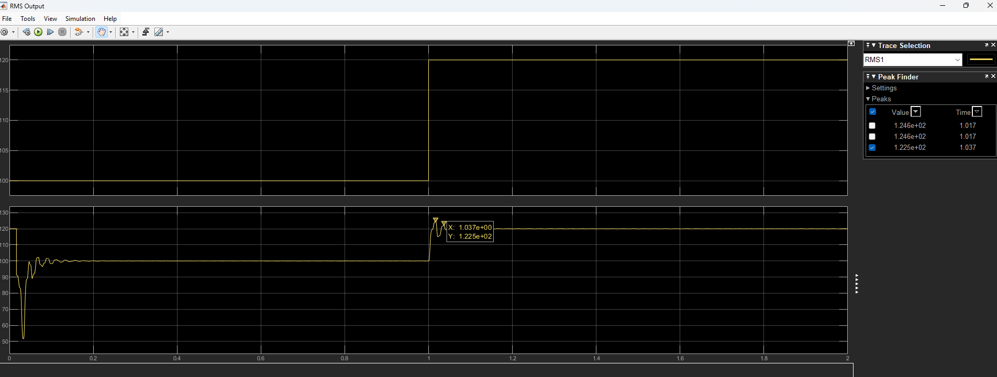
Figure 5: RMS Output scope
1. Reference voltage
2. RMS of the Output Voltage
In Figure 5 the reference is 100 V until t = 1 s and then 120 V. The measured RMS voltage follows it: it settles at 100 V, and after the step it goes to 120 V with a small overshoot (about 124.6 V at t ≈ 1.017 s) and then settles. At the very beginning the RMS curve starts at 120 V and falls to about 52 V. The starting 120 V is simply the initial value we set inside the RMS block, and the fall to 52 V is because the output has not built up yet. This start-up transient is not a real disturbance.
Next we divide the error signal by 100 (the gain block is 1/100). This scales the error down so that the controller does not act abruptly and corrects things more slowly and smoothly. For example, a 20 V error becomes 0.2.
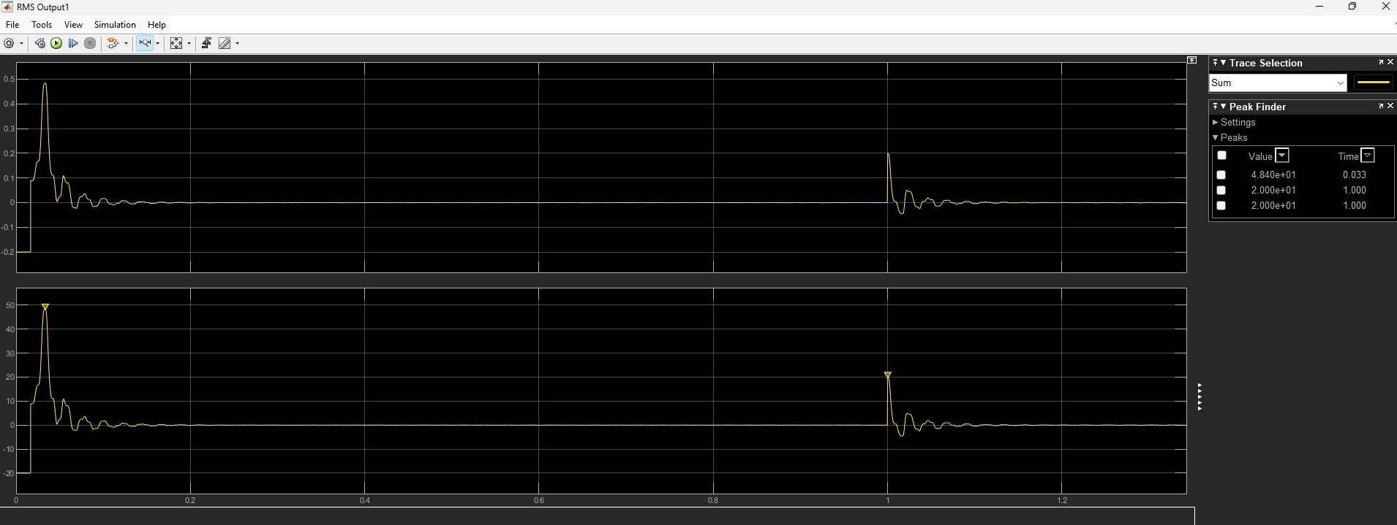
Figure 6: RMS Output1 scope (error signal)
1. Output from the gain block
2. Input to the gain block or the Error signal
Figure 6 shows the error. At the start it is −20 V (that is 100 V reference minus the initial 120 V of the RMS block), then it goes up to a peak of 48.4 V because the real output is still small. After the output builds up, the error goes to zero and stays at zero. At t = 1 s the reference steps up by 20 V, so the error jumps to +20 V, and then it again goes back to zero. The error being zero in the flat parts means the output is exactly at the reference.
The scaled error goes into a PI controller. Inside the PI controller we have two important constants: the proportional constant Kp = 2 and the integral constant Ki = 200. In the Laplace form the controller is
PI(s) = Kp + Ki / s = 2 + 200 / s
In the time domain this means the output is 2 times the error plus 200 times the integral (the running sum) of the error:
u(t) = 2 · e(t) + 200 · ∫ e(t) dt
The proportional part (2 · e) reacts immediately to the present error. The integral part (200 ∫e dt) keeps adding up as long as an error exists, so it keeps pushing until the error becomes exactly zero. This is why the output voltage settles exactly at the reference. (Because of the 1/100 gain in front, the effective gains are 0.02 and 2.)
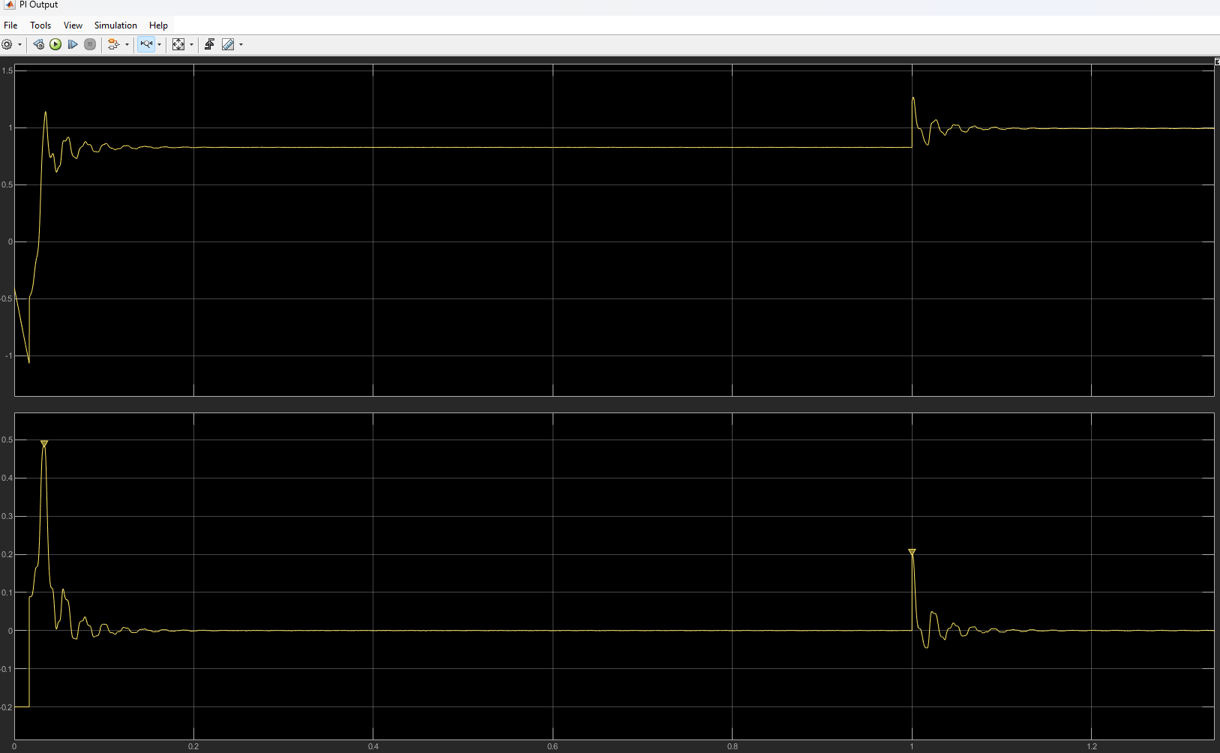
Figure 7: PI Output scope
1. Output from PI
2. Input to the PI or the scaled error signal fed to the PI block
In Figure 7 the PI output is about 0.83 before the step and about 1.0 after the step. These numbers make sense: 100 V / 120 V = 0.83 and 120 V / 120 V = 1.0. At the start the PI output dips below zero for a moment. That is because of the 120 V initial value of the RMS block, which made the first error negative. At the step it overshoots to about 1.27 and then settles to 1.0.

3.6 Multiplier blocks and the reference sine waves
Then we multiply the PI output with the reference sine waves using the multiplier blocks. We have two reference sine waves that are shifted by 180° from each other (one for each leg of the bridge), and both are multiplied with the PI output.
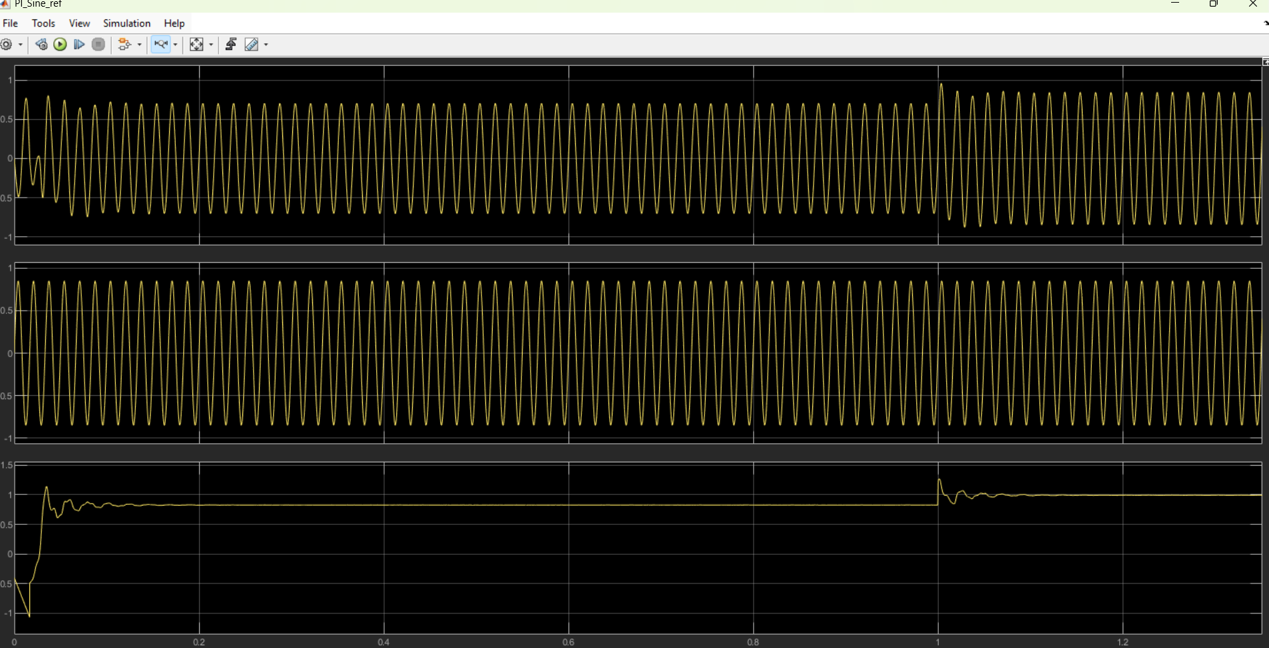
Figure 8: PI_Sine_ref scope
1. PI multiplied Sine Wave
2. Reference Sine Wave
3. PI signal fed to the Sine Wave
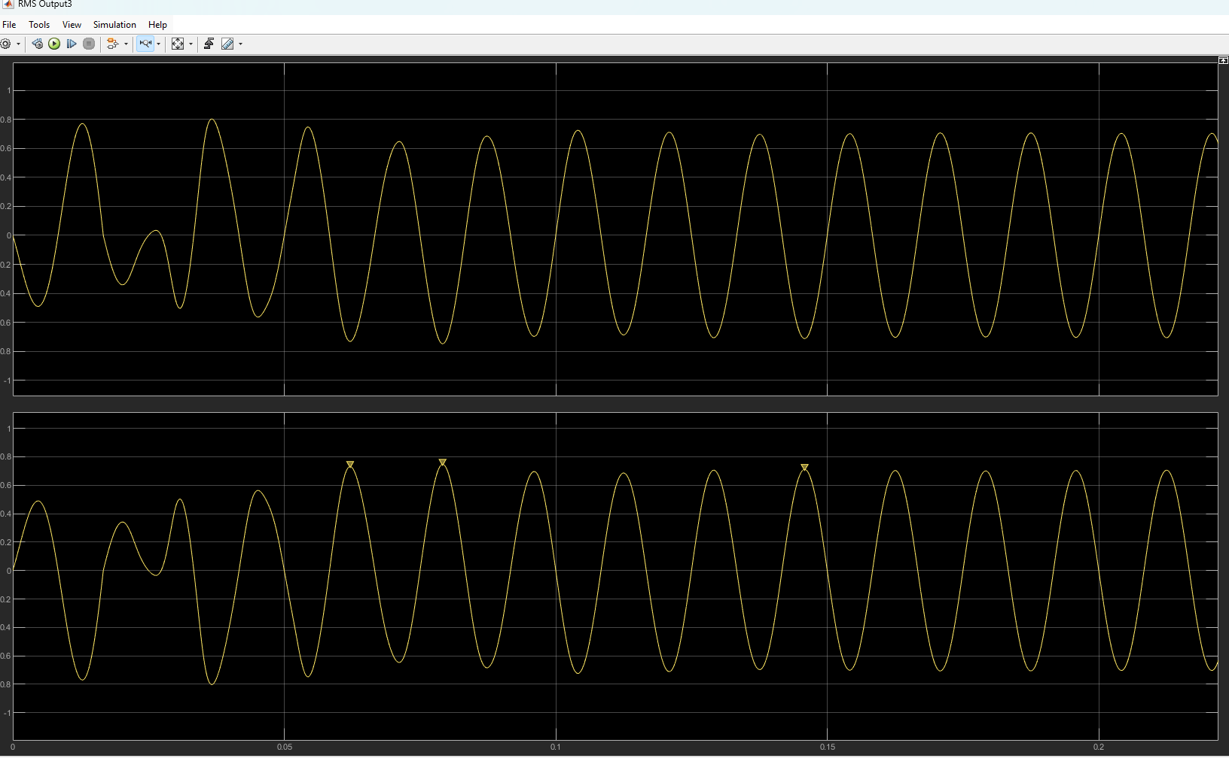
Figure 9: The two sine waves after multiplication (start-up)
1. The Two 180 degree Phase Shifted Sine Wave
So the output of the PI controller decides the amplitude of the reference sine wave. If the amplitude of the reference sine wave increases, the time during which the sine wave is greater than the triangular carrier increases. So the width of the PWM pulses increases. As the pulses become wider, the switches stay on for a longer time, and the average voltage given to the filter, and so the sinusoidal voltage across the load, becomes larger. This is the relation between the amplitude of the reference sine wave and the amplitude of the output sine wave. The controller uses exactly this relation to raise or lower the output voltage.
The reference sine wave also decides the frequency of the output. The output has the same frequency as the reference sine wave, which is 60 Hz here. If we change the frequency of the reference sine wave, the output frequency changes by the same amount. Note that the PI controller only regulates the voltage (RMS). The frequency is not controlled by feedback, it is simply set by the sine wave source.
In short, the PI controller regulates the RMS voltage of the load by changing the amplitude of the reference sine waves, and the reference sine wave frequency sets the output frequency.

4. Effect of changing a Parameter (Keeping others constant)

DC voltage source: 200 V
The output peak cannot be higher than the DC voltage. We need 170 V peak for 120 V RMS, so 200 V gives a modulation index of 170/200 = 0.85, which leaves some margin for the controller.
If it is increased | If it is decreased
The bridge has more voltage than needed, so the PI controller lowers the pulse width to hold 120 V. The switches see a higher voltage and the ripple current in the inductor becomes larger (ripple grows with the DC voltage). | The needed modulation index goes toward 1. Below about 170 V the output cannot reach 120 V RMS any more: the wave gets flattened, harmonics appear, and the PI integrator keeps adding up without being able to remove the error.

Reference sine amplitude: 0.85
This is the starting modulation index: 0.85 × 200 V = 170 V peak = 120 V RMS. In the closed loop it is multiplied by the PI output, which is about 1 when the output is at 120 V.
If it is increased | If it is decreased
The output gets bigger for the same PI output, so the PI controller reduces its own output to bring the RMS back to 120 V. If the amplitude goes above 1 the sine becomes larger than the carrier peak, giving over-modulation (flat pulses and extra low-order harmonics). | The output gets smaller for the same PI output, so the PI controller raises its output to compensate. It keeps working until the product becomes too small to compensate, for example if the amplitude is 0.5 the PI output must go above 1.6.

Reference sine frequency: 60 Hz
This is the US power frequency. It sets the frequency of the output voltage directly.
If it is increased | If it is decreased
The output frequency goes up by the same amount. There are fewer pulses in each cycle (5000/120 ≈ 42 at 120 Hz), so the output has more ripple. The RMS block is also set to 60 Hz, so it would measure wrongly unless we change it too. | The output frequency goes down. There are more pulses per cycle so the output is smoother, but the capacitor current and the inductor drop change slightly. The RMS block frequency should be changed to match.

Phase of the second sine wave: 180°
The two bridge legs are driven by sine waves in opposite phase. In this way one leg goes up while the other goes down, and the load sees the difference between them, which is the full bridge swing.
If it is increased | If it is decreased
If the phase is made less than 180° (for example 90°), the two legs partly move together, the difference between them becomes smaller, and the output amplitude drops and its shape gets distorted. | If the phase is made 0° (both sines equal), both legs switch in the same way, the voltage difference across the load is zero, and the output is zero no matter what the PI controller does.

Carrier frequency: 5 kHz (amplitude ±1)
We want the carrier to be many times higher than 60 Hz: 5000/60 ≈ 83 pulses per cycle. It is also several times higher than the filter cutoff (796 Hz), and with two legs the load sees 10 kHz. In Simulink the carrier is a repeating table with time [0 1 2 3 4]/20000 and output [0 1 0 -1 0], which is a triangle of period 0.2 ms.
If it is increased | If it is decreased
Frequency up: there are more pulses per cycle, less ripple and lower distortion, but in a real circuit the switching losses grow, and the simulation needs a smaller time step. Amplitude up: the modulation index becomes 0.85 divided by the carrier amplitude, so the output voltage falls. | Frequency down (for example 1 kHz): only about 17 pulses per cycle, so the output has a lot of ripple and a distorted shape, because the filter (796 Hz) cannot separate it from 60 Hz. Amplitude down: the modulation index goes up and the circuit can over-modulate.

Inductor L: 2 mH
The inductor limits the ripple current and sets the filter cutoff together with C. At 60 Hz its impedance is only 2π × 60 × 2 mH ≈ 0.75 Ω, which is small compared to the 14.4 Ω load, so the voltage drop across it is small.
If it is increased | If it is decreased
The cutoff goes down (for example 5 mH gives about 503 Hz) so the ripple is filtered better. But the voltage drop at 60 Hz becomes larger (1.9 Ω at 5 mH), so the PI controller must raise the pulse width, and the response becomes slower. | The cutoff goes up (0.5 mH gives about 1.6 kHz) so more ripple reaches the output. The ripple current in the inductor grows (ripple is proportional to 1/L), so the switches carry more peak current and the waveform is more distorted.

Capacitor C: 20 µF
The capacitor removes the ripple and passes the high-frequency current away from the load. With L it gives a characteristic impedance √(L/C) = 10 Ω, close to the 14.4 Ω load, so the filter is reasonably damped. At 60 Hz the capacitor draws only about 0.9 A of extra current.
If it is increased | If it is decreased
The cutoff goes down (50 µF gives about 503 Hz) so the output is cleaner, but the capacitor draws more reactive current at 60 Hz (about 2.3 A at 50 µF), so the bridge carries more current. The response also gets slower. | The cutoff goes up (5 µF gives about 1.6 kHz) so more ripple reaches the output. The filter can ring (oscillate) more, because it becomes less damped.

Load resistance R: 14.4 Ω
We chose the load for 1 kW at 120 V RMS: R = V²/P = 120²/1000 = 14.4 Ω. That gives a peak current of about 11.8 A.
If it is increased | If it is decreased
The load is lighter: the current falls (170 V / 50 Ω = 3.4 A peak at 50 Ω). The voltage drops are smaller, but the filter is less damped, so there is more ringing after a change. | The load is heavier: the current rises (34 A peak at 5 Ω). The voltage drop across the inductor and the switches increases, so the controller must give wider pulses, and with a 200 V supply it can run out of range. The switches and the inductor would need to carry more current.

Reference voltage: 100 V → 120 V RMS (step at 1 s)
We use a step to show that the controller follows a change. First it holds 100 V, then it goes to the normal 120 V value.
If it is increased | If it is decreased
A higher reference needs a higher peak voltage. For 150 V RMS we would need 212 V peak, which is more than the 200 V supply, so the output cannot reach it and the integrator winds up. | A lower reference needs narrower pulses (a smaller modulation index). The RMS value is still correct, but the ripple becomes a bigger part of the smaller output.

RMS block: 60 Hz, initial value 120 V
The RMS block averages over one cycle of 60 Hz (16.7 ms), so its frequency must be 60 Hz. The initial value is what the block outputs before it has measured one full cycle.
If it is increased | If it is decreased
Frequency set higher than the real frequency: the averaging time is shorter than a cycle, so the measured RMS ripples at the output frequency and this ripple enters the loop. Initial value higher than the reference: the first error is negative, which causes the dip we see in Figures 6 and 7. | Frequency set lower than the real frequency: the averaging time is longer, so the measurement is slow and the loop reacts later. Initial value equal to the reference (100 V): there is no false error at the start, so the dip in the PI output disappears.

Gain block: 1/100
The error is in volts (tens of volts) but the controller output must stay around 1. Dividing by 100 makes the correction smooth and not abrupt.
If it is increased | If it is decreased
A bigger gain (for example 1/50) is the same as raising Kp and Ki together: the response is faster but there is more overshoot, and it can start to oscillate. | A smaller gain (for example 1/500) is the same as lowering Kp and Ki together: the response is smoother but slow, and the output may not reach the reference in the available time.

PI controller: Kp = 2, Ki = 200
Kp gives the immediate reaction and Ki removes the remaining error. With the 1/100 gain these act like 0.02 and 2. They were chosen by trial: the output reaches the reference in about 0.15 s with only a small overshoot.
If it is increased | If it is decreased
Kp up: faster reaction but more overshoot, and it can oscillate because the RMS block takes one cycle to measure. Ki up: the error is removed faster, but the overshoot is bigger and the ringing lasts longer. | Kp down: slower reaction and a bigger dip at the step. Ki down: the error is removed slowly, so the output may take a long time to reach the reference and may not settle within 2 s.

Switch on-resistance: 1 mΩ
It is a small, realistic value. At 12 A the voltage drop across two switches is only about 24 mV, which does not affect the output.
If it is increased | If it is decreased
A larger Ron (for example 0.5 Ω) gives more loss and voltage drop (about 12 V across two switches at 12 A), so the output falls and the controller must compensate. | A smaller Ron makes the switches closer to ideal with almost no loss. There is no downside in simulation.

Solver step size: 1 µs
The comparator output is only updated once every time step, so the pulse edges can only be placed in steps of 1 µs. With a 5 kHz carrier (200 µs period) this gives 200 steps per period, which is accurate.
If it is increased | If it is decreased
A larger step (for example 10 µs) gives only 20 steps per carrier period, so the pulse widths are rounded in 5% steps, the waveform gets distorted, but the simulation runs faster. | A smaller step (for example 0.1 µs) gives more accurate pulse widths and allows a higher carrier frequency, but the simulation becomes about ten times slower.

N.B.
- Start-up dip: the RMS block starts at 120 V while the first reference is 100 V. Setting the RMS block initial value to 100 would remove the negative dip at the start.

