PHASE 1.11 — SWOT ANALYSIS
SWOT Analysis
Al Safa 2 Park — Synthesis of Phase 1.01–1.10 Findings
────────────────────────────────────────────────────────────

1. Purpose
This report synthesizes findings from Phase 1.01-1.10 into a single SWOT matrix. Nothing here is new invented data — every point traces back to an earlier Phase 1 sub-analysis document.
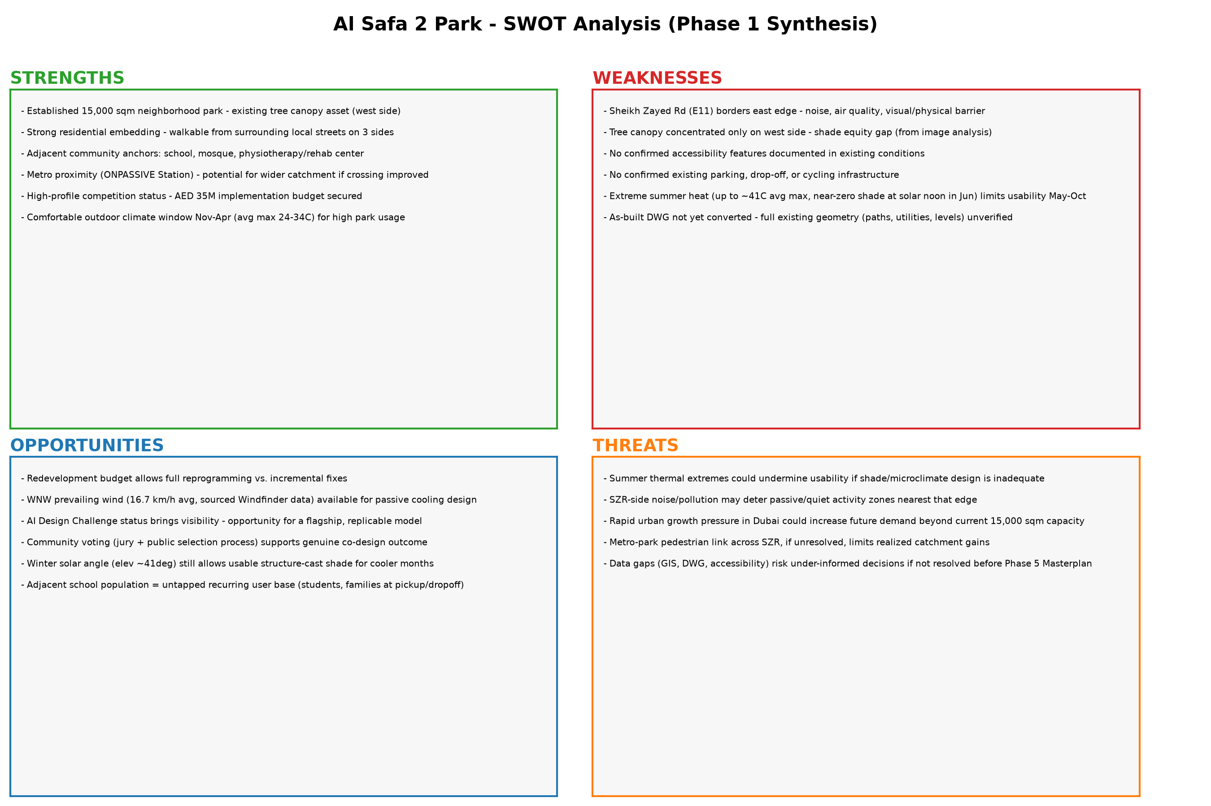
Figure 1 — SWOT Matrix (Python-generated synthesis).

2. Opportunities & Constraints Summary
Constraints (hard facts that limit design freedom):
- Fixed site area: 15,000 sqm — no expansion possible.
- Fixed budget ceiling: AED 35,000,000 implementation cost.
- Sheikh Zayed Road borders the east edge — a permanent noise/physical barrier.
- Submission requires Concept + Preliminary Design only — detailed construction documentation is explicitly out of scope at this stage.
- All winning-entry IP transfers to Dubai Municipality.
- Climate: ~5 months (May-Oct) of extreme heat with near-zero natural shade at solar noon — a hard environmental constraint.
Opportunities (real, evidence-based, not yet decided how to use):
- Full redevelopment scope (not retrofit) — every zone can be reprogrammed from scratch.
- WNW prevailing wind pattern (16.7 km/h avg, sourced) — usable for passive ventilation corridors.
- Winter sun angle (~41° at noon) — usable for solar-responsive seasonal design.
- Adjacent school, mosque, and rehab center — built-in recurring user bases.
- Metro proximity — a genuine regional catchment opportunity IF pedestrian connectivity across SZR is addressed.
- High public visibility of the AI Design Challenge — potential citywide precedent.
This document intentionally stops at listing opportunities/constraints — it does not select or prioritize a design response. That belongs to Phase 3 (Opportunity & Design Objectives).

Appendix — Program Proof (Source Code)
The analysis, figures, and tables in this report were generated by the Python script 01_PHASE1_EXISTING_PARK/_scripts/04_swot_synthesis.py below. Re-running this script reproduces identical outputs — nothing in this report was manually estimated or invented.
"""
Phase 1.11 - SWOT Synthesis
Synthesizes findings from Phase 1.01-1.10 into a visual SWOT matrix.
This is a synthesis of already-documented findings, not new invented data.
"""

import os
import matplotlib.pyplot as plt

OUT = os.path.join(os.path.dirname(__file__), "..", "11_SWOT", "outputs")
os.makedirs(OUT, exist_ok=True)

swot = {
"STRENGTHS": [
"Established 15,000 sqm neighborhood park - existing tree canopy asset (west side)",
"Strong residential embedding - walkable from surrounding local streets on 3 sides",
"Adjacent community anchors: school, mosque, physiotherapy/rehab center",
"Metro proximity (ONPASSIVE Station) - potential for wider catchment if crossing improved",
"High-profile competition status - AED 35M implementation budget secured",
"Comfortable outdoor climate window Nov-Apr (avg max 24-34C) for high park usage",
],
"WEAKNESSES": [
"Sheikh Zayed Rd (E11) borders east edge - noise, air quality, visual/physical barrier",
"Tree canopy concentrated only on west side - shade equity gap (from image analysis)",
"No confirmed accessibility features documented in existing conditions",
"No confirmed existing parking, drop-off, or cycling infrastructure",
"Extreme summer heat (up to ~41C avg max, near-zero shade at solar noon in Jun) limits usability May-Oct",
"As-built DWG not yet converted - full existing geometry (paths, utilities, levels) unverified",
],
"OPPORTUNITIES": [
"Redevelopment budget allows full reprogramming vs. incremental fixes",
"WNW prevailing wind (16.7 km/h avg, sourced Windfinder data) available for passive cooling design",
"AI Design Challenge status brings visibility - opportunity for a flagship, replicable model",
"Community voting (jury + public selection process) supports genuine co-design outcome",
"Winter solar angle (elev ~41deg) still allows usable structure-cast shade for cooler months",
"Adjacent school population = untapped recurring user base (students, families at pickup/dropoff)",
],
"THREATS": [
"Summer thermal extremes could undermine usability if shade/microclimate design is inadequate",
"SZR-side noise/pollution may deter passive/quiet activity zones nearest that edge",
"Rapid urban growth pressure in Dubai could increase future demand beyond current 15,000 sqm capacity",
"Metro-park pedestrian link across SZR, if unresolved, limits realized catchment gains",
"Data gaps (GIS, DWG, accessibility) risk under-informed decisions if not resolved before Phase 5 Masterplan",
],
}

# --- 2x2 SWOT matrix visualization ---
fig, axes = plt.subplots(2, 2, figsize=(18, 12))
configs = [
("STRENGTHS", "#2ca02c", axes[0, 0]),
("WEAKNESSES", "#d62728", axes[0, 1]),
("OPPORTUNITIES", "#1f77b4", axes[1, 0]),
("THREATS", "#ff7f0e", axes[1, 1]),
]
for label, color, ax in configs:
ax.set_facecolor("#f7f7f7")
ax.set_title(label, fontsize=18, fontweight="bold", color=color, loc="left")
text = "\n\n".join(f"- {item}" for item in swot[label])
ax.text(0.02, 0.95, text, transform=ax.transAxes, fontsize=9.5,
verticalalignment="top", wrap=True)
ax.set_xticks([])
ax.set_yticks([])
for spine in ax.spines.values():
spine.set_edgecolor(color)
spine.set_linewidth(2)

plt.suptitle("Al Safa 2 Park - SWOT Analysis (Phase 1 Synthesis)", fontsize=20, fontweight="bold")
plt.tight_layout(rect=[0, 0, 1, 0.96])
fig.savefig(os.path.join(OUT, "swot_matrix.png"), dpi=150)
plt.close(fig)
print("Saved: swot_matrix.png")

# --- Text version ---
with open(os.path.join(OUT, "swot_matrix.md"), "w", encoding="utf-8") as f:
f.write("# Phase 1.11 - SWOT Analysis\nAl Safa 2 Park (synthesized from Phase 1.01-1.10 findings)\n\n")
for label in ["STRENGTHS", "WEAKNESSES", "OPPORTUNITIES", "THREATS"]:
f.write(f"## {label}\n")
for item in swot[label]:
f.write(f"- {item}\n")
f.write("\n")

print("Saved: swot_matrix.md")

