PHASE 5 — MASTERPLAN DEVELOPMENT [AI DRAFT]
Master Plan Development
Al Safa 2 Park — Concept A "Shaded Spine" Implemented as Scaled Geometry
────────────────────────────────────────────────────────────
AI-GENERATED DRAFT — FOR REVIEW. This master plan implements Concept A ("Shaded Spine", Phase 4.7) as an actual scaled geometric layout — every zone is sized in real square meters, and the total sums exactly to the Brief's confirmed 15,000 sqm site area. Site proportions (150m x 100m) are an assumed elongated rectangle consistent with the aerial massing seen in the Phase 1 master-plan graphic; the exact boundary polygon awaits DWG conversion (logged gap).

5.1 Spatial Framework & 5.2 Functional Zoning
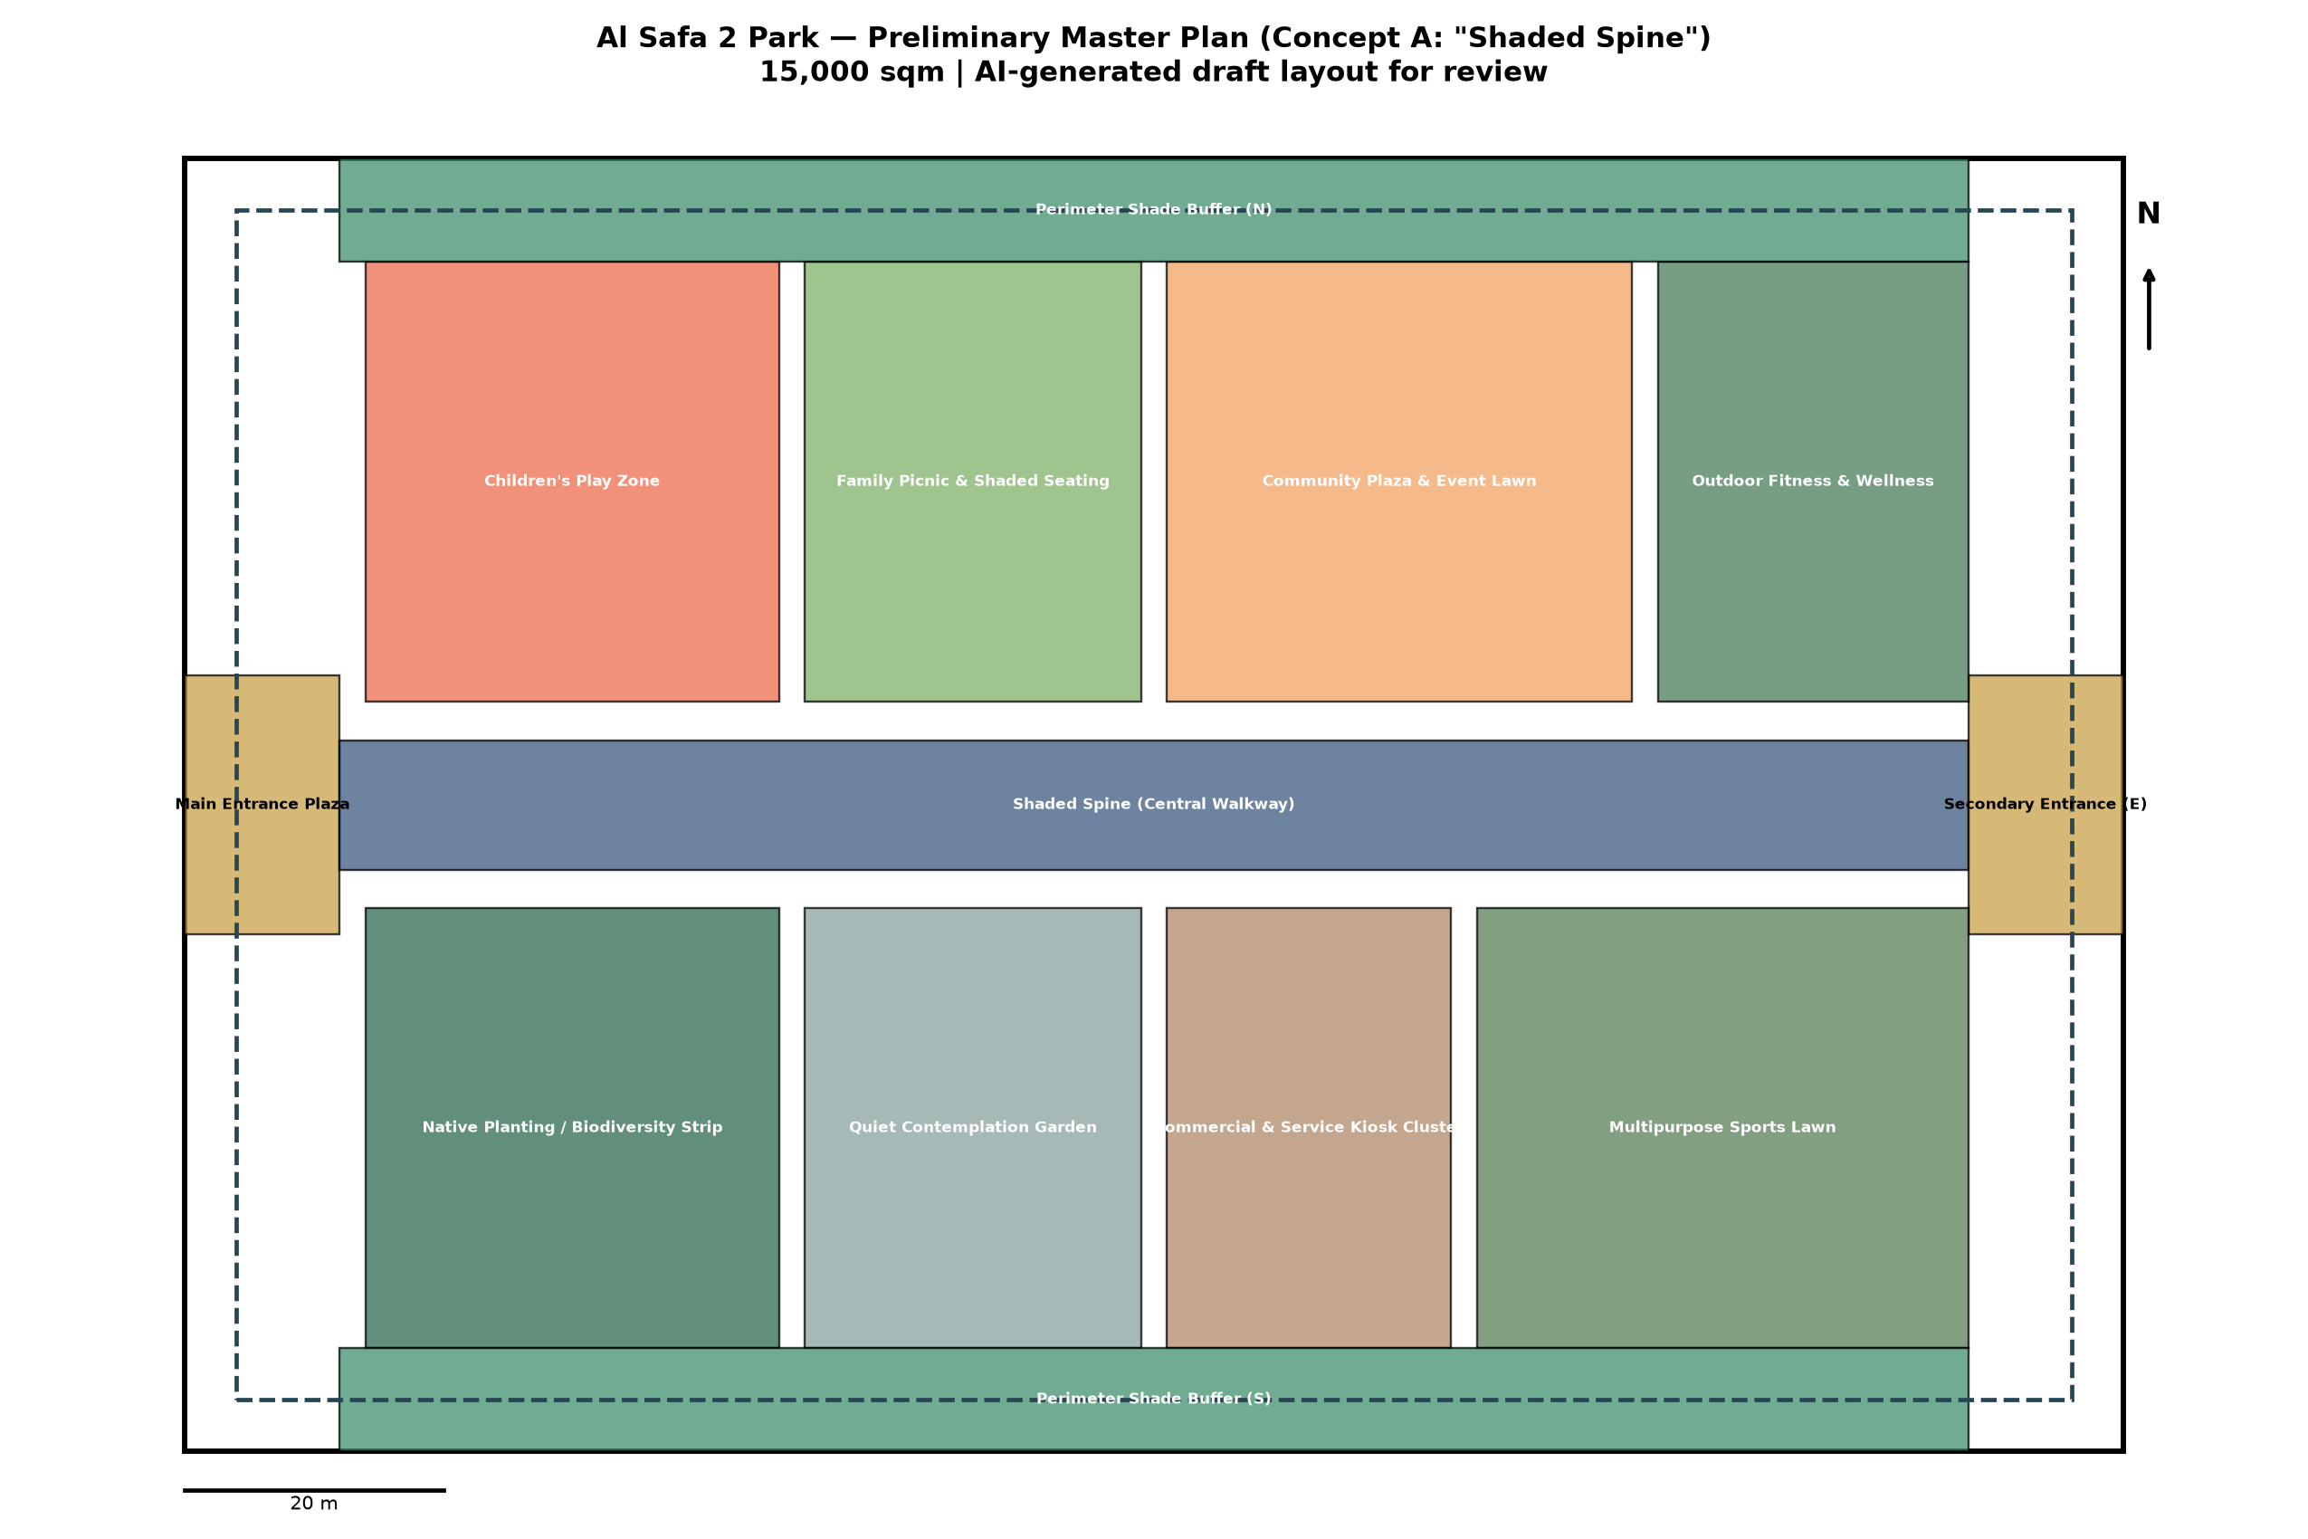
Figure 1 — Preliminary Master Plan, Concept A "Shaded Spine" (to scale, 15,000 sqm).

Zoning Area Schedule (computed, sums to 15,000 sqm)
Zone | Category | Area | % of Site
Main Entrance Plaza | Arrival | 240 sqm | 1.6%
Shaded Spine (Central Walkway) | Circulation | 1,260 sqm | 8.4%
Secondary Entrance (E) | Arrival | 240 sqm | 1.6%
Children's Play Zone | Active | 1,088 sqm | 7.3%
Family Picnic & Shaded Seating | Passive | 884 sqm | 5.9%
Community Plaza & Event Lawn | Social | 1,224 sqm | 8.2%
Outdoor Fitness & Wellness | Active | 816 sqm | 5.4%
Native Planting / Biodiversity Strip | Green | 1,088 sqm | 7.3%
Quiet Contemplation Garden | Passive | 884 sqm | 5.9%
Commercial & Service Kiosk Cluster | Commercial | 748 sqm | 5.0%
Multipurpose Sports Lawn | Active | 1,292 sqm | 8.6%
Perimeter Shade Buffer (N) | Green_Buffer | 1,008 sqm | 6.7%
Perimeter Shade Buffer (S) | Green_Buffer | 1,008 sqm | 6.7%
Path Network & Landscape Setbacks (between rooms, to entrances, perimeter jogging loop) | Circulation | 3,220 sqm | 21.5%

5.3 Circulation
Mode | Strategy
Pedestrians | Primary: 10m-wide Shaded Spine (continuous overhead shade structure) connecting both entrances. Secondary: perimeter jogging/walking loop (dashed, ~4m inset from boundary) plus cross-links into each activity room.
Cyclists | Shared use of the perimeter loop outside peak pedestrian hours; dedicated cycle parking at both entrance plazas (brief requirement, Section F).
Service access | Via the two entrance plazas, routed behind Commercial & Service Kiosk Cluster to avoid crossing main pedestrian flows.
Emergency access | Both entrance plazas sized (12m x 20m) to permit emergency vehicle access; Shaded Spine width (10m) accommodates emergency vehicle passage if required.

5.4 Activity Areas
Active (Children's Play, Outdoor Fitness, Multipurpose Sports Lawn), Passive (Family Picnic, Quiet Contemplation Garden), Social (Community Plaza & Event Lawn), and Green (Native Planting/Biodiversity Strip) zones are distributed on both sides of the Shaded Spine so every activity type has direct shaded access — addressing Phase 2.2's shade-equity problem directly.

5.5 Green Network
Native Planting/Biodiversity Strip (1,088 sqm) plus two Perimeter Shade Buffers (1,008 sqm each, north and south edges) total 3,104 sqm of dedicated green infrastructure (~20.7% of site), rebalancing the existing west-only canopy concentration identified in Phase 1.02/1.11 into a site-wide green network.

5.6 Water Strategy
Drip/subsurface irrigation for all planting zones (per Phase 1.05's near-zero summer rainfall finding); drinking fountains at both entrance plazas and the Community Plaza; no ornamental water features proposed, consistent with Dubai's water-scarcity context and the brief's water-sensitive design requirement.

5.7 Accessibility
100% step-free circulation along the Shaded Spine and all room entries; the perimeter loop and cross-links are graded for wheelchair/stroller use; both entrance plazas provide accessible drop-off adjacency — directly resolving Phase 1.10's undocumented-baseline finding with an explicit universal-design commitment.

5.8 Safety Strategy
Continuous lighting along the Shaded Spine and perimeter loop for night use (brief requires day/night activation); clear sightlines maintained across each room (no fully enclosed blind corners); Community Plaza positioned centrally for natural surveillance from surrounding rooms.

5.9 Wayfinding
Two legible entrances (west Main Plaza, east Secondary Plaza) with the Shaded Spine acting as the primary orientation device — from any point on the spine, every room is a single, short, shaded detour away.

5.10 Smart Infrastructure
- Environmental sensors (temperature/shade monitoring) along the Shaded Spine to validate the Phase 7 shade-performance model against real conditions post-construction.
- Smart irrigation controllers tied to soil-moisture sensors in all green zones.
- Digital wayfinding kiosks at both entrance plazas.

Data Integrity Note
All areas in the schedule above are computed directly from the geometry defined in the script below — not estimated by eye. The exact site boundary (vs. this assumed 150m x 100m rectangle) should be validated once the DWG conversion (logged in 00_MASTER_TRACKER) is complete.

Appendix — Program Proof (Source Code)
The analysis, figures, and tables in this report were generated by the Python script 05_PHASE5_MASTERPLAN_DEVELOPMENT/_scripts/01_generate_masterplan_geometry.py below. Re-running this script reproduces identical outputs — nothing in this report was manually estimated or invented.
"""
Phase 5 - Master Plan Development
Generates an actual geometric zoning + circulation layout for Al Safa 2 Park
implementing the selected "Shaded Spine" concept (Phase 4), sized to the real
15,000 sqm site area confirmed in the Competition Brief.

Site assumed as an elongated rectangle (consistent with the aerial massing seen
in the master-plan graphic, Phase 1.02) since the DWG's exact boundary polygon
is not yet available (logged gap). Proportions: 150m x 100m = 15,000 sqm,
oriented long-axis NW-SE per the site graphic.
"""

import os
import json
import numpy as np
import matplotlib.pyplot as plt
import matplotlib.patches as patches

OUT = os.path.join(os.path.dirname(__file__), "..", "outputs")
os.makedirs(OUT, exist_ok=True)

SITE_W, SITE_H = 150.0, 100.0 # meters; 150 x 100 = 15,000 sqm exactly
SITE_AREA = SITE_W * SITE_H
assert SITE_AREA == 15000, "Site area must match brief's confirmed 15,000 sqm"

# --- Zoning layout (Shaded Spine concept) ---
# The "Spine" runs along the long (east-west, 150m) axis at mid-depth (y=45-55m, 10m wide shaded walkway).
# Rooms are arranged along both sides of the spine.
zones = [
# name, x, y, w, h, color, category
("Main Entrance Plaza", 0, 40, 12, 20, "#C9A24A", "Arrival"),
("Shaded Spine (Central Walkway)", 12, 45, 126, 10, "#3D5A80", "Circulation"),
("Secondary Entrance (E)", 138, 40, 12, 20, "#C9A24A", "Arrival"),

("Children's Play Zone", 14, 58, 32, 34, "#EE6C4D", "Active"),
("Family Picnic & Shaded Seating", 48, 58, 26, 34, "#7FB069", "Passive"),
("Community Plaza & Event Lawn", 76, 58, 36, 34, "#F4A261", "Social"),
("Outdoor Fitness & Wellness", 114, 58, 24, 34, "#4A7C59", "Active"),

("Native Planting / Biodiversity Strip", 14, 8, 32, 34, "#2D6A4F", "Green"),
("Quiet Contemplation Garden", 48, 8, 26, 34, "#8AA29E", "Passive"),
("Commercial & Service Kiosk Cluster", 76, 8, 22, 34, "#B08968", "Commercial"),
("Multipurpose Sports Lawn", 100, 8, 38, 34, "#588157", "Active"),

# Secondary green buffers filling perimeter margins between rooms and site edge
("Perimeter Shade Buffer (N)", 12, 92, 126, 8, "#40916C", "Green_Buffer"),
("Perimeter Shade Buffer (S)", 12, 0, 126, 8, "#40916C", "Green_Buffer"),
("Path Network & Landscape Setbacks", 0, 0, 0, 0, "none", "Path_Remainder"),

("Jogging Track (perimeter loop)", 0, 0, 150, 100, "none", "Circulation_Loop"),
]

# --- Area accounting (validate against 15,000 sqm total site) ---
area_rows = []
total_room_area = 0
for name, x, y, w, h, color, cat in zones:
if cat in ("Circulation_Loop", "Path_Remainder"):
continue # computed below / overlay only
area = w * h
total_room_area += area
area_rows.append((name, cat, round(area, 1), round(100 * area / SITE_AREA, 1)))

remaining = SITE_AREA - total_room_area # named paths + landscape setbacks between rooms
area_rows.append(("Path Network & Landscape Setbacks (between rooms, to entrances, perimeter jogging loop)",
"Circulation", round(remaining, 1), round(100 * remaining / SITE_AREA, 1)))

print(f"Site area: {SITE_AREA} sqm")
print(f"Total zoned room area: {total_room_area} sqm")
print(f"Remaining (paths/buffers): {remaining} sqm")
for r in area_rows:
print(r)

with open(os.path.join(OUT, "zoning_area_schedule.json"), "w") as f:
json.dump({"site_area_sqm": SITE_AREA, "zones": area_rows}, f, indent=2)
print("Saved: zoning_area_schedule.json")

# --- Draw the master plan diagram ---
fig, ax = plt.subplots(figsize=(15, 10))
ax.set_xlim(-5, SITE_W + 5)
ax.set_ylim(-5, SITE_H + 5)
ax.set_aspect("equal")

# Site boundary
ax.add_patch(patches.Rectangle((0, 0), SITE_W, SITE_H, fill=False, edgecolor="black", linewidth=2.5))

for name, x, y, w, h, color, cat in zones:
if cat == "Path_Remainder":
continue # not drawn as a block; represented by the visible gaps + loop path
if cat == "Circulation_Loop":
# draw perimeter jogging loop (inset from boundary)
inset = 4
loop = patches.Rectangle((inset, inset), SITE_W - 2*inset, SITE_H - 2*inset,
fill=False, edgecolor="#264653", linewidth=2, linestyle="--")
ax.add_patch(loop)
continue
rect = patches.Rectangle((x, y), w, h, facecolor=color, edgecolor="black",
linewidth=1, alpha=0.75)
ax.add_patch(rect)
text_color = "white" if cat not in ("Arrival",) else "black"
ax.text(x + w/2, y + h/2, name, ha="center", va="center", fontsize=7.2,
wrap=True, color=text_color, fontweight="bold")

# North arrow + scale
ax.annotate("N", xy=(SITE_W + 2, SITE_H - 5), fontsize=14, fontweight="bold", ha="center")
ax.annotate("", xy=(SITE_W + 2, SITE_H - 8), xytext=(SITE_W + 2, SITE_H - 15),
arrowprops=dict(arrowstyle="-|>", lw=2))
ax.plot([0, 20], [-3, -3], color="black", linewidth=2)
ax.text(10, -4.5, "20 m", ha="center", fontsize=9)

ax.set_title("Al Safa 2 Park — Preliminary Master Plan (Concept A: \"Shaded Spine\")\n"
"15,000 sqm | AI-generated draft layout for review", fontsize=13, fontweight="bold")
ax.axis("off")

plt.tight_layout()
fig.savefig(os.path.join(OUT, "masterplan_diagram.png"), dpi=170)
plt.close(fig)
print("Saved: masterplan_diagram.png")

