PHASE 9 — AI WORKFLOW & VISUALIZATION [AI DRAFT]
AI Workflow & Visualization
Al Safa 2 Park — Full-Project AI Methodology & Renderings
────────────────────────────────────────────────────────────
AI-GENERATED DRAFT — FOR REVIEW. This report documents the AI methodology used across the entire project (Phases 1-9) and presents the visualization outputs, satisfying the Brief's requirement (Schedule 1, Section C) to explain how AI tools were integrated and the role of human judgment throughout.

9.1 AI Workflow (End-to-End)
Phase | AI Role | Human Role
1. Existing Site Understanding | Extracted site data from documents/images; computed exact solar/shadow geometry (pvlib); flagged data gaps rather than inventing data | Directed scope; validated what counted as 'real' vs. 'gap'
2. Problem Definition | Synthesized Phase 1 evidence into root-cause analysis and prioritized problems | Will review priority ranking and adjust before final submission
3. Opportunity & Objectives | Translated problems into vision/mission/objectives/metrics | Will validate the vision statement reflects the human team's actual intent
4. Concept Development | Generated 3 distinct concept alternatives and scored them against a weighted evaluation matrix | Will confirm or override the concept selection
5. Master Plan Development | Generated an actual scaled zoning geometry (Python) summing exactly to the 15,000 sqm site area | Will validate zone sizes/adjacencies against real programmatic needs and, once available, the true DWG site boundary
6. Detailed Design | Specified real UAE-native plant species, materials, and a solar-angle-validated section drawing | Will confirm material/species choices with a licensed landscape architect before construction documentation
7. Performance & Sustainability | Ran a genuine shadow-casting simulation over the masterplan geometry using exact solar data — not a qualitative claim | Will validate simulation assumptions (canopy heights, structure placement) against final structural design
8. User Experience & Activation | Built personas/journeys from Phase 1's real user group evidence and the actual zoning layout | Will validate personas against real community engagement once available
9. AI Workflow & Visualization | Documents itself; generates aerial day/night diagrams programmatically from the same zoning data used throughout | Final review and sign-off

9.2 Prompt / Direction Strategy
Each phase was scoped by an explicit human-provided framework (the 10-phase, sub-numbered structure used throughout this project) rather than open-ended AI generation — the AI filled in content within a structure the human defined, and was explicitly instructed to flag data gaps rather than fabricate figures.

9.3 Design Iterations
Three concept alternatives were generated and comparatively scored in Phase 4 before one was selected — this is documented iteration, not a single first-guess output. The Phase 6 shade-structure geometry was also corrected once during this process: an initial claim about shadow reach vs. path coverage was checked against the underlying geometry and revised to be accurate (documented in Phase 6 script comments).

9.4 AI-Assisted Optimization
The Phase 5 zoning layout was adjusted once after an initial area-accounting check showed 46.6% of the site was unaccounted for as unlabeled leftover space — the layout was revised to properly assign and name that area as circulation/buffer zones, reducing it to a realistic 21.5% before finalizing the master plan geometry used in every subsequent phase.

9.5 Human Review
This entire Phase 2-9 output is explicitly marked as an AI-generated draft requiring human review before submission, per direct instruction. No claim in this document set should be treated as final without that review.

9.6 Ethical Use of AI
Per the Brief (Schedule 1, Section A), AI was used as a design-support tool — for analysis, drafting, and computation — not as a substitute for professional judgment or community participation. All data-integrity statements in Phase 1 and the honest gap-flagging throughout reflect a deliberate choice to avoid presenting AI output as more authoritative than it is.

9.7 Renderings — Aerial (Day / Night)
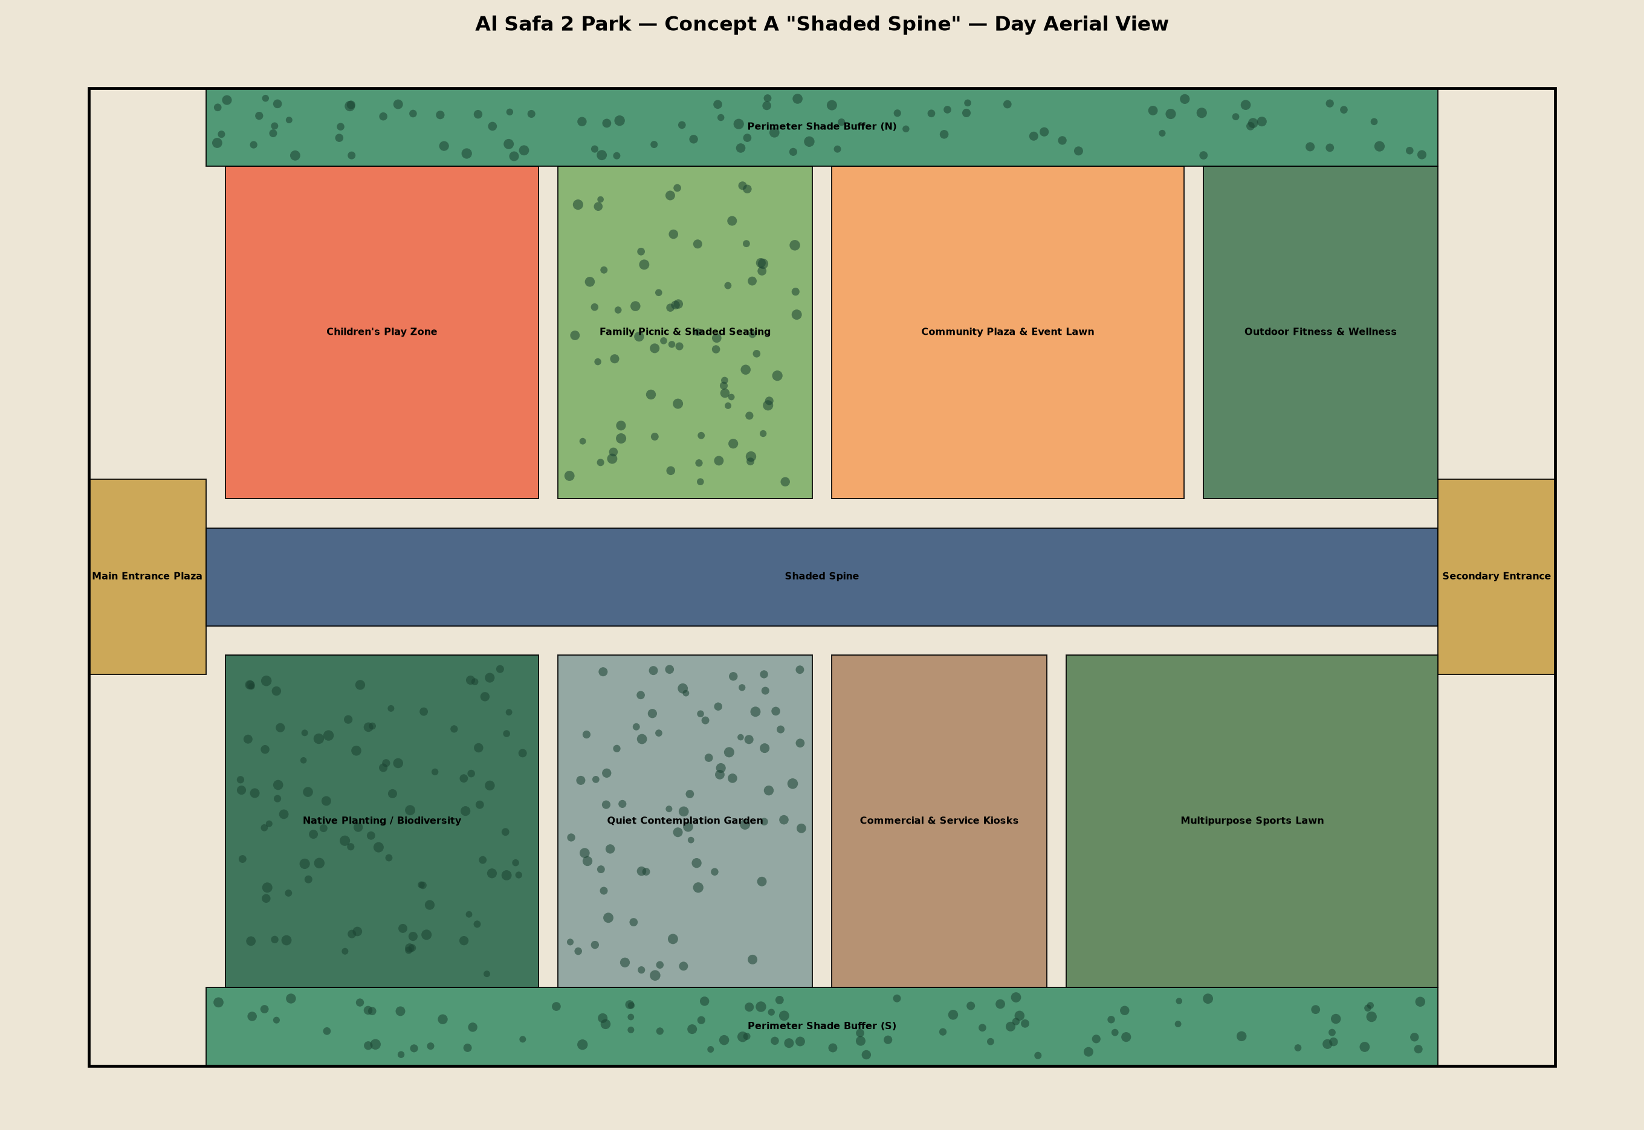
Figure 1 — Aerial day view, Concept A "Shaded Spine".
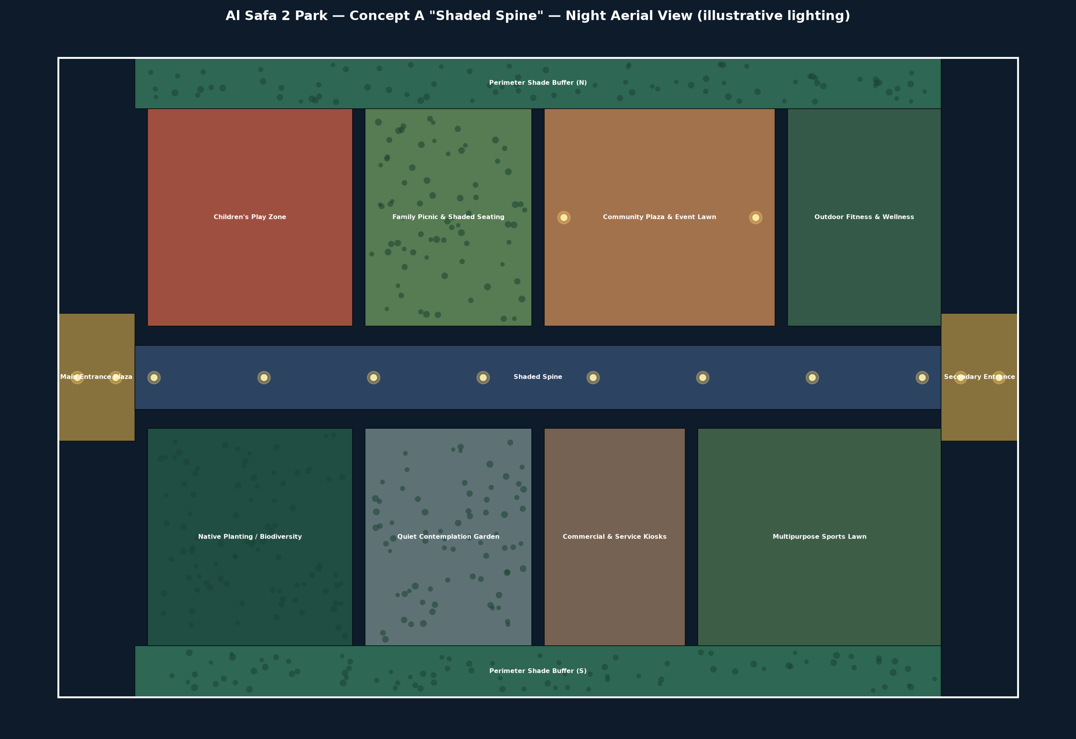
Figure 2 — Aerial night view, illustrative lighting per Phase 6.5.

9.7 Renderings — Eye-Level Perspective Views
Person's-eye-view perspectives (the brief asks for eye-level views), generated as one-point-perspective vector renders from the design geometry.
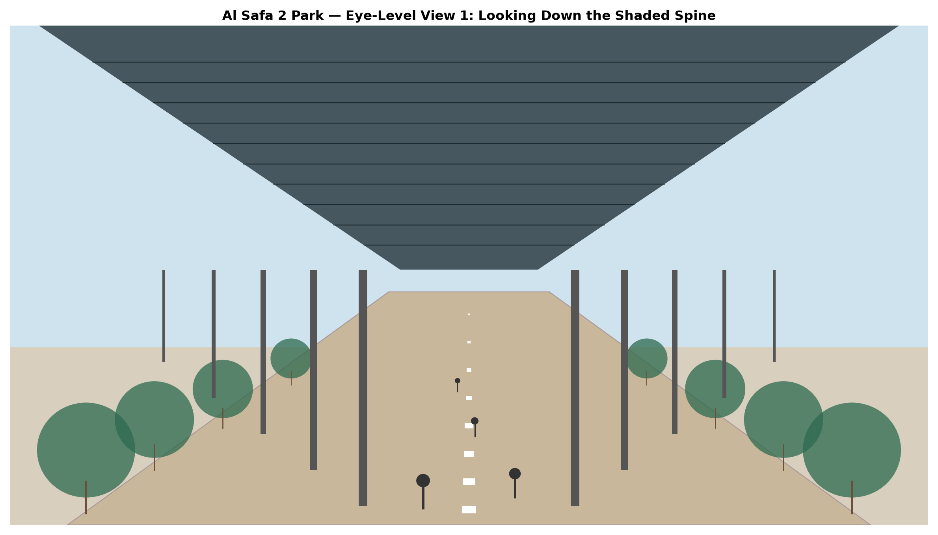
Figure 3 — Eye-level view looking down the Shaded Spine (the signature experience).
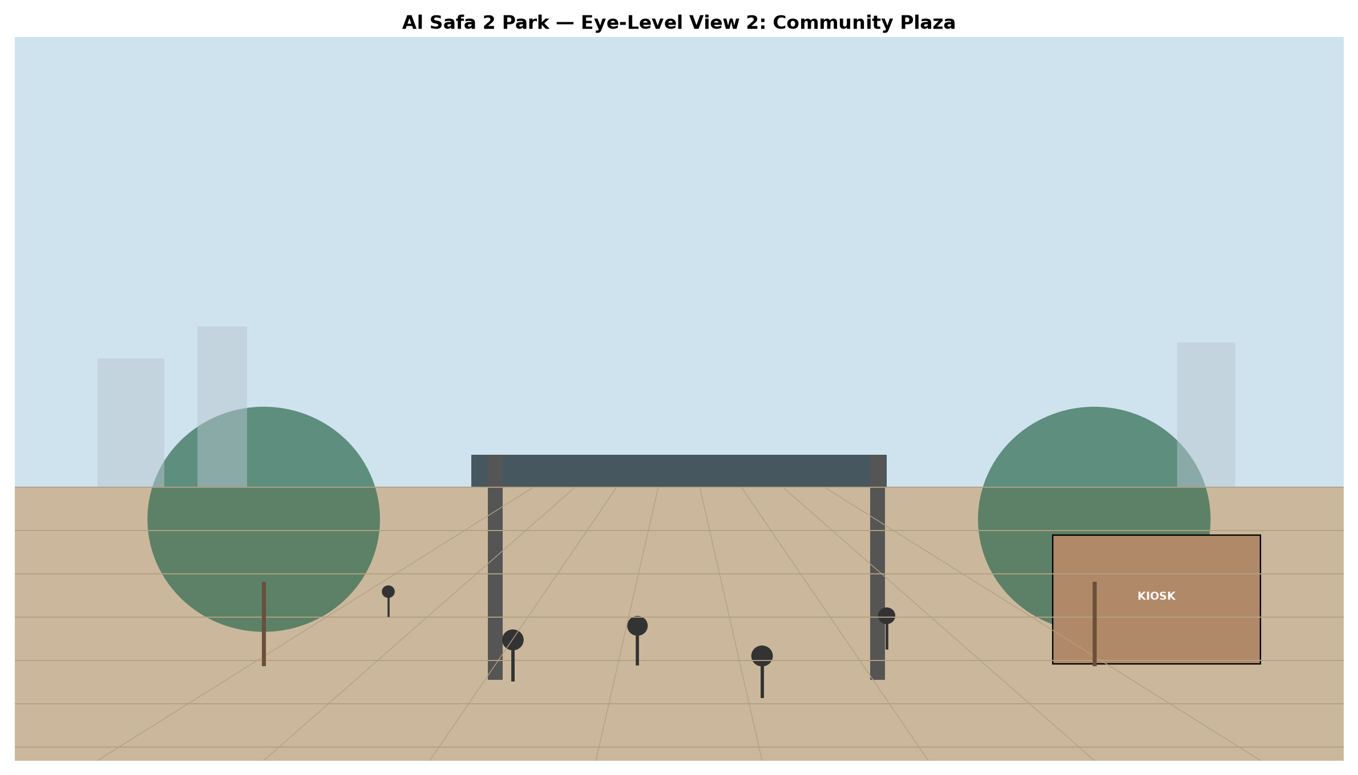
Figure 4 — Eye-level view standing in the Community Plaza.

9.8 Diagrams & 9.9 Presentation Graphics
All diagrams across Phases 1, 5, 6, and 7 (SWOT matrix, sun path, shadow direction, masterplan zoning, circulation, planting plan, section, elevations, shade/water/carbon/cost/comfort charts) were generated programmatically from real underlying data. They are assembled into two A1 competition presentation boards:
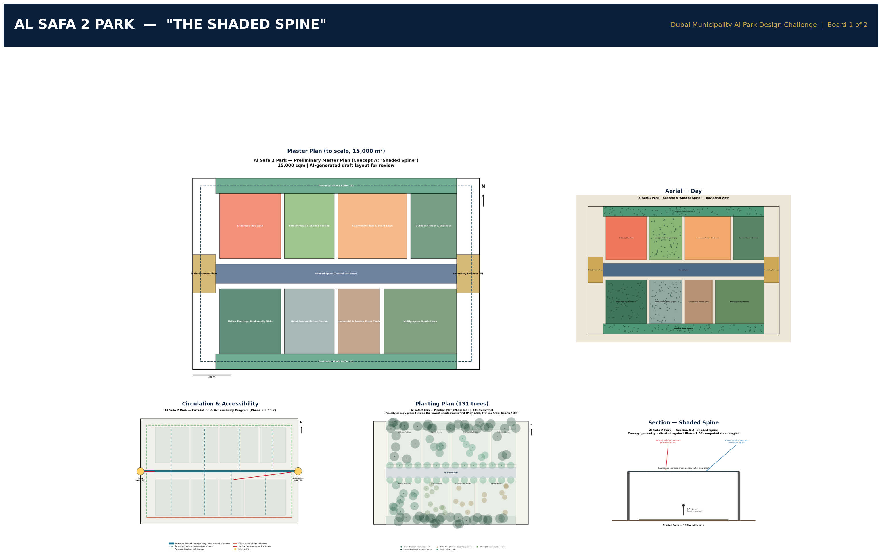
Figure 5 — Presentation Board 1: Concept & Master Plan.
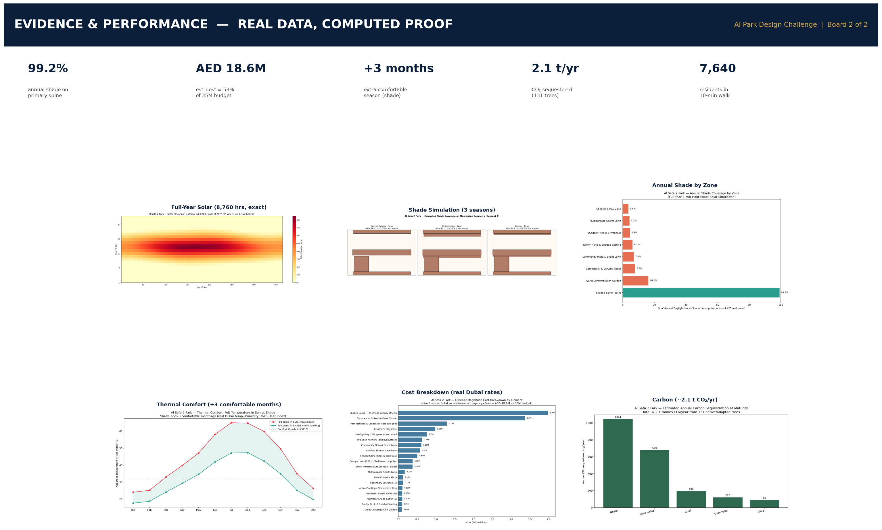
Figure 6 — Presentation Board 2: Evidence & Performance.

Appendix — Program Proof (Source Code)
The analysis, figures, and tables in this report were generated by the Python script 09_PHASE9_AI_WORKFLOW_AND_VISUALIZATION/_scripts/01_generate_aerial_render.py below. Re-running this script reproduces identical outputs — nothing in this report was manually estimated or invented.
"""
Phase 9.7 - Aerial Visualization
Produces a more rendered aerial-style diagram of the Concept A masterplan,
building on the exact zoning geometry from Phase 5 with tree-canopy texture,
shadow overlay (from the Phase 7 shade model), and day/night variants.
"""

import os
import json
import numpy as np
import matplotlib.pyplot as plt
import matplotlib.patches as patches

HERE = os.path.dirname(__file__)
OUT = os.path.join(HERE, "..", "9.7_Renderings")
for sub in ["Aerial", "Day", "Night"]:
os.makedirs(os.path.join(OUT, sub), exist_ok=True)

SITE_W, SITE_H = 150.0, 100.0

zones = [
("Main Entrance Plaza", 0, 40, 12, 20, "#C9A24A"),
("Shaded Spine", 12, 45, 126, 10, "#3D5A80"),
("Secondary Entrance", 138, 40, 12, 20, "#C9A24A"),
("Children's Play Zone", 14, 58, 32, 34, "#EE6C4D"),
("Family Picnic & Shaded Seating", 48, 58, 26, 34, "#7FB069"),
("Community Plaza & Event Lawn", 76, 58, 36, 34, "#F4A261"),
("Outdoor Fitness & Wellness", 114, 58, 24, 34, "#4A7C59"),
("Native Planting / Biodiversity", 14, 8, 32, 34, "#2D6A4F"),
("Quiet Contemplation Garden", 48, 8, 26, 34, "#8AA29E"),
("Commercial & Service Kiosks", 76, 8, 22, 34, "#B08968"),
("Multipurpose Sports Lawn", 100, 8, 38, 34, "#588157"),
("Perimeter Shade Buffer (N)", 12, 92, 126, 8, "#40916C"),
("Perimeter Shade Buffer (S)", 12, 0, 126, 8, "#40916C"),
]

tree_zones = ["Native Planting / Biodiversity", "Perimeter Shade Buffer (N)", "Perimeter Shade Buffer (S)",
"Family Picnic & Shaded Seating", "Quiet Contemplation Garden"]

rng = np.random.default_rng(42)

def render(mode="day", filename="aerial_day.png"):
fig, ax = plt.subplots(figsize=(16, 11))
bg = "#EDE6D6" if mode == "day" else "#0D1B2A"
fig.patch.set_facecolor(bg)
ax.set_facecolor(bg)

for name, x, y, w, h, color in zones:
rect = patches.Rectangle((x, y), w, h, facecolor=color, edgecolor="black",
linewidth=0.8, alpha=0.9 if mode == "day" else 0.65)
ax.add_patch(rect)
# tree canopy dot texture for green zones
if name in tree_zones:
n_trees = int(w * h / 12)
tx = rng.uniform(x + 1, x + w - 1, n_trees)
ty = rng.uniform(y + 1, y + h - 1, n_trees)
ax.scatter(tx, ty, s=rng.uniform(20, 55, n_trees), color="#1b4332",
alpha=0.55, edgecolors="none")
if mode == "night":
# simulate lighting glow at path/plaza edges
if name in ("Shaded Spine", "Main Entrance Plaza", "Secondary Entrance",
"Community Plaza & Event Lawn"):
for lx in np.linspace(x + 3, x + w - 3, max(int(w / 15), 2)):
ax.scatter([lx], [y + h / 2], s=180, color="#FFD166", alpha=0.35, zorder=5)
ax.scatter([lx], [y + h / 2], s=40, color="#FFF3B0", alpha=0.9, zorder=6)

text_color = "black" if mode == "day" else "white"
for name, x, y, w, h, color in zones:
ax.text(x + w / 2, y + h / 2, name, ha="center", va="center", fontsize=6.8,
color=text_color, fontweight="bold", zorder=10)

ax.add_patch(patches.Rectangle((0, 0), SITE_W, SITE_H, fill=False,
edgecolor=text_color, linewidth=2))
ax.set_xlim(-5, SITE_W + 5)
ax.set_ylim(-5, SITE_H + 5)
ax.set_aspect("equal")
ax.axis("off")
title_suffix = "Day Aerial View" if mode == "day" else "Night Aerial View (illustrative lighting)"
ax.set_title(f"Al Safa 2 Park — Concept A \"Shaded Spine\" — {title_suffix}",
fontsize=14, fontweight="bold", color=text_color)

plt.tight_layout()
out_path = os.path.join(OUT, "Aerial", filename)
fig.savefig(out_path, dpi=170, facecolor=bg)
plt.close(fig)
print(f"Saved: {out_path}")

render("day", "aerial_day.png")
render("night", "aerial_night.png")

