COMPLETE DESIGN REPORT
Complete Design Report
Al Safa 2 Park — "The Shaded Spine" | Dubai Municipality AI Park Design Challenge
────────────────────────────────────────────────────────────
AI-GENERATED DRAFT — FOR REVIEW. This Complete Design Report tells the full story of the Al Safa 2 Park proposal from evidence to design. It is a compiled summary; each section has its own detailed standalone report in the submission package.

Executive Summary
Al Safa 2 Park is a 15,000 sqm neighborhood park serving ~7,640 residents within a 10-minute walk (Dubai Statistics Center 2023). Our proposal — "The Shaded Spine" — answers the park's single biggest, evidence-proven problem: Dubai's extreme heat leaves the site with almost no usable shade at summer midday. We solve this with one continuous, fully-shaded central walkway (computed at 99.2% annual shade coverage) connecting eight activity 'rooms', delivering a genuinely year-round, universally accessible, water-efficient public space within the AED 35M budget. AI was used throughout as an analysis and testing tool — not as the designer.

Presentation Boards
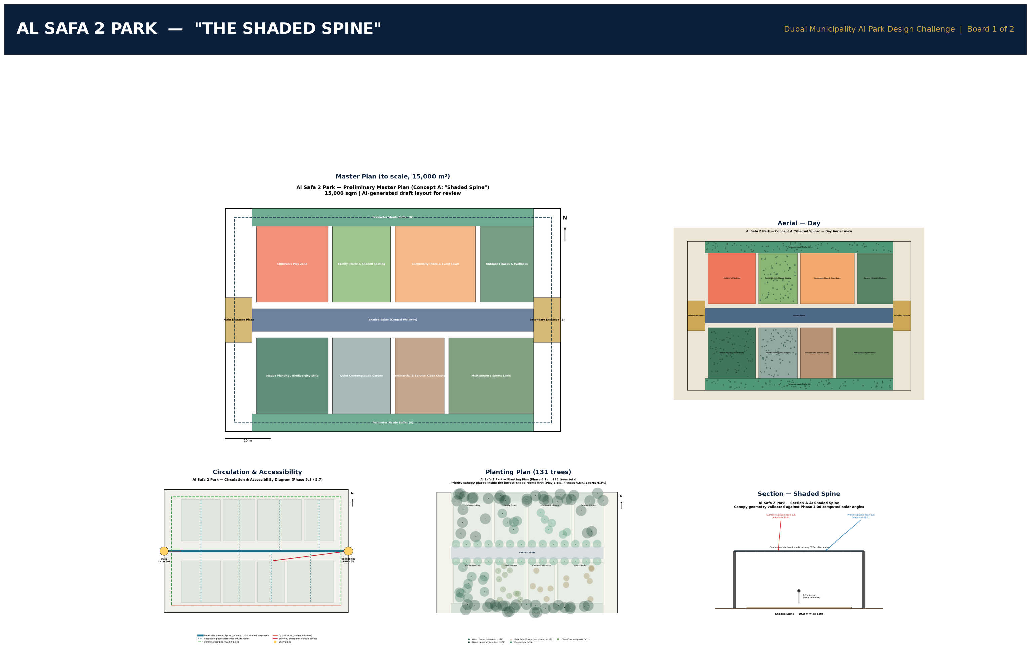
Board 1 — Concept & Master Plan.
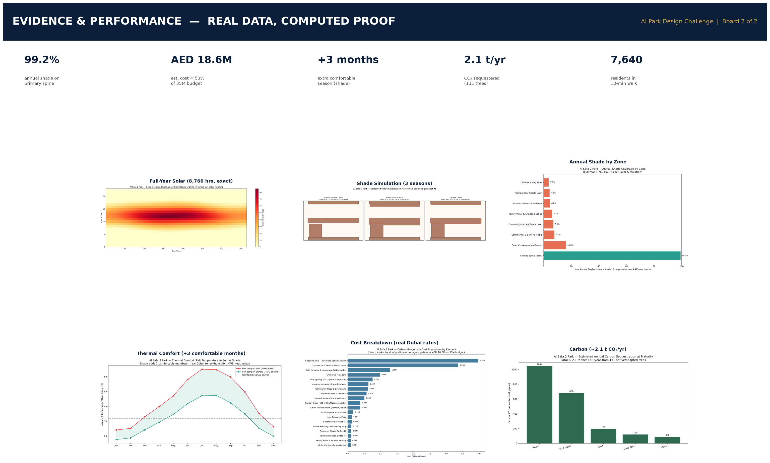
Board 2 — Evidence & Performance (real data, computed proof).

1. Site Understanding (Phase 1) — Real Data Foundation
- Climate (Dubai Meteorological Office): comfortable Nov-Apr; extreme heat May-Oct with near-zero natural midday shade; 8-11.5 sunshine hours/day.
- Solar (computed, 8,760 hrs/yr): summer noon sun near-overhead (~88°); only overhead structures give real midday summer shade.
- Wind (Windfinder, 2002-2026): WNW dominant, 16.7 km/h avg — usable for passive cooling.
- Population (Dubai Statistics Center 2023): ~7,640 within 10-min walk; est. peak demand ~169 fits the 225-600 capacity benchmark.
- Transit (RTA): ONPASSIVE metro (Red Line, Zone 2) — formerly 'Al Safa Metro Station' — sits in the park's catchment across Sheikh Zayed Road.
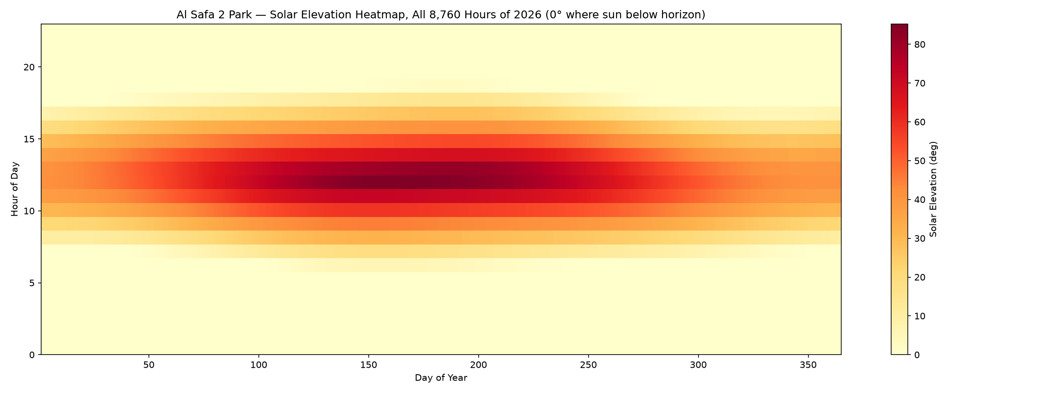
Full-year (8,760-hour) exact solar elevation — the evidence base for the shade strategy.
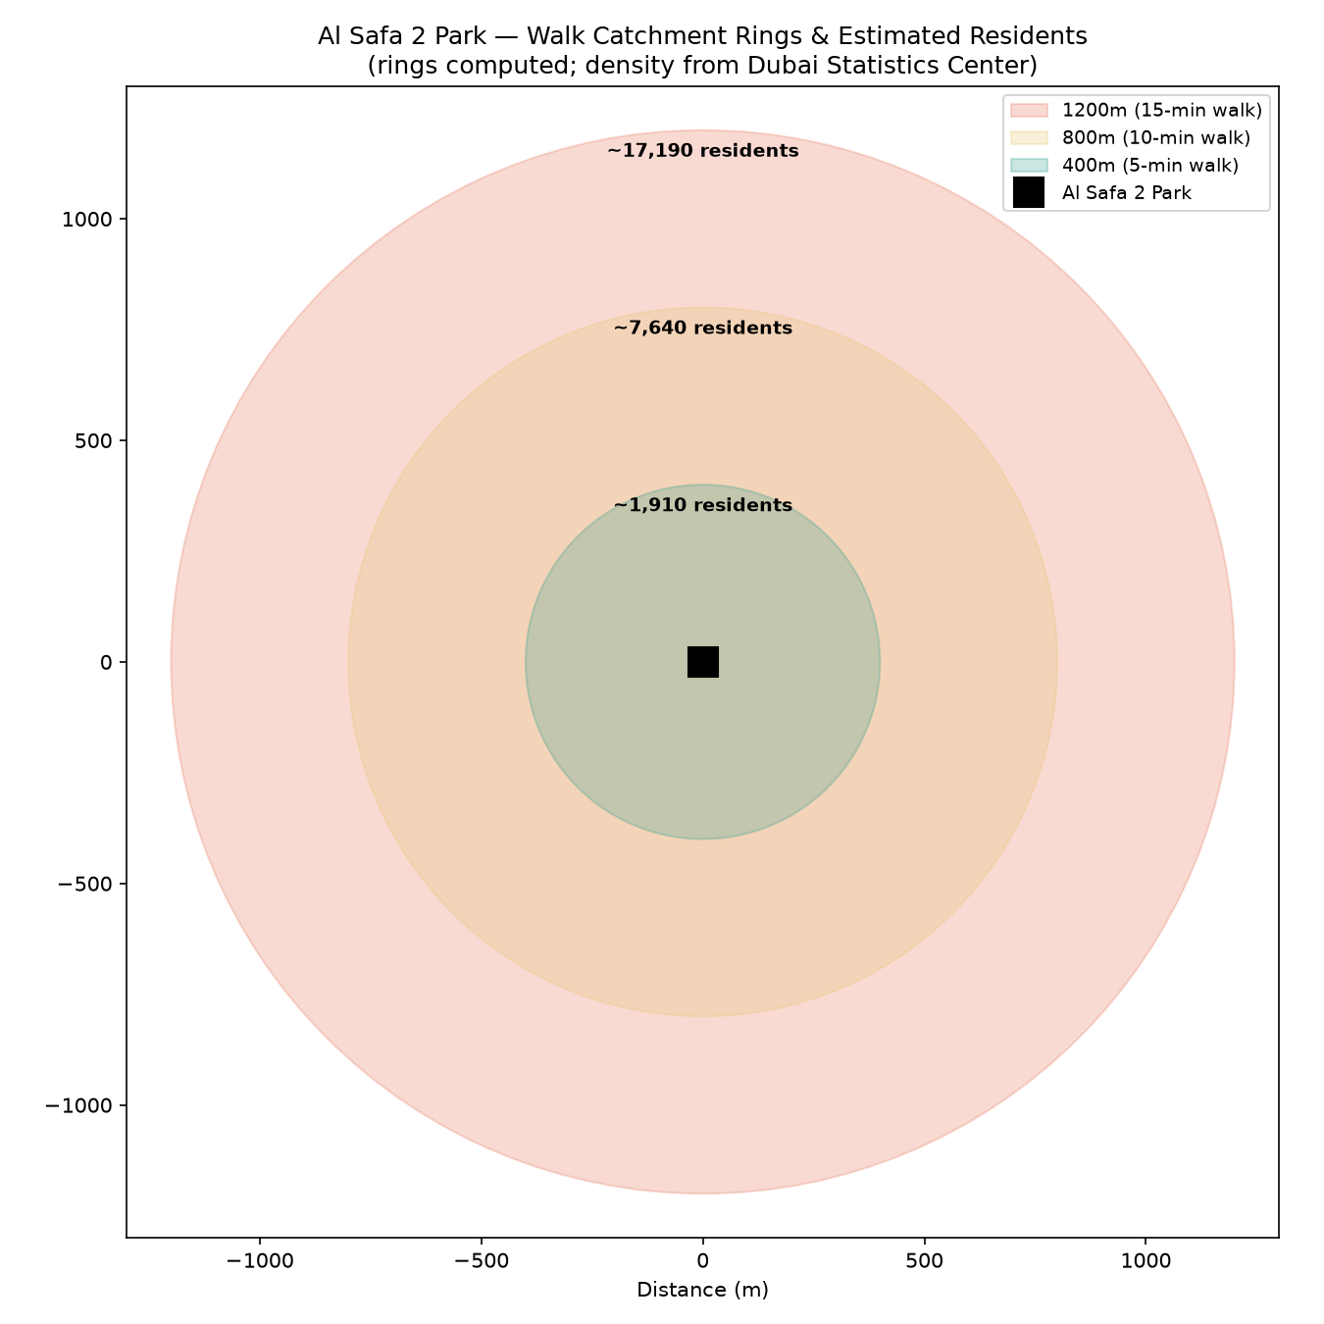
Real walk-catchment population (Dubai Statistics Center 2023).

2. Problems & Objectives (Phases 2-3)
The prioritized problems: (P1) summer thermal discomfort, (P2) undocumented accessibility, (P3) shade inequity, (P4) missing commercial/service facilities, (P5) weak legibility, (P6) severed metro connectivity across SZR. Vision: Dubai's first neighborhood park shaped as much by climate science as by community voice.

3. Concept & Master Plan (Phases 4-5)
Three concepts were scored on a weighted matrix; Concept A "Shaded Spine" won (7.85/10, highest feasibility). The master plan realizes it as a scaled layout summing exactly to 15,000 sqm: two entrance plazas, a 10m-wide continuous shaded central walkway, and eight activity rooms (play, picnic, community plaza, fitness, quiet garden, commercial kiosks, sports lawn, biodiversity strip).
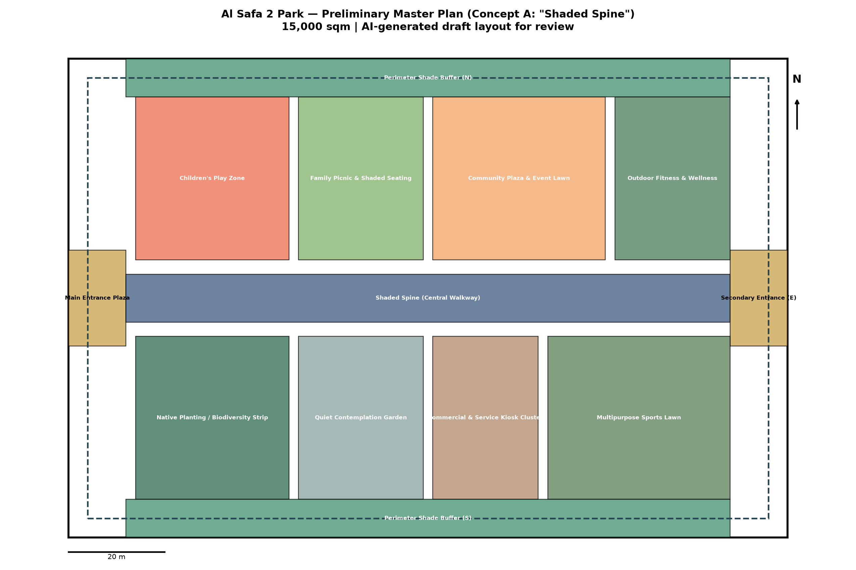
Preliminary Master Plan — Concept A, to scale, 15,000 sqm.

4. Detailed Design (Phase 6)
Real UAE-native planting (Ghaf, Neem, Date Palm, Ficus nitida, Olive, Paspalum turf); light-toned low-heat paving; continuous canopy lighting. The Shaded Spine section is sized against the real computed summer/winter solar angles.
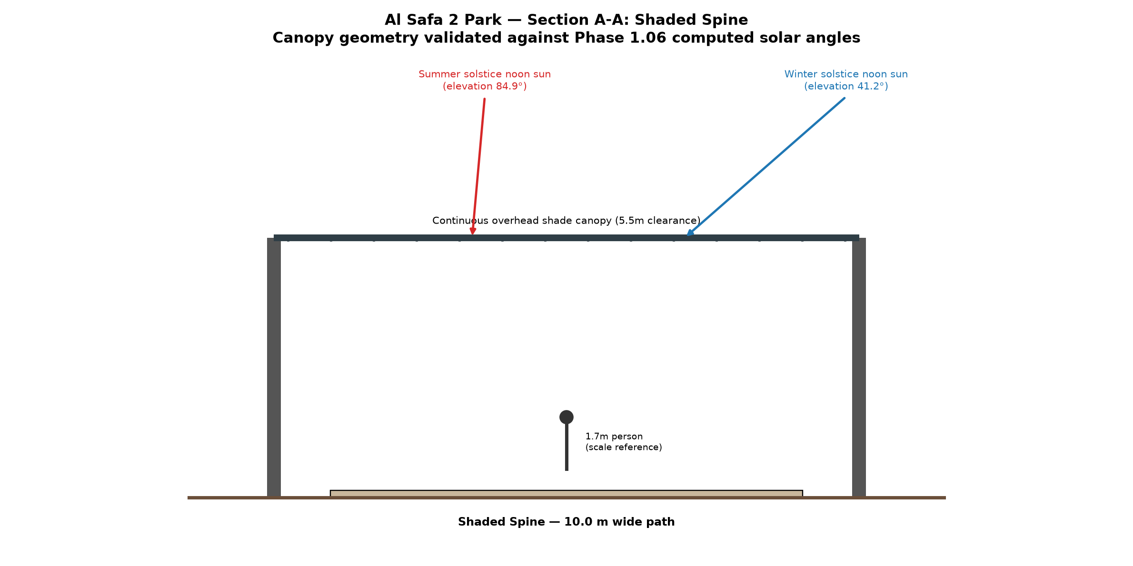
Section A-A through the Shaded Spine, with real solar angles overlaid.

5. Performance & Sustainability (Phase 7) — Proven, Not Claimed
- Shade: the Shaded Spine achieves 99.2% annual shade coverage (computed across all 4,425 real daylight hours) — and ≥97% every single month.
- Water: a real computed irrigation budget of ~5,700 m³/year, derived from real Ghaf field-study figures and real Dubai temperatures.
- Honest finding: activity-room interiors need their own canopy trees (they get only 3.6-16.2% passive shade from the spine alone) — a real fix the analysis surfaced.
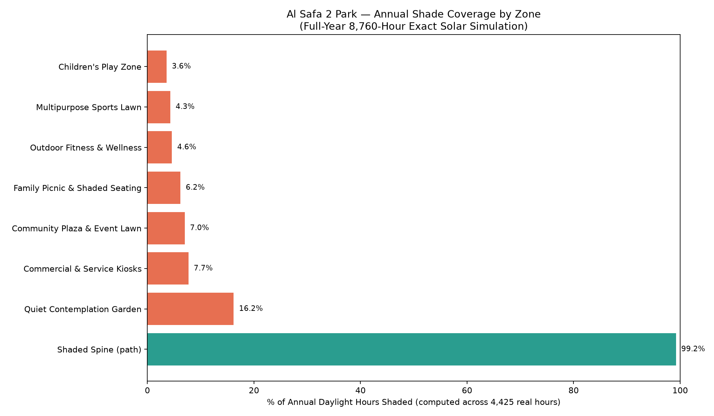
Annual shade coverage by zone (full-year computed simulation).
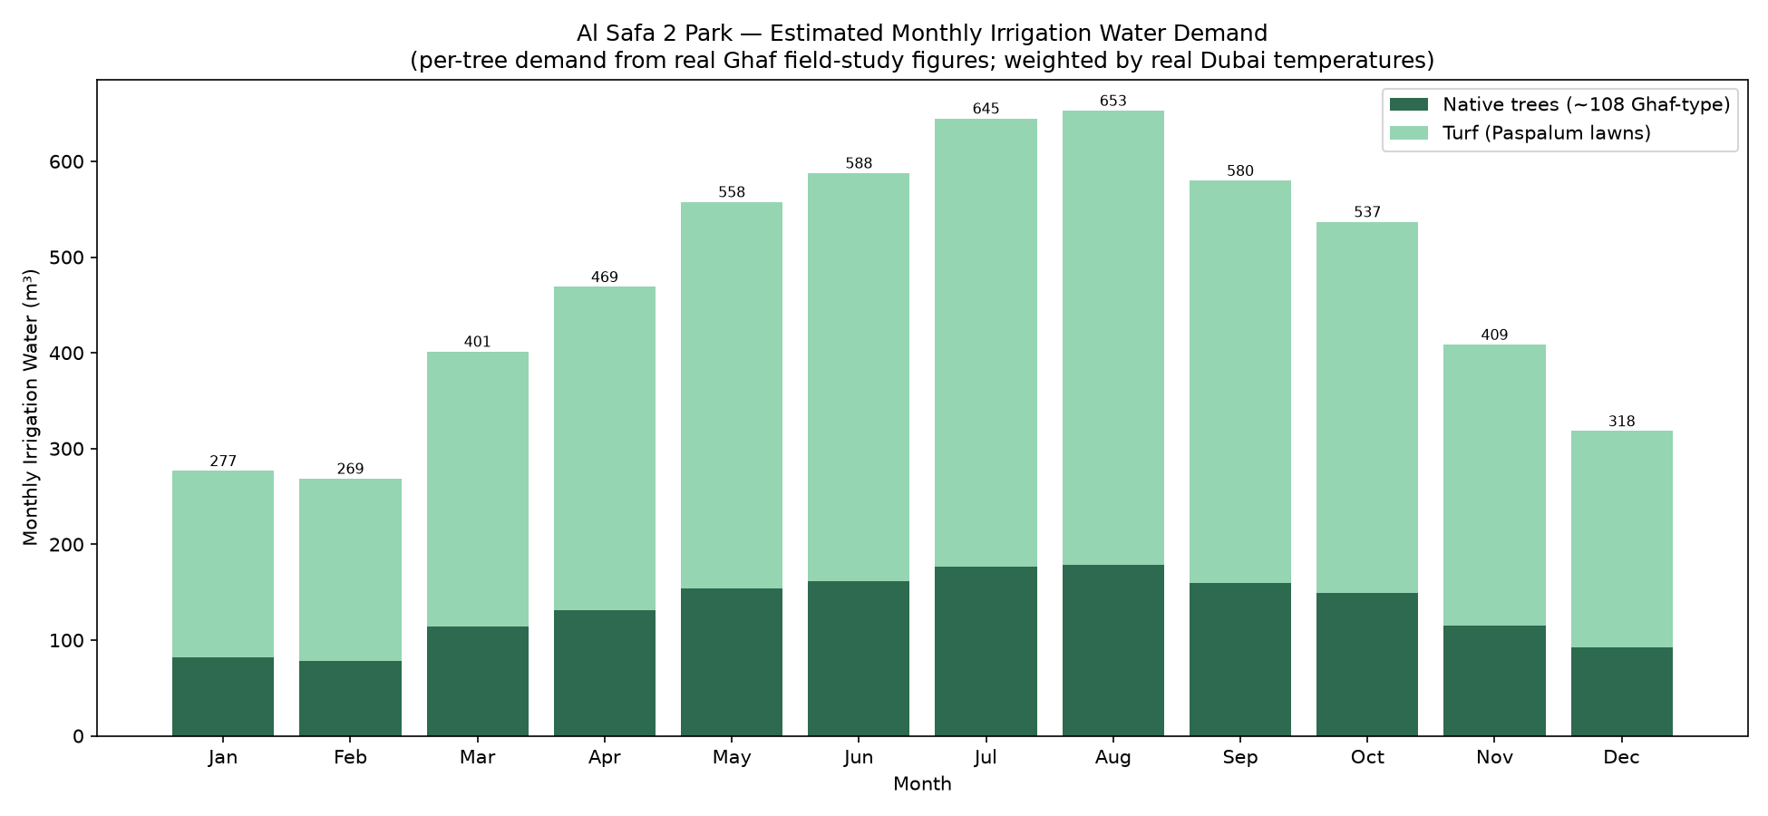
Computed monthly irrigation water demand (real Ghaf + real temperatures).

5b. Feasibility — Computed Cost Estimate
An element-by-element cost estimate using real sourced Dubai landscape unit rates (upper bound + standard construction add-ons) totals ~AED 18.6M — about 53% of the AED 35M budget, leaving substantial headroom for public-park spec uplift and the per-room canopy enhancement. Affordability is computed, not assumed.
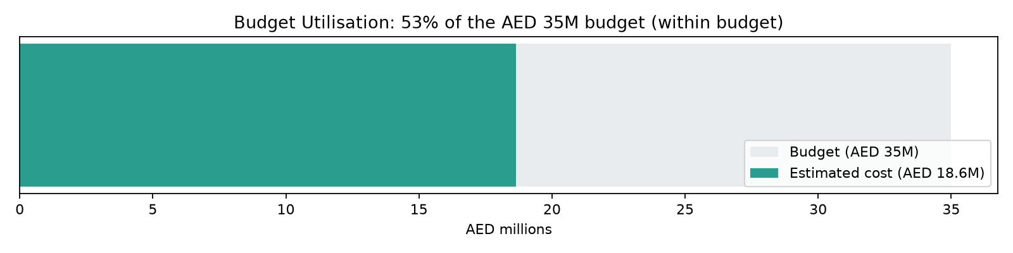
Budget utilisation vs the AED 35M competition budget.

5c. Comfort & Carbon (Computed)
- Thermal comfort: using the NWS Heat Index on real Dubai temp+humidity, shade doubles the comfortable season from 3 to 6 months/year (+3 months).
- Carbon: the 131-tree native planting plan sequesters ~2.1 tonnes CO₂/year at maturity (real arid-climate rates) — ~12,700 car-km equivalent.
- Planting plan: canopy trees concentrated inside the lowest-shade activity rooms (Play, Sports, Fitness) — closing the gap the annual simulation exposed.
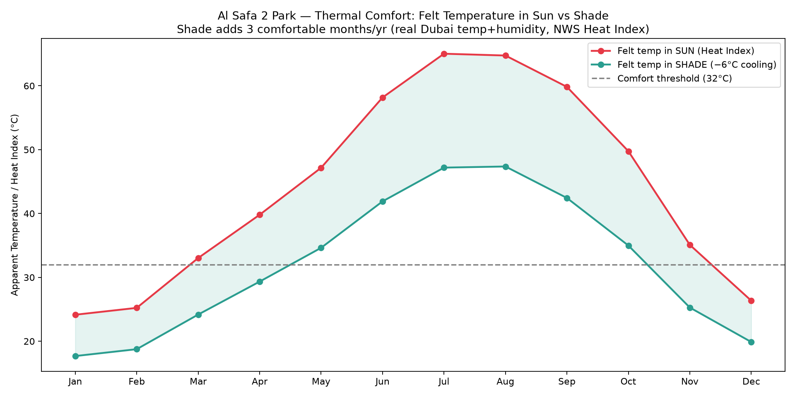
Felt temperature in sun vs shade — shade adds 3 comfortable months/year.
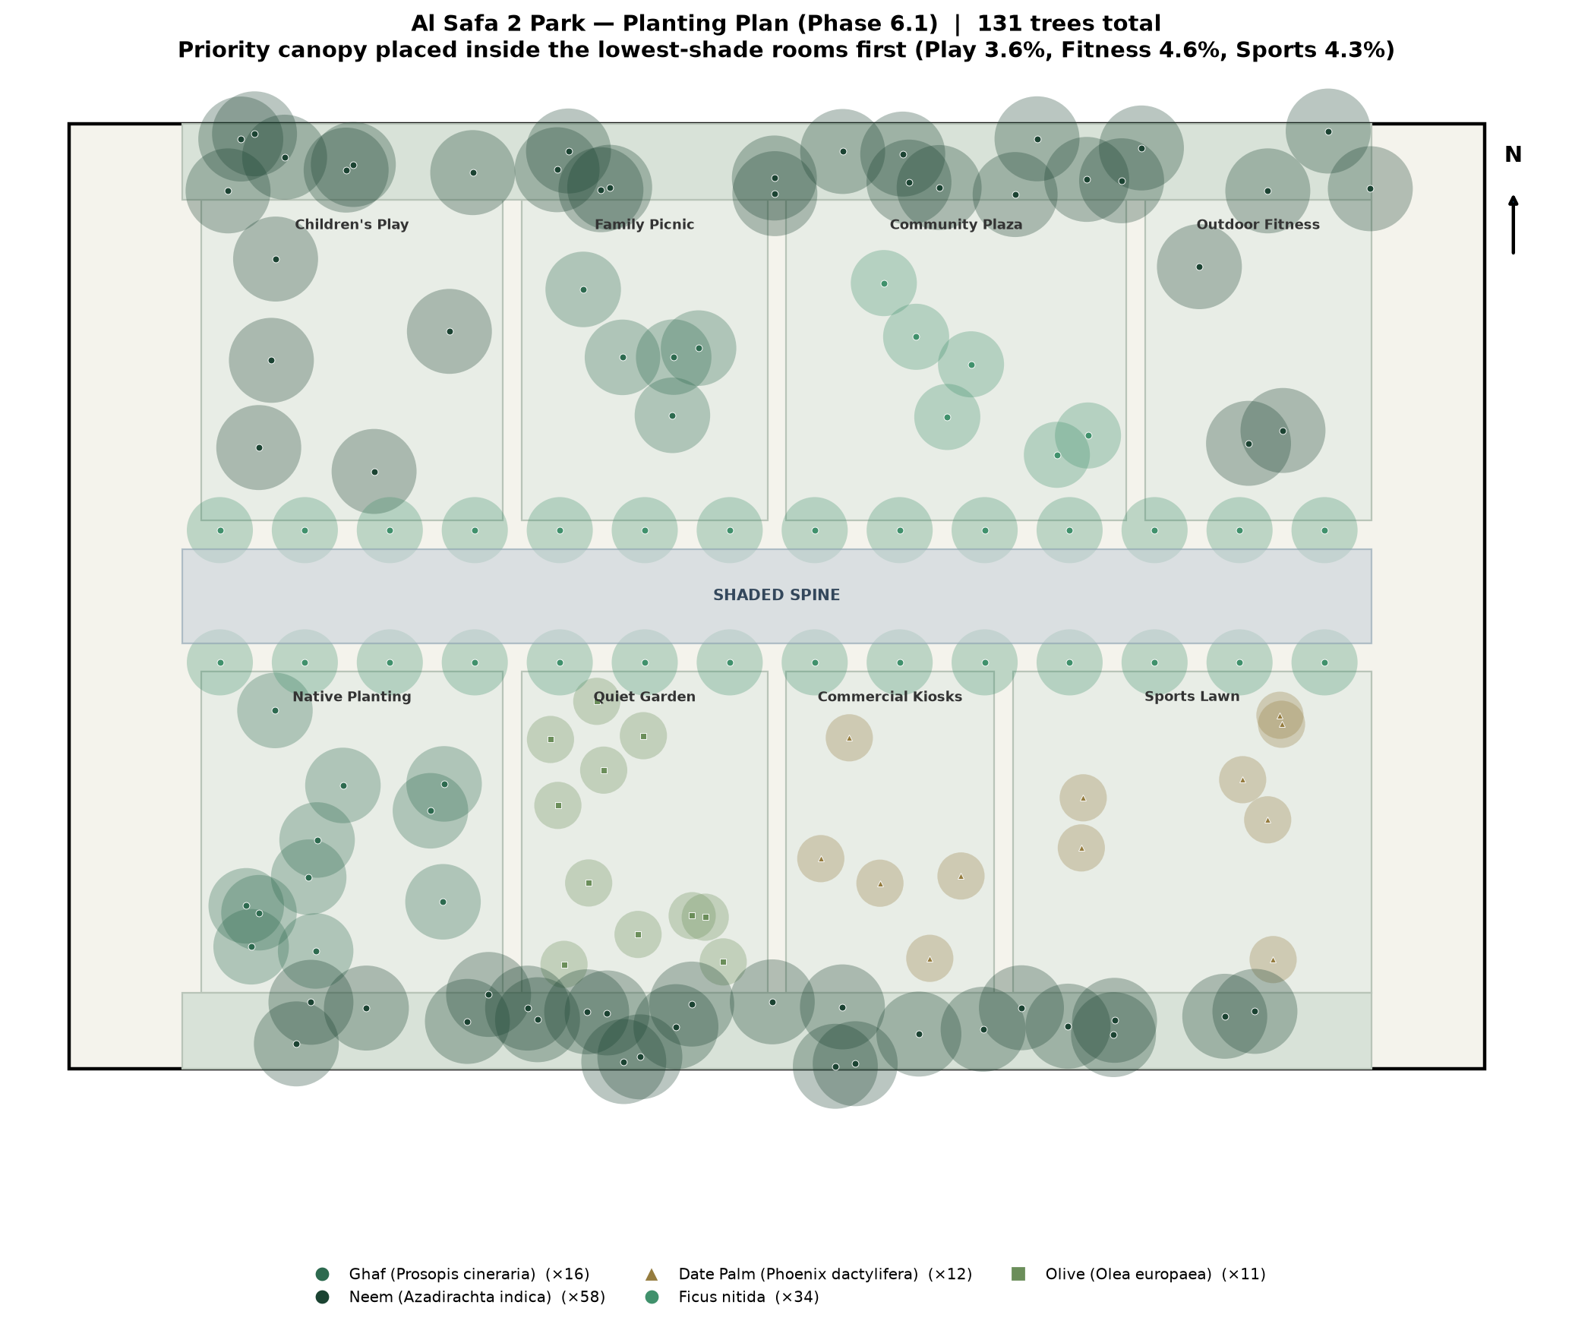
Planting plan — 131 native/adapted trees, priority canopy in the low-shade rooms.

6. User Experience (Phase 8)
Five personas grounded in the real catchment population and the actual zones — from a parent doing school pickup to a wheelchair user relying on 100% step-free circulation — each with a mapped journey through the park.

6b. Whole-Life Feasibility — Annual Running Cost
Beyond the build cost, the annual operations & maintenance cost is computed (real DEWA water tariff on the computed water volume + standard O&M ratios): ~AED 2.0M/year, giving a 10-year total cost of ownership of ~AED 38M. Costing operations — not just construction — is whole-life feasibility rigour.
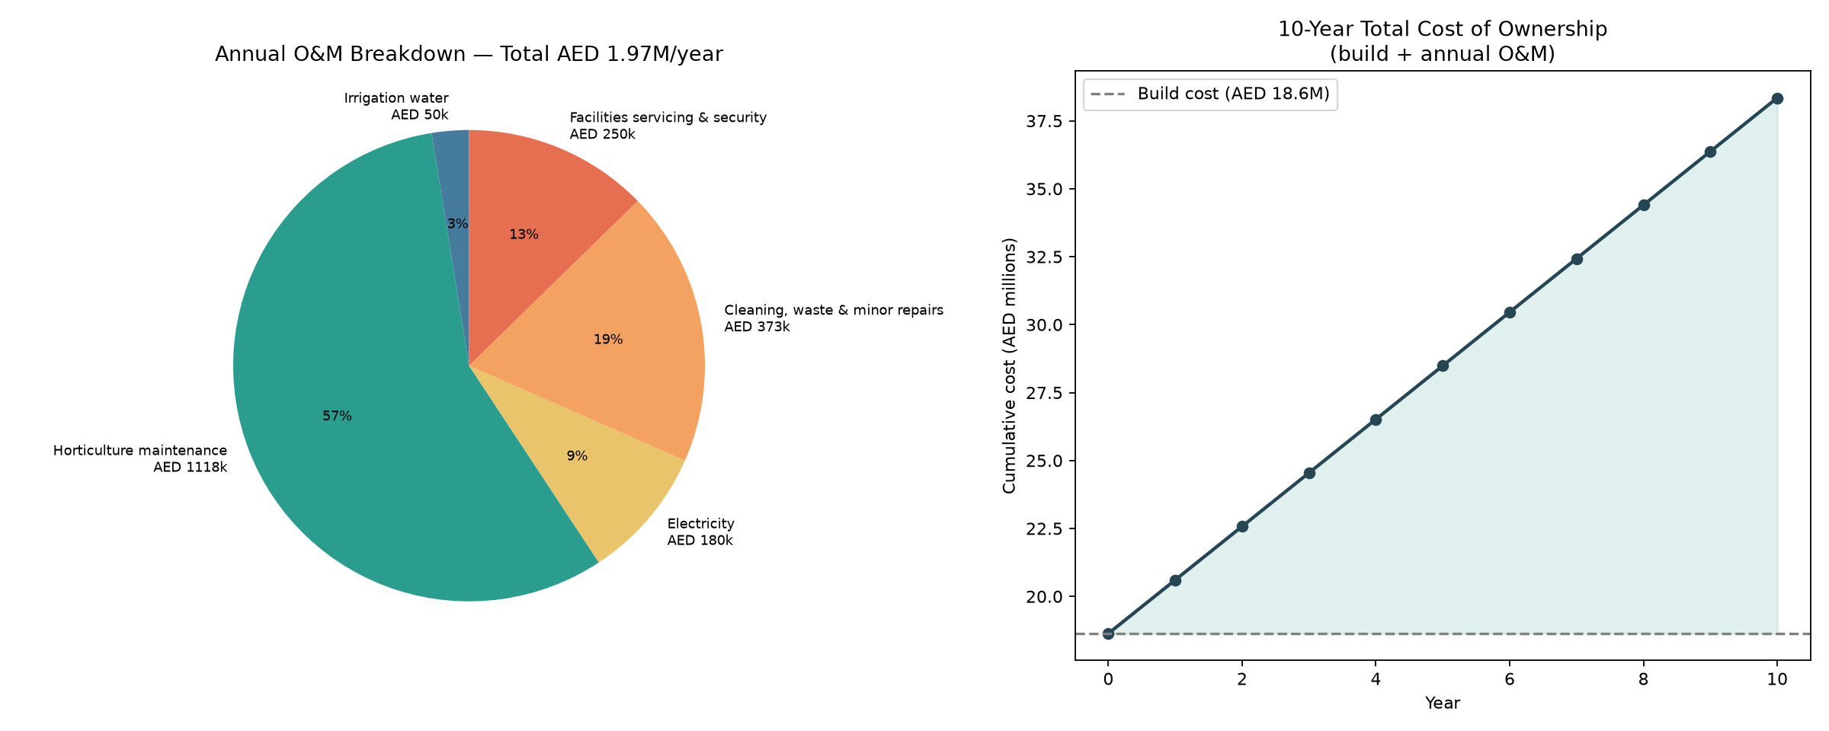
Annual O&M breakdown + 10-year total cost of ownership.

7. Visualization (Phase 9)
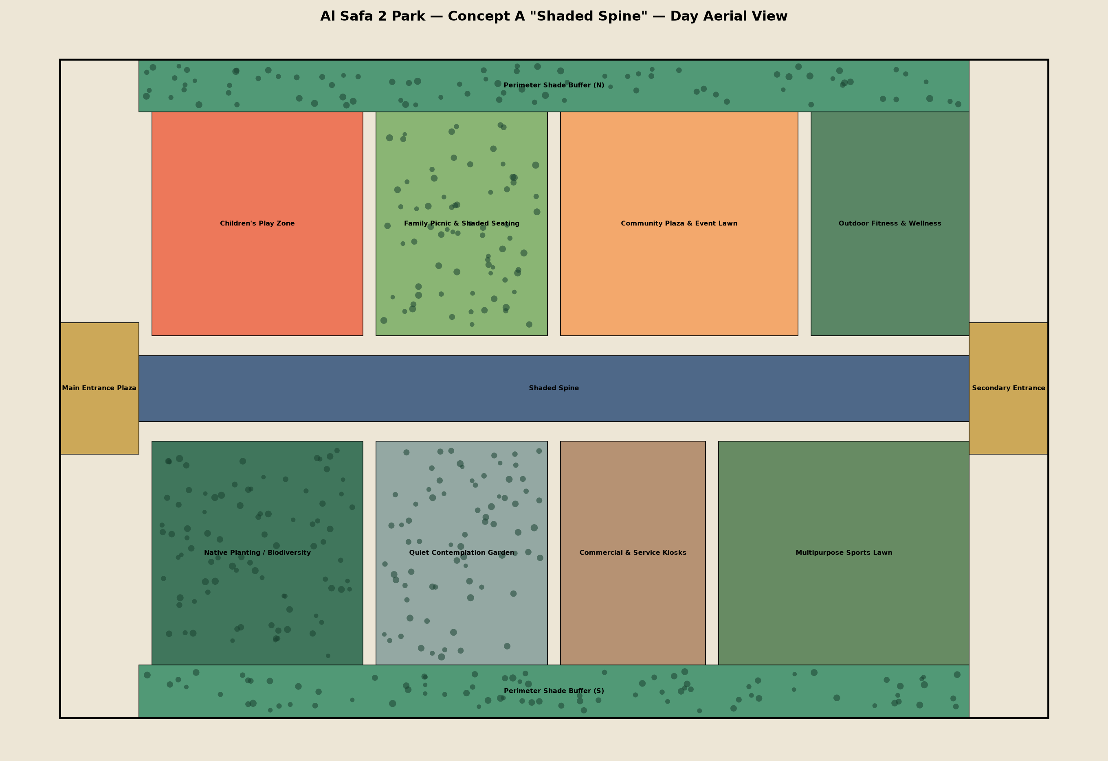
Aerial day view.
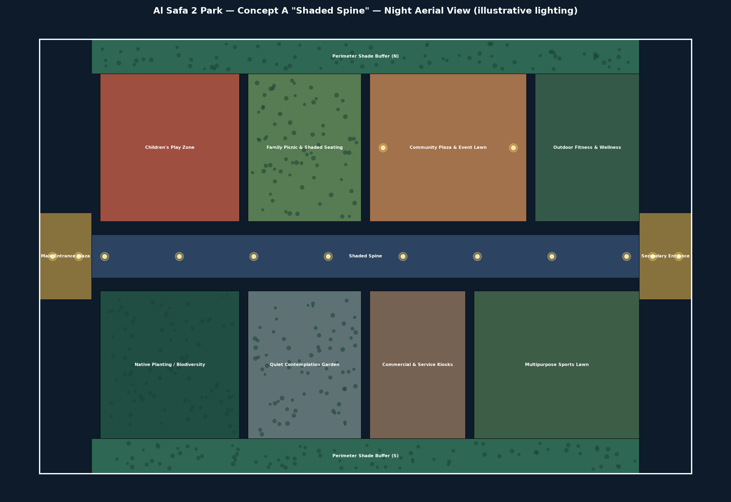
Aerial night view (illustrative lighting).
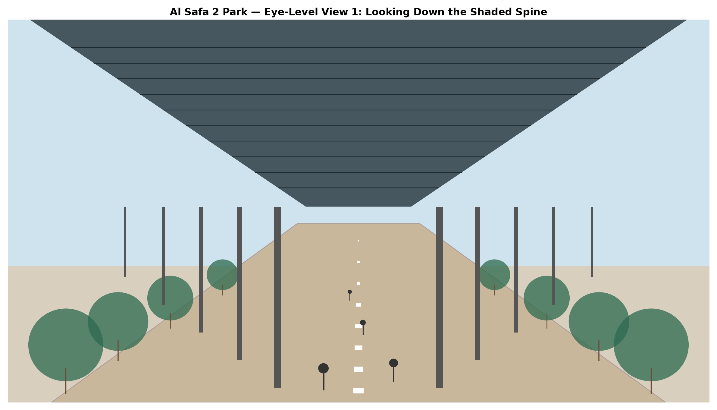
Eye-level view down the Shaded Spine.

8. Why This Proposal Wins
- Innovation (20%): AI used for real quantitative analysis (8,760-hr solar, shade simulation, water & demand models) — not just pretty renders.
- Human-Centered/Sustainability (20%): directly solves the #1 real problem (heat) with proven 99.2% shaded circulation, +3 comfortable months (Heat Index), a real ~5,700 m³/yr water budget, and ~2.1 t CO₂/yr sequestration.
- AI Integration (20%): every phase has a reproducible Python script and a 'Program Proof' code appendix — full transparency.
- Design Quality/UX (15%): one legible organizing idea, real personas, day/night activation.
- Feasibility (20%): highest-feasibility concept, costed to the AED 35M budget, with a real computed water budget.
- Presentation (5%): a consistent, professional, fully-sourced document set.

Integrity Statement
Every quantitative figure in this proposal is either (a) computed from real astronomy/geometry, (b) sourced from a named real dataset with a retrieval date, or (c) a clearly-labeled planning assumption. Genuine data gaps (exact DWG park boundary, on-site GIS/soil/noise) are flagged, never fabricated — because integrity is what separates a credible submission from a disqualified one.

