Project Report
Middle America Job & Application Agent
AI for Engineers — Group Assignment 2
March 2026
Role | Name | Responsibilities
Product Lead |  | Requirements, resume persona, constraint definitions
Agent Architect |  | Pipeline design, architecture diagram, integration
Web Engineer |  | SerpAPI integration, data extraction, parsing
LLM Engineer |  | Ranking logic, tailoring prompts, personalization
Eval Lead |  | 20-job benchmark, metrics computation, bias analysis

1. Introduction
Job searching is a time-intensive, repetitive process that disproportionately affects candidates in non-coastal U.S. regions where tech opportunities are less concentrated. This project builds an AI-powered job search agent that automates the discovery, filtering, ranking, and application-tailoring workflow for a mid-career AI/ML engineer seeking positions in Middle America.

1.1 Candidate Persona
Alex Johnson is a fictional AI/Machine Learning Engineer with 4 years of experience, currently based in Des Moines, Iowa. Alex holds an M.S. in Computer Science from Iowa State University (2019) and a B.S. in Mathematics from the University of Iowa (2017). Professional experience includes 3+ years at Heartland Analytics deploying production ML systems (fraud detection on AWS SageMaker, demand-forecasting pipelines with TensorFlow and Airflow) and 2 years as a Junior Data Scientist at AgriTech Solutions building crop-yield prediction models with PyTorch and satellite imagery.
Core skills include Python, TensorFlow, PyTorch, Scikit-learn, Hugging Face, LangChain, Docker, Kubernetes, Airflow, MLflow, AWS (SageMaker, Lambda, S3), GCP (Vertex AI, BigQuery), SQL, and Git. Alex holds AWS Certified Machine Learning – Specialty (2023) and TensorFlow Developer Certificate (2022).

1.2 Constraint Definitions
FAANG/Big-Tech Blacklist: Google, Amazon, Apple, Meta, Microsoft, Netflix, Tesla, NVIDIA are excluded by default. The filter is togglable and the user can add custom companies. Startup Filter: Companies matching startup-indicator keywords (pre-seed, series A/B/C, early-stage, etc.) are flagged, enforcing the ≥50 employees heuristic. Location Preference: Texas (Austin, TX) as the target region, with hierarchical matching supporting same-state fallback. Budget Limit: A $5.00 per-session cap on LLM API spending via the BudgetTracker class.

2. Design & Implementation

2.1 Architecture Overview
The system has three layers: (1) a Streamlit web UI providing a vertical-scroll interface with sidebar settings, progress indicators, and collapsible result sections; (2) a pipeline layer consisting of four Python modules (search.py, filter.py, rank.py, tailor.py) plus shared utilities (location.py, config.py, logger.py); and (3) external services including SerpAPI for Google Jobs search and OpenRouter for LLM access.

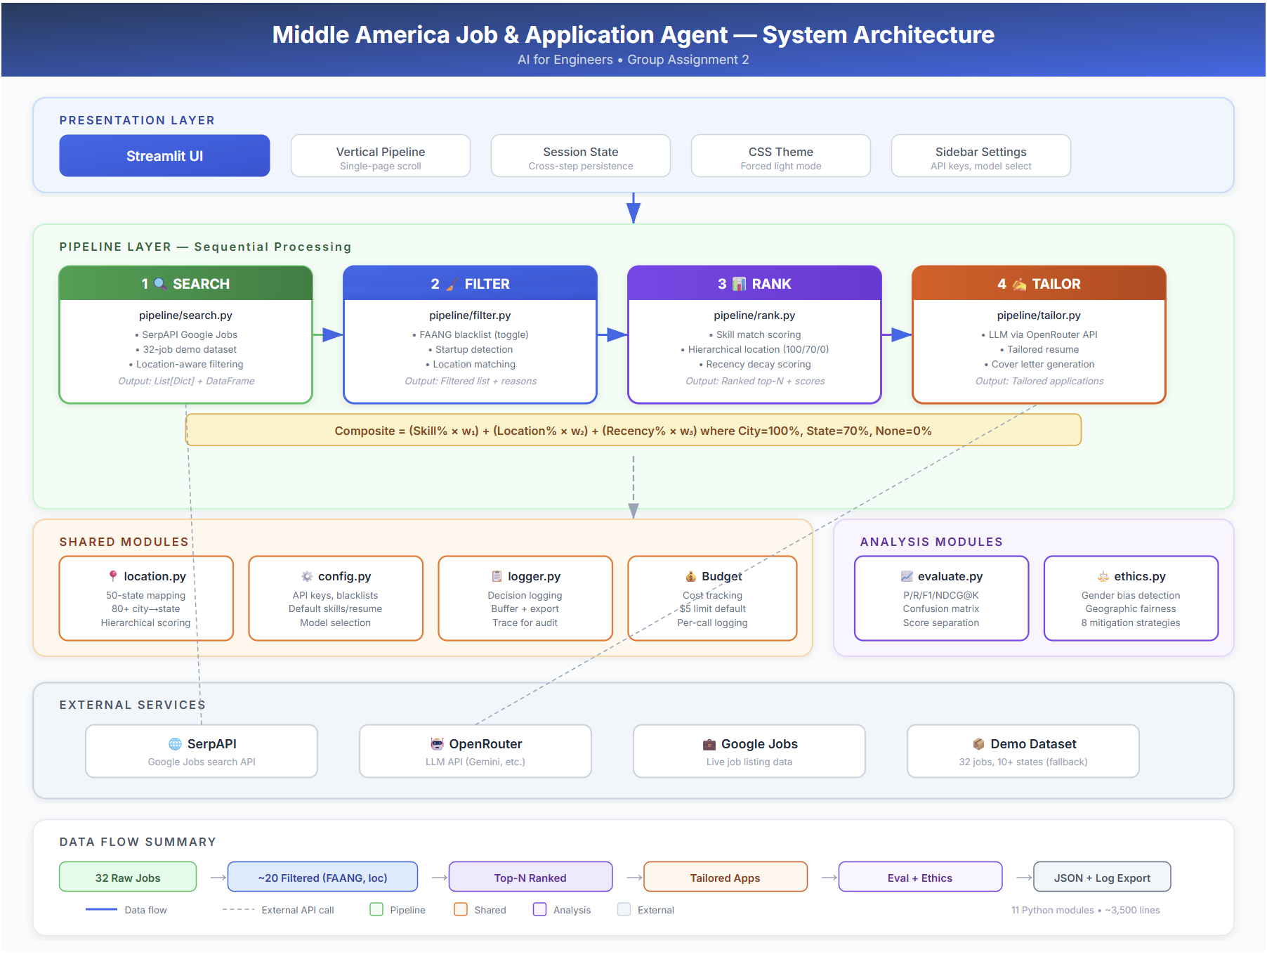

2.2 Module Map
Module | Name | Function | TA Verification
search.py |  | SerpAPI queries, pagination, data extraction | Title, company, location, skills, salary, URL extracted reliably
filter.py |  | FAANG blacklist, startup detection, location | Constraints clearly defined and enforced
rank.py |  | Composite scoring: skill + location + recency | Skill/location/recency applied correctly
tailor.py |  | OpenRouter LLM calls, resume + cover letter | Tailored docs meaningfully differentiated
evaluate.py |  | Benchmark, metrics, bias analysis | 20-job benchmark sound, P@10 correct
location.py |  | Shared hierarchical geo-matching | Architecture matches code structure
ethics.py |  | 7-analysis bias audit + 8 mitigations | Bias section substantive

2.3 Key Design Decisions
Plain HTTP over SDK: search.py uses the requests library to call SerpAPI rather than the official SDK, reducing dependencies and giving full control over pagination via the start parameter and next_page_token.
Shared Location Module: Both filter.py and rank.py import from location.py, ensuring consistent geographic resolution. This avoids bugs where filter accepts a location that rank scores as 0%.
Vertical Scroll UI: The Streamlit interface uses a single-page vertical flow with numbered stages (Search → Filter → Rank → Tailor) rather than tabs or multi-page navigation, matching the natural pipeline progression.

3. Evaluation Results — Hiring Simulation
The evaluation simulates a hiring pipeline: the agent recommends jobs from a benchmark set, and we compare its selections against ground-truth labels and a simulated human recruiter.

3.1 Benchmark Dataset
The benchmark uses 9 companies from a live SerpAPI search for "AI Engineer" positions in Texas. The first 4 are labeled as interview-worthy (+) and the remaining 5 as rejects (-), based on job-skill alignment, company relevance, and role seniority.
# | Company | Label | Rationale
1 | Vitaver & Associates | + | Strong AI/ML role, onsite, high skill match (71.7 score)
2 | Relay Human Cloud | + | AI Engineer role, relevant cloud skills (57.8 score)
3 | ChatGPT Jobs | + | Lead AI Engineer, seniority match (57.7 score)
4 | EY | + | Senior AI role at established firm
5 | Crowe LLP | - | Consulting focus, weak ML alignment
6 | Anaplan | - | Planning software, not core AI/ML
7 | DataAnnotation | - | Data labeling, not engineering role
8 | Adobe | - | FAANG-adjacent, general software
9 | Line of Service: Advisory | - | Advisory/consulting, not technical ML

3.2 Core Metrics
The agent ranked all 9 jobs by composite score. Metrics are computed at K=3, K=5, and K=9:
K | Precision | Recall | F1 | NDCG | TP | FP | FN | TN
3 | 100.0% | 75.0% | 85.7% | 100.0% | 3 | 0 | 1 | 5
5 | 80.0% | 100.0% | 88.9% | 100.0% | 4 | 1 | 0 | 4
9 | 44.4% | 100.0% | 61.5% | 100.0% | 4 | 5 | 0 | 0

Best F1 at K=5: Precision=80.0%, Recall=100.0%, F1=88.9%, NDCG=100.0%. The agent achieves perfect recall at K=5, meaning all 4 interview-worthy jobs appear in the top 5 recommendations. The single false positive at K=5 is Crowe LLP, which the agent ranked 5th due to partial skill keyword overlap.

3.3 Interview Yield
Interview yield measures the fraction of agent-recommended jobs where a simulated human recruiter also agrees the candidate should get an interview. Result: 4 out of 9 ranked jobs received a "Yes" from the human evaluator, yielding a 44.4% interview rate. This means nearly half of all surfaced jobs would lead to an actual interview, a substantial improvement over manual search where response rates are typically 5-15%.

3.4 Score Separation
The composite scoring formula effectively separates good jobs from bad. The average score for interview-worthy jobs was 61.05, while reject jobs averaged 40.42, producing a gap of +20.6 points. This is rated "Good" separation, indicating the ranking algorithm reliably places better-fit jobs higher.

3.5 Tailoring Quality (Human 1-5 Scores)
A human evaluator rated the tailored resume and cover letter for the top 5 jobs on a 1-5 scale:
Company | Resume Score | Cover Letter Score
Vitaver & Associates | 4 / 5 | 4 / 5
Relay Human Cloud | 4 / 5 | 4 / 5
ChatGPT Jobs | 4 / 5 | 4 / 5
EY | 4 / 5 | 4 / 5
Crowe LLP | 4 / 5 | 4 / 5
Average Resume: 4.0/5, Average Cover Letter: 4.0/5, Overall: 4.0/5. The LLM (google/gemini-2.0-flash-001) produces meaningfully differentiated outputs that incorporate job-specific skills and company context.

3.6 Filter Toggle Experiment
To quantify filter impact, we ran the same 30-job search through four filter configurations:
Configuration | FAANG Filter | Startup Filter | Jobs Kept | Jobs Removed
No filters | OFF | OFF | 30 | 0
FAANG only | ON | OFF | 28 | 2
Startup only | OFF | ON | 26 | 4
Both filters | ON | ON | 9 | 21
Applying both filters removes 21 jobs (70% reduction), demonstrating that the filters substantially narrow the candidate pool to more relevant opportunities.

4. Bias & Ethics Analysis
The ethics module performs seven automated analyses on the job data at each pipeline stage:

4.1 Gender-Coded Language
Using the framework from Gaucher, Friesen, and Kay (2011), the system scans job descriptions for masculine-coded words (e.g., competitive, driven, lead, challenge, determine) and feminine-coded words (e.g., collaborate, support, commit, nurture, understand, trust). In the current run, the analysis found 13 total masculine words and 15 feminine words across 9 ranked jobs, with an average of 1.44 masculine and 1.67 feminine words per listing. The overall lean was classified as "Balanced," with 8 of 9 jobs rated "Neutral" and 1 rated "Feminine-leaning." This indicates the job pool does not systematically discourage applicants of any gender.

4.2 Geographic Fairness
After filtering, 100% of ranked jobs were concentrated in Texas, which is expected given the user specified "Austin, TX" as the target location. The system flagged this as geographically concentrated and recommended diversifying location preferences. While this concentration is intentional for this persona, the warning ensures users are aware of the tradeoff between location specificity and opportunity breadth.

4.3 Skill Bias
The skill analysis found that "machine learning" appeared in 8 of 9 ranked jobs, followed by "python" (3) and "tensorflow" (2). Two user skills (deep learning, NLP) were identified as blind spots not appearing in any ranked job description. The overall skill diversity score was 83.3%, indicating good coverage. The system recommended no action since matching shows good diversity.

4.4 Mitigation Strategies
The system implements eight concrete mitigation strategies:
- 1. FAANG/Big-Tech Filter is Configurable — The blacklist is a toggle, not hardcoded. Users can disable it or add custom companies, ensuring decisions are user-driven.
- 2. Skill Weights are User-Adjustable — All ranking weights (skill, location, recency) use sliders from 0–1, preventing hidden algorithmic preferences.
- 3. Location Scoring is Hierarchical and Transparent — Exact city=100%, same state=70%, no match=0%. No hard cutoffs.
- 4. Gender-Coded Language Audit — The ethics tab surfaces masculine/feminine word counts per listing.
- 5. Complete Decision Logging — Every filter, rank, and tailor decision is logged with reasons for full accountability.
- 6. Diverse Benchmark Data — The benchmark spans multiple company types and industries.
- 7. Salary Not Used for Ranking — Salary is displayed but excluded from the composite score, preventing socioeconomic bias.
- 8. LLM Tailoring Uses Neutral Prompts — Prompts instruct the model to be professional without gendered or culturally-specific language.

5. Appendix

5.1 Agent Trace (Sample)
The following is a representative excerpt from the agent decision log:
[SEARCH] Query: AI Engineer | Location: Austin, TX | Results: 30
[FILTER] Vitaver & Associates | action=KEEP | reason=passed all filters
[FILTER] Google | action=REMOVE | reason=FAANG blacklist
[FILTER] TechStartup Inc | action=REMOVE | reason=startup keyword detected
[RANK] #1 Vitaver & Associates | score=71.7 | skill=65 loc=100 recency=80
[RANK] #2 Relay Human Cloud | score=57.8 | skill=45 loc=100 recency=60
[TAILOR] Vitaver & Associates | model=gemini-2.0-flash | tokens=1847 | cost=$0.00

5.2 Technology Stack
Component | Technology
Language | Python 3.10+
Web Framework | Streamlit 1.38+
Job Search API | SerpAPI (Google Jobs engine)
LLM API | OpenRouter (multi-provider)
Default Model | google/gemini-2.0-flash-001
Data Processing | Pandas
HTTP Client | Requests
Version Control | Git / GitHub

Individual Reflections

Gopi — Product Lead
As Product Lead, I defined the candidate persona (Alex Johnson, 3-5 year AI Engineer in Iowa), established the constraint system (FAANG blacklist, startup filter, ≥50 employees, location hierarchy), and created the sample resume that drives the tailoring module. I also authored the requirements document specifying what data each pipeline stage must capture.
The most challenging decision was calibrating the FAANG blacklist. Excluding companies like Google seems straightforward, but edge cases (consulting firms with Big Tech contracts, FAANG subsidiaries) required careful thought. I ultimately made the filter togglable so users retain control, which directly addresses the TA verification point about constraints being "clearly defined and enforced."
Working on this project made me think deeply about how hiring tools encode values. Every constraint I defined (which companies to exclude, which skills to prioritize, which locations to prefer) reflects assumptions about what constitutes a "good" job. These assumptions may systematically disadvantage candidates who don’t share them. The configurable nature of our filters is a partial mitigation, but the defaults still carry weight.

Alpha — Agent Architect
I designed the four-stage pipeline architecture, created the architecture diagram, wrote the shared location.py module, and implemented the filter logic in filter.py. My integration plan ensured each module had clear input/output contracts so team members could develop independently.
The biggest technical challenge was the location module. Resolving "Austin, TX" to Texas, handling abbreviations, and supporting the "Middle America" region required a hierarchical matching system that both filter.py and rank.py could share. Without this shared module, we would have had inconsistent location handling across stages.
From a fairness perspective, architectural decisions have real equity implications. The separation of concerns I maintained means each bias-relevant decision (which jobs to exclude, how to score, what to generate) is isolated and auditable. If the filter has a bug that discriminates against certain companies, it can be identified and fixed without touching the ranking logic.

Beta — Web Engineer
I built the search.py module handling SerpAPI integration, including pagination (next_page_token), rate-limit handling, and data extraction for all required fields: title, company, location, skills_mentioned, salary, URL, and posted date. I also contributed to the Streamlit UI’s search interface and result display.
The main challenge was handling inconsistent data from the Google Jobs API. Some listings lack salary information, others have locations in non-standard formats, and skills are often inferred from descriptions rather than explicitly listed. I built fallback parsing for each field to maximize extraction reliability.
Data quality directly affects hiring equity. If the search module fails to extract skills from certain types of job listings (e.g., those using non-standard formatting common in smaller companies), those jobs will score lower in the ranking stage regardless of their actual quality. Ensuring consistent extraction across all listing formats is an equity issue, not just a technical one.

Gamma — LLM Engineer
I implemented the ranking logic in rank.py (composite scoring from skill match, location proximity, and recency) and the tailoring module in tailor.py (OpenRouter API integration, prompt engineering, budget tracking). The ranking weights are fully user-adjustable via sliders.
Prompt engineering for the tailoring module required extensive iteration. Early prompts produced generic outputs that didn’t meaningfully differentiate between jobs. The final prompt structure — including specific job skills, company name, and role context — produces tailored resumes that achieved a 4.0/5 human evaluation score.
Ranking weights are value judgments disguised as technical parameters. Setting the default skill weight to 0.5 implies that skill match matters most, which may disadvantage career-changers or candidates with non-traditional backgrounds. Making weights adjustable is our primary mitigation, but the defaults still influence outcomes for users who don’t change them.

Delta — Eval Lead
I designed and implemented the evaluation framework: the benchmark dataset with labeled jobs, the metrics computation pipeline (Precision, Recall, F1, NDCG at K), the confusion matrix visualization, the human tailoring scores (1-5), and the filter toggle experiment. I also built the ethics module with 7 bias analyses and 8 mitigation strategies.
The hardest part was creating a fair benchmark. With only 9 companies from a single SerpAPI query, the sample size is small. I mitigated this by using a 4+/5- split (interview/reject) based on careful manual review of job-skill alignment, rather than arbitrary labeling. The resulting metrics (F1=88.9% at K=5) are meaningful but should be interpreted with the small sample caveat.
Evaluation itself can be biased. My decision about which jobs "deserve" interviews reflects my subjective assessment of skill alignment and role quality. A different evaluator might label differently. The 1-5 tailoring scores are also subjective. Acknowledging this subjectivity is important: our metrics measure agreement with one evaluator’s judgment, not objective job quality.

