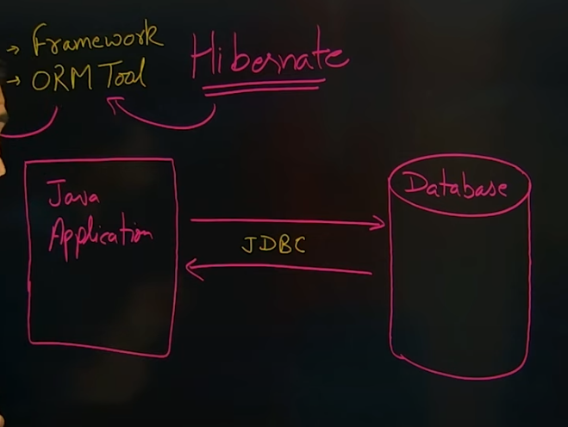

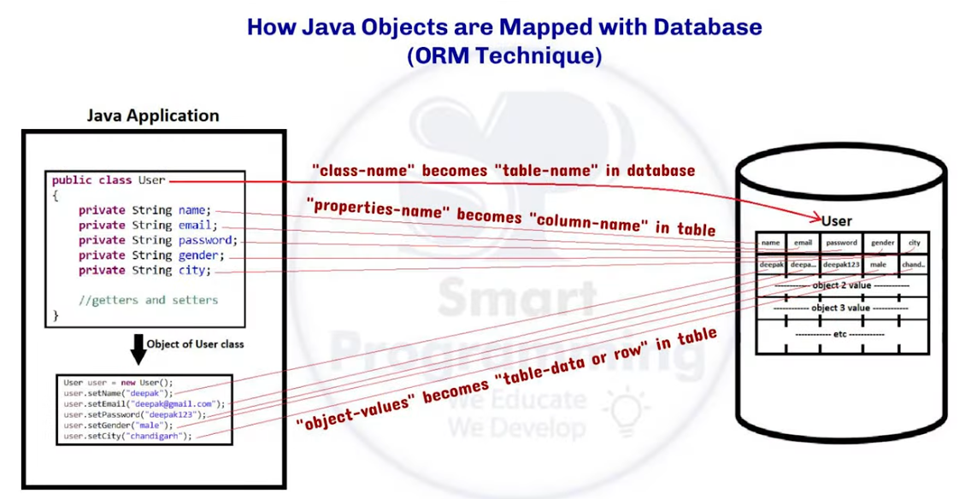

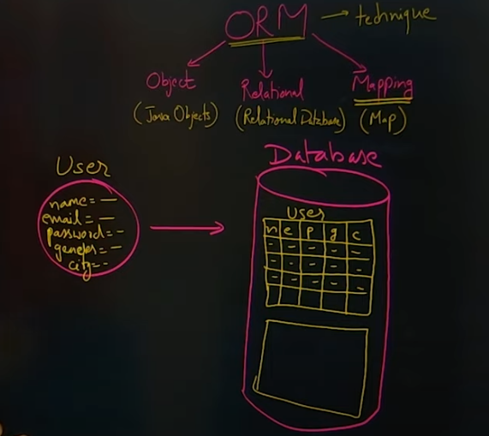

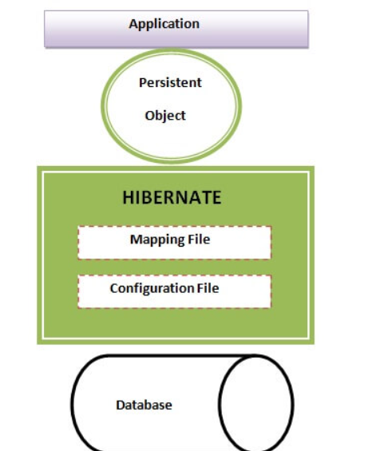

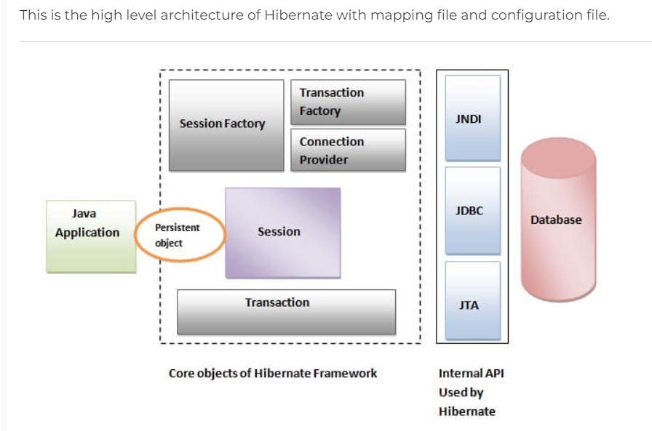

Maven Project u can use simple java project also

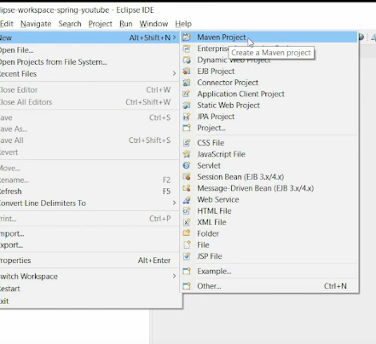

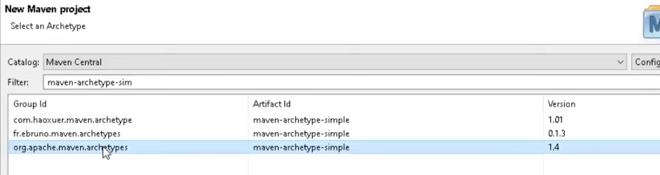

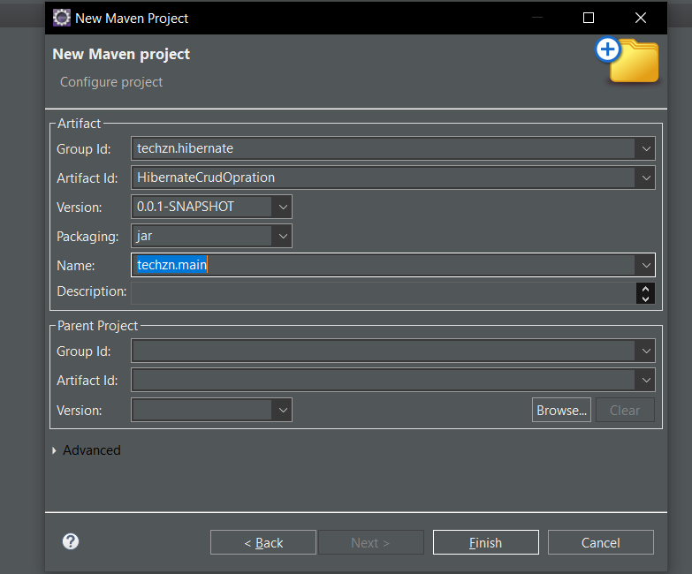



Add hibernate and mysql dependency in side pom.xml

Create table name java class

After create config file name as

Hibernate.cnf.xml

And add this

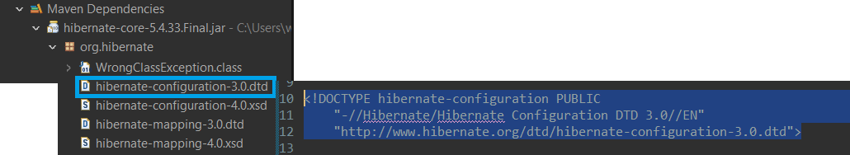

If configuration.cfg.xml showing error goto Preference..

<?**xml** version=*"1.0"* encoding=*"UTF-8"*?>

<!**DOCTYPE** hibernate-configuration PUBLIC

"-//Hibernate/Hibernate Configuration DTD 3.0//EN"

"http://www.hibernate.org/dtd/hibernate-configuration-3.0.dtd">

<**hibernate-configuration**>

<**session-factory**>

<!-- Database connection settings -->

<**property** name=*"hibernate.connection.driver_class"*>com.mysql.cj.jdbc.Driver</**property**>

<**property** name=*"hibernate.connection.url"*>jdbc:mysql://localhost:3306/hibernate</**property**>

<**property** name=*"hibernate.connection.username"*>root</**property**>

<**property** name=*"hibernate.connection.password"*>root</**property**>

<!-- Hibernate settings -->

<**property** name=*"hibernate.dialect"*>org.hibernate.dialect.MySQL8Dialect</**property**>

<**property** name=*"hibernate.show_sql"*>true</**property**>

<**property** name=*"hibernate.hbm2ddl.auto"*>update</**property**>

<!-- Mapping class -->

<**mapping** class=*"hibernateEntities.User"*/>

</**session-factory**>

</**hibernate-configuration**>

