**University of West London**

Dian Dyankov

[Company name]  [Company address]

Group poject

**ITMB (Information Technology Management for Business)**

SEGA

Students’ IDs:

21282648

21298459

21277482

21302755

21282542

Table of Contents

*Project’s vision:* 3

*Our Solution:* 3

*Scrum Phases and Processes for the Project* 4

*Allocation of user stories and tasks* 6

*User story 1:* 6

*User story 2:* 7

*User story 3:* 8

*User story 4:* 9

*User story 5:* 10

*User story 6:* 11

*User story 7:* 13

*User story 8:* 14

*User story 9:* 14

*User story 10:* 15

# ***Project’s vision:***

The project's vision is to setup a CRM tool to get a better insight into SEGA's client base and use this data to increase sales conversions.

# ***Our Solution:***

**Zoho CRM** is an On-demand Customer Relationship Management (CRM) software for managing your customer relations in an efficient manner. It is efficient because, Zoho CRM helps streamline your organization-wide sales, marketing, customer support, and inventory management functions in a single system.

Be it multi-channel communication, sales productivity, CRM insights, product customization, or third-party integration, Zoho CRM offers a host of features to support the requirements of small businesses as well as large enterprises.

What's more, with artificial intelligence and advanced automation features, Zoho CRM also helps you sell smarter, faster and better (Zoho, 2017).

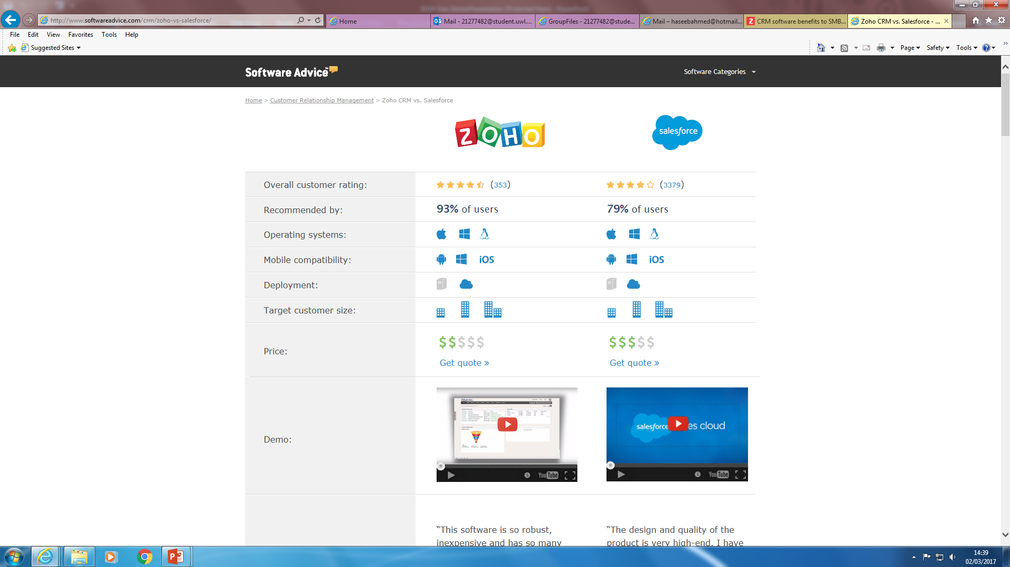

Benefits:

* 360 degree view of business
* Reduce cost on customer acquisition
* Centralized customer interaction
* Improved customer support
* Increase customer satisfaction
* High rate of customer retention
* Boost new business

# ***Scrum Phases and Processes for the Project***

|  |  |  |
| --- | --- | --- |
| **Processes** | **Description** | **Responsible Person** |
| 1. **Project Vision** | The project's vision is to setup a CRM tool to get a better insight into SEGA's client base and use this data to increase sales conversions. | The team |
| **2. Scrum Stakeholders** | Sega's Customer Service Manager and team, Sega's Marketing Manager and team, Sega's customers | Naila |
| **3. Form a SCRUM team** | Naila Akhtar, Wasim Mahmood, Haseeb Ahmed, Dian Dyankov are the group members, with Bianca Vidal as a team leader | The team |
| **4.Epics** | Please refer to the epic table below. | Bianca |
| **5. Create PPB (Prioritized Product Backlog)** | Pending |  |
| **6. Conduct release planning** | Pending |  |
| **7. Create user stories** | Done | The team |
| **8. Approve, estimate, and Commit user stories** | Done by Samia/ Sent to Francis TBC | The team |
| **9. Create tasks** | Daily and Weekly allocation of tasks | Dian |
| **10. Estimate tasks** | Pending |  |
| **11. Create Sprint Backlog** | Done | Wasim |
| **12. Create Deliverables** |  |  |
| **13. Conduct daily stand up** |  |  |
| **14. Groom prioritized Product Backlog** |  |  |
| **15. Convene Scrum of Scrums** |  |  |
| **16. Demonstrate and validate sprint** |  |  |
| **17. Retrospect Sprint** |  |  |
| **18. Ship deliverables** |  |  |
| **19. Retrospect project** |  |  |
|  |  |  |

**Epics**

|  |  |  |
| --- | --- | --- |
| **No** | **Epic** | **Acceptance Criteria** |
| **1** | As a customer service manager, I want to see the interaction between the customers and our customer service representatives. | * The system will monitor the complaints from customers and how quickly they are resolves * They system will monitor the number of on-going customer queries * The system will monitor the customer interest of a product through email marketing * The system will measure sales received through email marketing. |
| **2** | As a customer advisor, I want to log communication between our customers and our customer service advisors. | * Customer service advisor has the access rights to register new customers * Can view customer information and purchase history. * Can log and resolve customer complaints * Customer service managers have system rights to amend existing customer information(delete) |
| **3** | As a Marketing Assistant, I want to find which market segmentation is attracted to our products and services. | * Age group analysis from the data received on excel * Gender analysis on excel monitored on Zoho * The system will monitor Review forums on our product |
| **4** | As a Sales Manager, I want to see the performance of my team. | * The system will show me the sales activities of my team * The system will detect which products to promote to customers according to their purchase history and spending habbits * The system will monitor the average spend per customer |

# ***Allocation of user stories and tasks***

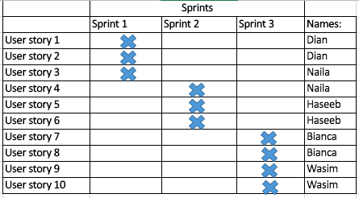

# ***User story 1:***

*Card****:***

As a Customer Service Manager, I want to identify the location of our followers on Twitter, to find where most customers are located

*Conversation*:

Identifying the location of our Twitter followers can be completed from the CRM – Zoho. By analyzing the location of the followers, some actions and campaigns could be addressed specifically, and therefore the results can be measured.

*Confirmation:*

For that purpose, the different locations need to be indicated along with corresponding numbers of followers, sales and statements. They can be kept in a table format, which could make the comparisons with previous analysis easier.

Scenario1: We don’t have a big number of active customers in Twitter from Spain

***Given***: We don’t have sufficient number of active customers in Twitter from Spain

***When***: We try to increase sales on certain game/s

***Then***: Develop a strategy, which attracts more customers from this specific region.

Scenario2: We want to understand whether our activity in Twitter can cause an impact on the sales for a particular country

***Given***: We concentrate more efforts and resources on a campaign for a certain game in a certain country

***When***: We promote new games in some countries more than others

***Then***: Measure, compare and contrast the sales results and the engagement of the customers in Twitter

# ***User story 2:***

*Card****:***

As a Customer Service Advisor, I want to resolve customer complaints through social media – Twitter

*Conversation*:

Any bad comments or tweets in the social media Twitter can influence the company’s reputation and also the reputation of a certain game. For that reason, Twitter needs to be checked daily, so as to respond quickly to any harmful for the business comments, and where possible to turn their effect around to a positive one.

*Confirmation*:

Once a bad comment or tweet is registered, there will be an option for indicating whether it has been solved. It will include brief explanation and the corresponding user details and reason for their bad reaction. It would be more efficient if one person or a couple of people work on this project. On a further stage, records with problems could be kept, with the aim of spotting bad trends or patterns and their improvements.

Scenario1: We find any complaints on Twitter

***Given***: We find a complaint on Twitter

***When***: We are checking for any comments or tweets on Twitter

***Then***: Open a new Task, including the account name of the person, their first name, last name, email address, and respective complaint. All the complaints will be kept on one place with the purpose of spotting if there are plenty complaint from the same nature

# ***User story 3:***

*Card:*

As a Customer Service Manager, I want to be able to see how many people have showed interest in marketing emails that they receive

*Conversation:*

Each contact stored on the system will need to have an email address. Once the emails have been sent to the chosen contacts the CRM software will track the recipient’s activity. In order to view how many people have opened and unopened the emails sent out. Also once all the data has been collected, the user can check which links inside each email have received the most clicks.

*Confirmation:*

* When analysing the reactions to the marketing emails a percentage will be calculated to show how effective it has been.

* The analysis report will also show how many emails have been successfully delivered to each person.

Scenario1: We want to gain a better understanding of how effective the marketing emails have been over a period of time

***Given*:** Multiple emails have achieved their purpose and the customer Service Manager would like to see which emails did better than others.

***When*:** The reports can be compared, allowing the manager to understand which emails the customers react to better.

***Then*:** The manager can give feedback to the marketing team suggesting ways that they can improve the marketing emails.

# ***User story 4:***

*Card*:

As a Customer Service advisor, I want to be able to monitor and maintain our customer’s social media responses, feedback and conversations

*Conversation*:

Different social media activity can be monitored on the same page which includes, posts by particular users, search results of hash tagged keywords, likes and more. Allowing the customer service advisor to keep up do date with the most important social media posts.

*Confirmation*:

Only social interactions across twitter, Facebook and Google+ will be viewed.

Scenario1: To understand when the best time to give feedback to customers on social media is.

***Given***: The number of customers are increasing

***When***: When publishing content on social media is scheduled at the right time.

***Then***: The number of people viewing and responding to the content should increase

# ***User story 5:***

*Card:*

As a Customer Service advisor, I want to be able to monitor and maintain our customers' social media responses.

*Conversation:*

The information we need for our company to keep on top of this user story are:

* Social media accounts

* Check the feeds every day

* Keys worlds that offer the customers the chance to respond.

* Also any other personal information will be displayed or looked up when trying to offer any products.

This information will be displayed on Zoho (CRM) to show how many customers have used social media to respond about our services. This will enable us to identify whether social media is a good way to promote our products.

*Confirmation:*

* The software will show the number of people that have responded on social and how many times they have. This will be in an table form showing us how many people have responded and how many times they have responded. .

* This will tally which key words have been used showing which trend is popular.

*Scenario 1:* The customer service advisor will we able track, monitor and maintain customer responses on social and the key words trend.

Given: The CRM software, Zoho will display records of how many people have responded on social media and the amounts of responses per customer using which key words, our customer service advisors will easily see which customer has responded and how many times, but also which trend is the most popular.

***When:*** The customer service advisors identify who our customers are and how many times they have responded, they will be able to obtain more personal information of the customers (such as full name, email address, key words used)

***And:*** When the Customer service advisor see the number of people responding to us via social media they will be able to acknowledge the areas in which we will need to work on more in order to improve users responding. Also identify what social media gives us more responses.

***Then:*** The Customer Service Advisors will be able to work on the social media site that has the most percentage in responses; this will give them the chance to use their marketing techniques through social media and even will get more customers talking about our services. They will be able to respond back to the customer which have attempted to contact us and also gives us the knowledge of checking the popular social media sites more often. The response times will then improve and will have happy customers

# 

# ***User story 6:***

*Card:*

As a customer service advisor, I want to be able to register and log our customer complaints so that we can deliver a better service to our customer

*Conversation:*

The information needed for our company for this user story is details of our customers (first name, surname, description of complaint and date complaint was posted). Which can help us maintain and resolve any customer complaints pending.

This information will be displayed on Zoho and it will show in a table format an customers that have any complaints or problems on any of our products and services. It will be updated whenever there is a customer that sends through a complaint and we will be able to analyse and resolve the complaint as soon as possible.

*Confirmation:*

As the CRM will display all this information as well as the customers full name, email address or contact number it will also show the date of complaint which we will then be able to solve whenever our customer service assistant has the chance to. For example; John Smith has entered a complaint regarding our customer service, this complaint will have other information regarding the customer so the customer service department will be able to solve the issue.

Scenario 1: The customer service advisor will be able to maintain and update the software by checking if there are any customer complaints that need to be solved and there will a time frame in which the complaints will be resolved.

***Given:*** That the customer service advisors will use the CRM Zoho, they will be able to check if there are any customer complaints and then can do their best to contact the unsatisfied consumers and try to resolve the issue. Through being able to check their person details that are entered with each complaint.

***When:*** Our customer advisors/ assistants will be able to see the few or many customer complaints then they will be able to see what the main problem is in our overall products and services and by looking through and understanding each complaint they can see what areas the company needs to improve on and then send the information to other departments within the organisation.

***Then:*** This gives the customer assistants a chance to satisfy the customers depending on the issue from giving future discounts via emails to the specific consumers or even any other ways (order replacement or sincere apologies), depending on the seriousness of the complaint. Which can then stop any negative information being spread by our potential customers and will help us offer a better customer service in the future through improvement.

# ***User story 7:***

*Card:*

As a Marketing Manager, I want to see which customers we have gained through our email marketing campaign.

*Conversation:*

The Marketing Manager will be able to see customers gained through email marketing campaign from online sales.

*Confirmation:*

A Marketing Manager will receive reports of online sales gathered from a specific email-marketing campaign to monitor their success.

*Scenario1:*

***Given:*** A marketing manager needs to monitor their e-mail marketing campaign

***When:*** A potential customer clicks on the link and successfully proceeds to an online sale.

***Then:*** The sale will report the email-marketing type to come up in his reports.

# ***User story 8:***

*Card:*

As a Customer Service Advisor, I want to view our customer information.

*Conversation:*

Customer service advisor will be able to access a customer’s information through either the customer’s account number or name search.

*Confirmation:*

Customer service advisor can access and view customer accounts

*Scenario1:*

***Given:*** A customer advisor receives a call from a customer.

***When:*** The customer advisor can search for the customer by their account number or search their name or add the customer onto their database.

***Then:*** The customer advisor can view the customer’s information.

# ***User story 9:***

*Card:*

As the Sales department, we want to track how much each of our customers are spending on our products so we can offer them any product promotions in the future depending on the amount they spend.

*Conversation:*

The information we need for our company to keep on top of this user story are:

* Customers first and surname

* Customer address

* Total amount spent when purchasing any product/s from our website/retailers in pounds (£).

* Also any other personal information will be displayed or looked up when trying to offer any products.

This information will be displayed on Zoho (CRM) to show the highest number amount spent by our top product purchasing consumers which will easily enable us to contact them regarding our newly promoted products.

*Confirmation:*

* The CRM software will be showing the highest spending consumers on Zoho, for example, they will be numbered from 1 to 10 with their personal details.

* For example, the top 10 highest spending consumers for our company will be presented in a table and they will keep getting updated on a regular basis.

*Scenario1:* The sales department will be able to track and maintain records of our consumers that are spending the most on our company’s products which will then enable us to reward them with promotional products.

***Given:*** Given the CRM software, Zoho will display records of our top consumer’s expenditure, our sales department will easily see which our top consumers are to offer discounted products to.

***When:*** When the sales department check who our consumers are and how much they are spending on our products, they will be able to obtain more personal information of the consumers (such as full name, address, phone number/email address)

***Then:*** Then they will be able to contact those top selected consumers and will set out to communicate them regarding any promotion that our company has got on offer to reward our special customers to keep them satisfied.

# ***User story 10:***

*Card:*

As a Marketing Assistant, I want to be able analyse reports using statistics from our email campaigns to find out the geographic location of where our receipts are based when they open an email to identify where most of our target market are for future advertisement.

*Conversation:*

The required information needed for this specific user story is our stakeholders (consumers) email address in which we can send out emails such as promotional offers, newsletters and even our exceptional customer support to get in touch with our consumer base.

Once this information is gathered we will then use it on Zoho (CRM) and there will be some sort of a map showing email open by location in which can enable us to analyse where our consumers are based through the email campaign I explained above.

*Confirmation:*

* Our CRM software will display the percentage of people based in which geographic location and there will be a bar which will go from for example 0%-40% (0 being low percentage and 40% being red) to show which shaded area has how much percentage of consumers.

* An example can be that UK will be shaded red at 36% and Japan shaded as green showing us that the majority of consumers reading our emails are located in the UK.

*Scenario1:* The marketing team will be able to identify where our consumers are based using a geographic tracker, which Zoho allows us to use. This way they can identify where majority of the percentage of their target market are to be able to advertise more on the lower percentage and make sure that the current majority areas of our target market increases as a percentage too.

***Given***:

Given the CRM software, Zoho will present a geographic map of all the continents (including countries) show which percent of our customers are opening our emails in which country and this will help us analyse the percentage of customers depending on the shaded area on the map. (Red being high % and green being low %).

***When***:

When the marketing department will analyse on the percentage of our customers that are opening our emails which we have sent out, they will then be able to obtain the data and see which parts of the world they need to make their marketing strategies more effective on.

***Then***:

Then, the marketing department (employees) will be able to work on the lower percentage countries that they feel have more potential in purchasing our products at a high scale and will use their marketing techniques through social media and even print media to promote and advertise loads of products that they feel can generate immense profit on the organisation.