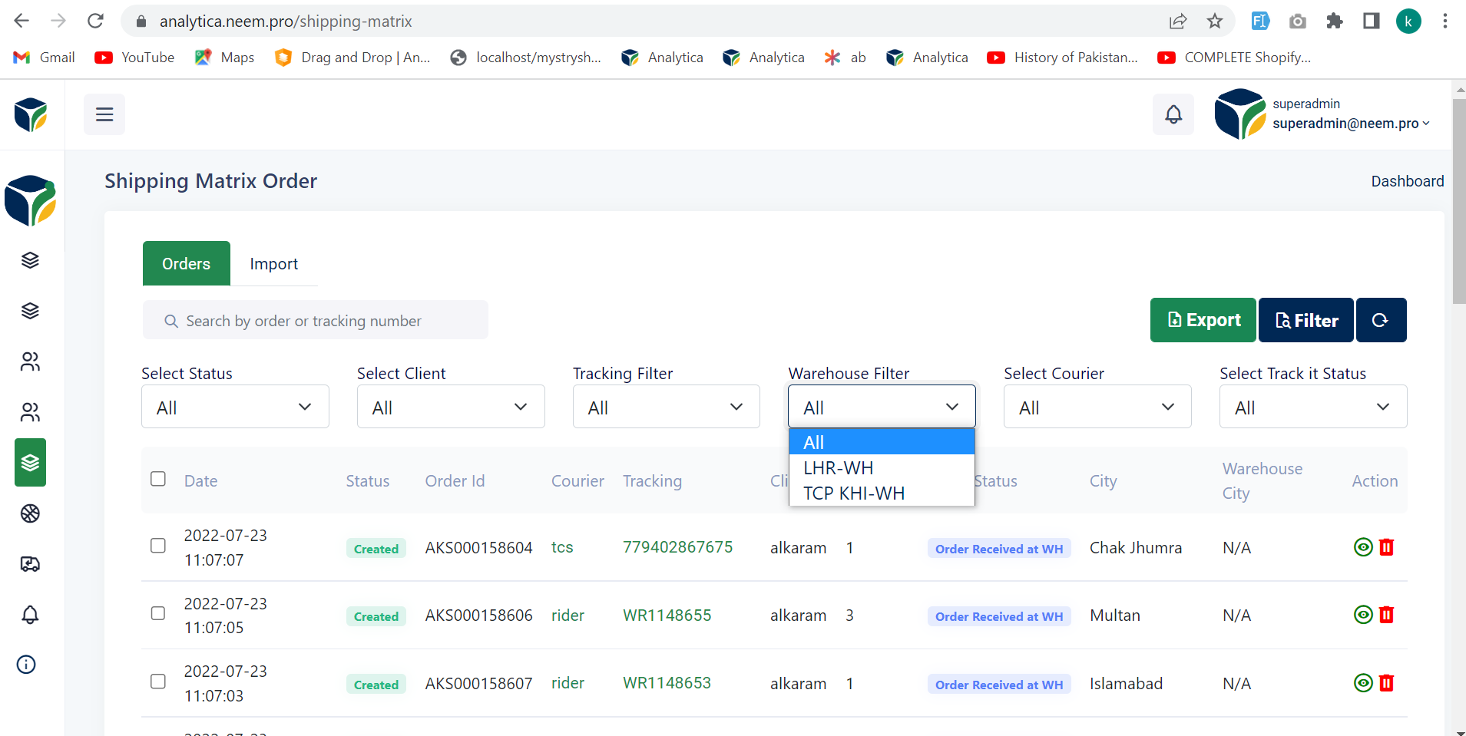

* Please add this filter in the order reports filter.

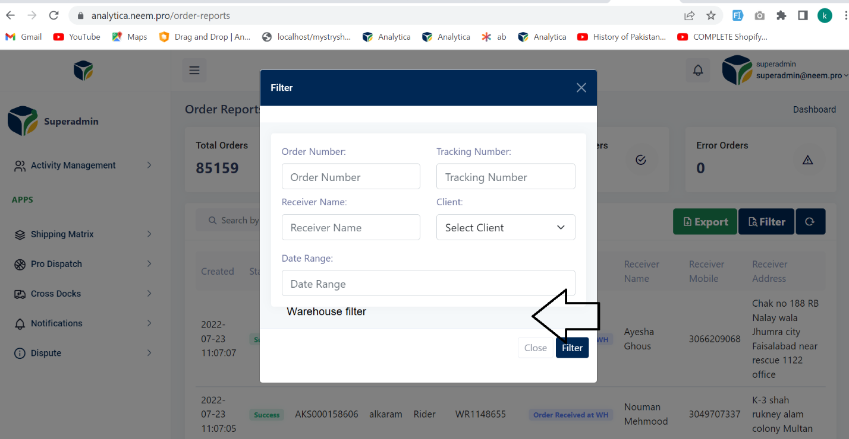

* Create a permission “orders-reports-warehouse-filter” this dropdown should be shown to those who are having the permission

Note: This work is already performed on Select Client Filter in Order Reports Filter.

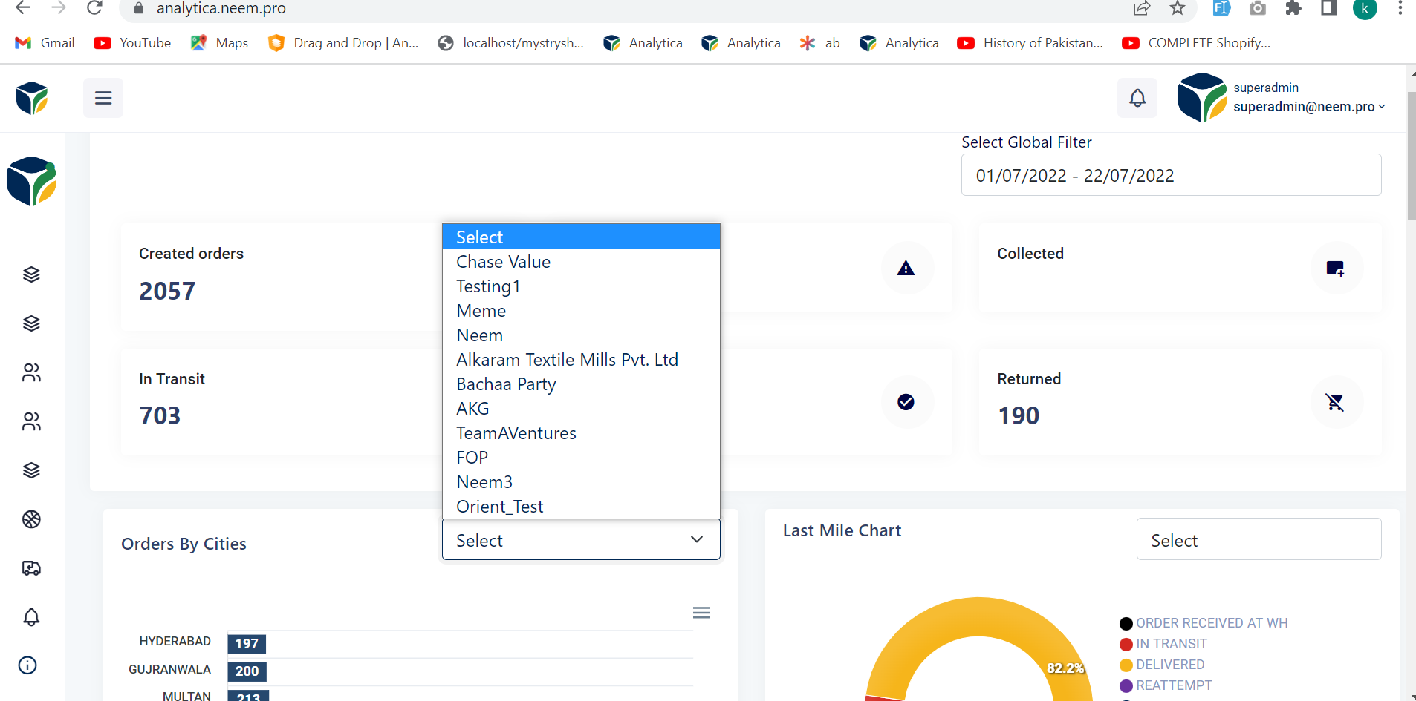

* Make this client filter Global e.g Date_Range is global on change of date range it reflects almost complete dashboard this should be done for Select Client global and on selection of client it should send the request to all those API’s which are reflect by change of date_range.

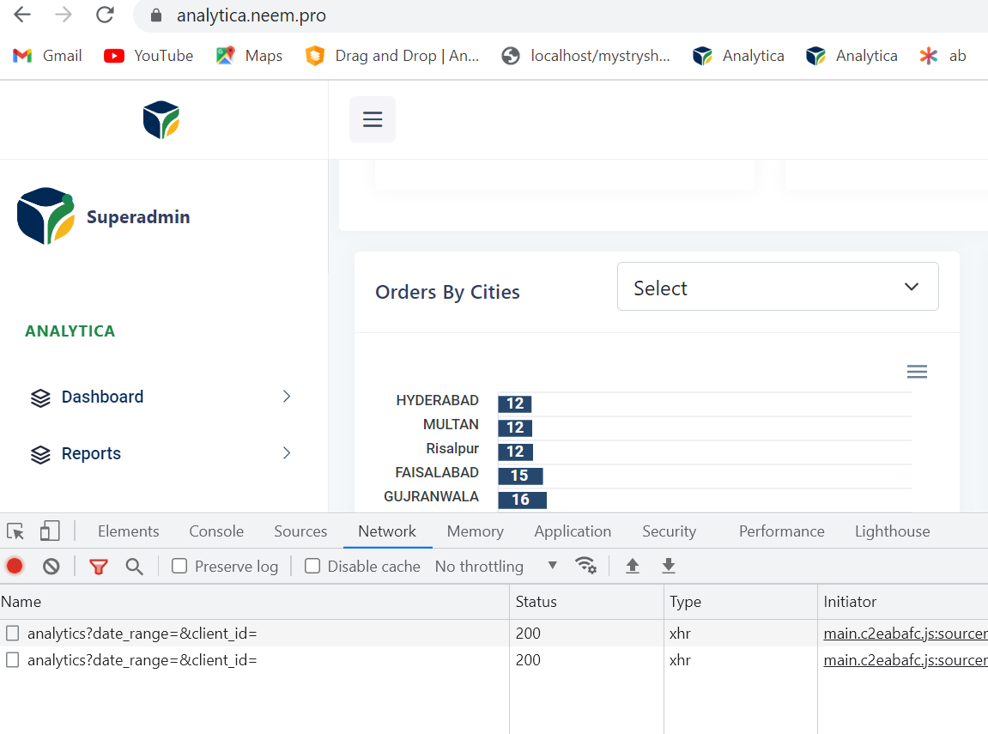

* I clicked once and the API is sent two times on single click (This should be send only once).