Jamia Millia Islamia



Dept. of Computer Science

Subject: Pattern Matching Using Python

Submitted By: Wasit Shafi Submitted To:Dr.Taran Singh Bharti
Roll No: 18MCA054
Date: 11-OCT-2020

Q1. Write a program to perform input and output operations.
Sol.
n = int(input('Enter value of n:')) # Input Operation
if n % 2 == 0:
print(n ,' is even') # Output Operation
else:
print(n, ' is odd')

Output:

Q2. Write a programs to illustrate decision making statements i.e. displaying division of students based on their marks, prime number, leap year, searcing, arranging values.
Sol.
def get_division(p):
if p >= 75:
return "Distiction"
elif p >=60:
return "1 Division"
elif p >=50:
return "2 Division"
elif p >=40:
return "3 Division"
else:
return "4 Division(Fail)"

def isPrime(n):
if n < 2:
return False;
else:
i = 2
while i * i <= n:
if n % i == 0:
return False
i += 1
return True

def isLeapYear(year):
return True if ((year % 4 == 0 and year % 100 != 0) or (year % 400 == 0)) else False

def searchKey(arr, key):
length = len(arr)
for i in range(length):
if arr[i] == key:
return i
return -1;

def mySort(arr): # Using Bubble Sort Algorithm
n = len(arr)
for i in range(n - 1):
for j in range(n - i - 1):
if arr[j] > arr[j + 1]:
temp = arr[j]
arr[j] = arr[j + 1]
arr[j +1] = temp
# Division Of Marks
print("STUDENT MARKS DIVISION")
marksObtained = int(input('Enter marks obtained : '))
maxMarks = int(input('Enter max. marks : '));
percentage = (marksObtained / maxMarks) * 100
print('Division : ', get_division(percentage))

# Prime Numbers
print("\nPRIME NUMBERS")
n = int(input('Enter Value of n...'))
if isPrime(n):
print(n , 'is Prime Number')
else:
print(n, 'is not a Prime Number')

# Leap Year
print("\nLEAP YEAR")
year = int(input('Enter a Year...'))
if isLeapYear(year):
print(year , 'is Leap Year')
else:
print(year, 'is not a Leap Year')

# Searching
print("\nSEARCING ELEMENT")
n = int(input('Enter no. elements...'))
arr = [None] * n
for i in range(n):
arr[i] = int(input('arr[' + str(i) +']:'))
key = int(input('Enter key Element to search...'))
index = searchKey(arr, key)
if index == -1:
print('Key Element(', key, ') not found in array.')
else:
print('Key Element(', key, ') found in at index ', index, 'array.')

# Arranging
print("\nARRANGING ELEMENTS")
print("Array before sorting : ", arr)
mySort(arr) # soring in non-decreasing order
print("Array after sorting : ", arr)

Output :
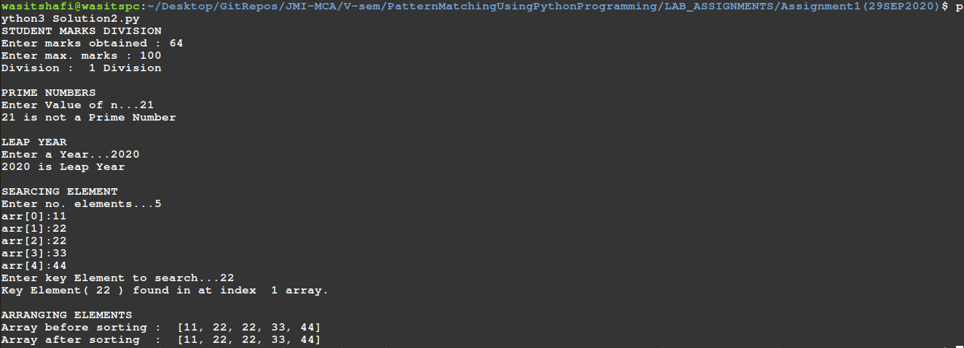
Q3. Write a program illustrating the functioning (creation, inserting, deletion, max, min etc) of list, tuples and dictionary.
Sol.
# List : List is a collection which is ordered and changeable. Allows duplicate members.
print("LIST :")
list1 = ['hello', 'world', 'The', 'quick', 'brown']
list1.append('fox') # added at end of the list
list1.append('jumps')
list1.insert(2,'from python...!') # added at specific index
print('List : ', list1)
list1.remove('The') # deleting element by value
list2 = list1.copy() # copy list1 elements to list2
del list1[1] # deleting element by index
print('List1 : ', list1)
print('List2 : ', list2)
print('list2[2:5] : ', list1[2:5])

print('list1 min value : ', min(list1)) # lexicographically smallest
print('list1 max value : ', max(list1))

# Tuples : A tuple is a collection which is ordered and unchangeable. In Python tuples are written with round brackets.
print("TUPLES :")
tuple1 = ('zero', 'one', 'two', 'three', 'four', 'five', 'six', 'seven', 'eight', 'nine')
print('tupel1', tuple1)
print('tupel1[2:5]', tuple1[2:5])
print("'four' in tuple1", 'four' in tuple1 )
print("'ten' in tuple1'", 'ten' in tuple1 )
print('max(tuple1) : ' , max(tuple1))
print('min(tuple1) : ' , min(tuple1))
print('len(tuple1) : ', len(tuple1))

# Dictionary : Dictionary is a collection which is unordered, changeable and indexed. No duplicate members.
print("\n\nDICTIONARY :")
dict1 = {1 : 'One', 2 : 'Two', 3 : 'Three', 4 : 'Four', 5 : 'Five', 6 : 'Six', 7 : 'Seven'}

for key, value in dict1.items(): # printing Dictionary
print(key, ':', value)

print('dict1[1] : ', dict1[1]) # return value of key '1', if key is not found then it raises an error
print("1 in dict1 :", 1 in dict1) # return true if dict1 contains key 1, else return false
print("20 in dict1 :", 20 in dict1)# return true if dict1 contains key 1, else return false

dict1.pop(2) # removes element
dict1[1] = 'ONE' # if dict1 contains key, then it overwrites value else it insert as a new element
dict1[50] = 'fifty'
print("\nAfter inserting/deleting dict1 : ")
for key, value in dict1.items(): # printing Dictionary
print(key, ':', value)
Output
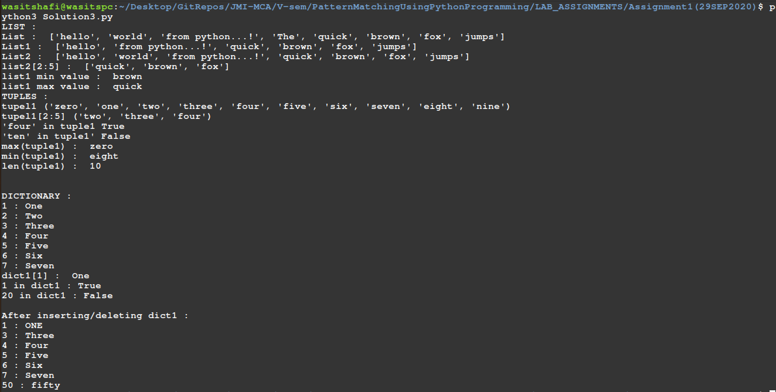
Q4. write a program using functions and procedures.
Sol.
def func1(x, y): # function to return minimum
if x < y:
return x
else:
return y

def proc1(n): # procedure to print 0 - n
for i in range(n+1):
print(i)

minimum = func1(10, 5)
print('minimum element : ', minimum)
proc1(minimum)
Output
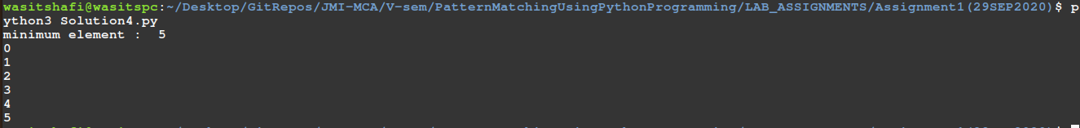
Q5. Write a program to implement OOPs concepts in python i.e. inheritance etc.
Sol.

class Person:
def __init__(self, name, age, address): # constructor
self.name = name
self.age = age
self.address = address

def set_data(self, name, age, address):
self.name = name
self.age = age
self.address = address

def get_data(self):
print('Name : ', self.name)
print('Age : ', self.age)
print('Address : ', self.address)

def get_name(self):
return self.name

def get_age(self):
return self.age

def get_address(self):
return self.address

class Student(Person):
def __init__(self, name, age, address, rollno, course, marksObtained, maximumMarks): # constructor
super().__init__(name, age, address)
self.rollno = rollno
self.course = course
self.marksObtained = marksObtained
self.maximumMarks = maximumMarks

def set_data(self, rollno, course, marksObtained, maximumMarks):
self.rollno = rollno
self.course = course
self.marksObtained = marksObtained
self.maximumMarks = maximumMarks

def get_data(self):
print('Name : ', super().get_name())
print('Age : ', super().get_age())
print('Address : ', super().get_address())
print('Rollno : ', self.rollno)
print('Course : ', self.course)
print('Marks Obtained : ', self.marksObtained)
print('Maximum Marks : ', self.maximumMarks)
print('Percentage : ', '{:.2f}'.format(self.get_percentage()), '%')

def get_rollno(self):
return self.rollno

def get_course(self):
return self.course

def get_marksObtained(self):
return self.marksObtained

def maximumMarks(self):
return self.maximumMarks

def get_percentage(self):
return marksObtained / maximumMarks * 100

print('PERSON DETAILS : ')
name = input('Enter Name of Person : ')
age = int(input('Enter Age of ' + name + ' : '))
address = input('Enter Address of ' + name +' : ')
p1 = Person(name, age, address) # Object of Person Class

print('\nSTUDENT DETAILS : ')
name = input('Enter Name of Student: ')
age = int(input('Enter Age of Student : '))
address = input('Enter Address of Student: ')
rollno = input('Enter Rollno of Student : ')
course = input('Enter Course of Student : ')
marksObtained = float(input('Enter Marks Obtained of Student : '))
maximumMarks = float(input('Enter Maximum Marks of Student : '))
s1 = Student(name, age, address, rollno, course, marksObtained, maximumMarks)

# Printing Person Details
print("\n\nPerson Details are as :")
p1.get_data();

#Printing Student Detatils
print("\n\nStudent Details are as :")
s1.get_data();
Output
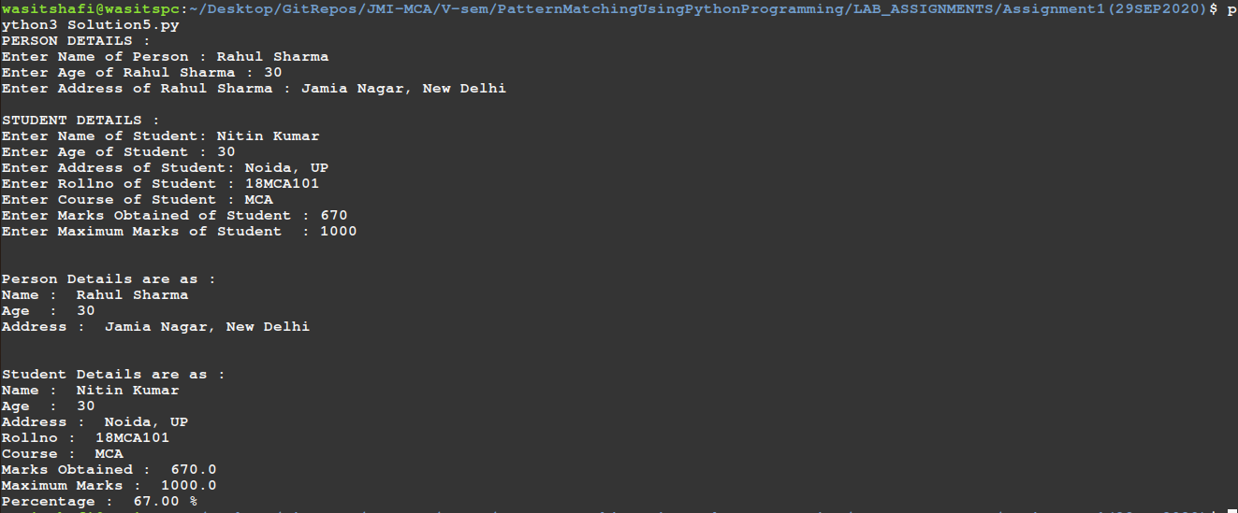

Q6. Write a program for creation, insertion, deletion operation in files, text files, csv files, excel files, etc.
Sol.
Text File Operations
def read_file(file):
for line in file.readlines():
print(line.rstrip('\n'))

def write_file(file):
n = int(input('Enter no. of line you want to have in file : '))

for i in range(n):
file.write(input())
if i != n-1 :
file.write("\n")

def delete_line(file_name):
file = open(file_name, 'r')
lines = file.readlines()
print(lines)
file.close()
n = int(input('Enter line no you want to delete (MAX : ' + str(len(lines)) + ':)'))
if n > len(lines):
print('Invalid Line no.')
return

file = open(file_name, 'w')
for i in range(len(lines)):
if i+1 != n:
if i + 2 == n and i + 2 == len(lines): # if we have to delete the last line
file.write(lines[i].rstrip('\n'))
else:
file.write(lines[i])
file.close()

### Main ###
# Creating new text file
file_name = 'file1.txt'
file = open(file_name, 'w') # opening a file in write mode

# Writing file
write_file(file)
file.close()

file = open(file_name, 'r+') # opening a file in read & write mode
# Read file
#print("File contents are as : ", file.read()) # Method 1
# Method 2
print("\n\nFile contents are as : ")
read_file(file)
file.close()

# Deleting a specific line from text file
#delete_line(file_name)
delete_line('file1.txt')
print("\n\nFile contents are After Delete operation as : ")
file = open(file_name, 'r+') # opening a file in read & write mode
read_file(file)
file.close()
Output
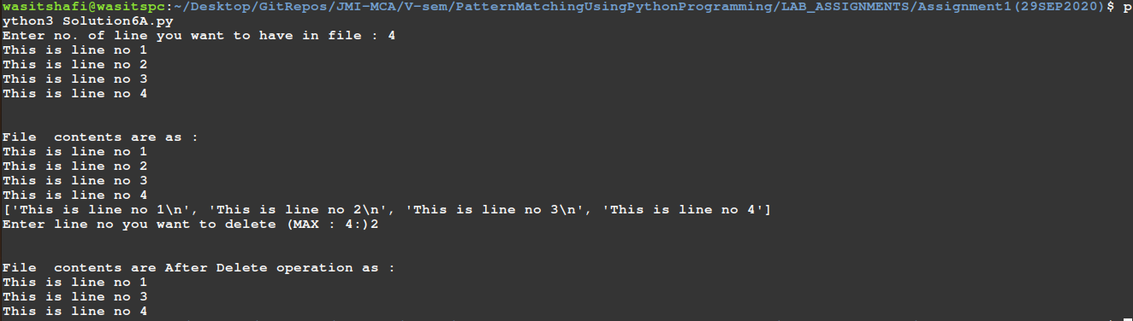

CSV File Operations
import pandas as pd
# Q6. Write a program for creation, insertion, deletion operation in files, text files, csv files, excel files, etc.

def write_file(file_name):
data = {
'EID' : [101, 102, 103, 104, 105, 106],
'Name' : ['Rahul', 'Akashay', 'Priya' ,'Rashmi', 'Sunjay', 'Gurmeet'],
'Salary': [20000, 35000, 10000, 75000, 36000, 15000]
}
df = pd.DataFrame(data)
df.to_csv(file_name, index=False)

def read_file(file_name):
df = pd.read_csv(file_name)
print(df)

def delete_file(file_name):
data = pd.read_csv(file_name)
data.drop([2], inplace = True) # deleting row
data.drop([1], inplace = True) # deleting row
data.drop(['Salary'], axis=1, inplace = True) # deleting col
data.to_csv(file_name, index = False)

file_name = 'data1.csv'
# Writing file
write_file(file_name)

# Reading file
print ("\n\nFile Before Delete operation")
read_file(file_name)

# Deleting
delete_file(file_name)
print ("\n\nFile After Delete operation")
read_file(file_name)
Output
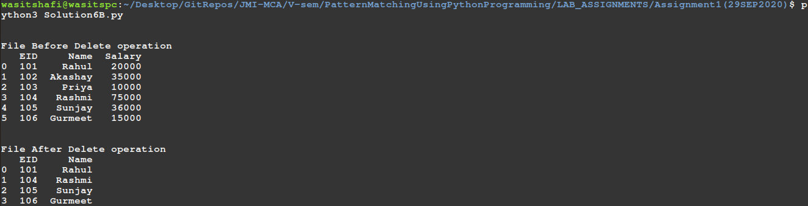
Q7. write a program to perform some data analytics using machine learning packages, i.e. pandas, preprocessing regression, classification, clustering, datasets, etc.
Sol.
Linear Regression
import pandas as pd
from sklearn import linear_model

FILE_NAME = 'homeprice.csv'
df = pd.read_csv(FILE_NAME)

print('df : ', df)
model = linear_model.LinearRegression()
model.fit(df[['area']], df['price'])
print('model coef : ', model.coef_)
print('model intercept : ', model.intercept_)
print('Predicting price for home with area 33000 sq.ft : ', model.predict([[33000]]))
Output
