Tutoruial 2
Komputer yang digunakan sudah terinstal python
2.1.2. Interactive Mode
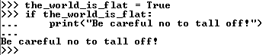
2.2. The Interpreter and Its Environment
2.2.1. Source Code Encoding
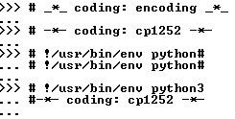
3.1. Using Python as a Calculator
3.1.1. Numbers
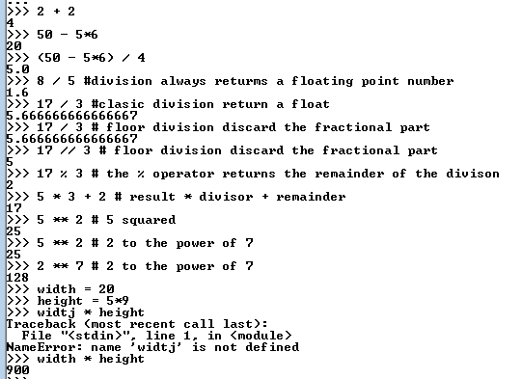
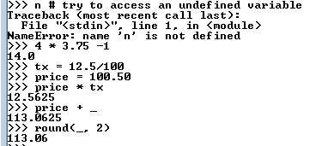
3.1.2. Strings
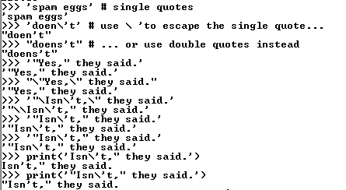
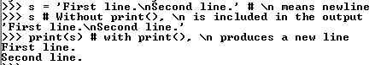
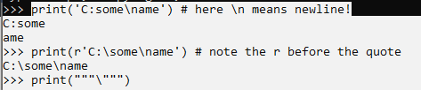
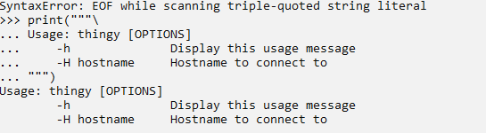
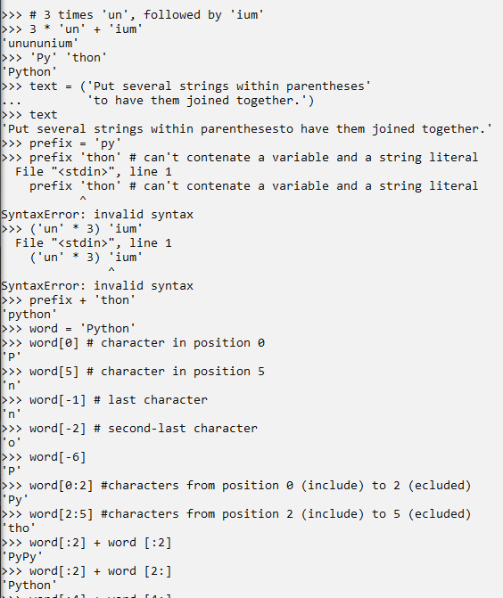
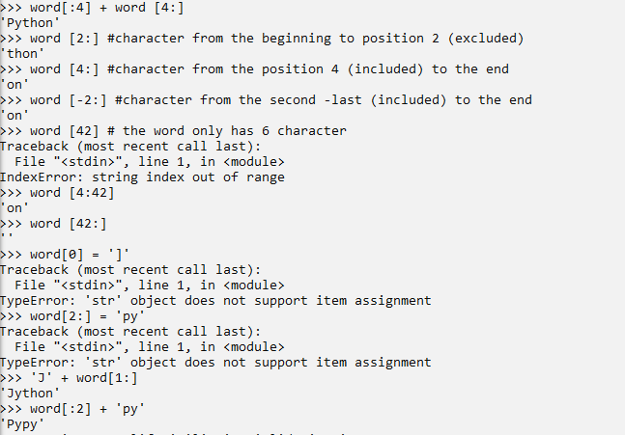
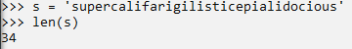
3.1.3. Lists
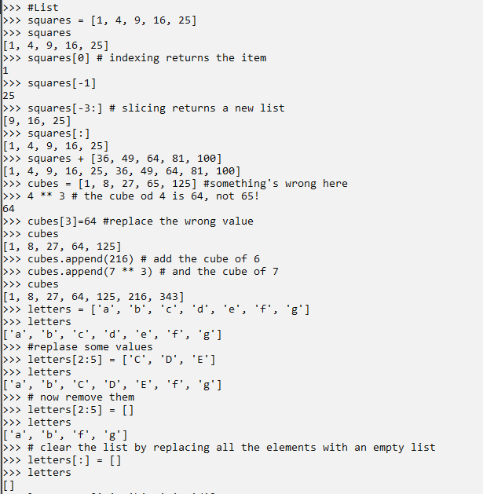
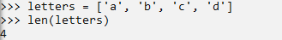
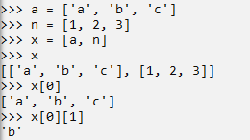

3.2. First Steps Towards Programming
