Create New Account Request for David with initial balance 1000

Response is the account id= 46140523-6f8f-43ea-9d63-af87daec12fb

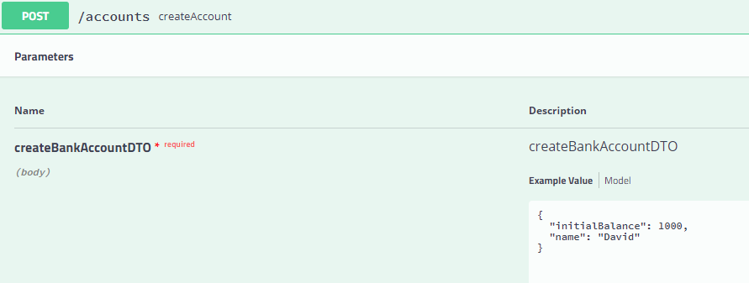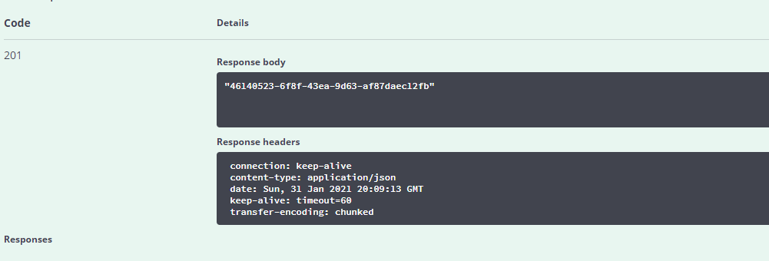

Deposit: Deposit transaction for account id = 46140523-6f8f-43ea-9d63-af87daec12fb and amount 1550

Response status code 200 ok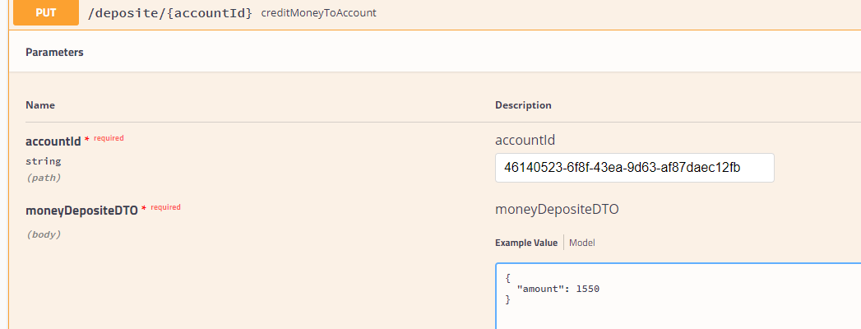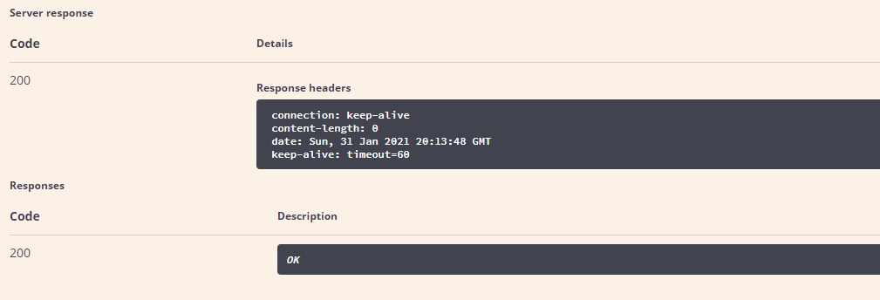

Withdraw from account id 46140523-6f8f-43ea-9d63-af87daec12fb amount 255

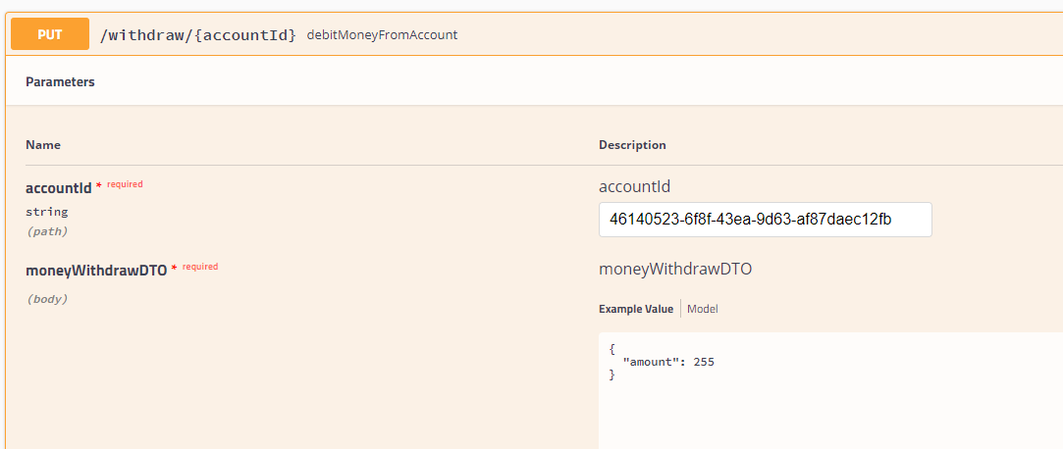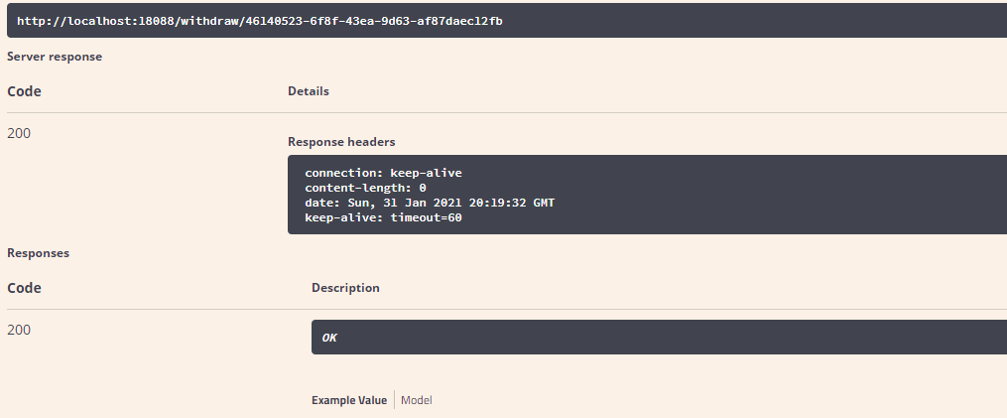

Axon Server view

We can see three transactionS create, deposit and withdraw

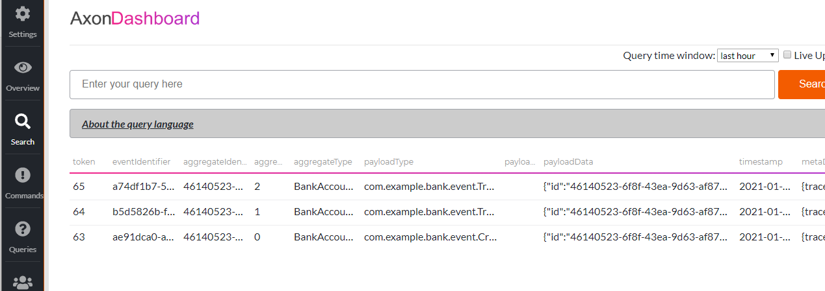

Query for account details

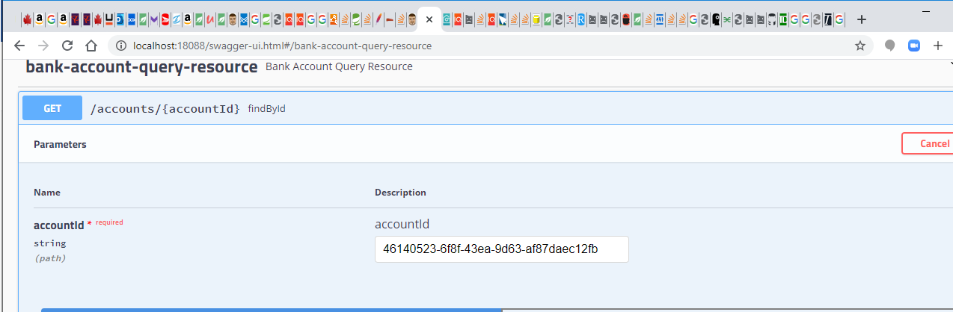

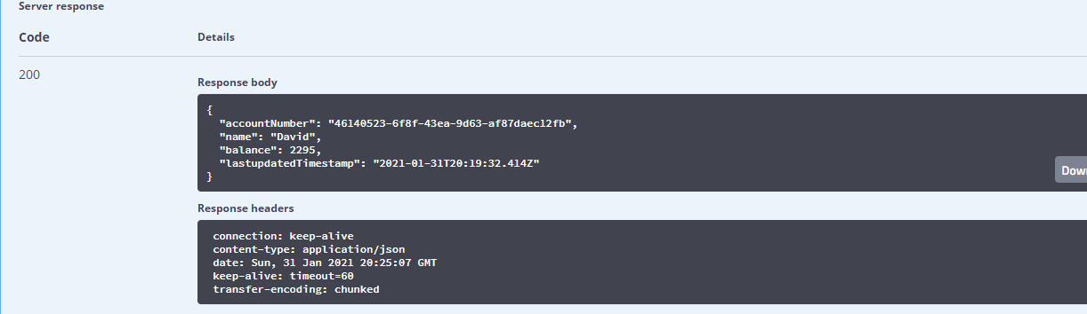

Query for all transactions with date range….

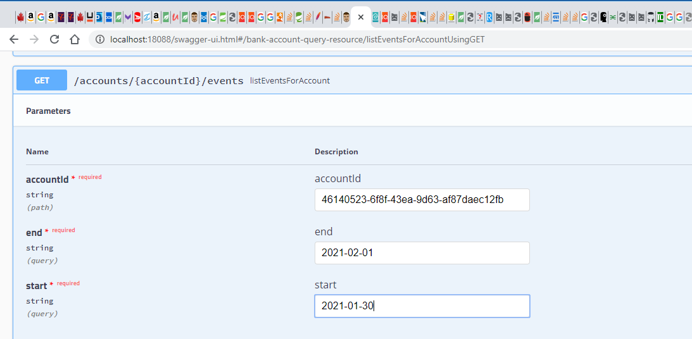Q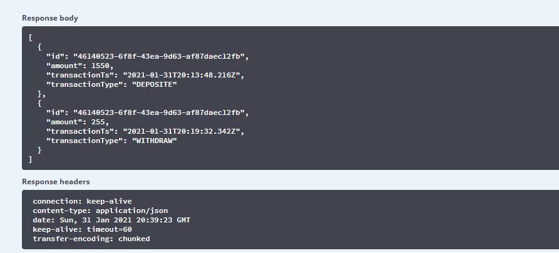

Query transaction with transaction type e.g. Withdraw

