Having : Here we are using amount which is greater than 100

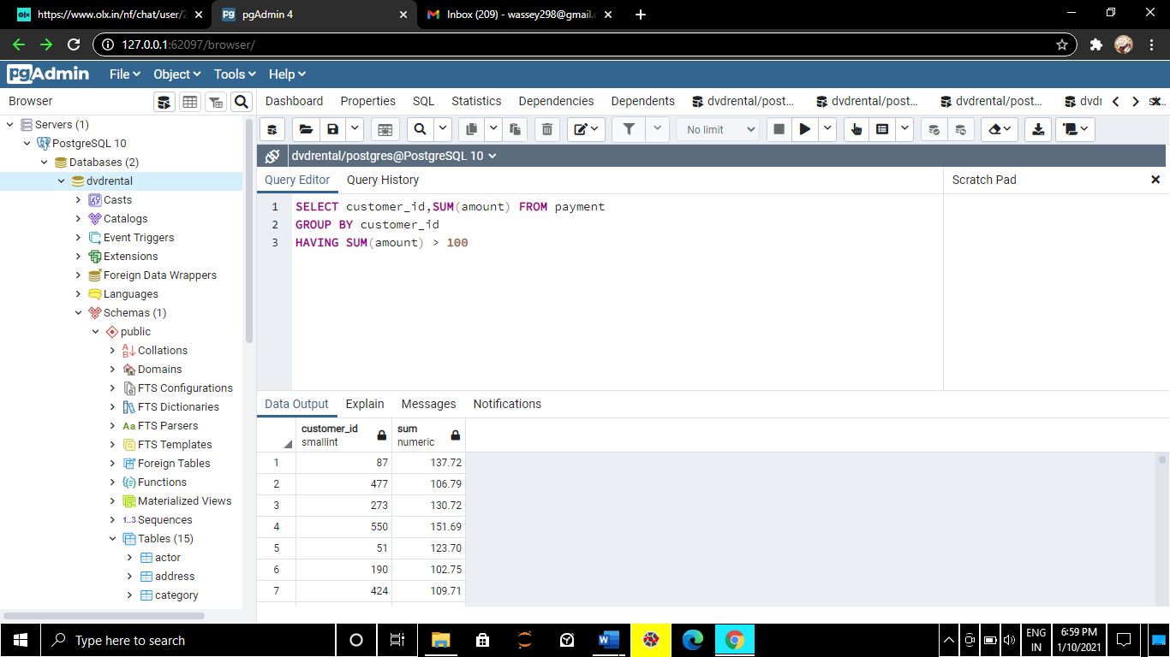

Here we are knowing no of customers per store.

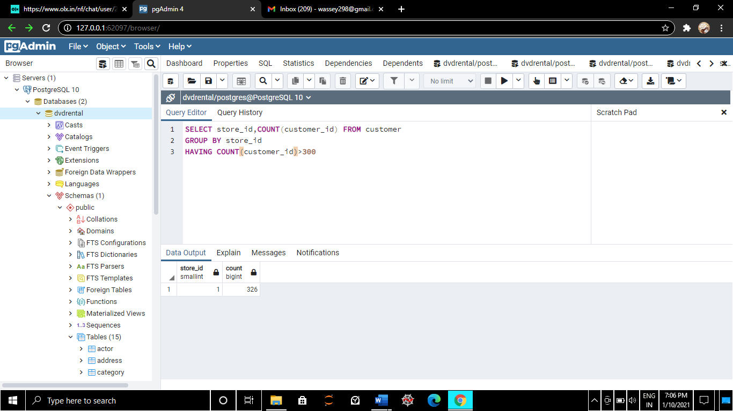

We will assign platinum status to customers that have had 40 or more transaction payments

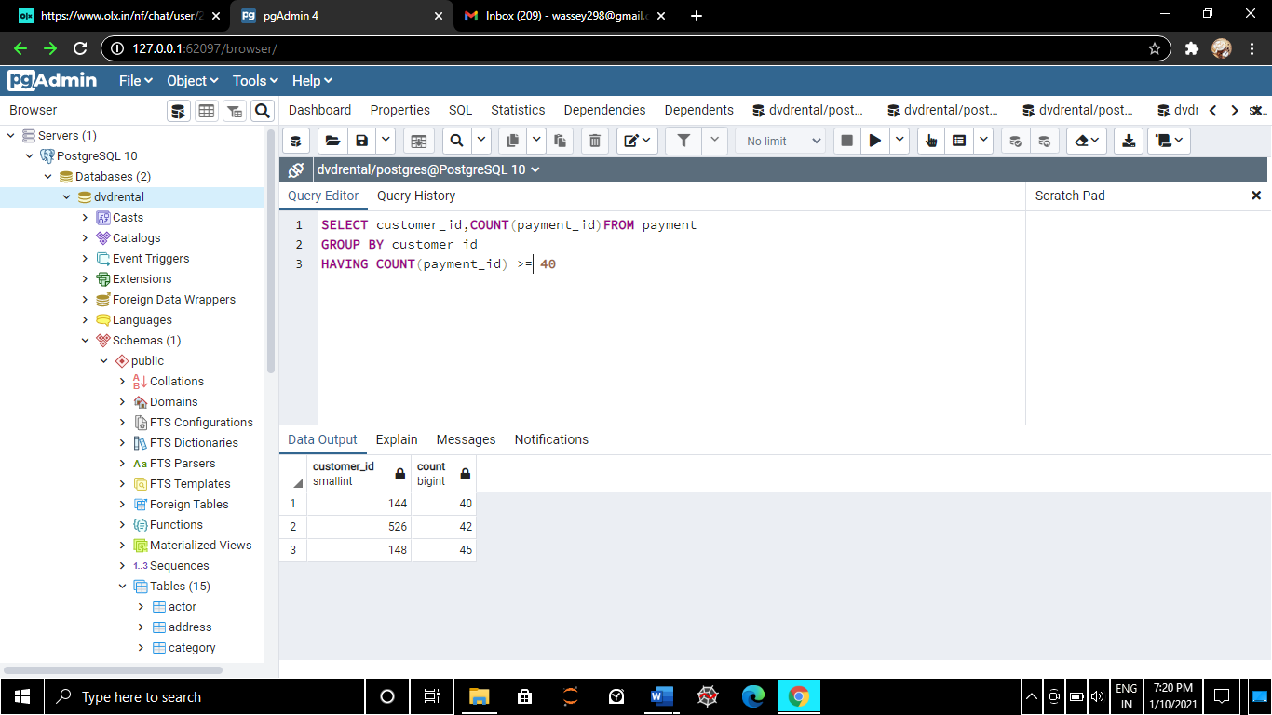

What are the customer ids who have spent more than $100 in payment transactions with staff id no 2

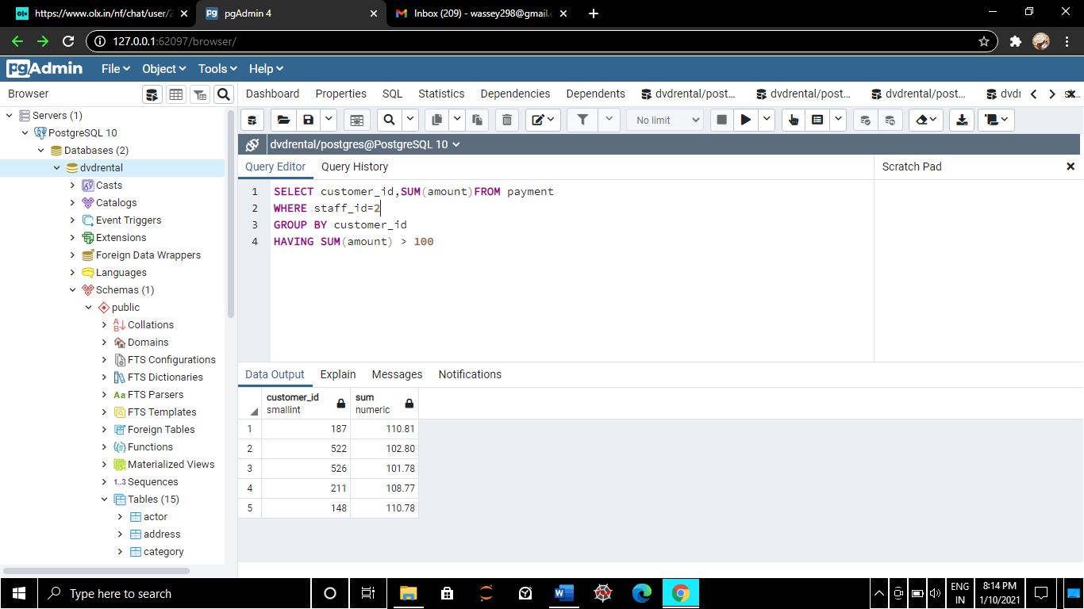

Return the cust id of customers who have spent atleast 110$ with the staff id no 2

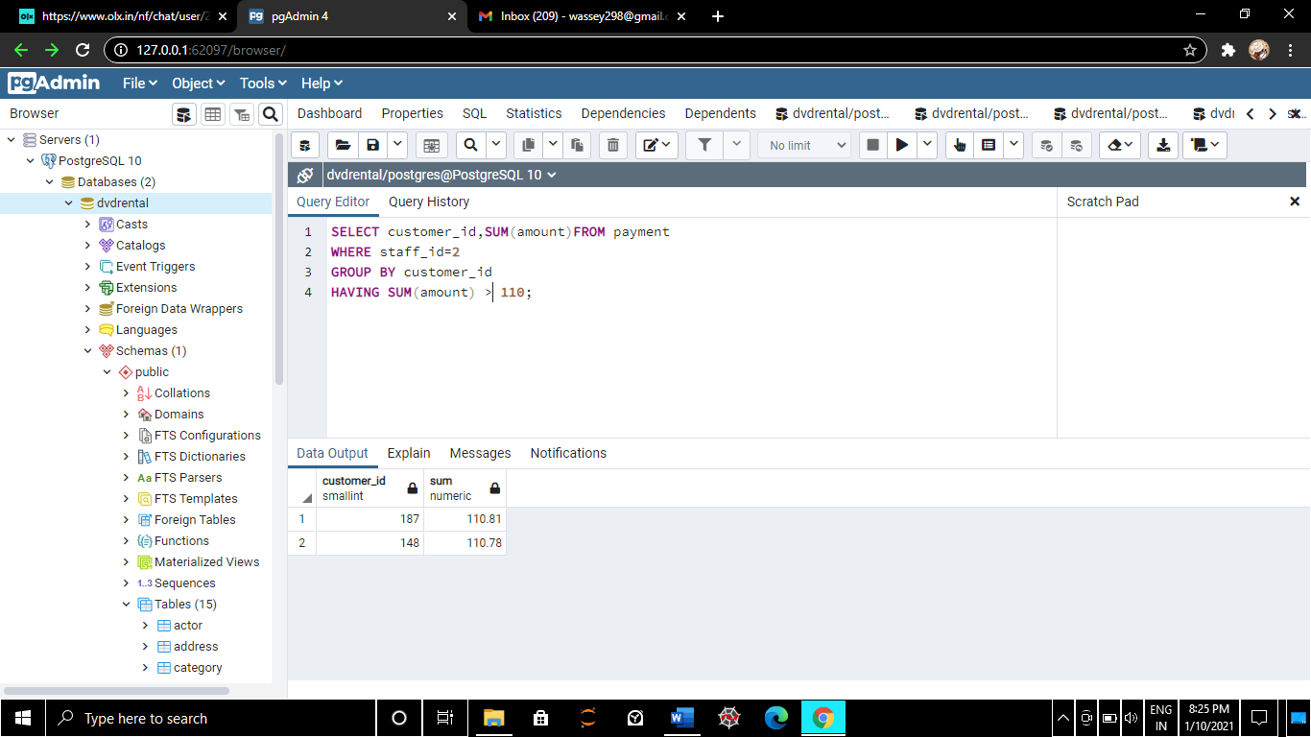

How many films begin with letter J.

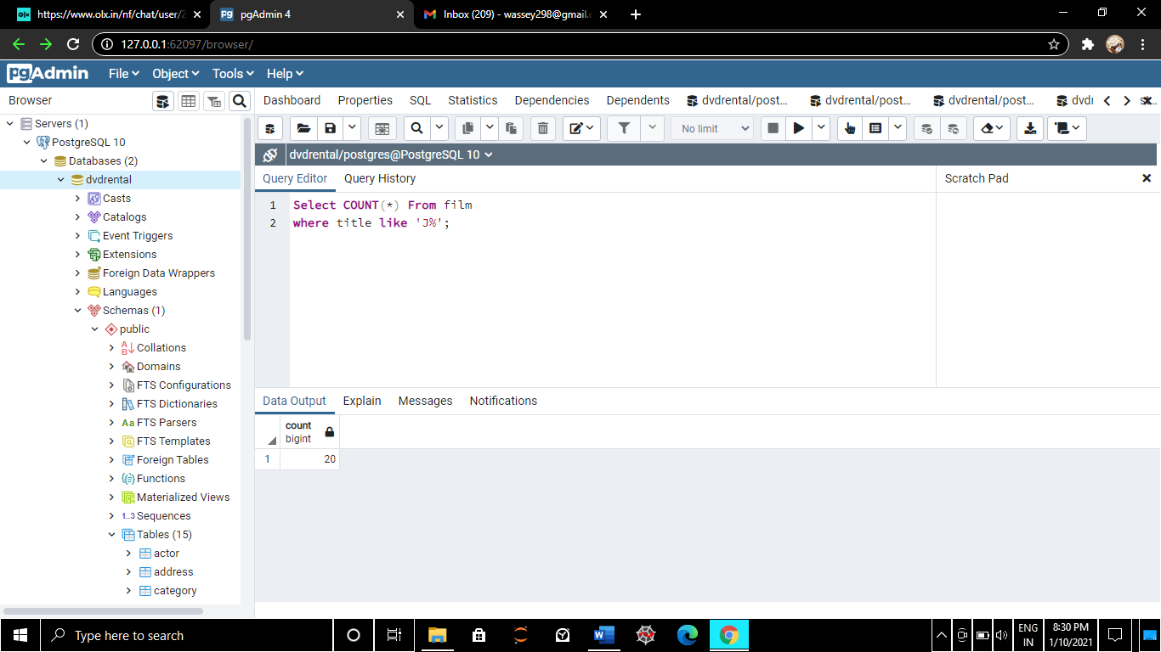

What customer has the highest customer id no whose name starts with an E and has an add id lower than 500?

