IT 3203 Web Development Project

Center For   
applied research in Information Technology report

Denise Mutombo

Function/content:

1. Home page named “index.html”

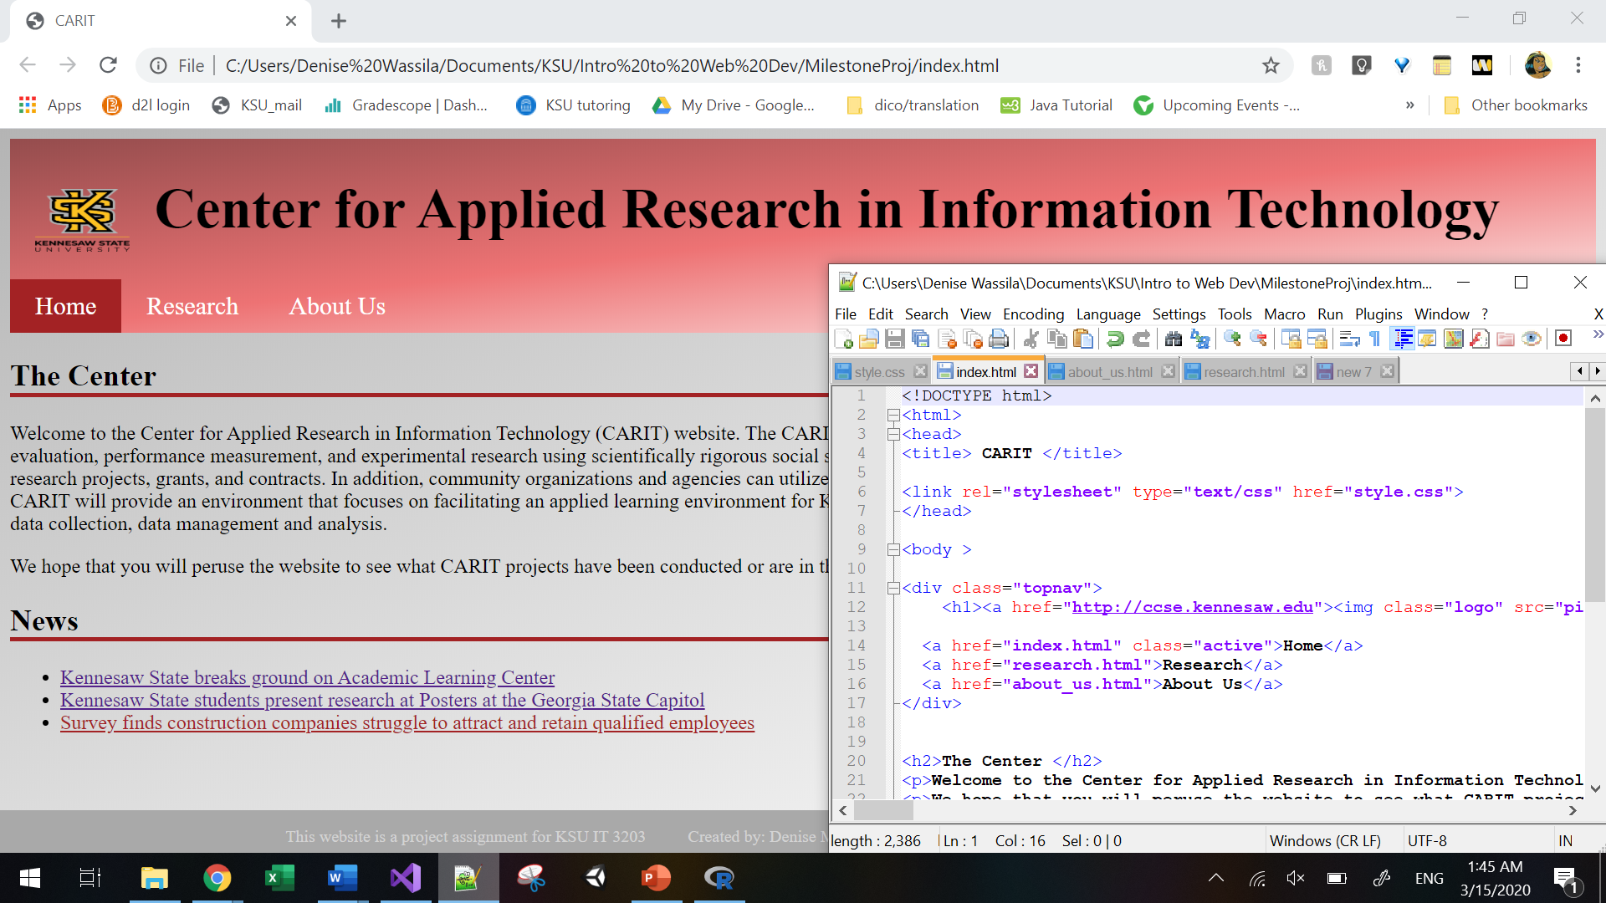

The index page is called home in the website. It introduces CARIT through a couple of short paragraphs description in the first section. Below it is the news section which is a list of new titles directing to some related KSU news pages. The content itself has been taken from the example websites.

The banner is a light red solid color with a KSU logo redirecting to the KSU website and it also includes the tabs to direct to all of the website pages and highlight in a darker red the active page, as to know “Home” here.

1. About us (faculty) page

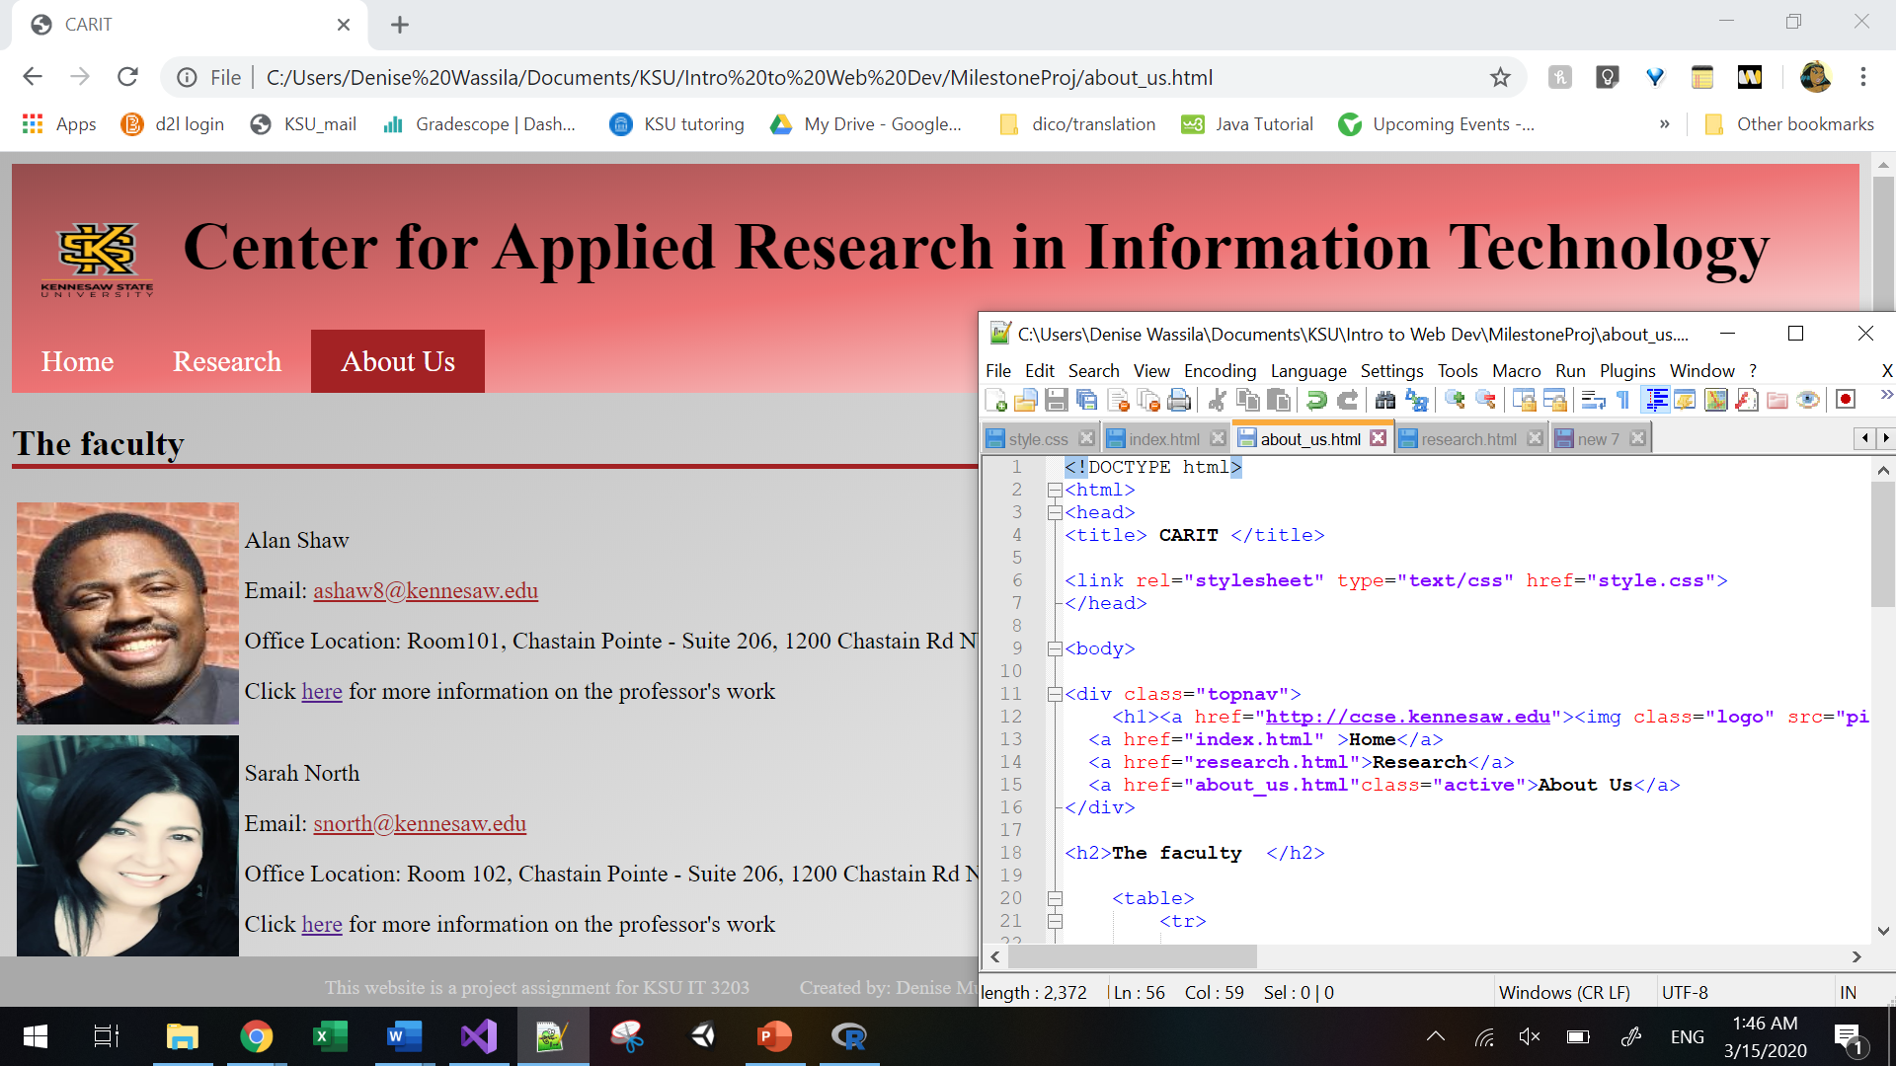

This page introduces the faculty members of CARIT as to know three professors. I have used a table to separate in a consistent manner the pictures and information text including the professors’ name, office location, email which is directly clickable and link directing to their professional webpage. Here again, the “about us” tab is highlighted to show as current page.

1. Third page named Research

For thi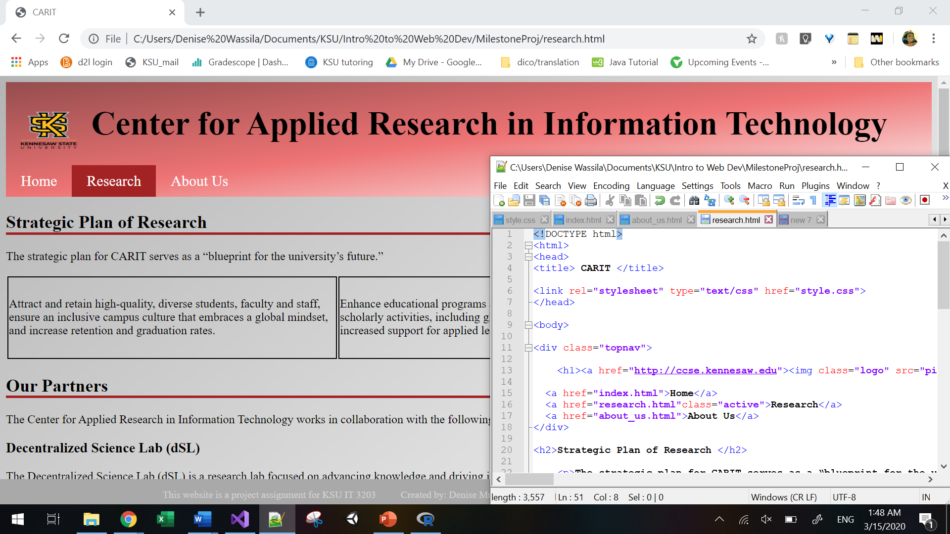s third page I have decided to introduce CARIT research plans and partners. Those categories have been separated into two distinct sections with titles just like in the Home page.

The first section includes a table that gives information on how CARIT strategic plan follows KSU’s plan of development as a school, through different axis.

The partners section introduces the other KSU’s centers that collaborates with CARIT to accomplish those goals. Each center has a description with link to their webpage.

Style

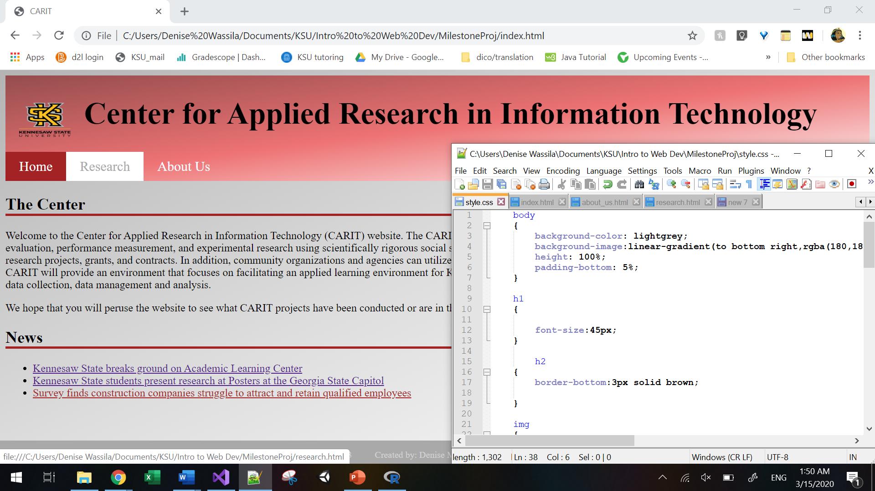

All pages display the name of the center as the title in the banner. The logo for KSU is also presented there and redirect to <http://ccse.kennesaw.edu/it>. The tabs within that banner redirect to the respective page and is highlighted accordingly as well. When hovering over the tabs they go from dark-red to white in the background and from white to grey for the font.   
The footer is styled dark grey in the background with white font. It gives information about the website being a class project, my name and email address as a webmaster.   
The rest of the body is a gradient dark grey to white color.

LINK TO THE WEBSITE

<http://studentweb.kennesaw.edu/~dmutomb1/CARIT/index.html>

References

<http://facultyweb.kennesaw.edu/>

<https://www.kennesaw.edu/research.php>

<https://uncw.edu/ssarc/>

<https://egarc.ucr.edu/>