# Exploring the Landscape of Information and Communication Technologies (TIC) and Their Impact on Modern Computing

**Prepared for:**

**Redouane Bouchekir**

**Prepared by :**

**( BOUTMEDJET ABD ELMOUDJIB )**

**GROUPE 16**

**Date :**

**27/12/2023**

Table des matières

**Introduction1**

1.1 Background

1.2 Objectives

1.3 Scope of the Report

**Information and Communication Technologies (TIC)**2

2.1 Defining TIC

2.2 Evolution and Trends

2.3 Role of TIC in Modern Society

**Google Services**3

3.1 Overview

3.2 Key Google Services

3.3 Integration and Collaboration Features

3.4 Impact on Productivity

**Microsoft Tools4**

4.1 Introduction

4.2 Noteworthy Microsoft Tools

4.3 Comparative Analysis with Google Services

4.4 Case Studies

**Git and GitHub**5

5.1 Version Control Concepts

5.2 Git: A Foundation for Collaborative Development

5.3 GitHub: A Platform for Open Source Collaboration

5.4 Use Cases and Best Practices

**Interoperability and Challenges**6

6.1 The Importance of Interoperability

6.2 Challenges in Integrating TIC Technologies

6.3 Strategies for Successful Integration

**Conclusion**7

7.1 Summary of Findings

7.2 Implications for Industry and Academia

7.3 Recommendations for Further Research

## **1. Introduction:**

* 1. ***Background:***

*The pervasive influence of Information and Communication Technologies (TIC) on modern life necessitates a comprehensive examination. This section provides an overview of the context and importance of the report.*

* 1. ***Objectives:***

*This report aims to investigate the evolution and impact of TIC, with a specific focus on Google services, Microsoft tools, Git, and GitHub. The objectives include understanding their functionalities, analyzing their role in modern computing, and exploring challenges and opportunities related to their integration.*

* 1. ***Scope of the Report:***

The scope of this report encompasses a detailed exploration of TIC technologies and their interplay. It delves into specific tools and services provided by Google and Microsoft, shedding light on their functionalities and their implications for collaborative work. Additionally, the report examines the significance of version control through Git and collaborative development on GitHub.

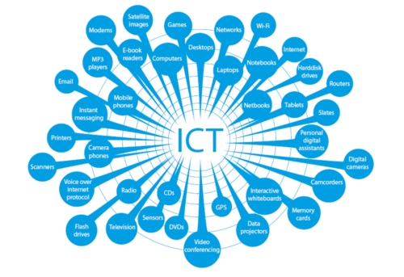

## ***2. Information and Communication Technologies (TIC):***

***2.1 Defining TIC:***

TIC refers to a broad spectrum of technologies that enable the acquisition, processing, storage, and dissemination of information. This section provides a comprehensive definition to set the stage for subsequent discussions.

***2.2 Evolution and Trends:***

A historical analysis of TIC's evolution reveals the transformative trends that have shaped the contemporary technological landscape.

***2.3 Role of TIC in Modern Society:***

An exploration of TIC's role in modern society elucidates its impact on communication, collaboration, and information access.

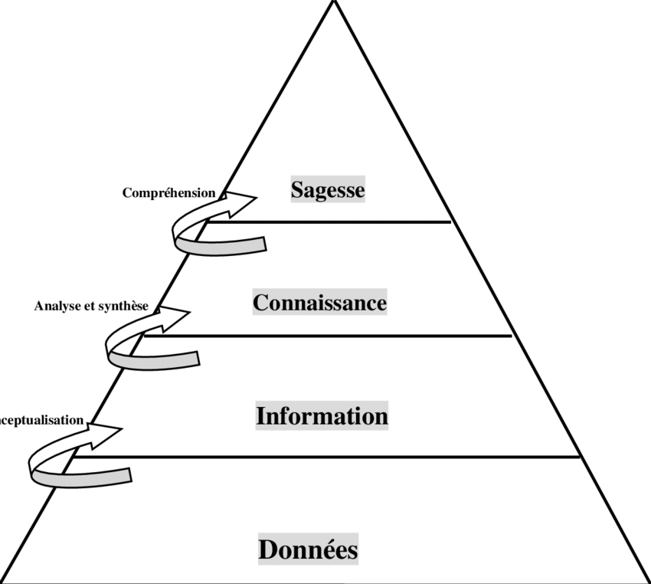

### ***3. Google Services:***

***3.1 Overview:***

Google, a global technology giant, offers a comprehensive suite of services that have become integral to individuals, businesses, and educational institutions. These services span a wide range of applications, fostering communication, collaboration, and productivity in various domains.

***Key Google Services:***

***Gmail:***

Google's email service, Gmail, is known for its intuitive interface, robust spam filtering, and seamless integration with other Google services. With features like Google Meet integration for video conferencing and Google Drive attachment capabilities, Gmail stands as a cornerstone for communication.

***Google Drive:***

Google Drive is a cloud-based storage solution that enables users to store, share, and collaborate on documents, spreadsheets, presentations, and more. Its real-time collaboration features facilitate concurrent editing by multiple users, enhancing productivity and eliminating version control issues.

***Google Workspace:***

Formerly known as G Suite, Google Workspace is a suite of cloud-based productivity tools designed for business and education. It includes applications such as Google Docs, Sheets, Slides, and Forms, fostering seamless collaboration and document creation.

***Google Calendar:***

Google Calendar simplifies schedule management, allowing users to schedule events, set reminders, and share calendars with colleagues. Integration with Gmail ensures that events mentioned in emails are automatically added to the calendar.

***Google Meet:***

Google Meet is a video conferencing platform that supports virtual meetings, webinars, and collaborative discussions. With features like screen sharing and real-time captions, Google Meet facilitates effective communication in remote or distributed teams.

***Google Search:***

Google Search, the world's most widely used search engine, is a fundamental tool for information retrieval. Its advanced algorithms provide users with relevant and personalized results, contributing to the efficiency of information access.

***3.3 Integration and Collaboration Features:***

Google services are renowned for their seamless integration, fostering collaboration and productivity. One notable example is the integration between Google Drive and Google Workspace, which allows real-time collaborative editing of documents, spreadsheets, and presentations. Additionally, Google Meet provides a robust platform for virtual meetings, enhancing remote collaboration.

***3.4 Impact on Productivity:***

Research indicates that organizations utilizing Google services experience enhanced productivity due to streamlined collaboration and efficient document management. The cloud-based nature of these services facilitates easy access to information, fostering a dynamic and agile work environment.

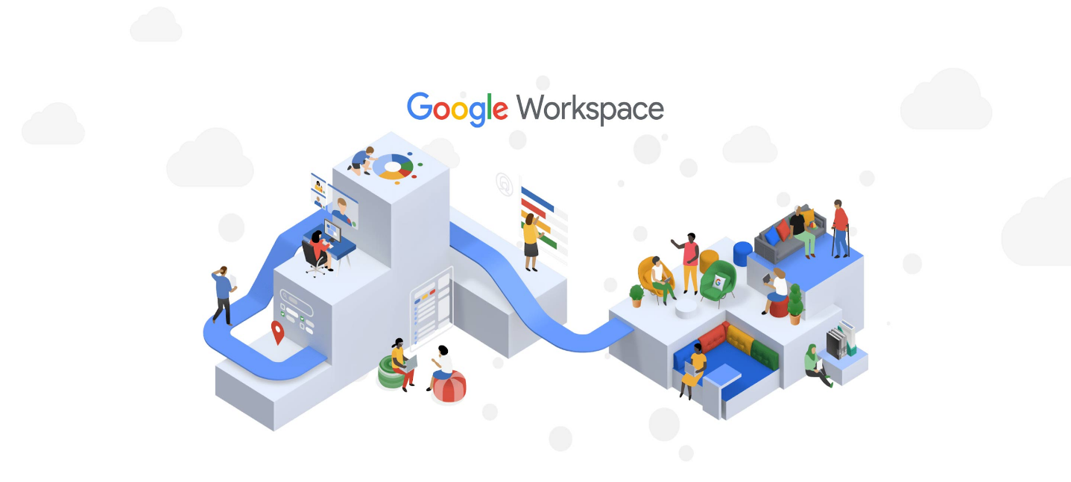

### ***4. Microsoft Tools:***

***4.1 Introduction:***

Microsoft, a technology giant, provides a suite of powerful tools that cater to diverse needs, from productivity and collaboration to development and data analysis. These tools have become foundational elements in various industries, shaping the way individuals and organizations work, communicate, and innovate.

Microsoft's commitment to innovation is evident in its continuous development of tools that address contemporary challenges and leverage emerging technologies. This section provides an introduction to the diverse ecosystem of Microsoft tools, highlighting their role in shaping modern computing.

***4.2 Noteworthy Microsoft Tools:***

Microsoft offers a comprehensive suite of tools that cater to different aspects of work, ranging from document creation and project management to data analysis and software development. Here are some noteworthy Microsoft tools that have gained prominence:

**Microsoft 365:**

Microsoft 365 is an integrated suite that includes a range of productivity tools, such as Word, Excel, PowerPoint, Outlook, and Teams. It offers a seamless experience for document creation, communication, and collaboration. Teams, in particular, has emerged as a hub for virtual collaboration, providing chat, video conferencing, and file sharing in one platform.

**Azure DevOps:**

Azure DevOps is a set of development tools that facilitates collaboration between development and operations teams. It includes services for version control, build automation, release management, and more. Azure DevOps supports Agile methodologies and DevOps practices, streamlining the software development lifecycle.

**Power BI:**

Power BI is a business analytics tool that enables users to visualize and share insights from their data. It connects to a wide range of data sources, transforms raw data into meaningful visuals, and provides interactive dashboards for data exploration. Power BI plays a crucial role in data-driven decision-making.

**SharePoint:**

SharePoint is a web-based collaboration platform that integrates with Microsoft 365. It serves as a document management and storage system, providing a centralized location for team collaboration. SharePoint supports version control and workflow automation, enhancing team efficiency.

**Visual Studio:**

Visual Studio is a comprehensive integrated development environment (IDE) for software development. It supports a variety of programming languages and frameworks, offering tools for code editing, debugging, and testing. Visual Studio is widely used by developers for building applications across platforms.

***4.3 Comparative Analysis with Google Services:***

While both Microsoft and Google offer productivity suites, they differ in their approach and feature sets. Microsoft's tools often integrate seamlessly with on-premises infrastructure, making them suitable for enterprises with diverse IT environments. Google services, on the other hand, emphasize cloud-based collaboration and real-time editing. A comparative analysis can provide insights into the strengths and considerations of each suite.

***4.4 Case Studies:***

Incorporating Microsoft tools into organizational workflows has yielded significant benefits. Case studies of enterprises adopting Microsoft 365 reveal improved communication through Teams, enhanced project management with Planner, and efficient document collaboration via SharePoint. The versatility of tools such as Excel and Power BI has empowered data-driven decision-making.

## **5. Git and GitHub:**

**5.1 Version Control Concepts:**

**Definition of Version Control:**

Version control is a crucial aspect of collaborative software development that allows multiple contributors to work on a project simultaneously. It tracks changes to source code over time, providing a historical record of modifications and facilitating collaboration among developers.

**Key Concepts in Version Control:**

**Repository (Repo):** A repository is a storage space where the project's files and their revision history are stored.

Merge: Merging is the process of combining changes from one branch into another, typically used to integrate new features or bug fixes.

**Commit:** A commit is a snapshot of changes made to the code at a specific point in time. It includes a unique identifier, a commit message, and details of modifications.

**Branching:** Branching enables the creation of separate lines of development, allowing developers to work on features or fixes independently.

**Merge:** Merging is the process of combining changes from one branch into another, typically used to integrate new features or bug fixes.

**5.2 Introduction to Git:**

**Git as a Distributed Version Control System:**

Git is a distributed version control system (DVCS) that allows developers to work collaboratively on projects. Each contributor has a complete copy of the project's code and its history, enabling decentralized and parallel development.

**Key Features of Git:**

**Speed:** Git is designed to be fast, enabling quick commits, merges, and overall responsiveness.

**Branching and Merging:** Git's branching model is lightweight, making it easy to create, switch, and merge branches.

**Distributed Development:** Every user has a complete repository, enabling offline work and collaboration without a centralized server.

**Data Integrity:** Git ensures the integrity of the project by using cryptographic hashe

**5.3 GitHub: A Collaborative Development Platform:**

**Overview of GitHub:**

GitHub is a web-based platform that utilizes Git for version control. It enhances the collaborative nature of Git by providing additional features for project management, issue tracking, and code review.

**Key Features of GitHub:**

**Repository Hosting:** GitHub serves as a hosting platform for Git repositories, making it accessible and manageable through a user-friendly web interface.

**Collaboration Tools:** GitHub facilitates collaboration through features such as pull requests, issues, and wikis, enhancing communication and coordination among contributors.

**Code Review:** Pull requests on GitHub enable code review, allowing contributors to discuss, review, and suggest modifications before changes are merged into the main codebase.

**Integration with CI/CD:** GitHub integrates with Continuous Integration/Continuous Deployment (CI/CD) tools, automating the testing and deployment processes.

**Community and Open Source Development:**

GitHub has become a hub for open source development, fostering a global community of developers. It enables individuals and organizations to share, contribute to, and collaborate on a vast array of projects.

**5.4 Use Cases and Best Practices:**

**Use Cases of Git and GitHub:**

Collaborative Software Development: Git and GitHub are widely used for collaborative software development projects, allowing multiple developers to work on code simultaneously.

**Documentation and Wikis:** GitHub's wiki feature is often utilized for project documentation, providing a central location for information and guidelines.

**Issue Tracking and Bug Reporting:** GitHub's issue tracker is employed to report and manage bugs, feature requests, and tasks, enhancing project management.

**Best Practices:**

Branching Strategy: Adopting a clear branching strategy, such as Gitflow, helps manage feature development, releases, and hotfixes.

Meaningful Commit Messages: Writing descriptive and concise commit messages enhances clarity and assists in understanding changes over time.

Regular Pull Requests and Code Reviews: Regular pull requests and code reviews promote collaboration, knowledge sharing, and code quality assurance.

### ***6. Interoperability and Challenges:***

**6.1 The Importance of Interoperability:**

Interoperability is a critical aspect of Information and Communication Technologies (TIC) that ensures seamless communication and collaboration between diverse systems, applications, and platforms. It allows for the efficient exchange of data and functionalities, promoting a cohesive and integrated digital environment. The importance of interoperability can be outlined in several key dimensions:

**Efficient Information Exchange:**

Interoperability enables different systems to share and exchange information seamlessly. This efficiency is crucial in environments where multiple technologies coexist, ensuring that data flows smoothly between various components.

**Collaboration Across Platforms:**

In collaborative settings, interoperability ensures that individuals using different tools or platforms can work together effectively. This is particularly relevant in modern workplaces where diverse TIC solutions are employed for various tasks.

**Enhanced User Experience:**

Interoperability contributes to a more user-friendly experience by eliminating barriers between different technologies. Users can access and utilize functionalities across platforms without encountering compatibility issues.

**Cost Reduction:**

By fostering compatibility between systems, interoperability can reduce development and maintenance costs. It allows organizations to integrate new technologies without the need for extensive modifications to existing infrastructure.

***6.2 Challenges in Integrating TIC Technologies:***

While interoperability is essential, integrating diverse TIC technologies presents several challenges that organizations must address to ensure a smooth and effective implementation:

**Differing Standards and Protocols:**

One of the primary challenges in achieving interoperability is the existence of varying standards and communication protocols across technologies. Different vendors may implement their own specifications, leading to compatibility issues.

**Data Security and Privacy Concerns:**

Integrating TIC technologies often involves the exchange of sensitive data. Ensuring the security and privacy of this data during transmission and across integrated systems is a paramount concern.

**Complexity in Legacy System Integration:**

Organizations may have legacy systems that were not designed with modern interoperability in mind. Integrating these legacy systems with newer technologies can be complex and may require additional development efforts.

**Vendor Lock-In:**

Some organizations may face challenges when trying to integrate technologies from different vendors. Vendor-specific proprietary solutions can lead to vendor lock-in, limiting flexibility and options for future technology choices.

**Lack of Industry Standards:**

In some cases, the absence of universally accepted industry standards can hinder interoperability efforts. The development and adoption of standardized approaches are crucial for ensuring compatibility across diverse technologies.

***6.3 Strategies for Successful Integration:***

Ensuring interoperability among TIC technologies requires careful planning. Adopting standardized communication protocols, such as RESTful APIs, can facilitate seamless integration. Additionally, establishing clear data governance policies and conducting regular system audits are vital for maintaining consistency and integrity across integrated platforms.

|  |  |
| --- | --- |
| **Challenge Area** | **Strategies for Mitigation** |
|  | **1. Adopt Standardized Protocols:** Implement widely accepted communication protocols (e.g., RESTful APIs) to ensure compatibility across platforms. |
|  | **2. Establish Data Standards:** Define and adhere to standardized data formats and structures, promoting consistency in information exchange. |
| ***Interoperability Issues*** | **3. Conduct Compatibility Testing:** Regularly test the interoperability of systems to identify and address potential issues proactively. |
|  | **4. Collaborative Standards:** Foster collaboration between vendors and industry groups to establish common standards for seamless integration. |
|  | **5. Implement Middleware Solutions:** Utilize middleware to facilitate communication between diverse systems, acting as an intermediary for data exchange. |

## **8. Conclusion:**

**8.1 Summary of Findings:**

In this report, we embarked on a comprehensive exploration of Information and Communication Technologies (TIC) and related tools, with a specific focus on Google services, Microsoft tools, Git, and GitHub. The key findings can be summarized as follows:

**TIC Landscape:** Information and Communication Technologies have evolved significantly, shaping the way individuals and organizations communicate, collaborate, and access information.

**Google Services:** Google offers a suite of services that excel in collaboration, productivity, and communication. The seamless integration of Google services and their cloud-based nature contribute to enhanced productivity and streamlined workflows.

**Microsoft Tools:** Microsoft provides a diverse set of tools, from productivity applications in Microsoft 365 to development tools like Azure DevOps. These tools are instrumental in addressing various needs in different domains, contributing to efficient and collaborative work environments.

**Git and GitHub:** Git, as a distributed version control system, and GitHub, as a collaborative development platform, play pivotal roles in modern software development. They facilitate version control, collaboration, and community-driven open source development.

**Interoperability Challenges:** Achieving interoperability across diverse TIC technologies is crucial but poses challenges, including differing standards, security concerns, and the complexity of integrating legacy systems.

**8.2 Implications for Industry and Academia:**

The insights gained from this exploration have significant implications for both industry practitioners and academia:

**Industry:** Organizations can leverage the collaborative features of Google services and Microsoft tools to enhance productivity. Implementing robust version control practices with Git and GitHub can streamline software development processes.

**Academia:** Academic institutions can incorporate TIC technologies into their curricula to prepare students for the modern workforce. Emphasizing the importance of interoperability and providing hands-on experience with Git and GitHub can contribute to well-rounded technical education.

**8.3 Recommendations for Further Research:**

While this report provides a comprehensive overview, there are areas that warrant further investigation:

**Interoperability Standards:** Future research could delve into the development and adoption of standardized interoperability protocols to address challenges in data exchange between diverse systems.

**Security in Collaborative Platforms:** Exploring advanced security measures for collaborative platforms like GitHub to ensure the confidentiality and integrity of shared code repositories.

**Impact of TIC on Specific Industries:** Conducting industry-specific studies to analyze the impact of TIC technologies on sectors such as healthcare, finance, or education.