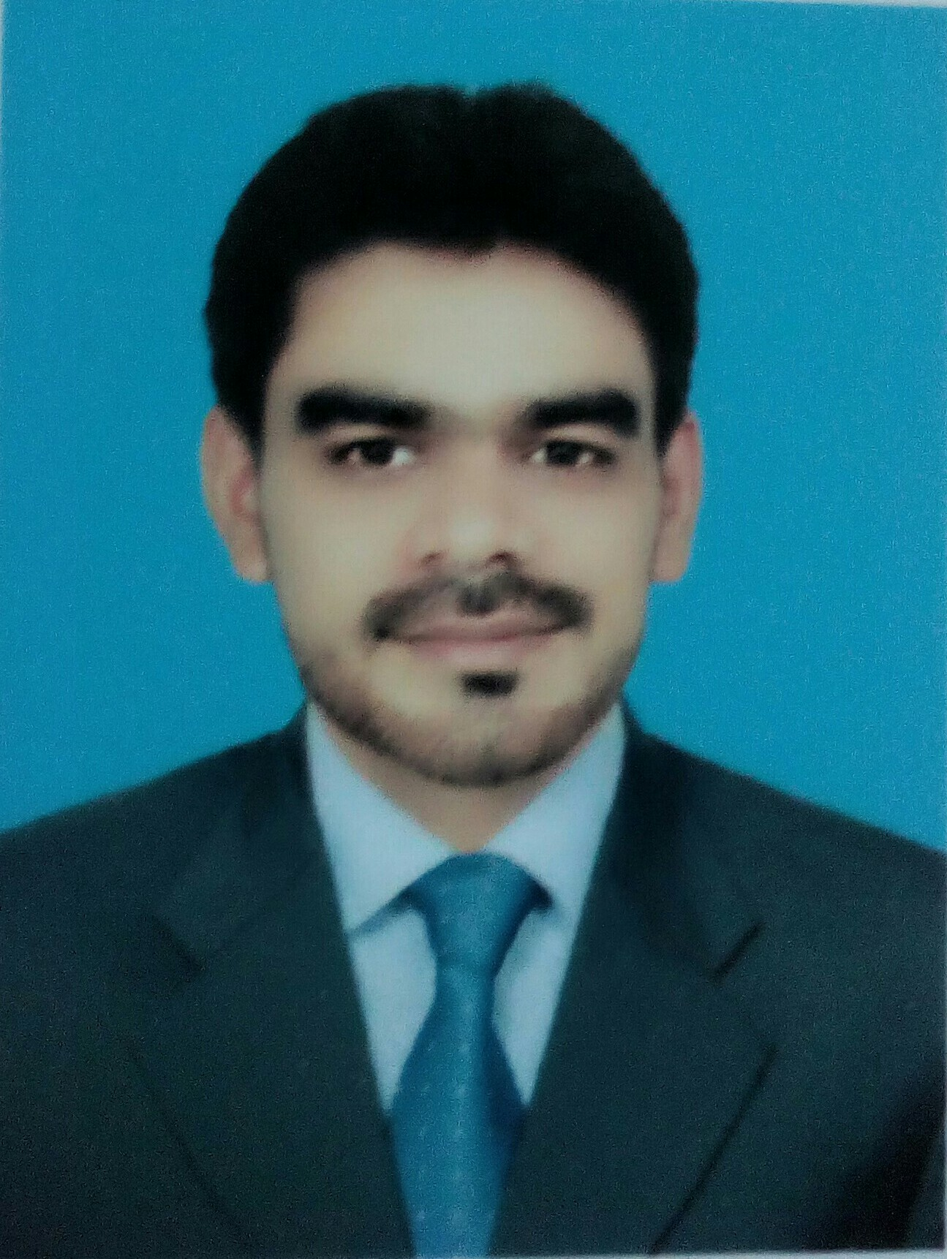
Curriculum Vitae of

Zaheer Ahmad

Pakistan

Cell : +923345254457
E-mail: Sheikhzaheer025@gmail.com

OBJECTIVE:

Seeking for a good opportunity in a growing dynamic institution to enhance my knowledge and contribute to the success of an organization through my in depth skills..

ACADEMIC TRANSCRIPTION:

- DAE civil Punjab board of technical education (Lhr) 2018
- Matriculation Federal board of intermediate and secondary education, Islamabad
2012

IT Skills:

- Microsoft Office (MS Excel)
Experience
- Internship

INTERESTS:

- Internet Browsing
- Travelling
- Sports
PERSONAL PROFILE:

Name: Zaheer Ahmad
Fathers Name: Maqbool Ahmad
Date of Birth: Mar 3, 1994
Address: Ho no: 08 St no: 05 Block "B" soan garden, Islamabad
Marital Status: Single
Religion: Islam
Nationality: Pakistani
Language Known: Urdu, English, Punjabi

Reference:
References will be furnished on request.

