CURRICULUM VITAE

OBJECTIVE:

To obtain a challenging position in a reputable organization. I want to work with a team of professionals and a well organized environment to enhance my abilities and skills to achieve the organizational goals.
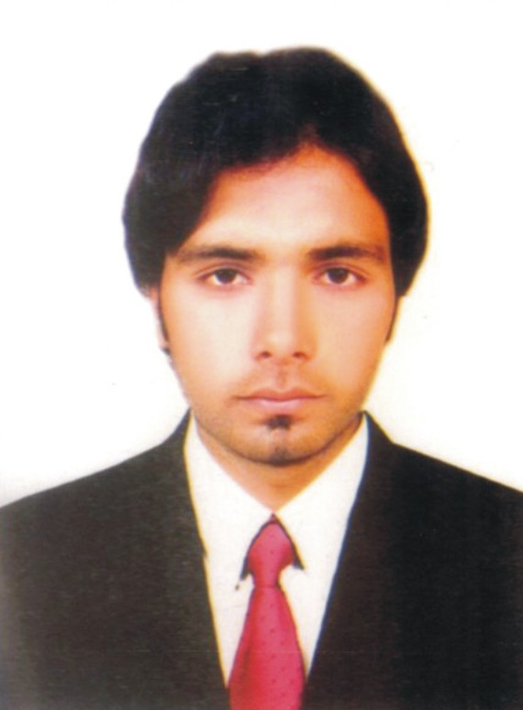
PERSONAL INFORMATION:

- Name : Sajjad Akram
- Father’s Name : Muhammad Akram
- Date of Birth : 18-01-1994
- Nationality : Pakistan
- Marital Status : Single
- Passport No. : CZ1321361
- Cell Phone No. : +971-552175965
- E-mail Address : doctorsajjad102@gmail.com
- Visa Status : Visit Visa
- Visa Expiry Date : 15th December, 2018
ACADEMIC QUALIFICATION:

Certificate/Degree | Board/Institute | Year | Subject
Metric | B.I.S,E Gujranwala | 2010 | Science
InterASS | Lahor Board | 2013

WORKING EXPERIENCE:

- Work experience as a security Guard in Aleena Center Gujrat Oct. 2013 To Jun 2015
- Work Experience as a security Guard Ravi Construction Company Gujrat Sept.2015 to August 2018
A COMPUTER SKILLS:

- Basic Knowledge of Computer
LANGUAGE:

- English , Urdu , Punjabi ,
REFRENCE:

- Will be furnished on Demand.

