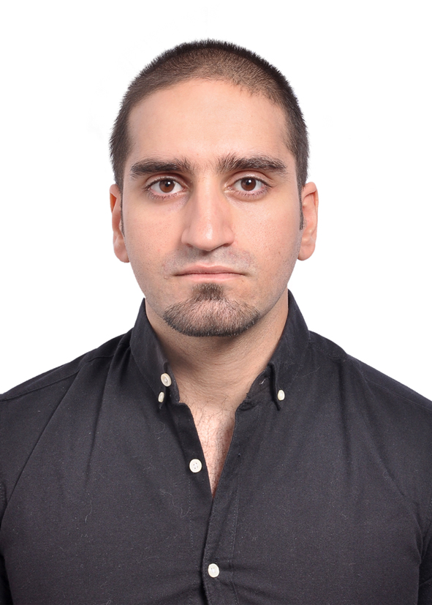
M. MAlik m. besiso
mmbsaiso@gmail.com, P.O.Box: 5855, SHARJAH, UAE, Mobile: +971-50-6368237
Objective
Carry on my career in a challenging position where I can prove myself, and improve my qualities, and make good use of my acquired skills through my Engineering education.

Education
September 2007 – January 2013 American University of Sharjah (AUS) - Sharjah, UAE
Bachelor of Science in Civil Engineering
Professional Experience

April 2018 – Until Now Traffic Engineer Engineer/ Parsons Corporation

- Calculate trip generation of all phases of developments based on Dubai Trip Generation and Parking Rates Manual (DTGM) and ITE Trip Generation Manual.

- Analyze and design traffic operations of internal and external junctions.

- Analyze the traffic operations of the interchanges.

- Identify traffic problems and coordinate with Highway Design team to produce working design solutions for junctions, interchanges and roads with adequate capacity to cover traffic demand.

- Calculate developments cost share based on Dubai Roads and Transport Authority (RTA) guidelines.

April 2014 – April 2018 Highway Design Engineer/ Parsons Corporation

- Meeting High profile clients and understanding their requirements for the project at hand

- Implementing the use of advanced software to deliver Horizontal alignments, Vertical alignments. Grading in addition to various tasks required by a highway engineer.

- Coordinating between clients and other involved parties in the project to meet deadlines with a high-quality submission.

- Conducting quality checks during the submission process for a project to minimize redundancy and minor faults.

Projects Worked on include but not Limited to the following:

- Al Etihad Road – RAK : Was involved in the follow-up between RAK Municipality and client (Marjan Island). Also, attended to concerns from the client and fixed them form technical point of view

- Al Zahia City Center - Sharjah: Took a Major part in the Design and development of the Access to the Mall
- Dubai Cycle Track – Dubai: Took a Major part in the Design and development of the Cycle track project in Dubai
- Remraam - Dubai: worked on getting Traffic Impact Studies (TIS) approvals from RTA Dubai
- Crown Plaza Service road Access - Dubai: Work on the enhancement of the crown plaza access to allow for smoother traffic flow.
- GEC - QATAR: Took part in this project that worked on the overall enhancement of the roads in various places in Qatar.
- JEWEL OF CREEK – Dubai: Was involved in the technical part of this project in tender stages
- SHINDIGA – Dubai: Took part in the design and development of the SHINDIGA Tunnel enhancement project in Dubai.

January 2013 – April 2014 Site Civil Engineer/ DLUSSO Facilities Supply

- Supervising Site Activities
- Meeting Established Timelines for the Work
- Ensuring all the Construction materials needed are Available on site

June 2012 – August 2012 Intern Civil Engineer/ Parsons Corporation

- Implementing the Geometric design manual for Dubai roads for hypothetical roads
- Learning design and modification process for ongoing projects
- Conducting progress reports for various projects
July 2008 – January 2013 Administrative Assistant / Office of Enrollment at AUS

- Aiding new students to fulfil the requirements for the admission process
- Evaluating the applicants’ status and acquire the approval for the university enrolment.
- Promoting the university’s unique programs by arranging school visits on/off campus

Relevant Skills

- Language Skills: Fluent in English and Arabic.
- Computer Skills: Excellent skills in Microsoft Office (very good experience in Adobe Photoshop, Bluebeam Revu)
- Synchro & SIDRA - Traffic Analysis/Simulation Software
- HCS – Highway Capacity Software
- VISSIM – Traffic Analysis/Simulation Software
- VISUM – Traffic Modelling/Forecast Software
- MicroStation & AutoCAD – Design & Drafting Software
- Auto-turn for Swept path Analysis

personal Skills

- Strong leadership skills with ability to motivate others
- Work well under pressure with Flexibility in multi tasking.
- Problem solver using analytical and logical thinking.
- Excellent communication skills including public speaking and group presentation skills.
- A team player with big energy and passion toward over delivery.
- Determined, self-starter who is willing to do whatever is required to achieve his goals.

personal information

- Place & Date of birth: Dubai, UAE. 25th February 1990
- Canadian Permeant Resident

References

Are available upon request

