# **Waste Education System Game Design**

### **Instruction：**

Waste Education System(WES) is aimed to help students to develop a good understanding of waste recycling process. Based on this purpose, WES should provide students with a lively interface so that they could realize the importance of waste management better. Game is a preferable method to achieve this goal. However, education is the major purpose, the game should play a key role in educating students. All games might be simple and partial, but the integration of them could establish a whole diagram form waste generating, waste storage, waste resorting or waste regenerating. So, all games should be organized according to this baseline, which is also called storyline in this paper.

#### **How to educate students the concept of waste management based on story line?**

One solution is to design the process like question solving, just as bellow:

* **How we manage(recycle/reuse) waste? (Game)**

1. Waste management at the Uni is divided into 4 recycling streams and is colour coded accordingly (see below). Refuse sorting is the major goal in this application, so interactive and impressive games must be applied to fulfil it.

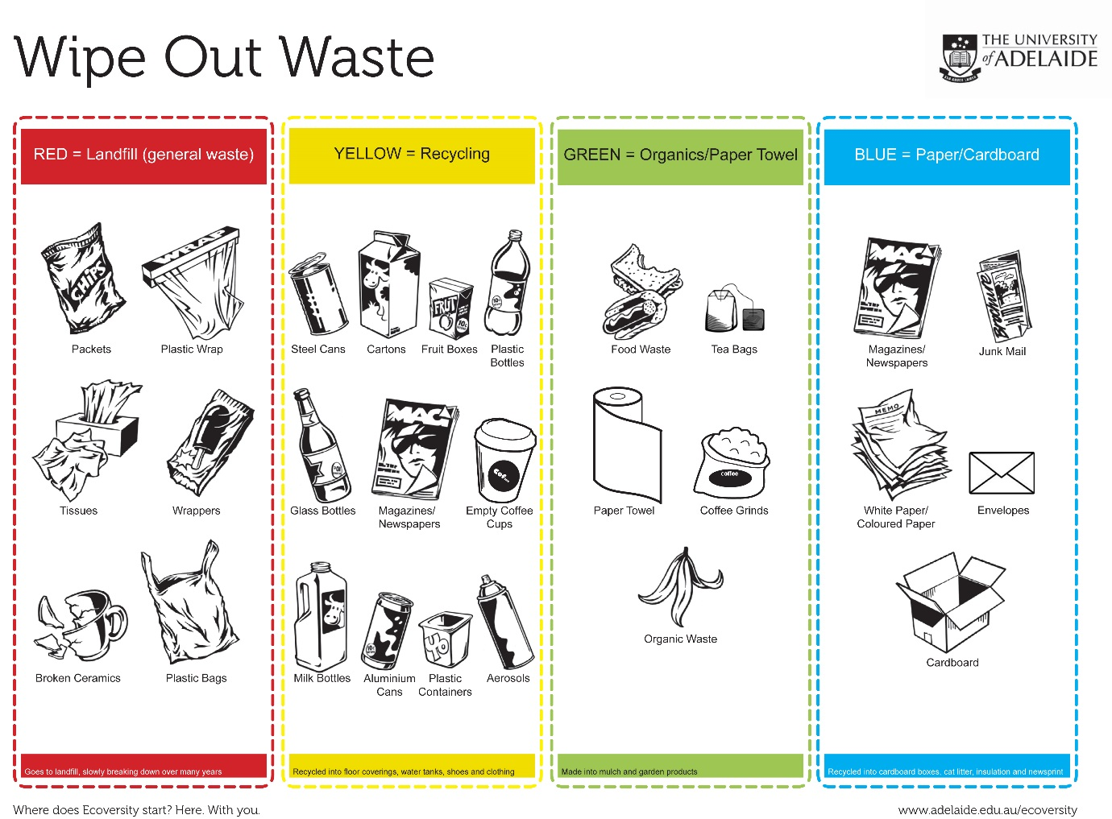

General waste management game usually only includes “How we manage(recycle/reuse) waste” this section. But I think it is not enough to tell the whole story of waste management. How waste is generated from daily life and the benefit of waste management are also very important, particularly the benefit section should be highly accentuated.

In this project, we define this story line the overall user experience of WES application.

User experience

Story Line

Figure1.User experience is the same as story line

What? (static pages)

Why? (games)

How? (games)

Result? (benefit)(games)

Story Line

Cognitive processes by users(students)

Figure2. Decomposition of story line

Based on this definition, this project will link games as a whole rather than separate games. That means, 4 games provided will abide by the sequence according to the story line. Students must fulfil the task of previous game, then he could go to the next one.

According to the cost and labour force invested in this project, we just use the **simple game** rather than complexed one to compose the story line.

1.Separate games could not build up a whole picture of aims.

2.Each game has less relationships with others, so it is not suitable for educating student to familiar with the entire waste management process step by step.

Figure4. Games without story line

**What**

**Why**

**How**

**Result**

Story Line

Game Line

Figure3. 4 games follow story line

**Game Line**

**First game: How we produce waste.**

This game is to let students to know we generate waste very commonly in daily life, such as if new paper is broken, it would be waste.

Before Click

(paper)

After Click

(broken paper/waste)

Score:30

Time:59

Figure4: 1st game

1. Commodity icons, such as paper, cans, emerges randomly in square grid, and they would disappear in a very short time.
2. Students should click those icons to get score. When a commodity icon is clicked, it would change into corresponding waste icon and then disappeared.
3. The time of commodity icon appearing would be shorter and shorter when the level of this game rises.
4. When the total time is used up, the game is over.
5. If a student gets required score, then he can get into next game.

**Second game: How to place these waste.**

This game is to let students to know that daily waste is becoming more and more. If we do not address this problem, the pollution would be quite serious and the storage space would also be used up.

Waste

(Falling down)

Protect Bar (controlled by user)

Earth

Figure5: 2ed game

1. Different types of waste with respective score fall down form the top of screen. The bottom is the image of earth. It looks like a bag. Initially, the colour of earth is light and respective.
2. Students should darg a protect bar above the earth to keep off falling waste. If success, he could get the score. If not, the waste would drop into the earth, the earth becomes a bit bigger, and the colour becomes darker.
3. If there are too many waste dropping into the earth, the earth would be broken, and the colour of it would be rather ugly. Then this game is over.
4. If a student gets required score, then he can get into next game.

**Third game: How to sort waste.**

This game is to let students to know we still have some effective ways to deal with those waste. One way is to sort them for recycling. This game is the most important one among 4.

Sequence of waste

Paper

Recycle

organic

land fill

Drag waste into correct bin

Figure6: 3rd game

1. There are different types of waste recycle bins on the top of screen.
2. There are different types of waste randomly in the sequence on the bottom. The left one is active and others are locked.
3. A student should drag the active waste into correct garbage bin. Then he can get score and at the same time get this recycled waste (This waste would be used in next game).
4. When an active waste is dragged into waste bin correctly, the next waste move to active position, others move ahead. A new wast is supplement in the last position.
5. If a student gets required score, then he can get into next game.

**Forth game: Waste can become treasure**

This game is also very important, it used the waste student sorted correctly in the last game, and then combine different amount and types of waste then get new resource which is called treasure in this game. Then combination rule could come from real recycle rules or virtual rules. For example, 3 recycled plastics and 1 recycled can could generate a treasure of blue stars. Some treasures are very easy to get, but some are really rear. The main purpose of this game is to let students to know that waste could also become useful resource, especially in this game, we highlight these resource as “treasure”.

3 Plastic bottles

1Can

The recycle waste collected form last game

Different waste group generates different treasure

If one can collect all treasures, he could get a real prize, such as a cup, from our university

Treasure1

Treasure2

Treasure3

Treasure4

Figure6: 4th game

1. Students must use the waste recycled form last game, and then make different group to get the final combination products.
2. If there are not enough recycled waste, student could go back to replay last waste resorting to get required waste.
3. Some treasures are hard to obtain, sometimes, it need students to exchange treasure between each other, students could use Facebook or other ways to ask friends for specific treasures, so it is more active than only virtual games.
4. If a student could collect all treasures (maybe 10), then he or her could get a real prize form university, like recycle bag or a cup.

Timeframe

|  |  |
| --- | --- |
| Design & app development | 2 May |
| Review 1 | 6 June |
| Re-develop | 25 July |
| Waste audit – baseline | 15 August |
| Review 2 | 15 August |
| Finalise | 22 August |
| Launch in the Hub | 5 September |
| Waste audit – evaluation | 12 September |