Zenobia Design and Development Log

Report of group xx

Queen Marry & BUPT

Qiu zhichao, Liang tianze , Xu yidan, Luo zhongjie, Li shuhang……

**2017XXXXX**

**Introduction**

Zenobia is a drawing robot with extended functions. It is based on one Integrated circuit and demonstration board and other functional modules. Zenobia has four main functions: remote control movement, drawing several basic geometric shapes, avoiding obstacle and mobile phone operation function. To achieve these capabilities, we use peripherals such as Bluetooth modules, speakers, remote controls, etc., and we also design a nice appearance. Our market position for Zenobia is an amazing gift. In order to extend all of Zenobia's charm to the users, we have made a website, which is a general e-commerce enterprise website. Our website has strong database support to protect the security and stability of shopping. We hope our website will allow visitors to shop comfortably and comfortably. In addition to the website, we have produced a video to show the shape and usage of the Zenobia.

Contents

I. Product Design and Development......................................................................4

1.1 Product Positioning and Function Planning...........................................................4

1.2 Logical Designing and Programming ........................................................................5

1.3 Monolithic integral circuit and peripheral equipment.......................................9

1.4 Appearance Designing and Production.................................................................13

1.4.1 Design thought............................................................................................................................13

1.4.2 Introspection and improvement.........................................................................................14

1.5 Planning and Management........................................................................................16

II. Company Website ................................................................................................. 18

2.1 General Introduction...................................................................................................18

2.2 Design Concept ..............................................................................................................18

2.3 Main Function ................................................................................................................19

2.4 Division of Work ...........................................................................................................24

2.5 Software ...........................................................................................................................24

III. Marketing Video .................................................................................................... 25

IV.Reference................................................................................................................26 Conclusion..........................................................................................................................27 Appendix............................................................................................................................. 28

**Product design and development**

***1.1 product positioning and function planning***

The name of our product is Zenobia, a drawing robot used as a gift. It is well known that there are thousands of different types of drawing robots on the market. We are working on the function and meaning of drawing robots, not only for drawing operations, but also for a beautiful decoration.

The appearance of the Zenobia was a steam steamship in industrial era. You can control the route by means of a special remote control attached to it, and it will “sail” as you wish. If you choose to draw graphics, it will leave your choice of graphics in the "navigation" in the process of trajectory (never mind keep the car on the drawing function of large enough paper, otherwise you will become the No. Zenobia floor board). Of course, you can also download a dedicated cell phone, App, to operate it via bluetooth.

When your guest praises a steam ship model on a shelf, who can think of it as a fully functional drawing robot?

**The preferred features of the Zenobia are as follows:**

1 remote control function

The user can operate the Zenobia by using a dedicated remote controller, or by means of an exclusive mobile App. The user can control it, move forward, backward, turn left, turn right, draw graphics, and so on.

2 drawing function

Once the drawing instruction is received, the Zenobia will execute the instruction for plotting until the drawing is done.

3 obstacle avoidance function

Zenobia has advanced ultrasonic obstacle avoidance capabilities, and if obstacles are encountered during the progress, the Zenobia will determine the space on the left and right of the obstacle and turn to a larger direction. If an obstacle is encountered during drawing, the Zenobia will stop drawing automatically.

4 whistle function

The Zenobia can mimic the steam boat siren sounds and users can operate via the remote control or cell phone App.

In addition, we consider four aspects in the design and manufacturing process:

5 appearance

Since the Zenobia is designated as a gift, its exquisite appearance requires it to occupy a space in the living room and attract guests' attention. As an ornament with special functions, it also needs strong stability.

6 security

Security is the most important aspect we need to consider. Because the Zenobia has sophisticated circuitry inside, we must make sure that the user does not touch the circuit components. In addition, make sure that the shell is not damaged by minor collisions, thus exposing the circuit and affecting the appearance.

7 convenience

A good product should be easy to use. For example, if a user is remotely operated, the response is always slower than expected, or even fails, and the user will have a bad impression of it. Therefore, we should consider how to design the method is used so that it can react quickly.

8 stability

We hope that the product can perform its function more stably, and will not lose accurate drawing and obstacle avoiding ability because of the slight power shortage, and hope that the circuit will not break because of the simple collision. Therefore, we consider upgrading the product as well as the stability of its internal program.

1.2逻辑设计与编程

***1.3 integral circuit and peripheral equipment***

***1.3.1 design principle***

We use Arduino uno board as the control module, according to different code processing different input, and output to the motor, to achieve the purpose of moving and drawing.

In this process, we learned and used Proteus and Protel to connect the motor, the steering gear and all kinds of sensors together, and realize the basic functions. As shown in the following figure:

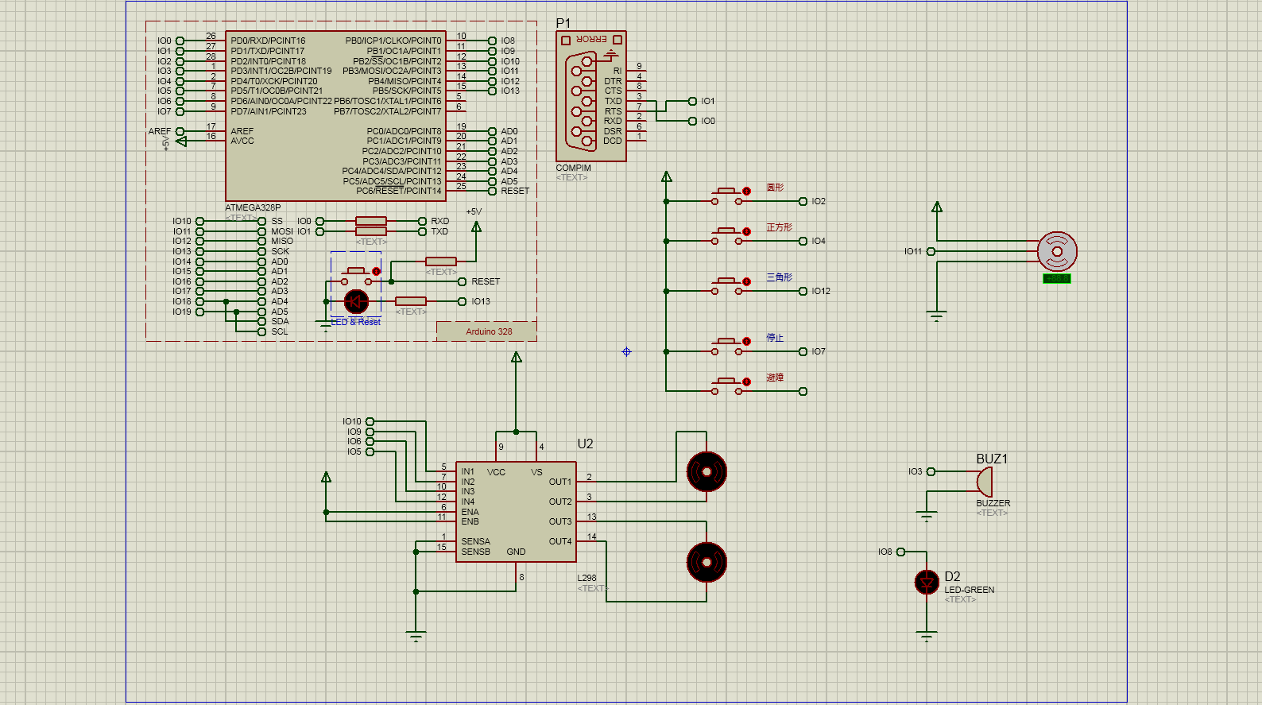

(Because of the software, some sensors cannot be used directly, so we choose other devices instead, and the overall function can still be achieved)

Because of the constraints of the interface, we input the signal to the input signal from the button, and only set up the basic simple action. when press the circle, IO2 will receive a high level, after encoding processing, two motors will receive different signals and change in different degrees, IO11 will by rotating a certain amplitude and cycle back to the original point of view, while buzzer and LED will change accordingly, at the end of the process, the paper will get a fine round. Accordingly, if the square is pressed, the IO4 will accept a high level, and the UNO board outputs the signal to the motor according to another corresponding code and draws the correct image. If you press the triangle, IO12 will accept a high level, and the UNO board will control the motor according to another corresponding code and draw the corresponding image. If press stop, IO7 will accept a high level, all motors will receive high potential so that the motor will stop and the car will stop. Other functions are not shown in the simulation interface due to limited interface, but the basic principle is the same, you can complete all the functions of the car according to the map.

Motor drive module:

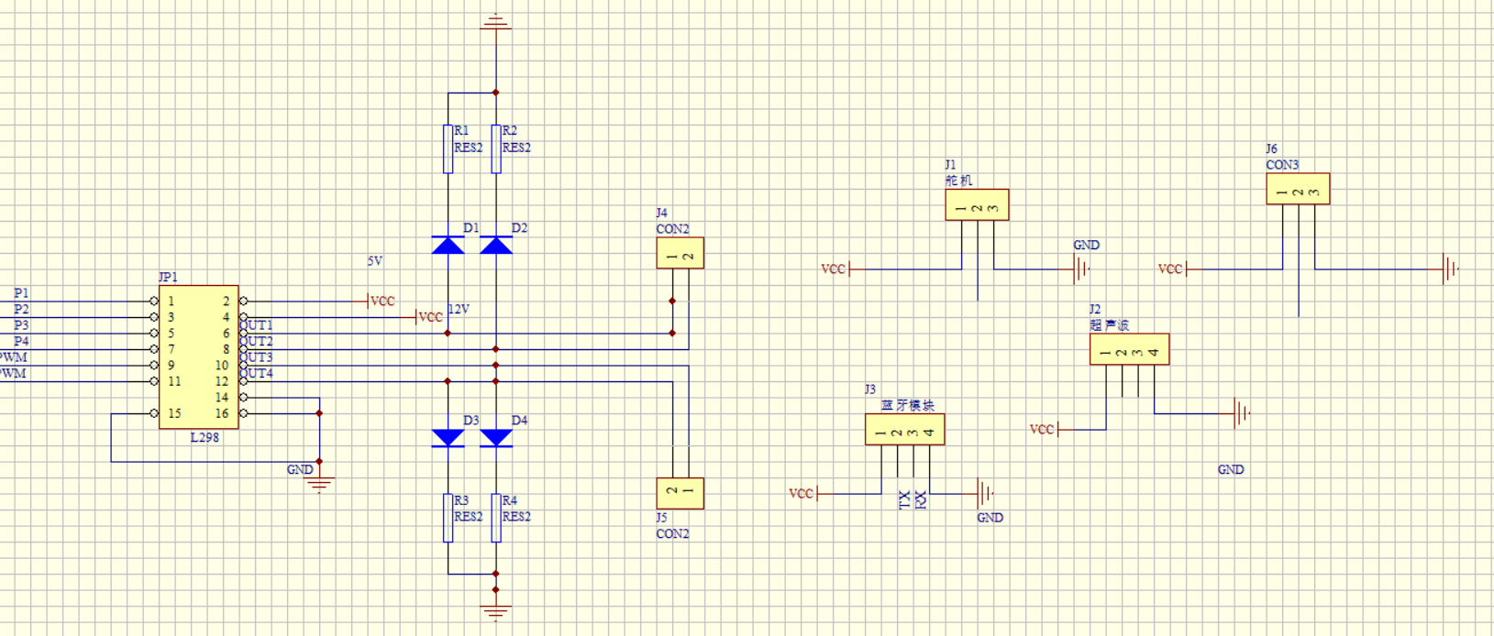

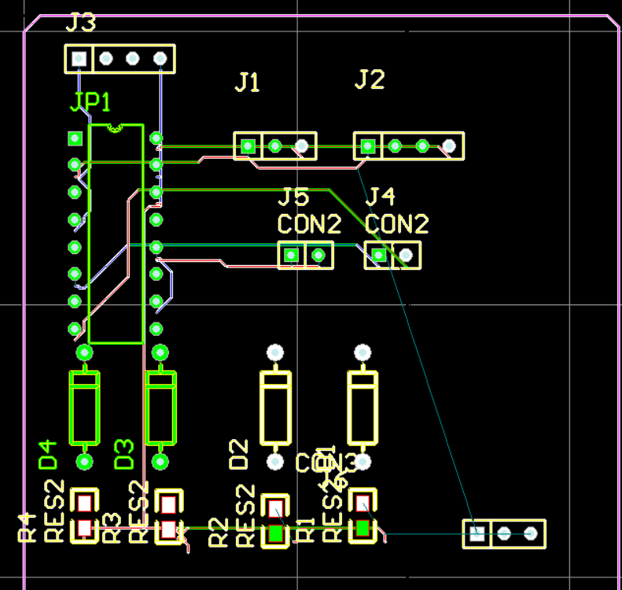

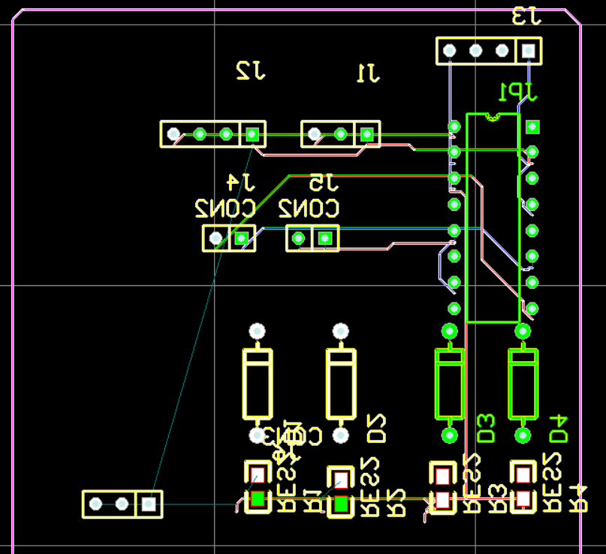

Power supply system

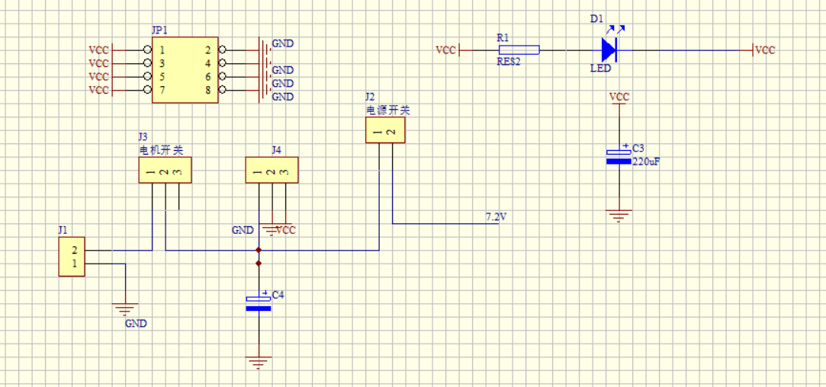

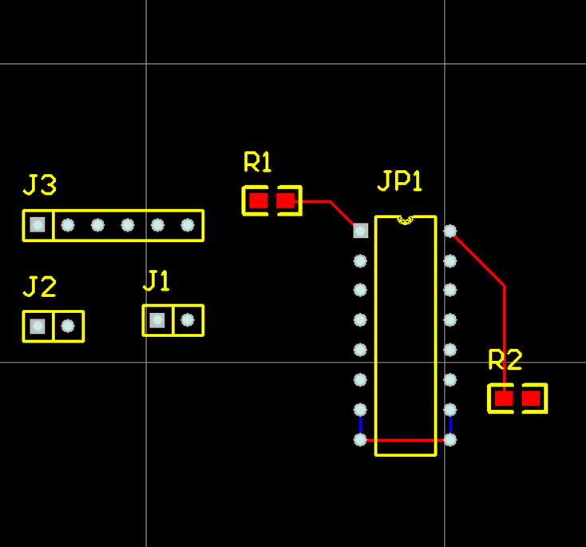

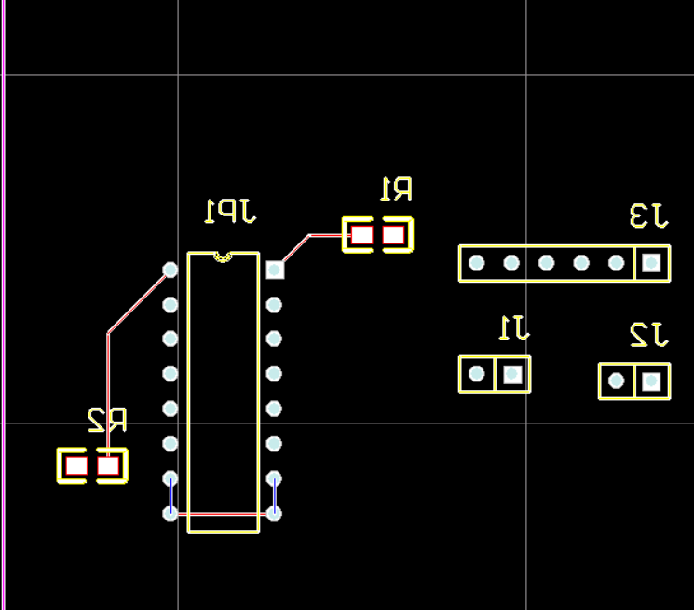

Infrared sensor module

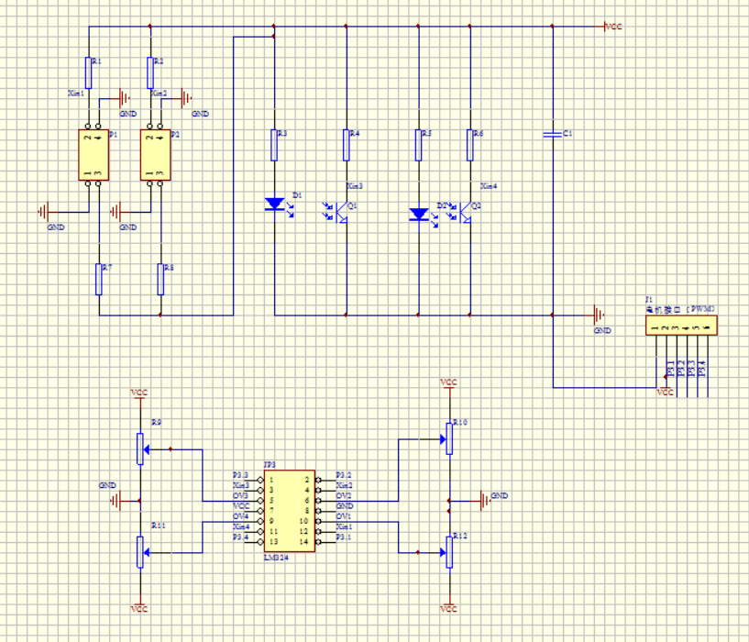

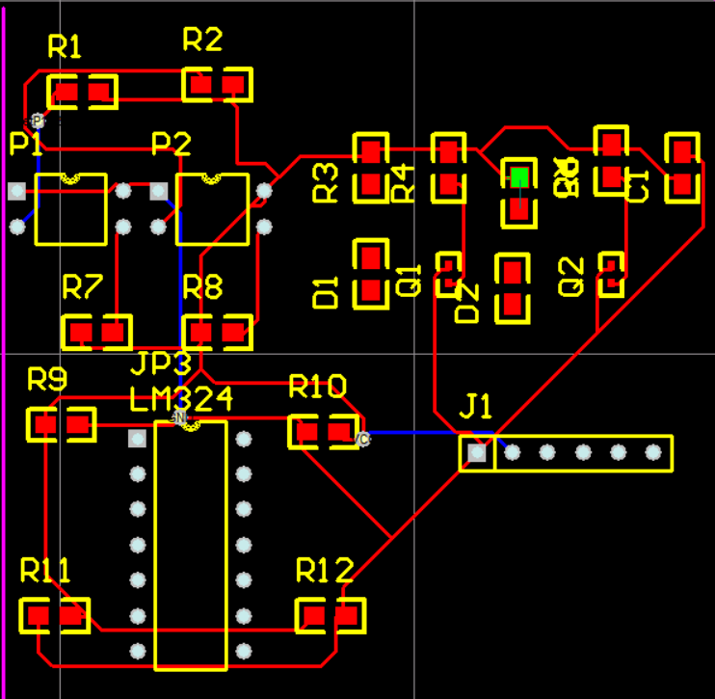

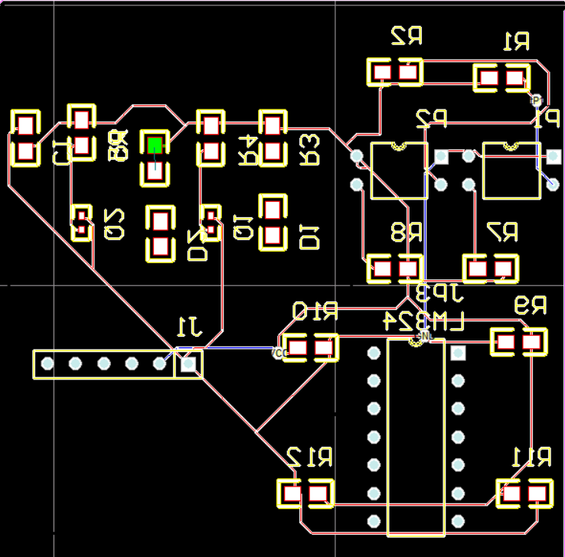

***1.4 appearance design and production***

***1.4.1 design idea***

For part of the design, we focus on several main aspects:

1 material selection

In order to ensure the drawing function of the robot can keep stable, reduce unnecessary power consumption, the Zenobia Design Group product portability is an important factor to consider in the choice of the materials. In the beginning, we chose the thin wood, but found its weight and hardness exceeded our expectations, after a period of research, we found a lighter, and the plasticity of the chevron board as the main material to make the shell, and use printing coated paper making fine appearance texture. As for adhesive, we chose the 502 to ensure the stability, to avoid the poisonous gas, dry for a few days, to ensure the safety and no pollution. And in the crevice, we chose the sealed glue to fill the gap, strengthen the appearance, make it more suitable for careful appreciation. Its portability also ensures that the drawing robot does not produce unnecessary waste of electricity due to the influence of weight, but also convenient for younger users and play, but also strong assurance, not easily broken.

2 creative

After a detailed discussion of the members of the group, we made a decision. First of all, we plan to target it as a beautiful gift. Next, we believe that the interior structure of the car fits perfectly with the appearance of the steam steamship in the industrial age. We built a preliminary look using CAD, and then adjusted it according to the actual function. We designed the electric indicator light in the captain's room, set the horn in the whistle position, made the appearance of the steam boat closer to reality, and tried to reflect the romantic feeling of steam punk in the industrial age.

***1.4.2 introspection and improvement***

3 design

After making the initial idea, we produced engineering drawings for Zenobia. In the design process, we also face many problems, for example, the lack of professional industrial design experience. So it took us a long time to search the Internet and for books to find ideas that fit our design ideas, engineering drawings have been revised many times to meet the standards.

4 manufacturing

To put the integrated circuit board inside and protect, the robot's shell must be thick enough, about 3-5mm. And does not affect the wheel rotation. Smooth chevron board we choose to meet the requirements. A difficult problem is the motor and the chassis is not fit, so we were covered with a layer of paste in the chevron board used to support the top of the motor. And the tyres don't agree with the click size, and we do extra reinforcement. Another problem is how to fix the shell. We use a combination of mortise and tenon to make it stable on the chassis without affecting the circuit.

5 draw AutoCAD pictures

In fact, we haven't learned much about modeling before. Before starting modeling, we looked at a number of related tutorials and books to see how to use it. We found that although CAD is not a good 3D modeling software, its full size setting function enables us to produce more accurate designs when designing. Although the final product was partially adjusted for the new features that were temporarily added, the design of the CAD still made us very smooth.

The success of a product is never to blame for one person, but to the success of our entire team.

This is a screenshot of our CAD modeling

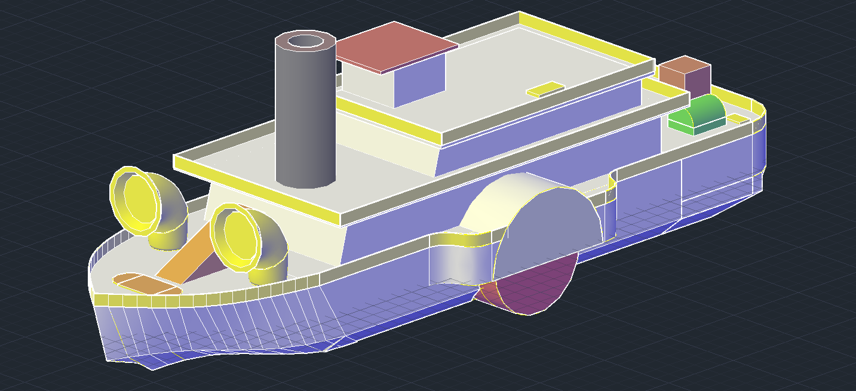

**Time planning**

7.4 learning basic knowledge and circuit soldering

7.5 learning about software usage and installation software (Proteus, CAD, PROTEL, Arduino)

7.6 assign tasks according to the workload (Qiu zhichao and Luo zhongjie are responsible for Proteus simulation, Liang tianze is responsible for CAD, Li shuhang is responsible for Protel, and Xu xiaodan is responsible for Arduino)

7.7 according to the assigned work, began to learn their own work

7.8-7.10 study and work for a period of time and exchange experience with each other

7.11, the collective went out to purchase the task materials, and began to make the appearance

7.12, each task is completed, start debugging and repair small bug

7.13 ask the teacher for detailed acceptance of the project, and continue debugging.

7.14 acceptance trolley

7.15-9.15 during the summer vacation, they study related technical problems, and often exchange experience

9.16-9.21 complete mission reports and related materials

**Team meeting:**

7.6: the meeting highly evaluated the benefits of the experiment, and decided to appoint Qiu Zhichao and Luo Zhongjie as Proteus heads; Liang Tianze is responsible for the CAD project; Li Shuhang is responsible for Protel; Xu Xiaodan is responsible for arduino.

7.9: the meeting confessed their situation which they accept, exchanging experience, found Proteus and Arduino and the appearance of surplus labor force, making the pressure too large, the meeting decided to assign Qiu Zhichao to help to complete Arduino, Luo Zhongjie to help complete the appearance of production.

7.10: summary of the completion of each link, according to the 7.9 meeting re allocation of manpower, and decided to purchase materials in 7.11, the cost of procurement staff to share by all.

7.13: summing up the task, ready for acceptance

8.20: a WeChat conference, exchange the research experience.

9.17: the meeting decided to complete the corresponding part of the report, in the unified integration.