PROJECT DOCUMENTATION
WhatNext Vision Motors
Shaping the Future of Mobility with Innovation and Excellence
A Salesforce CRM Implementation (NM Project)
Project Title | WhatNext Vision Motors: Shaping the Future of Mobility with Innovation and Excellence
College / University | 2124 – Sree Sastha Institute of Engineering and Technology

Team Details
Role | Name | Registered Email ID
Team Lead | P Kishore | kishorep996@gmail.com
Team Member | Kishore Kanna S | kishorekannas147@gmail.com
Team Member | Prashanth T | prashantharasu05@gmail.com

User Story
WhatNext Vision Motors is an automotive company that wants buying and servicing a vehicle to feel simple for customers while removing repetitive work for its own staff. This project delivers a Salesforce CRM application that keeps vehicles, dealers, customers, orders, test drives and service requests together in one connected system.
A customer is registered with contact details and an address, picks a vehicle and places an order. Before the order is accepted, the system checks stock, so a vehicle that is out of stock cannot be ordered. Orders that are still Pending are picked up by a scheduled process that runs every day, confirms them once stock is available and keeps the stock count accurate. The customer also gets an email reminder before a booked test drive, and an automated flow looks up the dealer whose location matches the customer's address.

Features implemented
- Six custom objects (Vehicle, Vehicle Dealer, Vehicle Customer, Vehicle Order, Vehicle Test Drive, Vehicle Service Request) with lookup relationships
- A WhatNext Vision Motors Lightning app with a tab for every object
- Record-triggered flow to find the dealer that matches the customer's address
- Record-triggered flow with a scheduled path that emails a test drive reminder one day before
- Apex trigger with a handler class that blocks out-of-stock orders and reduces stock when an order is confirmed
- Batch Apex and Scheduled Apex that confirm Pending orders every day

Key user stories
- As a customer, I want the nearest dealer suggested from my address so that I do not have to search for one myself.
- As a customer, I want to be stopped from ordering an out-of-stock vehicle so that I am not disappointed later.
- As a sales coordinator, I want Pending orders confirmed automatically once stock is available so that I do not check inventory by hand.
- As an inventory manager, I want stock to reduce automatically when an order is confirmed so that inventory figures stay accurate.
- As a customer, I want a reminder email before my test drive so that I do not miss the booking.
- As a service advisor, I want to log service requests against a customer and vehicle so that servicing is organised and traceable.

Business requirements fulfilled
- Store and manage vehicle, stock, dealer and customer information in Salesforce
- Track orders, test drives and service requests in one place
- Prevent orders for vehicles that are out of stock
- Match orders to dealers based on location
- Send automated test drive reminders
- Update order status automatically through scheduled batch processing

1. Introduction

1.1 Project Overview
WhatNext Vision Motors needed a modern way to handle vehicle ordering and dealership operations. This project builds that on Salesforce. The application records vehicles and dealers, validates stock when an order is placed, links customers to dealers, reminds customers about test drives and updates order status on a schedule. It replaces manual and disconnected processes with one automated platform, which saves staff time and gives customers a clearer, faster experience.

1.2 Purpose
The purpose of the project is to bring vehicle ordering, stock control, dealer matching and customer communication under one Salesforce CRM. By reducing manual effort, the application aims to remove order errors, keep stock figures reliable, make order status easy to track and improve overall productivity for both the company and its customers.
Different stakeholders benefit in different ways:
- Customers get availability checks, a matching dealer and test drive reminders.
- Operations managers get accurate stock and fewer manual follow-ups.
- Dealer managers receive orders that are already linked to their location.
- Inventory managers see stock that updates automatically as orders are confirmed.

2. Ideation Phase

2.1 Problem Statements
The table below captures the main problems faced by each user of the application before a CRM was in place.
PS | I am | I am trying to | But | Because | Which makes me feel
PS-1 | Operations Manager | manage vehicle orders and stock | stock details are kept manually in registers and sheets | the systems are disconnected | stressed
PS-2 | Customer | place a vehicle order | I cannot tell whether the vehicle is available | updates reach me late | uncertain
PS-3 | Dealer Manager | receive orders from customers near my showroom | orders are passed on by hand and sometimes reach the wrong dealer | nothing matches customers to dealers by location | overloaded
PS-4 | Inventory Manager | keep stock counts correct | I update stock manually after every order | orders and inventory are not linked | worried about errors
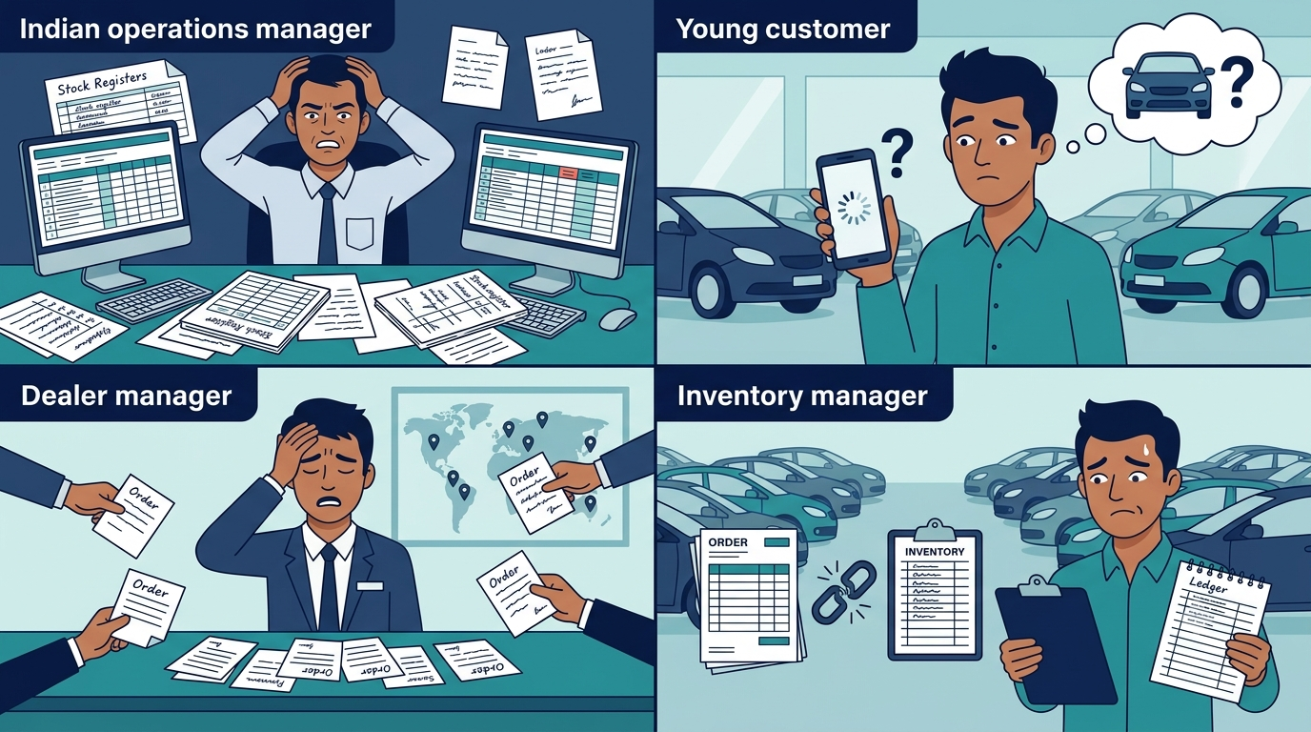

2.2 Empathy Map Canvas
An empathy map was prepared for each main user persona.

Persona 1: Customer
Role | Customer
Primary responsibility | Chooses a vehicle, places an order, books test drives and raises service requests
Think & Feel | Wants to find the right vehicle quickly and is worried about ordering something that cannot be delivered
Hear | Stories from friends and reviews about delayed deliveries and unclear order status
See | Vehicle details, dealer locations and stock information that is often unclear
Say & Do | Calls dealers to ask about availability and repeatedly checks the status of an order
Pain | Waiting for confirmation and not knowing whether stock exists
Gain | Instant clarity on availability, a nearby dealer, clear order status and timely reminders
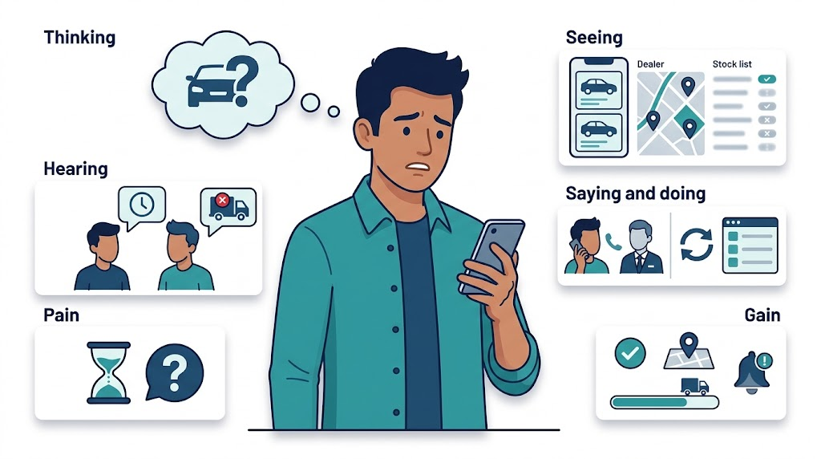

Persona 2: Operations Manager
Role | Operations Manager
Primary responsibility | Oversees vehicle orders and stock across dealerships
Think & Feel | Concerned about wrong orders and stock errors
Hear | Complaints from dealers and customers about delays
See | Registers and spreadsheets that rarely match each other
Say & Do | Follows up manually with dealers and updates stock by hand
Pain | Delays, cancellations and time lost reconciling data
Gain | Automation and one reliable source of information

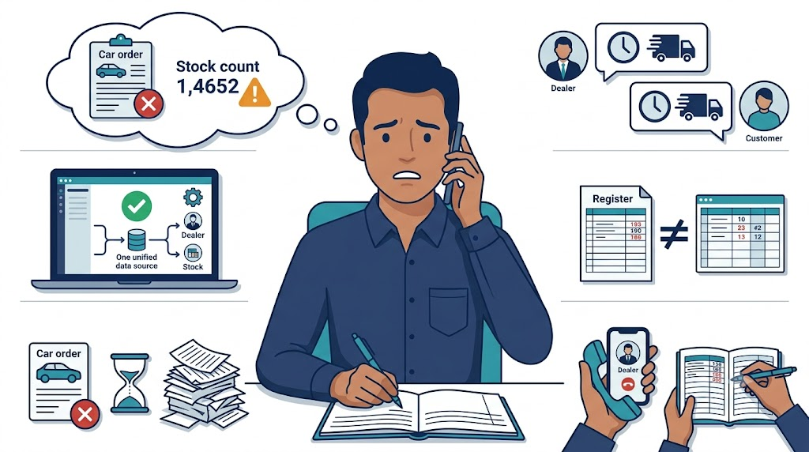

Persona 3: Dealer Manager
Role | Dealer Manager
Primary responsibility | Handles orders, test drives and servicing for a single dealership
Think & Feel | Wants to serve nearby customers well and know what is coming
Hear | Customers asking for test drive slots and delivery dates
See | Order details arriving by phone or email in no fixed format
Say & Do | Confirms test drives and coordinates deliveries manually
Pain | Orders that arrive late or at the wrong dealership
Gain | Orders routed automatically and a clear schedule of test drives

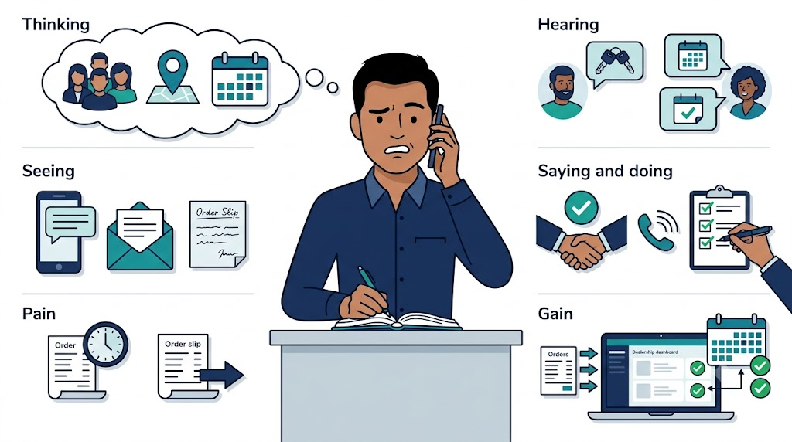

2.3 Brainstorming and Idea Prioritization
Idea considered | How it would work | Limitation
Manual registers | Staff record orders and stock in paper or document registers | Slow, error-prone and no live view of stock
Spreadsheet tracking | Shared sheets hold stock and order details | Version conflicts and no automation
Standalone portal | A custom web portal built separately | High build and maintenance cost, and separate from customer data
Salesforce CRM | Objects, flows and Apex working together on one platform | Needs some initial configuration effort

Final selection: Salesforce CRM was chosen because it offers:
- Automation of stock checks, dealer matching, reminders and order processing
- Scalability as more vehicles, dealers and customers are added
- Real-time visibility of orders and stock for every role
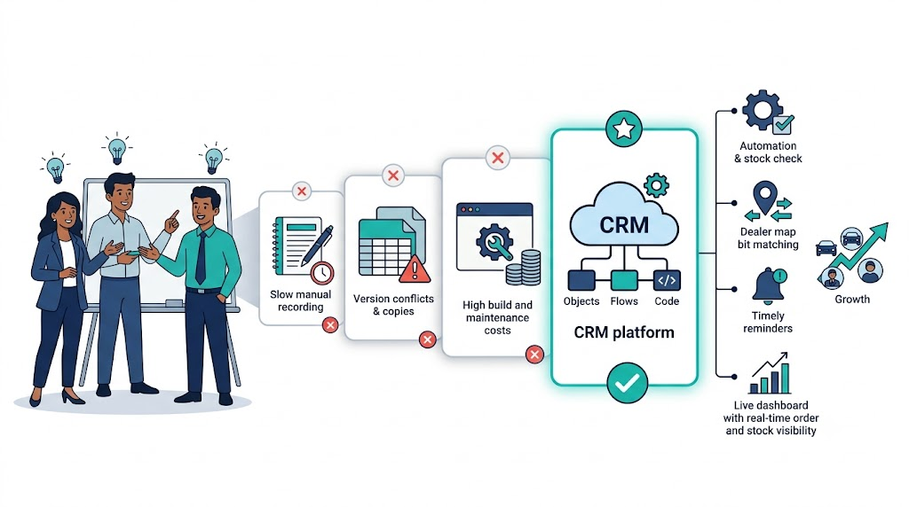

3. Requirement Analysis Phase

3.1 Customer Journey Map
The journey follows a customer from the first enquiry through to servicing after delivery.
Stage | What the customer does | What the system does
Inquiry | Contacts WhatNext Vision Motors about vehicles | Customer details are saved in the Vehicle Customer object
Vehicle selection | Chooses a vehicle model | Vehicle details, price and status come from the Vehicle object
Order placement | Places an order for the vehicle | A Vehicle Order record is created with status Pending
Dealer assignment | Waits for a dealer to be allocated | A flow finds the dealer whose location matches the customer's address
Stock validation | Expects the vehicle to be available | A trigger blocks the order if stock is zero
Test drive | Books a test drive | A Vehicle Test Drive record is created and a reminder email is sent one day before
Confirmation | Receives a confirmed order | Status becomes Confirmed and stock is reduced, either at once or by the daily batch job
Service | Raises a service request after delivery | A Vehicle Service Request record tracks it from Requested to Completed
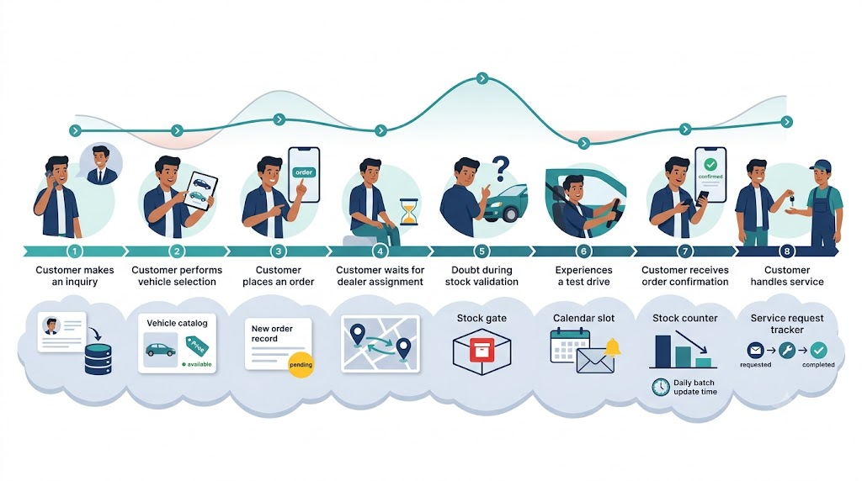

3.2 Solution Requirements

Functional requirements
FR No | Requirement | How it is delivered
FR-1 | Vehicle management | Vehicle object with model, price, stock quantity and status
FR-2 | Dealer management | Vehicle Dealer object with location, code and contact details
FR-3 | Customer management | Vehicle Customer object with contact details, address and preferred vehicle type
FR-4 | Order creation and tracking | Vehicle Order object with statuses Pending, Confirmed, Delivered and Canceled
FR-5 | Stock validation | Apex trigger and handler block orders when stock is zero
FR-6 | Dealer assignment | Record-triggered flow matches dealer location with customer address
FR-7 | Test drive scheduling and reminders | Vehicle Test Drive object and a flow with a scheduled path that emails one day before
FR-8 | Automated order processing | Batch Apex and a Schedulable class confirm Pending orders every day
FR-9 | Service request tracking | Vehicle Service Request object with statuses Requested, In Progress and Completed

Non-functional requirements
Requirement | Description
Usability | Lightning app with one tab per object for easy navigation
Security | Salesforce profiles and field-level security control who can see and edit data
Reliability | The trigger, flows and batch job apply the same rules every time
Performance | Orders are processed in batches of 50 and the Apex code works on collections, so it handles bulk records
Availability | Cloud-hosted on Salesforce and reachable at any time
Scalability | New vehicles, dealers and customers are simply new records; batch size can be tuned
Maintainability | A trigger handler class keeps business logic out of the trigger itself

3.3 Data Flow Diagram
Data moves through the application in the following order:
- Customer and order details are entered in Salesforce.
- A Vehicle Order record is created with status Pending.
- The Apex trigger checks the stock of the selected vehicle and rejects the order with an error message if stock is zero.
- The record-triggered flow reads the customer's address and looks up the dealer with a matching location.
- When an order is Confirmed, the handler reduces the vehicle's stock quantity by one.
- Every day the batch job checks Pending orders, confirms those with available stock and updates the stock.
- For test drives, the flow emails the customer one day before the scheduled date.
- Users view the results in the WhatNext Vision Motors Lightning app.
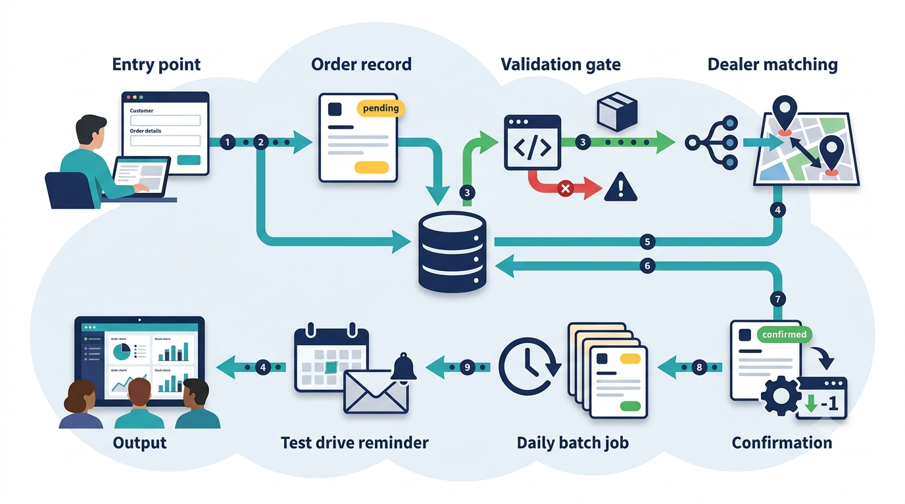

3.4 Technology Stack
Layer | Technology
User interface | Salesforce Lightning app with custom object tabs
Database | Salesforce custom objects, fields and lookup relationships
Process automation | Record-triggered flows with a scheduled path
Business logic | Apex trigger and trigger handler class
Scheduled processing | Batch Apex and Scheduled Apex
Development tools | Salesforce Developer Org, Setup and Developer Console

4. Project Design Phase

4.1 Problem-Solution Fit
Each problem identified earlier is matched with the feature that solves it.
Problem | Solution | Why it fits
Orders can be placed for vehicles that are out of stock | Apex trigger and handler | Checks stock before the order is saved and shows a clear error
Orders are not matched to a dealer | Record-triggered flow | Looks up the dealer whose location matches the customer's address automatically
Pending orders wait for staff to re-check stock | Batch Apex scheduled daily | Confirms orders as soon as stock is available without manual work
Customers forget their test drive | Flow with a scheduled path | Sends a reminder email one day before the date
Information is spread across registers and sheets | Six connected custom objects and a Lightning app | Keeps all data in one place with clear relationships

4.2 Proposed Solution
Parameter | Description
Problem | Manual and disconnected vehicle ordering, stock tracking and dealer coordination
Solution | A Salesforce CRM application with automation built from flows, Apex and scheduled jobs
Innovation | Automatic dealer matching, stock-aware order validation and daily order confirmation
Impact | Faster order handling, fewer errors and more accurate stock information
Business model | Supports a network of dealers selling and servicing vehicles under one brand
Scalability | Handles more dealers, vehicles and customers by adding records, with no redesign

4.3 Solution Architecture
Layer | Components
Data | Vehicle, Vehicle Dealer, Vehicle Customer, Vehicle Order, Vehicle Test Drive and Vehicle Service Request objects
User interface | WhatNext Vision Motors Lightning app and object tabs
Automation | Auto Assign Dealer flow and Test Drive Reminder flow
Business logic | VehicleOrderTrigger and VehicleOrderTriggerHandler
Scheduled processing | VehicleOrderBatch and VehicleOrderBatchScheduler

Object relationships
Child object | Lookup field | Parent object
Vehicle | Dealer | Vehicle Dealer
Vehicle Order | Customer | Vehicle Customer
Vehicle Order | Vehicle | Vehicle
Vehicle Test Drive | Customer | Vehicle Customer
Vehicle Test Drive | Vehicle | Vehicle
Vehicle Service Request | Customer | Vehicle Customer
Vehicle Service Request | Vehicle | Vehicle
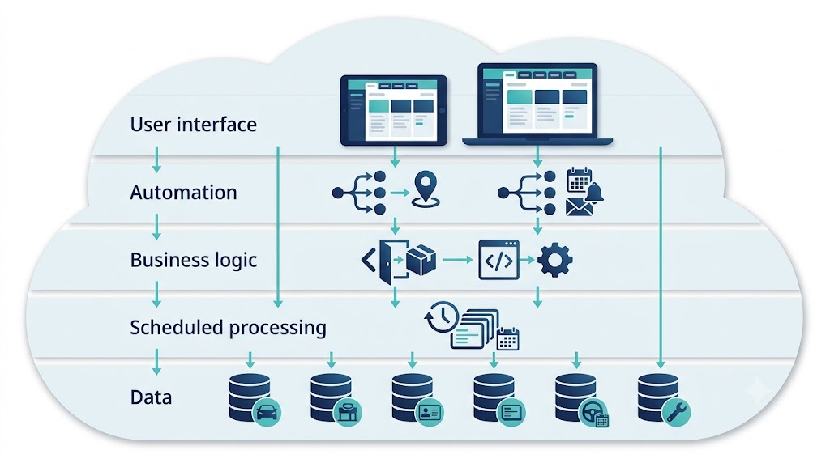

5. Project Planning and Scheduling

5.1 Project Planning
- The project followed the Agile methodology and was divided into sprints.
- Work was organised as epics, user stories and story points.
- Each sprint finished a block of work before the next one began.
- Velocity (story points completed per sprint) was used to judge progress.
- Tasks were shared among the three team members, as shown in the backlog below.

Product backlog and sprint schedule
Sprint | Functional requirement (Epic) | USN | User story / task | Story points | Priority | Team member
Sprint-1 | Developer Setup | USN-1 | As a system administrator, I want to create and verify a Salesforce Developer Org so that the team has a shared environment to build the application. | 3 | High | P Kishore
Sprint-1 | Developer Setup | USN-2 | As a team member, I want a clear user scenario for the project so that everyone builds towards the same business requirements. | 2 | High | Kishore Kanna S
Sprint-2 | Data Modeling | USN-3 | As an admin, I want Vehicle and Vehicle Dealer objects so that vehicle and dealer information is stored in one place. | 3 | High | Kishore Kanna S
Sprint-2 | Data Modeling | USN-4 | As an admin, I want Vehicle Customer, Vehicle Order, Vehicle Test Drive and Vehicle Service Request objects so that customer activity can be tracked. | 5 | High | Prashanth T
Sprint-2 | Data Modeling | USN-5 | As a staff member, I want a tab for every object and a WhatNext Vision Motors Lightning app so that I can navigate the application easily. | 5 | High | P Kishore
Sprint-3 | Fields and Relationships | USN-6 | As an admin, I want key fields on Vehicle and Vehicle Dealer (model, price, stock quantity, status, location) so that complete vehicle and dealer details are captured. | 5 | High | Kishore Kanna S
Sprint-3 | Fields and Relationships | USN-7 | As an admin, I want lookup relationships between vehicles, dealers, customers and orders so that related records are connected. | 3 | High | Kishore Kanna S
Sprint-3 | Fields and Relationships | USN-8 | As an admin, I want the remaining fields on Customer, Order, Test Drive and Service Request objects so that every record holds the details it needs. | 5 | High | Prashanth T
Sprint-4 | Automation | USN-9 | As a sales coordinator, I want the nearest dealer found automatically when an order is created so that orders reach the right dealership faster. | 5 | High | Prashanth T
Sprint-4 | Automation | USN-10 | As a customer, I want a reminder email before my test drive so that I do not miss it. | 4 | Medium | Prashanth T
Sprint-5 | Apex and Batch | USN-11 | As a system, I want an Apex trigger and handler that block out-of-stock orders and reduce stock on confirmation so that inventory stays correct. | 5 | High | P Kishore
Sprint-5 | Apex and Batch | USN-12 | As an inventory manager, I want a scheduled batch job to confirm Pending orders when stock is available so that nobody has to check stock manually. | 5 | High | P Kishore

Project tracker, velocity and burndown chart
Sprint | Total story points | Duration | Sprint start date | Sprint end date (planned) | Story points completed | Sprint release date (actual)
Sprint-1 | 5 | 1 days | 29/08/26 | 29/08/26 | 5 | 29/08/26
Sprint-2 | 13 | 2 days | 30/08/26 | 01/09/26 | 13 | 01/09/26
Sprint-3 | 13 | 1 day | 01/09/26 | 02/09/26 | 13 | 01/09/26
Sprint-4 | 9 | 2 days | 01/09/26 | 02/09/26 | 9 | 02/09/26
Sprint-5 | 10 | 1 day | 02/09/26 | 03/09/26 | 10 | 03/09/26

Velocity: total story points across the five sprints = 50, so the average velocity = 50 / 5 = 10 story points per sprint.
Burndown chart:
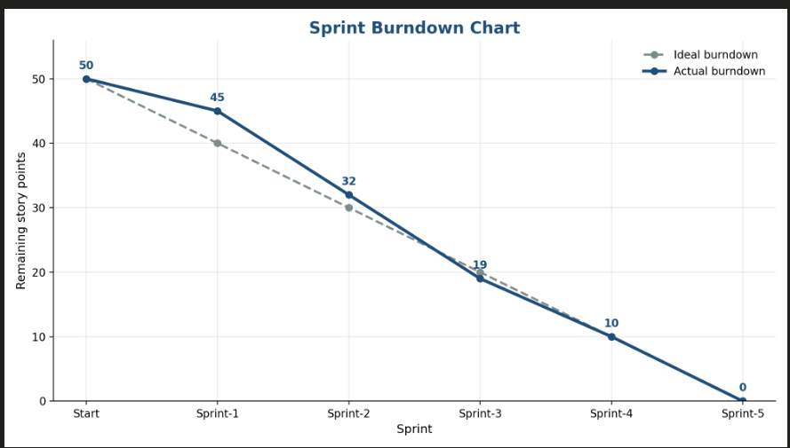

6. Project Development Phase
Skills applied in this phase: data modelling, fields and relationships, Lightning App Builder, record-triggered flows, Apex and Apex triggers, Batch Apex and Scheduled Apex.

Milestone 1: Salesforce Account

Activity 1: Creating the Developer Org
- Open https://developer.salesforce.com/signup in a browser.
- Fill in the sign-up form: first and last name, email, role (Developer), company (college name), country (India), postal code and a unique username in email format.
- Click Sign me up.

Activity 2: Account activation
- Open the verification email (it can take 5 to 10 minutes) and click Verify Account.
- Set a password, answer the security question and click Change Password.
- Salesforce then opens the Setup home page.

All team members work in the same org by sharing its username and password. They sign in at login.salesforce.com and enter the verification code sent to the email the org was created with.

Milestone 2: Data Management - Objects
Object | API name | Purpose | Relationships
Vehicle | Vehicle__c | Stores vehicle details | Related to Dealer and Orders
Vehicle Dealer | Vehicle_Dealer__c | Stores authorised dealer information | Related to Vehicles
Vehicle Customer | Vehicle_Customer__c | Stores customer details | Related to Orders, Test Drives and Service Requests
Vehicle Order | Vehicle_Order__c | Tracks vehicle purchases | Related to Customer and Vehicle
Vehicle Test Drive | Vehicle_Test_Drive__c | Tracks test drive bookings | Related to Customer and Vehicle
Vehicle Service Request | Vehicle_Service_Request__c | Tracks servicing requests | Related to Customer and Vehicle

Activity 1: Create the Vehicle object
- Go to Setup, open Object Manager, click Create and choose Custom Object.
- Enter the label Vehicle and the plural label Vehicles.
- Set the record name to Vehicle Name with data type Text.
- Tick Allow Reports and Allow Search, then click Save.
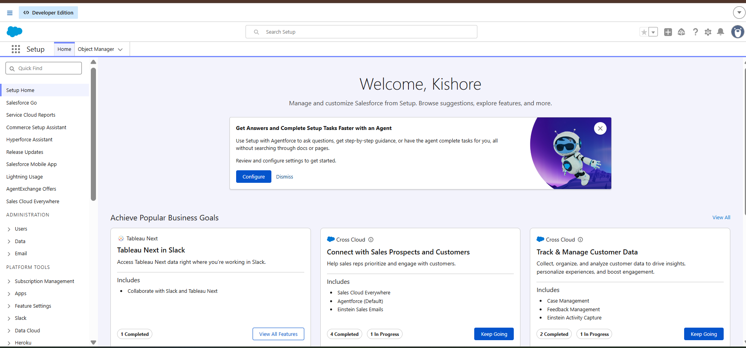

Activity 2: Create the Vehicle Dealer object
- Create another custom object with the label Vehicle Dealer and plural label Vehicle Dealers.
- Set the record name to Dealer Name with data type Text.
- Tick Allow Reports and Allow Search, then click Save.

Activity 3: Create the remaining objects
The same steps were repeated for Vehicle Customer, Vehicle Order, Vehicle Test Drive and Vehicle Service Request.
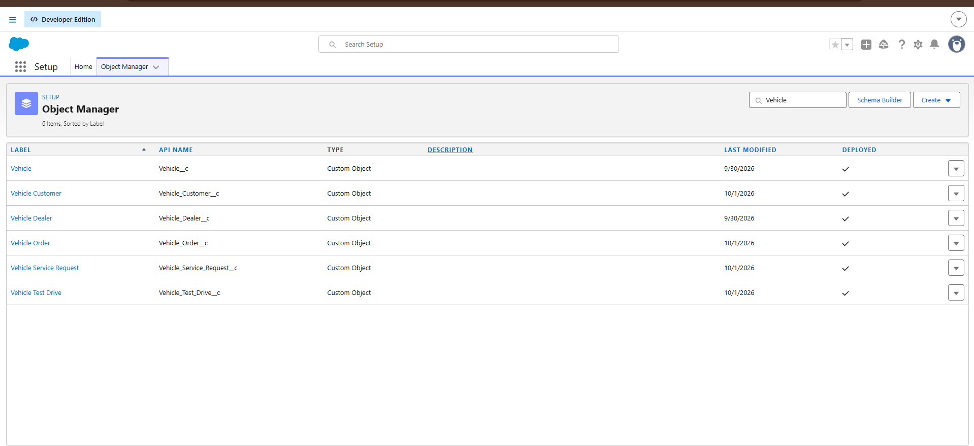

Milestone 3: Data Management - Tabs

Activity 1: Create a custom tab for Vehicle
- In Setup, type Tabs in the Quick Find box and open Tabs.
- Under Custom Object Tabs, click New.
- Select the Vehicle object and choose a tab style.
- Keep the profile visibility and custom app settings at their defaults and click Save.

Activity 2: Create tabs for the other objects
A tab was created in the same way for every other custom object.

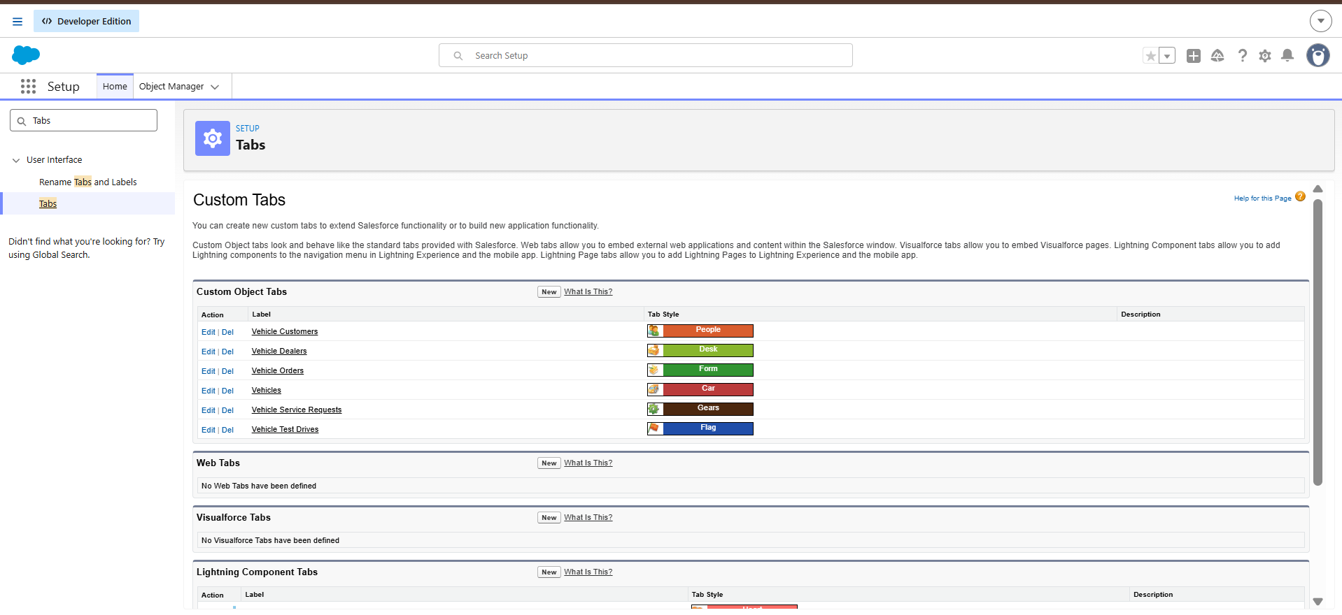

Milestone 4: Data Management - App Manager

Activity 1: Create the Lightning app
- In Setup, search for App Manager and click New Lightning App.
- Enter the app name WhatNext Vision Motors. The developer name fills in automatically.
- Enter the description: WhatNext Vision Motors is a Salesforce CRM app for managing vehicles, dealers, customers, test drives and orders in one place. It improves stock visibility, automates dealer assignment and test drive reminders, and helps teams make faster, data-driven decisions.
- Leave the image and primary colour at their defaults, then click Next through the app options and utility items pages.
- Under navigation items, move Vehicles, Vehicle Dealers, Vehicle Customers, Vehicle Orders, Vehicle Test Drives, Vehicle Service Requests, Reports and Dashboards to the selected list and click Next.
- Select the System Administrator profile and click Save & Finish.

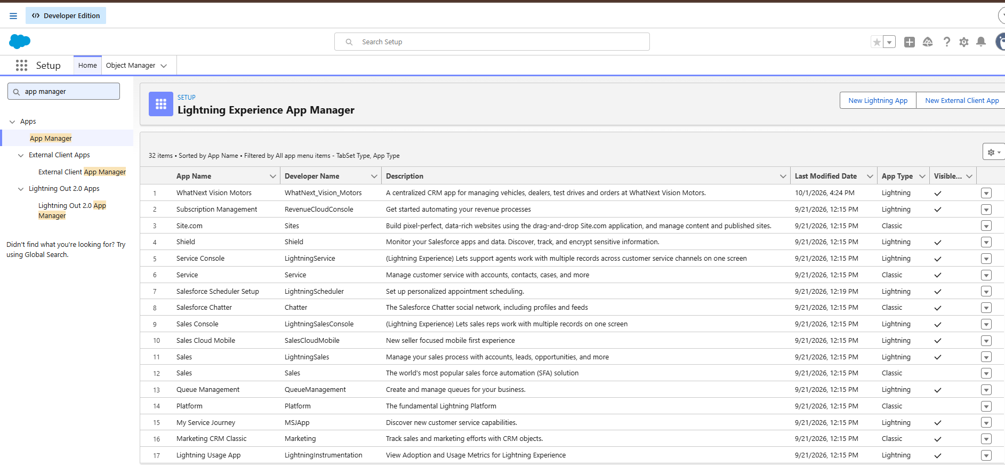

Milestone 5: Data Management - Fields and Relationships
The key fields created on each object are listed below.

Vehicle
Field label | API name | Data type
Vehicle Name | Name | Text (record name)
Vehicle Model | Vehicle_Model__c | Picklist: Sedan, SUV, EV, etc.
Stock Quantity | Stock_Quantity__c | Number
Price | Price__c | Currency
Dealer | Dealer__c | Lookup to Vehicle Dealer
Status | Status__c | Picklist: Available, Out of Stock, Discontinued
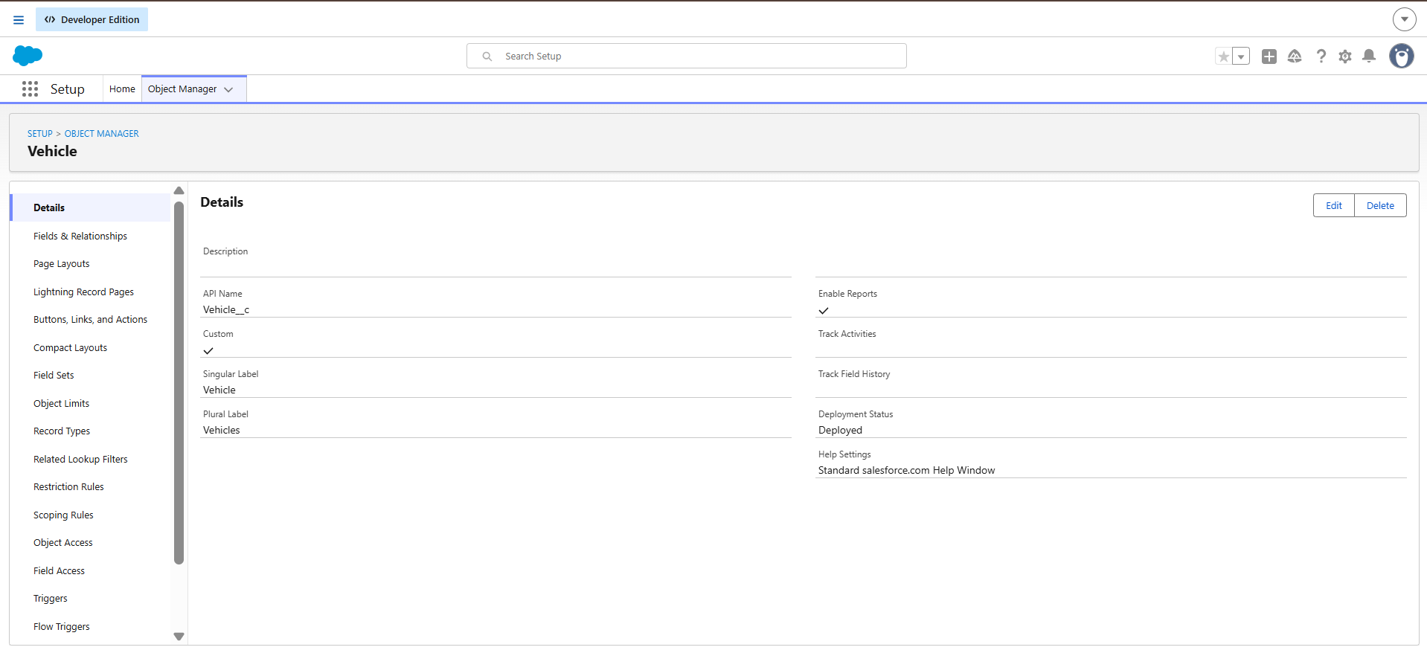

Vehicle Dealer
Field label | API name | Data type
Dealer Name | Name | Text (record name)
Dealer Location | Dealer_Location__c | Text
Dealer Code | Dealer_Code__c | Auto Number
Phone | Phone__c | Phone
Email | Email__c | Email
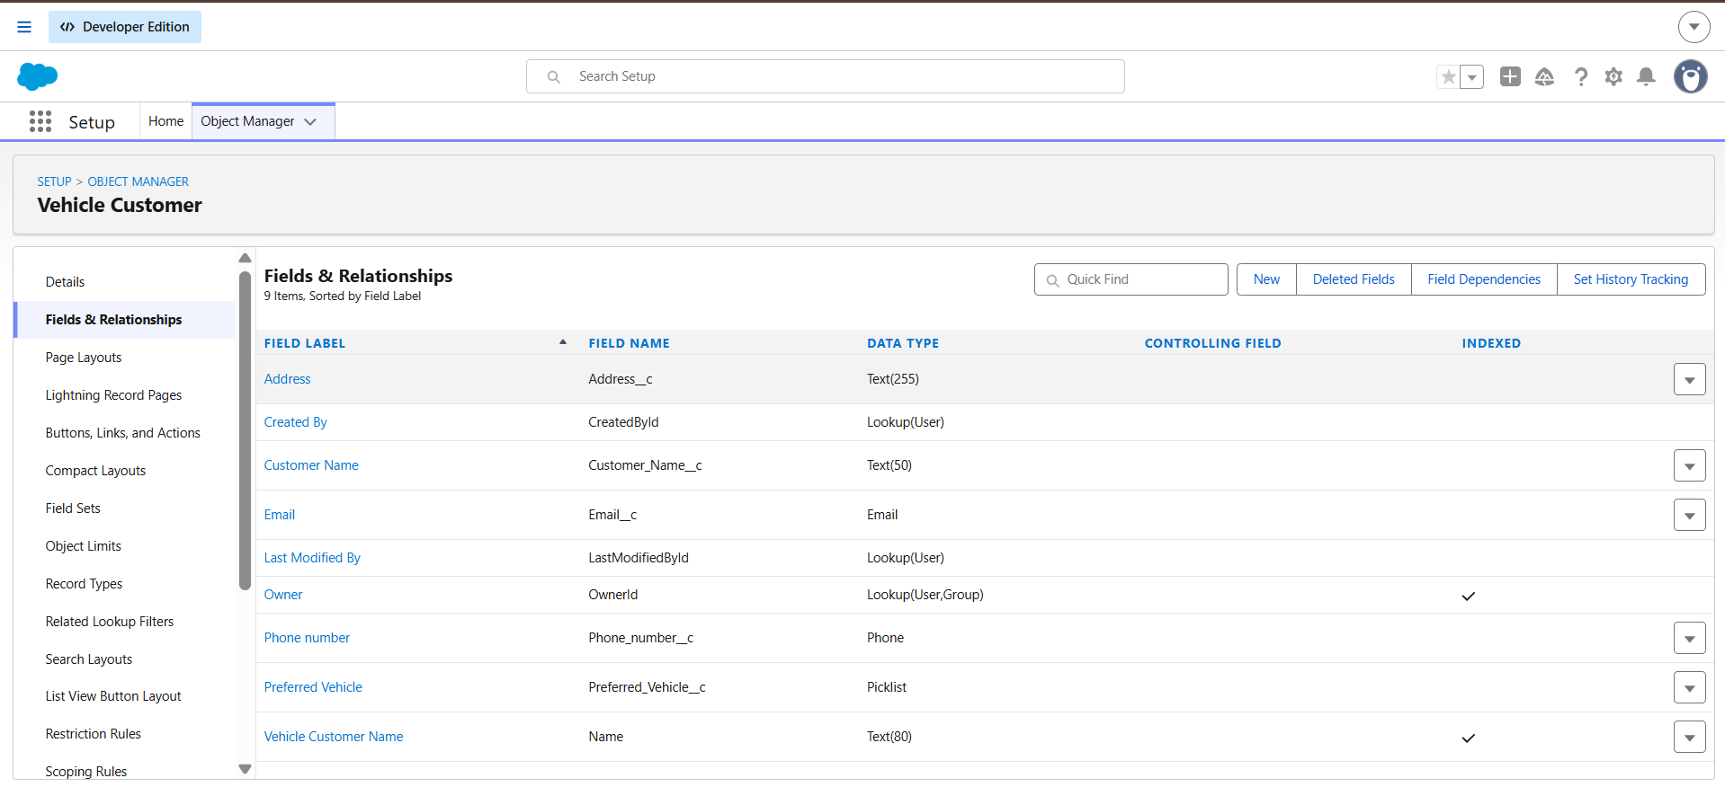

Vehicle Customer
Field label | API name | Data type
Customer Name | Name | Text (record name)
Email | Email__c | Email
Phone | Phone__c | Phone
Address | Address__c | Text
Preferred Vehicle Type | Preferred_Vehicle_Type__c | Picklist: Sedan, SUV, EV, etc.

Vehicle Order
Field label | API name | Data type
Customer | Customer__c | Lookup to Vehicle Customer
Vehicle | Vehicle__c | Lookup to Vehicle
Order Date | Order_Date__c | Date
Status | Status__c | Picklist: Pending, Confirmed, Delivered, Canceled

Vehicle Test Drive
Field label | API name | Data type
Customer | Customer__c | Lookup to Vehicle Customer
Vehicle | Vehicle__c | Lookup to Vehicle
Test Drive Date | Test_Drive_Date__c | Date
Status | Status__c | Picklist: Scheduled, Completed, Canceled

Vehicle Service Request
Field label | API name | Data type
Customer | Customer__c | Lookup to Vehicle Customer
Vehicle | Vehicle__c | Lookup to Vehicle
Service Date | Service_Date__c | Date
Issue Description | Issue_Description__c | Text
Status | Status__c | Picklist: Requested, In Progress, Completed
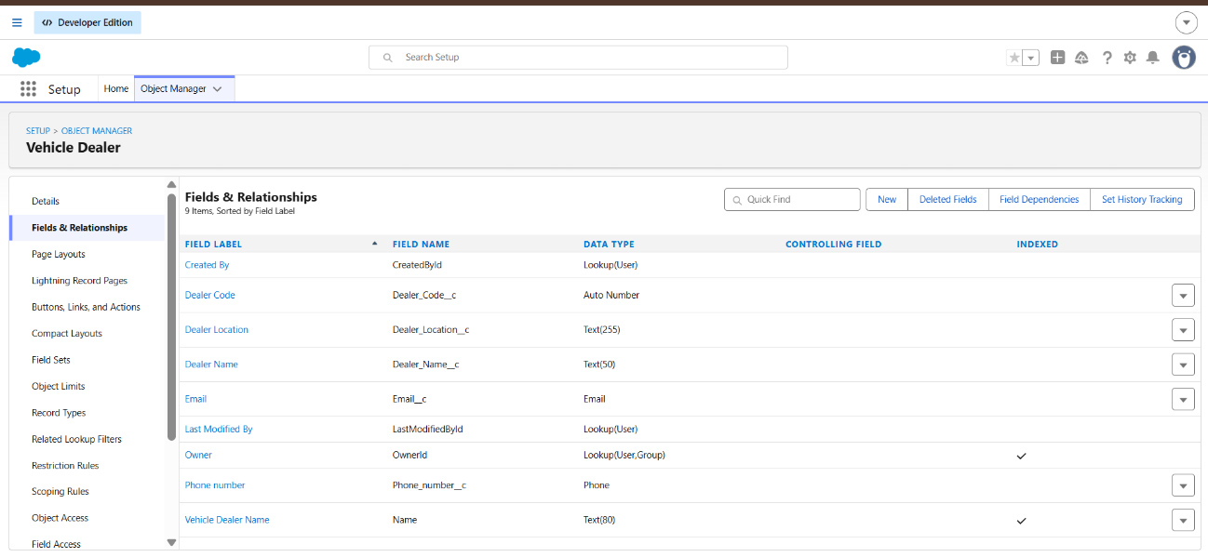

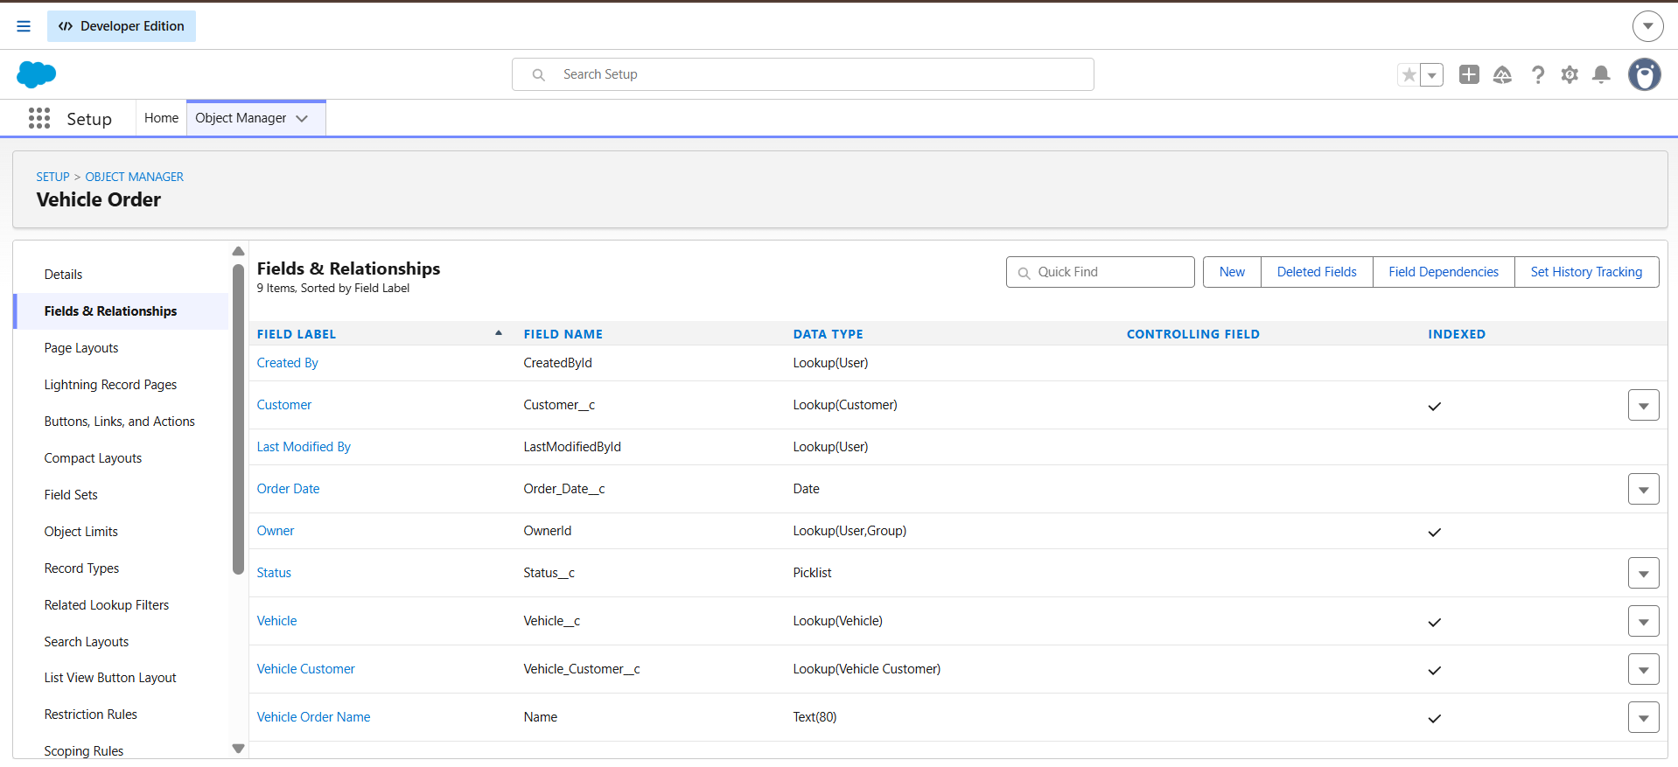
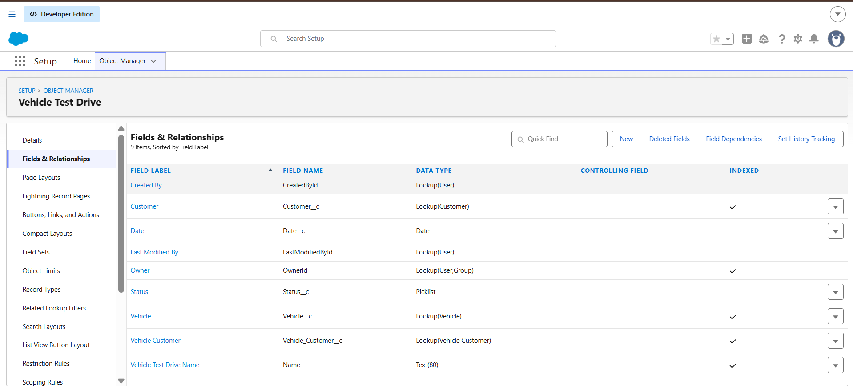
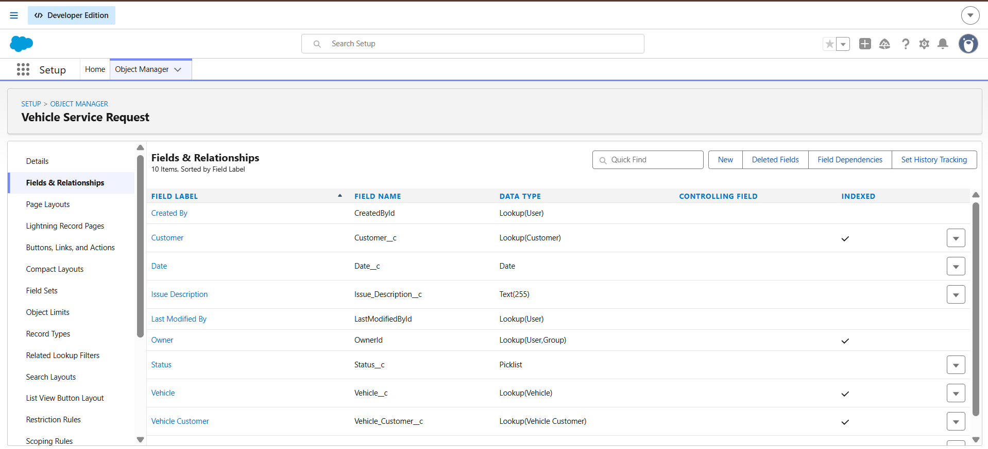

Activity 1: Create a picklist field (Vehicle Model)
- Go to Setup, open Object Manager and select the Vehicle object.
- Click Fields & Relationships and then New.
- Choose the data type Picklist and click Next.
- Enter the field label Vehicle Model and add the picklist values, one per line.
- Click Next, Next and Save & New.

Activity 2: Create a number field (Stock Quantity)
- On the Vehicle object, click New under Fields & Relationships.
- Choose the data type Number and click Next.
- Enter the field label Stock Quantity, keeping the default length and zero decimal places.
- Click Next, Next and Save & New.

Activity 3: Create a lookup relationship (Vehicle to Vehicle Dealer)
- On the Vehicle object, click New under Fields & Relationships.
- Choose Lookup Relationship and click Next.
- Select Vehicle Dealer as the related object and click Next.
- Keep the field label as Dealer and click Next.
- Leave field-level security and page layout settings at the defaults and click Save.

Activity 4: Create the remaining fields and relationships
All remaining fields and the Customer and Vehicle lookups on Vehicle Order, Vehicle Test Drive and Vehicle Service Request were created in the same way.

Milestone 6: Automation

Flow 1: Auto Assign Dealer
This record-triggered flow finds the dealer whose location matches the customer's address when a new order is created.
- In Setup, type Flows in the Quick Find box, open Flows and click New Flow.
- Choose Record-Triggered Flow.
- Select the Vehicle Order object and set the trigger to run when a record is created.
- Set the entry condition: All Conditions Are Met (AND), Status__c Equals Pending.
- Add a Get Records element labelled Get Customer Information. Object: Vehicle Customer. Condition: Id Equals {!$Record.Customer__c}.
- Add a second Get Records element labelled Get Nearest Dealer. Object: Vehicle Dealer. Condition: Dealer_Location__c Equals {!Get_Customer_Information.Address__c}.
- Add an Update Records element labelled Assign Dealer to Order. Choose to use the IDs and field values from a record or record collection and select {!Get_Nearest_Dealer}.
- Save the flow with the label Auto Assign Dealer and click Activate.

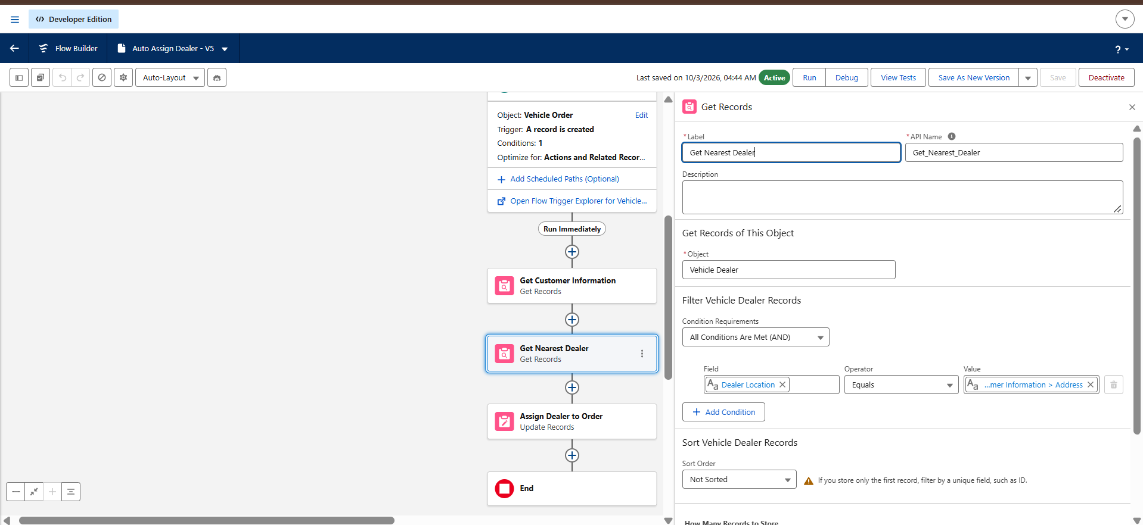

Flow 2: Test Drive Reminder
This record-triggered flow emails the customer one day before a scheduled test drive.
- Create a new Record-Triggered Flow on the Vehicle Test Drive object, triggered when a record is created or updated.
- Set the entry condition: All Conditions Are Met (AND), Status__c Equals Scheduled.
- Click Add Scheduled Paths. Label: Reminder Before Test Drive. Time source: Test_Drive_Date__c. Offset: 1 Days Before. Click Done.
- On the scheduled path, add a Get Records element labelled Get Customer Information. Object: Vehicle Customer. Condition: Id Equals {!$Record.Customer__c}. Store only the first record and all fields.
- Create a Text Template resource named EmailSent with the body: Dear {!Get_Customer_Information.Name}, this is a reminder that your test drive for {!$Record.Vehicle__c} is scheduled for tomorrow. If you need to reschedule, contact us at (add support email). Thank you, WhatNext Vision Motors Team.
- Add an Action element of type Send Email, labelled Send Test Drive Reminder. Subject: Reminder: Your Test Drive is Tomorrow! Recipient address list: {!Get_Customer_Information.Email__c}. Rich-text-formatted body: True. Body: EmailSent.
- Save the flow with the label Test Drive Reminder and click Activate.
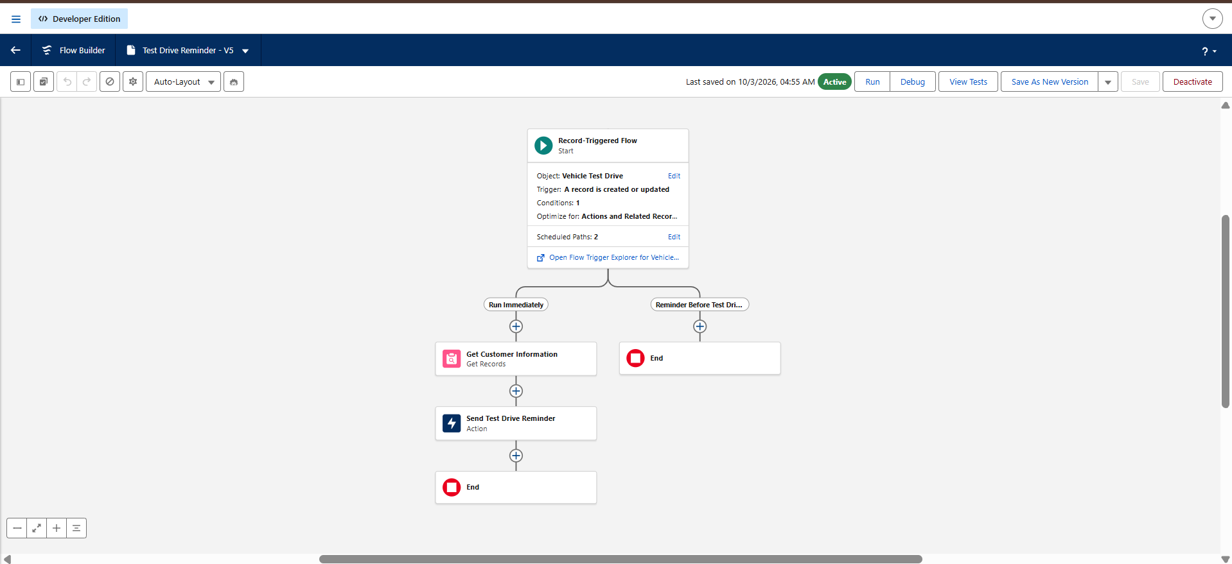

Milestone 7: Apex and Batch Class

Step 1: Create the trigger handler class
- Click the gear icon and open Developer Console.
- Choose File, then New, then Apex Class.
- Name the class VehicleOrderTriggerHandler and click OK.
- Enter the code below and save it.

public class VehicleOrderTriggerHandler {

public static void handleTrigger(List<Vehicle_Order__c> newOrders,
Map<Id, Vehicle_Order__c> oldOrders,
Boolean isBefore, Boolean isAfter,
Boolean isInsert, Boolean isUpdate) {

if (isBefore) {
if (isInsert || isUpdate) {
preventOrderIfOutOfStock(newOrders);
}
}

if (isAfter) {
if (isInsert || isUpdate) {
updateStockOnOrderPlacement(newOrders);
}
}
}

// Prevent orders when the vehicle is out of stock
private static void preventOrderIfOutOfStock(List<Vehicle_Order__c> orders) {
Set<Id> vehicleIds = new Set<Id>();
for (Vehicle_Order__c order : orders) {
if (order.Vehicle__c != null) {
vehicleIds.add(order.Vehicle__c);
}
}

if (!vehicleIds.isEmpty()) {
Map<Id, Vehicle__c> vehicleStockMap = new Map<Id, Vehicle__c>();
for (Vehicle__c vehicle : [SELECT Id, Stock_Quantity__c
FROM Vehicle__c
WHERE Id IN :vehicleIds]) {
vehicleStockMap.put(vehicle.Id, vehicle);
}

for (Vehicle_Order__c order : orders) {
if (vehicleStockMap.containsKey(order.Vehicle__c)) {
Vehicle__c vehicle = vehicleStockMap.get(order.Vehicle__c);
if (vehicle.Stock_Quantity__c <= 0) {
order.addError('This vehicle is out of stock. Order cannot be placed.');
}
}
}
}
}

// Update vehicle stock when an order is placed
private static void updateStockOnOrderPlacement(List<Vehicle_Order__c> orders) {
Set<Id> vehicleIds = new Set<Id>();
for (Vehicle_Order__c order : orders) {
if (order.Vehicle__c != null && order.Status__c == 'Confirmed') {
vehicleIds.add(order.Vehicle__c);
}
}

if (!vehicleIds.isEmpty()) {
Map<Id, Vehicle__c> vehicleStockMap = new Map<Id, Vehicle__c>();
for (Vehicle__c vehicle : [SELECT Id, Stock_Quantity__c
FROM Vehicle__c
WHERE Id IN :vehicleIds]) {
vehicleStockMap.put(vehicle.Id, vehicle);
}

List<Vehicle__c> vehiclesToUpdate = new List<Vehicle__c>();
for (Vehicle_Order__c order : orders) {
if (vehicleStockMap.containsKey(order.Vehicle__c)) {
Vehicle__c vehicle = vehicleStockMap.get(order.Vehicle__c);
if (vehicle.Stock_Quantity__c > 0) {
vehicle.Stock_Quantity__c -= 1;
vehiclesToUpdate.add(vehicle);
}
}
}

if (!vehiclesToUpdate.isEmpty()) {
update vehiclesToUpdate;
}
}
}
}

Step 2: Create the trigger
- In Developer Console, choose File, then New, then Apex Trigger.
- Name the trigger VehicleOrderTrigger and select the Vehicle_Order__c sObject.
- Call the handler class from the trigger, as shown below.

trigger VehicleOrderTrigger on Vehicle_Order__c
(before insert, before update, after insert, after update) {

VehicleOrderTriggerHandler.handleTrigger(
Trigger.new, Trigger.oldMap,
Trigger.isBefore, Trigger.isAfter,
Trigger.isInsert, Trigger.isUpdate);
}

Step 3: Create the batch job
When a customer's order is waiting because the vehicle was out of stock, the order stays Pending. After new stock is added, the batch job confirms the order and reduces the stock.
- Create a new Apex class named VehicleOrderBatch.
- Enter the code below and save it.

global class VehicleOrderBatch implements Database.Batchable<SObject> {

global Database.QueryLocator start(Database.BatchableContext bc) {
return Database.getQueryLocator([
SELECT Id, Status__c, Vehicle__c
FROM Vehicle_Order__c
WHERE Status__c = 'Pending'
]);
}

global void execute(Database.BatchableContext bc,
List<Vehicle_Order__c> orderList) {
Set<Id> vehicleIds = new Set<Id>();
for (Vehicle_Order__c order : orderList) {
if (order.Vehicle__c != null) {
vehicleIds.add(order.Vehicle__c);
}
}

if (vehicleIds.isEmpty()) {
return;
}

Map<Id, Vehicle__c> vehicleStockMap = new Map<Id, Vehicle__c>(
[SELECT Id, Stock_Quantity__c FROM Vehicle__c
WHERE Id IN :vehicleIds]
);

List<Vehicle_Order__c> ordersToUpdate = new List<Vehicle_Order__c>();
Map<Id, Vehicle__c> vehiclesToUpdate = new Map<Id, Vehicle__c>();

for (Vehicle_Order__c order : orderList) {
if (vehicleStockMap.containsKey(order.Vehicle__c)) {
Vehicle__c vehicle = vehicleStockMap.get(order.Vehicle__c);
if (vehicle.Stock_Quantity__c != null
&& vehicle.Stock_Quantity__c > 0) {
order.Status__c = 'Confirmed';
vehicle.Stock_Quantity__c -= 1;
ordersToUpdate.add(order);
vehiclesToUpdate.put(vehicle.Id, vehicle);
}
}
}

if (!ordersToUpdate.isEmpty()) {
update ordersToUpdate;
}
if (!vehiclesToUpdate.isEmpty()) {
update vehiclesToUpdate.values();
}
}

global void finish(Database.BatchableContext bc) {
System.debug('Vehicle order batch job completed.');
}
}

Step 4: Create the scheduler class
A Schedulable class calls the batch class so that it can be run on a timetable.

global class VehicleOrderBatchScheduler implements Schedulable {
global void execute(SchedulableContext sc) {
VehicleOrderBatch batchJob = new VehicleOrderBatch();
Database.executeBatch(batchJob, 50); // 50 is the batch size
}
}

Step 5: Schedule the batch job
Open Debug, then Open Execute Anonymous Window, and run the code below. It schedules the job to run every day at 12:00 PM.

String cronExp = '0 0 12 * * ?'; // Runs daily at 12:00 PM
System.schedule('Daily Vehicle Order Processing', cronExp,
new VehicleOrderBatchScheduler());

Step 6: Confirm the job is scheduled
In Setup, search for Scheduled Jobs. The job Daily Vehicle Order Processing appears with the type Scheduled Apex and its next run time.
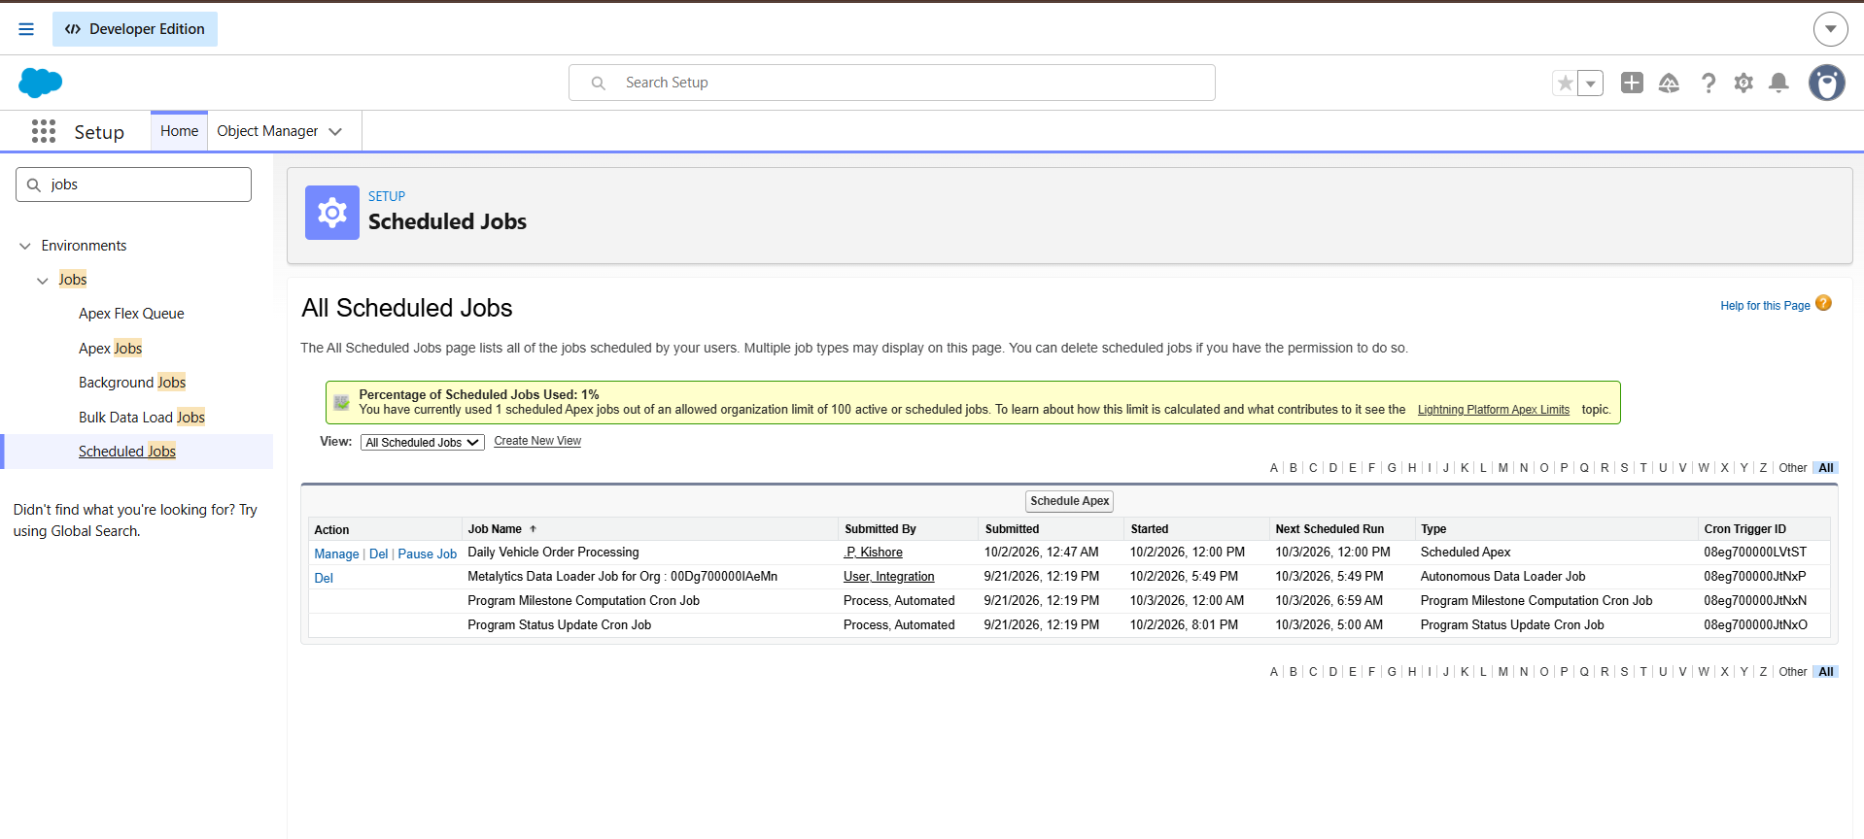

7. Functional and Performance Testing
Each feature was tested in the Salesforce org. The table lists the scenario and the expected result; a screenshot of the actual result follows for every test case.
Test | Scenario | Expected result | Actual result
TC-1 | Create a Vehicle with a stock quantity and a Vehicle Dealer record | Both records save with all fields | Vehicle and Vehicle Dealer records were saved successfully with all field values.
TC-2 | Place an order for a vehicle whose stock quantity is 0 | The error "This vehicle is out of stock. Order cannot be placed." appears and the order is not saved | The error "This vehicle is out of stock. Order cannot be placed." appeared and the order was not saved.
TC-3 | Place an order for an in-stock vehicle with status Confirmed | The order saves and the vehicle's stock reduces by 1 | The order was saved with status Confirmed and the vehicle's stock reduced by 1.
TC-4 | Run Database.executeBatch(new VehicleOrderBatch(), 50); with Pending orders present | Pending orders whose vehicle has stock become Confirmed and stock reduces | The batch job changed Pending orders to Confirmed where stock was available and reduced the stock.
TC-5 | Open the Scheduled Jobs page | Daily Vehicle Order Processing is listed as Scheduled Apex with the next run at 12:00 PM | Scheduled Jobs shows "Daily Vehicle Order Processing" (Scheduled Apex) with the next run at 12:00 PM.
TC-6 | Create an order for a customer whose address matches a dealer location | The Auto Assign Dealer flow runs and finds the matching dealer | The order was saved and the Auto Assign Dealer flow ran, finding the dealer that matches the customer's address.
TC-7 | Create a test drive with status Scheduled and a date | A reminder email reaches the customer one day before the date | The test drive was saved with status Scheduled and the reminder email was received by the customer.

TC-1 screenshot
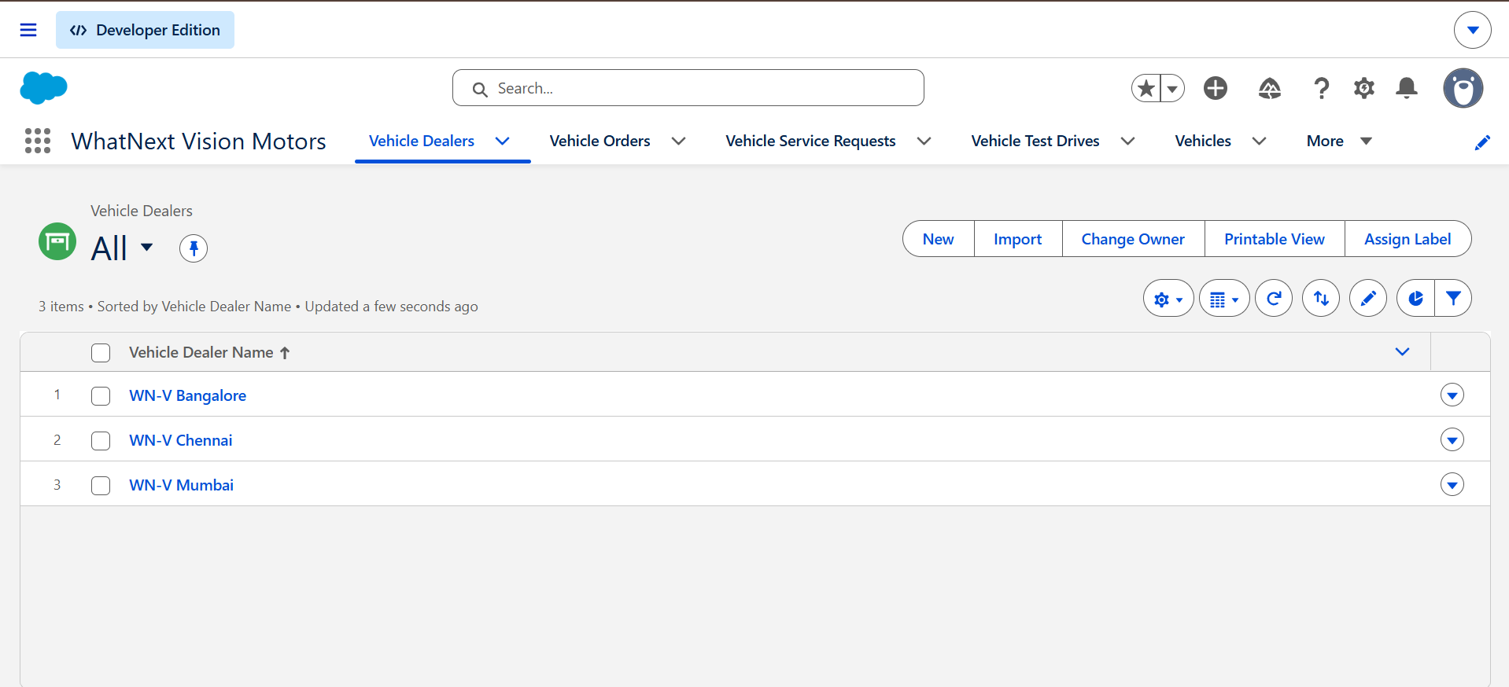

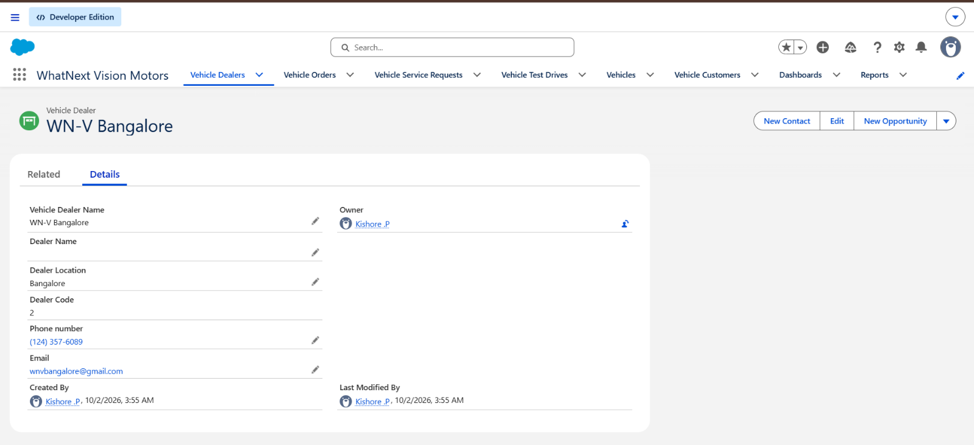

TC-2 screenshot
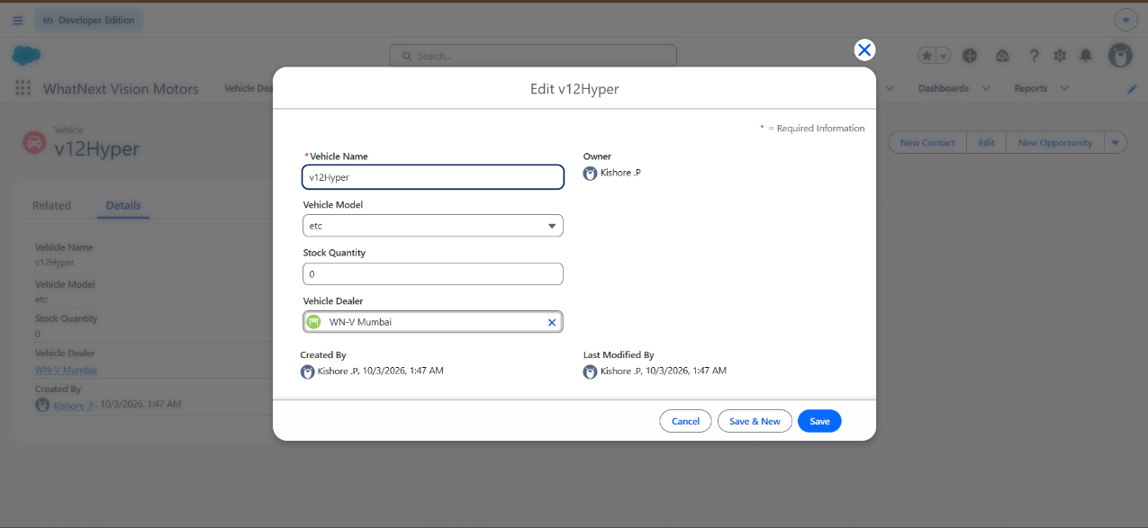

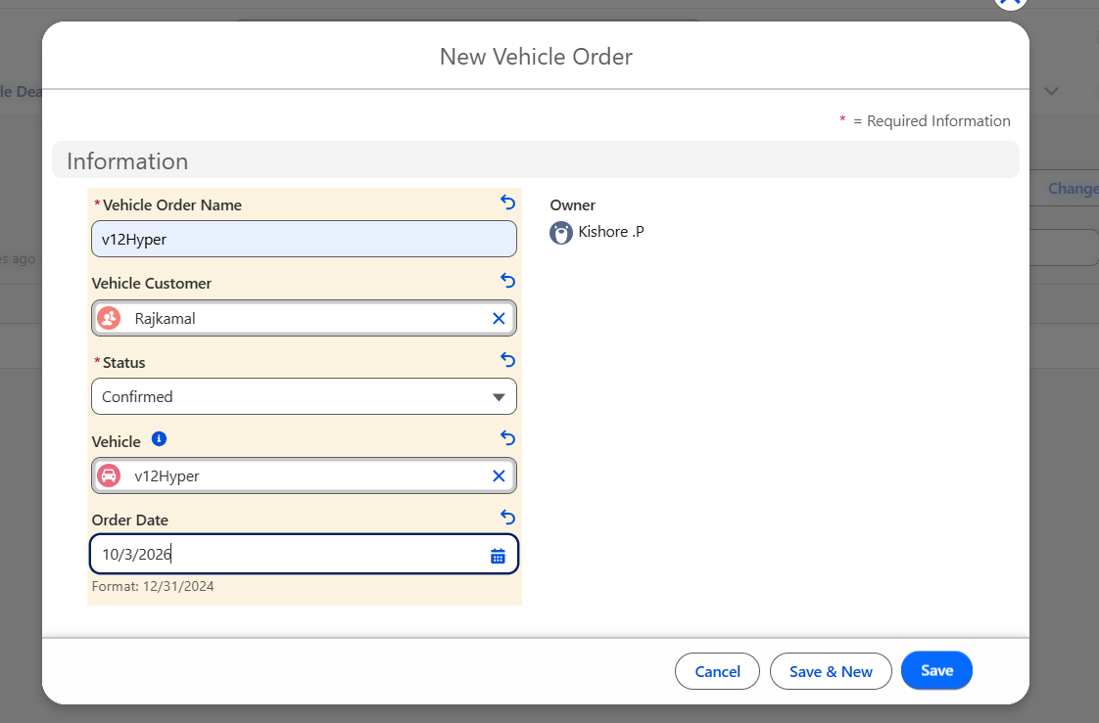

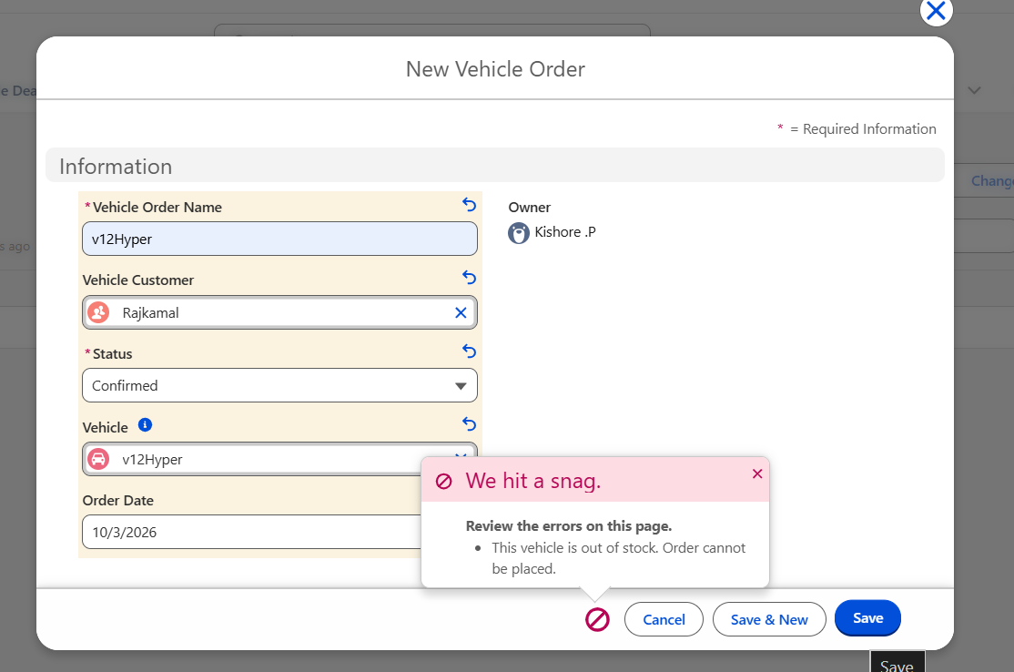

TC-3 screenshot
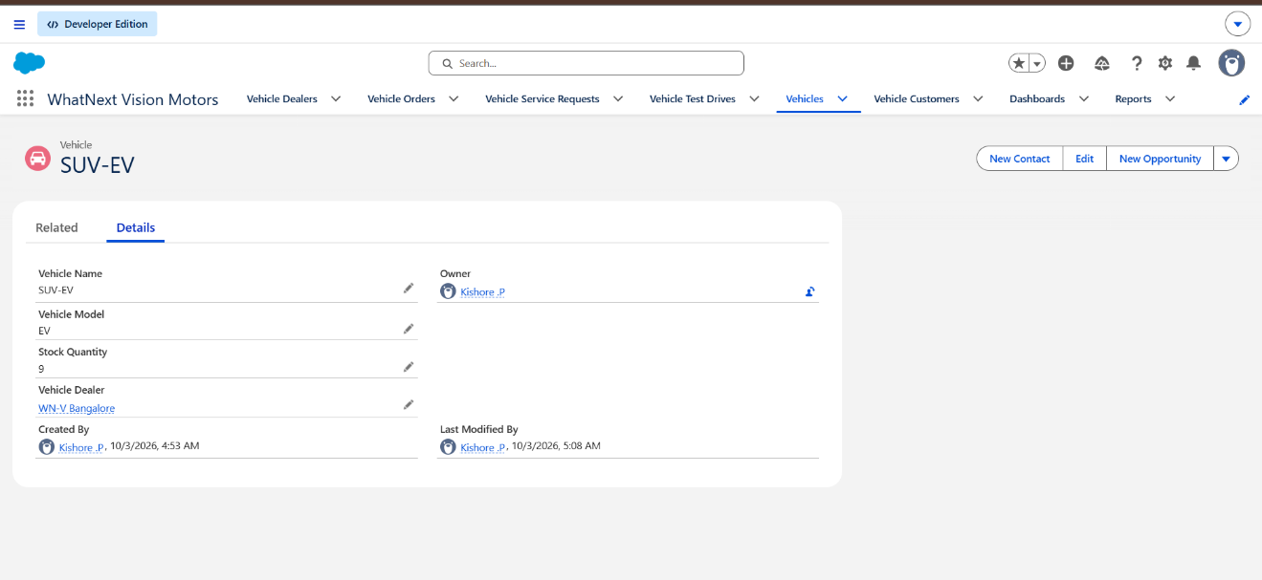

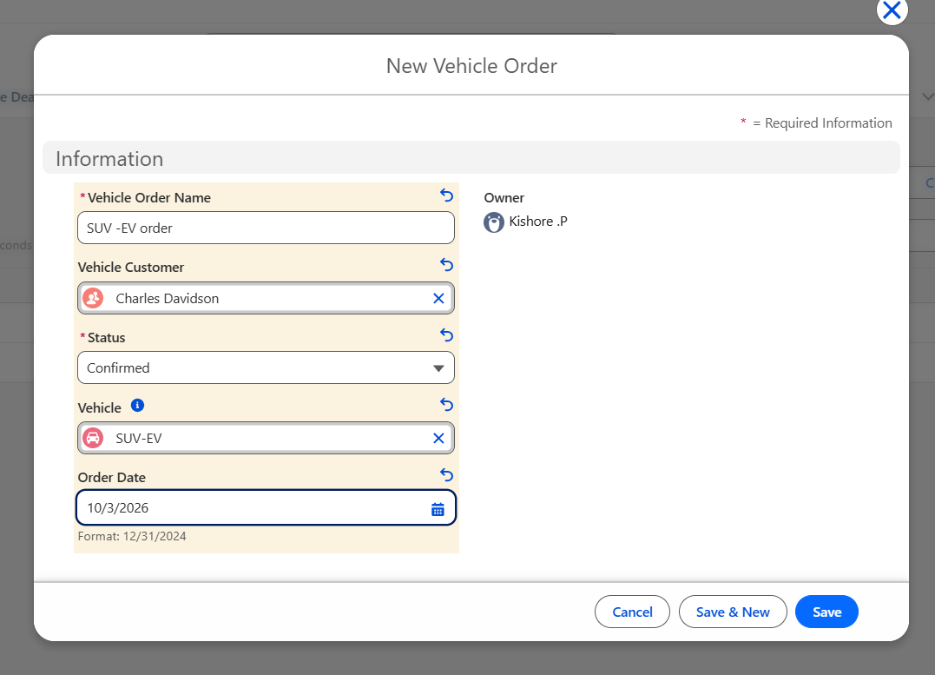

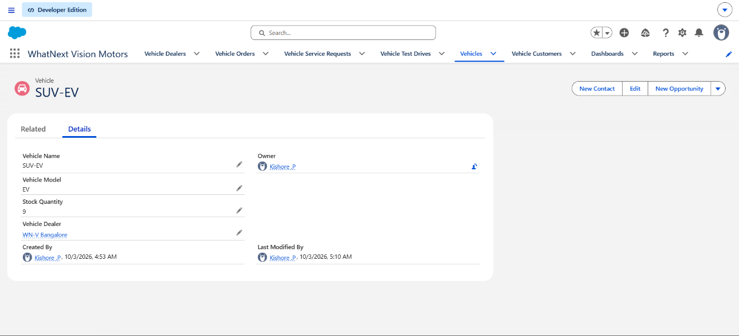

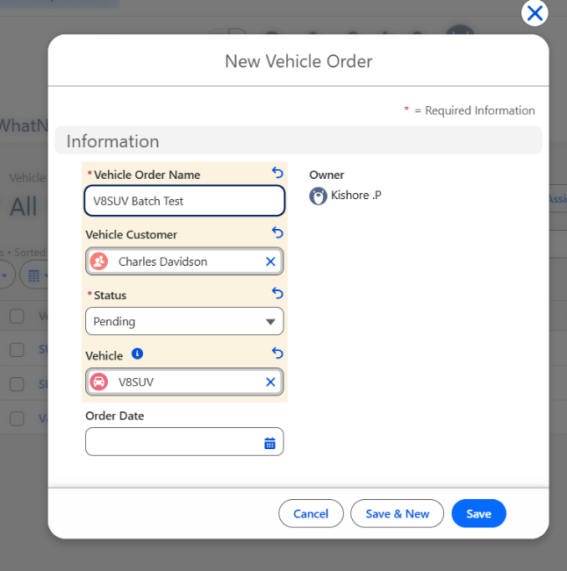
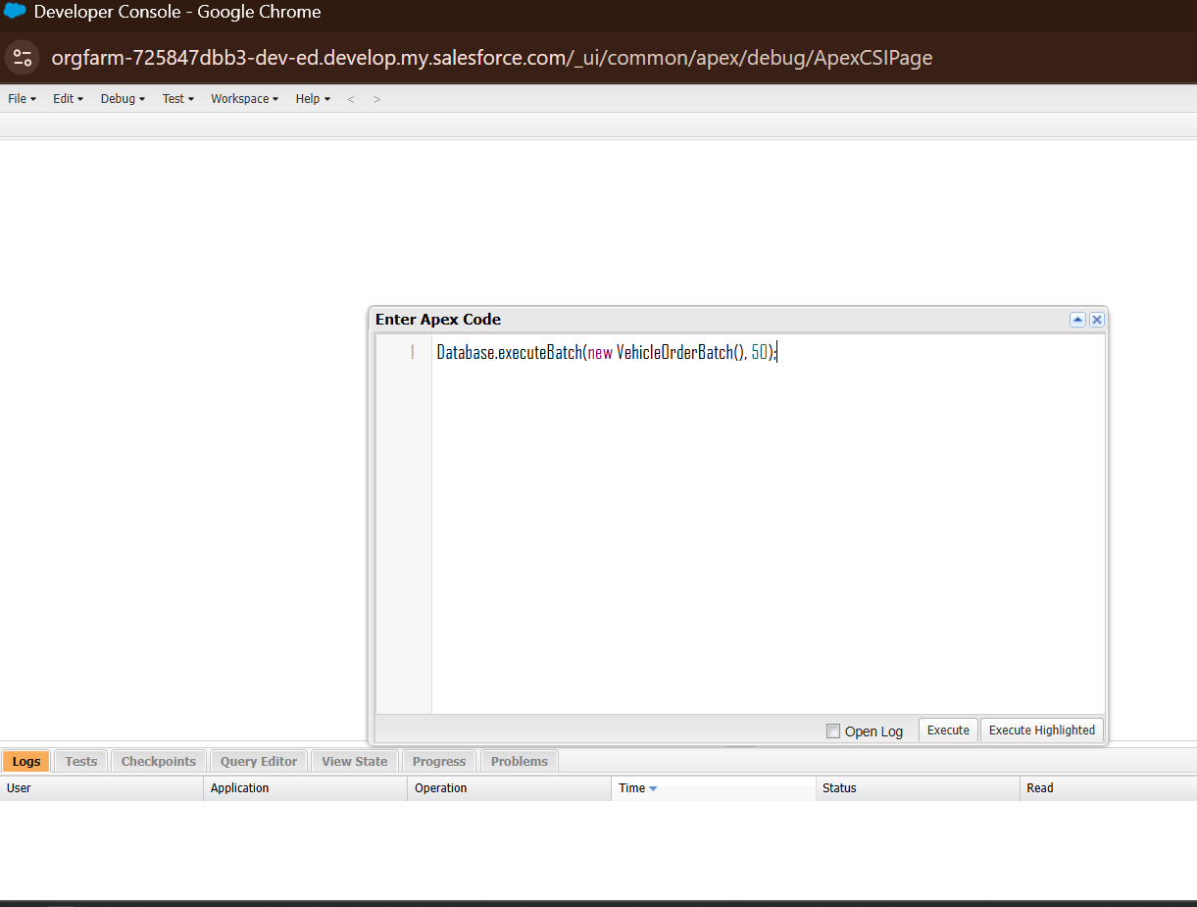
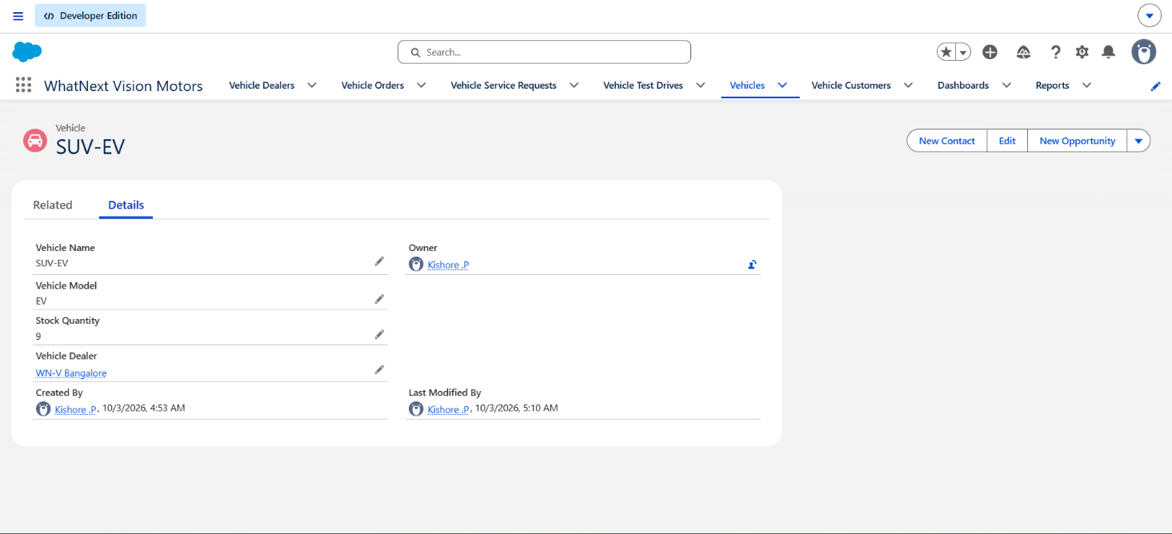
TC-4 screenshot

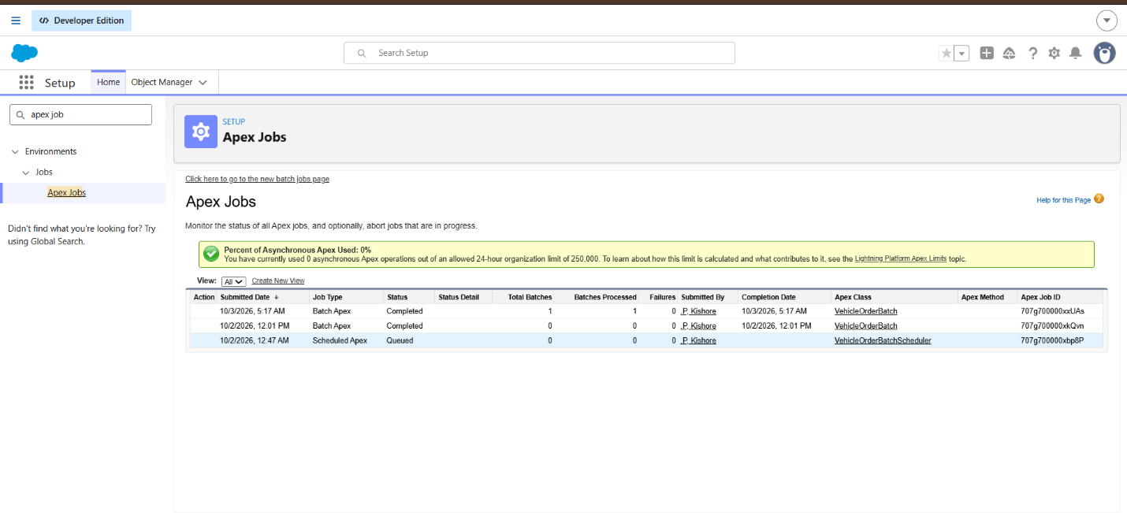

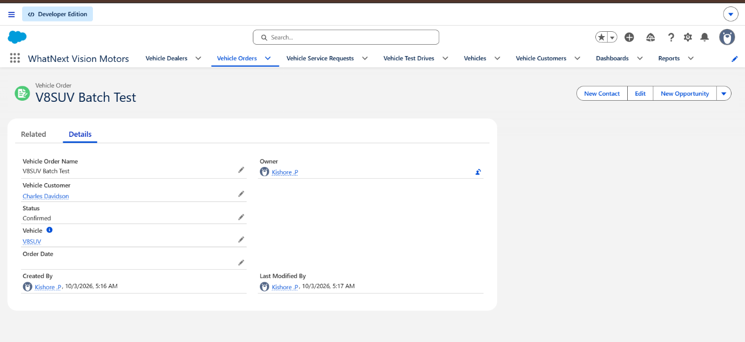

TC-5 screenshot
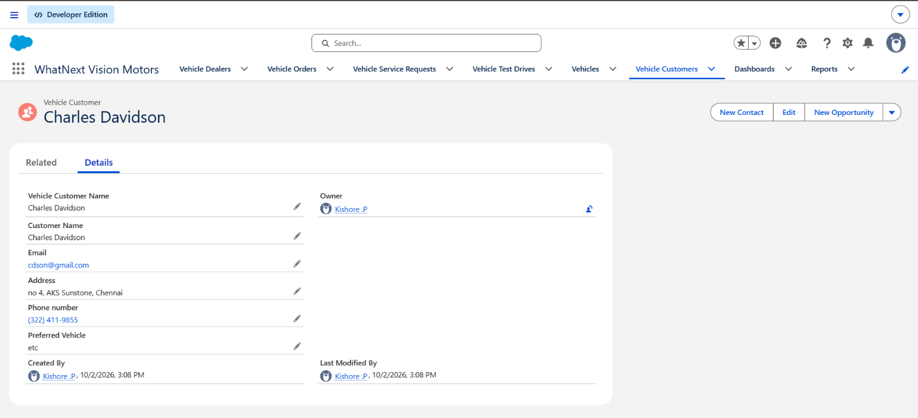
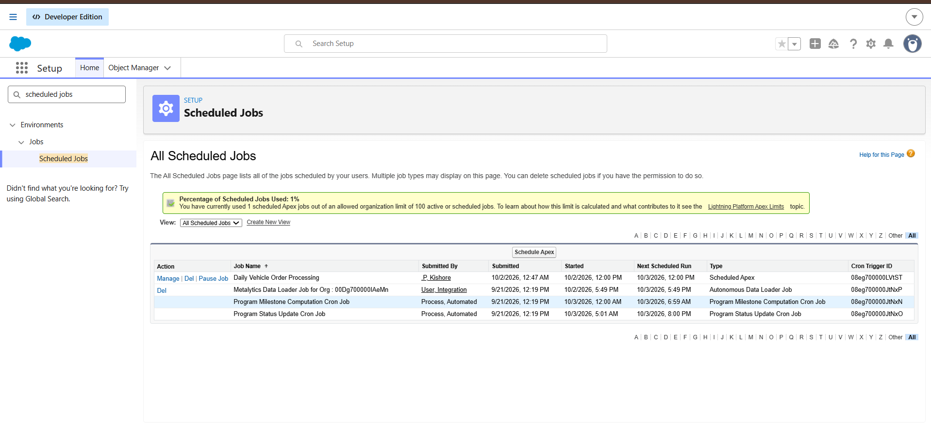
TC-6 screenshot

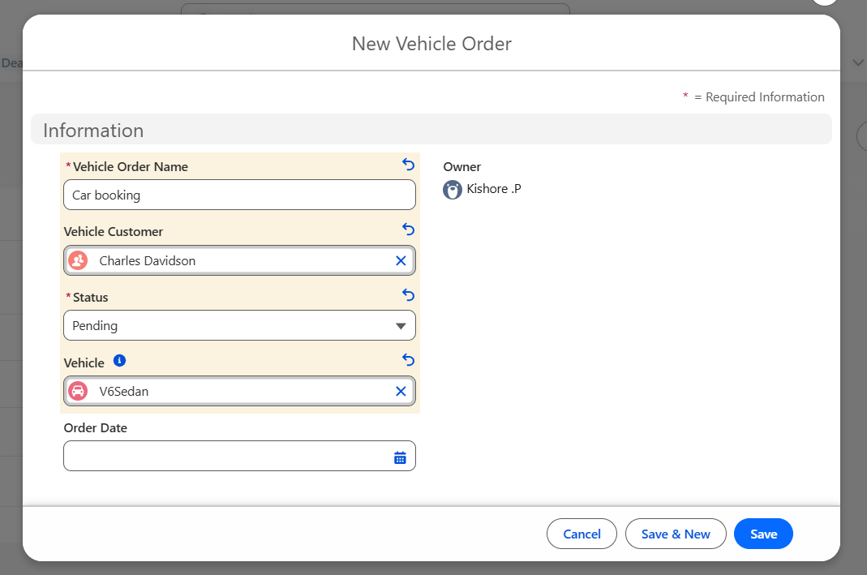
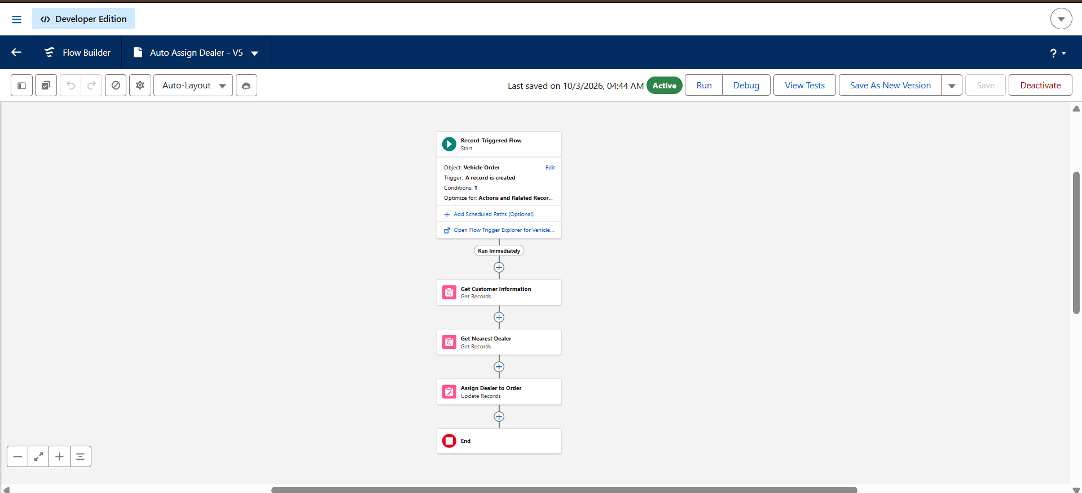

TC-7 screenshot
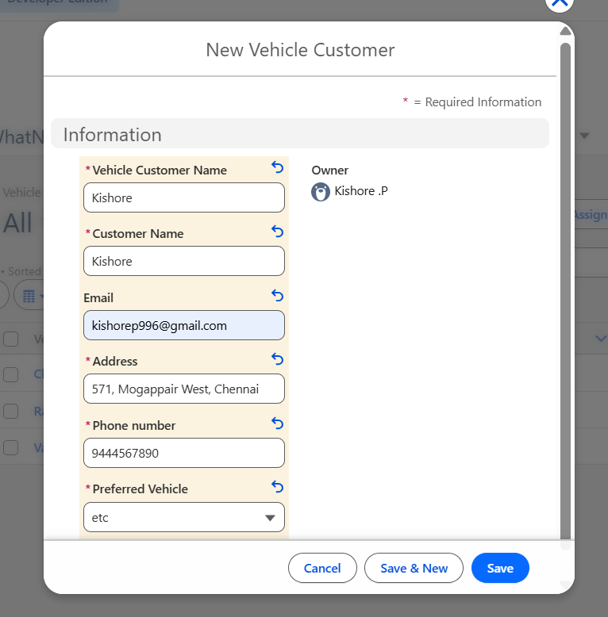

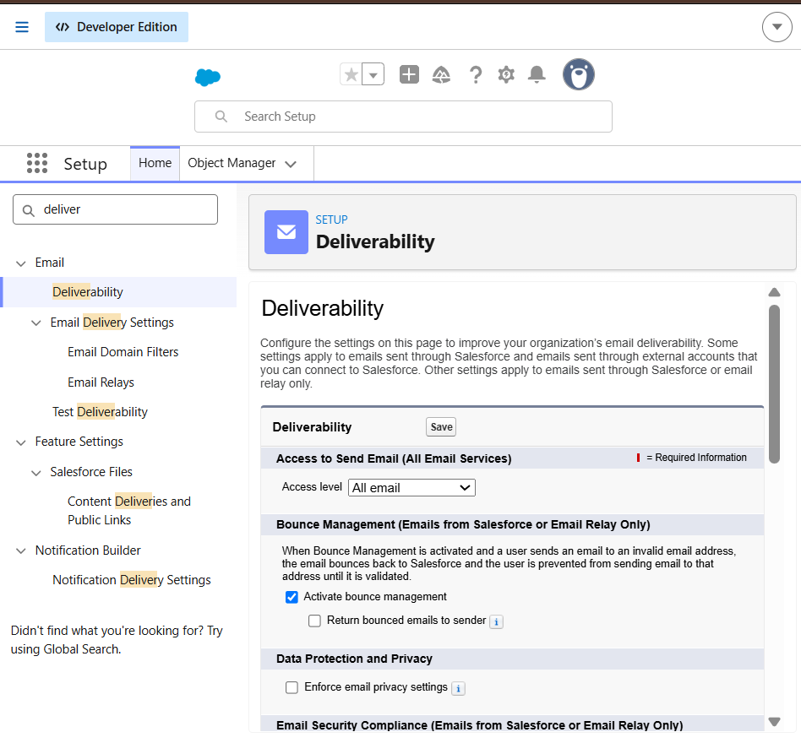

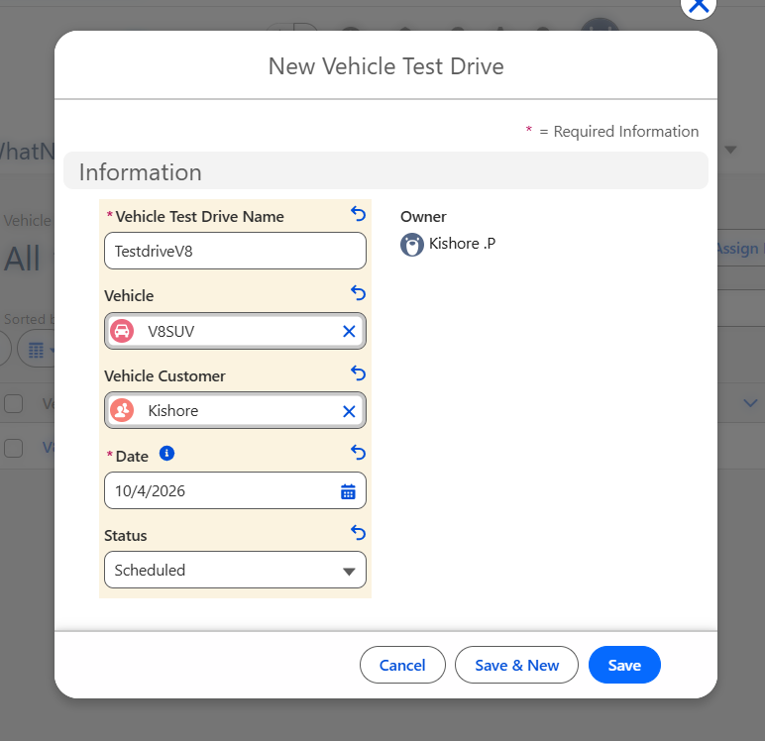

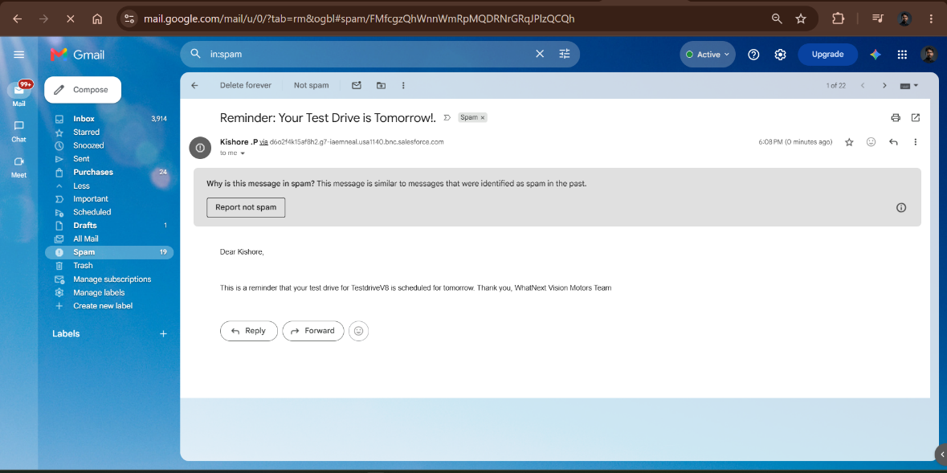

8. Advantages and Disadvantages

Advantages
- All vehicle, dealer, customer and order data is kept in one place.
- Stock checks, dealer matching, reminders and order confirmation run automatically.
- Order errors are reduced because out-of-stock orders are blocked at entry.
- The application grows easily as more dealers, vehicles and customers are added.

Disadvantages
- The solution depends on the Salesforce platform and its limits.
- It needs initial configuration effort and basic Salesforce knowledge to maintain.
- Dealer matching currently compares the customer's address with the dealer location text, so the two must be entered in the same format.

9. Conclusion
The Salesforce CRM built for WhatNext Vision Motors brings vehicle ordering, stock control, dealer matching and customer communication together on one platform. Automation through flows, Apex and scheduled jobs reduces manual work, improves the accuracy of orders and gives customers a smoother experience.

10. Future Scope
- Reports and dashboards for order status, dealer performance and sales metrics
- A mobile app for placing orders and booking test drives
- Distance-based dealer matching using GPS or map data
- SMS notifications alongside email reminders
- AI-based demand forecasting for stock planning

11. Appendix
- Source code: Apex classes and trigger are given in Milestone 7 of Section 6.
- Data: Salesforce custom objects and fields described in Milestone 5.
Thank You

