**JAVA DOCUMENTATION:**

**EMPLOYEE SALARY SYSTEM (ESS)**

**INTRODUCTION**

The Employee Salary System (ESS) is a Java program that is secured with a password and calculates weekly hours, gross weekly salary, and net weekly salary.

**JFRAME 1 (MAIN CLASS)**

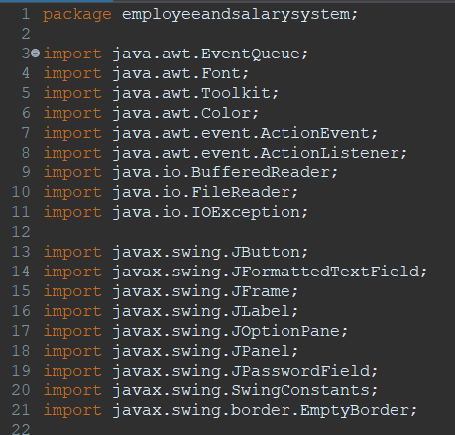

* The code is in the package **employeeandsalarysystem**.
* It imports various classes from **java.awt**, **javax.swing**, and **java.io** packages which are necessary for GUI creation and file input/output operations.

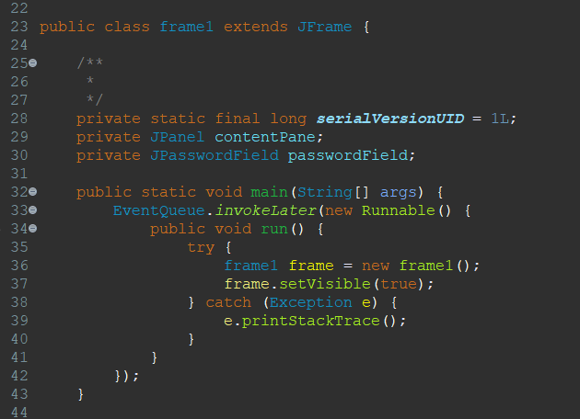

* **frame1** class extends **JFrame**, indicating that it represents a GUI window.
* It has a **JPanel** named **contentPane** and a **JPasswordField** named **passwordField**.
* It also overrides the **main** method for starting the application.

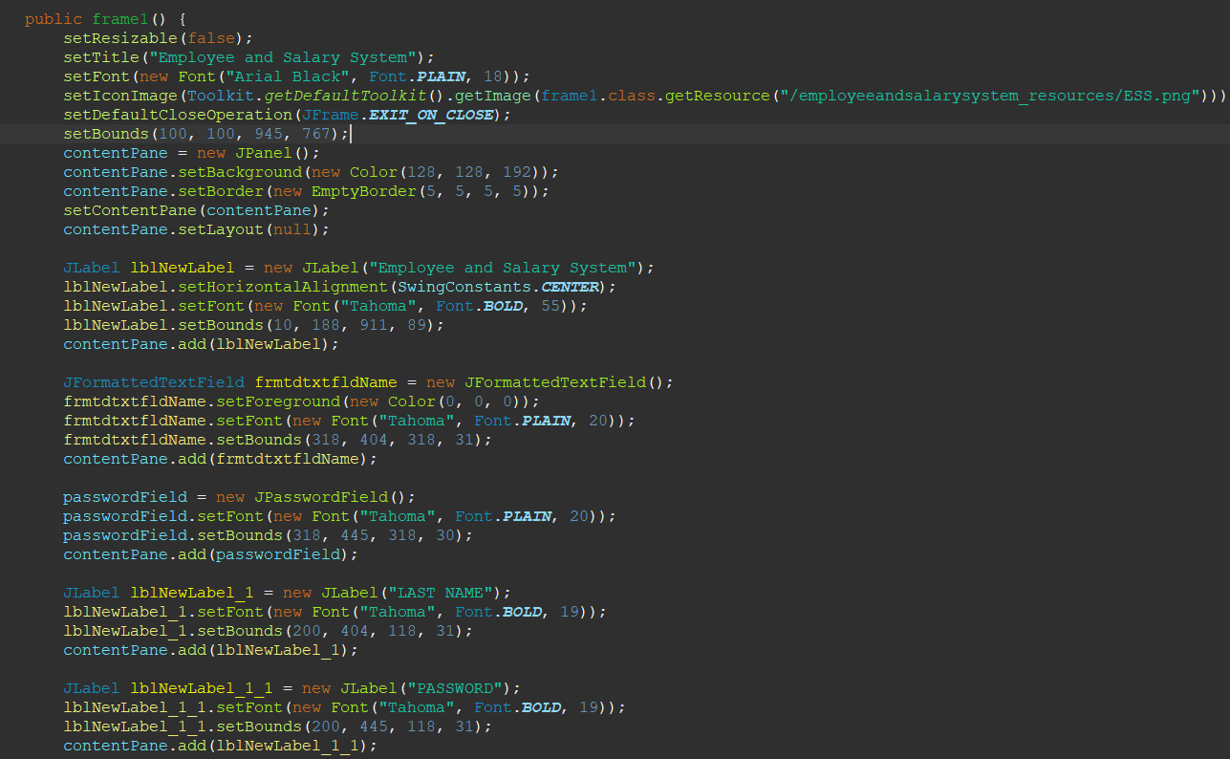

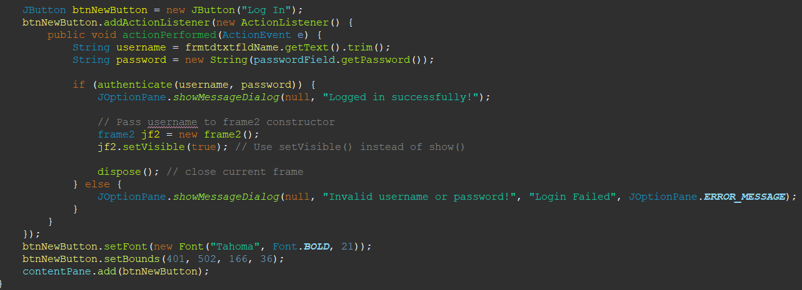

* + The **main** method starts the application by creating an instance of **frame1** within the Event Dispatch Thread (EDT).
  + Sets up the GUI window properties like title, size, background color, etc.
  + Adds labels, text fields (**JFormattedTextField**), password fields (**JPasswordField**), and a button (**JButton**) to the content pane.
  + Sets up action listeners for the login button (**btnNewButton**).
  + Inside the action listener for the login button, it retrieves the username and password entered by the user, calls the **authenticate** method, and handles the authentication result by showing a message dialog accordingly.
  + If authentication is successful, it opens a new instance of **frame2** and closes the current frame.

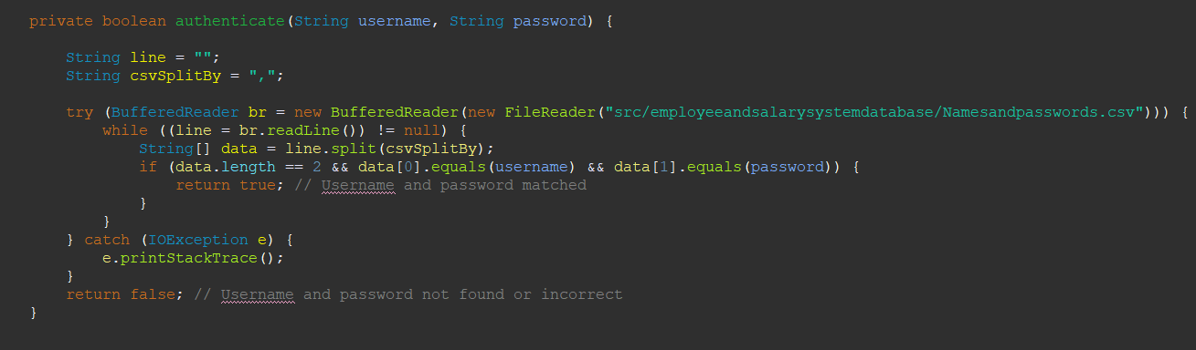

* Reads user credentials from a CSV file (**Namesandpasswords.csv**) to authenticate the user.
* It iterates through each line of the CSV file, splits it by a comma, and checks if the username and password match the provided input.
* If a match is found, it returns **true**, indicating successful authentication; otherwise, it returns **false**.

**JFRAME 2 – MAIN MENU**

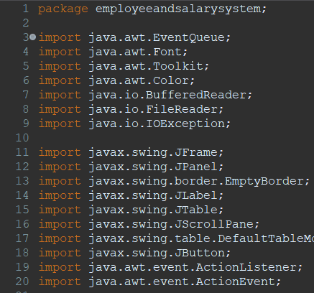

* The code is in the package **employeeandsalarysystem**.
* It imports various classes from **java.awt**, **javax.swing**, and **java.io** packages, which are necessary for GUI creation and file input/output operations.

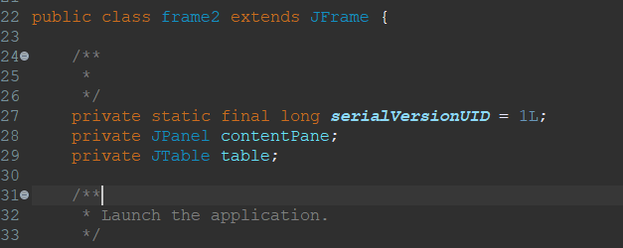

* **frame2** class extends **JFrame**, indicating that it represents a GUI window.
* It has a **JPanel** named **contentPane** and a **JTable** named **table**.
* It also overrides the **main** method for starting the application.

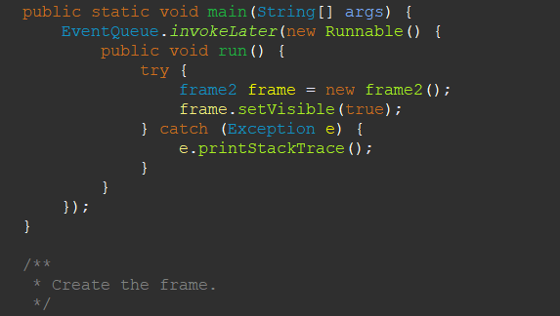

The **main** method starts the application by creating an instance of **frame2** within the Event Dispatch Thread (EDT).

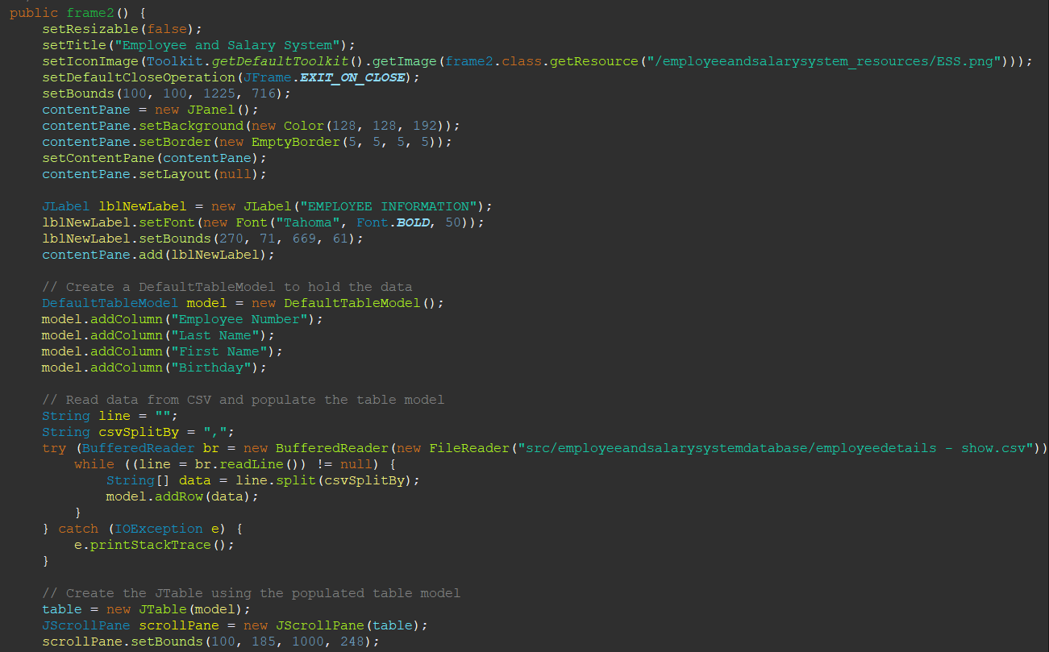

* Sets up the GUI window properties like title, size, background color, etc.
* Adds a label (**JLabel**) for displaying "EMPLOYEE INFORMATION" in a large font.
* Creates a **DefaultTableModel** named **model** to hold the data for the table. It defines column headers.
* Reads data from a CSV file (**employeedetails - show.csv**) and populates the table model.
* Creates a **JTable** (**table**) using the populated table model and adds it to a scroll pane.
* Adds two buttons (**JButton**) for navigating to other frames (**frame3weeklyhours** and **frame4netsalary**). These buttons have action listeners to handle the button clicks. Upon clicking, they open respective frames and close the current frame.

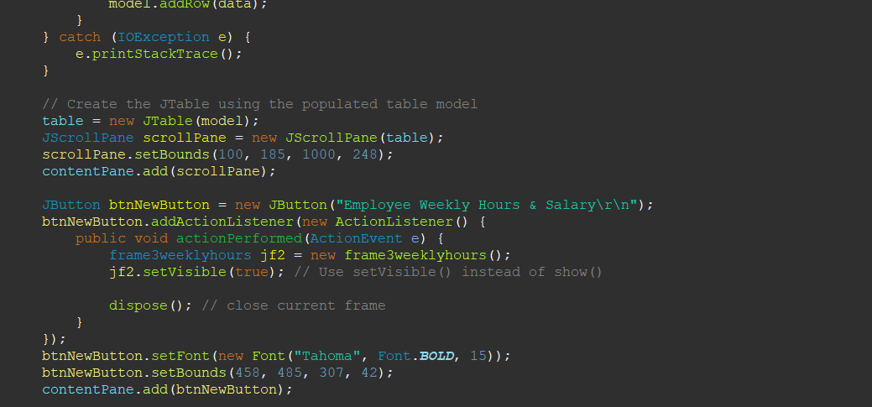

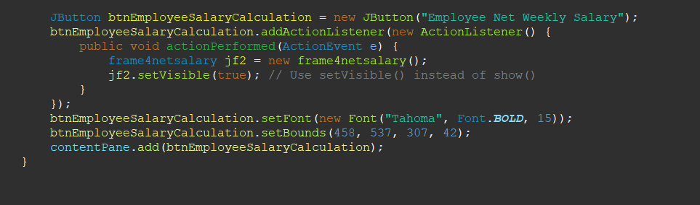

* The first button (**btnNewButton**) is for navigating to **frame3weeklyhours**. Upon clicking, it creates an instance of **frame3weeklyhours**, makes it visible, and disposes of the current frame.
* The second button (**btnEmployeeSalaryCalculation**) is for navigating to **frame4netsalary**. Upon clicking, it creates an instance of **frame4netsalary** and makes it visible.

**JFRAME 3 – EMPLOYEE WEEKLY HOURS & (GROSS WEEKLY) SALARY**

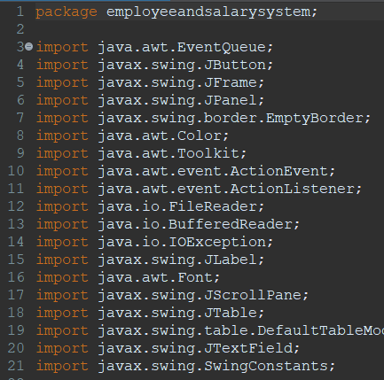

* **The code is in the package employeeandsalarysystem.**
* **It imports various classes from java.awt, javax.swing, and java.io packages, which are necessary for GUI creation and file input/output operations.**

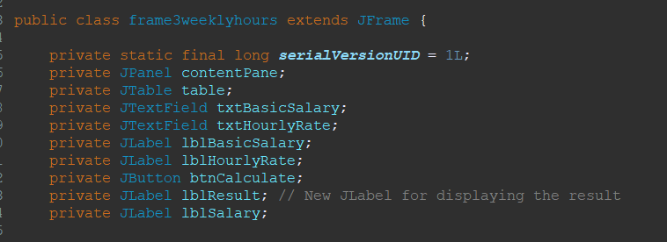

* **frame3weeklyhours** class extends **JFrame**, indicating that it represents a GUI window.
* It has various components like **JPanel**, **JTable**, **JTextField**, **JLabel**, and **JButton** for creating the user interface.

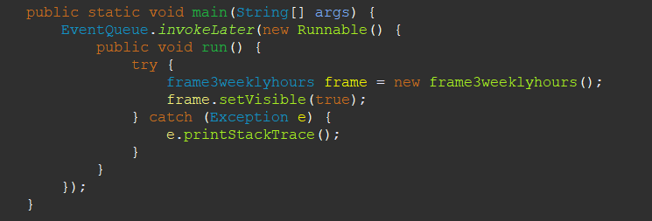

**The main method starts the application by creating an instance of frame3weeklyhours within the Event Dispatch Thread (EDT).**

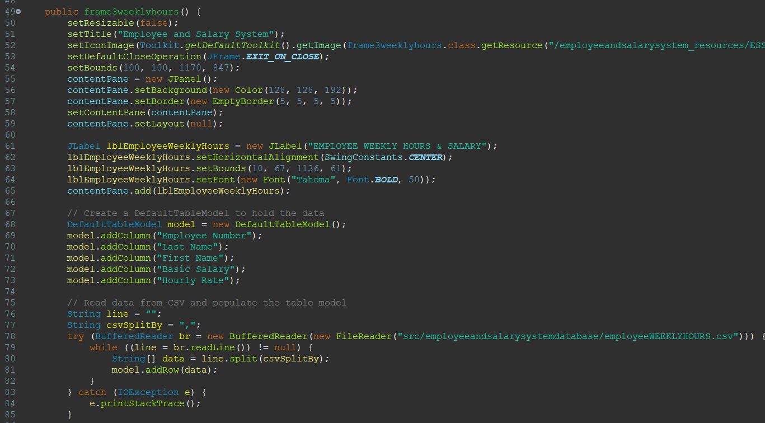

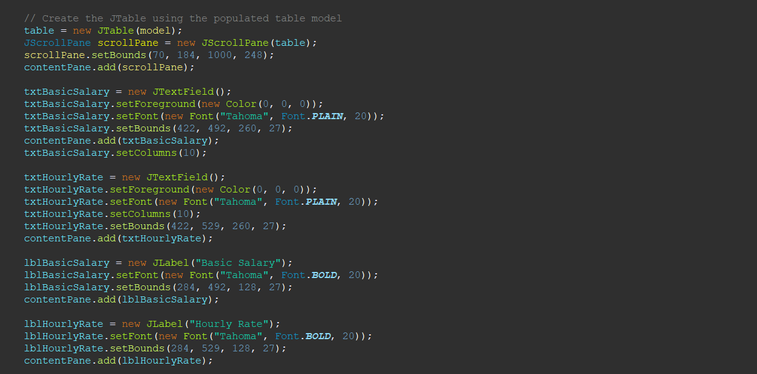

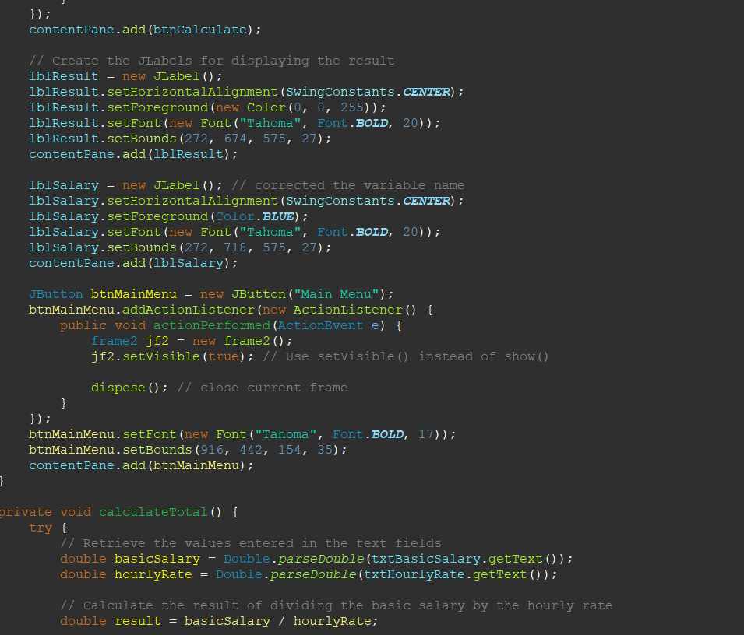

* **Sets up the GUI window properties like title, size, background color, etc.**
* **Adds labels (JLabel) for displaying headings.**
* **Creates a DefaultTableModel named model to hold the data for the table. It defines column headers.**
* **Reads data from a CSV file (employeeWEEKLYHOURS.csv) and populates the table model.**
* **Creates a JTable (table) using the populated table model and adds it to a scroll pane.**
* **Adds text fields (JTextField) for entering basic salary and hourly rate, along with labels for them.**
* **Adds a button (JButton) for calculating weekly hours and salary. It also attaches an action listener to this button for handling the calculation.**
* **Adds labels (JLabel) for displaying the calculated results.**
* **Adds a button (JButton) for returning to the main menu (frame2). It also attaches an action listener to this button for navigation.**

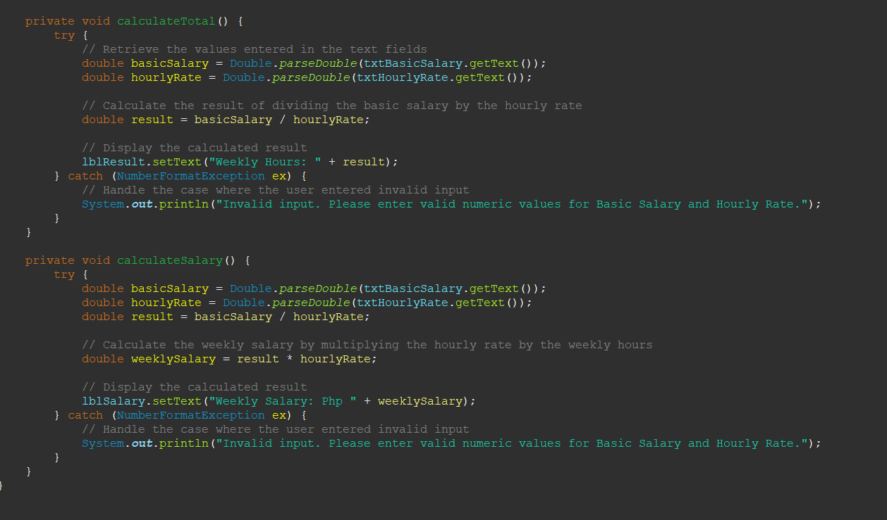

* These are private methods for calculating weekly hours and salary based on the input provided by the user in the text fields.
* They retrieve values from text fields, perform calculations, and update corresponding labels with the calculated results.
* They handle NumberFormatException to deal with invalid input from the user.

**JFRAME 4 – NET WEEKLY SALARY**

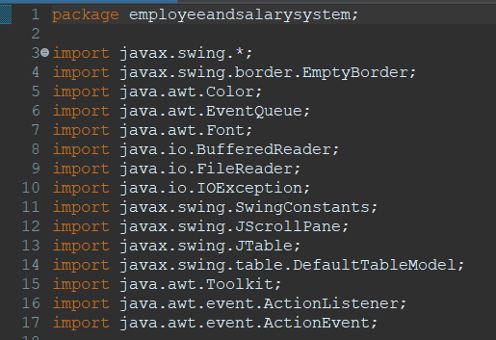

* The code is in the package **employeeandsalarysystem**.
* It imports various classes from **javax.swing** and **java.io** packages, necessary for GUI creation and file input/output operations.

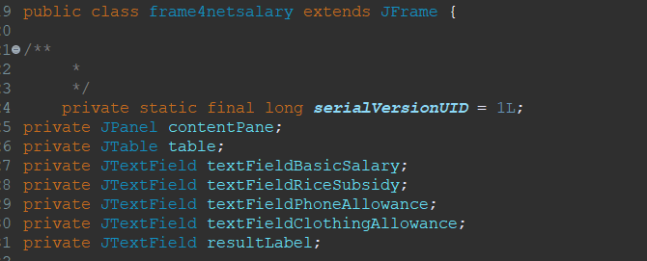

* **frame4netsalary** class extends **JFrame**, indicating that it represents a GUI window.
* It has various components like **JPanel**, **JTable**, **JTextField**, and **JButton** for creating the user interface.

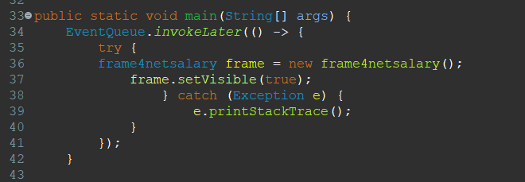

The **main** method starts the application by creating an instance of **frame4netsalary** within the Event Dispatch Thread (EDT).

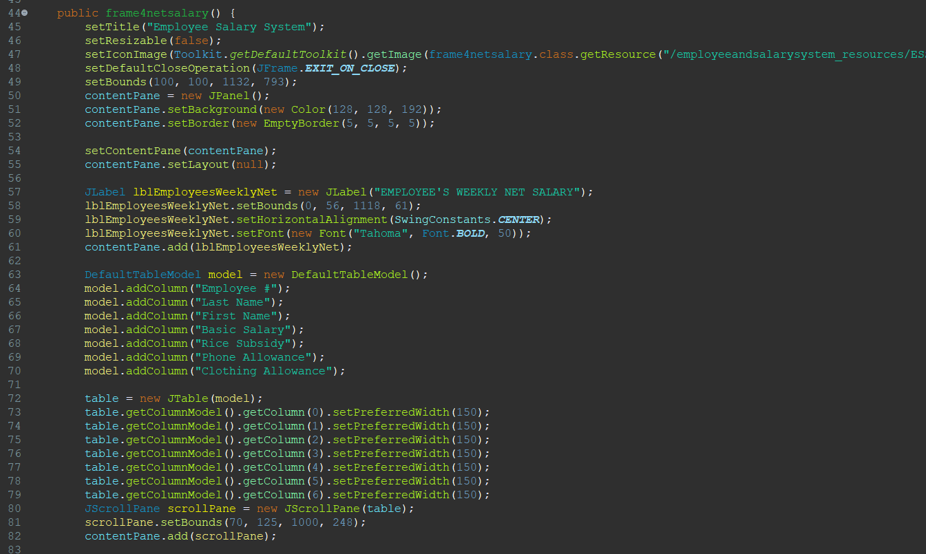

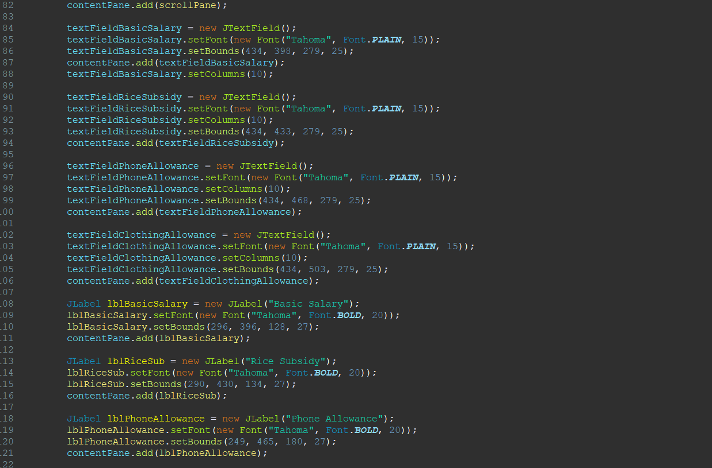

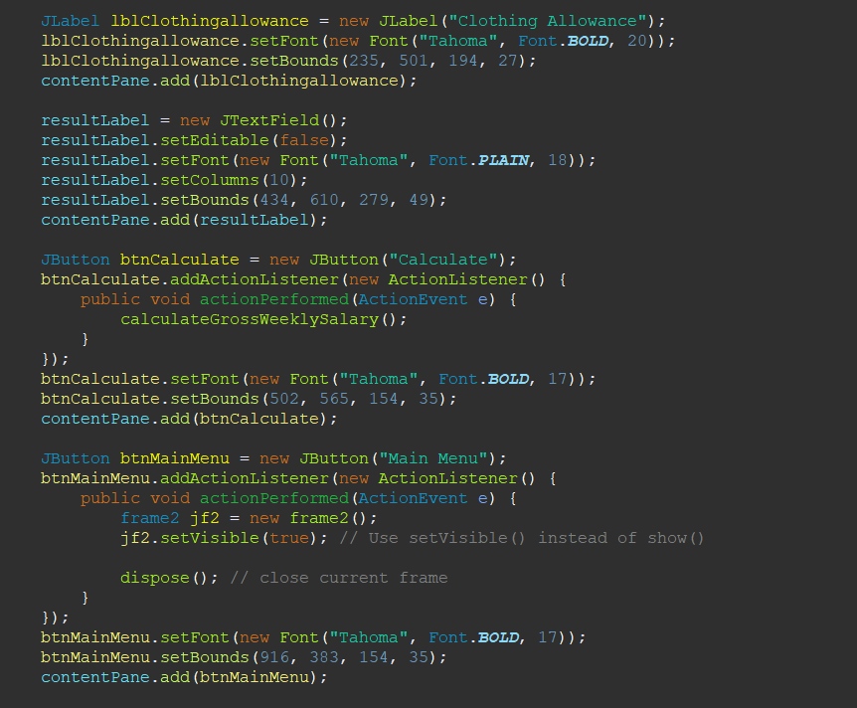

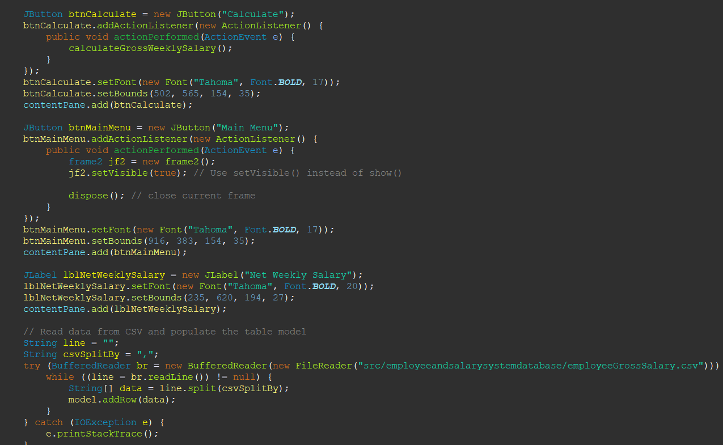

* Sets up the GUI window properties like title, size, background color, etc.
* Adds labels (**JLabel**) for displaying headings.
* Creates a **DefaultTableModel** named **model** to hold the data for the table. It defines column headers.
* Reads data from a CSV file (**employeeGrossSalary.csv**) and populates the table model.
* Creates a **JTable** (**table**) using the populated table model and adds it to a scroll pane.
* Adds text fields (**JTextField**) for entering basic salary, rice subsidy, phone allowance, and clothing allowance, along with labels for them.
* Adds buttons (**JButton**) for calculating net weekly salary and returning to the main menu (**frame2**). It also attaches action listeners to these buttons for handling the calculations and navigation.

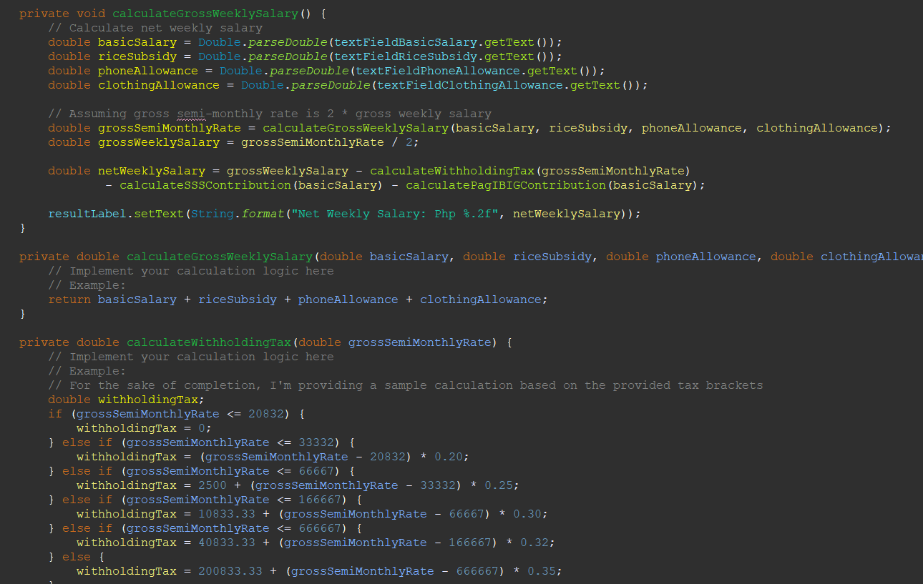

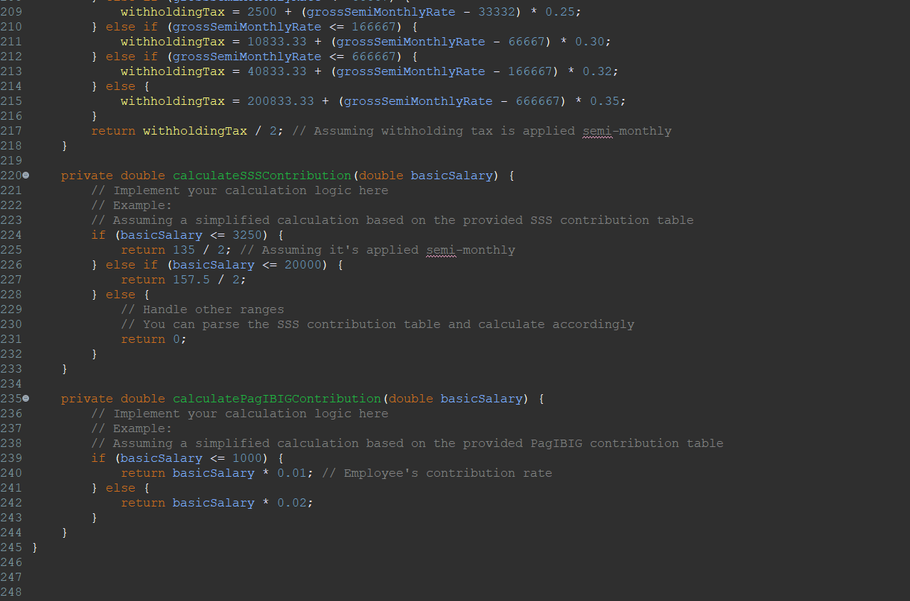

**calculateGrossWeeklySalary(), calculateWithholdingTax(), calculateSSSContribution(), and calculatePagIBIGContribution():**

* These are private methods for calculating gross weekly salary, withholding tax, SSS contribution, and Pag-IBIG contribution based on the input provided by the user in the text fields.
* They retrieve values from text fields, perform calculations, and update the corresponding labels with the calculated results.