Project Title: NAWI TASK 5.17 - (Salveson, Andy) Data-Driven Fault Detection and Process Control for Potable Reuse with Reverse Osmosis

**PROGRESS AND STATUS BY SUBTASK:**

# **Task: Task 5.17.1** – Desktop Evaluations

## **Task:** **Subtask 5.17.1.5 –** Data-Driven Model Optimization (DDMO) for Chloramine and Anti-Scalant Dosing

**Subtask Lead: Steve Hayden**

Research Questions:

* How much cost and energy could be saved across the reuse treatment train applying DDMO to adjust the pre-chloramine and antiscalant doses and predict a fault in real-time in response to water quality changes?

**PROGRESS AND STATUS:**

* Collected data from:
  + Las Virgenes Municipal Water District
    - All necessary data is available and shared among the team
  + Orange County Water District
    - All necessary data is available and shared among the team
  + West Basin Municipal Water District
    - Additional data from WBMWD is still needed.

【下記、Q3の構成】

### Budget Spent (YCA)

### Summary (Kawata-san)

In Task 5.17.1.5, data driven model optimization is used to optimize chloramine and anti-scalant dosing ahead of RO. In this report, we report data analysis underway for the model creation based on OCWD’s full scale plant and LVMWD’s demonstration plant. A key study objective is chemical optimization (e.g., anti-scalant) in the RO operation at both plants.

...

### Desktop Evaluation based on OCWD (Operational Excellence Gr.)

#### Water Quality Prediction (Imoto-san)

#### RO Membrane Scaling using Xact Data (Soya-san)

濃度分極モデルと計算結果

#### RO Optimization Simulation Model (Kumagai)

### Desktop Evaluation based on LVMWD (Operational Excellence Gr.)

#### Water Quality Prediction (Imoto-san)

#### RO Membrane Fouling (Soya-san)

ベルヌーイの定理から抵抗を算出するというコンセプト

#### RO Optimization Simulation Model (Kumagai)

### Desktop Evaluation based on WBMWD (Kawata-san)

#### Target Process for Data Analysis and Measurements Points

#### Trend Charts

#### Title 22 Requirements

#### Predicting Turbidity from Title 22

### Future Tasks (Kawata-san)

【下記、書式設定等】

特に指示されていないが、提出済レポートから参考にした。

[フォント]

・基本的に、フォントスタイルはTimes New Romanで、フォントサイズは12ptで統一する。

[章構成]

・各自で該当章を記入するが、内容や分量に応じて、追加で節・項などを挿入しても良い。ただし、「見出し」を設定しているため、Word上部「表示」タブ⇒「ナビゲーションウィンドウ」で段落のレベルを合わせる。

[図表]

・図表は、テキストボックスに挿入し、キャプションと共に管理する。テキストボックスは「文字列の折り返し」を「上下」にする。

・図表のキャプションのフォントはbold体とする。

・図表の位置は、ページの下部、または上部に寄せるように調整する。

・図表番号は、前から順にFigure1、Figure2、…と若い番号で割り当てていく（合体前は自分のパートだけで割り当てて良い）。ただし、図表の数は多くなりがちなので、類似の図はsubfigureとして一つにまとめる。

・jpegファイルをwordに貼ると、圧縮されて解像度が下がる。Word上部タブの「ファイル」⇒「オプション」⇒「詳細設定」⇒「ファイル内のイメージを圧縮しない」にチェックを入れることで防ぐ。（このファイルは設定済だが、一応書いておく）

・図の例を下記に示す。

[グラフのフォーマット]

・X軸ラベルとY軸ラベルを付ける。単位がある場合は単位も付す。（例：Feed Temperature [℃]）

・同じグラフに、複数種類のデータがある場合は、凡例を付ける。可能なら、単位がある場合は単位も付す。（例：Feed Temperature [℃]）

・X軸方向の目盛線とY軸方向の目盛線を追加する。

・X軸が日付なら「Date」とする。日付のフォーマットは、“dd-Month-yy”とする（2023/11/10なら、10-Nov-23）。pythonなら、datetimeオブジェクトをstrftime関数などで、英語表記に変更できる。

[数式]

・数式は画像で張り付けるのではなく、wordの数式エディタを用いる。Word上部「挿入」タブ⇒「数式」から挿入可能。

・数式番号は、前から順に(1)、(2)、…と若い番号で割り当てていく（合体前は自分のパートだけで割り当てて良い）。

・数式の例を下記に示す。

[付録（Additional Materials）]

・メインパートに全ての数式や図表を多く挿入するとメインにレポートしたい主張が見づらくなるため、補足的な数式や図表は全てAdditional Materialsに移す。

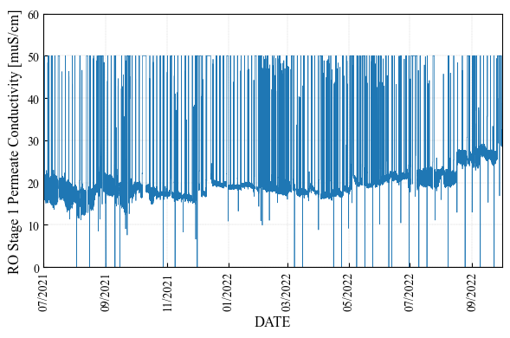 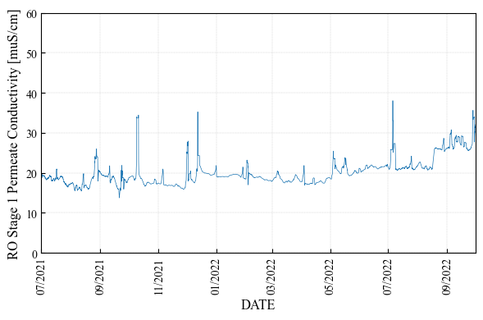

(a): 1st Stage Raw Conductivity (b): 1st Stage Preprocessed Conductivity

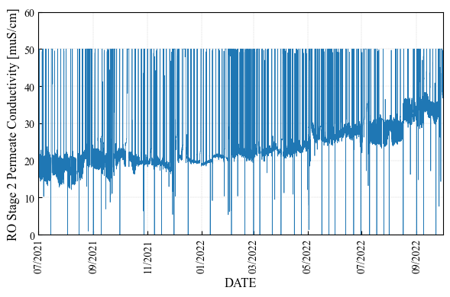 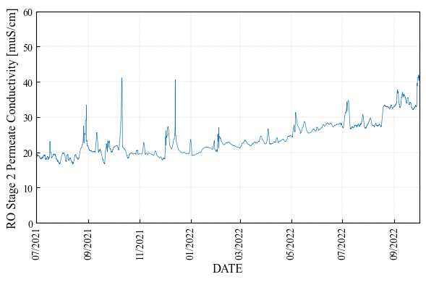

(c): 2nd Stage Raw Conductivity (d): 2nd Stage Preprocessed Conductivity

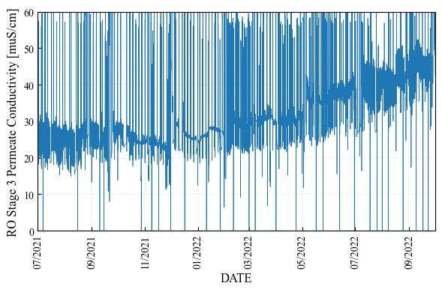 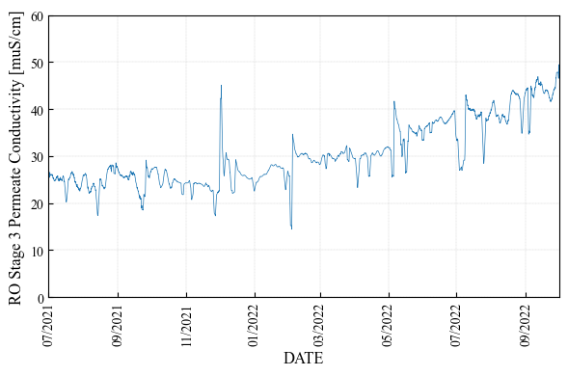

(e): 3rd Stage Raw Conductivity (f): 3rd Stage Preprocessed Conductivity

**Figure XX: Raw and Preprocessed Data of Permeate Conductivity in Each RO Stage [sample figure]**

[sample mathematical formula]

The evaluation index is Mean Absolute Percentage Error (MAPE) [%], which is a relative prediction error and formulated as follows:

Here, is the actual data and is the predicted data at time . is the length of the prediction period.

### Additional Materials

#### A1) RO System Configuration (OCWD)

The data set provided to this team is for the 100 mgd system. We note that the capacity has recently been upgraded to 130 mgd. The full-scale RO membrane system in OCWD, for the longer running 100 mgd of capacity, consists of 21 RO units (3 RO units x 7 RO trains) and each unit has 5 MGD capacity. As OCWD reported in Figure XX**[1]**, these 21 RO systems are being operated by different types of RO membranes. Current analysis focuses upon RO UNIT B01. As shown in the figure below, the membrane type of RO UNIT B01 is Filmtec BW30XFRLE installed in October 2020.

RO UNIT B01 is a 3-stage configuration, with flow rate, pressure, conductivity, and differential pressure measured as shown in the Figure XX. 50 categories of data were provided including feed & permeate flow rate, feed & permeate water qualities (such as conductivity, TOC, turbidity), feed & permeate pressure, Xact, and chemical dosage.

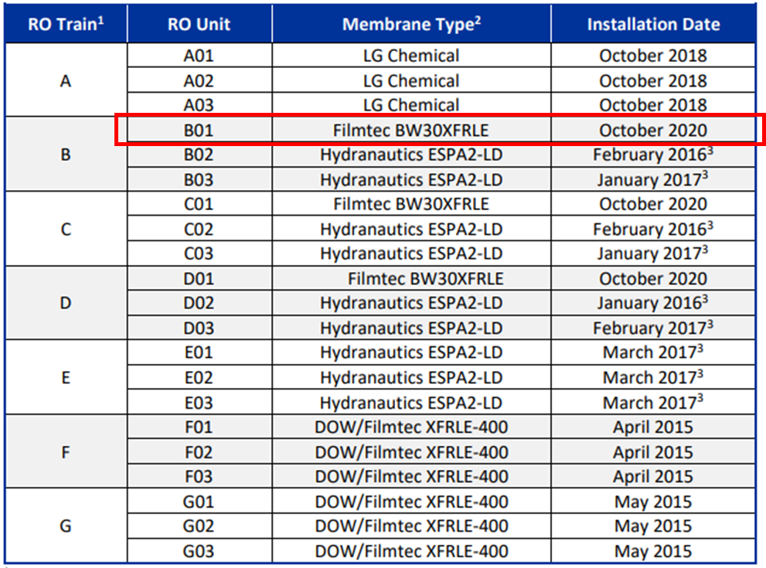

**Figure XX: RO System Membranes (OCWD)**



**Figure XX: RO Unit B01 System Configuration (OCWD)**



**Figure XX: RO System Configuration (OCWD)**

#### A2) RO System Configuration (LVMWD)

The RO membrane system in LVMWD is a pilot scale system. The RO system consists of 3-stage configuration, utilized the Toray TMG10D membrane, and is shown in the Figure XX.



**Figure XX: RO System Configuration and Measurement Points (LVMWD)**

#### A3) Temperature Correction Factor

Used mathematical equations for Temperature Correction Factor (TCF) or normalization in this report are as follows:

* Water Viscosity (Temperature dependency; Andrade equation):

Here, is the water temperature and is a specific coefficient. in LVMWD data, in OCWD data.

* Water Fluidity (Temperature dependency):

Here, is the water viscosity.

* Temperature Correction Factor (TCF):

Here, is the water temperature and is the standard temperature. Eq.(A3) is used in LVMWD data and Eq.(A4) is used in OCWD data.

* Temperature Correction Factor for Flow:

Here, is the water viscosity, is the water temperature and is the standard temperature.

* Temperature Correction Factor for Salt:

Here, is the water viscosity, is the water temperature and is the standard temperature.

* Net Driving Pressure (NDP)

Here, is the RO transmembrane pressure, is the differential RO module pressure, is the osmotic pressure, is the number of RO stages in the system, is the RO feed pressure, is the RO permeate pressure of entire train, and is the RO brine pressure. Unit of each pressure is bar in LVMWD data and psi in OCWD data. in OCWD data.

* Average Osmotic Pressure Differential:

Here, is the average of osmotic pressure between feed and brine flow, is the permeate osmotic pressure, is the log mean factor between feed and brine for TDS, is the permeate TDS, and are constant coefficients. Eq.(A12) is used in LVMWD.

* Log Mean Factor considering concentration polarization on RO surface: ,

Here, is the log mean factor between feed and brine for TDS, is the log mean factor for brine concentration, is the feed TDS, is the brine TDS, and is the recovery rate. Unit of each TDS is ppm in LVMWD data. Eq.(A15) is used in LVMWD data and Eq.(A16) is used in OCWD data.

* Recovery Rate:

Here, is the RO feed flow rate and is the RO permeate flow rate.

* Average Feed and Brine Concentration:

Here, is the RO feed concentration and is the log mean factor for brine concentration.

* Average Feed and Brine Flow Rate:

Here, is the RO feed flow rate, is the RO permeate flow rate, and is the RO brine flow rate. Unit of each flow rate is gpm (gallon per minute) in LVMWD data and OCWD data. Eq.(A19) is used in LVMWD data and Eq.(A20) is used in OCWD data.

* Calculated TDS:

Here, is the RO feed TDS, is the RO permeate TDS, is the RO brine TDS, is the RO feed flow rate, is the RO permeate flow rate, and is the RO brine flow rate. are conductivities. In Eqs.(A22) and (A23), are constant coefficients and given by as follows:

where is the feed conductivity.

1. GWRS 2020 ANNUAL REPORT (https://www.ocwd.com/wp-content/uploads/2020-gwrs-annual-report-appendices-1.pdf)