Yokogawa

NAWI Q2 2023 Quarterly Report

Date: 3/27/2023

Task 5.17.1 – Desktop Evaluations

Subtask 5 – Data-Driven Model Optimization for Chloramine and Anti-Scalant Dosing

* **Budget spent through February 28.**

|  |  |  |
| --- | --- | --- |
| **Task** | **Fed Funding** | **Yokogawa In Kind** |
| **1 [Year 1]** | $31,570 | $16,450 |
| **2 [Year 2]** | $41,460 | $16,420 |
| **3 [Year 3]** | $12,720 | $5,740 |

|  |  |  |  |
| --- | --- | --- | --- |
| **Funding Source** | **Organization Spending the Budget** | **Estimated Budget** | **$ Spent thru reporting quarter (Total)** |
| NAWI (Fed Funds) | YCA | $31,570 | $15,126 |
| YCA (Cost Share) | YCA | $16,450 | $8,642 |

* **Summary**

Yokogawa Corporation of America (YCA) received the data and the reverse osmosis (RO) membrane process information from Orange County Water District (OCWD), Las Virgenes Municipal Water District (LVMWD) and West Basin Municipal Water District (WBMWD). In the 2nd quarterly report, we report data analysis underway for the model creation based on OCWD’s full scale plant and LVMWD’s demonstration plant. A key study objective is chemical optimization (e.g., anti-scalant) in the RO operation at both plants.

OCWD is measuring trace chemicals in the RO feed and permeate by Xact 920, which documents the trace chemicals passage across RO and thus informs the RO membrane scaling for RO stages 1, 2, and 3. A complete correlation analysis for the RO data sets has not yet been completed (RO permeability, the trace chemical passage and the RO fouling status), but all tag information has been identified and behavior examined within available data sets from April 2022 to November 2022.

LVMWD’s data spans April 2021 to October 2022. Normalized flow rate, differential pressure, and salt passage for TMG10D RO membranes (Toray) were determined using Toray’s software to understand the general performance trends. In addition, work has begun to develop the autoregression model to predict salt passage in the RO stages from 1st to 3rd.

WBMWD analysis is not included in this report. A large data set was provided by WBMWD to the project team in March of 2023, but that data set is incomplete. Further information has been requested.

* **Desktop Evaluation based on OCWD**

The data set provided to this team is for the 100 mgd system. We note that the capacity has recently been upgraded to 130 mgd. The full-scale RO membrane system in OCWD, for the longer running 100 mgd of capacity, consists of 21 RO units (3 RO units x 7 RO trains) and each unit has 5 MGD capacity. As OCWD reported in Figure 1, these 21 RO systems are being operated by different types of RO membranes. Current analysis focuses upon RO UNIT B01. As shown in Figure 1, the membrane type of RO UNIT B01 is Filmtec BW30XFRLE installed in October 2020.

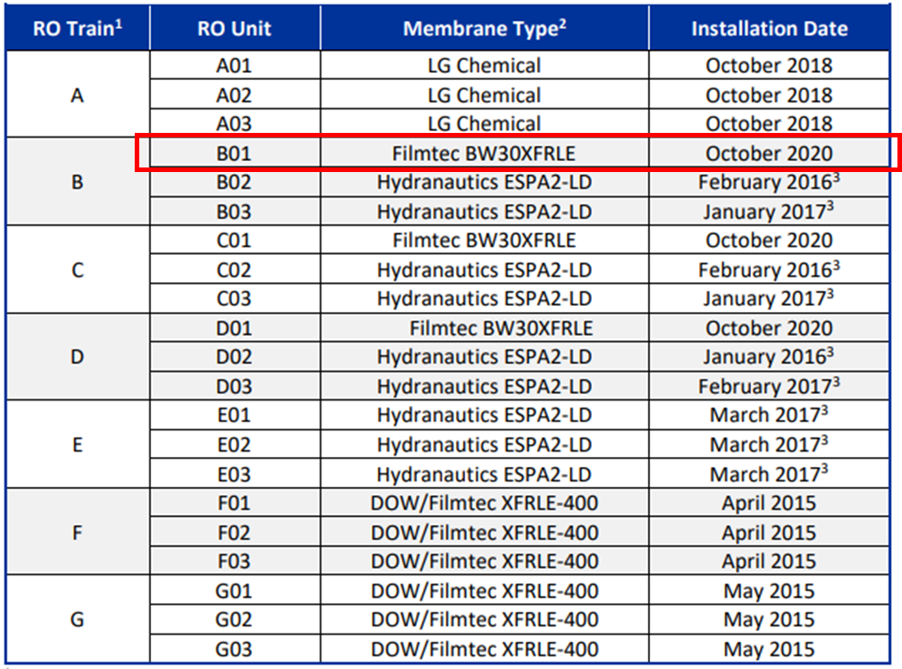

Figure 1: RO System Membranes[1]

RO UNIT B01 is a 3-stage configuration, with flow rate, pressure, conductivity, and differential pressure measured as shown in Figure 2. 50 categories of data were provided including feed & permeate flow rate, feed & permeate water qualities (such as conductivity, TOC, turbidity), feed & permeate pressure, Xact, and chemical dosage.

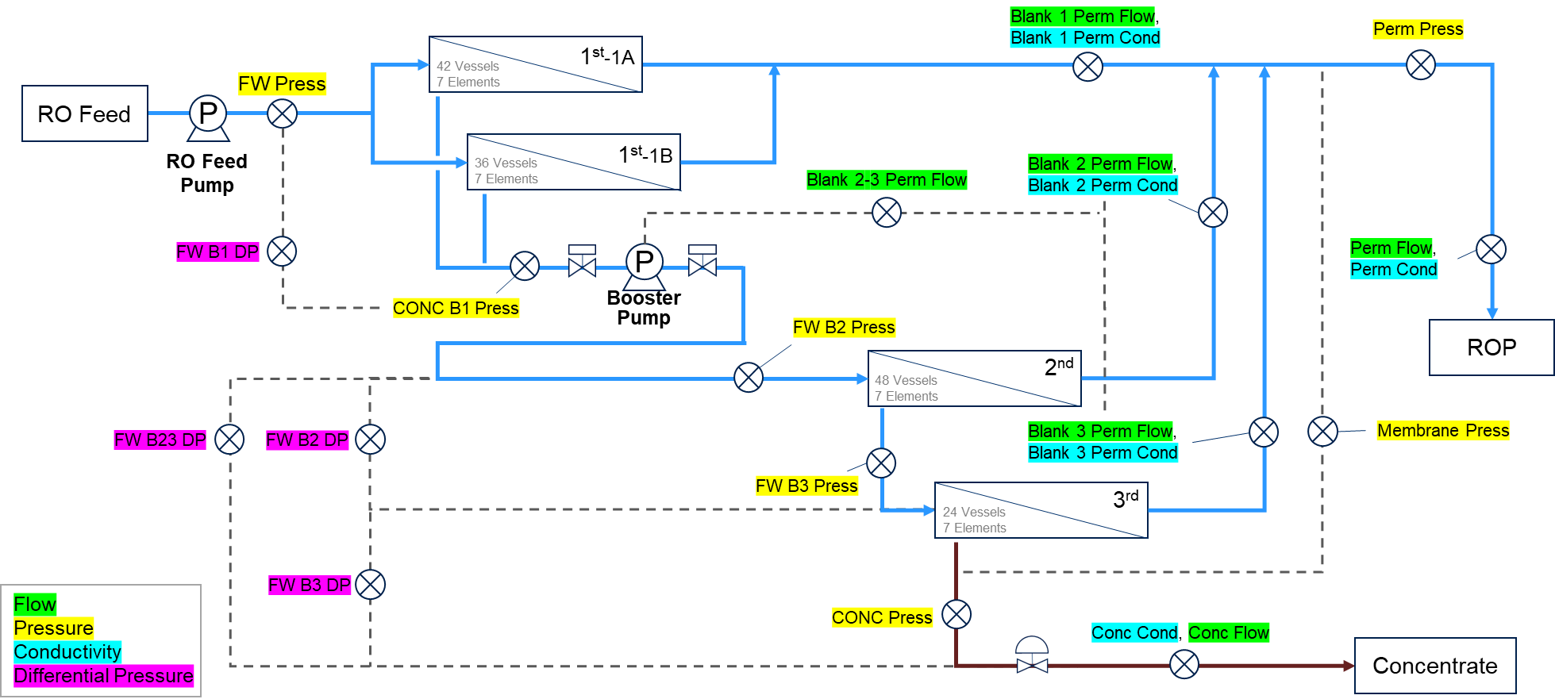

Figure 2: RO UNIT B01

The project team is investigating outlier and correlation analysis. Figure 3 (left) is a plot of the raw data of RO B01 Permeate Conductivity (combined RO Permeates from 1st to 3rd stage). Figure 3 (right)is the data after removing outliers. Ideally, the threshold for outliers should be adjusted dynamically according to the fluctuation changes. For this effort, outliers were removed by upper-lower bounds as a first step. Similar outlier removal was conducted for every variable received.

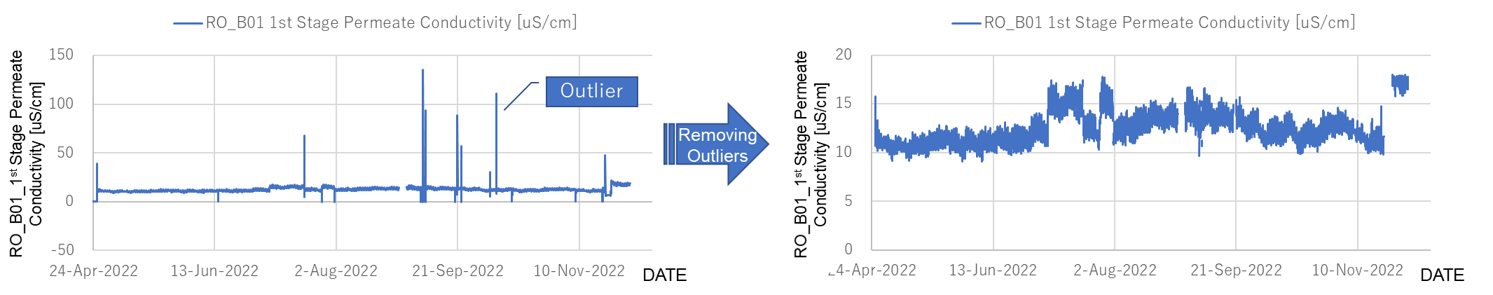

Figure 3: Example of Outliers Removal

The temperature correction data for the Permeate Flow Rate () was generated using the formula below, calculated in terms of , Net Driving Pressure () and Temperature Correction Factor (). and using the formula provided by OCWD. The formula for normalization of by OCWD is pending. Accordingly, is calculated them using reference formula below.

Normalized Permeate Flow Rate is given by Eq.(1).

Here, is real-time measured flow rate, is net driving pressure, and is temperature correlation factor. “” indicates the values of those variables at the reference point. Equations for and are given in the Appendix.

Figure 4 shows the Permeate Flow Rates of 1st to 3rd stages and the overall Permeate Flow Rate of RO Unit B01 since April 2022. The blue line is the Permeate Flow Rate, and the yellow line is the Normalized Permeate Flow Rate. The Permeate Flow Rates of 1st to 3rd stages ranged from 1,900 to 2,500 GPM, 1,000 to 1,300 GPM and 250 to 400 GPM, respectively. The Normalized Permeate Flow Rates were descending after September (3rd stage is the most significant), which were recovered on November 23rd. More information from OCWD is needed to understand if the recovery was caused by CIP, and if the CIP event was scheduled, what kind of cleaning was provided on the day.

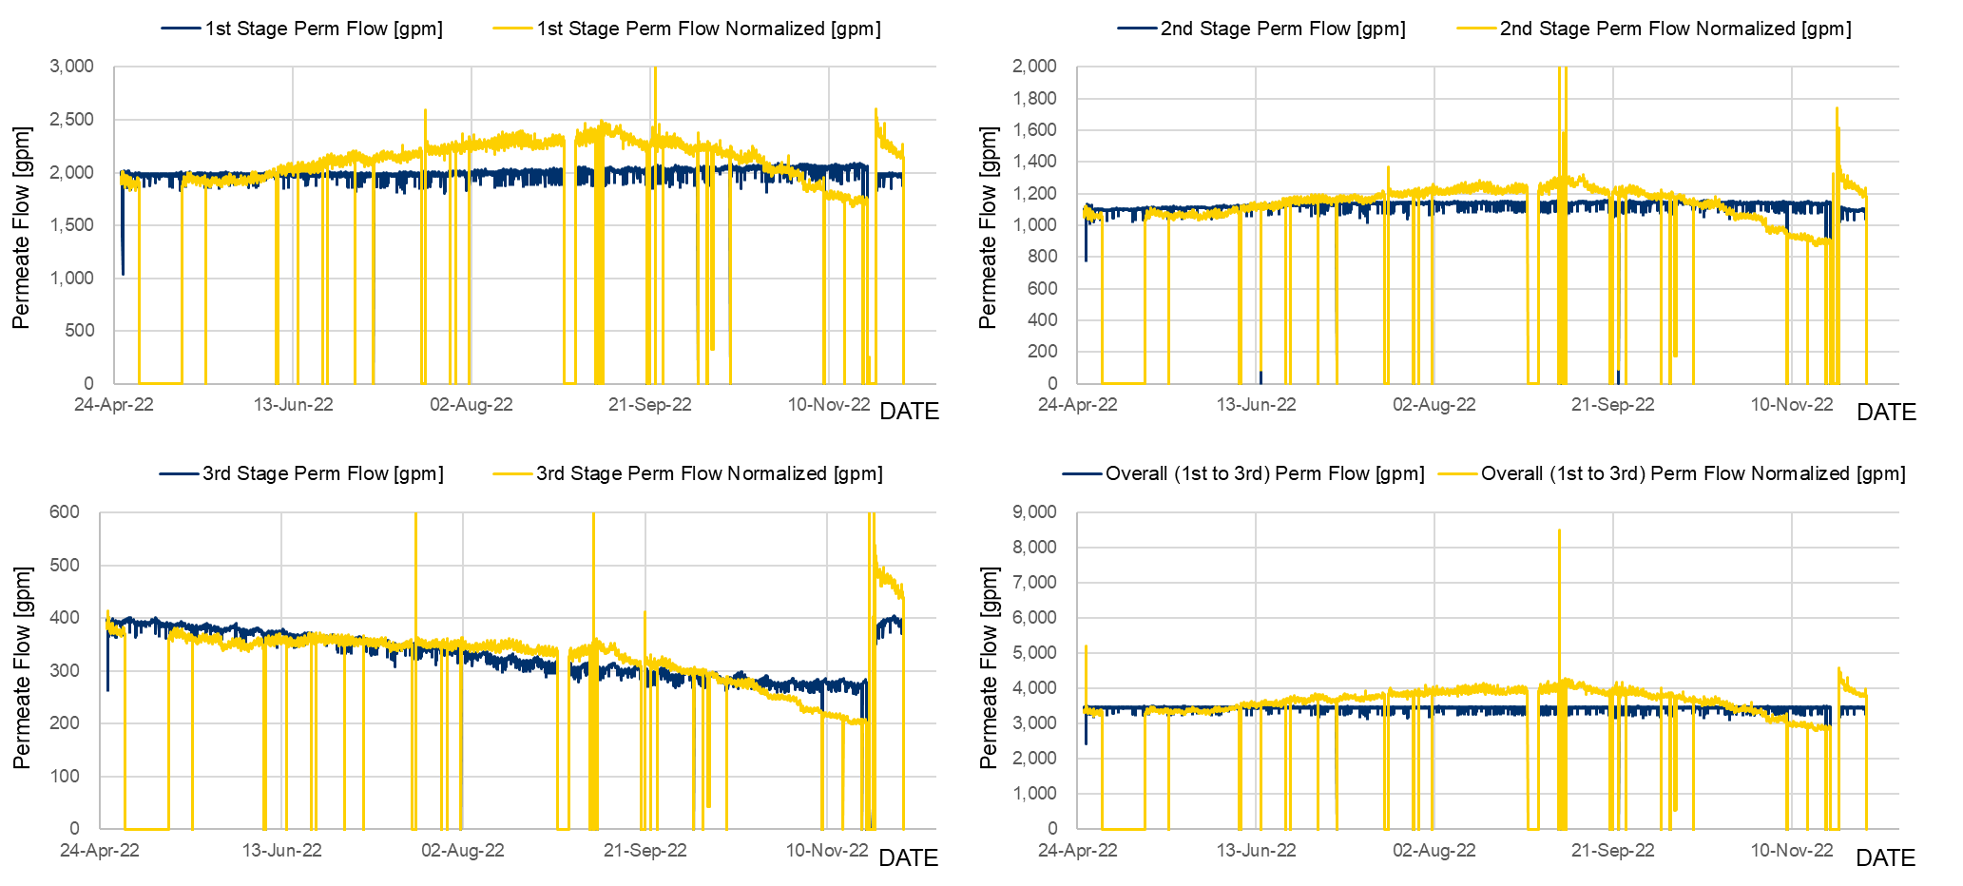

Figure 4: RO Unit B01 Permeate Flow

To investigate the major contribution factor of the Net Driving Pressure, focus was placed upon Pressure Feed, Osmotic Pressure generated, and Differential Pressure, all temperature corrected. The Pressure Feed values at each stage were most synchronized with Net Driving Pressure as shown in Figure 5.

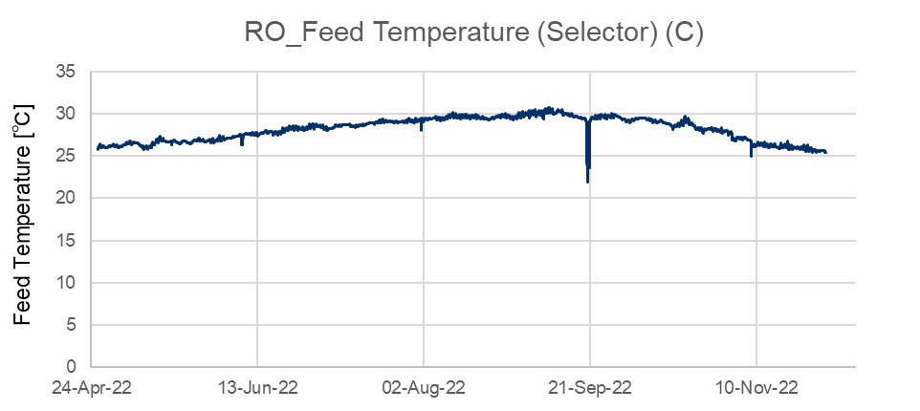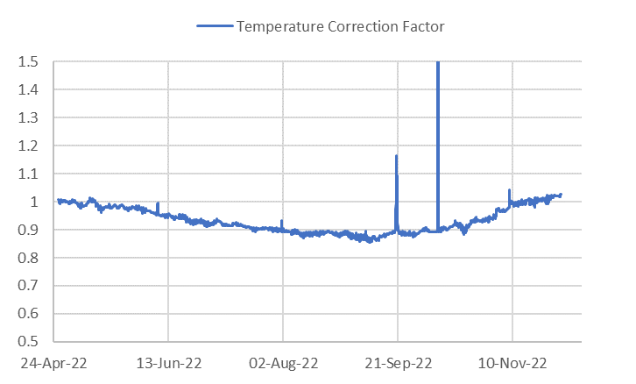

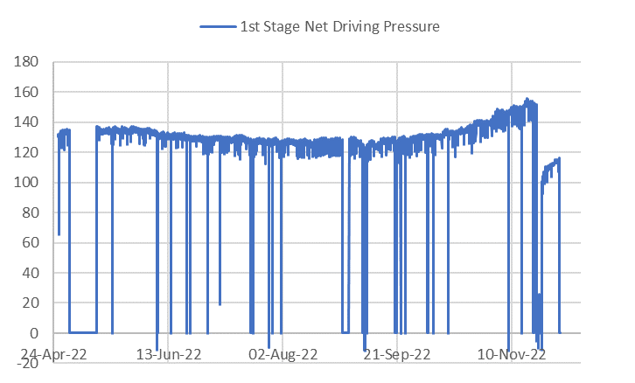 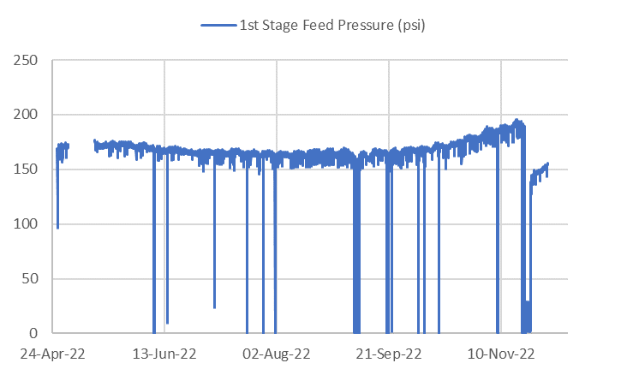

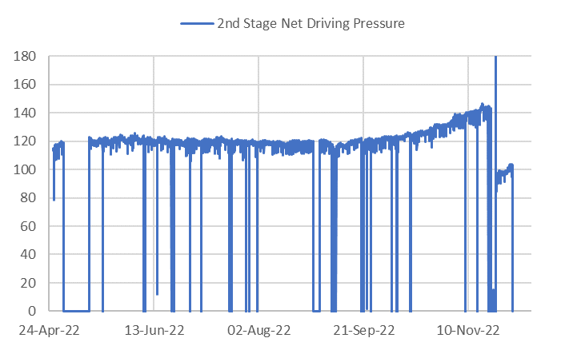 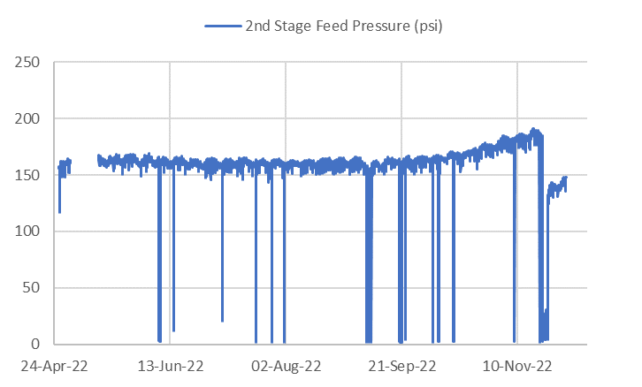

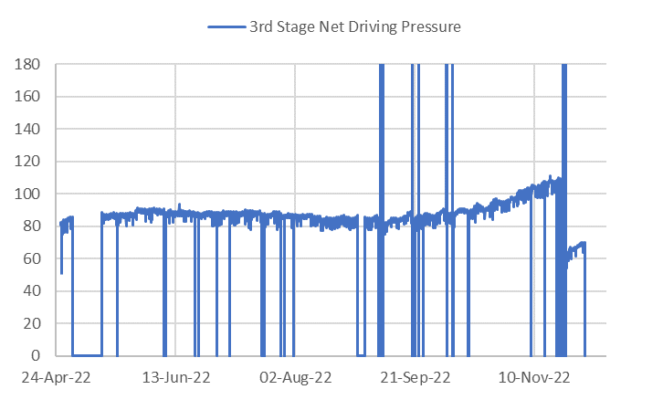 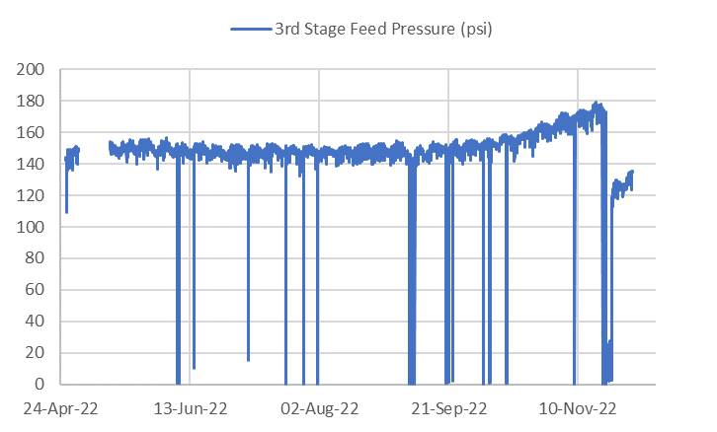

Figure 5: Factors that contribute to temperature correction

Figure 6 shows the Permeate Conductivity from 1st to 3rd and the combined Permeate Conductivity after April 2022. The trends of the Permeate Conductivity from 1st to 3rd fluctuated from 10 to 20 uS/cm, 18 to 40 uS/cm, and 38 to 120 uS/cm, respectively. The trends of the combined Permeate Conductivity fluctuated from 30 to 65 uS/cm.

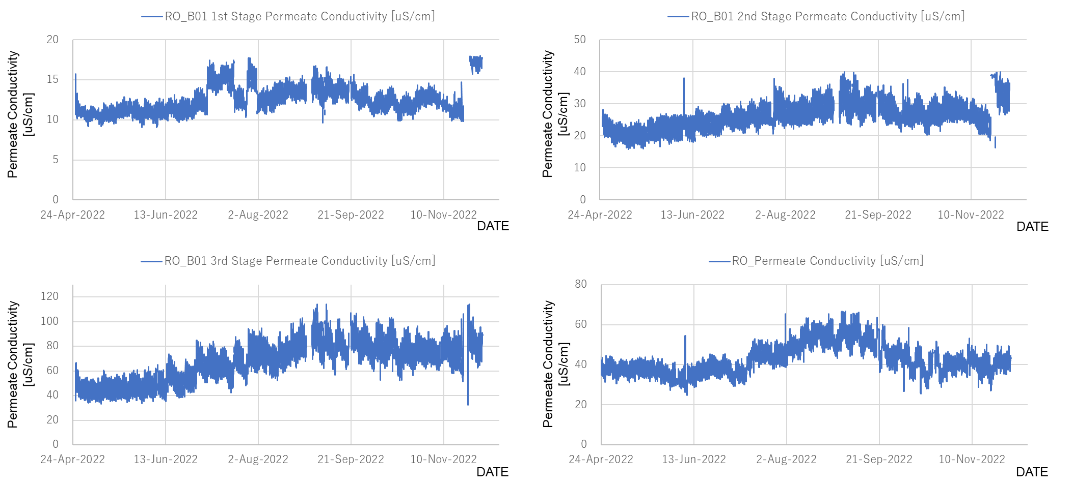

Figure 6: RO Unit B01 Permeate Conductivity

The temperature correction data for the Salt Passage were given by the formula below. Since the specific formula was not clear, we calculated with formula in common. Salt Passage was calculated in terms of Permeate Flow Rate, Salt Transport Temperature Correction Factor (), Permeate Concentration and apparent concentration of the RO feed within the RO vessel (Feed-Brine Concentration). In this calculation, is used as a substitute of .

Normalized Salt Passage is given by Eqs.(2) and (3).

Here, [%] is Actual Salt Passage, is Element Permeate Flow rate at actual conditions, is Salt Transport Temperature Correction Factor at actual conditions, is Permeate concentration [ppm], and is average Feed and Brine Concentration. “” indicates the values of those variables at the reference point or standard condition. Equation for is given in Appendix.

Figure 7 shows the Salt Passage from 1st to 3rd and the Salt Passage for the combined RO Permeate after April 2022. The blue line is the Salt Passage, and the yellow line is the Normalized Salt Passage. The trends of the Normalized Salt Passage from 1st to 3rd fluctuated 0.4 to 0.8 %, 0.4 to 1.5 %, and 0.4 to 1.0 %, respectively. Since these were calculated including conductivity, the trends normalized were fluctuated according to the conductivity changes (Figure 6).

After Nov 23rd, 2022, each RO stage saw a rapid increase in salt passage (see red dottend box). . More information from OCWD on the event of this day is needed.

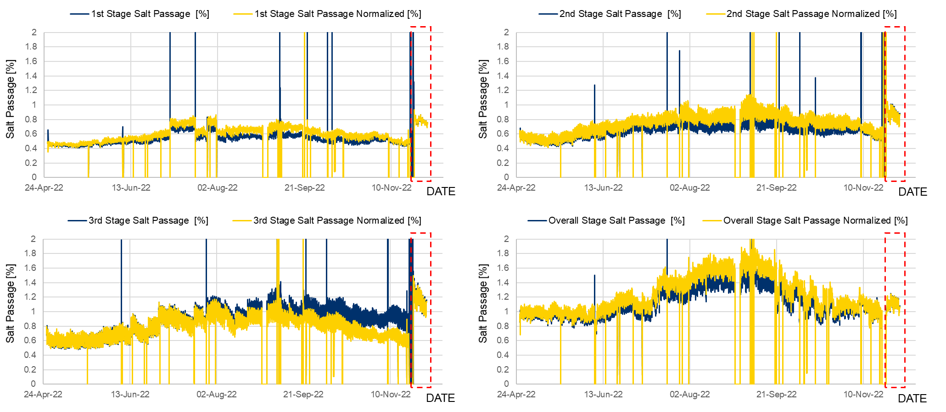

Figure 7: RO Unit B01 Normalized Salt Passage

The temperature correction data for the Differential Pressure were generated using the formula provided by OCWD below, using Differential Pressure, Permeate Flow, and Brine Flow.

Normalized Differential Pressure is given by Eqs.(4) and (5).

Here, is the differential RO module pressure, is the RO feed pressure, is the RO brine pressure, and is average Feed and Brine Flow Rate. Unit of each pressure is Pound-force per Square Inch (psi) in OCWD data. “” indicates the values of those variables at the reference point or standard condition. Equation for is given in the Appendix.

Figure 8 shows the Differential Pressure from the 1st to 3rd stages as well as the combined flow Differential Pressure after April 2022. The blue line is the Differential Pressure, and the yellow line is the Normalized Differential Pressure. The trends of the Normalized Differential Pressure from 1st to 3rd stage fluctuated, 15 to 20 psi, 11 to 12 psi, and 10 to 13 psi, respectively. The trend of the 1st Stage Normalized Differential Pressure was slightly increasing. However, the trend of the 2nd Stage and 3rd Stage were almost constant.

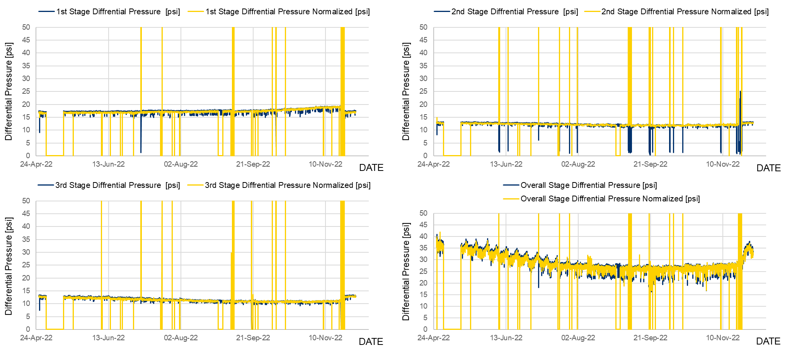

Figure 8: RO Unit B01 Normalized Differential Pressure

The Xact 920 in OCWD is considered a unique analyzer for RO performance evaluation. The Groundwater Replenishment System (GWRS) RO process using the information to verify membrane integrity through monitoring trace elements as well as detection of mineral-scale forming metals[2]. This effort focuses upon on the relationships between Xact 920 data and other data to detect membrane scaling.

Figure 9 shows the Xact 920 data of feed Ca and permeate Ca. Noted in the figure are days in which the feed CA is lower than expected which also coincides with permeate Ca being higher than expected. Figure 10 shows the Xact 920 data of feed Sr and permeate Sr. Similar to the Ca data set, the figure notes when concentrations differ from expectations. The project team will investigate the reasons of the deviations.

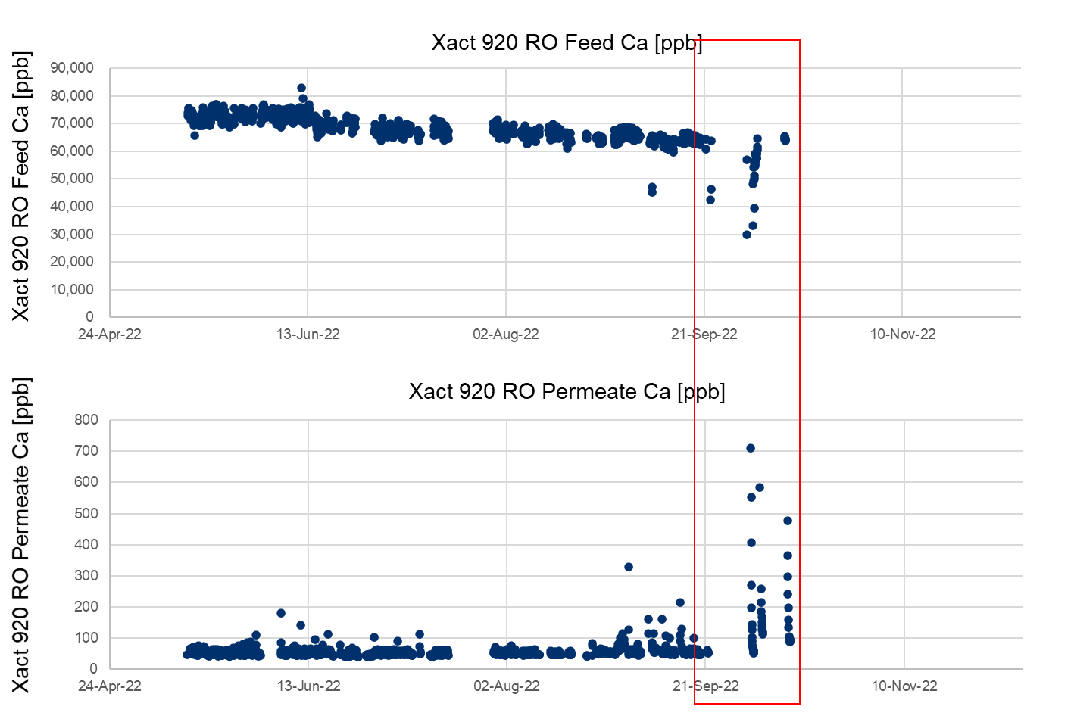

Figure 9: Xact Feed and Permeate Ca

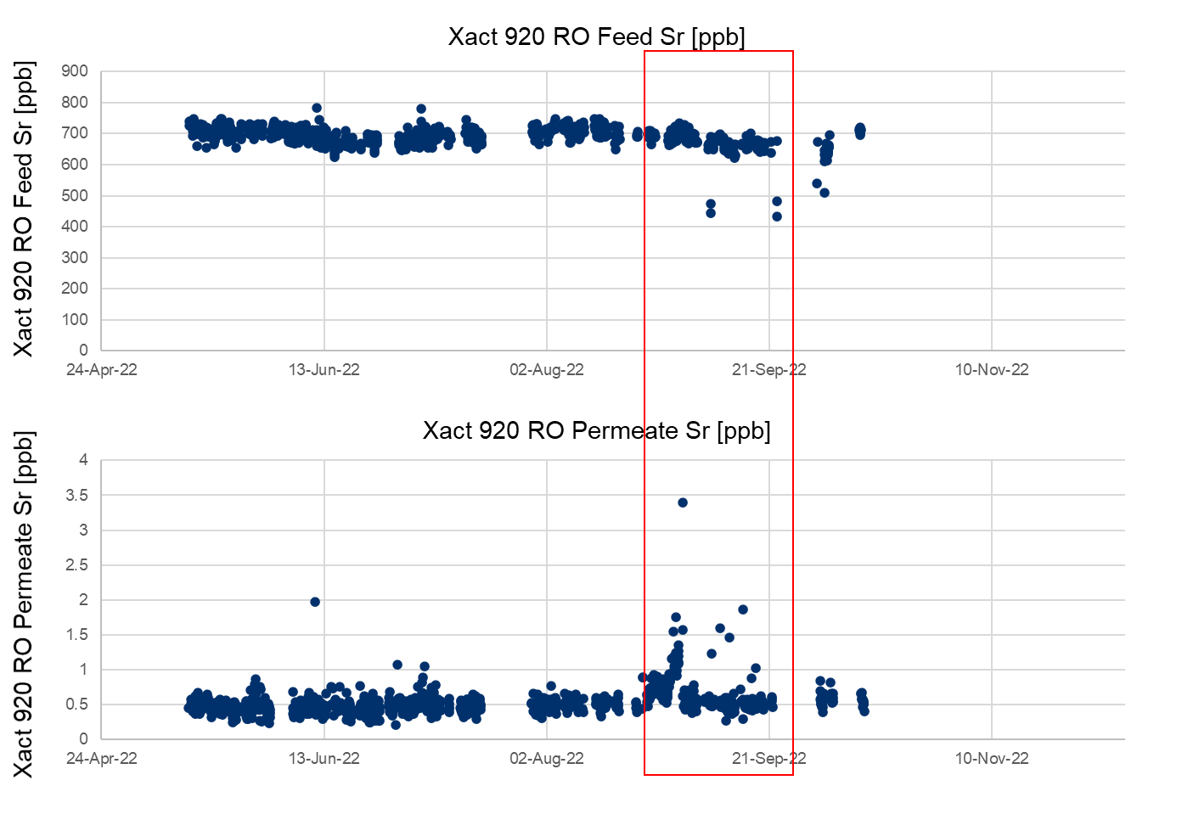

Figure 10: Xact Feed and Permeate Sr

* **Desktop Evaluation based on LVMWD**

The RO membrane system in LVMWD is a pilot scale system. The RO system consists of 3-stage configuration and utilized the Toray TMG10D membrane. Temperature correction data with 30 min intervals was used for analysis. Figure 12 shows the Permeate Flow from 1st to 3rd stages and the Overall Permeate Flow after Nov 2020, with all data temperature corrected. The temperature correction data for the Permeate Flow were generated using the equations below provided by Toray. It was calculated in terms of TCF and Net Driving Pressure (NDP).

Normalized Permeate Flow Rate is given by Eq.(6).

Here, is measured permeate flow rate, is net driving pressure, and is temperature correlation factor for flow rate. “” indicates the values of those variables at the reference point or standard condition. Equations and are given in Appendix.

The data from Nov 2020 to June 2021 were unstable (and marked in gray in the figure below), noting a significant number of data points at zero. The trends of the Permeate Flow from 1st to 3rd and the Overall Permeate Flow were decreasing from 20 to 8 GPM, 8 to 5 GPM, 3 to 1.6 GPM, and 25 to 17 GPM except for the unstable data marked in gray. Overall, the permeate flow decreased by 30% in 2 years.

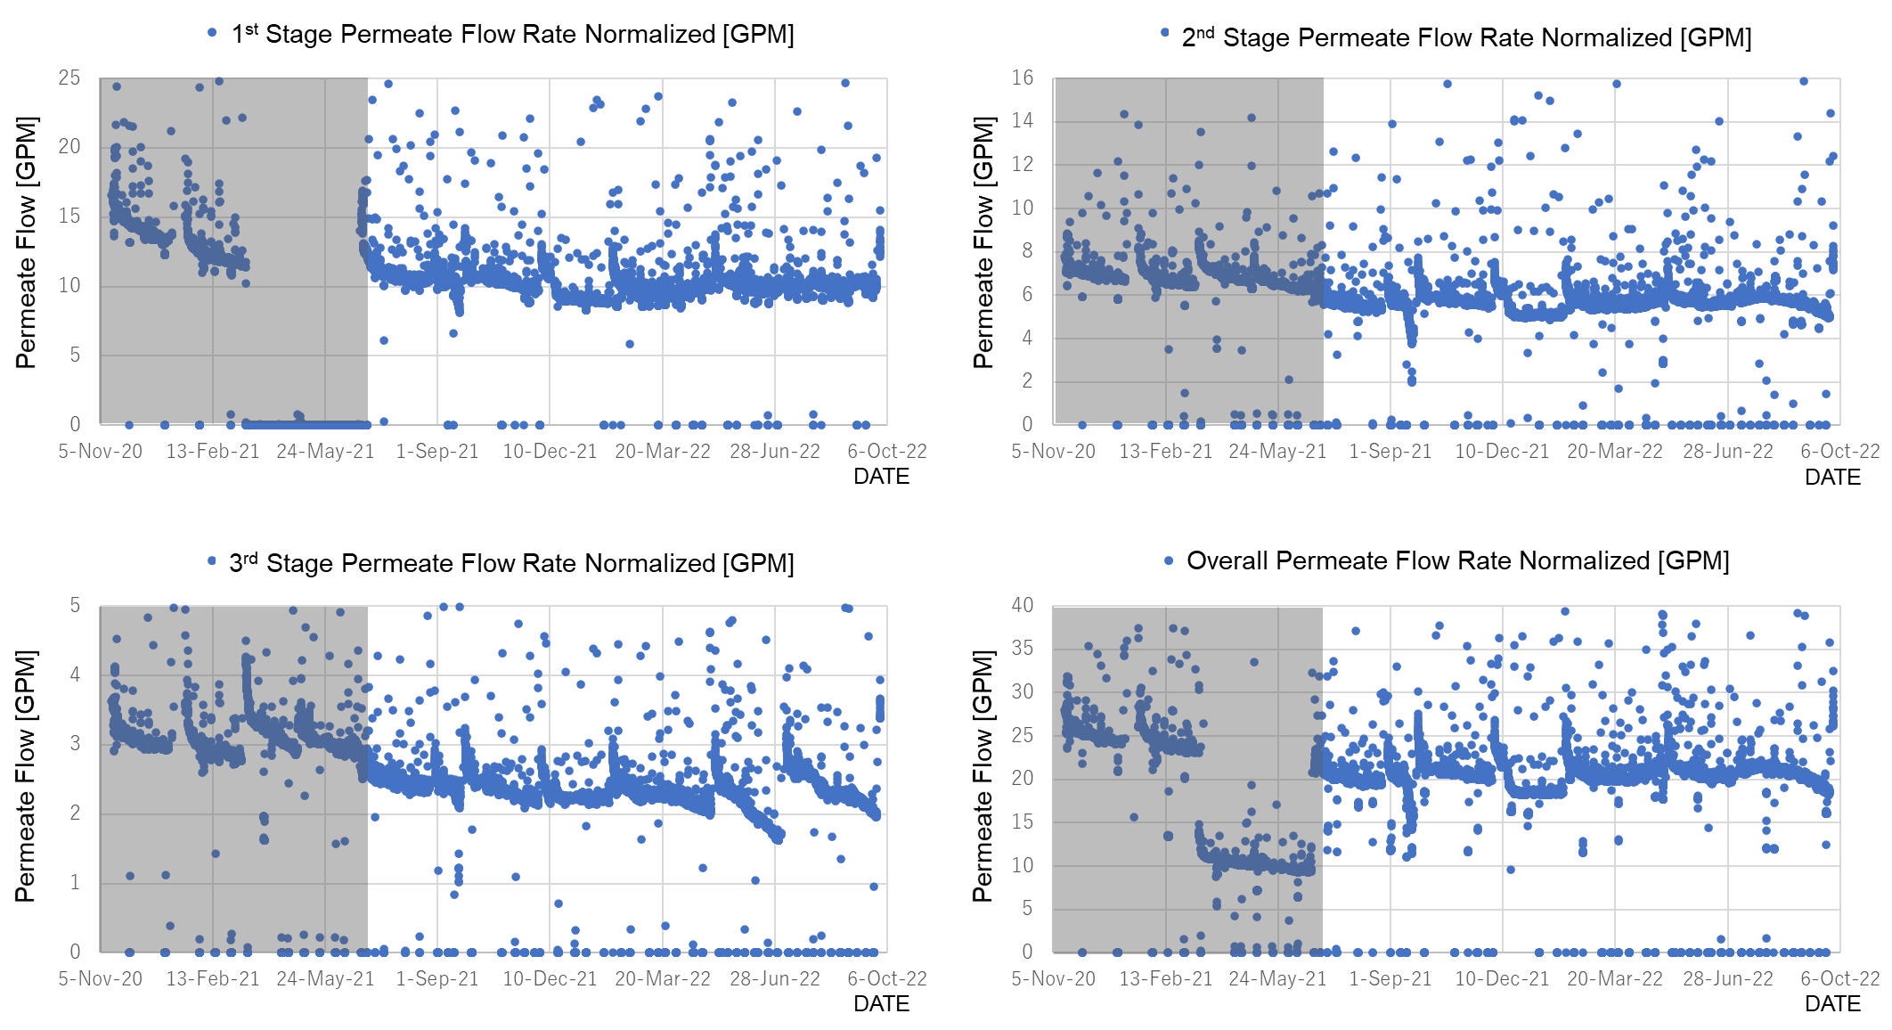

Figure 12: Normalized Permeate Flow

Figure 13 shows the Normalized Differential Pressure of each stage and the Overall Differential Pressure after Nov 2020, which were corrected by temperature.

The Temperature correction data for the Salt Passage were generated using the equations below provided by Toray. It was calculated using Permeate Flow, TCF, Feed Brine, and Feed TDS. Feed Brine and Feed TDS are calculated by the equations shown above in Normalized Permeate Flow calculation.

Normalized Salt Passage is given by Eqs.(7) and (8).

Here, [%] is Actual Salt Passage, is Permeate Flow Rate, is temperature correlation factor for salt, is the log mean factor between feed and brine for TDS, is feed TDS, and is permeate TDS. “” indicates the values of those variables at the reference point or standard condition. Equations for are given in Appendix.

The trends of the Normalized Differential Pressure at the 1st stage and the 3rd stage were increasing from 7.5 to 8.2 psi and 8.9 to 10.4 psi except for the unstable data marked in gray. The Normalized Differential Pressure at the 2nd stage and the Overall Normalized Differential Pressure were almost constant from 5.3 to 5.3 psi and 21.3 to 20.6 psi, respectively.

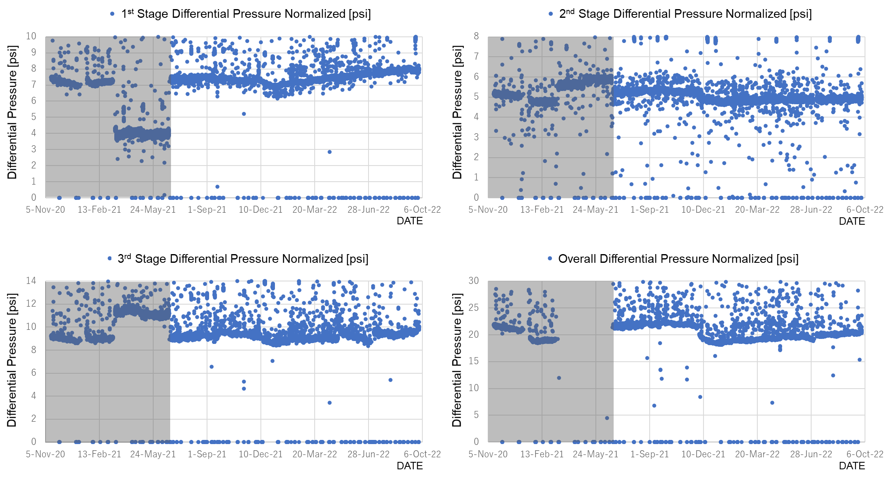

Figure 13: Normalized Differential Pressure

Figure 8 shows the Salt Passage from the 1st to 3rd stages and the Overall Salt Passage after Nov 2020, which were corrected by temperature. The Temperature correction data for the Differential Pressure were generated using the equations below provided by Toray. It was calculated in terms of Differential Pressure, Feed Flow, Concentration Flow, and Water Viscosity. Water Viscosity is calculated by the equation shown above in Normalized Permeate Flow calculation.

Normalized Differential Pressure is given by Eq.(9).

Here, is Module Differential Pressure, is average Feed and Brine Flow Rate, and is water viscosity at temperature . The coefficient is specific to membrane. “” indicates the values of those variables at the reference point or standard condition. is given by Eq.(5) and Equations for are given in Appendix.

The trends of the Salt Passage from the 1st to 3rd stages and the Overall Salt Passage were gradually increasing to 1.5%, 1.0%, 0.7%, and 0.8%, respectively. It suggests the possibility that RO clogging was progressing.

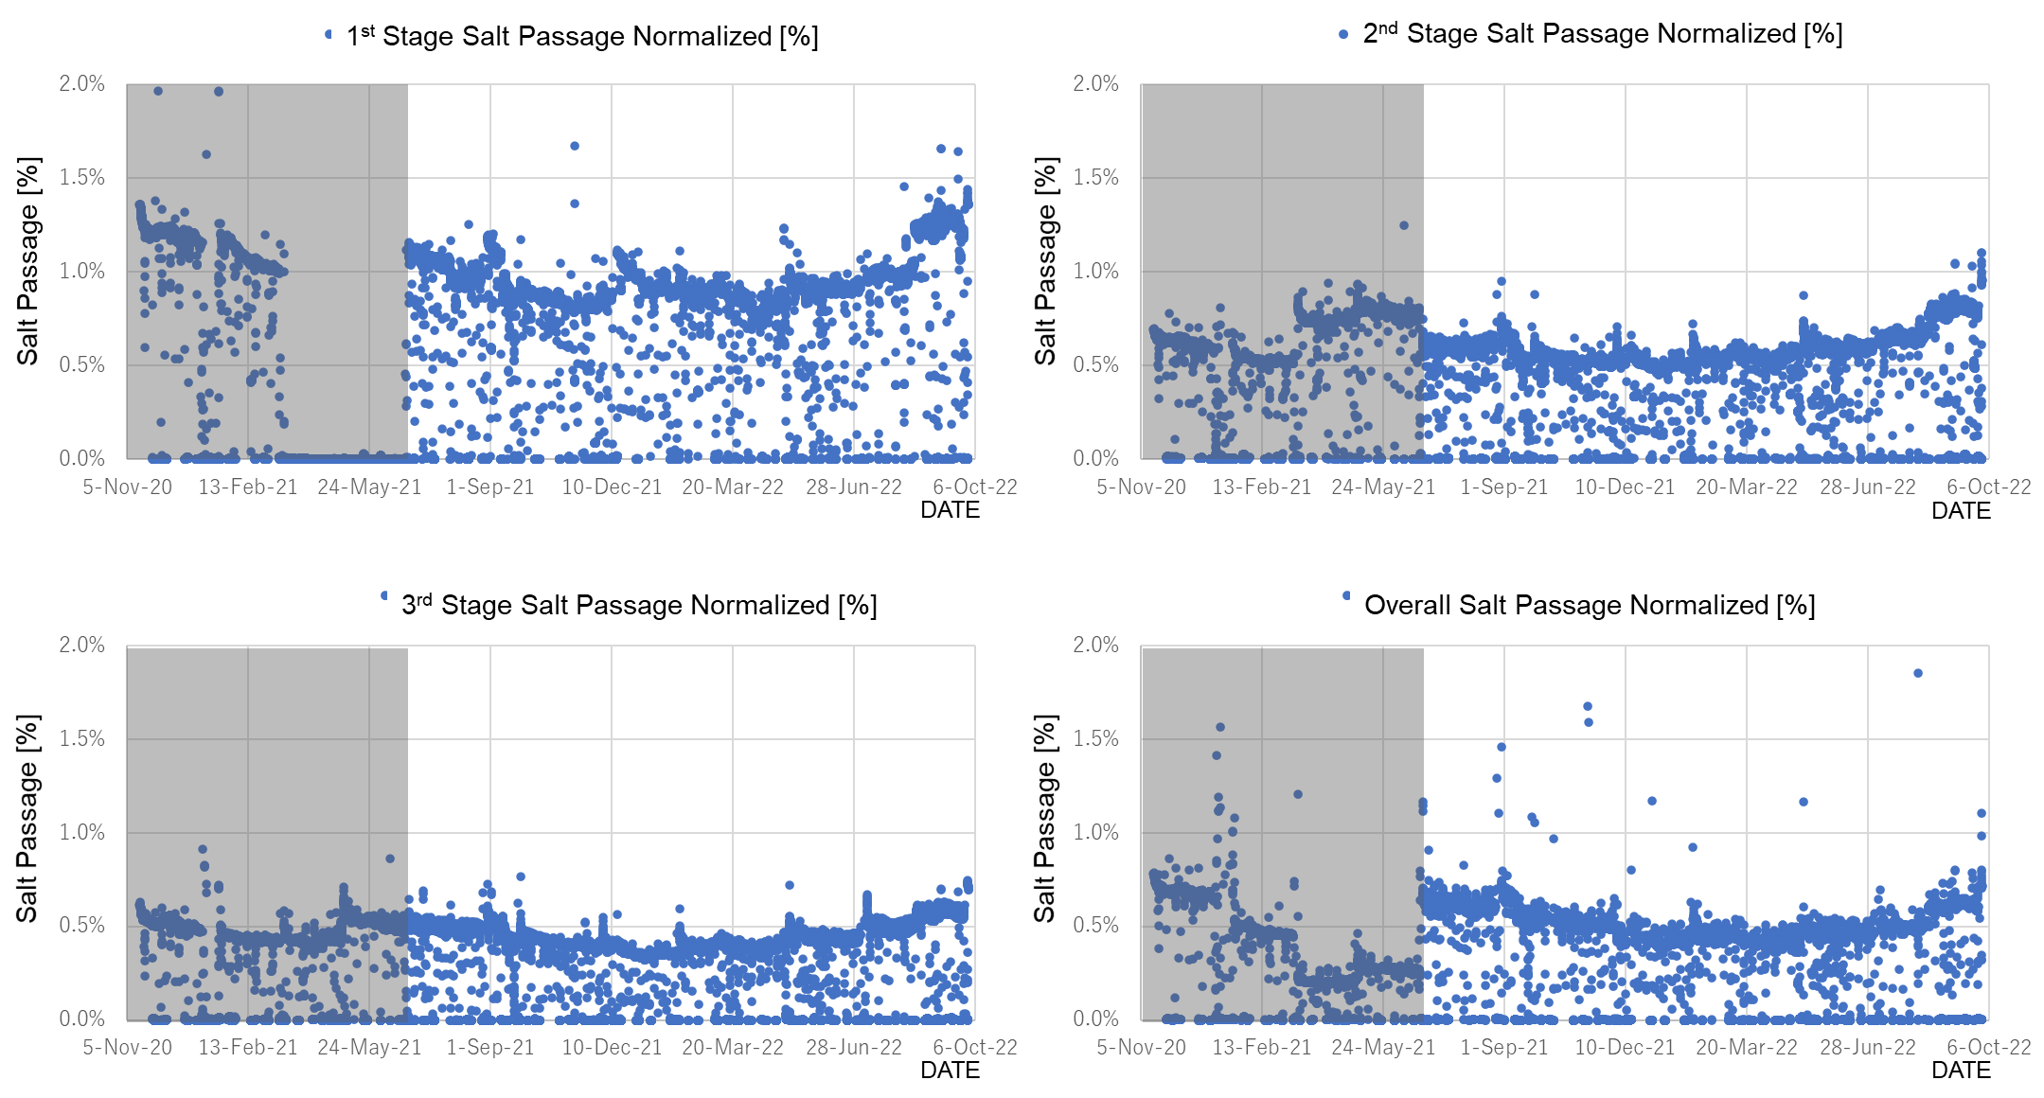

Figure 14: Normalized Salt Passage

From Figure 12 to Figure 14, the correlation between variables using the data after July 2022. In Figure 15(a), the Correlation Coefficient R between Normalized Overall Permeate and Normalized Overall Salt Passage was -0.65. In Figure 15(b), the Correlation Coefficient R between Salt Passage and Normalized Overall Differential Pressure was 0.63. It matches the theoretical behavior of RO.

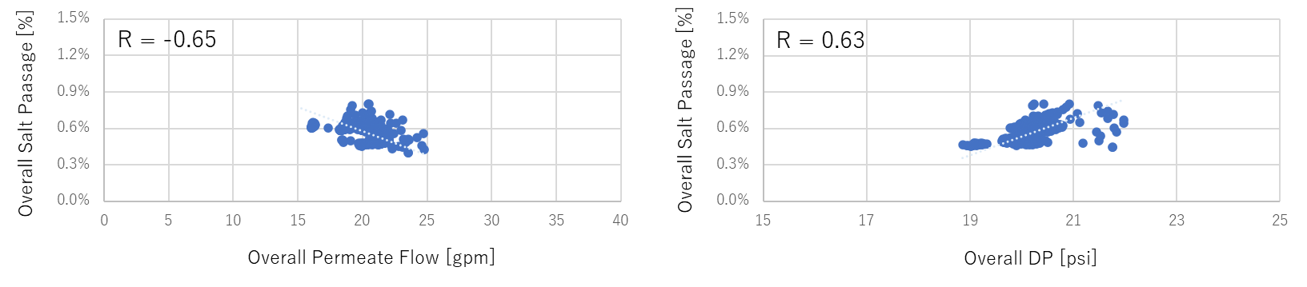

(a): Correlation between (b): Correlation between Salt Passage and

Salt Passage and Permeate Flow Differential Pressure

Figure 15: Scatter Plot and Correlation between Variables

* Permeate Conductivity Prediction

Permeate conductivity, which is considered an indicator of RO membrane scaling, was focused to predict the behavior based on the AI algorithm.

* Preprocessing Data

[]. Figure 16 shows a data preprocessing flow chart, e.g., outlier filtering, down-sampling, smoothing, and missing data imputation. Outlier filtering is to remove outlier data by imposing upper or lower limits. Down-sampling is to convert the time series data with 1 minute interval into 30-minute interval data by average. Smoothing is to smooth the time series data by moving averages with 96 window steps. Missing data imputation is to fill missing row data by copying before and after actual data.

Figures 17(a)-(f) show the trend chart of preprocessed conductivity data in each RO stage from July 2021 to Sep 2022. By preprocessing the data, outliers are removed, and the data behavior can be extracted.

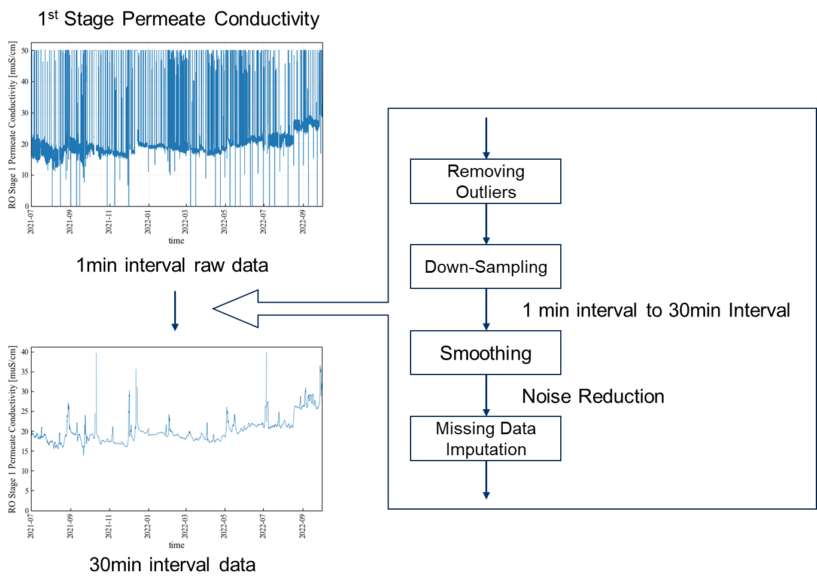

Figure 16: Data Processing Flow Chart

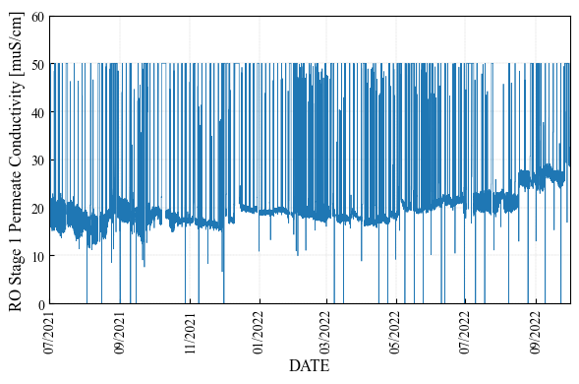 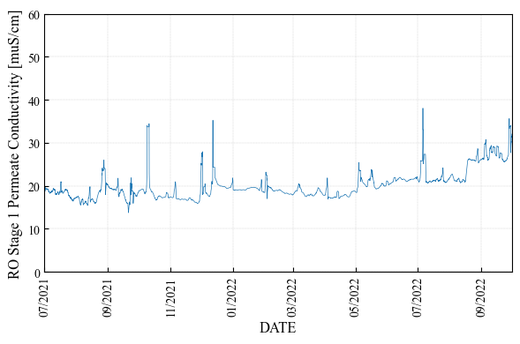

(a): 1st Stage Row Conductivity (b): 1st Stage Preprocessed Conductivity

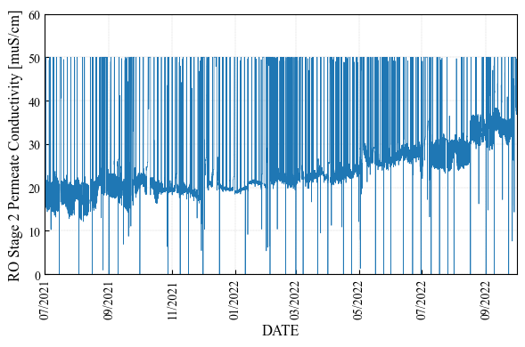 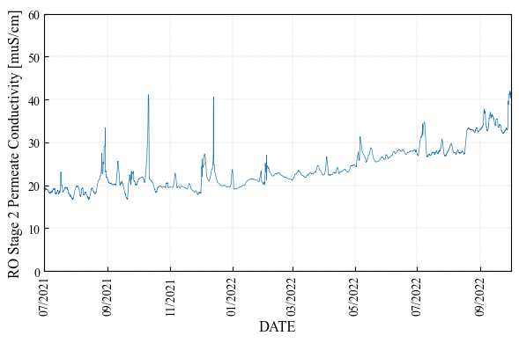

(c): 2nd Stage Row Conductivity (d): 2nd Stage Preprocessed Conductivity

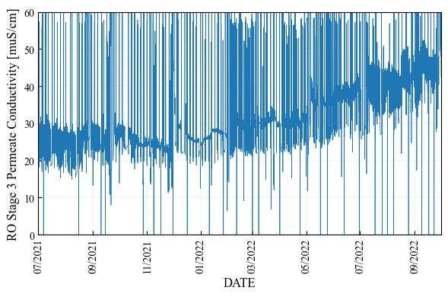 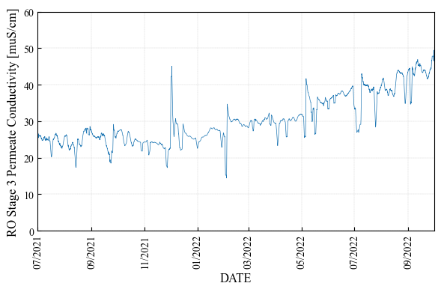

(e): 3rd Stage Row Conductivity (f): 3rd Stage Preprocessed Conductivity

Figure 17: Row and Preprocessed Data of Permeate Conductivity in Each RO Stage

* Data Analysis by Time-Series Theory

There are two analysis strategies to predict permeate conductivity in the future period: one is using other factors related to permeate conductivity in the future period; and the other is using data itself in the past period. This report uses a time-series model according to the latter strategy.

The first step is the seasonal decomposition of time series by loess (STL decomposition), which is a widely used analysis method based on the time-series theory in economic and environmental fields. The STL decomposition is to decompose from observed data into three components and find out which components or factors are dominant in observed data. The decomposition mathematical model (additive model) is formulated as follows:

Here, trend component is unsteady, aperiodic, or the overall motion of the series. The seasonal component is any regular or periodicity pattern in the series, e.g., monthly, weekly, or daily. The residual component is the rest of and can also be thought of as just statistical noise.

Figures 18(a)-(c) show the result of STL decomposition for permeate conductivity in each RO stage. The units for each figure in Figure 13 are the same as in Figure 12. From Figure 13, the following results are confirmed: (i) unsteady or aperiodic component is larger than the other components in observed conductivity; and (ii) seasonal and residual components are very small in observed conductivity. Therefore, the prediction model needs to consider unsteady or aperiodic components based on time-series model.

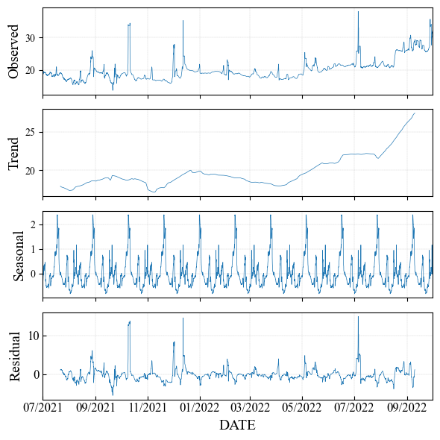 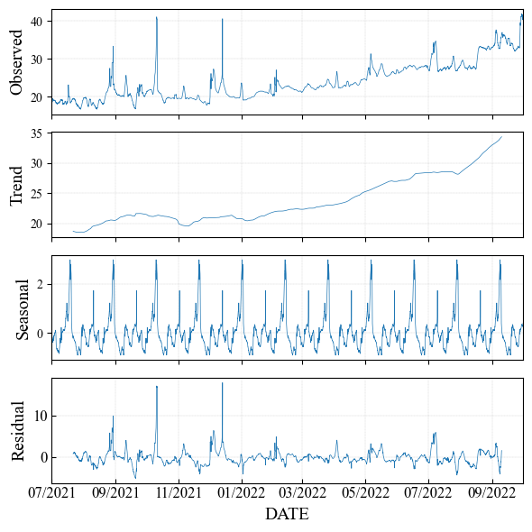

(a): 1st Stage Permeate Conductivity (b): 2nd Stage Permeate Conductivity

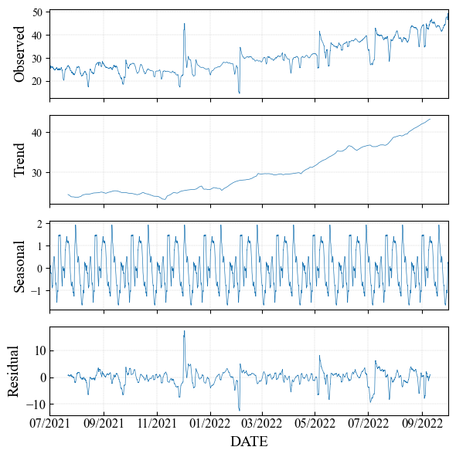

(c): 3rd Stage Permeate Conductivity

Figure 18: STL Decomposition Result for Permeate Conductivity in Each RO Stage

* Prediction

A conductivity prediction model using Prophet[3] (developed by Facebook) was constructed and applied to RO 1st Stage, RO 2nd Stage, and RO 3rd Stage as a first step. The Prophet model is one of ARIMA model based on time-series theory. According to Prophet model, the objective variable consists of three components and the mathematical model (multiplicative model) is formulated as follows:

Here, is trend component, is seasonal component, and is suddenly effect factors (e.g., event or holiday). While the general ARIMA model has too high a complexity and many hyperparameters, Prophet has a few human-interpretable hyperparameters (e.g., yearly, weekly, and daily seasonality). In this report, only weekly and daily seasonality are turned on.

The calculation conditions are as follows: the training period is from July 2021 to Sep 2021, the evaluation period (=the prediction period) is Oct 2021 to Dec 2021, and the evaluation index is Mean Absolute Percentage Error (MAPE) [%], which is a relative prediction error and formulated as follows:

Here, is the actual data and is the prediction data at time . is the length of the prediction period.

Figures 14(a)-(c) show the prediction result for permeate conductivity in each RO stage. The blue line is the actual value, the orange line is the estimated value, and the green line is the predicted value in Figure 14. MAPEs for relative prediction error were 11.0% for RO 1st Stage, 14.9% for RO 2nd Stage, and 13.1% for RO 3rd Stage. The trend of predicted value follows the trend of actual values however each MAPE exceeds 10%. Our future tasks in prediction are as follows: (i) improving prediction model by using other related factors and (ii) data analysis regarding membrane scaling and TOC removal.

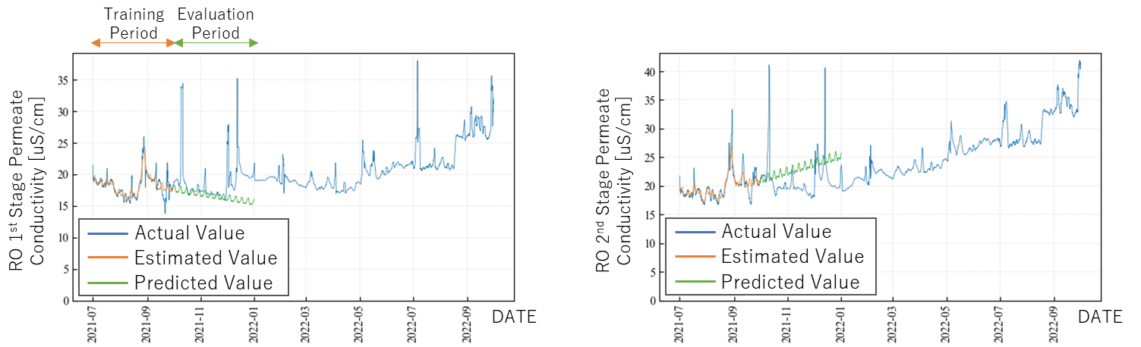

(a): 1st Stage Permeate Conductivity (b): 2nd Stage Permeate Conductivity

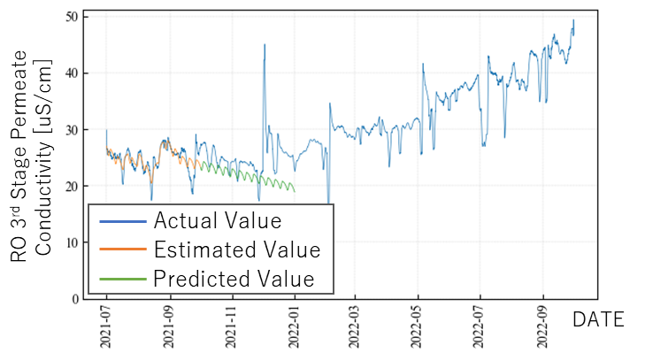

(c): 3rd Stage Permeate Conductivity

Figure 19: Prediction Result for Permeate Conductivity in Each RO Stage

* **Desktop Evaluation based on WBMWD**

Data analysis is behind schedule. We received data and process information in March and clarified the objectives for data analysis. Data analysis is underway.

* **Future Tasks**

In the model creation, we will continue to predict water qualities such as conductivity, TOC, etc. and detect membrane fouling using the temperature correction data. Also, we analyze the behavior of the salt rejection for driving pressure at each stage from 1st to 3rd and explore the optimal operation within the operational range recommended by membrane suppliers.

* **Appendix**

Used mathematical equations for Temperature Correction Factor (TCF) or normalization in this report are as follows:

* Water Viscosity (Temperature dependency; Andrade equation):

Here, is the water temperature and is a specific coefficient. in LVMWD data, in OCWD data.

* Water Fluidity (Temperature dependency):

Here, is the water viscosity.

* Temperature Correction Factor (TCF):

Here, is the water temperature and is the standard temperature. Eq.(A3) is used in LVMWD data and Eq.(A4) is used in OCWD data.

* Temperature Correction Factor for Flow:

Here, is the water viscosity, is the water temperature and is the standard temperature.

* Temperature Correction Factor for Salt:

Here, is the water viscosity, is the water temperature and is the standard temperature.

* Net Driving Pressure (NDP)

Here, is the RO transmembrane pressure, is the differential RO module pressure, is the osmotic pressure, is the number of RO stages in the system, is the RO feed pressure, is the RO permeate pressure of entire train, and is the RO brine pressure. Unit of each pressure is bar in LVMWD data and psi in OCWD data. in OCWD data.

* Average Osmotic Pressure Differential:

Here, is the average of osmotic pressure between feed and brine flow, is the permeate osmotic pressure, is the log mean factor between feed and brine for TDS, is the permeate TDS, and are constant coefficients. Eq.(A12) is used in LVMWD.

* Log Mean Factor considering concentration polarization on RO surface: ,

Here, is the log mean factor between feed and brine for TDS, is the log mean factor for brine concentration, is the feed TDS, is the brine TDS, and is the recovery rate. Unit of each TDS is ppm in LVMWD data. Eq.(A15) is used in LVMWD data and Eq.(A16) is used in OCWD data.

* Recovery Rate:

Here, is the RO feed flow rate and is the RO permeate flow rate.

* Average Feed and Brine Concentration:

Here, is the RO feed concentration and is the log mean factor for brine concentration.

* Average Feed and Brine Flow Rate:

Here, is the RO feed flow rate, is the RO permeate flow rate, and is the RO brine flow rate. Unit of each flow rate is ?? in LVMWD data and gpm in OCWD data. Eq.(A19) is used in LVMWD data and Eq.(A20) is used in OCWD data.

* Calculated TDS:

Here, is the RO feed TDS, is the RO permeate TDS, is the RO brine TDS, is the RO feed flow rate, is the RO permeate flow rate, and is the RO brine flow rate. are conductivities. In Eqs.(A22) and (A23), are constant coefficients and given by as follows:

where is the feed conductivity.

1. GWRS 2020 ANNUAL REPORT (https://www.ocwd.com/wp-content/uploads/2020-gwrs-annual-report-appendices-1.pdf)
2. REGULAR MEETING BOARD OF DIRECTORS (https://www.ocwd.com/wp-content/uploads/bod_20220420.pdf)
3. S. J. Taylor and B. Letham: “Forecasting at Scale”, PeerJ Preprints (2017)