CREDIT APPRAISAL MEMORANDUM

Bharat Steel Industries Pvt Ltd
CIN: U27100MH2015PTC265432
Generated: 03-Mar-2026 22:13
Powered by Intelli-Credit AI Engine

1. Executive Summary
Decision: APPROVED
Credit Score: 100/100 (Threshold: 60)
Loan Request: Term Loan — ₹ 5.0 Crore @ 11.5% p.a. (3-year tenor)
Purpose: Capacity expansion — new rolling mill unit
RECOMMENDATION: APPROVED

2. Five Cs of Credit Analysis

Character — Trustworthiness & Track Record
Score: 84/100
Metric | Value
Litigation Count | 3
Pending Cases | 1
Criminal Cases | 0
News Sentiment Score | 0.41
Mca Compliance Score | 88
Prior Defaults | 0
Director Disqualifications | 0
Roc Notices | 0

Capacity — Ability to Repay
Score: 75/100
Metric | Value
Dscr | 1.32
Icr | 2.8
Revenue Cr | 28.5
Revenue Cagr 3Yr | 19.974744817146384
Ebitda Margin Pct | 14.7
Pat Cr | 2.1
Operating Cash Flow Cr | 3.5
Current Ratio | 1.45

Capital — Financial Strength
Score: 90/100
Metric | Value
De Ratio | 0.69
Tangible Net Worth Cr | 11.8
Net Worth Cr | 12.3
Promoter Equity Pct | 75.0
Total Debt Cr | 8.5
Total Assets Cr | 25.8

Collateral — Security Coverage
Score: 60/100
Metric | Value
Asset Coverage Ratio | 1.64
Ltv Pct | 61.0
Security Type | immovable
Collateral Value Cr | 8.2
Encumbrance Flag | 1

Conditions — External Environment
Score: 68/100
Metric | Value
Industry Outlook Score | 72
Regulatory Risk Score | 35
Gst Compliance Score | 94.4
Qualitative Risk Adjustment | 2
Qualitative Notes Count | 4

3. Financial Highlights
Metric | FY 2022 | FY 2023 | FY 2024
Revenue (₹ Cr) | 19.80 | 24.20 | 28.50
Ebitda (₹ Cr) | 2.60 | 3.50 | 4.20
Pat (₹ Cr) | 0.90 | 1.60 | 2.10
Total Debt (₹ Cr) | 10.10 | 9.20 | 8.50
Net Worth (₹ Cr) | 8.60 | 10.20 | 12.30
Dscr | 1.05 | 1.18 | 1.32
Icr | 1.90 | 2.40 | 2.80
De Ratio | 1.17 | 0.90 | 0.69
Current Ratio | 1.22 | 1.35 | 1.45

4. Scoring Model — Feature Contributions
**Decision: APPROVED** — Credit Score: 100/100 (Threshold: 60)
**Model:** XGBoost + SHAP TreeExplainer
**Strengths (positive contributors):**
• Prior Defaults: **+19.7 pts** — favourable signal
• Pending Cases: **+16.1 pts** — favourable signal
• D/E Ratio: **+10.8 pts** — favourable signal
• Criminal Cases: **+10.1 pts** — favourable signal
• Litigation Count: **+9.8 pts** — favourable signal
• GST Compliance: **+8.3 pts** — favourable signal
**Risk Factors (negative contributors):**
• Tangible Net Worth: **-0.1 pts** — needs attention
• Encumbrance Flag: **-0.7 pts** — needs attention
• ICR: **-0.9 pts** — needs attention
• Current Ratio: **-1.8 pts** — needs attention
**Net Assessment:** Score of 100 is ABOVE ✅ the approval threshold of 60.
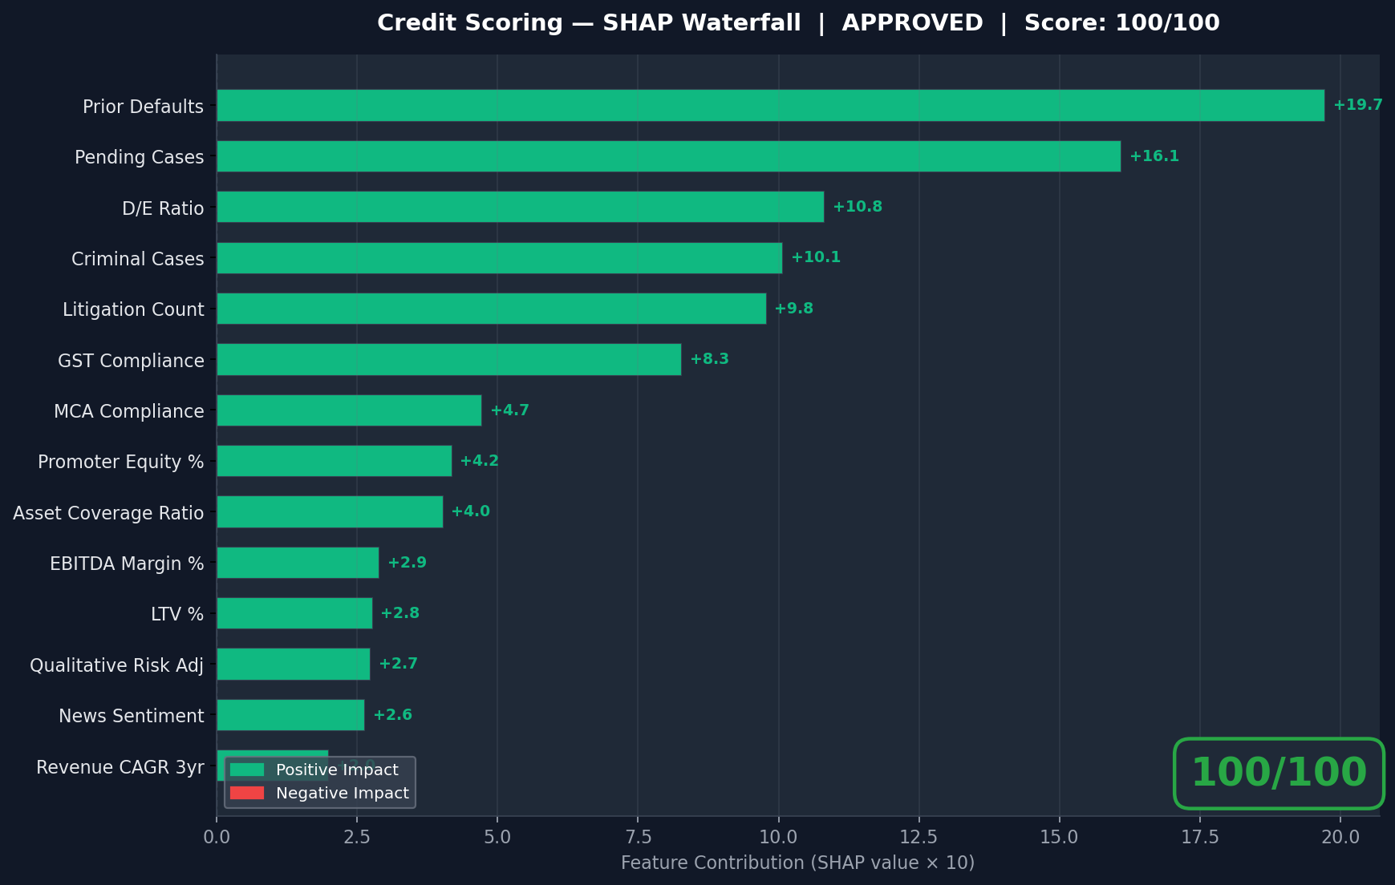

5. Research Findings

5.1 News & Sentiment Analysis
Overall news sentiment is mildly positive. Company recently won a Rs 10 Cr order from L&T. Steel sector faces headwinds from Chinese imports but domestic infrastructure demand remains strong.
- • [POSITIVE] Bharat Steel wins Rs 10 Cr order from L&T for construction steel — Economic Times
- • [POSITIVE] Pune steel makers eye capacity expansion amid infrastructure boom — Business Standard
- • [NEGATIVE] Steel prices soften in Q3 as Chinese imports rise — LiveMint
- • [POSITIVE] MIDC Pune industrial zone sees 15% growth in manufacturing output — Times of India

5.2 MCA21 Compliance
Company has clean MCA records. 1 open charge in favor of SBI (working capital). No ROC notices or director disqualifications. Annual returns filed on time.

5.3 Litigation Analysis
Total 3 cases found: 2 disposed, 1 pending. No criminal cases. 1 pending consumer complaint (Rs 0.12 Cr). All civil cases resolved. Low litigation risk.

5.4 Industry & Regulatory Analysis
Steel manufacturing sector outlook is positive, driven by government infrastructure push (PM Gati Shakti). Anti-dumping duties protect domestic players. Rising coking coal prices and mandatory BIS certification are moderate headwinds. RBI's revised MSME lending guidelines are favorable for credit access.

6. GST Compliance Analysis
GSTIN: 27AABCB1234F1Z5
GSTR-3B Turnover: ₹ 27.8 Cr
Bank Credits: ₹ 29.2 Cr
Turnover Variance: 5.0%
Compliance Score: 94/100
Risk Level: LOW
- ⚠ GST data appears consistent with bank records

7. Credit Officer's Qualitative Notes
- • Factory operating at 65% capacity — room for growth with new rolling mill
- • Second-generation promoter, father established the business in 1990
- • Long-standing relationship with SBI (10+ years)
- • Strong dealer network across Maharashtra and Gujarat

8. Decision Audit Trail
The following data sources were consulted during this credit appraisal:
Agent | Method | Risk Score | Summary
News & Sentiment | demo | 25 | Overall news sentiment is mildly positive. Company recently won a Rs 10 Cr order from L&T. Steel sec
MCA21 Filings | demo | 18 | Company has clean MCA records. 1 open charge in favor of SBI (working capital). No ROC notices or di
Litigation / NJDG | demo | 22 | Total 3 cases found: 2 disposed, 1 pending. No criminal cases. 1 pending consumer complaint (Rs 0.12
Sector Analysis | demo | 28 | Steel manufacturing sector outlook is positive, driven by government infrastructure push (PM Gati Sh

— End of Credit Appraisal Memorandum —
Generated by Intelli-Credit AI Engine | Confidential

