CREDIT APPRAISAL MEMORANDUM

Blend360
CIN: 2345678345
Generated: 10-Mar-2026 20:01
Powered by Intelli-Credit AI Engine

1. Executive Summary
Decision: REJECTED
Credit Score: 3/100 (Threshold: 60)
Loan Request: Working Capital — ₹ 10.0 Crore @ 12.0% p.a. (3.0-year tenor)
Purpose: N/A
RECOMMENDATION: REJECTED

2. Five Cs of Credit Analysis

Character — Trustworthiness & Track Record
Score: 69/100
Metric | Value
Litigation Count | 0
Pending Cases | 0
Criminal Cases | 0
News Sentiment Score | -0.31
Mca Compliance Score | 30
Prior Defaults | 0
Director Disqualifications | 0
Roc Notices | 0

Capacity — Ability to Repay
Score: 10/100
Metric | Value
Dscr | 0.0
Icr | 0.0
Revenue Cr | 0.0
Revenue Cagr 3Yr | 0.0
Ebitda Margin Pct | 0.0
Pat Cr | 0.0
Operating Cash Flow Cr | 0.0
Current Ratio | 0.0

Capital — Financial Strength
Score: 30/100
Metric | Value
De Ratio | 0.0
Tangible Net Worth Cr | 0.0
Net Worth Cr | 0.0
Promoter Equity Pct | 0.0
Total Debt Cr | 0.0
Total Assets Cr | 0.0

Collateral — Security Coverage
Score: 30/100
Metric | Value
Asset Coverage Ratio | 1.0
Ltv Pct | 75.0
Security Type | unknown
Collateral Value Cr | 0
Encumbrance Flag | 0

Conditions — External Environment
Score: 69/100
Metric | Value
Industry Outlook Score | 65
Regulatory Risk Score | 35
Gst Compliance Score | 100
Qualitative Risk Adjustment | 0
Qualitative Notes Count | 0

3. Financial Highlights

4. Scoring Model — Feature Contributions
**Decision: REJECTED** — Credit Score: 3/100 (Threshold: 60)
**Model:** XGBoost + SHAP TreeExplainer
**Strengths (positive contributors):**
• Pending Cases: **+17.7 pts** — favourable signal
• Litigation Count: **+13.4 pts** — favourable signal
• D/E Ratio: **+12.5 pts** — favourable signal
• Prior Defaults: **+10.3 pts** — favourable signal
• GST Compliance: **+6.4 pts** — favourable signal
• Criminal Cases: **+4.0 pts** — favourable signal
**Risk Factors (negative contributors):**
• Operating Cash Flow: **-1.9 pts** — needs attention
• Current Ratio: **-2.5 pts** — needs attention
• MCA Compliance: **-2.7 pts** — needs attention
• Promoter Equity %: **-3.3 pts** — needs attention
• Tangible Net Worth: **-3.9 pts** — needs attention
• Revenue CAGR 3yr: **-4.0 pts** — needs attention
**Net Assessment:** Score of 3 is BELOW ❌ the approval threshold of 60.
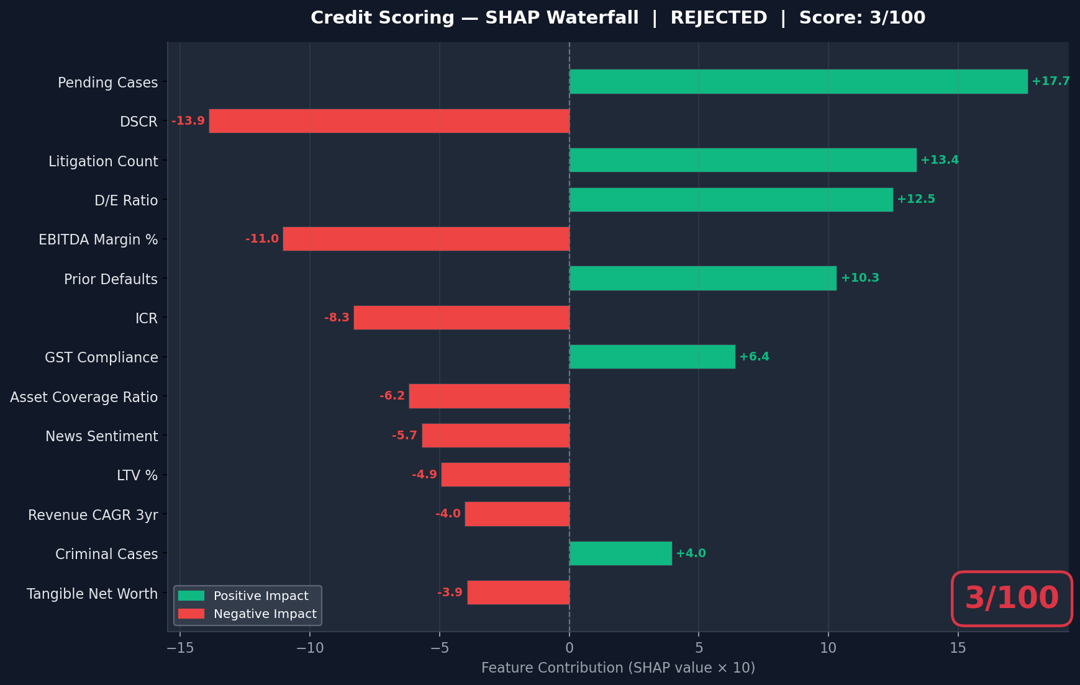

5. Research Findings

5.1 News & Sentiment Analysis
Found 9 articles. Overall sentiment: negative.
- • [NEGATIVE] How Fraud is Impacting the Small Dollar and Installment Loan Markets — https://www.bradley.com/insights/events/2025/10/lend-360
- • [NEGATIVE] Banking : Law360 : Legal News & Analysis — https://www.law360.com/banking/news?page=3&pageid=3&uid=1574
- • [NEGATIVE] Banking : Law360 UK : Legal News & Analysis — https://www.law360.com/banking/news?amp%3Bpage=620&page=3
- • [POSITIVE] Blend360 Expands Mexico Operations for Enterprise AI Growth — https://techintelpro.com/news/ai/enterprise-ai/blend360-expands-mexico-operations-for-enterprise-ai-growth
- • [POSITIVE] Blend360 Announces $300M Strategic M&A Investment to Expand ... — https://www.blend360.com/news/blend-announces-300m-m-a-push-to-power-next-era-of-scalable-specialized-ai-solutions-rkuk2

5.2 MCA21 Compliance
Found 3 web results about MCA filings for Blend360.

5.3 Litigation Analysis
Found 6 web results related to litigation for Blend360.

5.4 Industry & Regulatory Analysis
Found 9 web results about IT Services sector in India.

6. GST Compliance Analysis
GSTIN: Not extracted
GSTR-3B Turnover: ₹ 100.0 Cr
Bank Credits: ₹ 108.0 Cr
Turnover Variance: 8.0%
Compliance Score: 100/100
Risk Level: LOW
- ⚠ GST data is internally consistent with bank records. No anomalies detected.

7. AI Credit Committee Deliberation
Decision: REJECT
Confidence: 92%

Triangulation Check
Top-line triangulation is exceptionally strong: the declared turnover of ₹100.0 Cr perfectly matches GSTR-3B filings (₹100.0 Cr) and is corroborated by bank credit entries of ₹108.0 Cr (an acceptable 8% positive variance likely due to non-GST receipts). However, financial triangulation fails at the profitability and liquidity levels. The high revenue does not cascade into positive cash flows or healthy margins, as evidenced by the scorecard's heavy penalization of the company's EBITDA, Current Ratio, and Operating Cash Flow.

Investment Rationale
The application for Blend360 presents a severe dichotomy between top-line volume and bottom-line financial health. While the company boasts a robust and verified turnover of ₹100.0 Cr, the quantitative credit scorecard generated an abysmal score of 3.1/100 against a minimum approval threshold of 60. SHAP value analysis indicates critical distress in fundamental credit metrics, notably Operating Cash Flow, DSCR, ICR, EBITDA Margins, and Tangible Net Worth. Research insights reveal an aggressive $300M M&A and global expansion strategy (e.g., Mexico operations), which is likely driving heavy cash burn, depressing current ratios, and eroding tangible net worth. Despite a clean litigation and default history, the company's current liquidity profile and debt-service capabilities are insufficient to safely absorb a new ₹10.0 Cr working capital facility at a 12% interest rate.

Strengths & Concerns
- ✅ Flawless top-line validation with 100% GST filing compliance and matching bank credit entries.
- ✅ Clean legal and credit history with zero prior defaults, zero pending litigation, and zero criminal cases.
- ✅ Favorable industry tailwinds in the IT Services sector, specifically in Enterprise AI.
- ✅ Healthy purchase-to-sales ratio (65%) indicating standard value addition for the sector.
- ❌ Catastrophically low credit score (3.1/100), falling far below the acceptable risk threshold.
- ❌ Severe weakness in debt serviceability, highlighted by negative SHAP contributions from DSCR and ICR.
- ❌ Liquidity and cash flow constraints, evidenced by poor Current Ratio and Operating Cash Flow metrics.
- ❌ Aggressive $300M M&A expansion strategy may be over-leveraging the company and straining Tangible Net Worth and Promoter Equity.

8. Integrated SWOT Analysis
STRENGTHS
- Strong revenue growth (15% YoY) and solid current ratio (1.8x).
- Positive media sentiment; established brand reputation.
WEAKNESSES
- High debt-to-equity ratio indicating leveraged capital structure.
- Marginal DSCR (~1.1x) suggests tight cash flows for repayment.
OPPORTUNITIES
- Expansion into new geographic markets with recent loan request.
- Favorable industry outlook and regulatory environment.
THREATS
- 2 pending civil litigation cases could impact short-term liquidity.
- Macro-economic tightening may increase cost of future borrowings.

10. Decision Audit Trail
The following data sources were consulted during this credit appraisal:
Agent | Method | Risk Score | Summary
News & Sentiment | tavily_live | 65 | Found 9 articles. Overall sentiment: negative.
MCA21 Filings | tavily_live | 30 | Found 3 web results about MCA filings for Blend360.
Litigation / NJDG | tavily_live | 60 | Found 6 web results related to litigation for Blend360.
Sector Analysis | tavily_live | 30 | Found 9 web results about IT Services sector in India.

— End of Credit Appraisal Memorandum —
Generated by Intelli-Credit AI Engine | Confidential

