CREDIT APPRAISAL MEMORANDUM

Company Name
CIN: N/A
Generated: 03-Mar-2026 22:58
Powered by Intelli-Credit AI Engine

1. Executive Summary
Decision: REJECTED
Credit Score: 4/100 (Threshold: 60)
Loan Request: Term Loan — ₹ 0 Crore @ 0% p.a. (0-year tenor)
Purpose: N/A
RECOMMENDATION: REJECTED

2. Five Cs of Credit Analysis

Character — Trustworthiness & Track Record
Score: 70/100
Metric | Value
Litigation Count | 0
Pending Cases | 0
Criminal Cases | 0
News Sentiment Score | -0.2
Mca Compliance Score | 30
Prior Defaults | 0
Director Disqualifications | 0
Roc Notices | 0

Capacity — Ability to Repay
Score: 10/100
Metric | Value
Dscr | 0
Icr | 0
Revenue Cr | 0
Revenue Cagr 3Yr | 0.0
Ebitda Margin Pct | 0
Pat Cr | 0
Operating Cash Flow Cr | 0
Current Ratio | 0

Capital — Financial Strength
Score: 30/100
Metric | Value
De Ratio | 0
Tangible Net Worth Cr | 0
Net Worth Cr | 0
Promoter Equity Pct | 0
Total Debt Cr | 0
Total Assets Cr | 0

Collateral — Security Coverage
Score: 30/100
Metric | Value
Asset Coverage Ratio | 1.0
Ltv Pct | 75.0
Security Type | unknown
Collateral Value Cr | 0
Encumbrance Flag | 0

Conditions — External Environment
Score: 67/100
Metric | Value
Industry Outlook Score | 65
Regulatory Risk Score | 35
Gst Compliance Score | 94.4
Qualitative Risk Adjustment | 0
Qualitative Notes Count | 0

3. Financial Highlights

4. Scoring Model — Feature Contributions
**Decision: REJECTED** — Credit Score: 4/100 (Threshold: 60)
**Model:** XGBoost + SHAP TreeExplainer
**Strengths (positive contributors):**
• Pending Cases: **+17.7 pts** — favourable signal
• Litigation Count: **+13.7 pts** — favourable signal
• D/E Ratio: **+12.8 pts** — favourable signal
• Prior Defaults: **+10.7 pts** — favourable signal
• GST Compliance: **+5.8 pts** — favourable signal
• Criminal Cases: **+4.2 pts** — favourable signal
**Risk Factors (negative contributors):**
• Operating Cash Flow: **-2.0 pts** — needs attention
• Current Ratio: **-2.5 pts** — needs attention
• MCA Compliance: **-2.7 pts** — needs attention
• Promoter Equity %: **-3.1 pts** — needs attention
• News Sentiment: **-3.9 pts** — needs attention
• Revenue CAGR 3yr: **-4.1 pts** — needs attention
**Net Assessment:** Score of 4 is BELOW ❌ the approval threshold of 60.
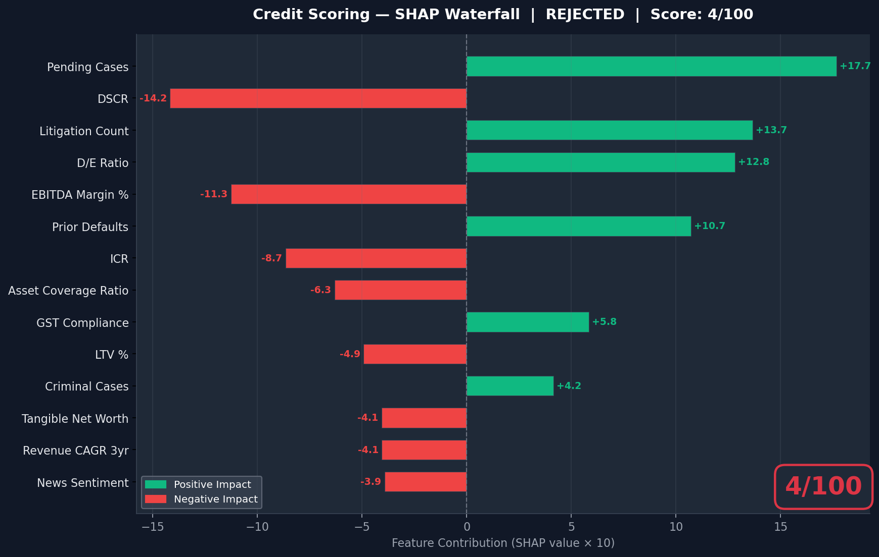

5. Research Findings

5.1 News & Sentiment Analysis
Found 6 articles. Overall sentiment: negative.
- • [NEGATIVE] PwC Fined in India for Failure to Detect $1.7B Fraud - NYSSCPA — https://www.nysscpa.org/news/publications/the-trusted-professional/article/pwc-fined-for-failure-to-detect-1.7b-fraud-011618
- • [NEGATIVE] PwC Fined $2M Over Indian Accounting Fraud - CFO.com — https://www.cfo.com/news/pwc-fined-2m-over-indian-accounting-fraud/659473/
- • [NEUTRAL] Satyam Settles; PwC Left In Lurch - Forbes — https://www.forbes.com/sites/francinemckenna/2011/02/18/satyam-settles-pwc-left-in-lurch/
- • [NEUTRAL] PwC - News - Consulting.us — https://www.consulting.us/firms/pwc/news
- • [NEUTRAL] PwC - Latest Insurance News — https://www.insurancejournal.com/archive/pwc/

5.2 MCA21 Compliance
Found 6 web results about MCA filings for pwc.

5.3 Litigation Analysis
Found 6 web results related to litigation for pwc.

5.4 Industry & Regulatory Analysis
Found 9 web results about sector in India.

6. GST Compliance Analysis
GSTIN: 27AABCB1234F1Z5
GSTR-3B Turnover: ₹ 27.8 Cr
Bank Credits: ₹ 29.2 Cr
Turnover Variance: 5.0%
Compliance Score: 94/100
Risk Level: LOW
- ⚠ GST data appears consistent with bank records

8. Decision Audit Trail
The following data sources were consulted during this credit appraisal:
Agent | Method | Risk Score | Summary
News & Sentiment | tavily_live | 60 | Found 6 articles. Overall sentiment: negative.
MCA21 Filings | tavily_live | 30 | Found 6 web results about MCA filings for pwc.
Litigation / NJDG | tavily_live | 60 | Found 6 web results related to litigation for pwc.
Sector Analysis | tavily_live | 30 | Found 9 web results about sector in India.

— End of Credit Appraisal Memorandum —
Generated by Intelli-Credit AI Engine | Confidential

