HW2.1

Nodal Displacements:

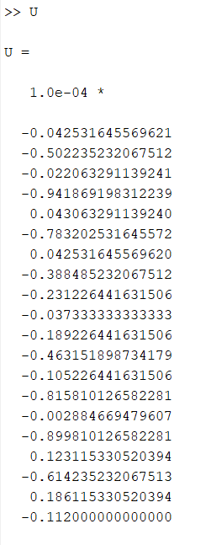

Stress:

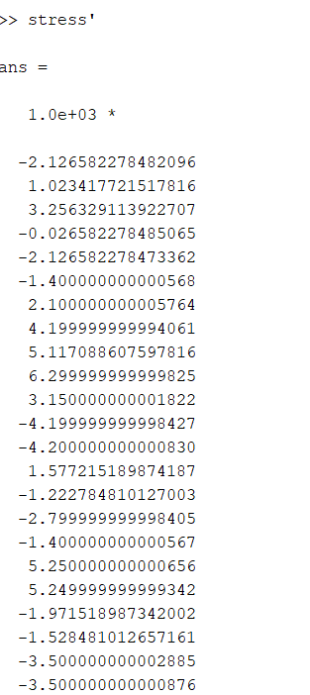

Deformed Structure

Mag = 100

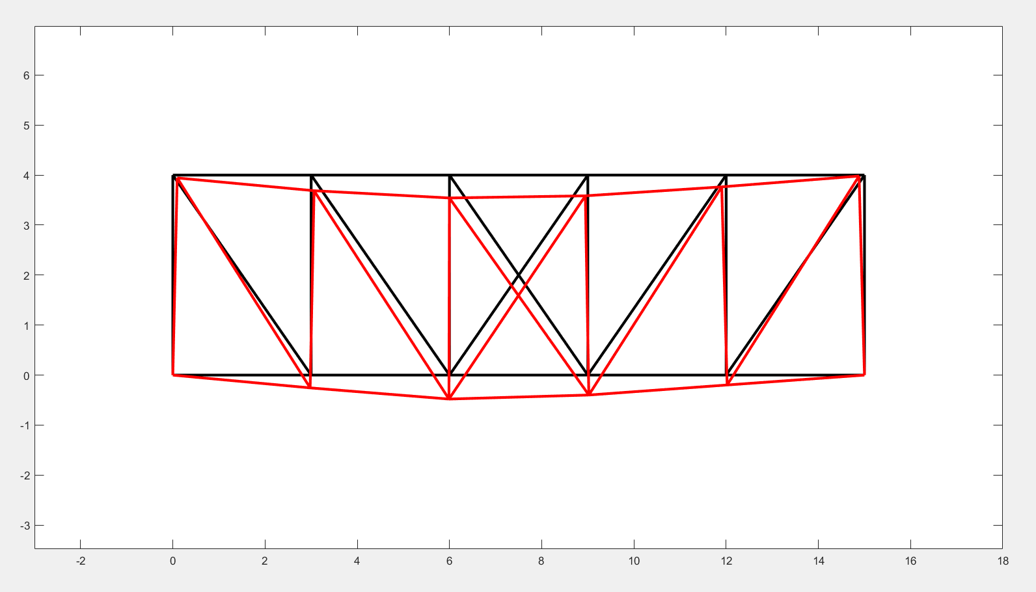

HW2.2a

Displacements:

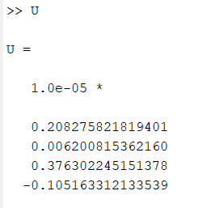

Stress:

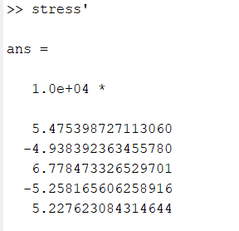

Visualization

Mag = 100000

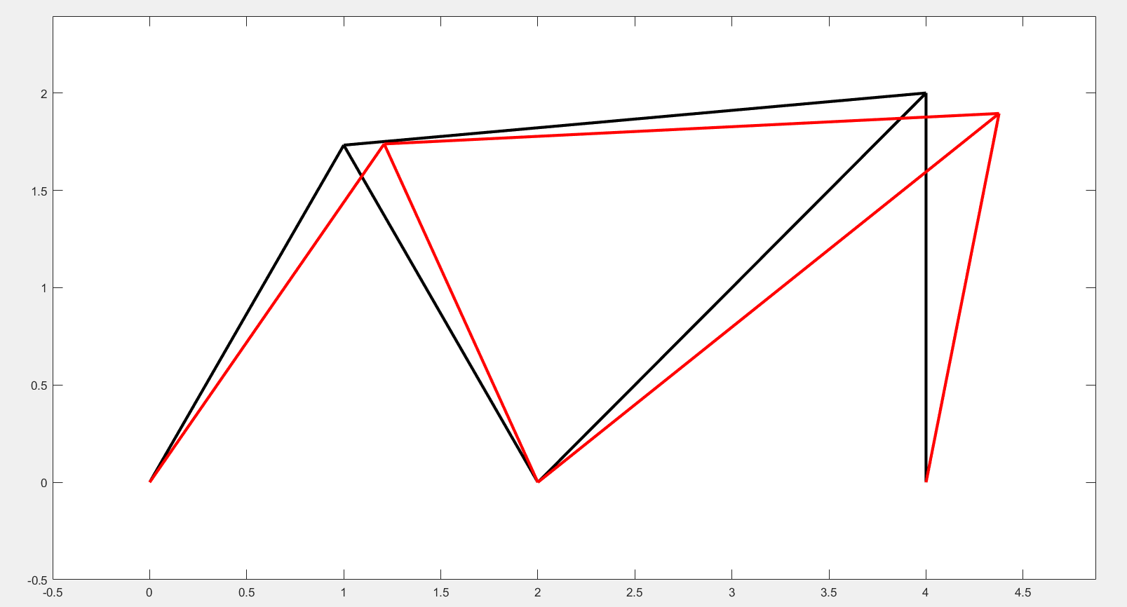

HW2.2b

Displacement:

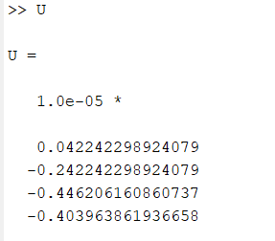

Stress:

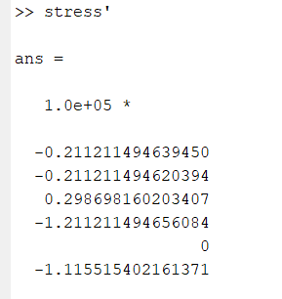

Visualization:

Mag = 100000

Note: Structure has been redrawn with roller supports on the right side to exploit the symmetry

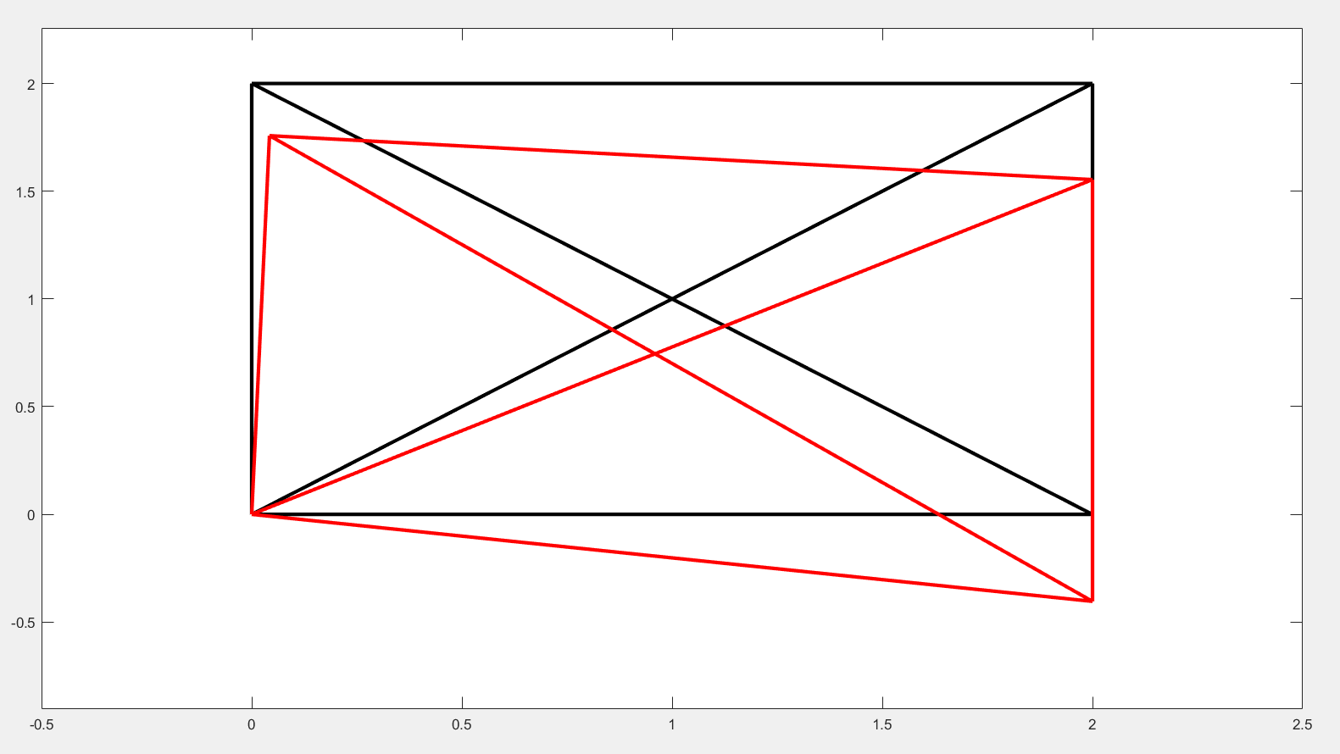

HW2.3

First, let’s try drawing the original structure and iterate from there:

Structure V1 (Mag = 100)

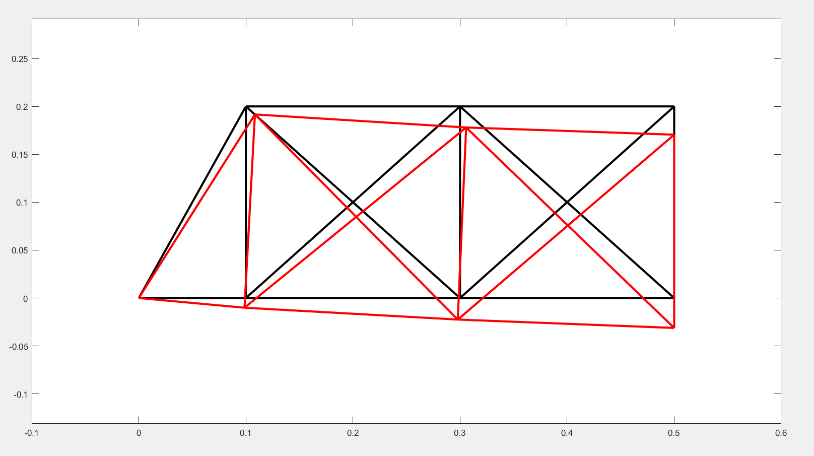

Weight and Optimization Criteria:

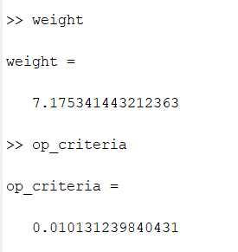

From the stress distribution, we can see that elements 5 and 10 experience the least stress while elements 1 and 3 experience the most stress. Thus, we remove elements 5 and 10 to get version 2 of our structure:

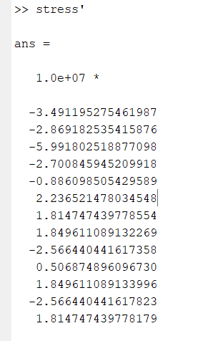

Structure V2

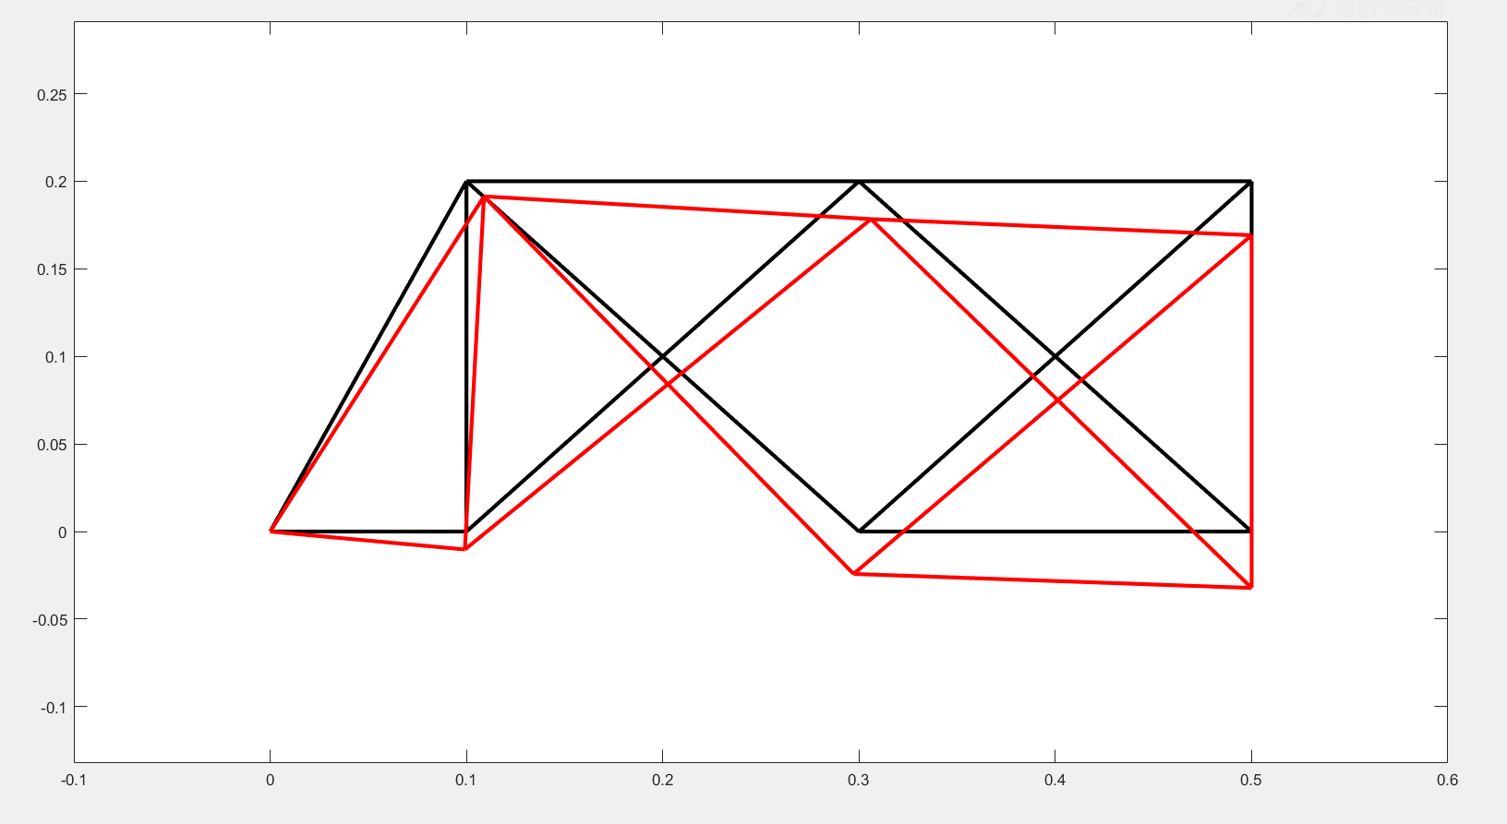

We see a significant reduction in both weight and optimization criteria:

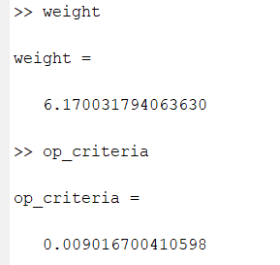

Members 4, 6 (previously 7), and 11 (previously 13) are experiencing the least stress. The other members seem to be carrying more of the load. Let us redesign a structure more similar to V2.

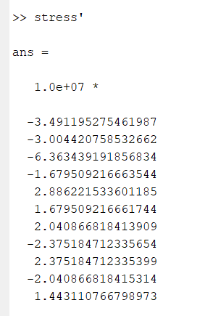

Structure V3:

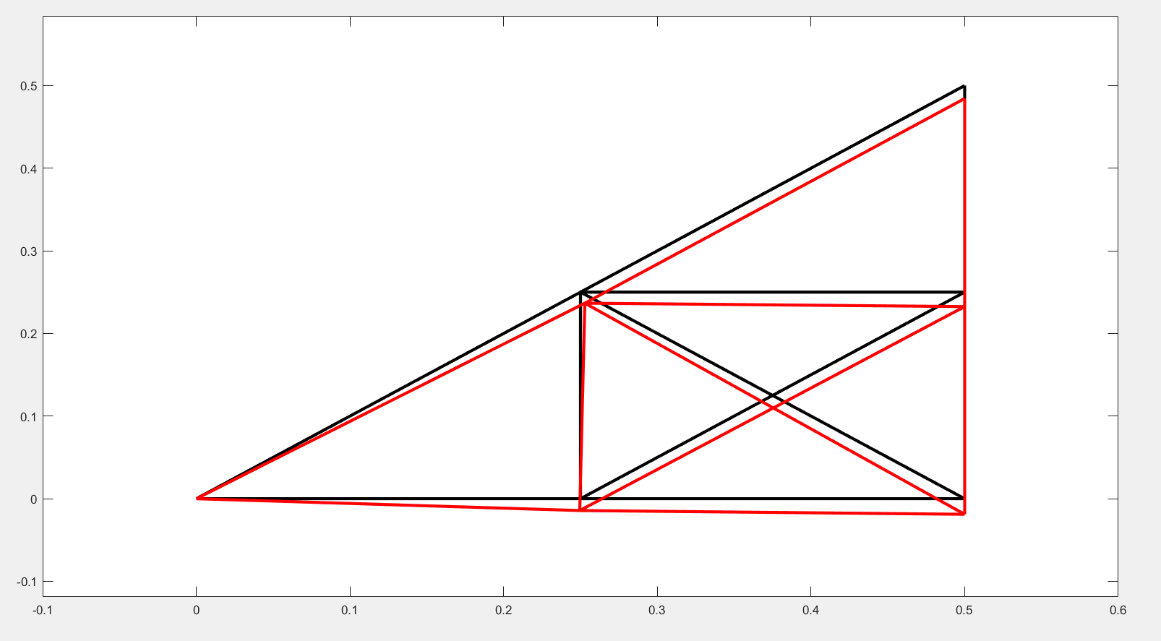

Our weight has increased slightly, however, our optimization criteria is much lower (better):

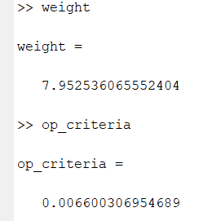

Stress:

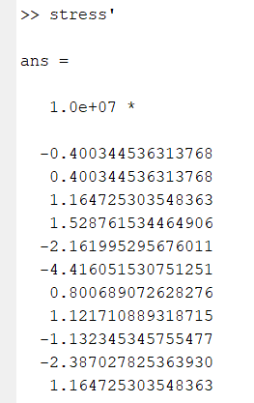

Now, we iterate by removing members that bear little load and are not fundamental to the bridge structure. Those are members 8 and 9:

Structure V4:

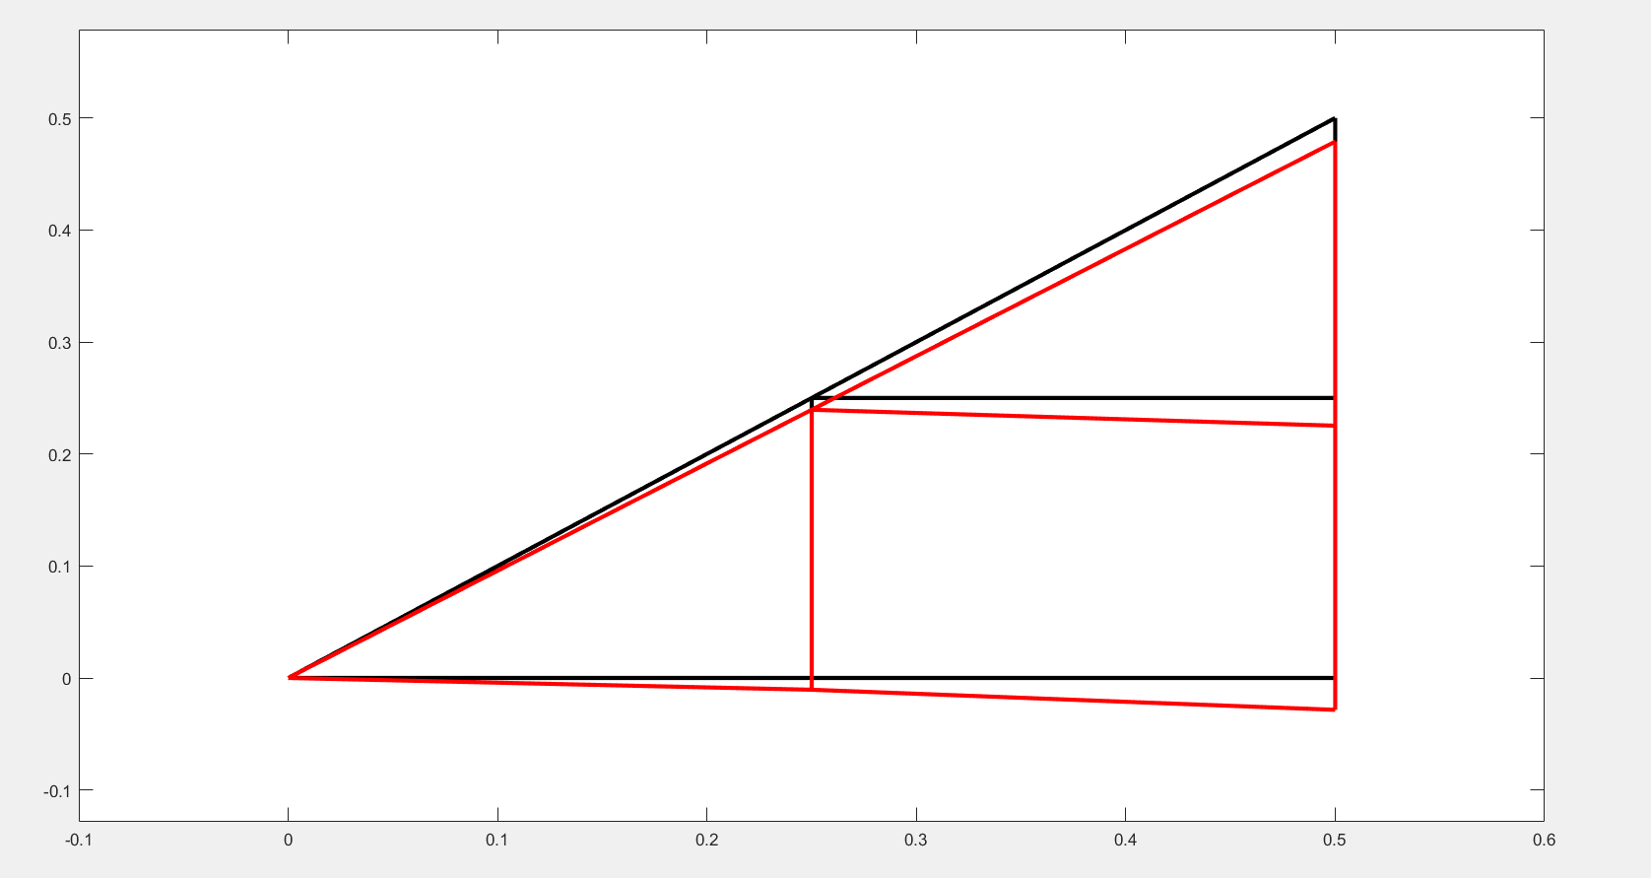

Both our weight and optimization criteria are lower (better):

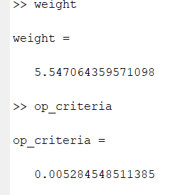

However, the stress is less evenly distributed.

