FreshFlow

Real-time expiry risk detection and agentic markdown decision support for grocery retail
CSCI318 Software Engineering Practices & Principles, Spring 2026 Group 06, "318 Hero"
Member | Student number | Role
Zihua (Andy) Zeng | 7164695 | AI and streaming lead: insight-service, Kafka Streams topology, the two agents, specifications and AI process
Reuben Kruger | 8973878 | Domain services lead: inventory-service and pricing-service domain models, use cases, Week 8 progress video, Postman collection
Modhuri (Madz) Dey Sithi | 9184843 | Platform and integration lead: sales-service, Kafka and Docker environment, architecture and UML diagrams

Member contribution
[[TEAM TO CONFIRM in the Week 11 meeting. The coordinator confirmed on 22 September 2026 that equal ratings are acceptable when the group agrees. Replace the bracketed text with the agreed rating per member and a justification of what each member did, naming artefacts in the repository: for example commits, diagrams in docs/diagrams, use cases, slides, minutes.]]
Member | Rating | Justification
Zihua (Andy) Zeng | [[contributed / NN%]] | [[...]]
Reuben Kruger | [[contributed / NN%]] | [[...]]
Modhuri (Madz) Dey Sithi | [[contributed / NN%]] | [[...]]

I agree with my group member contribution report and ratings. ______________________ (Zihua Zeng)
I agree with my group member contribution report and ratings. ______________________ (Reuben Kruger)
I agree with my group member contribution report and ratings. ______________________ (Modhuri Dey Sithi)

Abstract
FreshFlow is a prototype of an AI-powered, cloud-native application for a grocery retailer's perishable stock. It watches point-of-sale scans as a Kafka event stream, computes the rolling sell-through velocity of each product, joins that velocity against the live state of every stock batch, and flags batches that are unlikely to clear before their expiry date. For each flagged batch an LLM-backed agent gathers the facts through tools, proposes a discount tier with a written rationale, and leaves a persisted trace of every tool call. A second agent writes a plain-language end-of-day briefing from the same evidence. The agents only propose. Whether a markdown is allowed is decided by a deterministic business rule, the margin floor, inside the pricing service's domain layer, and that rule applies in the same way to a proposal from a person and to one from the agent.
The system is built as four bounded contexts, each a Spring Boot microservice with its own H2 database, integrated through Apache Kafka with Spring Cloud Stream, with Kafka Streams for the two real-time analyses and LangChain4j for the agentic components. The project was developed spec-first with an AI coding agent working under a four-phase gated pipeline, and the specifications, prompts, decision records and session logs that governed that process are part of the submitted repository.
Repository: https://github.com/watchcat2077/Freshflow (private until submission).

Table of Contents
[[Generate in Word after the final edit.]]

1. Introduction

1.1 The business problem
A supermarket loses money on short-dated stock in two directions. If it discounts a batch too early it gives away margin on units that would have sold at full price anyway. If it discounts too late, or not at all, the batch reaches its expiry date on the shelf and is written off in full. The decision between the two sits with floor staff, and it depends on three facts that nobody can reasonably hold in their head across a whole store: how fast this product is selling right now compared with its normal rate, how many units remain in this particular batch (not the product line, since two deliveries of the same yoghurt expire on different days), and how many trading hours are left before that batch expires. In most stores the decision is made by walking the aisle and guessing.
FreshFlow is a decision-support system for that problem. It is not a pricing engine and it does not change prices on its own. It makes the three facts visible as they change, identifies the batches that need a decision, and asks an agent to propose one.

1.2 Objectives
The requirements in Section 2 are traced to five objectives. They were written down at the start of the project and have not changed.
Objective | Statement
O1 | Reduce the value of perishable stock written off at expiry
O2 | Protect gross margin: no automated discount may sell below the margin floor set for the product
O3 | Remove the judgement burden from floor staff by surfacing which batches need action, and when
O4 | Make every markdown decision auditable, whether a person or an agent made it
O5 | Give the store owner end-of-day visibility without a dashboard

The stakeholders behind them are the store manager who receives deliveries, the checkout operator at the till, the shift supervisor who decides on markdowns during the day, and the store owner who sets price rules and reviews the day. O2 and O4 are the ones that shape the architecture most: an automated discount that destroys margin is worse than no automation, and a recommendation that cannot be explained afterwards will not be trusted by the people who have to act on it.

1.3 Core capabilities
The system does six things, and Section 2 states them as requirements.
- It records deliveries as stock batches with their own expiry date and cost, and deducts stock from the batch that expires soonest when a sale happens (first-expired, first-out).
- It records sales at the till and prices each line at the price in force at the moment of scan, including any markdown that has been activated for that product.
- It maintains price rules and a margin floor per product.
- It computes, in real time from the sales stream, a rolling sell-through velocity per product and compares it with a baseline.
- It joins that velocity with the live state of every batch and flags the batches that will not clear before expiry.
- It runs two agents: one that proposes a markdown for a flagged batch after gathering the facts through tools, and one that writes the store owner's end-of-day briefing. Both leave a persisted trace of what they looked at.

1.4 How AI adds value, and where it is not allowed to
The value of the agent is in the judgement it supplies between two numbers. The stream processing can say that a batch of 400 yoghurts has 9 trading hours left and is selling at 2.1 units an hour. It cannot say whether a 20 per cent or a 30 per cent markdown is the right response, whether the start time should be now or at the evening peak, or how to explain the choice to a supervisor in two sentences. A language model is good at exactly that kind of bounded reasoning over a small set of facts, provided the facts are supplied to it rather than recalled by it, which is why the agent reads them through tools rather than from its training data.
What the agent is not allowed to do is decide whether the markdown is permitted. A model is probabilistic; the same prompt can produce a different answer on a different day, and no prompt can be unit-tested. The margin floor is therefore enforced as a business invariant in the pricing service's domain model, and the pricing service treats the agent's recommendation as an untrusted proposal, in the same way it treats a proposal typed in by a supervisor. The lectures' framing fits this closely: AI should amplify architectural thinking rather than replace it, and the developer's job is to define the domains, events, constraints and invariants within which an agent operates (CSCI318 L1, slide 20). Combining a rule-based check with a model's recommendation is also one of the diversity techniques the dependability lecture recommends for AI components (L8, slide 9).
That split is the central argument of this report, and most of the design decisions in Section 3 exist to make it visible and testable.

2. Analysis, Requirements and Domain Modelling

2.1 Functional requirements
Sixteen functional requirements were specified in specs/spec-02-requirements.md, each with a user story, a scope tag and acceptance criteria. Twelve of them are presented here, each specified as a use case in docs/report/section-2-1-use-cases.md and illustrated with the UML activity diagram of the same number in docs/diagrams/. The four left out (FR3 write-offs, FR7 transaction history, FR10 automatic markdown expiry, and the markdown-expired half of FR6b) are reporting and housekeeping functions that would not demonstrate a further architectural pattern, and they were deliberately not built; where their absence matters it is stated, for example the briefing agent says that waste figures are unavailable rather than inventing them.
UC | FR | Requirement (as a user story) | Objective | Built
UC-01 | FR1 | As a store manager I want to record a delivery as a stock batch with SKU, quantity, expiry and unit cost, so that expiry risk is tracked per batch | O1 | Yes
UC-02 | FR2 | As a store manager I want batch stock to decrease automatically when items are sold, FEFO and idempotently, so that remaining quantity is accurate without counting | O1, O3 | Yes
UC-03 | FR4 | As a shift supervisor I want to query current stock and remaining shelf life for a batch or SKU, so that I can verify what the system tells me | O3, O4 | Yes
UC-04 | FR5 | As a checkout operator I want sales recorded with their line items, so that every downstream analysis starts from a real sale | O1, O3 | Yes
UC-05 | FR6a, FR6b | As a checkout operator I want each line priced at the price in force at the moment of scan, including a live markdown, so that a markdown decision reaches the till | O2 | Yes
UC-06 | FR8 | As a store owner I want to maintain price rules and margin floors per SKU, so that discounting never destroys profitability | O2 | Yes
UC-07 | FR9 | As a shift supervisor (or the agent) I want to activate a markdown for a batch at a discount tier and window, so that the price change takes effect | O1, O2 | Yes
UC-08 | FR11 | As a store owner I want any markdown that would breach the margin floor to be rejected and the rejection recorded, so that no automated component can discount below profitability | O2, O4 | Yes
UC-09 | FR12 | As a shift supervisor I want a rolling sell-through velocity per SKU from the live sales stream, so that I can see demand as it changes (real-time analysis) | O1, O3 | Yes
UC-10 | FR13 | As a shift supervisor I want batches that will not sell out before expiry flagged as they are detected, so that I act in time (real-time analysis) | O1, O3 | Yes
UC-11 | FR14 | As a shift supervisor I want an agent to recommend a markdown tier for a flagged batch with a written rationale and an auditable trace, so that the decision is informed and explainable (agentic AI) | O1 to O4 | Yes
UC-12 | FR15 | As a store owner I want a plain-language end-of-day briefing of what was marked down, what sold through and what is at risk, so that I can review the day without a dashboard (agentic AI) | O4, O5 | Yes

Each use case in the appendix file follows the same shape: actor, relevance to the objectives, preconditions, trigger, a numbered main flow written as what the system does for the actor, alternative flows derived from the requirement's own rejection rules, and postconditions. The activity diagrams were drawn from those flows, so the main flow is the straight path and each alternative flow is a decision diamond. Figure 2.1 shows UC-01 as the representative example; the other eleven are in the appendix and in the repository.
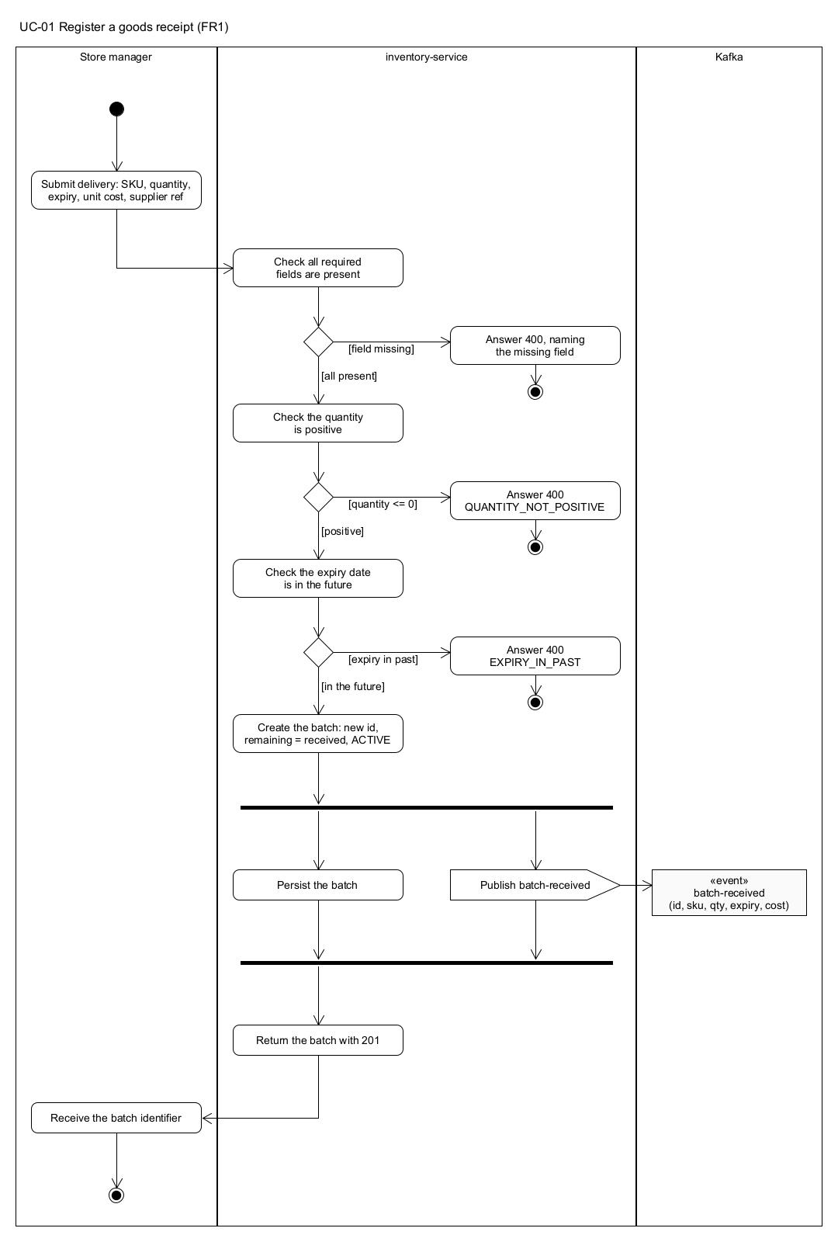
Figure 2.1: activity-UC-01

2.2 Real-time analysis requirements
Two of the user stories are real-time analyses over the sales stream, and both are implemented as one Kafka Streams topology in insight-service (Section 3.5).
FR12, rolling sell-through velocity (UC-09), windows the item-sold events by SKU on the producer-assigned time of sale, sums the quantity per hopping window, joins the result with a baseline velocity held in a table, and keeps the latest fully elapsed window per SKU in a state store that the REST endpoint GET /api/insight/velocity/{sku} reads through an interactive query. The value moves while you watch it, which is the point of the requirement.
FR13, expiry risk detection (UC-10), maintains a second table of the live state of every batch from batch-received and stock-level-changed, and when a velocity window closes it joins the velocity with every active batch of that SKU. A domain rule projects the sales achievable before expiry and compares them with the remaining quantity; a batch whose projected shortfall exceeds a threshold is marked at risk, and the transition into risk publishes a sell-through-risk-detected event, which is what triggers the agent. The risk list is served by GET /api/insight/risks.
Both analyses use event time rather than ingestion time. A sale that reaches Kafka late still lands in the window its occurredAt belongs to, and replaying the topic at a different speed produces the same velocities. That choice is a hard constraint in the architecture specification and is enforced by a single timestamp extractor shared by every input topic.

2.3 Agentic AI requirements
Two user stories use an agentic component, and they are served by two distinct agents behind two ports of the same shape.
FR14, the Markdown Decision Agent (UC-11), is triggered by the risk event. It is a tool-using agent in the ReAct style the lectures describe (L7, slides 19 to 20): the model reasons, asks for a tool, observes the result, and reasons again, inside a bounded loop. It has three tools and no more: getBatchDetails, which reads the batch's remaining quantity, expiry and cost from inventory-service; getSellThroughRate, which reads the current velocity from the FR12 state store; and proposeMarkdown, which records a recommendation for the flagged batch and nothing else. The orchestrator persists every tool call with its arguments and result, refuses a proposal that names a different batch, derives the end of the promotion window from the batch's expiry, and publishes markdown-recommended for pricing-service to validate.
FR15, the end-of-day briefing (UC-12), is a second agent with three read-only tools over the Insight context's own views: the current risk list, the markdown recommendations made that day, and the sell-through rate of any SKU the model wants to comment on. It writes a short summary for the store owner. The counts that accompany the summary are computed by the orchestrator from the tool results rather than taken from the model's text, so a number the model gets wrong cannot reach the caller as a fact, and the briefing is persisted with its tool calls so the narrative can be checked against its evidence.
The coordinator confirmed on 22 September 2026 that two user stories served by one agent would be acceptable; two agents were built because the second story has a different trigger (a request rather than an event), different tools and a different output, and because a second concrete example made the pattern easier to explain in Section 3.6.

2.4 Domain modelling

2.4.1 Domain classes by sub-domain
Domain distillation (L2, slides 10 to 13) asks which parts of the problem are the reason the system exists, which support that core, and which are generic enough that any retailer solves them the same way. For FreshFlow the answer came out as follows.
Sub-domain | Kind | Why | Domain classes
Expiry risk detection and the markdown decision | Core | This is the competitive value: knowing which batch to mark down, by how much, and proving the decision was sound. Nothing off the shelf does it for a store's own batches | RiskAssessmentPolicy, BatchRiskView, SkuVelocityView, AgentTraceRecord, MarkdownProposal, EndOfDayBriefing; MarkdownPlan, MarginFloorPolicy, MarginFloorAssessment, DiscountTier, PromotionWindow
Batch-level inventory tracking | Supporting | Necessary for the core and specific to perishables (two deliveries of one product are two batches), but not where the value is created | StockBatch, BatchId, Quantity, ExpiryDate, BatchStatus, FefoDeductionPolicy, DeductionPlan, BatchReceived, StockLevelChanged
Price-rule maintenance | Supporting | The margin floor is the constraint the core must respect; maintaining rules is routine | PriceRule, MarginFloor, PriceRulePublished
Sale transaction recording | Generic | Every retailer records a basket the same way; it could be bought rather than built | SaleTransaction, LineItem, PriceSnapshot

Money and Sku appear in every sub-domain and are modelled separately in each, for a reason given below.

2.4.2 The domain model diagram
Figure 2.13 is the UML domain model, drawn in UMLet from the code. It is grouped by bounded context rather than by sub-domain because the contexts are where the classes actually live; the mapping between the two is in the table above.
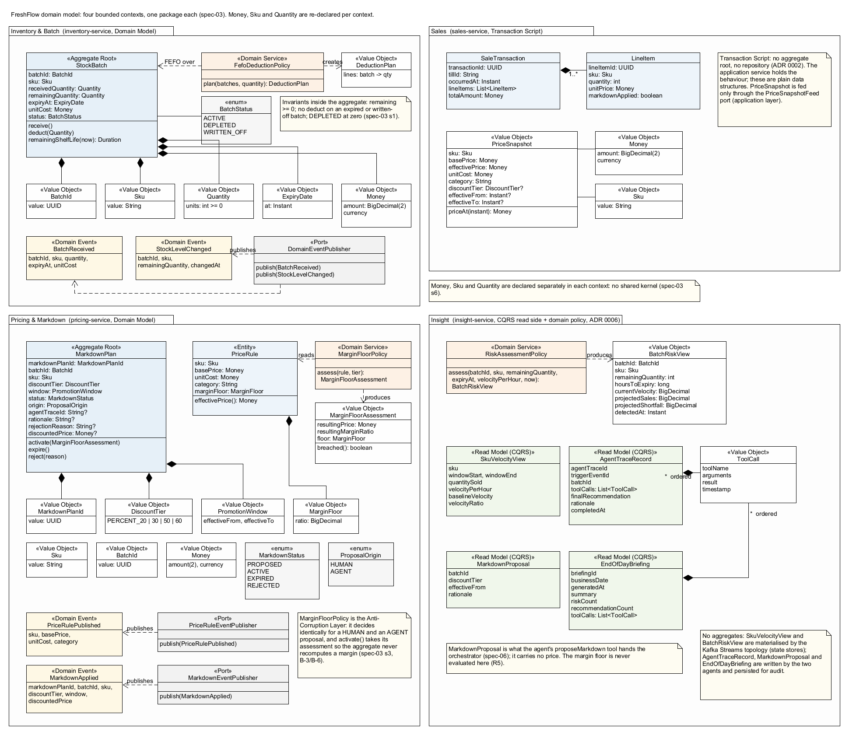
Figure 2.13: domain-model
Three things in the diagram are deliberate and are worth pointing out. StockBatch and MarkdownPlan are the only aggregate roots, because they are the only objects with invariants that span several values and a lifecycle to protect. The Sales context has no aggregate at all; its classes are plain records handled by a transaction script, which Section 3.2 explains. And Money and Sku are drawn inside every context, three and four times respectively, because there is no shared kernel.

2.4.3 Why these are the bounded contexts
A bounded context is a linguistic boundary that defines where a model applies (L3, slides 30 and 35). The strongest evidence that FreshFlow needs four of them is that the word "product" means a different thing in each. In Inventory a product is a physical batch with a quantity and an expiry date, and the batch, not the product line, is the thing whose state matters. In Sales a product is a barcode scanned at a price at a moment in time; the batch it came from is unknown at the till and irrelevant to the receipt. In Pricing a product is a cost-and-margin constraint set: a base price, a unit cost and a floor. In Insight a product is a read-side projection, a velocity and a list of batches at risk, assembled from the other three contexts' events and never written back to them. Modelling those four as one Product class would have given it attributes and rules that contradict each other, which is the single-model failure the lectures warn about (L3, slides 23 to 29).
The mapping from sub-domains to contexts is close to one-to-one but not exactly so. Inventory, Sales and Insight each hold one sub-domain. The Pricing context holds the supporting price-rule sub-domain and the enforcement half of the core markdown sub-domain, because the margin floor and the plan that must respect it belong in the same transaction. The lectures describe one-to-one as the ideal rather than a rule (L3, slide 31), and the alternative, a fifth context for markdown plans that would need the price rule synchronously, would have created exactly the coupling bounded contexts exist to prevent.
The decision not to share Money, Sku and Quantity through a shared kernel follows the same reasoning. A shared kernel is a shared portion of two models that both teams must agree to change (L5, slide 20). Here the three contexts do not even agree on what the types mean: Inventory's Quantity must allow zero because a depleted batch has zero left, while a sale's quantity must be at least one; Pricing's Money carries margin arithmetic that Sales must never perform. The only shared artefact is the contracts module, which holds the integration event records and nothing else. It is the published language of the system, in the sense Evans gives the term, and its one-way nature is what keeps the contexts independently changeable.

3. Design, Architecture and Implementation

3.1 Microservice architecture
Figure 3.1 is the microservice architecture diagram and Figure 3.2 the event flow. Four services, one per bounded context, each with its own H2 database and no shared schema. The contracts module is a compile-time dependency of all four and contains only event records; pos-simulator is a command-line client used for demonstrations and is not a service.
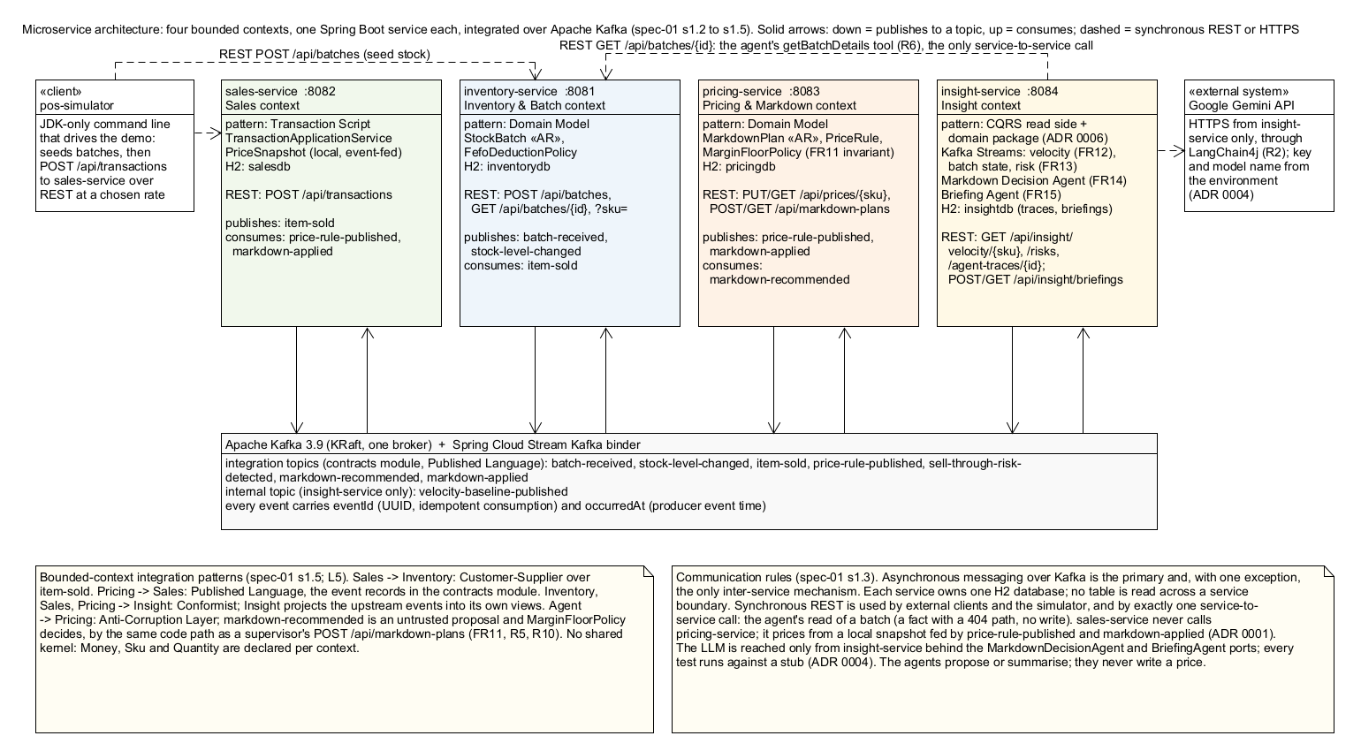
Figure 3.1: microservice-architecture
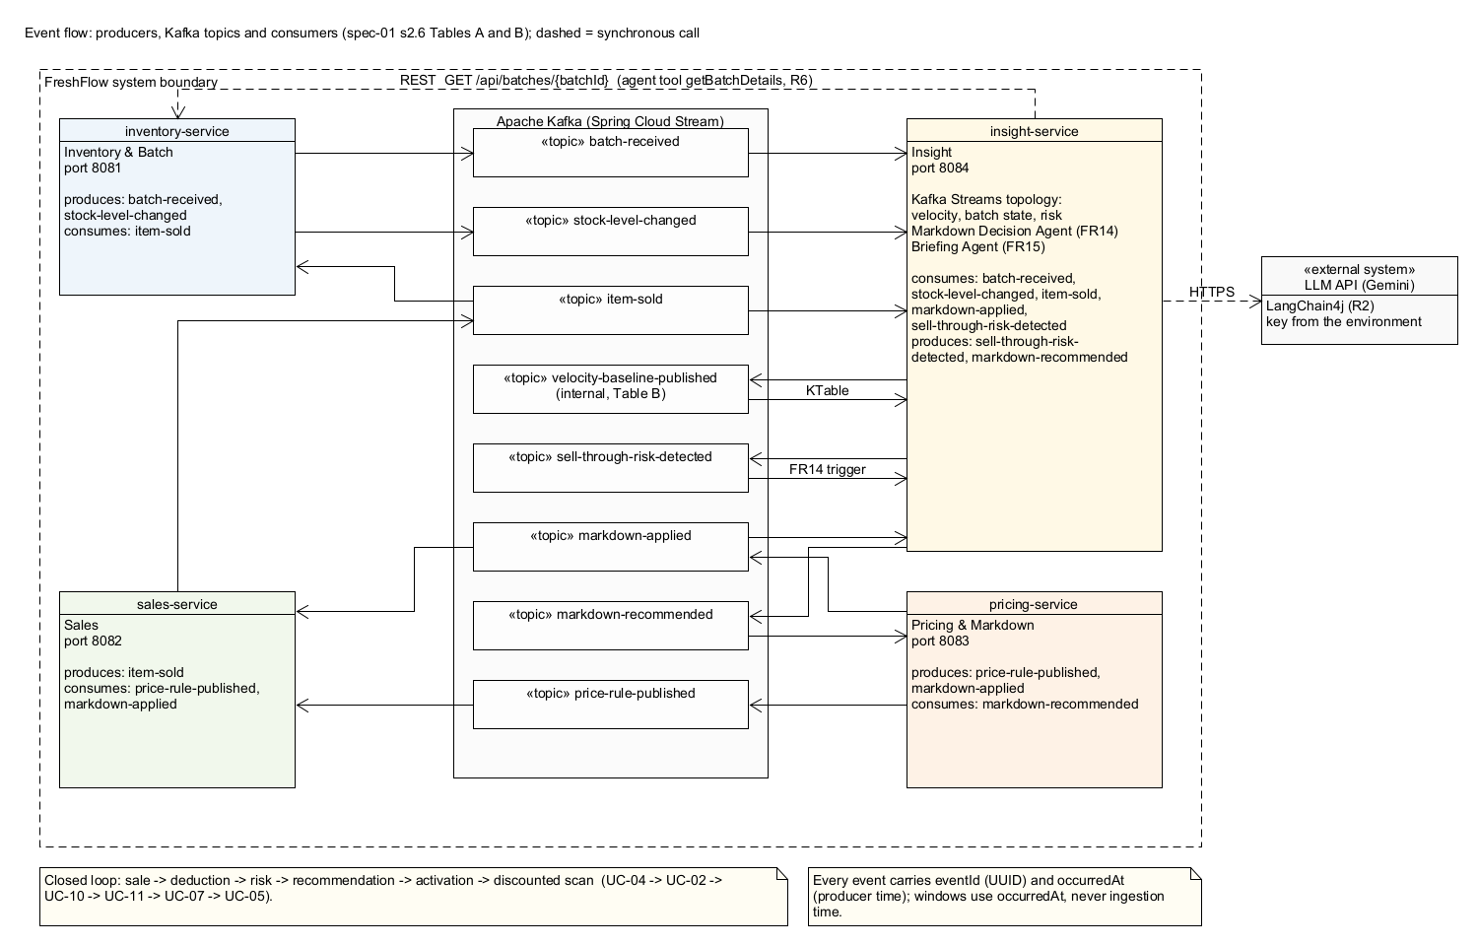
Figure 3.2: event-flow
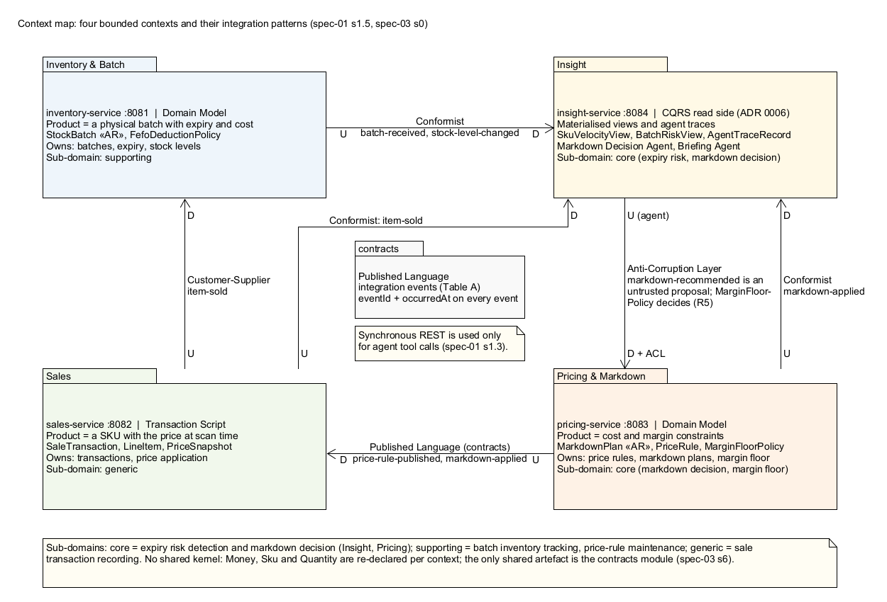
Figure 3.3: context-map
Service | Port | Publishes | Consumes | Synchronous calls
inventory-service | 8081 | batch-received, stock-level-changed | item-sold | none
sales-service | 8082 | item-sold | price-rule-published, markdown-applied | none
pricing-service | 8083 | price-rule-published, markdown-applied | markdown-recommended | none
insight-service | 8084 | sell-through-risk-detected, markdown-recommended, velocity-baseline-published (internal) | item-sold, batch-received, stock-level-changed, sell-through-risk-detected | GET /api/batches/{id} on inventory-service, from the agent's tool only; the LLM API

Asynchronous messaging over Kafka is the primary and, with one exception, the only inter-service mechanism. The exception is the agent's getBatchDetails tool, which reads a batch over REST at the moment the agent asks for it. That call was ruled on explicitly (spec-06, ruling of 10 September 2026): the agent needs the unit cost and the batch state as they are now, a read of a fact with a 404 path and no write, which is a different thing from the one synchronous call the architecture forbids. Sales-service may never ask pricing-service for a price, because that would put a pricing decision on a synchronous dependency at the till; it keeps a local price snapshot fed only by price-rule-published and markdown-applied events (ADR 0001).
The context map in Figure 3.3 names the integration pattern on each relationship. Two of the names are the lecture's (L5, slides 19 to 22): Sales to Inventory is customer-supplier, Sales publishes the sale and Inventory conforms to it; and the agent's relationship to Pricing is an anti-corruption layer. The other two are Evans's context-map terms, which the lecture does not name: Pricing to Sales is a published language, both sides agreeing to the event contract in contracts, and the three producing contexts to Insight are conformist, Insight accepting the upstream event models without negotiation and projecting them into its own views (Evans, 2003). Pricing re-validates every proposal against its own rule, so the model's output never enters the Pricing model as an authoritative command. That last pattern is the one most of the rest of this section is about.
Events are of two kinds, after a ruling recorded in spec-01 section 2.6: integration events, which cross a context boundary and are declared in contracts, and internal events, which one context both produces and consumes and which stay in that service's own packages. The distinction matters because putting an internal topic's payload in contracts would advertise an implementation detail as shared vocabulary. Every event of either kind carries an eventId for idempotent consumption and a producer-assigned occurredAt for windowing.

3.2 Layered architecture
Every service has the same four packages, and the package structure is the layer structure:
com.freshflow.<context>
├── presentation REST controllers and request/response DTOs
├── application application services, command handlers, read models, ports
├── domain aggregates, entities, value objects, domain services, domain events
└── infrastructure JPA entities and mappers, repository implementations, Kafka bindings,
└── repository the repository interfaces (ports) that application depends on

Figure 3.4 shows inventory-service as the worked example with the real classes in each layer, and Figure 3.5 the four services side by side.
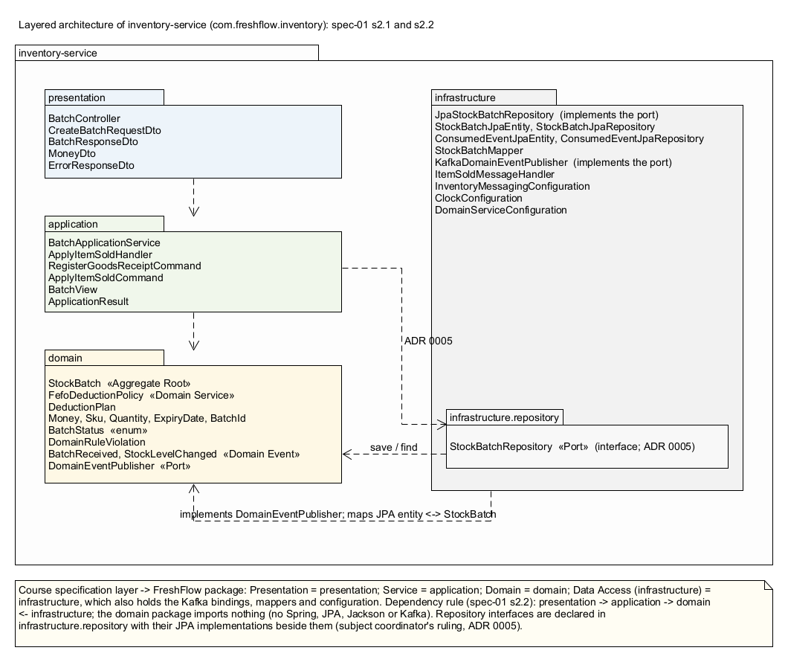
Figure 3.4: layered-architecture
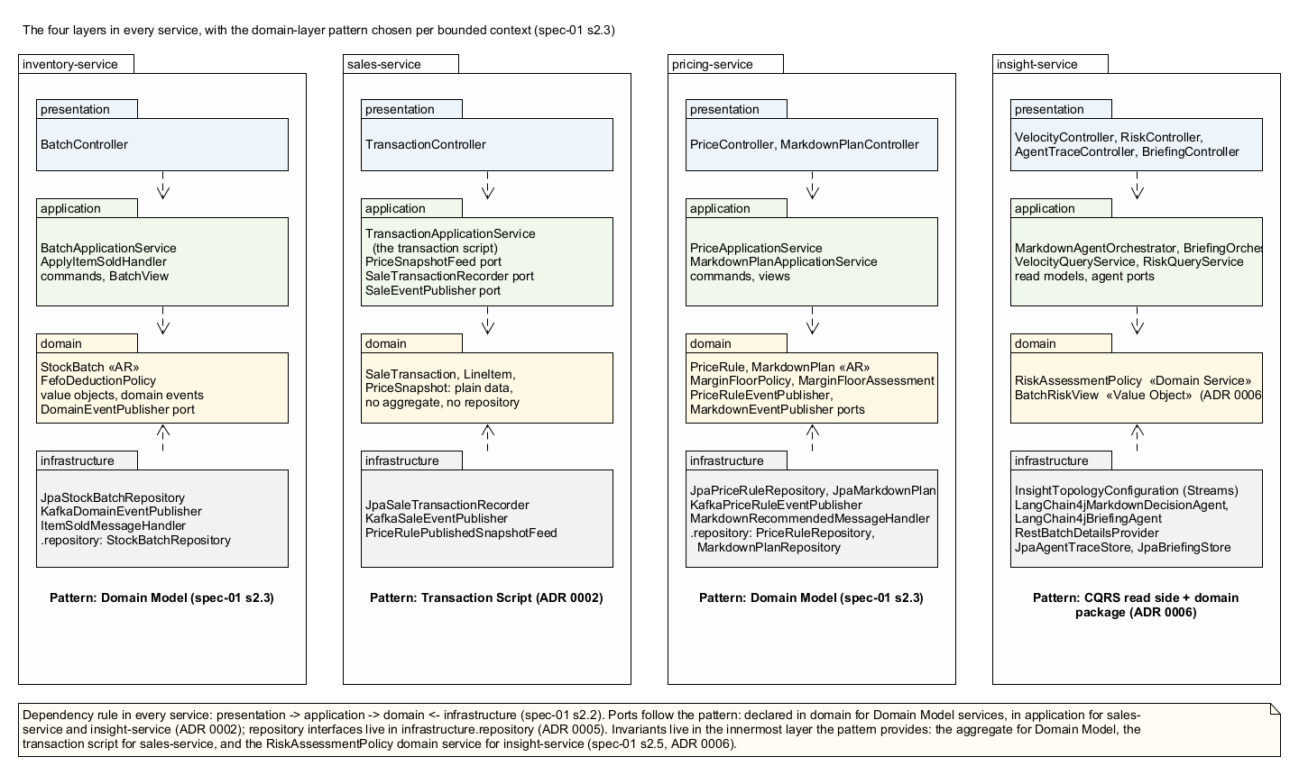
Figure 3.5: layered-architecture-all-services
Naming. The course specification calls the second layer the service layer; our package is named application. They are the same layer. The lecture that introduces the layering calls it the application service layer and describes it as representing the use cases of the application and hiding the complexity of the domain behind a façade (L3, slide 12), which is the description our package-info files carry. We kept the name because application is the vocabulary of the layered and ports-and-adapters literature the specifications cite, and renaming the package would have made the code disagree with its own specifications for no gain. The mapping is one-to-one:
Course specification layer | FreshFlow package | Note
Presentation | presentation | Controllers map HTTP to commands and views to DTOs; they decide nothing
Service | application | Use-case orchestration, commands and handlers, read models, ports
Domain | domain | The model; imports only java.*
Infrastructure (data access) | infrastructure and infrastructure.repository | Persistence, messaging, external clients, configuration

Responsibilities and the dependency rule. The presentation layer exposes the system's functions and translates between HTTP and the application layer's commands and views. The application layer represents the use cases: it validates the shape of a request, retrieves domain objects from a store, delegates the business decision to them, saves the result and publishes what happened. It contains no business rule, which is the lecturer's own description of application services (L4, slide 4, and L4, slide 42). The domain layer holds the model and every invariant, and depends on nothing: it is agnostic to the technicalities of the system (L3, slide 12). The infrastructure layer holds the technical details that let the application function, from JPA entities to Kafka bindings (L3, slide 13).
Dependencies face inward (L3, slide 11). The domain package of every service imports only java.*; no Spring, no JPA, no Jackson, no Kafka, and nothing from the other three packages. This is checked mechanically, by a test in each service that scans the domain sources and fails the build on any other import, so the rule cannot drift while nobody is looking. The application layer imports the domain and, for persistence, the repository interfaces; the infrastructure layer implements those interfaces and the domain's outbound ports (DomainEventPublisher, PriceRuleEventPublisher) and so points inward too.
Two decisions about placement that the coordinator ruled on. Repository interfaces were originally declared in domain, the Evans arrangement. The subject coordinator's answer to our question, by email on 17 September 2026 and in consultation on 22 September, was that repositories belong to the persistence layer, in a dedicated sub-package, and the corresponding lecture slide says the same (L4, slide 34). They were moved to infrastructure.repository and the decision, including the cost in dependency-inversion terms, is recorded as ADR 0005. The second ruling concerned insight-service, which was built as a CQRS read side with no domain package on the argument that it holds no transactional business data. The coordinator's view was that a CQRS context still has a domain layer, and in fact the service did have domain logic: the policy that decides whether a batch is at risk. It now lives in com.freshflow.insight.domain with the value it produces (ADR 0006), and all four services show the same four packages.
A different domain-layer pattern per context. The specifications assign the pattern per bounded context rather than uniformly (L3, slides 15 to 22). Inventory and Pricing use the Domain Model pattern: persistence-ignorant POJOs with behaviour, separate JPA entities and mappers in infrastructure. Sales uses Transaction Script: one procedure records a transaction, and the context deliberately has no aggregate root and no repository abstraction (ADR 0002), because recording a basket has little business logic and a full domain model there would have been over-engineering. Insight is a CQRS read side whose views are materialised by Kafka Streams and by the agents, with a small domain package for the rule that computes the risk view. Choosing the lighter pattern where the logic is light is itself a design decision the lectures ask for, and it is one the team would defend rather than apologise for.

3.3 Domain-Driven Design patterns
The tactical patterns realise the ubiquitous language in code, and each has a single responsibility (L4, slides 3 and 4). This section takes one representative of each pattern, shows the code, and says why it is that pattern and not another. Every snippet is from the repository as submitted; Javadoc is omitted for space.

Value object: `Money`
A value object has no identity, is defined by its attributes, is immutable and validates itself (L4, slides 5 and 8). Money is a Java record, so equality is attribute-based and the fields are final by construction. The compact constructor is where the self-validation lives: a blank currency or a negative amount is refused, and the amount is normalised to two decimal places so that 2.10 and 2.1000 compare equal, which BigDecimal would otherwise deny.
public record Money(BigDecimal amount, String currency) {
public static final int SCALE = 2;
public static final RoundingMode ROUNDING = RoundingMode.HALF_UP;

public Money {
Objects.requireNonNull(amount, "amount");
Objects.requireNonNull(currency, "currency");
if (currency.isBlank()) {
throw new DomainRuleViolation("CURRENCY_REQUIRED", "Currency must not be blank.");
}
if (amount.signum() < 0) {
throw new DomainRuleViolation("NEGATIVE_AMOUNT", "Money amount must not be negative.");
}
amount = amount.setScale(SCALE, ROUNDING);
}
}

The lecture's example of a sub-optimal design is representing a bid amount as a bare integer (L4, slide 7). The same argument applies to Sku, Quantity, ExpiryDate and BatchId, which wrap a primitive so that the rules about it have somewhere to live: Quantity knows it may be zero but never negative, and ExpiryDate knows how to compute remaining shelf life.

Aggregate root: `StockBatch`
An aggregate is a consistency boundary around a group of objects, and the root is the only entry point through which the group is changed (L4, slides 21 and 22). StockBatch holds a batch's quantities, expiry, cost and status, and every change goes through a method that enforces an invariant. The factory method receive refuses a non-positive quantity and an expiry that is not in the future, which are FR1's two rejection rules; deduct refuses to go below zero, and to touch an expired or written-off batch.
public static StockBatch receive(BatchId batchId, Sku sku, Quantity quantity, ExpiryDate expiryAt,
Money unitCost, Instant receivedAt) {
if (!quantity.isPositive()) {
throw new DomainRuleViolation("QUANTITY_NOT_POSITIVE", "Received quantity must be greater than zero.");
}
if (!expiryAt.isAfter(receivedAt)) {
throw new DomainRuleViolation("EXPIRY_NOT_IN_FUTURE", "Expiry must be after the receipt timestamp.");
}
return new StockBatch(batchId, sku, quantity, quantity, expiryAt, unitCost, BatchStatus.ACTIVE, receivedAt);
}

public void deduct(Quantity quantity, Instant now) {
if (status == BatchStatus.WRITTEN_OFF) {
throw new DomainRuleViolation("BATCH_WRITTEN_OFF", "A written-off batch cannot be deducted from.");
}
if (isExpired(now)) {
throw new DomainRuleViolation("BATCH_EXPIRED", "An expired batch cannot be deducted from.");
}
if (remainingQuantity.isLessThan(quantity)) {
throw new DomainRuleViolation("INSUFFICIENT_STOCK", "Stock on hand must never become negative.");
}
remainingQuantity = remainingQuantity.minus(quantity);
if (remainingQuantity.isZero()) {
status = BatchStatus.DEPLETED;
}
}

Two details follow the lecture's advice closely. The entity exposes behaviour, receive and deduct, rather than setters (L4, slide 16), and the invariants are enforced in the methods and the factory rather than in the controller or the application service (L4, slides 17 and 18). The class carries no JPA annotation. Persistence is handled by a separate StockBatchJpaEntity and a mapper in the infrastructure layer, so the aggregate can be tested with no database and the compiler, not convention, keeps infrastructure out of it. The coordinator pointed out that @Entity is only a JPA mapping and says nothing about whether a class is a DDD entity; we took the stricter route of keeping the two apart, at the cost of a mapper per aggregate, and that trade-off is recorded in the Week 7 comparison with the coordinator's own reference code.

Aggregate root: `MarkdownPlan`, and the invariant that constrains the agent
MarkdownPlan is the second aggregate, in the Pricing context, and it carries the invariant the whole project is built around: a plan may only be activated if the discounted price keeps the margin at or above the floor. The aggregate does not compute the margin itself; it receives a MarginFloorAssessment produced by the domain service below and decides from it, which keeps the arithmetic in exactly one place.
public void activate(MarginFloorAssessment assessment) {
Objects.requireNonNull(assessment, "assessment");
requireNotRejected("activated"); // invariant 4: REJECTED is terminal
if (status != MarkdownStatus.PROPOSED) { // invariant 3
throw new DomainRuleViolation("PLAN_NOT_PROPOSED",
"Only a PROPOSED plan may be activated; this plan is " + status + ".");
}
if (assessment.requestedTier() != discountTier) {
throw new DomainRuleViolation("ASSESSMENT_TIER_MISMATCH", ...);
}
if (assessment.breached()) { // invariant 1: the margin floor
status = MarkdownStatus.REJECTED;
rejectionReason = assessment.message();
throw new MarginFloorBreach(assessment);
}
status = MarkdownStatus.ACTIVE;
discountedPrice = assessment.resultingPrice();
}

The application service catches MarginFloorBreach inside its transaction, so the plan that just recorded itself REJECTED is committed rather than rolled back, and the controller maps the exception's assessment to the 422 body. The same service is called by the Kafka consumer for markdown-recommended, with origin AGENT, so the HTTP endpoint and the agent's recommendation are two entry points to one rule.
The other invariants listed in the domain specification are enforced in the same methods: only a PROPOSED plan may be activated, a REJECTED plan is terminal, the promotion window must end after it starts, and the origin (HUMAN or AGENT) is immutable after creation. A rejected plan is kept rather than discarded, because FR11 requires the rejection to be recorded and queryable, and an auditor reading it later should see what was asked for and why it was refused.

Domain service: `FefoDeductionPolicy` and `MarginFloorPolicy`
A domain service holds logic that does not belong to any one entity or value object, is stateless, and often orchestrates several domain objects (L4, slides 28 to 30). First-expired-first-out deduction is such a rule: a sale of three units may span two batches, so the decision of how much to take from which batch belongs to neither batch. FefoDeductionPolicy plans the allocation over the batches in expiry order and reports any shortfall as a fact rather than a negative allocation, and each StockBatch still gets to refuse its own part of the plan.
public DeductionPlan planDeduction(List<StockBatch> batchesInExpiryOrder, Quantity soldQuantity, Instant now) {
List<DeductionPlan.Allocation> allocations = new ArrayList<>();
int outstanding = soldQuantity.value();
for (StockBatch batch : batchesInExpiryOrder) {
if (outstanding == 0) break;
if (batch.isExpired(now) || batch.status() != BatchStatus.ACTIVE) continue;
int available = batch.remainingQuantity().value();
if (available == 0) continue;
int taken = Math.min(available, outstanding);
allocations.add(new DeductionPlan.Allocation(batch, Quantity.of(taken)));
outstanding -= taken;
}
return new DeductionPlan(allocations, Quantity.of(outstanding));
}

MarginFloorPolicy is the Pricing context's domain service and the enforcement point of the anti-corruption layer. It spans PriceRule and MarkdownPlan, which is why it is a service and not a method of either. It returns a value object rather than a boolean, because the HTTP 422 response has to report the resulting price and margin, and recomputing those outside the domain would have put the rule in two places.
public final class MarginFloorPolicy {
public MarginFloorAssessment assess(PriceRule rule, DiscountTier tier) {
Money resultingPrice = rule.priceUnder(tier);
BigDecimal resultingMarginRatio = marginRatio(resultingPrice, rule.unitCost());
return new MarginFloorAssessment(rule.basePrice(), rule.unitCost(), tier,
resultingPrice, resultingMarginRatio, rule.marginFloor());
}

private static BigDecimal marginRatio(Money sellingPrice, Money unitCost) {
BigDecimal price = sellingPrice.amount();
if (price.signum() == 0) {
return BigDecimal.ZERO.setScale(MarginFloorAssessment.RATIO_SCALE, Money.ROUNDING);
}
return price.subtract(unitCost.amount()).divide(price, MarginFloorAssessment.RATIO_SCALE, Money.ROUNDING);
}
}

public record MarginFloorAssessment(Money basePrice, Money unitCost, DiscountTier requestedTier,
Money resultingPrice, BigDecimal resultingMarginRatio, MarginFloor floor) {
public boolean breached() {
return resultingMarginRatio.compareTo(floor.ratio()) < 0;
}
public String message() {
return "Discount tier " + requestedTier.name() + " yields margin " + resultingMarginRatio.toPlainString()
+ ", " + (breached() ? "below" : "at or above") + " floor " + floor.ratio().stripTrailingZeros().toPlainString();
}
}

The margin is gross margin as a fraction of the selling price: resulting price less unit cost, divided by resulting price. With the seeded yoghurt rule (base 4.50, cost 2.10, floor 0.15) a 30 per cent markdown gives 3.15 and a margin of 0.333, which passes, while a 60 per cent markdown gives 1.80 and a negative margin, which is refused. Those two cases are the two examples in the API contract and the two requests in the demonstration.

Entity: `PriceRule`
PriceRule is an entity rather than a value object because it has an identity, the SKU, that stays fixed while its attributes change: a store owner may replace the base price or the floor and it is still the rule for that product (L4, slides 12 and 13). Its factory refuses a base price below cost and a currency mismatch between price and cost, so an impossible rule cannot be constructed.
public static PriceRule of(Sku sku, Money basePrice, Money unitCost, String category, MarginFloor marginFloor) {
if (!basePrice.currency().equals(unitCost.currency())) {
throw new DomainRuleViolation("CURRENCY_MISMATCH", "Base price and unit cost must be in the same currency.");
}
if (basePrice.amount().compareTo(unitCost.amount()) < 0) {
throw new DomainRuleViolation("BASE_PRICE_BELOW_COST", "Base price must not be below unit cost.");
}
return new PriceRule(sku, basePrice, unitCost, category, marginFloor);
}

Domain events: `BatchReceived` and its integration counterpart
A domain event records something that happened in the domain that other parts of the system care about (L4, slide 35), and the lecture distinguishes internal events, which stay inside a model, from external ones handled by other contexts (L4, slide 37). FreshFlow keeps that distinction in the type system. BatchReceived is a record in the Inventory domain package, expressed in the domain's own types; BatchReceivedEvent in contracts is its external form, with primitives, an eventId and an occurredAt. The application layer raises the domain event through a port, and the infrastructure adapter translates it to the integration event and publishes it, which is the division of labour the lecture describes when it places event publication and subscription in the application service layer (L4, slides 38 and 40).
public record BatchReceived(BatchId batchId, Sku sku, Quantity quantity, ExpiryDate expiryAt,
Money unitCost, Instant occurredAt) { }

Repositories, and where they live
Each aggregate has one repository whose interface speaks only the domain's language, save(StockBatch) and findById(BatchId), and whose JPA implementation hydrates the aggregate as a whole (L4, slides 27 and 34). As Section 3.2 explained, the interfaces are declared in infrastructure.repository on the coordinator's ruling; the application services depend on the interface and never on Spring Data. The Sales context has no repository on purpose: its persistence port is a single-method SaleTransactionRecorder, which is what a transaction script needs and no more (ADR 0002).

Commands and handlers
Commands are plain DTOs handled in the application layer and they never enter the domain (L5, slide 7). ApplyItemSoldCommand is a record of SKU, quantity and time; ApplyItemSoldHandler loads the batches, asks the policy for a plan, applies it through the aggregate and publishes the resulting events. The project preferred one command and one handler per complex use case over a bloated application service, as the CQRS lecture recommends (L5, slide 9), and the same shape recurs for RegisterGoodsReceiptCommand and CreateMarkdownPlanCommand.

3.4 Data persistence in microservices
Each service owns one H2 database, created from its JPA entities at start-up, and no service reads another's tables. Figure 3.6 is the database design, grouped by service.
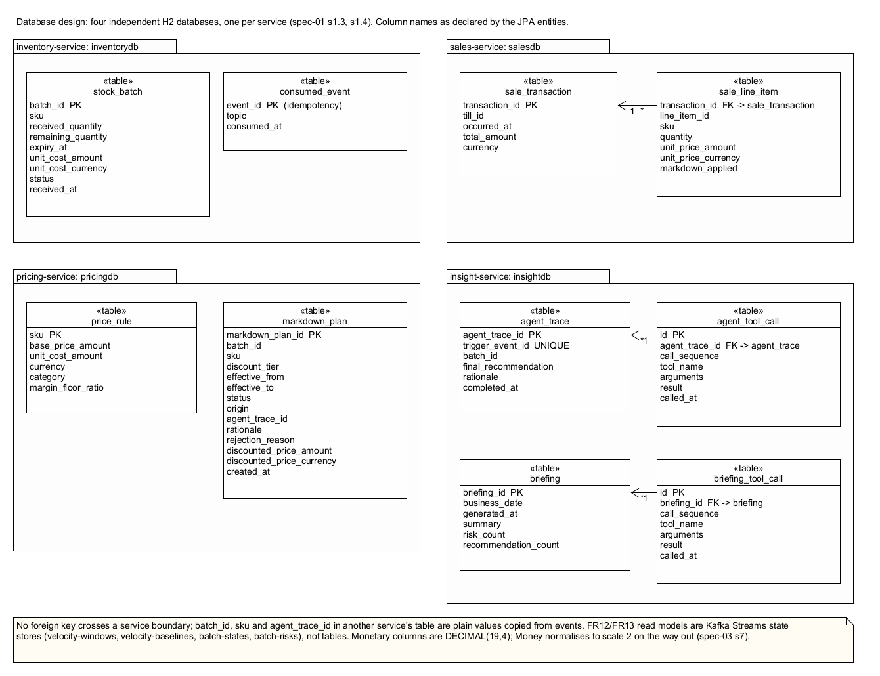
Figure 3.6: database-design
Microservice | Database | Tables it owns | How other services obtain the data
inventory-service | inventorydb | stock_batch, consumed_event | batch-received and stock-level-changed events; GET /api/batches/{id} for the agent's tool
sales-service | salesdb | sale_transaction, sale_line_item | item-sold events
pricing-service | pricingdb | price_rule, markdown_plan | price-rule-published and markdown-applied events
insight-service | insightdb | agent_trace, agent_tool_call, briefing, briefing_tool_call | GET /api/insight/agent-traces/{id} and GET /api/insight/briefings/{id}

Three design points are worth stating. The only foreign keys are inside a service (sale_line_item to sale_transaction, agent_tool_call to agent_trace, briefing_tool_call to briefing); nothing references a row in another service's database, which is what makes the services independently deployable and is the shared-nothing boundary the lectures describe (L5, slide 27). Money is stored at a precision of 19 and a scale of 4 and normalised to two decimal places by the Money value object on the way out, so the database never becomes the place where rounding happens. And the FR12 and FR13 read models are not tables at all: they live in four Kafka Streams state stores (velocity-windows, velocity-baselines, batch-states, batch-risks), are rebuilt from their changelog topics on restart, and are served to the REST layer by interactive queries. Only the agent trace and the briefing are persisted relationally, because they are audit records that must survive a topology restart and be readable by id.
The consumed_event table deserves a sentence of its own. It is the idempotency ledger for FR2: every item-sold event's identifier is recorded in the same transaction as the stock deduction it caused, so a redelivered event is recognised and ignored, and either a sale is applied and remembered or neither happens.

3.5 Event-driven architecture and stream processing

3.5.1 The event-driven design
Services collaborate by publishing facts and reacting to them, which is the event collaboration and choreography style the lecture contrasts with orchestration (L6, slide 6). No service commands another. A sale is published by sales-service without knowing that inventory-service will deduct stock or that insight-service will window it; a risk is published by the topology without knowing that an agent will deliberate on it; a recommendation is published by the agent without knowing how pricing-service will judge it. That last point is the one the lecture makes about agents in particular: an agent should publish its findings as an event and move on rather than wait on a blocking response (L6, slide 9).
Every topic is a Spring Cloud Stream binding declared in application.yml, so no adapter hard-codes a topic name. Producers use StreamBridge behind a domain port, and consumers are Consumer<Message<T>> function beans named in spring.cloud.function.definition. The producer side, from inventory-service:
@Override
public void publish(BatchReceived event) {
BatchReceivedEvent payload = new BatchReceivedEvent(UUID.randomUUID(), event.occurredAt(),
event.batchId().value(), event.sku().value(), event.quantity().value(),
event.expiryAt().value(), new MoneyPayload(event.unitCost().amount(), event.unitCost().currency()));
Message<BatchReceivedEvent> message = MessageBuilder.withPayload(payload)
.setHeader("sku", payload.sku())
.setHeader("eventId", payload.eventId().toString())
.build();
boolean sent = streamBridge.send(BINDING, message);
...
}

Messages are keyed by SKU so that every event about one product lands on one partition and stays ordered, which the Kafka Streams topology depends on when it groups by SKU. The consumer side, also from inventory-service, shows the idempotency rule in code: the event identifier is checked and then recorded in the same transaction as the deduction.
@Transactional
public boolean handle(ItemSoldEvent event) {
String eventId = event.eventId().toString();
if (consumedEvents.existsById(eventId)) {
log.info("[duplicate] topic={} eventId={} sku={} already applied; stock not deducted again", ...);
return false;
}
consumedEvents.save(new ConsumedEventJpaEntity(eventId, ItemSoldEvent.TOPIC, Instant.now()));
applyItemSoldHandler.handle(new ApplyItemSoldCommand(event.sku(), event.quantity(), event.occurredAt()));
return true;
}

Consumer groups are chosen per purpose. inventory-service joins a durable group for item-sold, because a deduction is a change that must be applied exactly once and must not be replayed on restart. sales-service joins an anonymous group for price-rule-published and markdown-applied and replays both topics from the beginning, because its price snapshot is a materialised view of the whole topic rather than a work queue, and replay is safe because the adapter deduplicates on eventId and resolves conflicts by occurredAt.

3.5.2 The stream processing queries
The two real-time analyses are one Kafka Streams topology with four input streams and one output stream, built with the DSL (L6, slides 24 to 26). The coordinator confirmed in writing that the DSL is the expected way to implement SQL-like analysis in this project, and the lecture's framing is that a live stream can be treated as a continuously appended table to which the usual relational operations apply (L6, slide 12). Each query is therefore given here twice: as the SQL-like statement it stands for, and as the DSL that implements it.
Query 1, FR12: units sold per SKU over a hopping window, compared with a baseline.
-- what the topology computes, in ksqlDB-style terms
SELECT sku, WINDOWSTART, WINDOWEND, SUM(quantity) AS quantitySold
FROM item_sold
WINDOW HOPPING (SIZE 60 SECONDS, ADVANCE BY 5 SECONDS, GRACE PERIOD 5 SECONDS)
GROUP BY sku
EMIT FINAL;

SELECT v.sku, v.quantitySold / 60.0 * 3600 AS velocityPerHour,
b.baselineVelocityPerHour, velocityPerHour / b.baselineVelocityPerHour AS velocityRatio
FROM velocity_windows v JOIN velocity_baselines b ON v.sku = b.sku;

KTable<Windowed<String>, Long> windowed = itemSold
.filter((key, event) -> event != null && event.sku() != null)
.groupBy((key, event) -> event.sku(), Grouped.with(Serdes.String(), new ItemSoldEventSerde()))
.windowedBy(TimeWindows.ofSizeAndGrace(velocity.window(), velocity.grace()).advanceBy(velocity.advance()))
.aggregate(() -> 0L, (sku, event, total) -> total + event.quantity(),
Materialized.<String, Long, WindowStore<Bytes, byte[]>>as(WINDOW_STORE)
.withKeySerde(Serdes.String()).withValueSerde(Serdes.Long())
.withRetention(velocity.retention()));

The correspondence is one to one: filter is the WHERE, groupBy the GROUP BY, windowedBy the WINDOW HOPPING, aggregate the SUM, and Materialized.as(WINDOW_STORE) names the state store that the interactive query reads. The baseline join is a table-table join against velocity-baselines, a KTable built from an internal topic that is seeded from configuration (ADR 0003). The window is 60 seconds advancing every 5 for the demonstration; the production target of 60 minutes advancing every 5 is a change to two configuration values.
Query 2, FR13: join the closed velocity window with the live state of every batch and project the shortfall.
SELECT b.batchId, b.sku, b.remainingQuantity,
TIMESTAMPDIFF(HOUR, v.WINDOWEND, b.expiryAt) AS hoursToExpiry,
v.velocityPerHour * hoursToExpiry AS projectedSales,
b.remainingQuantity - projectedSales AS projectedShortfall
FROM velocity_stream v JOIN batch_states b ON v.sku = b.sku
WHERE b.remainingQuantity > 0 AND hoursToExpiry > 0
AND projectedShortfall > 0; -- threshold, configured

KTable<String, SkuBatchStates> batchStates = receivedUpdates.merge(stockUpdates)
.groupByKey(Grouped.with(Serdes.String(), updateSerde))
.aggregate(SkuBatchStates::empty, (sku, update, states) -> states.apply(update),
Materialized.<String, SkuBatchStates, KeyValueStore<Bytes, byte[]>>as(BATCH_STATE_STORE)
.withKeySerde(Serdes.String()).withValueSerde(statesSerde));

KStream<String, VelocitySnapshot> velocityStream = windowed
.suppress(Suppressed.untilWindowCloses(Suppressed.BufferConfig.unbounded()))
.toStream()
.map((windowedKey, total) -> KeyValue.pair(windowedKey.key(), new VelocitySnapshot(...)));

KTable<String, RiskAssessment> assessments = velocityStream
.join(batchStates, this::assessEveryBatch, Joined.with(Serdes.String(), velocitySerde, statesSerde))
.flatMap((sku, views) -> ...) // one record per batch
.groupByKey(Grouped.with(Serdes.String(), assessmentSerde))
.reduce((previous, candidate) -> candidate.succeeding(previous),
Materialized.<String, RiskAssessment, KeyValueStore<Bytes, byte[]>>as(RISK_STORE)...);

return assessments.toStream()
.filter((batchId, assessment) -> assessment != null && assessment.newlyAtRisk())
.mapValues(this::toEvent); // sell-through-risk-detected

The batch-state table is the lecture's fourth scenario, a topic replicated into a local table held inside the service (L6, slide 15): batch-received and stock-level-changed are merged, re-keyed by SKU and aggregated into one SkuBatchStates per product. suppress(untilWindowCloses) makes the velocity stream emit once per closed window rather than on every update, which is the EMIT FINAL in the SQL. The stream-table join then runs the RiskAssessmentPolicy from the domain package over every batch of the SKU; the reduce keeps one standing assessment per batch so that only the transition into risk, newlyAtRisk, produces an event. That is what stops the agent being triggered every five seconds for the same batch.
Event time. Both queries window on the producer-assigned occurredAt, never on the time Kafka received the record. One timestamp extractor serves every input topic by matching on the IntegrationEvent interface that every contract implements:
@Override
public long extract(ConsumerRecord<Object, Object> record, long partitionTime) {
if (record.value() instanceof IntegrationEvent event && event.occurredAt() != null) {
return event.occurredAt().toEpochMilli();
}
log.warn("[dropped] topic={} ... carries no usable occurredAt; it will NOT be placed using ingestion time", ...);
return -1;
}

An earlier version of this class matched only ItemSoldEvent and silently dropped every batch event; the defect was found when the risk table stayed empty in a live run and is recorded in the Week 7 log. Event time is what makes the analysis reproducible: replaying the topic at any speed gives the same windows, and a sale that arrives late within the grace period lands in the window it belongs to.
Interactive queries as the read side. The REST endpoints do not query a database. VelocityController and RiskController call application-layer ports (VelocityWindowStore, RiskViewStore) whose infrastructure adapters read the state stores through InteractiveQueryService. The read-side selection rule is specified rather than left to chance: the velocity served is the latest fully elapsed window, and a SKU whose last window has aged out of retention answers 404. The coordinator's reference cargo-tracker presents the same shape, a StreamProcessor and an InteractiveQuery class behind a query controller; FreshFlow's equivalents are InsightTopologyConfiguration, the InteractiveQuery*Store adapters and the two controllers, with three additions the reference does not have: a hopping window with a grace period, event-time extraction, and a stream-table join.

3.6 The agentic AI component

3.6.1 The pattern
Both agents are tool-using agents in the ReAct style: the model reasons about what it needs, requests a tool, observes the result and reasons again, until it answers or a step limit stops it (L7, slides 19 and 20). The lectures' list of what turns a reactive model into an agent is memory, tools and retrieval (L7, slide 10); FreshFlow uses tools, keeps short-term memory as the conversation of one deliberation, and does no retrieval, because every fact the agent needs is a live number from a state store or a service rather than a document. The coordinator's two agent repositories name the same building blocks, tools and code-side orchestration around the model's output, and never use a framework agent loop; FreshFlow builds the loop explicitly for the same reason, so that every step is visible and the trace is complete.
Three design rules make the pattern safe to run inside a business system, and each is enforced in code rather than in the prompt.
- The model never sees a credential, a price write or a pricing rule. The Markdown Decision Agent's tools are getBatchDetails, getSellThroughRate and proposeMarkdown; there is no tool that reads the margin floor and no tool that writes a price. A guard test scans every main source file of insight-service, including the system prompt, and fails the build if the words "margin floor", "pricing" or the markdown-plans path appear.
- The orchestrator, not the model, decides what counts. A proposal is taken only from a proposeMarkdown call the registry accepted; a proposal naming a different batch from the one flagged is refused and recorded as declined; a model that stops without concluding produces a trace that says so.
- Every deliberation is persisted as a trace with its tool calls, arguments and results, and is idempotent on the trigger's event identifier, so a redelivered risk event is not deliberated twice.

3.6.2 LLM integration
The model sits behind a port in the application layer (ADR 0004). MarkdownDecisionAgent is an interface with one method; the runtime implementation uses LangChain4j's ChatModel against Google's Gemini API, and every test uses a deterministic stub, so no test touches the network and the suite passes with no API key set. The dependency surface is langchain4j-core plus exactly one provider module, a team ruling that keeps the approved list short and the version pinned in the root POM. Both of the coordinator's agent references obtain their ChatModel from the LangChain4j Spring Boot starter and build the agent as an AiServices proxy, one with @AiService and @Tool methods and the other with AiServices.builder. Those annotations live in the langchain4j and starter artifacts, not in langchain4j-core, so under the team's two-artifact ruling (R2) FreshFlow constructs the GoogleAiGeminiChatModel itself in a configuration class and drives the tool loop explicitly, which is also what makes every step of the loop visible to the trace. The construction sits behind two guards: a Spring profile that excludes it from every test context, and a condition on the API key being present.
The loop itself, from LangChain4jMarkdownDecisionAgent:
for (int step = 1; step <= maxSteps; step++) {
ChatResponse response = chatModel.chat(ChatRequest.builder()
.messages(conversation).toolSpecifications(specifications).build());
AiMessage answer = response.aiMessage();
conversation.add(answer);
if (!answer.hasToolExecutionRequests()) {
closing = answer.text();
break;
}
for (ToolExecutionRequest request : answer.toolExecutionRequests()) {
String arguments = MarkdownToolArguments.encode(request.name(), request.arguments());
String result = tools.invoke(request.name(), arguments);
calls.add(new ToolCall(calls.size() + 1, request.name(), arguments, result, clock.instant()));
conversation.add(ToolExecutionResultMessage.from(request, result));
if (AgentToolRegistry.PROPOSE_MARKDOWN.equals(request.name()) && result.startsWith(ACCEPTED)) {
proposal = MarkdownToolArguments.decodeProposal(request.arguments());
}
}
}

The tools are declared to the model as ToolSpecifications with JSON schemas, so the model's arguments arrive typed; the discount tier is an enum property, which is how the contract's four tiers reach the model without being spelled out in prose. The system prompt tells the model the order to work in, that it recommends a tier and a start time and nothing else, and that a tool answer beginning error= is to be read and corrected. maxSteps bounds the loop, the lecture's "maximum number of loop" (L7, slide 20), and the Gemini API's requirement to echo thought signatures on the second turn was the one integration defect found in the live run; it is recorded with its fix in the 14 September log.
The orchestrator around the agent is where the business rules of the use case live:
public AgentTraceRecord onRiskDetected(SellThroughRiskDetectedEvent trigger) {
String triggerEventId = trigger.eventId().toString();
Optional<AgentTraceRecord> alreadyHandled = traceStore.findByTriggerEventId(triggerEventId);
if (alreadyHandled.isPresent()) {
return alreadyHandled.get(); // a redelivered trigger is not deliberated twice
}
AgentDeliberation deliberation = agent.deliberate(trigger, tools);
Instant completedAt = clock.instant();
MarkdownProposal proposal = inScope(deliberation.proposal(), trigger); // refuses a foreign batchId (R7)
Instant effectiveTo = proposal == null ? null : promotionEnds(trigger); // from the batch's expiry
boolean recommends = proposal != null && effectiveTo != null;
AgentTraceRecord trace = new AgentTraceRecord(TRACE_ID_PREFIX + triggerEventId, triggerEventId,
trigger.batchId(), List.copyOf(deliberation.toolCalls()),
finalRecommendation(proposal, effectiveTo), // NO_MARKDOWN | PROPOSED_BUT_UNRESOLVABLE | "<TIER> from .. until .."
deliberation.rationale(), completedAt);
traceStore.save(trace);
if (recommends) {
publisher.publish(new MarkdownRecommendedEvent(UUID.randomUUID(), completedAt, trigger.batchId(),
trigger.sku(), proposal.discountTier(), proposal.effectiveFrom(), effectiveTo,
proposal.rationale(), trace.agentTraceId()));
}
return trace;
}

Three outcomes are possible and each leaves a trace: the agent declined (NO_MARKDOWN), the agent proposed but the batch could not be resolved to derive the window (PROPOSED_BUT_UNRESOLVABLE, ruling R9), or a recommendation was published. The trace is saved before the event is published; a crash between the two loses a recommendation but never duplicates one, and that window is recorded as known limitation G-7 rather than closed with a transactional outbox.
The second agent, the end-of-day briefing, follows the same shape with its own port, BriefingAgent, three read-only tools over the Insight context's views, and its own persisted record. Its orchestrator adds a grounding step: the risk count and recommendation count returned to the caller are computed from the same services the tools read rather than parsed from the model's prose.
public EndOfDayBriefing brief(LocalDate businessDate) {
Instant now = clock.instant();
LocalDate day = businessDate != null ? businessDate : LocalDate.ofInstant(now, ZoneOffset.UTC);
BriefingRequest request = new BriefingRequest(day, now);
BriefingDeliberation deliberation = agent.brief(request, tools); // the model writes the narrative
int riskCount = riskQueryService.listCurrentRisks().size(); // the service counts the facts
int recommendationCount = (int) agentTraceStore
.findCompletedBetween(request.businessDayStart(), request.businessDayEnd())
.stream().filter(BriefingOrchestrator::recordsAPublishedRecommendation).count();
EndOfDayBriefing briefing = new EndOfDayBriefing(newBriefingId(), day, now,
summaryOf(deliberation), riskCount, recommendationCount, toolCallsOf(deliberation));
briefingStore.save(briefing);
return briefing;
}

The briefing agent's system prompt tells the model to call listCurrentRisks and listRecommendations first, to call getSellThroughRate only for a SKU it wants to comment on, to write four to eight plain sentences naming batches and citing only numbers the tools returned, to state that write-off totals are unavailable because write-offs are not recorded, and that it "recommends nothing and changes nothing". The prompt contains no pricing vocabulary, which the guard test confirms on every build.
What the agent produces in practice is shown in Section 4.2: three real deliberations from the live run of 4 October 2026, each with its tool calls, including one in which the same batch was re-flagged at a higher velocity and the agent declined to propose anything, and two in which its proposals were refused by the Pricing domain and kept as rejected plans linked to their traces.

3.6.3 Guardrails and failure behaviour
The lectures list rule-based guardrails, human-in-the-loop review and monitoring as the controls for hallucination (L7, slide 31), and the dependability lecture lists human review of AI recommendations and the combination of rules with models among its redundancy and diversity techniques (L8, slide 9). FreshFlow uses all three. The rule-based guardrail is the margin floor in pricing-service, which judges the agent's proposal by the same code path as a supervisor's. The human-in-the-loop is the supervisor who can read the trace and the rejected plan. The monitoring is the trace itself, and the counts in the briefing that do not come from the model. When no model is configured the service starts, serves the two real-time analyses, logs each trigger as not deliberated, and answers 503 AGENT_NOT_CONFIGURED for a briefing; nothing in the other three contexts depends on the model being available. A configured model can also be unusable, and the second live run, on 5 October 2026, showed what that looks like: the model's daily free quota ran out mid-demonstration, the provider answered 429, and the raw exception reached a controller as a 500 and a Kafka consumer as a forty-line stack trace. The fix is at the port boundary rather than in either caller. Each adapter translates any provider exception into an application-layer AgentUnavailableException carrying a one-line, bounded, credential-free reason; the orchestrators let it propagate and store nothing, because an outage is not a decision and does not belong in the audit record; the briefing endpoint answers 503 AGENT_UNAVAILABLE naming the reason, distinct from "not configured" so that a caller can tell "set a key" from "try again later"; and the FR14 consumer logs one [fr14-agent-unavailable] line and lets the binder's retry policy decide. Ten tests pin that behaviour, from the exception's redaction rule to the 503 body, and the 503 was then confirmed against the real 429 before the model was switched.

3.7 Other important aspects
Mechanical enforcement of the architecture. Several of the rules in this report are checked by tests rather than by review. The domain packages' import rule fails the build on any non-java.* import. AntiCorruptionLayerGuardTest fails it if insight-service mentions pricing or a margin floor anywhere in its sources, prompt included. Every 404 assertion in the API tests also asserts that the request reached a real controller method, after two tests early in the project passed for the wrong reason because an unimplemented endpoint happened to return 404. MarkdownAgentTestProfileGuardTest starts a test context with an API key deliberately set and asserts that no model client was built, after a nested configuration was found to have escaped its profile guard. A contract test over the contracts module checks that every event serialises eventId as a UUID and occurredAt as an ISO-8601 instant, after one topic shipped its timestamp as an epoch number because the Kafka Streams serde used a different object mapper from the binder. None of these tests exists in the coordinator's reference repositories; they are where the project's own defects taught it something.
Ports and adapters as a substitution mechanism. sales-service's price snapshot entered through a PriceSnapshotFeed port in Week 5 from static configuration, and in Week 6 from the price-rule-published topic, behind the same interface; the application-layer diff for that change was empty. The same port now also receives markdown-applied. The LLM port follows the same idea: a deterministic stub in every test, a LangChain4j adapter at runtime, and a local Ollama adapter would be a second class in infrastructure and a configuration value, not a change to the application layer.
An injected clock. Every service takes a java.time.Clock bean. Expiry, remaining shelf life, promotion windows and the agents' timestamps are computed against it, which is what lets the integration tests use a fixed clock and assert on values that would otherwise move while the test runs.
Decision records. Six architecture decision records capture the choices the specifications did not settle: the placement of PriceSnapshotFeed (0001), the ports a transaction script may own (0002), the configuration-seeded velocity baseline (0003), the LLM behind a port (0004), repositories in the persistence layer (0005) and the Insight domain package (0006). Each records the alternatives, the lecture or ruling it rests on and the cost accepted.
Where FreshFlow departs from the coordinator's reference code, and why. The cargo-tracker reference keeps command objects in the domain and lets the aggregate's constructor handle them; FreshFlow keeps commands as DTOs in the application layer with explicit handlers, following the CQRS lecture (L5, slide 7), and gives the aggregates intention-revealing methods instead. The reference annotates aggregates with @Entity and publishes events from an after-commit listener; FreshFlow keeps the domain persistence-ignorant with mappers, publishes through a port, and records the resulting save-then-publish window as a known limitation (G-7) rather than closing it with an outbox, which is also the position the reference's listener is in. The reference's shared event classes carry neither an event identifier nor a timestamp; FreshFlow's carry both, because idempotent consumption and event-time windowing need them.
Known limitations, stated. G-3: trading hours are configuration and default to 24 clock hours. G-4: risk assessment is triggered by a closing velocity window, so a SKU that stops selling entirely is not re-assessed; the fix is a stream-time punctuator and it was not built. G-6: the event wire format was unenforced until the contract test above was added. G-7: the trace is saved and the recommendation published in two steps that are not atomic; a crash between them loses a recommendation but never duplicates one, and that was accepted. FR3, FR7 and FR10 were not built. Naming these in the report is deliberate; a marker who finds them unstated would be right to ask what else was missed.

4. Instruction and user story examples

4.1 Configuration and running instructions
The repository's README.md carries the full instructions and is kept in step with the code; this section summarises them. Prerequisites are JDK 21, Docker Desktop and Git. Maven is not required because the wrapper is committed.
- Start Kafka: docker compose up -d in the repository root starts a single-node broker in KRaft mode; docker compose ps should show it healthy.
- Build, test and install: .\mvnw.cmd clean install (or ./mvnw on Linux and macOS). The build ends with BUILD SUCCESS and runs every test without a broker or network connection; install is needed because each service is then started on its own and resolves the shared contracts module from the local Maven repository.
- Configure the LLM, in the shell that will start insight-service only: set LLM_API_KEY to a Google AI Studio key and LLM_MODEL to the model name (gemini-3.5-flash-lite, the model of the 5 October live run and of the coordinator's own agent reference; the 4 October run used gemini-3.6-flash). The key is read from the environment and is never written to a file. Without it the service still starts and serves FR12 and FR13.
- Start the four services, each in its own terminal, in the order inventory, pricing, sales, insight: .\mvnw.cmd -pl <service> spring-boot:run. Each logs Started ...Application on ports 8081 to 8084. IntelliJ users can use the run configurations in .run/, including one that starts all four.
- Drive the demonstration: .\scripts\demo.ps1 seeds a price rule, registers batches, runs the POS simulator for a few minutes and prints each read model as it changes; or use the Postman collection in docs/postman/, which has one request per endpoint in demonstration order.
- Stop with Ctrl+C in each terminal and docker compose down.
One operational note from the two live runs: the Gemini free tier enforces a daily request quota per model, and for the newest flash model it was twenty requests a day, which the run of 5 October exhausted mid-demonstration; a demonstration spends roughly ten to fifteen requests. The team therefore demonstrates on gemini-3.5-flash-lite, whose quota is far larger, and rehearses on a different model name or a second key so that the quota is intact on the day; if it is spent, the service degrades to 503 AGENT_UNAVAILABLE rather than failing, and FR12 and FR13 continue unaffected.
The configuration that a marker may want to vary is in insight-service/src/main/resources/application.yml: the velocity window, advance and grace (60, 5 and 5 seconds for the demonstration), the risk shortfall threshold and trading hours per day, and the LLM timeout and step limit.

4.2 User story input and output
Each implemented user story has at least one sample input and its output below. The inputs are the requests in the README and the Postman collection, sent by scripts/demo.ps1 at four sales a minute. The outputs were captured from one live run of the four services against a fresh Kafka and the Gemini API on Sunday 4 October 2026 between 19:44 and 19:48 AEDT, and are reproduced unedited apart from line wrapping. Every response is in docs/report/evidence/, one file per use case, with its request beside it; the table gives the request and the fields that matter, and the four responses that carry the project's argument are printed in full afterwards.
UC | Request | Response (status and the fields that matter) | Evidence file
UC-01 | POST /api/batches {"sku":"SKU-YOG-1KG","quantity":400,"expiryAt":"2026-10-04T09:54:42Z","unitCost":{"amount":2.10,"currency":"AUD"},"supplierRef":"DEMO-1"} | 201 batchId: BAT-B351F864, remainingQuantity: 400, status: ACTIVE, remainingShelfLifeHours: 1 | UC-01-post-batch-201.json
UC-01 | the same with "quantity": 0 | 400 {"error":"QUANTITY_NOT_POSITIVE","message":"Received quantity must be greater than zero."} | UC-01-400-quantity-not-positive.json
UC-02 | GET /api/batches/BAT-B351F864 two seconds after a sale of 2 units | 200 remainingQuantity: 398 (was 400); the inventory log shows the item-sold event consumed once and stock-level-changed published | UC-02-batch-after-fefo-deduction.json
UC-03 | GET /api/batches?sku=SKU-YOG-1KG | 200, one ACTIVE batch with remainingShelfLifeHours: 1 | UC-03-batches-by-sku.json
UC-04 | POST /api/transactions {"tillId":"TILL-02","lineItems":[{"sku":"SKU-YOG-1KG","quantity":2}]} | 201 transactionId: TXN-B54F5A46, totalAmount: 9.00, line unitPrice: 4.50, markdownApplied: false | UC-04-post-transaction-201.json
UC-05 | the same for SKU-STR-250G, quantity 1, after plan MDP-1F789397 was activated | 201 totalAmount: 4.20, line unitPrice: 4.20, markdownApplied: true | UC-05-transaction-inside-markdown-window.json
UC-06 | PUT /api/prices/SKU-STR-250G {"basePrice":{"amount":6.00,"currency":"AUD"},"unitCost":{"amount":3.00,"currency":"AUD"},"category":"PRODUCE","marginFloorRatio":0.20} | 201, the rule read back with effectivePrice: 6.00 and activeDiscountTier: null; after UC-07, GET shows effectivePrice: 4.20, activeDiscountTier: PERCENT_30 | UC-06-put-price-rule-201.json, UC-06-price-with-active-markdown.json
UC-07 | POST /api/markdown-plans {"batchId":"BAT-5FB092F4","sku":"SKU-STR-250G","discountTier":"PERCENT_30","effectiveFrom":"2026-10-04T08:46:01Z","effectiveTo":"2026-10-04T09:54:42Z","origin":"HUMAN","rationale":"Supervisor clearance of strawberries"} | 201 markdownPlanId: MDP-1F789397, status: ACTIVE, discountedPrice: 4.20; the pricing log shows markdown-applied published | UC-07-post-markdown-plan-201.json
UC-08 | the same for SKU-YOG-1KG with PERCENT_60, origin AGENT | 422, body printed below; GET /api/markdown-plans/MDP-69729816 returns the plan as REJECTED | UC-08-422-margin-floor-rejection.json
UC-08 | the agent's own recommendation, arriving on markdown-recommended | no HTTP answer; the plan MDP-9ED492B6 is persisted REJECTED with rejectionReason: "Discount tier PERCENT_50 yields margin 0.0667, below floor 0.15" and the pricing log shows [fr11-rejected] | UC-08-agent-origin-plan-1.json, -2.json
UC-09 | GET /api/insight/velocity/SKU-YOG-1KG | 200 windowStart: 08:46:00Z, windowEnd: 08:47:00Z, quantitySold: 3, velocityPerHour: 180.0, baselineVelocity: 120.0, velocityRatio: 1.5 | UC-09-velocity-at-detection.json
UC-10 | GET /api/insight/risks | 200, one entry: BAT-B351F864, remainingQuantity: 387, hoursToExpiry: 1, currentVelocity: 180.0, projectedSales: 180.0, projectedShortfall: 207.0 | UC-10-risk-at-detection.json
UC-11 | triggered by sell-through-risk-detected; GET /api/insight/agent-traces/TRC-14b8e872-... | 200, three tool calls and finalRecommendation: "PERCENT_50 from 2026-10-04T08:44:45Z until 2026-10-04T09:54:42Z"; printed below | UC-11-agent-trace-1.json
UC-11 | the same batch re-flagged a minute later at 360 units an hour | finalRecommendation: NO_MARKDOWN, rationale: the current rate will clear the 391 remaining units in about 1.09 hours, before expiry | UC-11-agent-trace-2.json
UC-12 | POST /api/insight/briefings {} | 201 briefingId: BRF-F300BA8E, riskCount: 1, recommendationCount: 2, three tool calls, a six-sentence summary; printed below | UC-12-post-briefing-201.json

The 422 of UC-08, the Pricing domain refusing a 60 per cent markdown on the seeded yoghurt rule:
{"error":"MARGIN_FLOOR_BREACH","markdownPlanId":"MDP-69729816","sku":"SKU-YOG-1KG","requestedTier":"PERCENT_60",
"resultingPrice":{"amount":1.80,"currency":"AUD"},"unitCost":{"amount":2.10,"currency":"AUD"},
"resultingMarginRatio":-0.1667,"marginFloorRatio":0.1500,
"message":"Discount tier PERCENT_60 yields margin -0.1667, below floor 0.15"}

The agent's first deliberation (UC-11), as persisted and served by GET /api/insight/agent-traces/{id}:
{"agentTraceId":"TRC-14b8e872-fb36-4072-afeb-348bb7fdbf81","triggerEventId":"14b8e872-fb36-4072-afeb-348bb7fdbf81",
"batchId":"BAT-B351F864",
"toolCalls":[
{"sequence":1,"toolName":"getBatchDetails","arguments":"BAT-B351F864",
"result":"batchId=BAT-B351F864 sku=SKU-YOG-1KG remainingQuantity=397 expiryAt=2026-10-04T09:54:42Z unitCost=2.10 AUD","timestamp":"2026-10-04T08:45:03.615107Z"},
{"sequence":2,"toolName":"getSellThroughRate","arguments":"SKU-YOG-1KG",
"result":"velocityPerHour=180.0 baselineVelocity=120.0 velocityRatio=1.5","timestamp":"2026-10-04T08:45:05.105499Z"},
{"sequence":3,"toolName":"proposeMarkdown",
"arguments":"BAT-B351F864,PERCENT_50,2026-10-04T08:44:45Z,With 397 units remaining, an expiry timestamp of 2026-10-04T09:54:42Z (~1 hour away), and a current sell-through rate of 180.0 units/hour, approximately 217 units are projected to remain unsold at expiry. A 50% discount is recommended to accelerate sales and clear the stock.",
"result":"recorded batchId=BAT-B351F864 tier=PERCENT_50","timestamp":"2026-10-04T08:45:11.733437Z"}],
"finalRecommendation":"PERCENT_50 from 2026-10-04T08:44:45Z until 2026-10-04T09:54:42Z",
"rationale":"With 397 units remaining, ... A 50% discount is recommended to accelerate sales and clear the stock.",
"completedAt":"2026-10-04T08:45:14.285603Z"}

What the Pricing context did with it (UC-08, agent origin), read back from GET /api/markdown-plans/MDP-9ED492B6:
{"markdownPlanId":"MDP-9ED492B6","batchId":"BAT-B351F864","sku":"SKU-YOG-1KG","discountTier":"PERCENT_50",
"effectiveFrom":"2026-10-04T08:44:45Z","effectiveTo":"2026-10-04T09:54:42Z","status":"REJECTED","origin":"AGENT",
"agentTraceId":"TRC-14b8e872-fb36-4072-afeb-348bb7fdbf81",
"rejectionReason":"Discount tier PERCENT_50 yields margin 0.0667, below floor 0.15","createdAt":"2026-10-04T08:45:14.455608Z"}

This pair of records is the project's central argument in data. The model looked at real numbers through its tools, reasoned sensibly (217 units would be left unsold), and proposed a discount that would have sold the yoghurt below the margin floor. The Pricing domain refused it by the same rule that refused the human's 60 per cent proposal, and kept the refusal with a link back to the trace, so an auditor can read both sides. A minute later the same batch was re-flagged at a higher velocity and the agent declined to propose anything, citing the new numbers, which is the behaviour the design intends and was not scripted.
The rule is a rule and not a veto, and the third run, on 5 October 2026, showed the other outcome. With a projected shortfall of 31 units the agent proposed PERCENT_20; the margin floor assessed 3.60 against a cost of 2.10, a margin of 0.4167 above the floor of 0.15, and the plan went ACTIVE with origin AGENT and discountedPrice 3.60 (UC-11-agent-trace-accepted-2026-10-05.json, UC-08-agent-origin-plan-ACTIVE-MDP-9AB8D589-2026-10-05.json). Across the three runs the same code path accepted one agent proposal and refused three, by arithmetic alone.
The briefing (UC-12), with the counts the orchestrator computed itself:
{"briefingId":"BRF-F300BA8E","businessDate":"2026-10-04","generatedAt":"2026-10-04T08:47:03.413845700Z",
"summary":"During today's evaluation, the automated agent initially recommended a 50 percent markdown for batch BAT-B351F864 because a velocity of 180.0 units per hour left a projected shortfall of 217 units out of 397 remaining units before expiry. A subsequent review of batch BAT-B351F864 recommended no markdown after its velocity increased to 360.0 units per hour, which was 3.0 times baseline and sufficient to clear the 391 remaining units. Additionally, the agent recommended a 50 percent markdown for batch BAT-5FB092F4 due to a velocity of 60.0 units per hour leaving a projected shortfall of 56 units out of 116 remaining units. Regarding sell-through rates, SKU-YOG-1KG is currently selling at 240.0 units per hour, which is 2.0 times its baseline velocity of 120.0 units per hour. Batch BAT-B351F864 for SKU-YOG-1KG remains currently at risk of expiring unsold with 387 units remaining, 1 hour to expiry, a velocity of 180.0 units per hour, and a projected shortfall of 207.0 units that may need attention tomorrow. Please note that write-off totals are not available in this briefing, because write-offs are not recorded by the system yet.",
"riskCount":1,"recommendationCount":2,
"toolCalls":[{"sequence":1,"toolName":"listCurrentRisks","arguments":"","result":"batchId=BAT-B351F864 sku=SKU-YOG-1KG remainingQuantity=387 hoursToExpiry=1 currentVelocity=180.0 projectedShortfall=207.0"},
{"sequence":2,"toolName":"listRecommendations","arguments":"2026-10-04","result":"(the three traces above, one line each)"},
{"sequence":3,"toolName":"getSellThroughRate","arguments":"SKU-YOG-1KG","result":"velocityPerHour=240.0 baselineVelocity=120.0 velocityRatio=2.0"}]}

The briefing names only batches and numbers that appear in its tool results, and its recommendationCount of 2 counts the two published recommendations rather than the three deliberations, because the orchestrator derived it from the trace store and not from the prose.

5. AI-driven development process

5.1 Human-AI collaborative development
The project was built with Claude Code as the development agent, and the way it was used is itself a designed artefact. The lectures describe the AI shift as engineers authoring specifications, context and constraints while agents synthesise the implementation (L1, slide 12), with the human acting as the manager who reviews the plan and the artefacts (L1, slide 28). FreshFlow followed that division of labour literally, and the repository holds the evidence.
Lifecycle phase | How the team worked with the agent | Artefacts in the repository
Requirements engineering | The team wrote the business case and objectives; the agent drafted sixteen requirements as user stories with acceptance criteria and a traceability matrix, and the team cut, split and re-tagged them (FR6 was split into FR6a and FR6b after a Phase 1 finding) | specs/spec-02-requirements.md; docs/ai-log/2026-08-26-phase-1.md
Domain modelling | The team decided the four bounded contexts and the per-context pattern; the agent produced the domain model specification with invariants per aggregate and the team ruled on every open item it raised | specs/spec-03-domain-model.md; ADR 0002, 0005, 0006
Architecture design | The architecture specification, the context map and the event contracts were written with the agent and are the governing documents; CLAUDE.md is the constraint set the agent worked under in every session | specs/spec-01-architecture.md, specs/spec-05-stream-processing.md, specs/spec-06-agent-orchestration.md, CLAUDE.md
Implementation | A four-phase gated pipeline, from the coordinator's own case study (L3, slide 8): inspect the specifications and halt on inconsistency; build the skeleton; write the tests from the OpenAPI contract and watch them fail; implement until they pass. No phase started without the team's written authorisation, and the agent was told to halt rather than guess | specs/dev-agent-prompt.md; docs/prompts/; every docs/ai-log/ entry ends with what was assumed, what deviated and where the agent judged the spec wrong
Testing | Tests were written before implementation from the contract and the agent was forbidden to weaken one to make it pass; the team added guard tests after each defect | *ApiIntegrationTest, AntiCorruptionLayerGuardTest, MarkdownAgentTestProfileGuardTest, MarkdownRecommendedEventContractTest
Documentation | Specifications, ADRs, logs, the runbook and the README were produced in the same sessions as the code they describe; the report was written by the team from them | docs/decisions/, RUNBOOK.md, README.md

Twenty-five session logs and six decision records are in docs/ai-log/ and docs/decisions/. Three examples show how proposals were accepted, rejected or modified, and why.
Accepted: the Phase 1 halt. The first agent run was told to inspect the four specifications and halt on any inconsistency. It halted with 28 findings, 7 of them blocking, among them that sales-service had no permitted way to obtain a price (the architecture forbade both a shared database and a synchronous call to pricing) and that MarkdownPlan.activate could not evaluate its own invariant because it did not receive the base price. The team accepted the halt, ruled on each finding over two days (recorded in docs/ai-log/2026-08-26-phase-1*.md), and only then authorised the skeleton. The price problem was resolved with the PriceSnapshotFeed port rather than an exception to the rule, which is the decision that later made the Week 6 swap to Kafka a zero-line change in the application layer (ADR 0001).
Rejected: a dependency the agent wanted. During the Week 7 stream-processing work the agent proposed adding kafka-streams-test-utils so the topology could be tested with TopologyTestDriver, and separately noted that a second LangChain4j provider module would make the local-model alternative easier. Both were outside the approved dependency list, and the team's rule, recorded as R2, was that an unapproved dependency is a halt, not a choice. The agent was told to proceed without them; the topology was verified against the real broker and logged instead. The team then asked the coordinator, who approved three test and validation dependencies by email on 17 September; the approval is recorded in the specification and none of the three has been added, because the work was already done without them.
Modified: where repository interfaces live. The agent followed the coordinator's own development prompt and declared repository interfaces in the domain packages, the Evans arrangement. The 8 September comparison of the coordinator's reference repositories found four different placements across his slides, specification, prompt and shipped code, and recommended asking rather than arguing. The coordinator's answer, on 17 and 22 September, was the persistence layer in a dedicated sub-package, matching his lecture (L4, slide 34). The agent's placement was reversed, with git mv so that history follows the files, and the cost in dependency-inversion terms was written down rather than hidden (ADR 0005). During that relocation the agent's first scripted edit truncated seven files to zero bytes; it noticed from its own output before anything was staged, restored them from the index and redid the edit by hand, and the incident is in the log because the log is the evidence base for how the tooling was used.
A third incident came from the second live run, on 5 October 2026, and is the one the team would point a marker at first. The daily free quota of the Gemini model ran out while the demonstration script was running; the FR15 endpoint answered 500 and the FR14 consumer printed a stack trace per trigger. Nothing in the suite had failed, because every test runs against a stub and no test had ever asked what happens when the model refuses. The team authorised a test-first change: ten failing tests were written for the behaviour wanted at each layer (the exception's shape, the two orchestrators storing nothing, the two adapters translating at the port, the endpoint's 503), then the smallest code that passed them, then the 503 was confirmed against the real 429 before the model was changed. The lesson sits beside the dependability lecture's point about AI components needing an explicit failure mode (L8): a port makes the model replaceable, but it also hides the model's failures from the tests until a boundary case is written down. The same afternoon a second limit surfaced the same way: after a day of demonstrations the briefing agent's listRecommendations tool answered just over 4,000 characters, one line per trace with the model's full rationale, and the column holding tool results was a fixed VARCHAR(4000). The fix was three failing tests and a @Lob mapping for every column that holds text a model writes or reads; the lesson is that a bound nobody chose on purpose is still a bound, and that only running the system for a whole day finds the ones the unit tests never push against.
Two further incidents are worth a sentence each. A claim in a Javadoc that two guards protected the test suite from building a live model turned out to be false for a nested configuration class; the team authorised a one-annotation fix and a test that would have caught it, and the test is now part of the suite. And the first live run of the agent failed on the second turn because the Gemini API requires thought signatures to be echoed back; the agent diagnosed it from the error, the team authorised a two-line configuration change, and the next run completed.

5.2 Lessons learned
Specifications were the leverage, and the halt was worth more than the code. The most valuable single output of the agent was a list of 28 contradictions in documents the team had thought were finished. The lecture warns that AI can generate technically correct code that solves the wrong problem when the specification it works from is poor (L2, slide 22); an agent instructed to halt on inconsistency turned the specifications into something that could be built from. The team's productivity gain came less from the speed of writing code and more from never having to rewrite it.
Constraints had to be mechanical to survive. Every rule that lived only in a document drifted at least once: the profile guard that a comment promised, the event timestamp format the specification required, the timestamp extractor that handled one topic. Every rule that was turned into a test stayed true. The lesson the team took from the dependability lecture is that a repeatable process depends less on the individual, or the individual prompt engineer, than a careful one (L8, slide 11); for an AI-assisted process the way to make it repeatable was to encode the architecture as tests the agent could not pass by accident.
Quality went up where the human knew what to look for, and nowhere else. The agent's code was consistently clean and its logs unusually honest, but it could not tell the team where a repository interface belongs in this subject, whether a CQRS read side needs a domain layer, or whether the Kafka Streams DSL satisfies a requirement worded around SQL. Those were questions for the coordinator, and the three consultations settled more than any amount of generated argument would have. The architectural decisions in this project were made by people and recorded as ADRs; the agent implemented them.
Collaboration changed shape. With one member driving the agent, the repository's commit record became lopsided, and the other members' contributions, diagrams, use cases, slides and minutes, had to be made visible in the repository on purpose rather than assumed. The team also found that reviewing an agent's output line by line does not scale; what scaled was reviewing its specifications, its tests and its logs, and the coordinator's advice on exactly this point, that the reviewer needs a firm grasp of the lecture material to know what to check, matched the team's experience.
Limits. The agent's confidence did not track its correctness: the two comments that were wrong were written with the same assurance as the hundreds that were right. A live model is a dependency with its own failure modes, from a missing thought signature to a rate limit, and the architecture had to be designed so that the rest of the system does not care whether the model is there. Finally, the cost of a dependable AI-assisted process was real: the logs, the ADRs and the guard tests took time that a team optimising for lines of code would not have spent, and that time is what the team would defend most readily.

References
Anthropic (2024) Building effective agents. Available at: https://www.anthropic.com/research/building-effective-agents (Accessed: 4 October 2026).
Apache Software Foundation (2026) Kafka Streams Developer Guide. Available at: https://kafka.apache.org/documentation/streams/ (Accessed: 4 October 2026).
Evans, E. (2003) Domain-Driven Design: Tackling Complexity in the Heart of Software. Boston: Addison-Wesley.
Fowler, M. (2002) Patterns of Enterprise Application Architecture. Boston: Addison-Wesley.
Google (2026) Gemini API documentation. Available at: https://ai.google.dev/gemini-api/docs (Accessed: 4 October 2026).
LangChain4j (2026) LangChain4j documentation. Available at: https://docs.langchain4j.dev/ (Accessed: 4 October 2026).
Millett, S. and Tune, N. (2015) Patterns, Principles, and Practices of Domain-Driven Design. Indianapolis: Wrox.
Seymour, M. (2021) Mastering Kafka Streams and ksqlDB. Sebastopol: O'Reilly.
Sommerville, I. (2016) Software Engineering. 10th edn. Harlow: Pearson.
Stopford, B. (2018) Designing Event-Driven Systems. Sebastopol: O'Reilly.
Su, G. (2026a) CSCI318 Lecture 1: Introduction to Modern Software Engineering. University of Wollongong.
Su, G. (2026b) CSCI318 Lecture 2: Domain Distillation. University of Wollongong.
Su, G. (2026c) CSCI318 Lecture 3: AI-Driven Development Case Study and Application Architecture. University of Wollongong.
Su, G. (2026d) CSCI318 Lecture 4: Tactical Design Patterns for Domain Models. University of Wollongong.
Su, G. (2026e) CSCI318 Lecture 5: Event Sourcing, CQRS and Bounded Context Integration. University of Wollongong.
Su, G. (2026f) CSCI318 Lecture 6: Event-Driven Architecture and Stream Processing. University of Wollongong.
Su, G. (2026g) CSCI318 Lecture 7: Agentic AI-Powered Applications. University of Wollongong.
Su, G. (2026h) CSCI318 Lecture 8: Trustworthy and Dependable Systems. University of Wollongong.
Su, G. (2026i) cargo-tracker-0.1 [source code]. Available at: https://github.com/gxshub/cargo-tracker-0.1 (Accessed: 4 October 2026).
Su, G. (2026j) book-and-library-management-system-v1 [source code]. Available at: https://github.com/gxshub/book-and-library-management-system-v1 (Accessed: 4 October 2026).
VMware (2026) Spring Cloud Stream Reference Documentation. Available at: https://docs.spring.io/spring-cloud-stream/reference/ (Accessed: 4 October 2026).
Vernon, V. (2013) Implementing Domain-Driven Design. Boston: Addison-Wesley.
Yao, S., Zhao, J., Yu, D., Du, N., Shafran, I., Narasimhan, K. and Cao, Y. (2023) 'ReAct: Synergizing reasoning and acting in language models', International Conference on Learning Representations (ICLR 2023).

Appendix A. Use cases
The twelve use cases follow, reproduced from docs/report/section-2-1-use-cases.md, each followed by its UML activity diagram (Figures 2.1 to 2.12).
FreshFlow, Group 06. Twelve use cases, one per functional requirement selected for the report (ruling of 4 October 2026). Each use case is written at the level of what the system does for its actor, not how the code does it. The numbered main flow is the straight path of the matching UML activity diagram; each alternative flow is a branch off a decision in that diagram. Objectives O1 to O5 are the ones stated in Section 1.
Objective | Statement
O1 | Reduce the value of perishable stock written off at expiry
O2 | Protect gross margin: no automated discount may sell below the margin floor
O3 | Remove the judgement burden from floor staff by surfacing which batches need action
O4 | Make every markdown decision auditable, whether a person or an agent made it
O5 | Give the store owner end-of-day visibility without a dashboard

Actors: Store manager (receives deliveries), Checkout operator (scans items at a till), Shift supervisor (checks stock and activates markdowns), Store owner (sets price rules and reads briefings), Markdown Decision Agent and Briefing Agent (the two LLM-backed agents inside insight-service), and the four services themselves where one service reacts to another's event.

UC-01: Register a goods receipt (FR1)
Actor | Store manager
Relevance | O1. Expiry risk can only be tracked at the level of the physical batch, because two deliveries of the same product expire on different days
Preconditions | inventory-service is running
Trigger | A delivery arrives and the manager records it

Main flow
- The store manager submits the delivery: SKU, quantity, expiry date, unit cost, and the supplier's reference.
- The system checks that every required field is present.
- The system checks that the quantity is positive.
- The system checks that the expiry date is in the future.
- The system creates a stock batch with a new batch identifier, remaining quantity equal to the received quantity, and status ACTIVE.
- The system publishes a batch-received event carrying the batch identifier, SKU, quantity, expiry and unit cost.
- The system returns the batch, including its identifier, with status 201.
Alternative flows
- 2a. A required field is missing: the system answers 400 with the field named, and creates nothing.
- 3a. The quantity is zero or negative: the system answers 400 QUANTITY_NOT_POSITIVE, and creates nothing.
- 4a. The expiry date is in the past: the system answers 400 EXPIRY_IN_PAST, and creates nothing.
Postconditions One ACTIVE batch exists; one batch-received event has been published; insight-service's batch-state view will include the batch.
Figure 2.1: activity-UC-01

UC-02: Deduct stock on sale (FR2)
Actor | sales-service (as the producer of item-sold); no human
Relevance | O1, O3. Remaining quantity must be accurate without manual counting, and the batch closest to expiry must be the one that sells first
Preconditions | At least one ACTIVE batch of the SKU exists
Trigger | An item-sold event arrives on Kafka

Main flow
- The system receives an item-sold event with its event identifier, SKU and quantity.
- The system checks whether the event identifier has already been consumed.
- The system loads the ACTIVE batches of the SKU in order of soonest expiry first (FEFO).
- The system plans the deduction across those batches, taking from the earliest-expiring batch until the quantity is covered.
- The system reduces each affected batch; a batch that reaches zero becomes DEPLETED.
- The system records the event identifier as consumed, in the same transaction as the deduction.
- The system publishes one stock-level-changed event per affected batch.
Alternative flows
- 2a. The event identifier was consumed before (a redelivery): the system ignores the event and deducts nothing. Nothing is published.
- 3a. No ACTIVE batch exists for the SKU: the system records the event as consumed and logs that the sale could not be matched to stock; nothing is deducted.
- 4a. The quantity exceeds all remaining stock: the system deducts everything available, marks those batches DEPLETED, and logs the shortfall.
Postconditions Remaining quantities reflect the sale; the event cannot be applied twice; insight-service's batch-state view is updated by the published events.
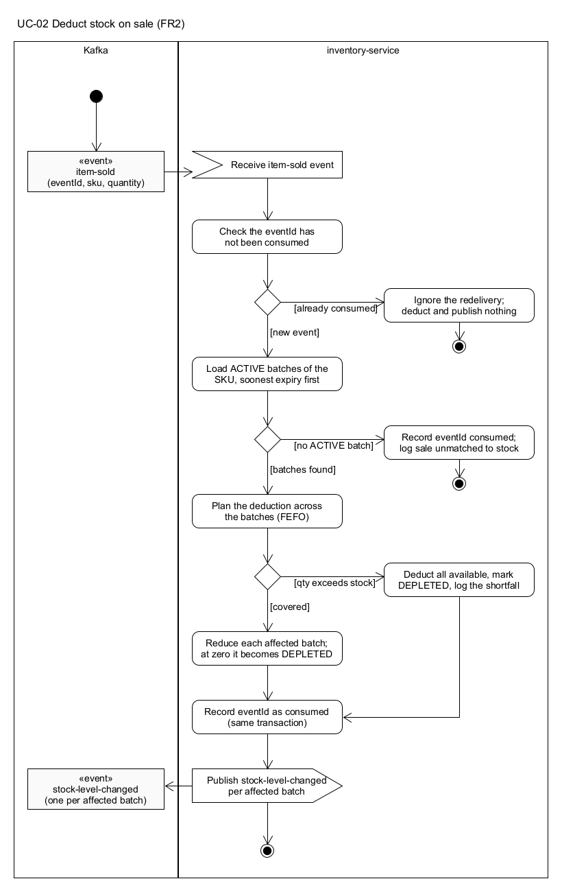
Figure 2.2: activity-UC-02

UC-03: Query stock position and remaining shelf life (FR4)
Actor | Shift supervisor; also the Markdown Decision Agent through its getBatchDetails tool
Relevance | O3, O4. Staff need to verify what the system tells them, and the agent needs the same facts
Preconditions | inventory-service is running
Trigger | The supervisor asks for a batch by identifier, or for all batches of a SKU

Main flow
- The shift supervisor requests a batch by its identifier.
- The system loads the batch.
- The system computes the remaining shelf life in whole hours from the current time to the expiry.
- The system returns the batch with its received and remaining quantities, expiry, unit cost, status and remaining shelf life.
Alternative flows
- 1a. The supervisor asks for a SKU instead: the system returns the ACTIVE batches of that SKU in soonest-expiry order, each with its remaining shelf life; an empty list means no active stock.
- 1b. The SKU parameter is missing or blank: the system answers 400.
- 2a. No batch has that identifier: the system answers 404.
Postconditions None; the query changes nothing and publishes nothing.
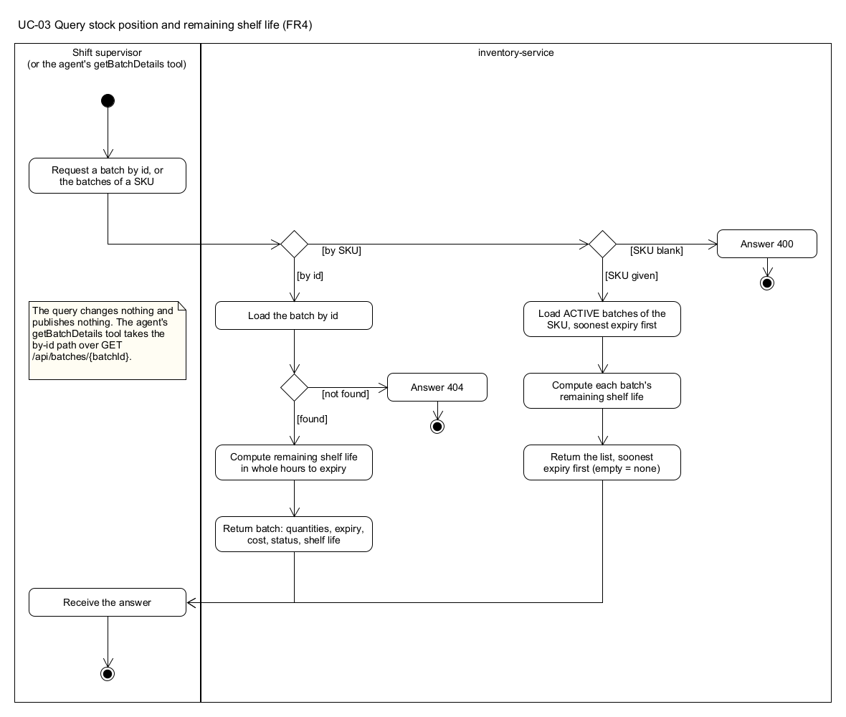
Figure 2.3: activity-UC-03

UC-04: Record a sale transaction (FR5)
Actor | Checkout operator (in practice the POS terminal, simulated by pos-simulator)
Relevance | O1, O3. Every downstream capability, from stock deduction to sell-through velocity, starts from a recorded sale
Preconditions | sales-service holds a price snapshot for each scanned SKU
Trigger | A basket is scanned at a till

Main flow
- The checkout operator submits the transaction: the till identifier, the time of sale, and one or more line items of SKU and quantity.
- The system checks that the till identifier is present and that there is at least one line item with a positive quantity.
- For each line item the system prices it (UC-05).
- The system sums the line totals into the transaction total.
- The system records the transaction with a new transaction identifier.
- The system publishes one item-sold event per line item, stamped with the producer-assigned time of sale.
- The system returns the recorded transaction with status 201.
Alternative flows
- 2a. The line-item list is empty: the system answers 400 EMPTY_LINE_ITEMS.
- 2b. A quantity is below one: the system answers 400 QUANTITY_NOT_POSITIVE.
- 3a. A SKU has no price snapshot: the system answers 400 UNKNOWN_SKU; no line is priced at zero and nothing is recorded.
- 1a. The time of sale is omitted: the system stamps the current time, never the broker's ingestion time.
Postconditions The transaction is stored; one item-sold event per line is on Kafka; inventory-service (UC-02) and insight-service (UC-09) react to it.
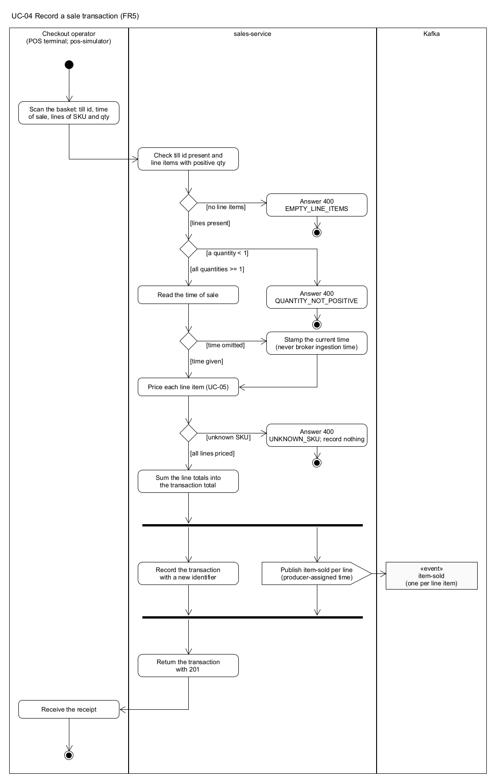
Figure 2.4: activity-UC-04

UC-05: Apply the price in force at the point of scan (FR6a, with FR6b)
Actor | sales-service, during UC-04
Relevance | O2. The till must charge the price the Pricing context authorised, and never a price it computed for itself
Preconditions | A price-rule-published event for the SKU has been consumed into the local price snapshot
Trigger | A line item is priced in UC-04

Main flow
- The system looks up the SKU in its local price snapshot, which is fed only by events from pricing-service.
- The system checks whether an activated markdown's promotion window contains the time of sale.
- No markdown is in force, so the system records the base price on the line with markdownApplied false.
Alternative flows
- 1a. The SKU is absent from the snapshot: UC-04 step 3a applies; the sale is refused rather than priced at zero.
- 2a. A markdown is in force at the time of sale (FR6b): the system records the discounted price carried on the markdown-applied event, with markdownApplied true.
- 2b. The markdown's window has ended: the base price is recorded; no further event is needed for the reversion.
Postconditions The line carries the price in force at the moment of scan; sales-service has made no synchronous call to pricing-service.
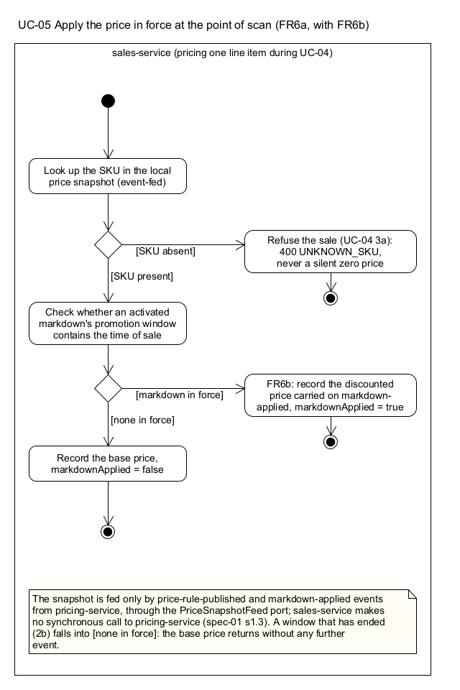
Figure 2.5: activity-UC-05

UC-06: Maintain price rules and margin floors (FR8)
Actor | Store owner
Relevance | O2. The margin floor is the business rule that constrains every markdown, including the agent's
Preconditions | pricing-service is running
Trigger | The owner creates or changes the rule for a SKU

Main flow
- The store owner submits, for a SKU, the base price, unit cost, category and margin floor ratio.
- The system checks that every field is present and that both money values are in the same currency.
- The system checks that the base price is not below the unit cost.
- The system checks that the margin floor ratio lies between 0 and 1.
- The system stores the rule, replacing any earlier rule for the SKU.
- The system publishes a price-rule-published event so sales-service's snapshot follows the change.
- The system returns the rule in force: 201 when created, 200 when replaced.
Alternative flows
- 2a. A field is missing or the currencies differ: the system answers 400 and stores nothing.
- 3a. The base price is below cost: the system answers 400 BASE_PRICE_BELOW_COST.
- 4a. The ratio is out of range: the system answers 400 MARGIN_FLOOR_OUT_OF_RANGE.
- 1a. The owner only reads the rule: the system returns the rule with its margin floor, the effective price, and the active discount tier if a markdown is in force.
Postconditions The rule is stored in pricing-service alone; sales-service learns of it only through the published event.
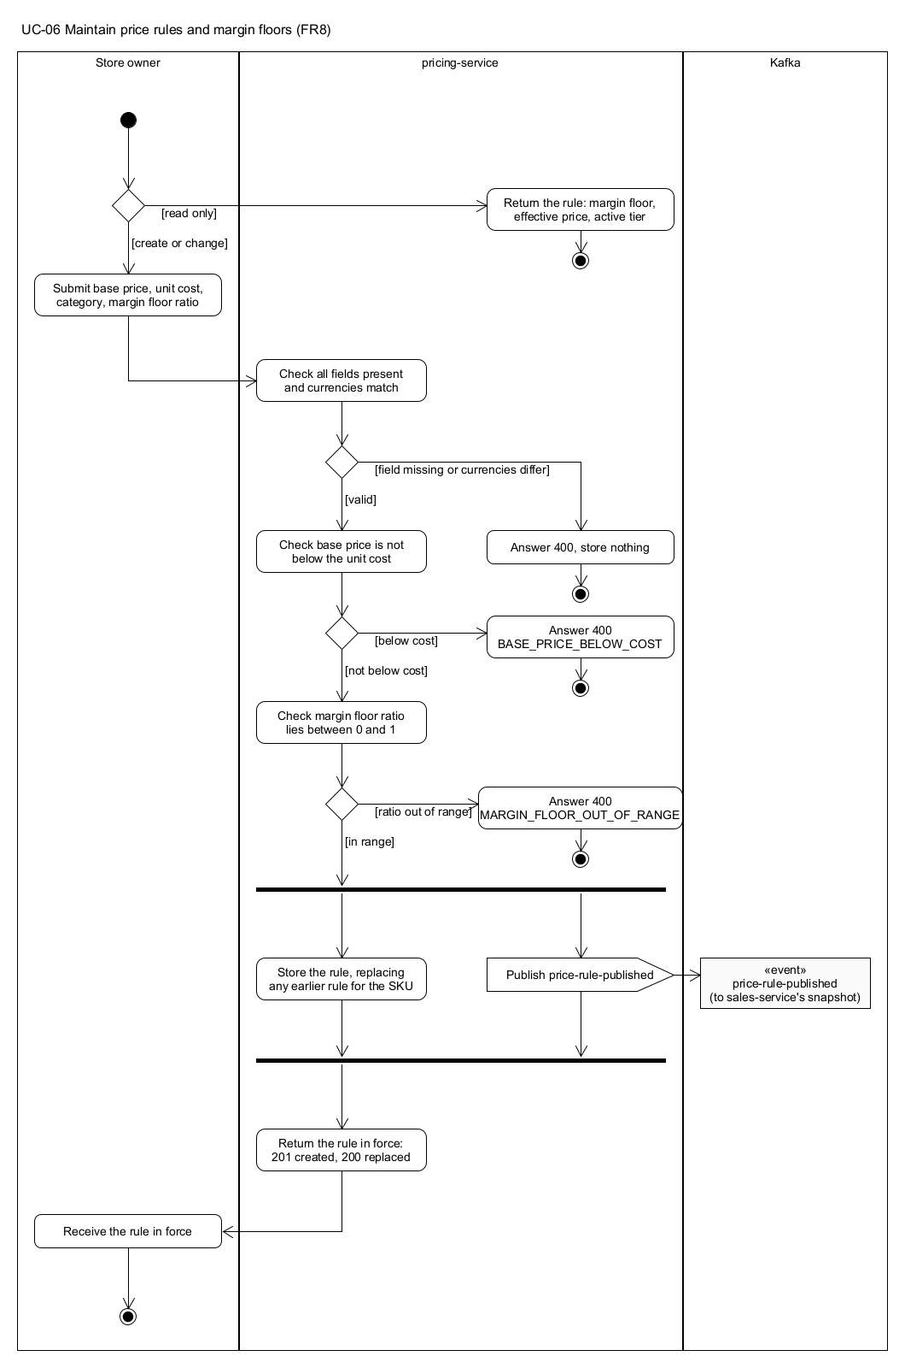
Figure 2.6: activity-UC-06

UC-07: Create and activate a markdown plan (FR9)
Actor | Shift supervisor (origin HUMAN) or the Markdown Decision Agent through its markdown-recommended event (origin AGENT)
Relevance | O1, O2. A markdown clears stock before expiry, and only takes effect at the till once the Pricing context has activated it
Preconditions | A price rule exists for the SKU (UC-06)
Trigger | A markdown is proposed for a batch at a discount tier with a promotion window

Main flow
- The proposer submits the batch, SKU, discount tier, promotion window, origin and rationale.
- The system checks that every field is present, that the tier is one of the four, and that the window ends after it starts.
- The system loads the price rule for the SKU.
- The system asks the margin floor policy to assess the tier against the rule (UC-08).
- The assessment passes, so the plan becomes ACTIVE with the discounted price the policy computed.
- The system stores the plan.
- The system publishes a markdown-applied event carrying the plan, its window and the discounted price.
- The system returns the ACTIVE plan with status 201.
Alternative flows
- 2a. A field is missing or the window is inverted: the system answers 400 and stores nothing.
- 3a. No price rule exists for the SKU: the system answers 404; there is no floor to check against.
- 5a. The assessment is breached: UC-08 takes over; the plan is stored as REJECTED and the system answers 422.
- 1a. The proposal arrives as a markdown-recommended event: the same steps run with origin AGENT and the agent's trace identifier attached; the outcome is a stored plan rather than an HTTP answer, and a redelivered event with a trace identifier already seen is ignored.
Postconditions An ACTIVE plan exists; sales-service applies the discounted price at the next scan inside the window (UC-05); the price query shows the active tier (UC-06).
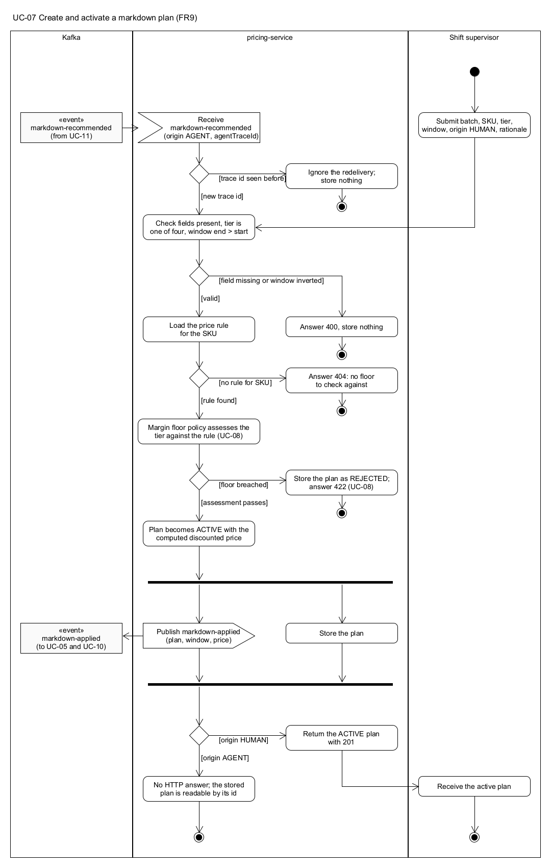
Figure 2.7: activity-UC-07

UC-08: Reject a markdown that breaches the margin floor (FR11)
Actor | pricing-service's domain layer, on behalf of the store owner; the proposer may be a person or the agent
Relevance | O2, O4. This is the rule that makes the agent safe to run: an LLM may propose, but a deterministic rule decides, and the refusal is kept
Preconditions | UC-07 has reached its assessment step
Trigger | A discount tier is assessed against a price rule

Main flow
- The margin floor policy computes the resulting price: the base price reduced by the tier's percentage, rounded to cents.
- The policy computes the resulting margin ratio: the resulting price less the unit cost, divided by the resulting price.
- The policy compares the ratio with the SKU's margin floor.
- The ratio is below the floor, so the plan records itself REJECTED with a reason naming the tier, the resulting margin and the floor.
- The system stores the rejected plan.
- The system answers 422 with the machine-readable rejection: the SKU, requested tier, resulting price, unit cost, resulting margin ratio and the floor.
Alternative flows
- 3a. The ratio is at or above the floor: the assessment passes and UC-07 continues at its step 5.
- 1a. The proposal came from the agent: steps 1 to 5 are identical; there is no HTTP answer, and the rejected plan is the auditable record of what the agent asked for and why it was refused.
Postconditions No price changed; no markdown-applied event was published; the rejected plan can be read back by its identifier.
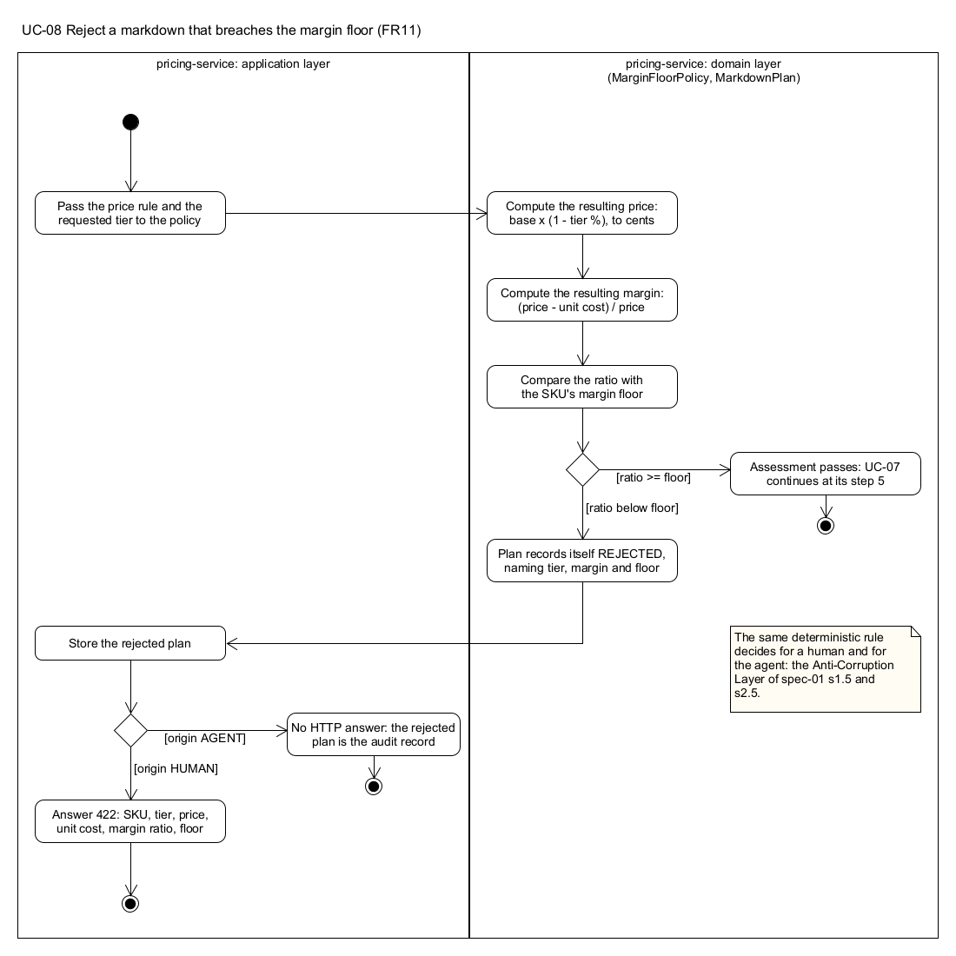
Figure 2.8: activity-UC-08

UC-09: Observe the rolling sell-through velocity of a SKU (FR12, real-time analysis)
Actor | Shift supervisor; also the Markdown Decision Agent through its getSellThroughRate tool
Relevance | O1, O3. Whether a batch will clear depends on how fast it is selling now, compared with normal
Preconditions | insight-service's stream topology is running against Kafka; a velocity baseline has been seeded for the SKU
Trigger | item-sold events arrive; a supervisor asks for the current velocity

Main flow
- The system consumes each item-sold event and assigns it to time windows by the producer's occurredAt, never by the time Kafka received it.
- The system groups events by SKU and sums the quantity sold in each hopping window (60 seconds wide, advancing every 5 seconds in the demonstration configuration).
- The system joins the windowed total with the SKU's baseline velocity held in a table.
- The system keeps the latest fully elapsed window per SKU in a queryable state store, with the velocity per hour and its ratio to the baseline.
- The supervisor requests the velocity for a SKU, and the system answers from the state store with the window bounds, quantity sold, velocity and ratio.
Alternative flows
- 5a. No window has closed for the SKU yet, or the last one has aged out of retention: the system answers 404.
- 1a. An event arrives late but inside the grace period: it is counted in the window its occurredAt belongs to.
Postconditions None beyond the state store; the query is read-only. Each window closing also triggers UC-10 for the SKU's batches.
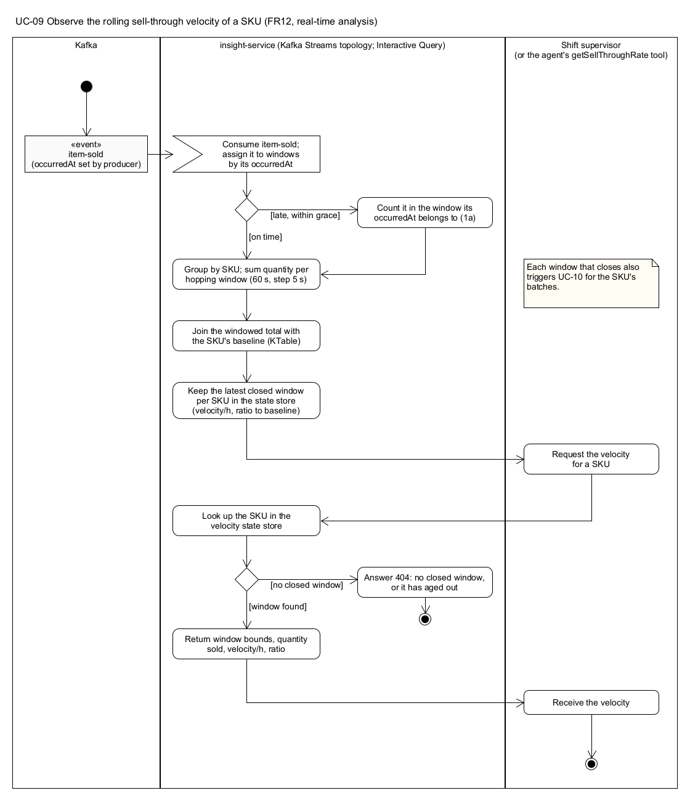
Figure 2.9: activity-UC-09

UC-10: Detect a batch at risk of expiring unsold (FR13, real-time analysis)
Actor | insight-service's stream topology; the shift supervisor reads the result
Relevance | O1, O3. This is the moment the system turns data into a decision prompt: which batches need attention now
Preconditions | UC-09 is producing velocities; batch-received and stock-level-changed events have built the batch-state table
Trigger | A velocity window closes for a SKU

Main flow
- The system maintains a table of live batch state per SKU from batch-received and stock-level-changed.
- When a velocity window closes, the system joins the velocity with every ACTIVE batch of that SKU.
- For each batch the risk policy projects the sales until expiry: velocity per hour multiplied by the trading hours remaining.
- The policy computes the projected shortfall: remaining quantity less projected sales.
- The shortfall exceeds the threshold, the batch has stock left, and it has not yet expired, so the batch is marked at risk in the risk view.
- On the transition into risk the system publishes a sell-through-risk-detected event, which triggers UC-11.
- The supervisor lists current risks and the system returns them, largest shortfall first.
Alternative flows
- 5a. The shortfall is within the threshold: the batch is recorded as not at risk and no event is published.
- 5b. The batch has already expired: it is not a risk the system can act on; it is left to write-off and no event is published.
- 2a. The SKU has stopped selling entirely: no window closes, so the batch is not re-assessed. This is known limitation G-4 and is stated in the report.
Postconditions The risk view reflects the latest assessment; at most one trigger event per transition into risk.
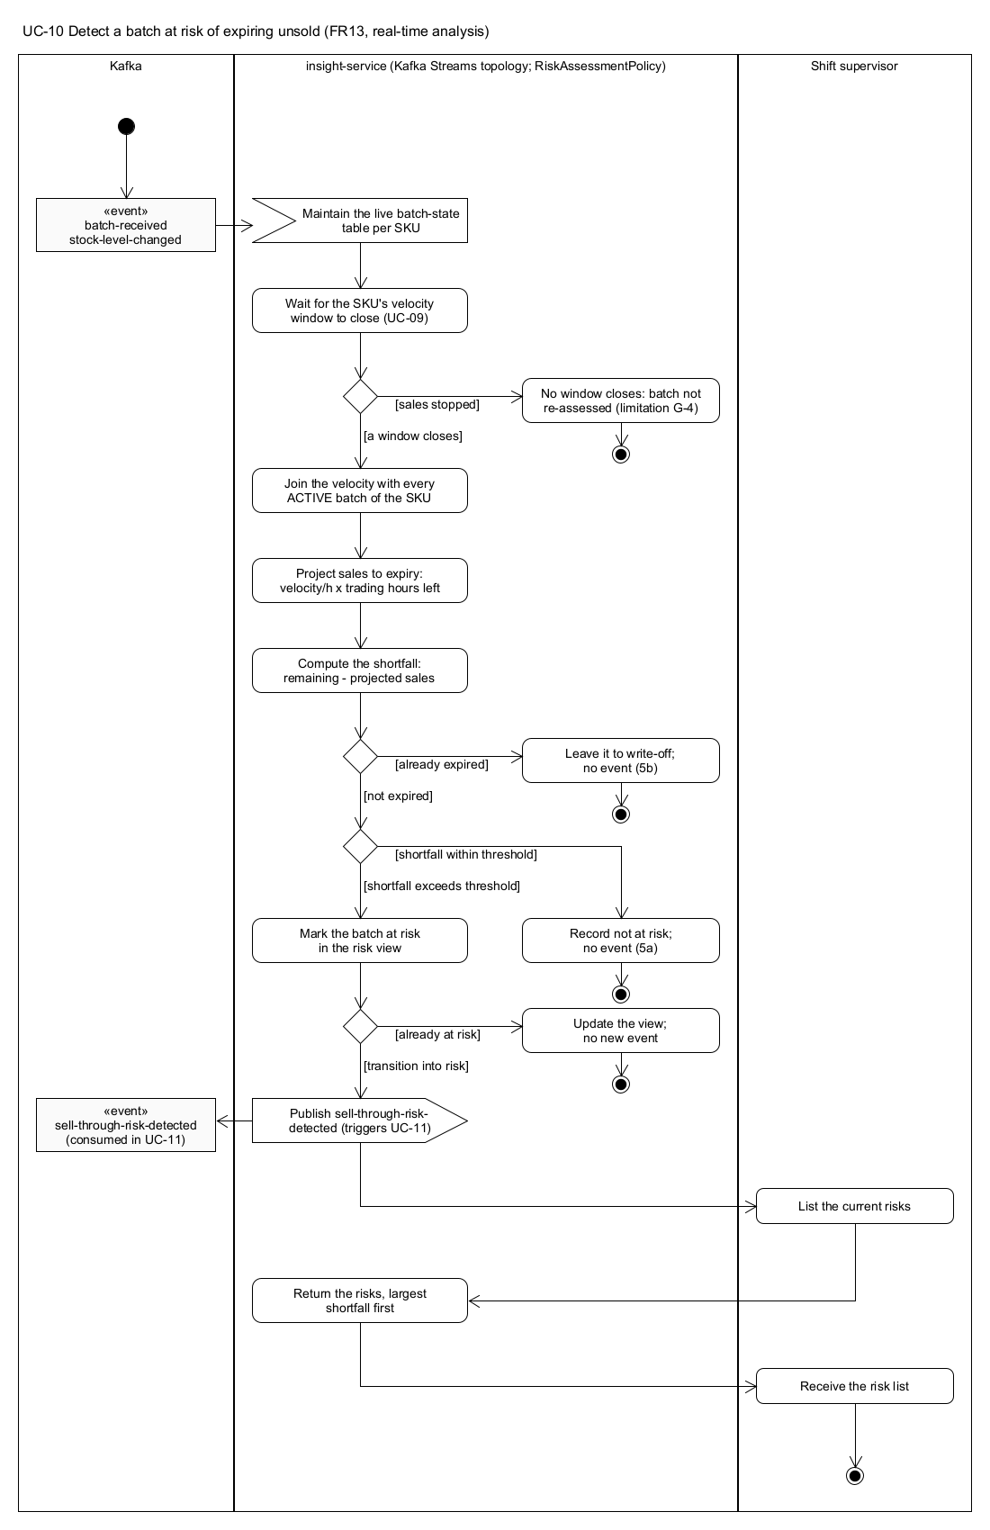
Figure 2.10: activity-UC-10

UC-11: Recommend a markdown for an at-risk batch (FR14, agentic AI)
Actor | Markdown Decision Agent; the shift supervisor and auditor read its trace
Relevance | O1, O2, O3, O4. The agent gathers evidence and proposes; it never sets a price, so O2 is protected by UC-08 and not by the prompt
Preconditions | An LLM API key and model are configured for insight-service; inventory-service is reachable for the batch lookup
Trigger | A sell-through-risk-detected event arrives

Main flow
- The system receives the trigger and checks that its event identifier has not been deliberated before.
- The orchestrator hands the trigger to the agent with three tools: getBatchDetails, getSellThroughRate and proposeMarkdown.
- The agent calls getBatchDetails for the flagged batch and receives its remaining quantity, expiry and unit cost over a synchronous request to inventory-service.
- The agent calls getSellThroughRate for the SKU and receives the current velocity and baseline ratio.
- The agent calls proposeMarkdown once, naming the flagged batch, a discount tier, a start time and a one or two sentence rationale citing the numbers it saw.
- The orchestrator checks that the proposal names the flagged batch and no other.
- The orchestrator derives the end of the promotion window from the batch's expiry.
- The orchestrator persists the trace: every tool call in order with its arguments and result, the final recommendation and the rationale.
- The orchestrator publishes a markdown-recommended event, which pricing-service consumes in UC-07.
Alternative flows
- 1a. The trigger was deliberated before (a redelivery): nothing is deliberated and nothing is published.
- 5a. The agent decides no markdown is warranted and says why: the trace is persisted with NO_MARKDOWN and nothing is published.
- 6a. The proposal names a different batch: the orchestrator refuses it, records the trace as declined, and publishes nothing (ruling R7).
- 7a. The batch cannot be resolved to derive the window: the trace records PROPOSED_BUT_UNRESOLVABLE and nothing is published (ruling R9).
- 2a. A tool answers with an error: the agent reads it, corrects its call and tries again, within a bounded number of steps.
- Pre. No LLM is configured: the trigger is logged as not deliberated and dropped; the service keeps serving UC-09 and UC-10.
Postconditions An auditable trace exists and is readable at GET /api/insight/agent-traces/{id}; at most one recommendation per trigger has reached pricing-service.
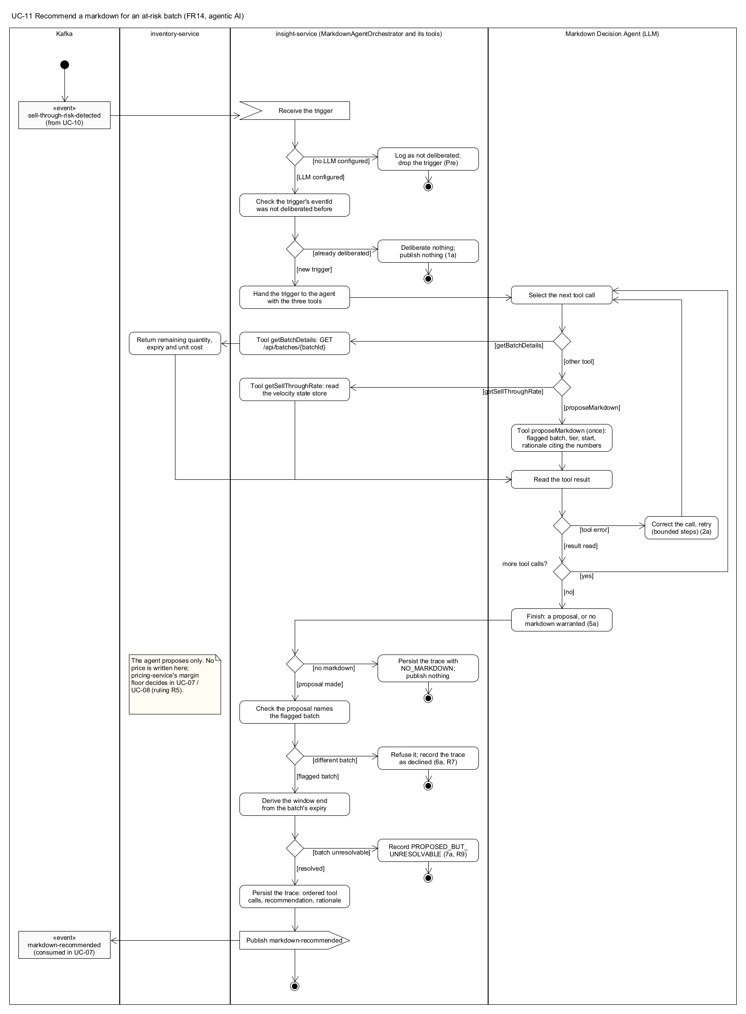
Figure 2.11: activity-UC-11

UC-12: Produce the end-of-day briefing (FR15, agentic AI)
Actor | Store owner; the Briefing Agent does the work
Relevance | O5, O4. The owner reviews the day in plain language, and the briefing can be checked against the evidence it was written from
Preconditions | An LLM API key and model are configured for insight-service
Trigger | The owner asks for the briefing for a business date (today by default)

Main flow
- The store owner requests a briefing, optionally naming the business date.
- The orchestrator hands the request to the briefing agent with three read-only tools: listCurrentRisks, listRecommendations for the date, and getSellThroughRate for any SKU.
- The agent calls listCurrentRisks and receives the batches currently at risk.
- The agent calls listRecommendations and receives the markdown recommendations made that day with their outcomes.
- The agent may call getSellThroughRate for SKUs it wants to comment on.
- The agent writes a short plain-language summary of what was marked down, what is selling through, and what is still at risk, stating that write-off figures are not available because write-offs are not recorded.
- The orchestrator counts the risks and recommendations from the tool results itself, so the numbers in the response do not depend on the model's text.
- The orchestrator persists the briefing with its ordered tool calls.
- The system returns the briefing with status 201.
Alternative flows
- Pre. No LLM is configured: the system answers 503 AGENT_NOT_CONFIGURED.
- 3a. There are no risks and no recommendations: the agent says the day needed no markdown action; the counts are zero.
- 1a. The owner later asks for a stored briefing by its identifier: the system returns it with its tool calls, or 404.
Postconditions A briefing with its evidence is stored and readable; nothing in any other context has changed.

Deliberately out of scope
FR3 (write off an expired batch), FR6b's markdown-expired consumption, FR7 (transaction history) and FR10 (automatic markdown expiry) are specified in spec-02 and were not built. They would add reporting and housekeeping rather than demonstrate a further architectural pattern, and the time went to the twelve above. Their absence is stated where it matters: UC-12 says that waste figures are unavailable, and UC-05 reverts to the base price at the end of a promotion window without needing FR10's event.
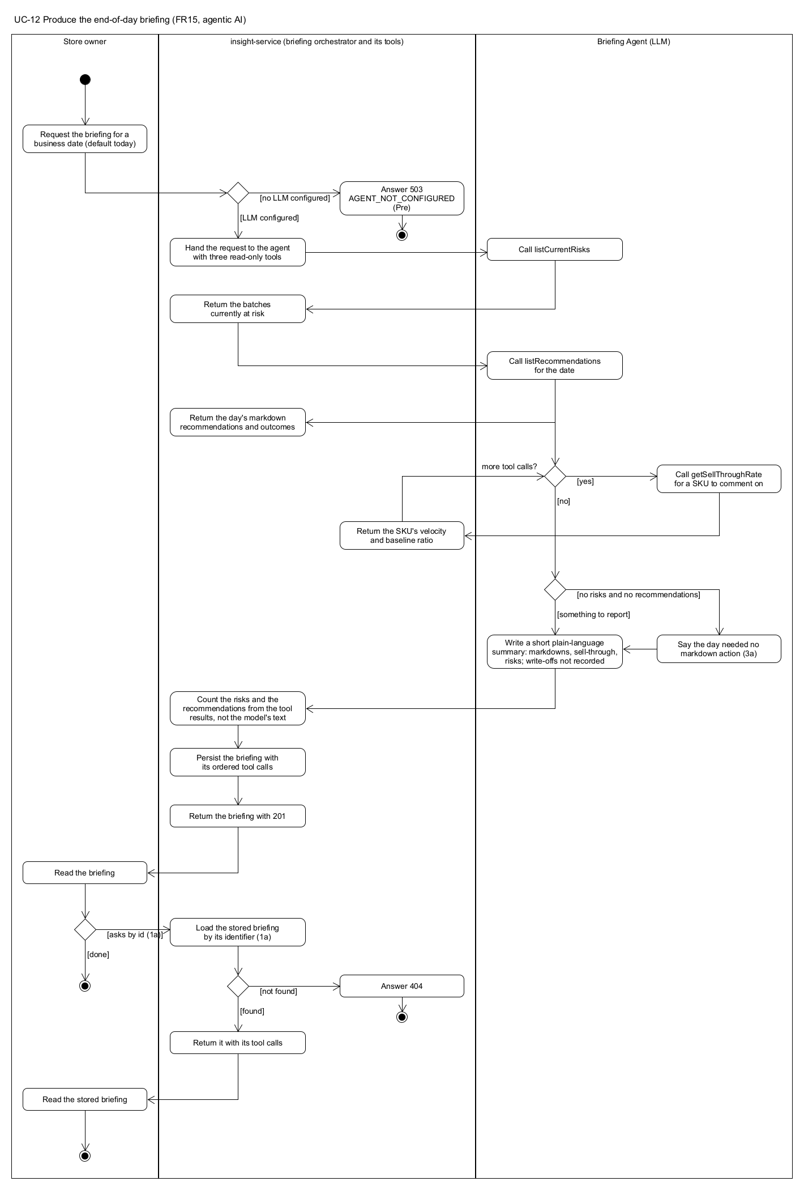
Figure 2.12: activity-UC-12

Appendix B. Figures
Figure | File | Section
2.1 to 2.12 | docs/diagrams/activity-UC-01.png to activity-UC-12.png | 2.1
2.13 | docs/diagrams/domain-model.png | 2.4
3.1 | docs/diagrams/microservice-architecture.png (UMLet; supersedes the draw.io A2 of 10 September) | 3.1
3.2 | docs/diagrams/event-flow.png | 3.1, 3.5
3.3 | docs/diagrams/context-map.png | 3.1, 2.4
3.4 | docs/diagrams/layered-architecture.png | 3.2
3.5 | docs/diagrams/layered-architecture-all-services.png | 3.2
3.6 | docs/diagrams/database-design.png | 3.4

