The SineWave Company
Design Specification
Currency Project

Document ID: N/A
Version: 0.0
Dated: 04-29-2009

Status: IN PROGRESS REVIEWED  APPROVED

Approval
Acrobat file with signatures ->

Core Product Team | Name | Approval Signature | Date
Chief Technology Officer
Product Manager
Development Manager
Development Lead

Table of Contents
1. Overview 3
1.1 Document Purpose and Target Audience 3
1.2 Requirements Mapping – required<Need Requirements Specification Doc> 3
1.3 Reference Documents 4
1.4 Terms and Definitions 4
2. Design and Architecture 5
2.1 Overall System Design 5
2.2 Initiative Design 5
2.2.1 Component Design 6
2.2.1.1 Region Money Module 6
2.2.1.1.1 Detail Design 6
2.2.1.1.2 Install Instruction 7
2.2.1.2 Money Web Component 7
2.2.1.2.1 Precompile an ASP.NET Web site for deployment 7
Step2: 8
2.2.1.3 MoneyServer Component 8
2.2.1.3.1 Abstract Class View 11
2.2.1.3.2 Utility Class Description 11
Errors Handling 11
3. Test Ability 11
3.1 Algorithm Validity 11
3.2 Performance 11
3.3 Quality Assurance 11
4. Tradeoffs - if applicable 11
5. Risk Factors 11
Prototyping 12

Status: IN PROGRESS/ REVIEWED / APPROVAL
Document Revision History
Version | Date | Author | Status | Revision Comments
0.0 | 02-26-2009 | Korey Wan | IN PROGRESS | Initial draft
0.0 | 04-29-2009 | Korey Wan, Jed Zhu,  Leon Zhu | IN PROGRESS | Add install instructions for money module, money server and money web components.

Overview
The Goal for This project is to add real-time currency system in OpenSim platform. For this purpose, we have to change current money module in OpenSim which is just sample code for now, and build up another server, money server, to manage the currency system.
Both of the functional features and security features will be taken into consideration. This document has listed all of these features mapped them to interfaces description of money module and money server. Also the technical design sections for each feature are appended after the map.

Document Purpose and Target Audience
TODO: e.g. this document is intended to help developers to understand the design specification and architecture of xxxx xxx project. It defined the implementation of the requirements with design details which will give project developers guidelines for implementation.

Requirements Mapping – required<Need Requirements Specification Doc>
<Required><This section maps the specific requirements being addressed with the section that contains the design details. Each entry in the table below must contain the requirement number and title from the requirements document, and the section number from this document that gives the design details for the requirement. Each entry must also contain a status indicator>

Status Indicators
- IN – This requirement will be implemented in this release.
- OUT – This requirement will not be implemented in this release, but may in a future release.

Functional Requirement |  | Status  (See Above) | Design  Section
Number | Title | Status  (See Above) | Design  Section
MM_001 | Get the balance from Money Server for specific user account. | IN
MM_002 | Push the pay to Money Server for specific user account. | IN
MM_003 | Retrieve Economy Data from configurable opensim.ini. | IN
MM_004 | Implement the handler to deal with the Economy Data request from client. | IN
MM_005 | Implement the handler to deal with the Pay Price request from client. | IN
MM_006 | Implement the handler to deal with the Logout/Closed event from client. | IN
MM_007 | Implement the handler to deal with the Money Balance Request from client. | IN
MM_008 | Implement the handler to deal with the Object Buy Request from client. | IN
MS_001 | Implement the handler to deal with the Object Buy Request from client. | IN
MS_002 | The database used in Money Server should be MySQL using InnoDB tables. | IN
MS_003 | Money Server should have primary index for each user in one single grid server. | IN
MS_004 | Money Server at least should have two basic tables. One is used to record balance for user account. The other records the transactions information for user. | IN
MS_005 | Money Server has a web based admin tool to manager user account. | IN
MS_006 | Money Server has a web based user tool to visit account information for specific user. | OUT
MS_007 | Money Server has a web based login system to differentiate users and administrators. | OUT

Security Requirement |  | Status  (See Above) | Design  Section
Number | Title | Status  (See Above) | Design  Section
S_001 | For each transaction, the SessionID and SecureSesionIDs will be match with specific user. | IN
S_002 | Hold currency transaction and provide a secure link based on SSL to user for confirm. | OUT
S_003 | The confirm link should include the necessary information about current transaction. And these fields can be configured in Money Server side. | IN
S_004 | The event “Money” will be fired once the confirm link is clicked by specific user. | IN

Reference Documents
Document | Location

Terms and Definitions
Term | Definition

Design and Architecture

Overall System Design
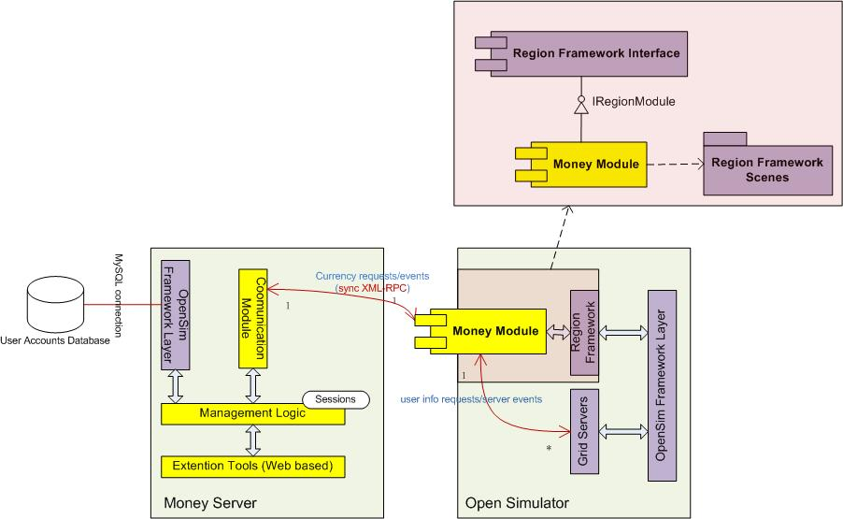

Initiative Design
TODO: The overall design for current project in component level. It provides detailed explanation for how many components in the project and what their functionalities are.

Component Design

Region Money Module

Detail Design
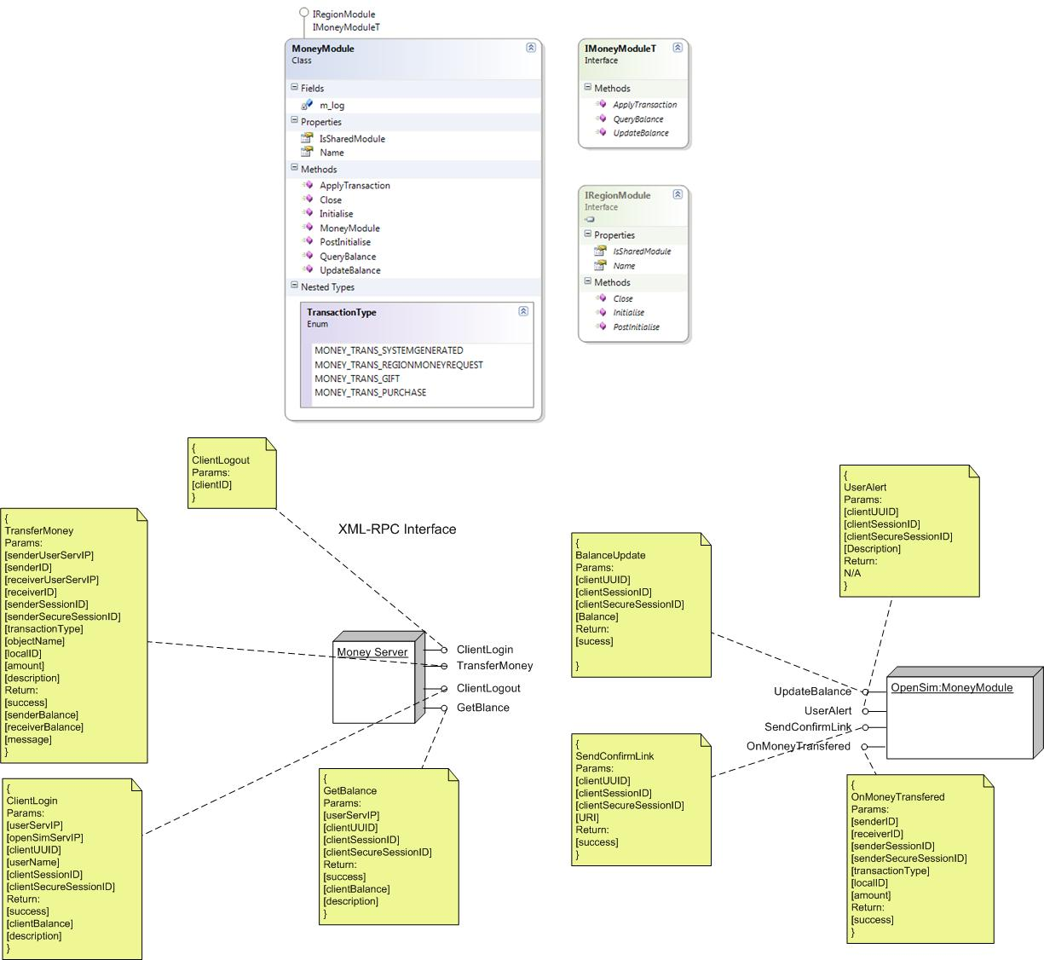

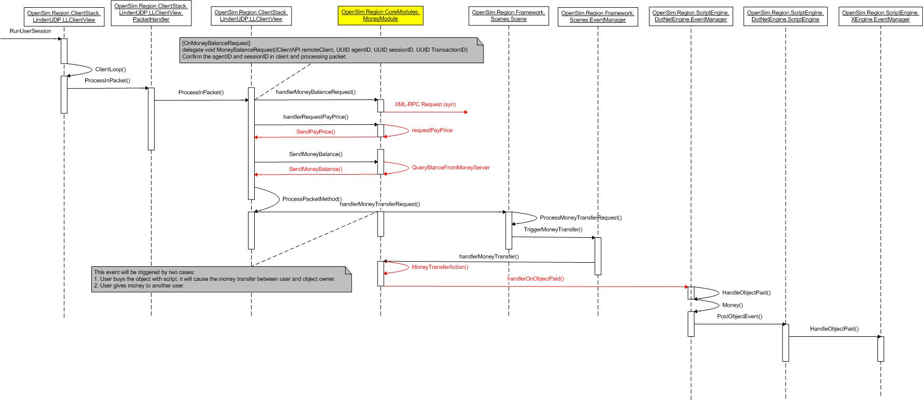

Install Instruction
- Download the currency project from http://forge.opensimulator.org/svn/currency
- Get the binary (OpenSim.Forge.Currency.dll) in folder “\trunk\source\bin\”. Also you could start the VS2008 solution to build the binary files by yourself.
- Copy the OpenSim.Forge.Currency.dll to your open simulator binary folder. OpenSim.Forge.Currency.dll has to work with
OpenMetaverse.dll, OpenMetaversType.dll, Opensim.Framework.dll, Opensim.Framework.Communications.dll, OpenSim.Framework.Servers.dll, OpenSim.Region.Framework.dll, log4net.dll, Nini.dll, XMLRPC.dll
- Modify your opensim.ini file with the [Economy] section as following:
[Economy]
; These economy values get used in the BetaGridLikeMoneyModule. - This module is for demonstration only -
; In grid mode, use this currency XMLRPC server. Leave blank for normal functionality
CurrencyServer = "https://your money server IP:8008"
; Uncomment this if one functional economy module is available.
; Otherwise, the legacy "SampleMoneyModule" will be chosen.
EconomyModule = DTLMoneyModule

- Make sure the URI of money server is available.
- Start your opensim servers and you can find the output information in region server console as “The SampleMoneyModule is disabled. The DTLMoneyModule is used for currency.”
- If the money module has loaded successfully and connected with the money server, use client to connect the opensim server and perform transaction.

Money Web Component

2.2.1.2.1 Precompile an ASP.NET Web site for deployment
Step1:
1) Open a command window and navigate to the folder containing the .NET Framework.
The .NET Framework is installed in the following location.

%windir%\Microsoft.NET\Framework\version

2) Run the aspnet_compiler command by typing the following at a command prompt, specifying the source as either a virtual path or physical path and the target folder for the compiled Web site.

aspnet_compiler -v virtualPath targetPath

If your Web site is not an Internet Information Services (IIS) application and therefore has no entry in the IIS metabase, used the following value for the -v switch.

aspnet_compiler -p physicalOrRelativePath -v / targetPath

In this case, the physicalOrRelativePath parameter refers to the fully qualified directory path in which the Web site files are located, or a path relative to the current directory. The period (.) operator is allowed in the physicalOrRelativePath parameter. The -v switch specifies a root that the compiler will use to resolve application-root references (for example, with the tilde (~) operator). When you specify the value of / for the -v switch the compiler will resolve the paths using the physical path as the root.
The targetPath parameter is a physical path to the destination directory

Step2:
1) Open a command window and navigate to the folder containing the .NET Framework.
The .NET Framework is installed in the following location.

%windir%\Microsoft.NET\Framework\version

2) Run the aspnet_compiler command by typing the following at a command prompt, specifying the source as either a virtual path or physical path, the target folder for the compiled Web site, and the -u switch indicating you want to compile the site for deployment and update.

aspnet_compiler -p physicalOrRelativePath -v / targetPath –u
3) Set up MoneyServerWeb on IIS with ssl support. About how to do this,please visit the following URL for more information. http://learn.iis.net/page.aspx/144/how-to-setup-ssl-on-iis-7

MoneyServer Component
2.2.1.1.1 How to install money server
2.2.1.1.1.1 Overview
There are two projects need to be set up. One is MoneyServer handling the core functions, the other is MoneyServerWeb handling the confirm link. They can be installed on separate servers.

2.2.1.1.1.2 SOP for the installation
Step 1:
Get the binary (MoneyServer.exe) in folder “\trunk\source\bin\”. Also you could start the VS2008 solution to build the binary files by yourself.

Step 2:
a) Set up MoneyServerWeb on IIS with ssl support. About how to do this,please visit the following URL for more information.
http://learn.iis.net/page.aspx/144/how-to-setup-ssl-on-iis-7

b) Open web.config and search the following section
<appSettings>
<add key="MoneyServerURI" value="https://192.168.0.106:8008"/>
</appSettings>
The https link is the money server URI.The ip address is the server ip where you run moneyserver.exe
Please change it to your own.

c) After finishing this,please make sure that you can visit the confirm page via https://xxxxx/confirm.aspx

Step 3:
Edit moneyserver.ini and launch MoneyServer
Here is a sample of the configuration file.
[MySql]

hostname=localhost

database=OpenSim

username=root

password=123

pooling=false

port=3306

;Max DB connections kept by money server.

MaxConnection = 15

[MoneyServer]

;The confirm link which will be sent to buyer inworld when a transaction starts.
;It should correspond to the MoneyServerWeb URL in step 2.

ConfirmURL = https://192.168.0.106/confirm.aspx

;If the user is not found in database,he/she will be created with the default balance.

DefaultBalance = 1000

;The transaction will be expired after a period of time if user does not click the confirm link.
;The measurement is second
ExpiredTime = 120
          - FAQ
Question 1:
Why does money server throw out exception of “System.IO.FileNotFoundException”?
Answer: Check if all of the dependencies have been copied to the start up folder of moneyserver.exe
Dependencies:
Fadd.dll
Fadd.Globalization.Yaml.dll
HttpServer.dll
HttpServer_OpenSim.dll
HttpServer_OpenSim.xml
log4net.dll
MoneyServer.ini
Mysql.Data.dll
Nini.dll
OpenMetaverseTypes.dll
OpenSim.Data.dll
OpenSim.Framework.Console.dll
OpenSim.Framework.dll
OpenSim.Framework.Servers.dll
OpenSim.Framework.Statistics.dll
OpenSim.Grid.Framework.dll
OpenSim.Grid.MoneyServer.exe.config
SineWaveCert.pfx
XMLRPC.dll

Abstract Class View
TODO: The independent section for designer to describe the pattern design and abstract class structure. It focuses on the ideal of the design for current component.

Utility Class Description
TODO: The independent section for designer to describe concrete class structure. It focuses on the implementation of the design for current component.

Errors Handling
TODO: List the error handling strategy for each component or class. Moreover, for the interface of each component, the list of error code or exception object description will be necessary here.

Test Ability

Algorithm Validity
TODO: Describe the way to validate the algorithm existed in components.

Performance
TODO: Describe the performance test approach and result. (The result is based on unit test period)
- CPU bench mark

Quality Assurance
TODO: The working approach of QA engineer. Or refer to the documents from QA team.

Tradeoffs - if applicable
<This section outlines the different design tradeoffs made for this initiative, for example what could be simplified and how if the specifications were less stringent, discussion of feature cost .vs. value, and dependencies on legacy design that may prevent a better implementation of a feature .vs. refactoring of the legacy design. >

Risk Factors
TODO: List the risk factors from development perspective including limitation or unfixed bug in current design.

Prototyping
TODO: Prototype reference mapping.

