**QUESTIONS – SECOND WEEK**

**1. PANDAS ---- > Can you explain how to merge two dataframe based on inner,outer,left,right value? Examples are given below. I understand how to do it if one key is given but It did not make sense with key1 and key2 together.**

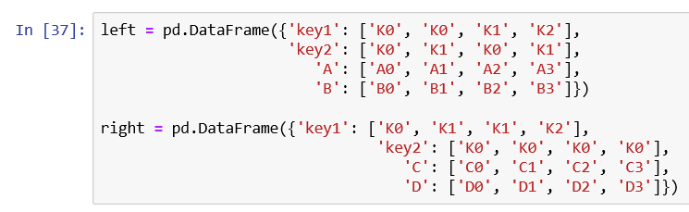

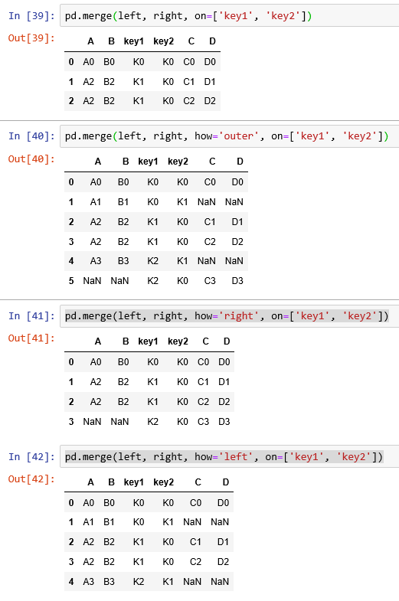



**2. What are the most essential tools for data scientist in daily work life and interview process? I want to prioritize the essential tools and work on them much. You mention about SQL in last office hour. Would it be better if I start to specialize on it now? What do you think about Tableu, and excel?**

**3. Could you please help me understand better some codes on Raymond Hettinger’s Python video? I put code lines below to show which ones I have struggle to figure out. I will send the pdf via email.**

**# Custom sort order: Line 25,26,34,32**

**# Call a function until a sentinel value: line 35,37,38**

**#Distinguishing multiple exit points in loops: line 39,40,41**

**#Looping over a dictionary keys and values: line 15**

**#Construct a dict from pairs: line 20**

**#defaultdict(): line 31,44**

**#Linking dictionaries: line 47,48,50**

**#Simultaneous state updates: line 66,67**

**#Updating sequences: line 90**

**# Using decorators to factor-out administrative logic:line 93,94,95**

**#Factor-out temporary context: line 96,97**

**4. What do you think about interview questions in SPRINGBOARD Chapter 4 Interview questions about Python Stack? What other interview questions may we face? I emailed also this document for you to review in case you can’t reach.**