**Web Deploy**

The purpose of this repo is to house the Code to be used for technical screen of DevOps candidates

1. Demonstrate three instances of this website running
2. Demonstrate procedures for deploying an updated change to the instances from #1
3. Provide code as a pull request to this repo
4. Solutions can be in the language of your choice
5. Technology of your choice

**Demonstrate three instances of this website running**

* Created a 3 Web Instances using AWS portal
* Created a RHEL Linux Machine through Portal by giving configuration details as necessary

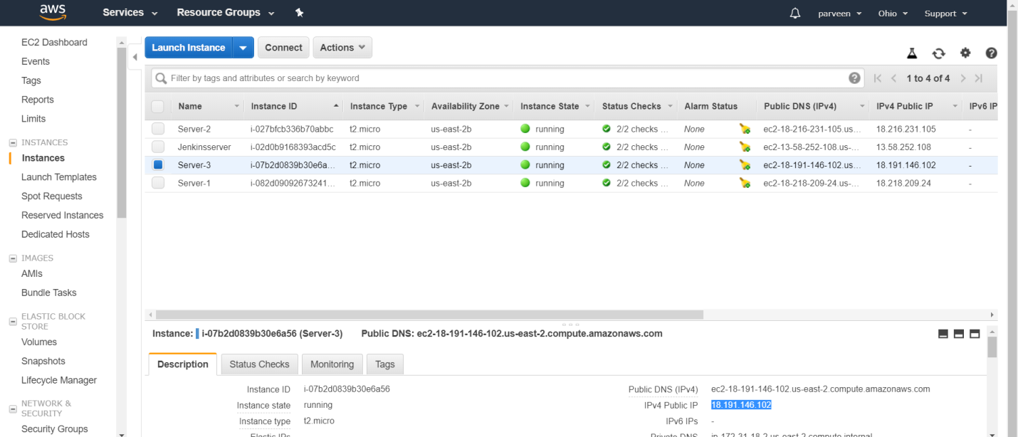

* Server1- 18.218.209.24
* Server2- 18.216.231.105
* Server3- 18.191.146.102
* Created another instance which is Jenkins Server and installed git and ansible to complete 2 and 3 steps
* Logged into the Jenkins Server using Putty and used the following commands to install Ansible and Git
* yum update –y
* yum install ansible* -y
* ansible all -i myserver.com, -m ping
* ansible all -i localhost -m ping
* ansible –version
* yum install git

Created git.sh to clone the git repo from the github in the server. The location is /root/test-app/

After installing Ansible configured its hosts with respective IP address and checked if I am able to ping them successfully

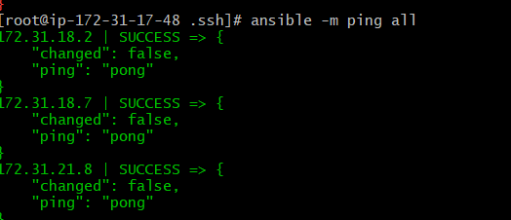

* created hosts file and /etc/ansible/roles/httpd/tasks/main.yaml
* Created playbooks with apache.yml.
* The playbook apache.yml ,hosts and main.yml file are attached for reference



This file contains the data to configure the servers

 This file contains the permissions or tasks for the web serevers

 This shell script consists of the file to clone the repository

- contains the list of IP address

Output executed when running a apache.yml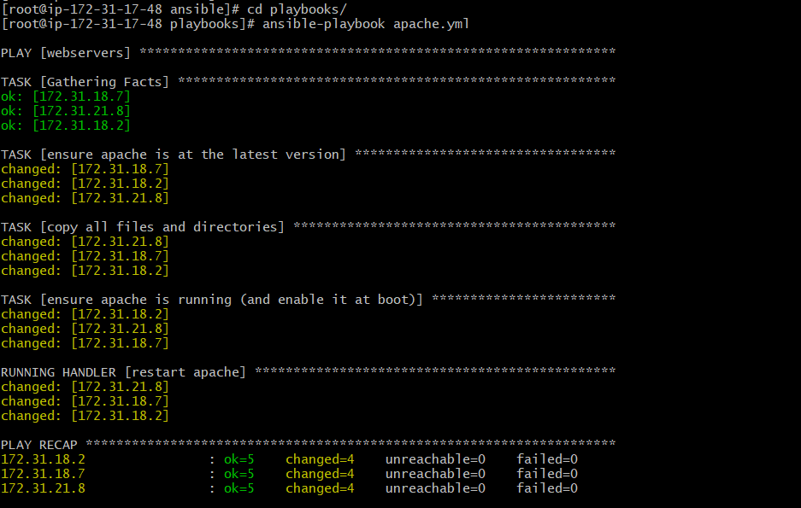

Server 1 – Output of instance 1

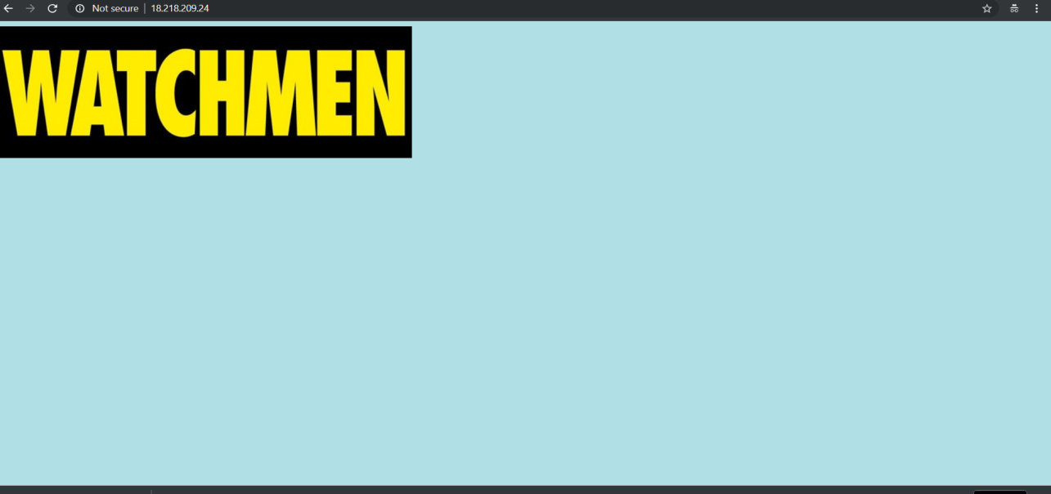

Server2 – output of instance 2

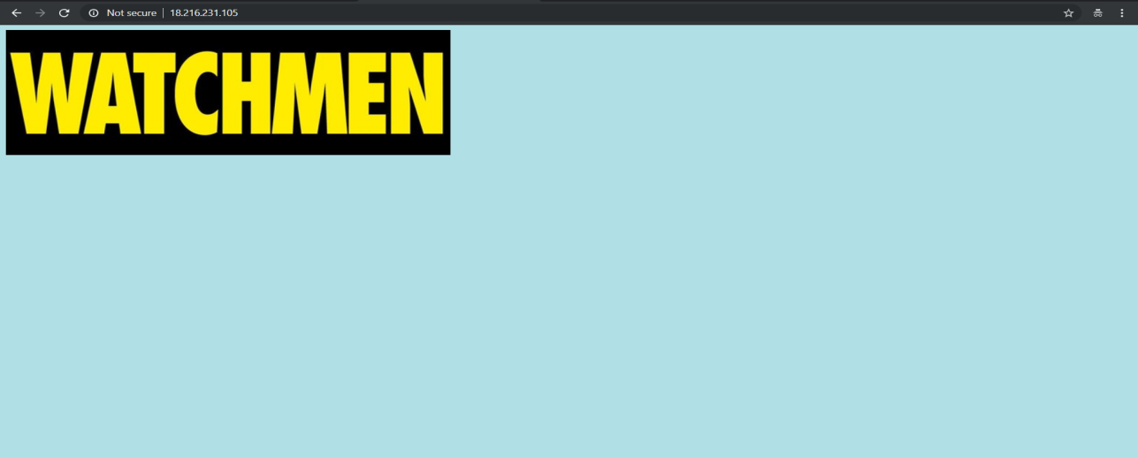

Server 3- output of instance 3

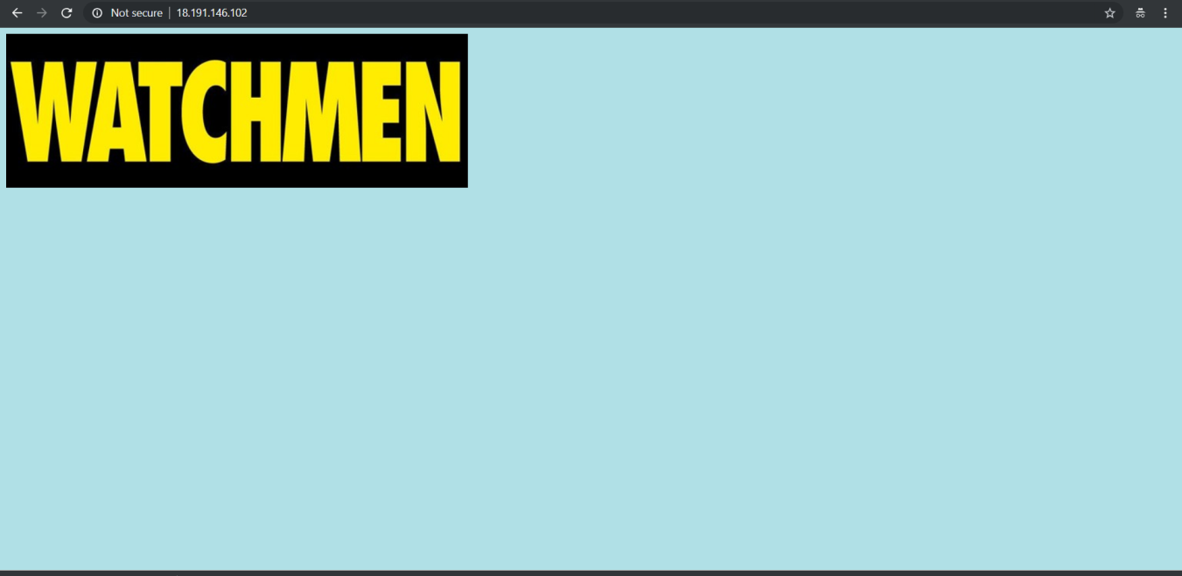

**Demonstrate procedures for deploying an updated change to the instances from #1**

For this forked the git repo to the my github repository <https://github.com/shaheena14/webdeploy>

Changed the background color to white and executed the apache.yml file

The outputs for each server is in below screenshot

Server1 when changed to white color background

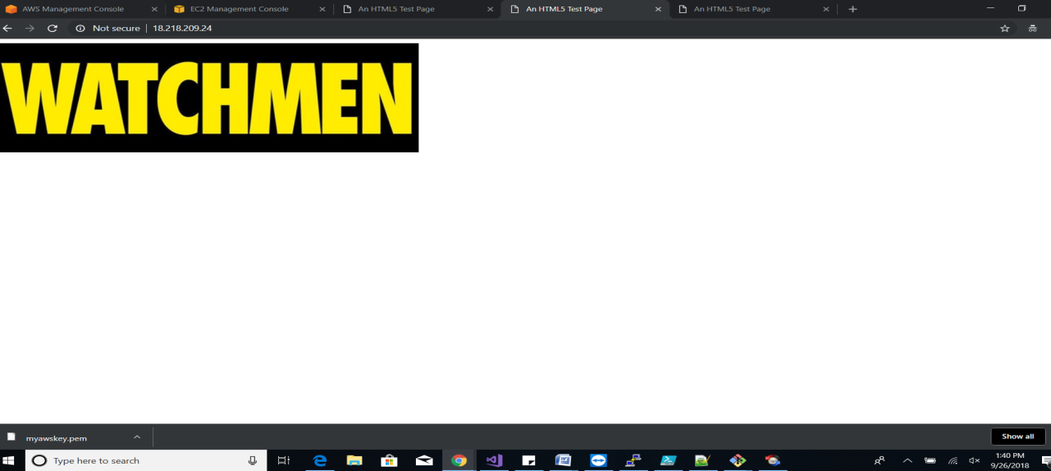

Server 2 when changed to white color

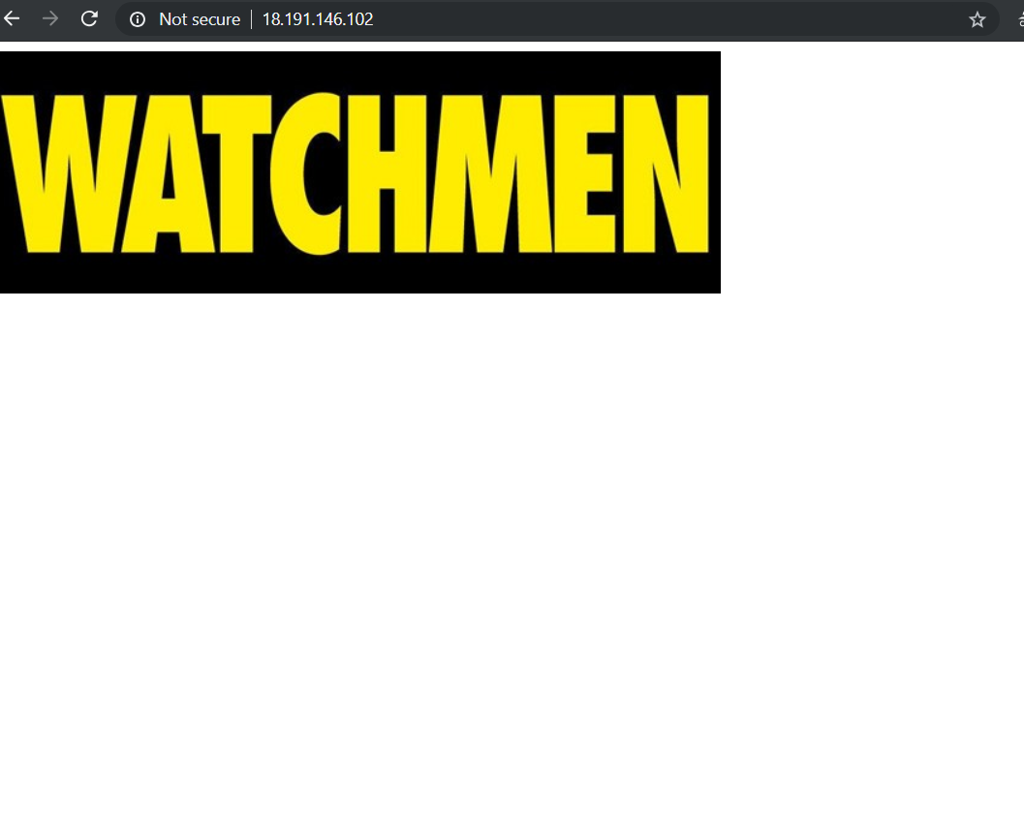

Server3 when changed to whote color

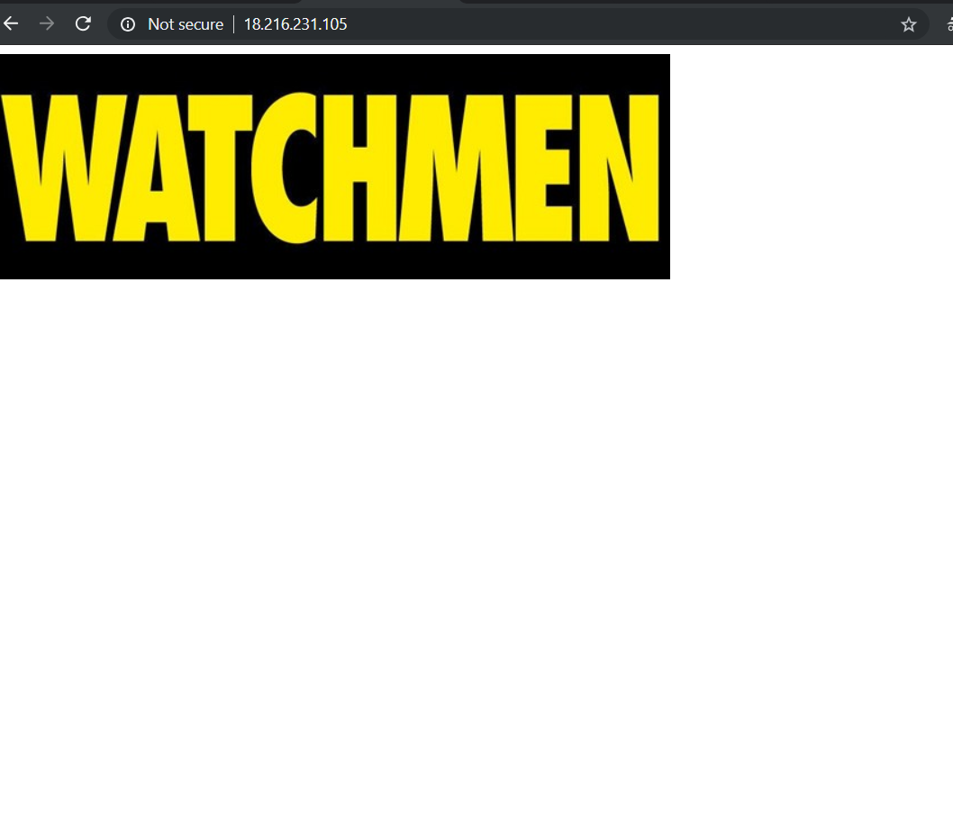

**Provide code as a pull request to this repo**

Will submit a pull request with this document added

**Solutions can be in the language of your choice**

The solution for this test is provided in yml ,shell scripting languages

**Technology of your choice**

Used AWS service to launch the instances and also used Ansible and GIT to complete this task

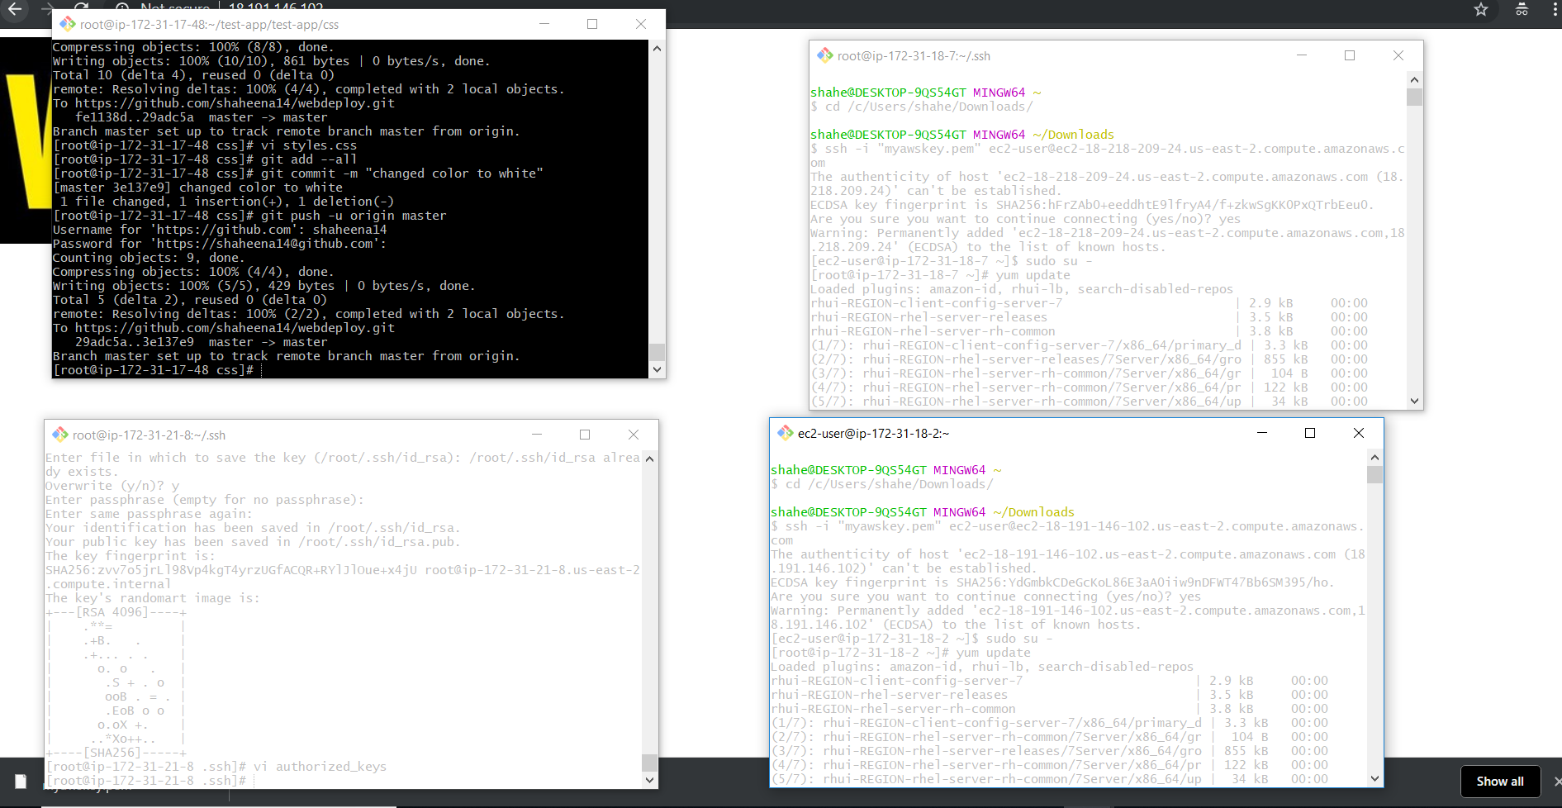

**NOTE: These Web Servers will be running until tomorrow morning 11 AM PST. His is just information for references**