Demo test -- https://github.com/watchmen-test/webdeploy

1. Three servers can be created for running as three instances and the web site requests can be routed through these servers and the website page will get appeared.
2. My assumptions : three virtual servers to host the code and apache webservers to be installed on them to route in to static code.

Steps :

1. Created the vitual server ( RheL AMI ) in AWS.

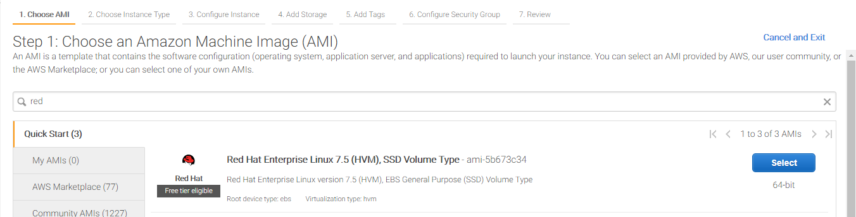

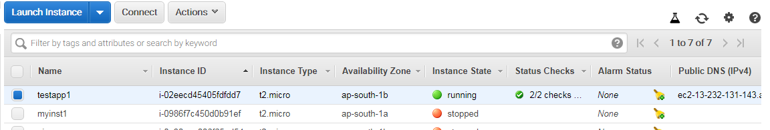

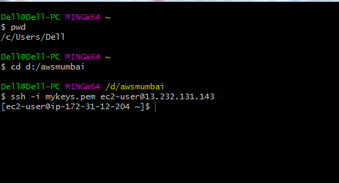

Connected to server, and installed apache webserver in the box.

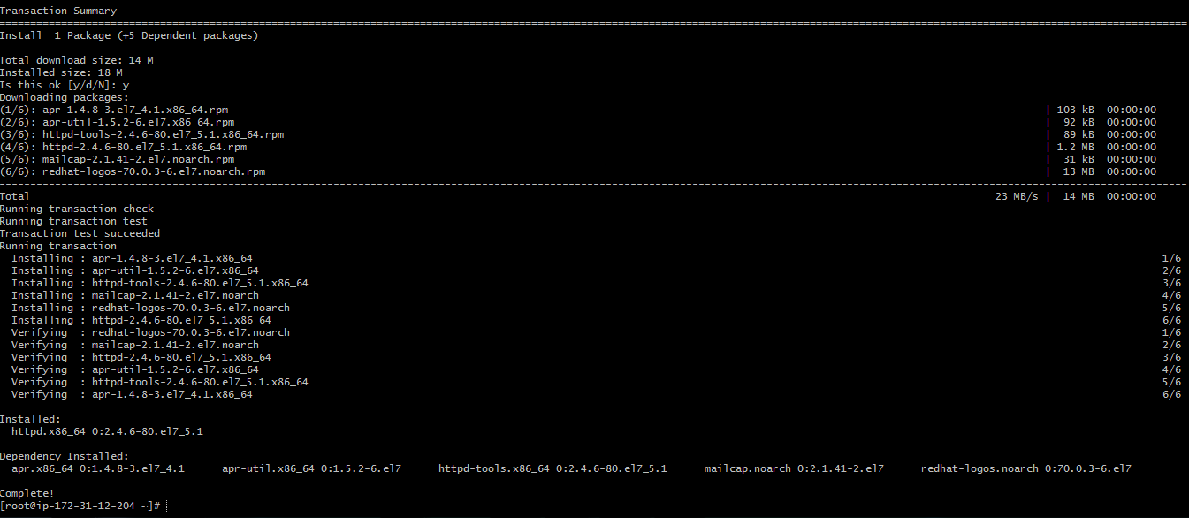

Tested the Apache webserver , and it is working fine

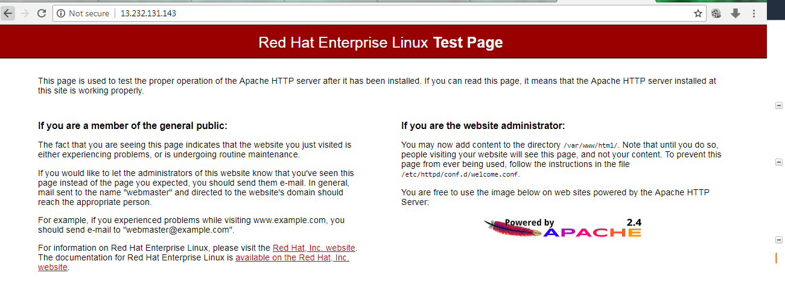

Installed Git in on the server for cloning the code in to the server.

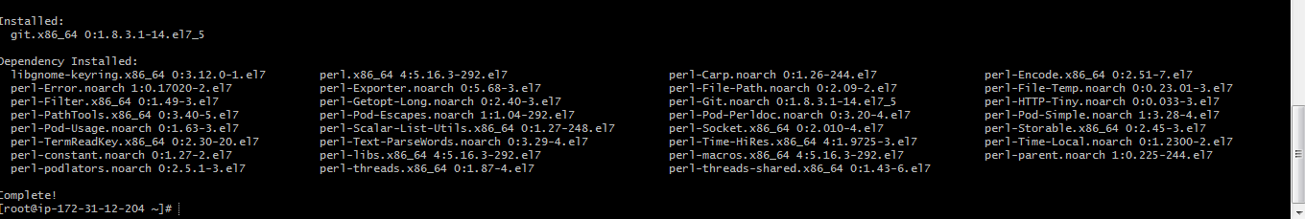

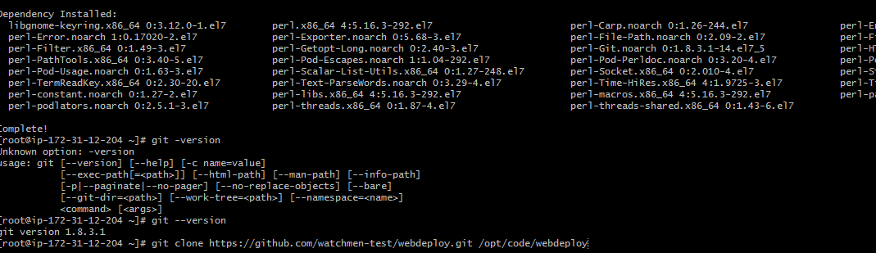

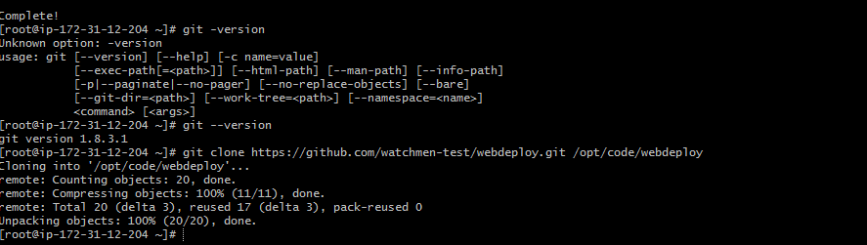

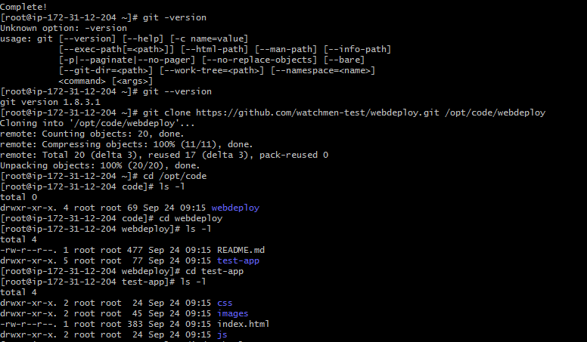

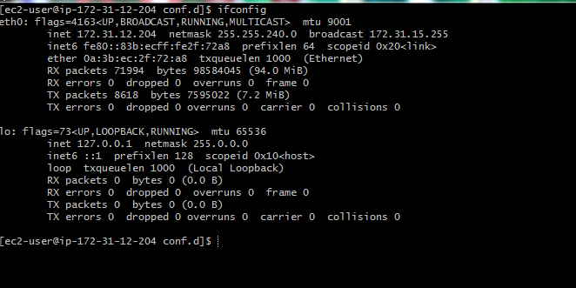

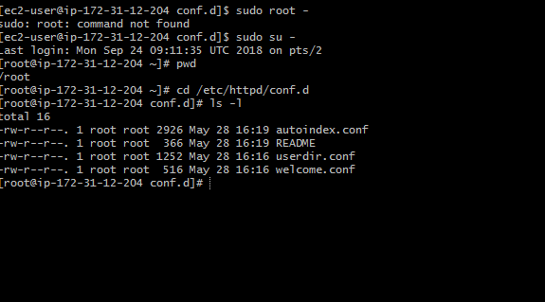

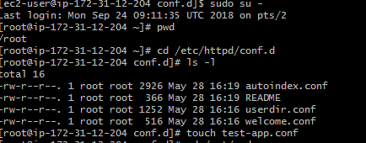

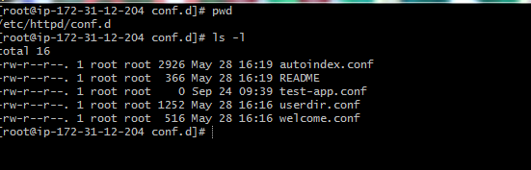



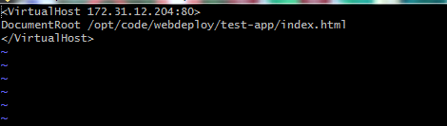

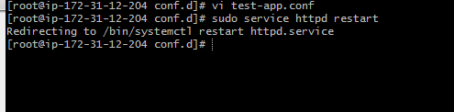

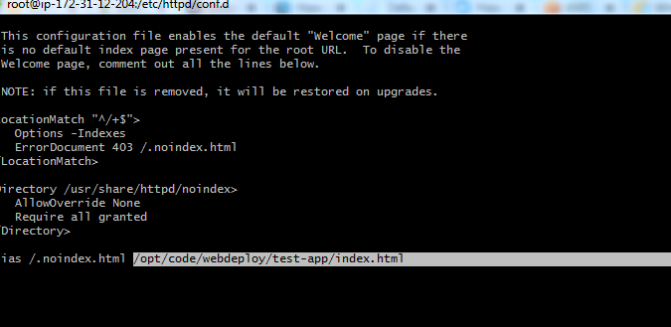

Worked on the configuration’s in the apache httpd.conf file and welcome.conf

Created one empty file test-app.conf file under /etc/httpd/conf.d as well to host the virtual host address of virtual server’s private ip , so that the request from this config file will be routed in to server and index.html will be called , whenever the request comes from the user.

Restarted the httpd service ,

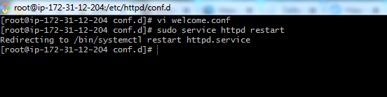



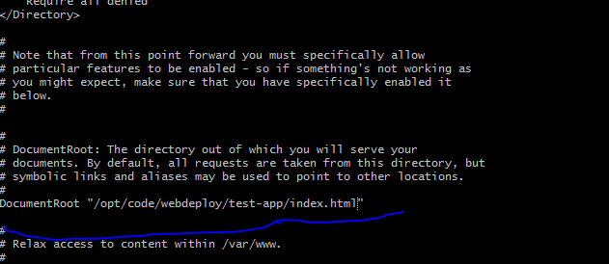

If everything goes fine, whenever i get in to the browser with the public/private ip, i should have see this image like this :





But i see configuration issues in my assumption scenario, There is forbidden access for some time and not able to connect to the server for some time .



Today is not my day , i was not able to clear/find root cause of the configuration issue here .