Building the Mouse



An early Mouse builder having fun

Introduction
The Mouse started life as an exercise to develop the smallest, cheapest possible usable boat for a group of kids to build during their summer holiday break from school. It had to be cheap to build, light and simple, with an absolute minimum of materials, sawcuts, difficult joints and all the rest - but it had to be effective as a boat as well, as the technical education teacher in charge was to be a veteran paddler called David Colpitts, a man I had met while holidaying in the middle of winter at Mystic, Connecticut.
David and I talked at Mystic and later via email about the kids' likely weight ranges, their ability in the workshop, and the need to keep the plywood bill down to a single sheet of 1/4in. I modelled a hull on my computer, produced a set of drawings and David knocked up a prototype. Wisely, I thought, he made it from the cheapest materials he could find for, despite what my computer was telling me, at that time I could not quite convince myself that it was possible to make a usable craft from so little material.
It soon turned out that we were wrong to doubt the little boat's potential. David took it paddling and amazed both himself and a group of fellow canoeists. Once fitted with a skeg (a small fin at its stern) that enabled it to be steered effectively, the Mouse is a stable little craft with sufficient buoyancy in its ends to keep out waves a few inches high. It isn't particularly fast for a canoe, but not half bad for its size - experience shows that it can keep up with other, grownup canoes on a cruise without unduly straining its skipper.
Since that time, David and I have developed a number of variants on the original Mouse, including an even simpler flat-bottomed 8ft Skinny Mouse, an 8ft sailing Flying Mouse, a 12ft Cruising Mouse and the Oarmouse, a fabulous 14ft fast rower shell for one. At the time or writing, one or two more designs along the same lines are being considered and may see the light of day in the next year or so.
All these boats share the same basic approach to construction: none will ever use more than a few sheets of ply and none will ever demand more than the most basic woodworking skills.

Gavin Atkin, Tunbridge Wells, Kent, November 2001

An email discussion forum for builders and users of this boat has been set up at http://groups.yahoo.com/group/mouseboats .

These construction notes are copyright Gavin Atkin and David Colpitts, 2001. Contact: gmatkin@clara.net.

WARNING: All Mouse designs are very small boats designed for use in sheltered waters in suitable weather under close supervision. Buoyancy tanks are preferred to provide the user something to hold onto in case of a capsize. They are particularly important where children are likely to use the craft. The authors and designers make no claims for these boats' performance or their safety in these or any other circumstances. These designs are built and used entirely at the risk of the builder and user.

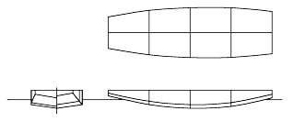

The Mouse
Although it's never going to be a boat for any sort of rough water, the Mouse has a lot to offer in at least three situations:

• it can providing hours of workshop and watery summer fun for a group of kids in a strictly supervised environment;
• it can provide an adult paddler with some cheap and harmless fun;
• and it can provide first-time boatbuilders with a cheap and easy introduction to stitch-and-glue boatbuilding.

In common with the rest of the Mouse family of mainly small stitch-and-glue epoxy and plywood boats it is designed to be easy to build, even for the clumsy woodbutcher. To make building as easy as possible there are no hard joints and there is a minimum of marking out and sawcuts - but if that alone is not enough to reassure you, do bear in mind that that most errors and gaps can be covered up with a little epoxy, a little filler, and tape if necessary.
We believe the Mouse can quickly be knocked up in 12-24 hours of work using almost any working surface, including many kitchen tables! The main material is 1/4in or so hardwood marine ply; the main hull takes one sheet, while the decks and first and third frames are intended to come out of an extra half sheet. (These enclose an area of emergency buoyancy that gives the user something to hold onto if the boat capsizes.)
The appropriate sheet material for building this boat really depends on what is available, the cost of the other materials, and what you can afford. This is a very basic craft and should probably be built from inexpensive materials of adequate quality - however, in areas such as the UK where reasonably good ply is expensive and epoxy is extremely expensive, builders may reflect that there's little point in putting a costly adhesive onto very poor quality plywood. Also, whatever ply you use must be made with waterproof glue!
The framing should probably be inch by half inch or so pine, although just about any cheap lumber will probably do at a pinch. The stitch and glue should be epoxy and glass tape; other glues may be of cheaper varieties such as polyurethane.

What you will need

Materials
• 1 or 1.5 sheets of 48 by 96in 1/4in marine plywood or good quality WBP plywood (Try not to use the stuff with thin walls and a trashy soft middle veneer as it soaks up water and rots in very short order.)
• brass, copper or galvanised iron nails, or brass or stainless steel screws
• a few pints of epoxy, disposable gloves, filler, 50-60ft of epoxy tape, a suitable spatula, and a supply of disposable rags and ordinary brown vinegar for cleaning
• around 40 strong plastic cable ties
• 'duct', 'gaffer' or 'carpet' tape
• around 20ft of 1 by 1in knot-free lumber (small knots that don't fall out are acceptable)
• 20ft of hardwood material suitable for the rubrail
• rot-proofer, paint, varnish etc for finishing
• drain plugs (if you are planning to include emergency buoyancy)

Marking-out
• pencils and a rubber (US: eraser)
• a tape measure
• a long straight-edge
• a long flexible moulding of a minimum of 8ft in length for use as a batten when marking out

Tools
- saws,
- a hammer
- a Surform or sharp traditional plane
- as many G-cramps (US: C clamps) as you can lay your hands on! You get by with a minimum of four, but a few more will be very useful.

Marking out and cutting

'Measure twice and cut once' and 'Always cut on the wastewood side of the line'

Marking out is the key to successfully building any boat, but bear these rules in mind, and you'll have little problem with marking out the few lines required for a Mouse. Among the materials you will have received with these instructions you should have a set of coordinates for marking out your plywood sheet. We think you should begin this task by using the tape measure and straightedge to draw grid of 10in by 10in squares across the face of the plywood material (use 12 x 12in if you prefer), as I find it helpful in confirming that each marked out point has been made correctly. If you have access to a large T-square of the sorts used in drafting or plasterboard/drywall work, it can help save time and increase accuracy. In making the grid, of course, I double-check all my measurements before actually ruling the lines.
Having drawn the grid, carefully mark out the coordinates themselves, then check them. The straight edges at the bows and stern can then easily be marked using the pencil and straight edge. At this stage, also take time to mark the forward and aft vertical 'stations', which are where the framing will subsequently be fitted.
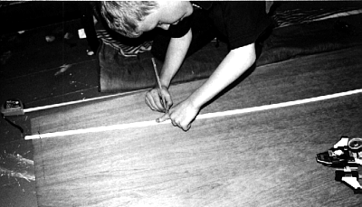
This boat is so simple that even young children can be involved in at least some parts of the process. Here a seven-year-old traces round a batten

The curved lines are drawn done using the batten. Traditionally, loftsmen do this using lead weights called ducks, but we can use panel pins or fine nails: pick a curved line and drive pins into each of the four coordinates that need to be connected, and then tap in further panel pins to hold the batten tight against the coordinates. Take great care to achieve a fair curve with no kinks, and certainly don't drive any pins through the batten itself, or you will produce a bad line and ruin the batten forever. Finally, when you are satisfied, carefully make a good, clear line you can saw to.
Once all four long seams have been marked and checked to make sure that each panel looks like its mate, it's almost time to start cutting wood.
You may find it helpful to cut out the two sides and the bottom chine pieces in a single cut by clamping two pieces of ply together.
It is important at this stage to clearly mark the wastewood so that there is no chance of cutting into the work, and cut on the wastewood side of the line.
Also, make sure your saw is good and sharp - I've been using a laser-cut Stanley saw, but the make does not matter so much as the condition, for a blunt saw makes much more mess and leaves jagged edges on the material. Cut carefully - it's worth taking time to cut the material neatly and accurately, for even if you think plywood is cheap you won't want to have to cut out the material twice. Finally, support the plywood well as you cut it, for a waggling sheet of ply is a difficult thing to cut well and safely.
Once they have been cut out successfully, compare the twinned chines - clamp them together and trim any slight discrepancies with a Surform or sharp traditional plane if need be.

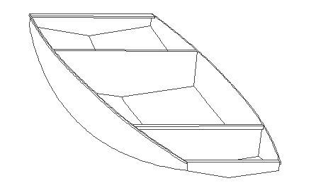Assembly
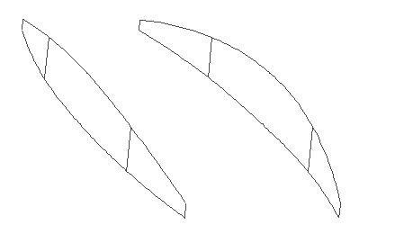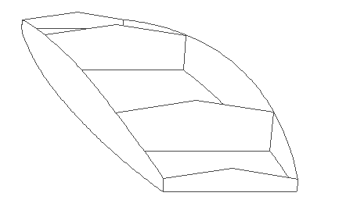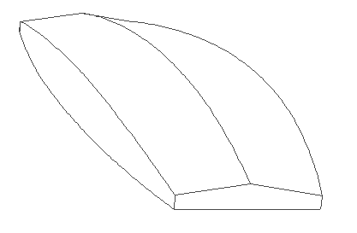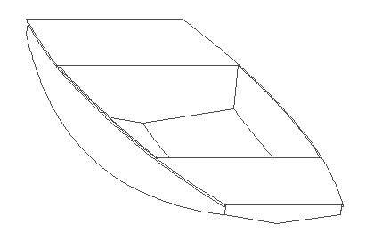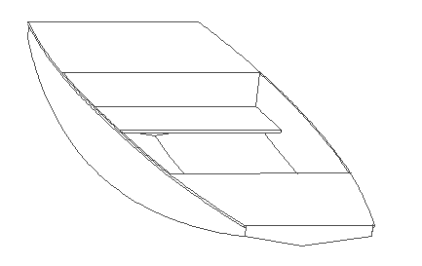
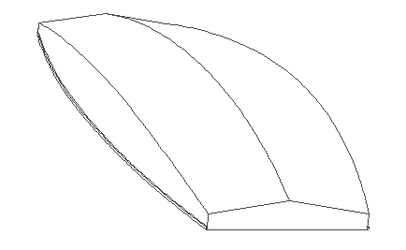
Mouse building sequence

This boat is designed to be assembled using the stitch and tape method, a modern variant of an ancient boat building technique that has all but died out - in this case, the hull is stitched using cable ties and sealed with epoxy, epoxy-filler mix and tape. First, holes large enough to accept the cable ties are drilled about 1/4in into the work at 9in intervals along the seams in the chines (less in the transom and stern). To make certain the chines holes match, MEASURE THESE FROM THE BOWS IN EVERY CASE! IT IS VITAL THAT MATCHING HOLES ACTUALLY MATCH! You may be able to save time by clamping the two opposite chines together before measuring and drilling.
Once the holes are done, stitching can begin using the ties, making sure that the tie connectors are outside the boat.
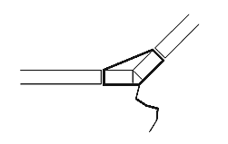
Cross section of seam tied with wire

Now it's starting to look like a boat! Next, add the internal framing. Exactly how you do this depends on whether you are choosing to have buoyancy tanks. If you are, mark out the frames indicated on the plans, attach and glue pieces of 1 by 1in along its edges. Try pushing the frame into place (which you should have penciled-in during marking out!) with the lumber side facing the nearest end of the boat - so the 'lumber side' of the forward frame should face the bows while the 'lumber side' of the aft frame should face sternwards. The lumber will of course need to be trimmed slightly so that the frame fits snugly against the boat's sides and bottom before being glued and screwed into place. (Make sure the hull looks square before you commit yourself. The traditional technique of horning, that is measuring from each bow to the opposite stern corner using string is useful here.)
If no buoyancy is to be used, an alternative frame can be made using 1 by 1in lumber and scraps of waste ply.

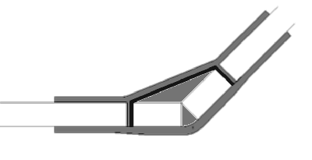

Cross section of the same tied seam after the seam has been filleted
with epoxy and filler, and tape and epoxy has been applied to both sides
There are many sources of information on how to tape the seams of stitch and tape boats - you will almost certainly have been given some by your epoxy supplier. If so, follow their instructions, but the following is how we do it.
Before epoxying begins, make absolutely sure you are using disposable gloves and are working in is well ventilated for your safety. Epoxy is a sensitiser, and may cause dermatitis and other conditions. The work area should also be warm and dry to ensure that the epoxy cures well and bonds powerfully to the wood. This is a minimum - take care to follow your epoxy manufacturer's instructions to the letter.
Always start with the inside seams. Tape the exterior seams with the duct tape to prevent drips and runs that will have to be tidied up later. Then mix your epoxy and paint a thin layer along the inside seams - remember you can clean your brush with the vinegar.
Before the first painted layer goes off (that is, within a few hours), mix some thickened epoxy (this is the standard stuff mixed with a powdered filler - your epoxy supplier should advise) and apply it to the seam using a rounded spatula to form a neat gusset of about 1in radius - the tongue depressors that doctors and dentists use are said to be perfect for the job, but I usually cut mine from the plastic often used to deliver takeaway meals or from unwanted store reward cards etc. Once this gusset has begun to harden, but before it sets fully, paint-on another layer of epoxy, apply the tape, and wet it well, trying to make a neat job with no creases and tidy overlaps where one seam meets another. (An old pair of scissors can be useful here.)
Once the inside seams are all done, remove the duct tape on the outside, cut off the tie ends, and round the chine edges slightly using a Surform before wetting and taping the external seams - by this point you should be an expert! Make sure the tape is well wetted, and, again, when the epoxy starts to harden but before it sets, add a second coat of epoxy to fill the weave in the tape.
The next task is to attach the gunwale (or rubrail). With the hull turned bottom-down, glue and attach two eight-foot lengths of gunwale material along the uppermost edge of the boat with a little material protruding at each end. Once this has set, use a saw to carefully cut off the excess at each end, and then glue and attach short gunwale sections fore and aft, again with a little excess at each side. Again, when set, saw off the excess and sandpaper the corners to make a neat job.
If buoyancy tanks are to be used, the next task is to trace the nearly complete hull's outline onto the decking ply before cutting out the fore and aft decks. At this point, it is as well to consider rot-proofing the interior of the buoyancy chambers. Some builders epoxy the insides of their tanks, some merely paint them, while still others apply timber rot-proofer. Glue and attach the decks. Apply paint or other finish to the boat. Fit drain plugs to your tanks (if you have them!) and remember use them to empty and ventilate your tanks every time the boat is used.
A piece of foam rubber makes a fine seat, but there's nothing to stop you installing a permanent seat if you prefer.
A simple double paddle can be made using a 5-ft length of plastic tubing and two 12in by 6in pieces of ply. Cut matching slots 8in deep into each end of the tube so that the ply material slides neatly into place (both in the same plane, natch!). To attach each paddle blade, clamp the pipe flat onto the ply and drive several short brass screws through the plastic into the ply. Again finish to taste.

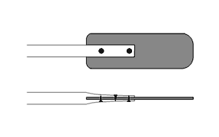

Construction of plastic-pipe paddle

Your boat is finished, and as a bonus you have a paddle as well. Happy paddling; stay safe and never, ever forget your PFD/buoyancy aid/lifejacket.

