|  |
| --- |
| **[ Final Project ]** |
| How to install Fedora |
| In Virtual Machine |

IT Data Analytics

Hyejung Bae(Cathy)

W0411909@nscc.ca

April. 23, 2019

**Contents**

1. Download Fedora image file from website 2

2. Installing Fedora in Virtual Machine 2

3. Setup Fedora 6

4. Installing other services 9

1) Open VM Tools 9

2) SSH 10

3) SAMBA 11

4) NGINX 15

5) GUI 19

**[ How to install and Set Fedora in Virtual Machine ]**

1. **Download Fedora image file from website**

* <https://getfedora.org/en/server/>
* Choose Net-install ISO

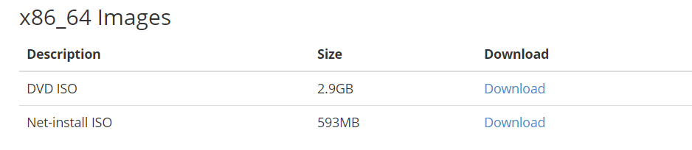

1. **Installing Fedora in Virtual Machine**

* Open your Virtual Machine and choose New Virtual Machine, click Custom

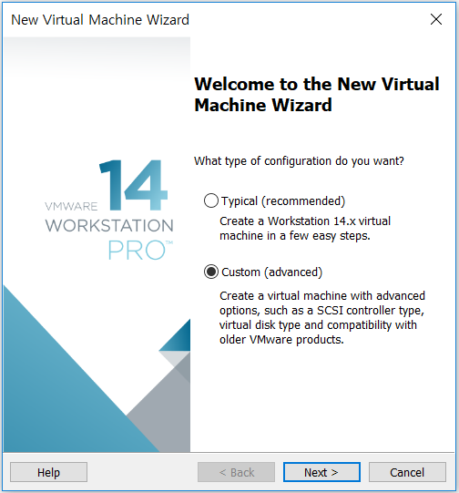 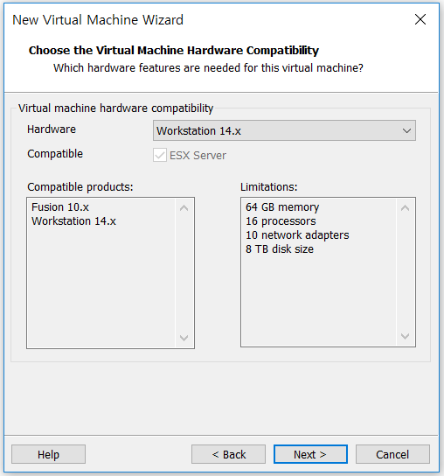

* Choose installing the operating system later and Fedora version

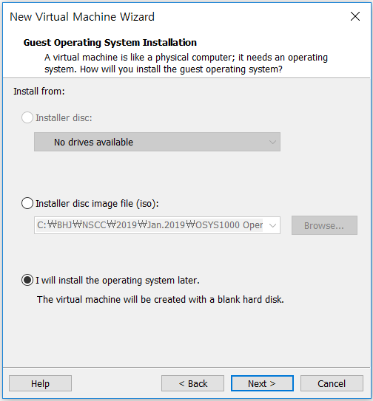 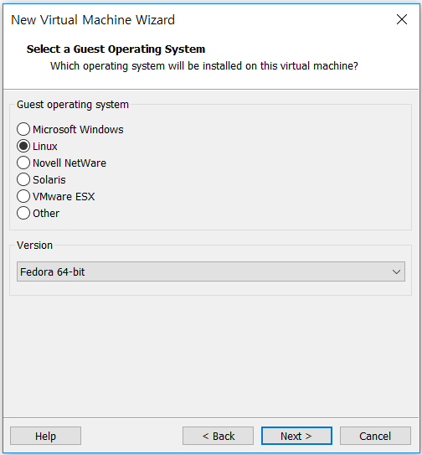

* Change the name of your Virtual Machine and your folder to save

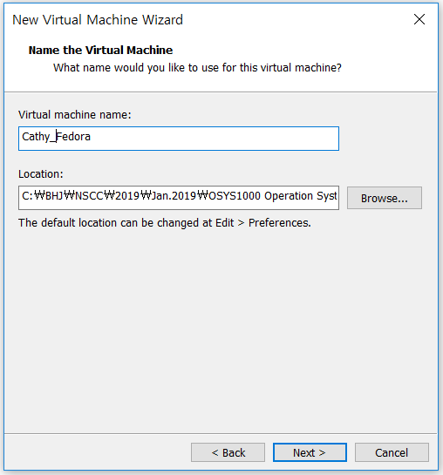 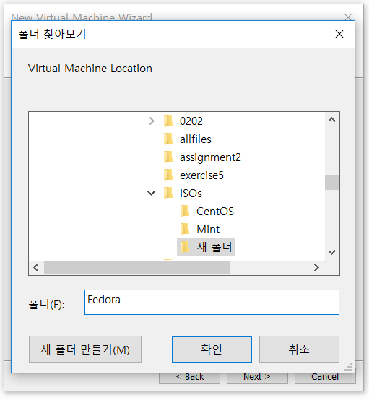

* Change process configuration and memory
* Suggestion - Number of Cores : 4, Memory : 4GB

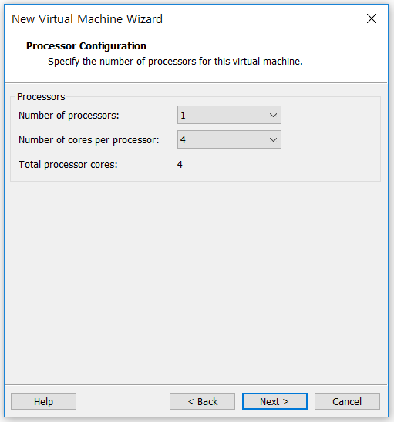 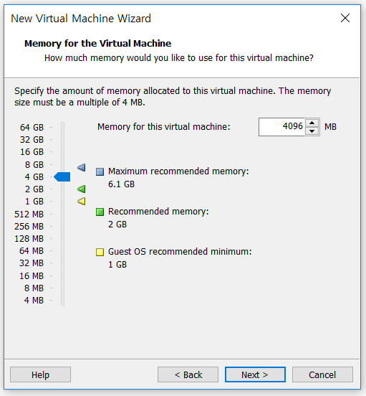

* Choose network type and I/O controller types
* Suggestion - Network Type : NAT, I/O controller types : LSI Logics

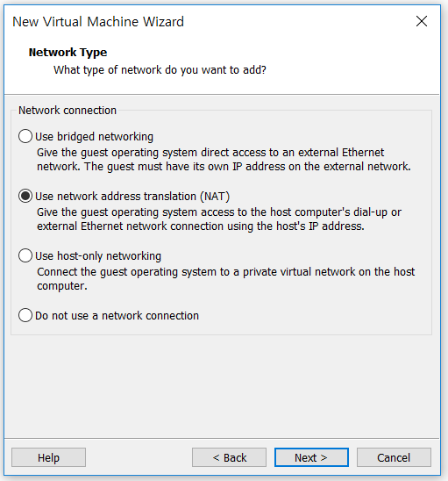 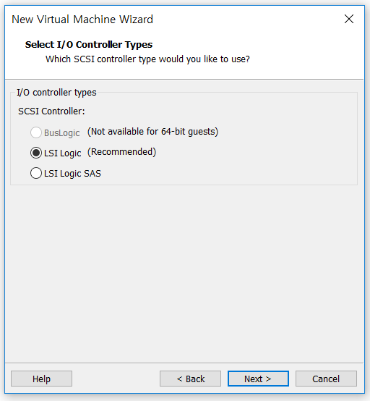

* Select Disk Type and a Disk
* Suggestion – Disk Type : SCSI, Disk : Create a new virtual disk

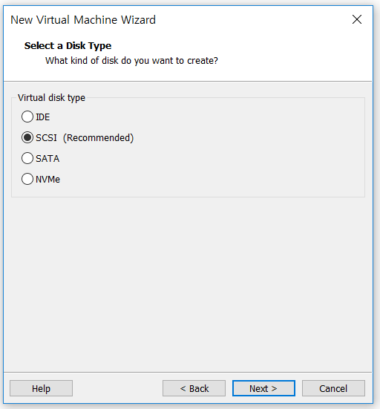 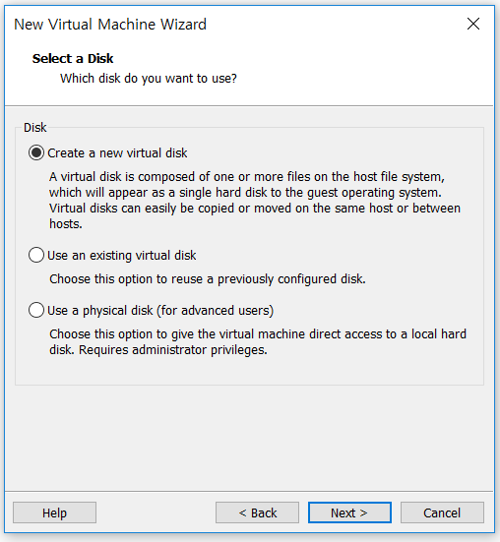

* Specify Disk Capacity and Disk File
* Suggestion – Disk Capacity : 40

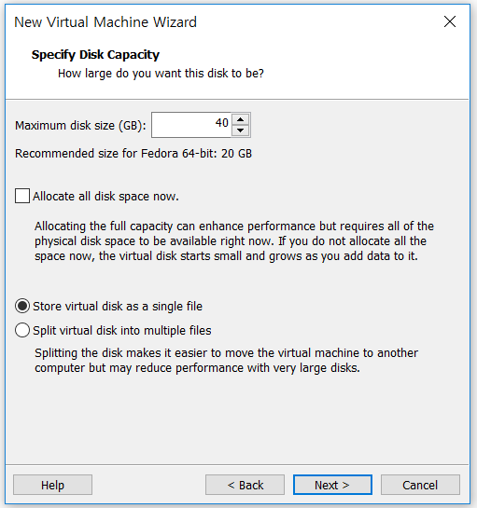 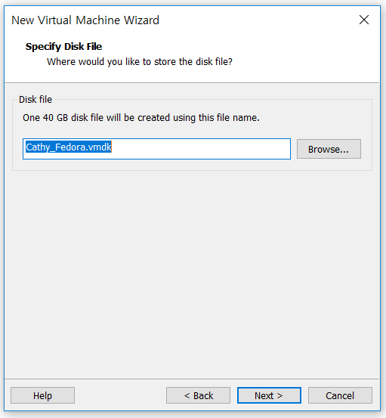

* Click Finish, Choose New CD/DVD and select your Use ISO image file

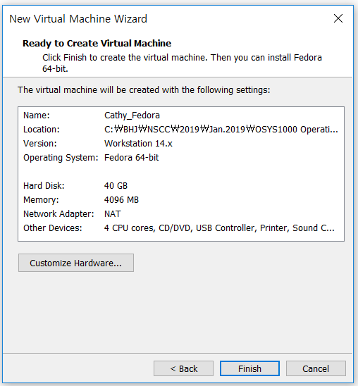 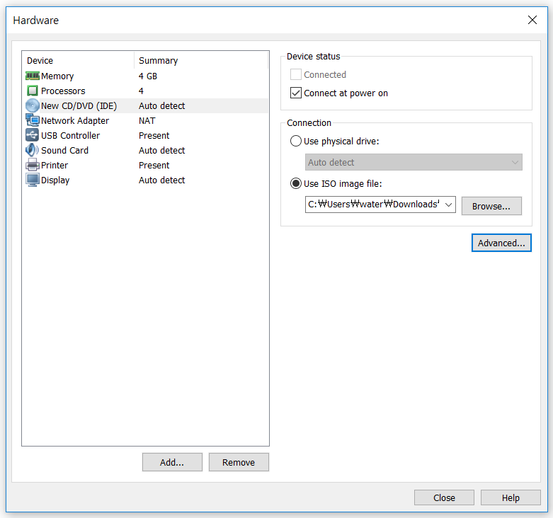

* Now, you finished Second step!

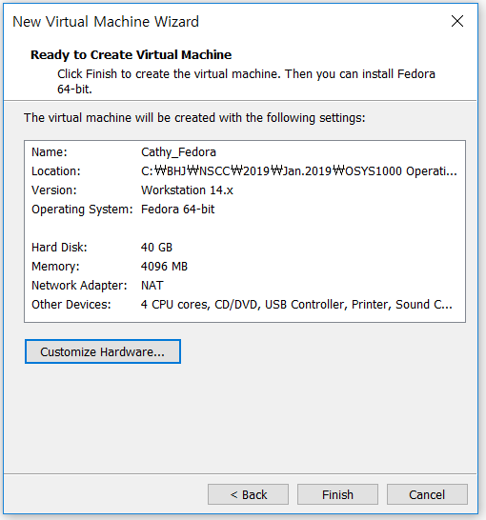

1. **Setup Fedora**

* Click Fedora and start it. Choose language

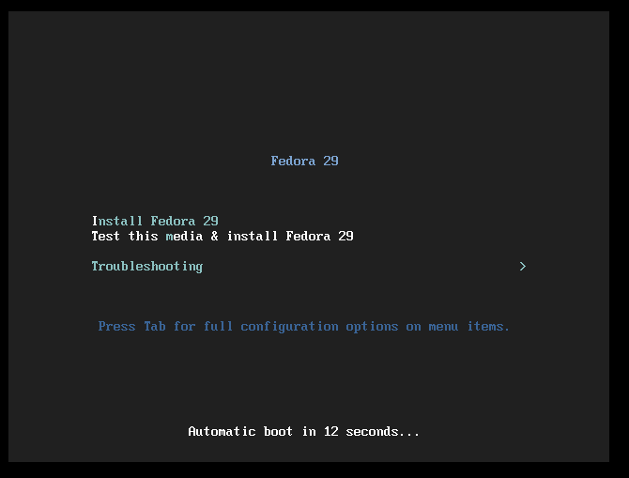 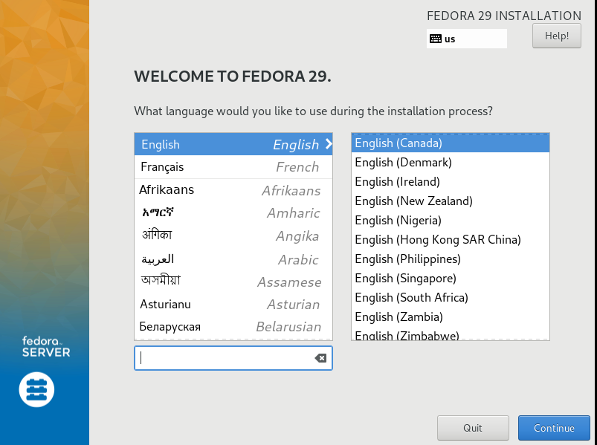

* Set Time & Date, Network & Host name
* Suggestion : Host Name with your first name

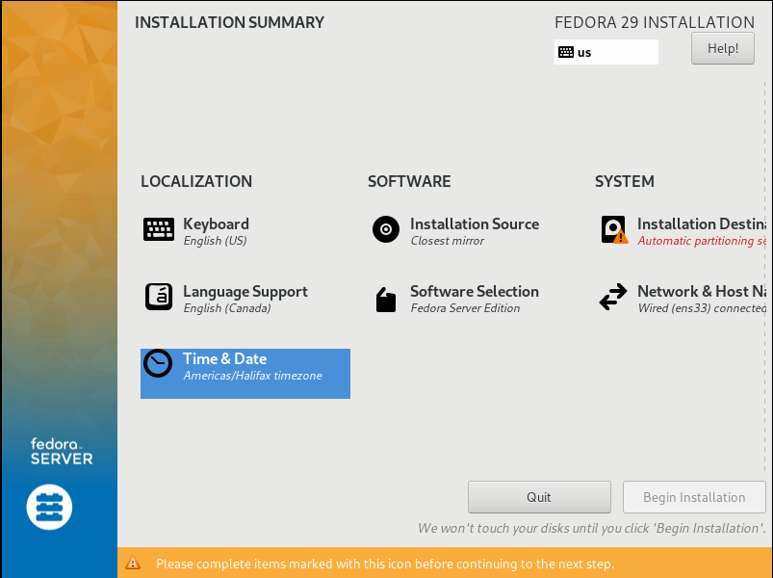 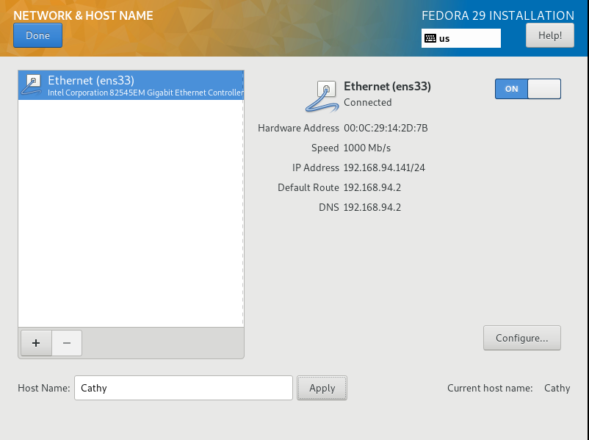

* Choose Storage Configuration with Custom, set partition
* Suggestion : swap -> 2.5 Gb, /data -> 10 Gb

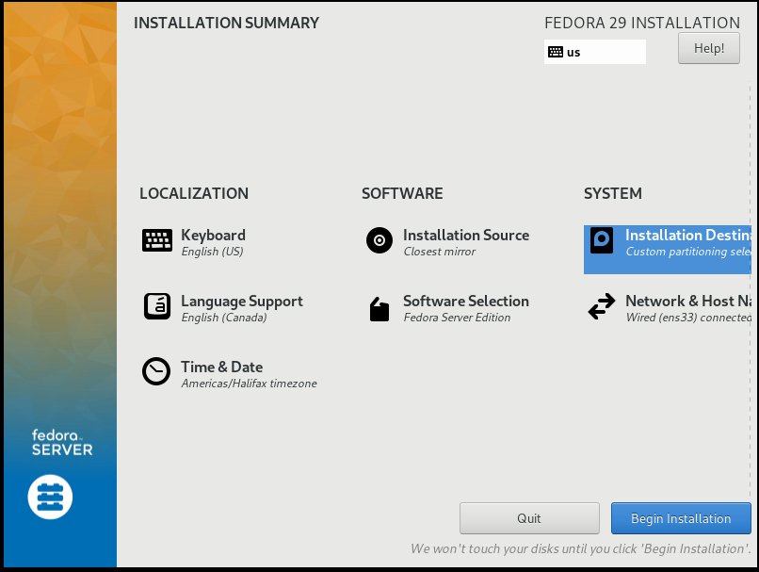 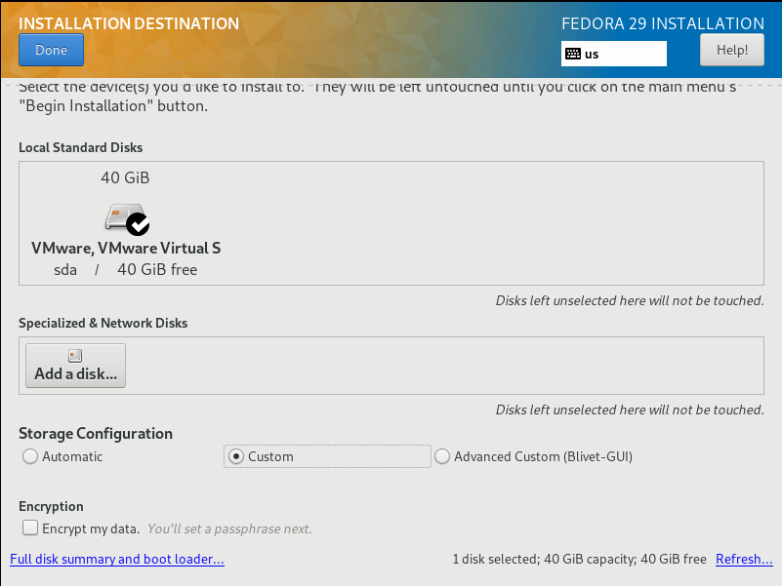

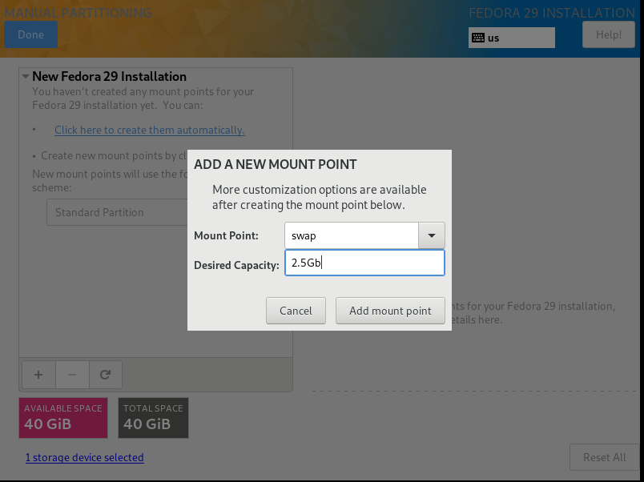 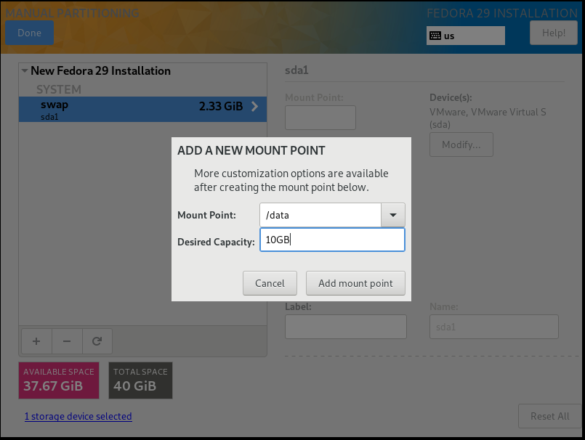

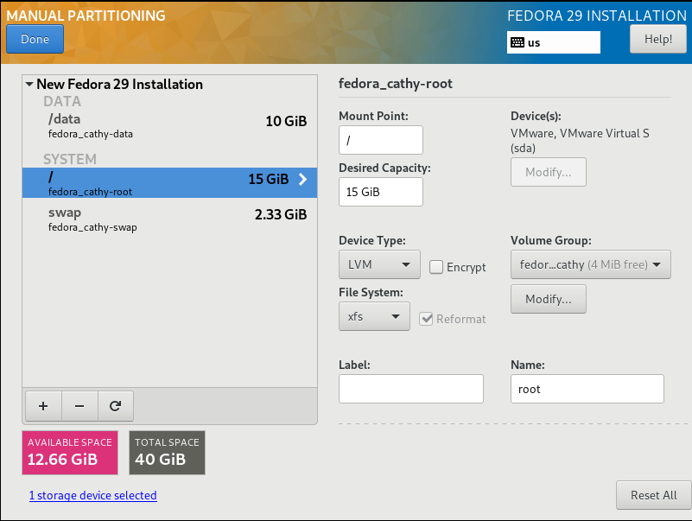

* Change User Setting and Reboot.

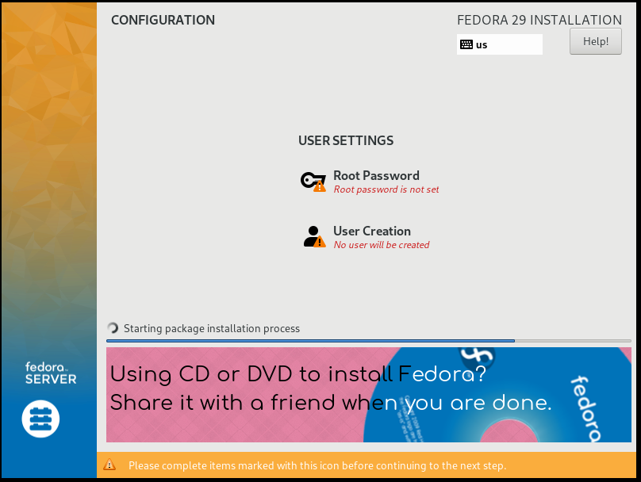 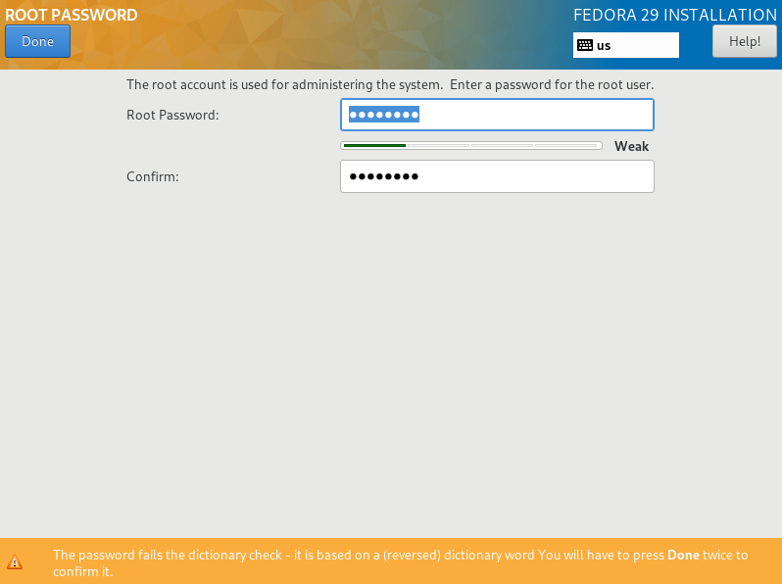

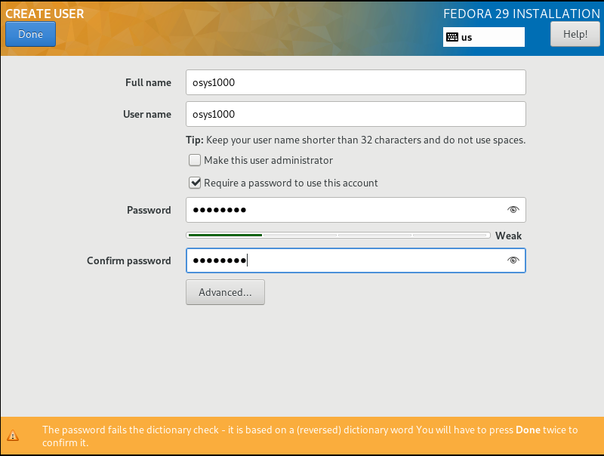 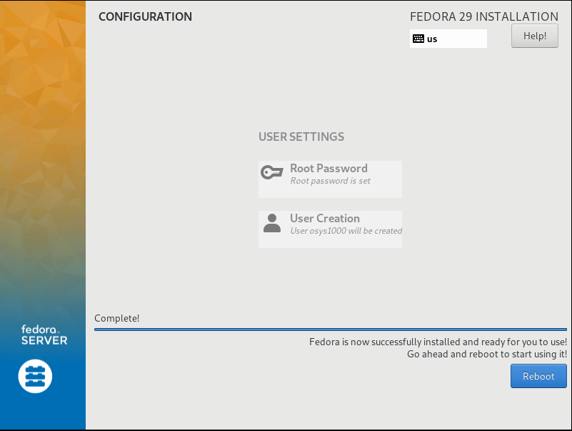

1. **Installing other services**
2. **Open VM Tools**

- Login in your terminal

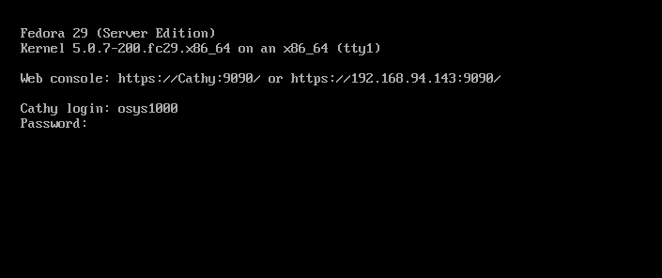

- Change user as root and type command as below

$ su

$ yum install open-vm-tools open-vm-tools-desktop

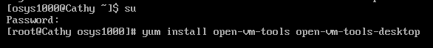

- Change usermod

$ usermod -gG wheel osys1000

$ sudo osys1000

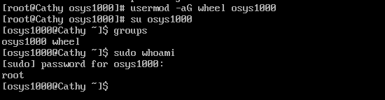

1. **SSH**

(ref: <https://linuxconfig.org/how-to-install-start-and-connect-to-ssh-server-on-fedora-linux>)

- Install SSH server

$ sudo yum install openssh-server

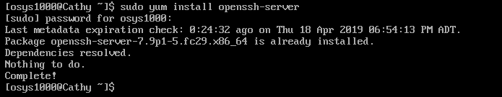

- We need to start it up, and make it enable

$ sudo systemctl start sshd

$ netstat -ant | grep 22 (for checking)

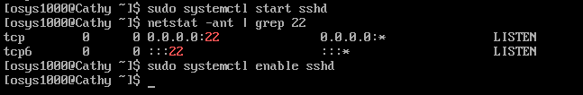

- Check SSH status

$ sudo systemctl status sshd (for checking)

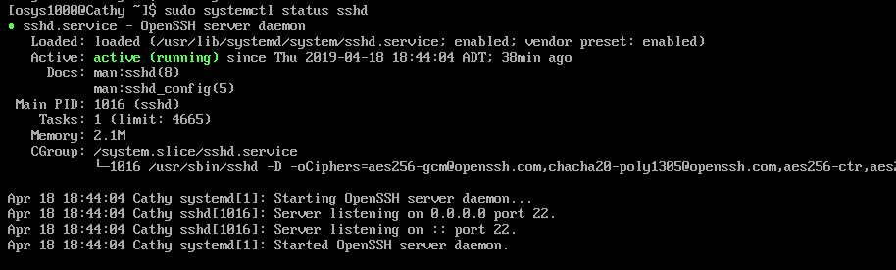

1. **SAMBA**

(ref:<https://www.hiroom2.com/2016/06/26/fedora-24-install-samba-and-share-with-windows-10/>)

- Install Samba

$ sudo yum install -y samba



- Start it up, and make it enable

$ sudo systemctl enable smb nmb



- Add service with firewall-cmd

$ sudo firewall-cmd --add-service=samba --permanent

$ sudo firewall-cmd --reload

$ sudo firewall-cmd --list-service

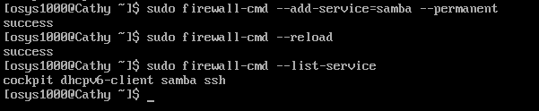

* Check status

$ sudo systemctl start smb nmb

$ sudo systemctl enable smb nmb

$ sudo systemctl status smb nmb (for checking)

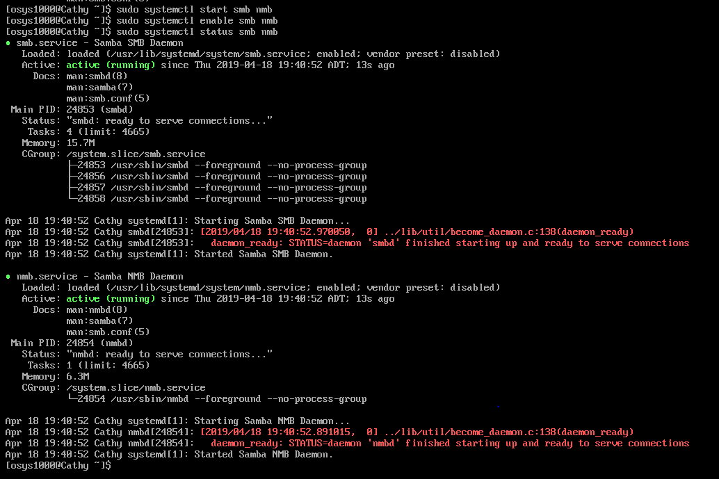

- Enable access to home directory

- Add user access to samba with pdbedit.

$ sudo setsebool -P samba_enable_home_dirs on

$ sudo pdbedit -a osys1000

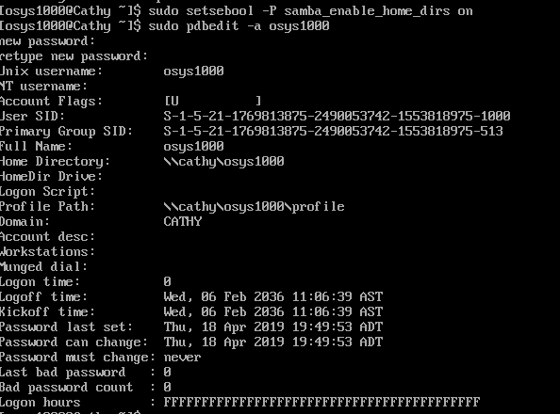

- Reboot smb and nmb after editing smb.conf

$ sudo systemctl restart smb nmb



- Add comment as below in smb.conf file

$ sudo vi /etc/samba/smb.conf



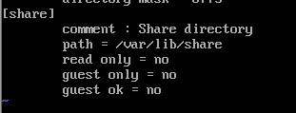

- Change /var/lib/share's permission to 0777. Add samba_share_t label to /var/lib/share

$ sudo mkdir /var/lib/share

$ sudo chmod 0777 /var/lib/share

$ sudo chcon -R -t samba_share_t /var/lib/share

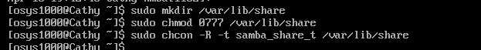

- Access samba from Windows 10

: Check your ip address and access to window

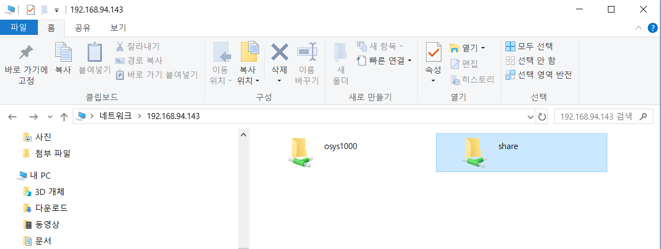

- Create new file in share folder in Fedora and check it in Window. And Vice versa.

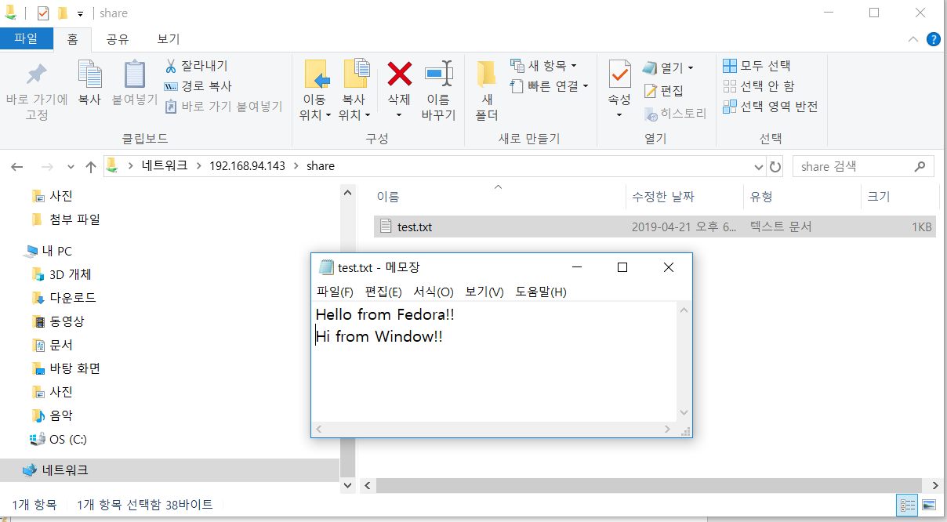

1. **NGINX**

(ref:<https://www.godaddy.com/garage/how-to-install-and-configure-nginx-on-fedora/>)

- Install NGINX

$ sudo yum -y install nginx



- Start NGINX and make it enable

$ sudo service nginx start



- Make our DocumentRoot based on the name public_html

$ sudo mkdir -p /var/www/nginxsite.com/public_html

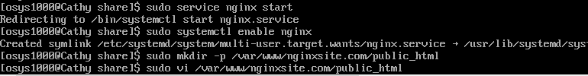

- Create index file and type “[www.nginxsite.com](http://www.nginxsite.com)” in index file

$ sudo vi /var/www/nginxsite.com/public_html/index.html



$ sudo chown 777 /var/www/nginxsite.com/public_html

$ sudo chown -R osys1000:osys1000 /var/www/nginxsite.com/public_html

- Give ownership of that directory



- Set up our directories where the server blocks will live

$ sudo mkdir /etc/nginx/sites-available

$ sudo mkdir /etc/nginx/sites-enabled



- Open the global NGINX configuration file

$ sudo vi /etc/nginx/nginx.conf



- Add these lines in conf. file

include /etc/nginx/sites-enabled/*.conf

server_names_hash_bucket_size 64;

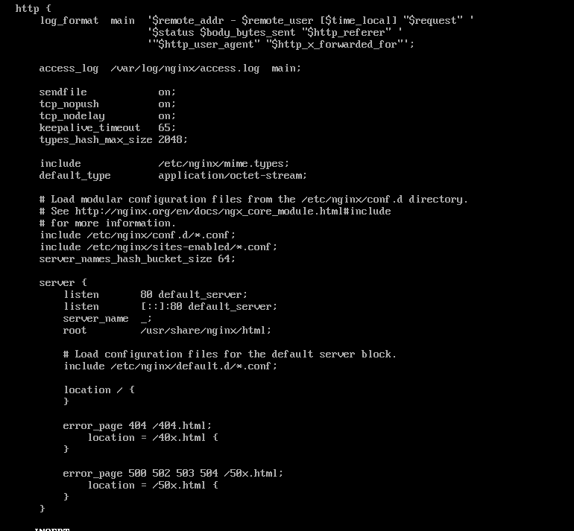

- Create a new file specifically for the server block for your site and open it

$ sudo vi /etc/nignx/sites-available/nginxsite.com.conf



- Paste a new NGINX server block in here

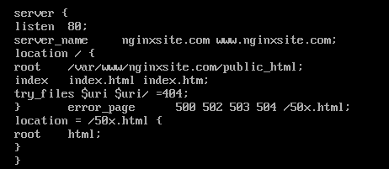

- Install firewall package

$ sudo dnf install firewalld

$ sudo systemctl enable firewalld

$ sudo systemctl start firewalld

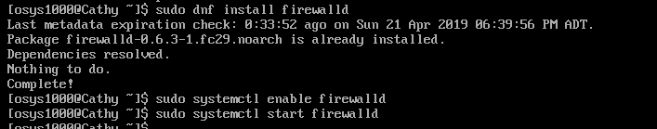

- Add port 80 and http service, Check your work

$ sudo firewall-cmd --add-port=80/tcp

$ sudo firewall-cmd --add-service=http

$ sudo firewall-cmd --list-port

$ sudo firewall-cmd --list-service

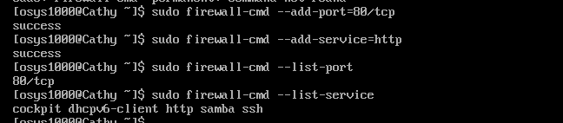

- Create a symbolic link between sites-available and sites-enabled

$sudo ln -s /etc/nginx/sites-available/nginxsite.com.conf /etc/nginx/sites-enabled/nginxsite.com.conf

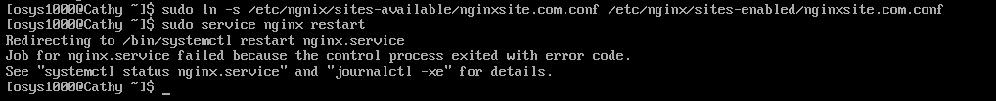

- Make it enable and check the status

$ sudo systemctl enable nginx

$ sudo systemctl status nginx (for checking)

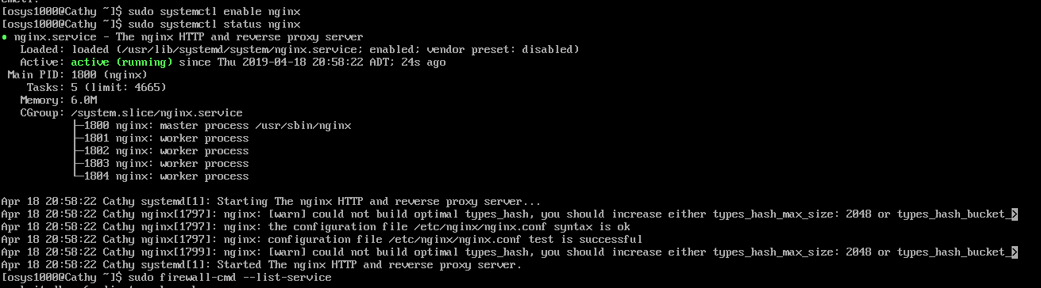

1. **GUI**

- Install GUI

$ sudo inf install @gnome-desktop



- You can start GUI when you want to use it

$ startx



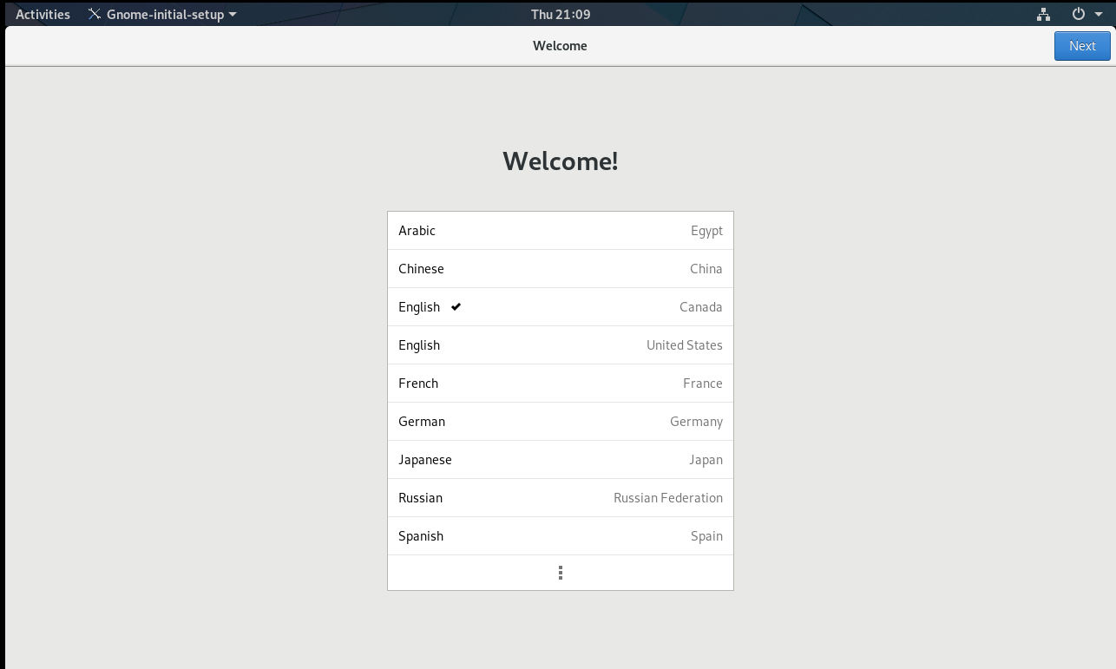

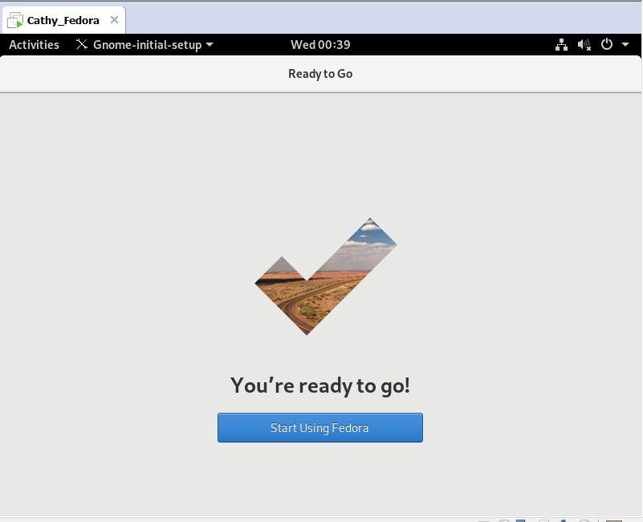

- You can check internet connectivity

