3. Add a new group to your system from the Terminal



4. Add a new user to your system from the Terminal

* 1. make their default group the group from Step 3

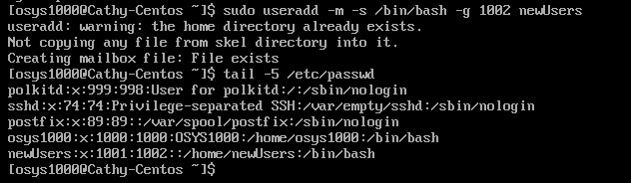

1. give them an additional group of **wheel** so they can run **sudo**



c. make a home directory for them at the same time

d. give them the bash shell

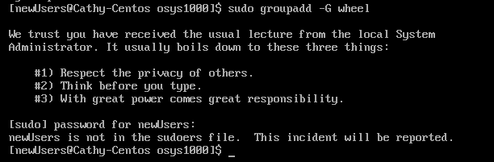

1. Logout of your system (**exit** might help) and login as the new user. Make sure their home directory and sudo powers work.

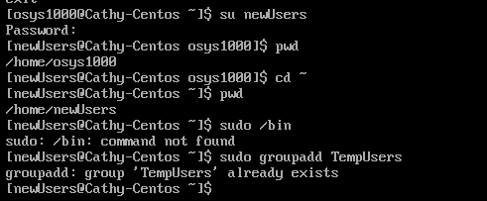

1. Logout again and log back in as your regular user.



1. Us the last command to show:

a.the last login time of the user you just added



b.the last time the system was shutdown

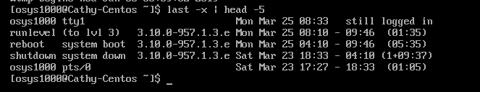

c.which user was logged in at a particular point in time

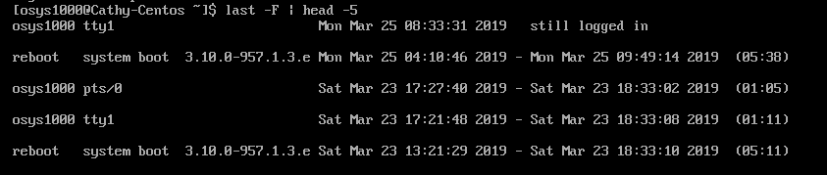

1. Post the Word document with your screenshots to the D2L Dropbox for the twelfth in-class exercise in order to obtain credit for completing it.
2. That’s it.