Development of Black Pixel Define Layer with Half-Tone Spacer Structure for Stylus-Compatible Foldable OLED Displays

Nakcho Choi, Daegi Kweon, Junyoung Kim, Youngin Hwang and Kwanhee Lee

**Mobile Display Division, Samsung Display Co., Ltd., Korea**

**Abstract**

*This study presents the successful implementation of black pixel define layer (BPDL) technology integrated with a novel half-tone spacer structure, enabling stylus compatibility in foldable OLED displays. Through the development of an innovative half-tone spacer design covering 50% of the BPDL with PSPI, mechanical stability and optical performance were significantly enhanced, leading to the world's first commercial application in the Galaxy Fold 3.*

**Author Keywords**

OLED; Black Pixel Define Layer; Half-Tone Spacer; Foldable Display; Stylus Integration; Display Manufacturing.

# Introduction

Recent advances in OLED display technology have driven a transition from traditional polarizers to color filters for enhanced efficiency in modern displays. This fundamental shift in display architecture, illustrated in Fig. 1, has necessitated significant changes in layer structure and materials. While this transition offers improved efficiency and display performance, it introduces new challenges in managing anode electrode reflectance.[1,2]

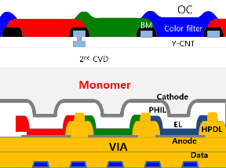 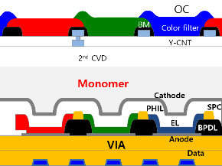

(a) (b)

**Fig. 1. Schematic comparison of traditional polarizer (a) and color filter structures (b) in OLED displays**

The conventional approach utilizing transparent organic layers, which served adequately in traditional displays, proves insufficient for contemporary display requirements, particularly in foldable devices incorporating stylus functionality. The primary limitation stems from reflection characteristics at the anode interface, which significantly impacts display visibility and contrast ratio, as demonstrated in Fig. 2. [3,4]

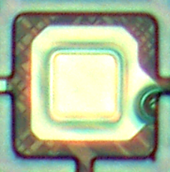 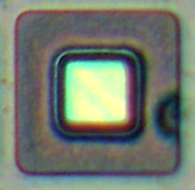

BM edge

PDL edge

**Fig. 2. Microscopic images of (a) PSPI and (b) BPDL structure in Pol less structure**

Black pixel define layer (BPDL) technology has emerged as a promising solution to address these challenges. BPDL, containing black pigment, offers superior reflectance reduction compared to conventional transparent organic layers. However, its implementation in mass production presents significant technical hurdles, particularly in maintaining structural integrity under mechanical stress. These challenges become especially critical in foldable displays, where the material must withstand repeated folding while maintaining consistent optical performance.

The integration of stylus functionality in foldable displays introduces additional complexity to these challenges. The display structure must simultaneously accommodate the mechanical stress from stylus interaction while maintaining flexibility for folding operations. This dual requirement necessitates careful consideration of material properties and structural design, as the conventional approaches to either requirement often conflict with the other. Prior studies have demonstrated various approaches to addressing individual aspects of these challenges. However, a comprehensive solution that simultaneously addresses mechanical stability, optical performance, and manufacturing feasibility has remained elusive. This paper presents a novel approach utilizing half-tone spacer (hSPC) technology to overcome these limitations, providing a practical solution for next-generation flexible displays.

Early implementations of BPDL technology revealed several critical issues that needed to be addressed. The most significant challenge was the emergence of black spot defects, which manifested as visible imperfections in the display panel. These defects became particularly pronounced under the mechanical stress conditions typical in foldable displays. Our initial investigation revealed that the interface between the BPDL and adjacent layers played a crucial role in the formation of these defects in Fig. 3.

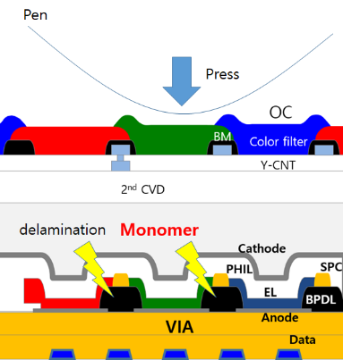

**Fig. 3. Microscopic analysis of black spot defects**

The mechanical properties of the BPDL material, particularly its modulus and adhesion characteristics, differed significantly from those of conventional materials like poly sensitive polyimide (PSPI). These differences created stress points at layer interfaces, potentially leading to delamination and subsequent defect formation. Additionally, the integration of stylus functionality introduced new complexities, as the display structure needed to withstand localized pressure while maintaining flexibility for folding operations.

# Experimentals

The materials used in this study comprised positive photoresist-type polyimide containing photoactive compound (PAC) for PSPI, and acrylic binder system containing photo initiator and black pigment for BPDL. To study adhesion properties, multiple samples were prepared: standard PSPI film, pure BPDL film, and BPDL films with varying PAC concentrations. A passivation layer was subsequently deposited using standard CVD processes.

Mechanical property characterization was conducted using nanoindentation equipment with a diamond tip under controlled loading conditions. Measurements were performed at room temperature under standard humidity conditions. Adhesion characteristics were evaluated through a modified tape test method following industry standards. The test pattern covered a designated area with controlled grid patterns.

Cross-sectional analysis utilized FIB-SEM technology with appropriate beam conditions for sample preparation and imaging. Mechanical stress testing employed customized pressure testing equipment capable of applying forces exceeding the target requirements. Tests were conducted across multiple points of the display area with particular attention to critical regions.

The hSPC structure was fabricated using standard photolithography equipment. The process included UV exposure with optimized doses, followed by development and post-bake treatment under controlled conditions. Film thickness measurements combined spectroscopic ellipsometry and surface profilometry techniques to ensure accuracy and uniformity.

# Results and Discussion

The mechanical properties of PSPI and BPDL materials were investigated to understand their fundamental differences and impact on display performance. Molecular structure analysis revealed that PSPI exhibits a plate-like structure with interconnected aromatic rings, while BPDL shows a chain structure with acrylic binder, as illustrated in Fig. 4. This structural difference significantly influences their mechanical behavior under stress conditions, particularly during stylus interaction.

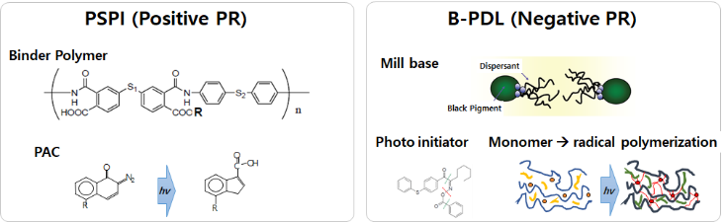

(a) (b)

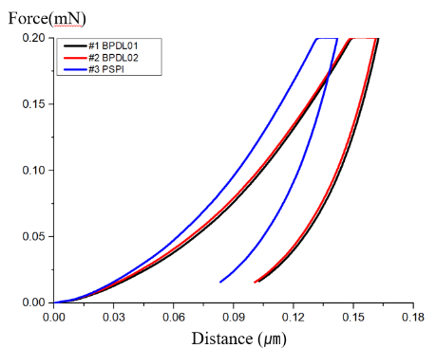

(c)

**Fig. 4. Comparative analysis of molecular structures and mechanical properties: (a, b) molecular configurations of PSPI and BPDL, (c) representative stress-strain curves showing distinct mechanical responses.**

The nanoindentation measurements provided quantitative evidence of these structural differences. As shown in Fig. 4(c), the stress-strain behavior demonstrates that BPDL exhibits notably lower resistance to deformation compared to PSPI. This characteristic explains the observed vulnerability to mechanical stress in initial implementations. The distinct slope variations in the curves suggest fundamental differences in material response to applied force, correlating with the molecular structure analysis.

Interface stability emerged as a critical factor in device reliability. The adhesion characteristics between layers showed strong dependence on surface chemistry, particularly PAC content. Our investigation revealed that the interface stability could be significantly enhanced through careful control of surface properties. This finding led to the development of the novel hSPC structure, which addresses both mechanical and adhesion challenges simultaneously in Fig. 5

.

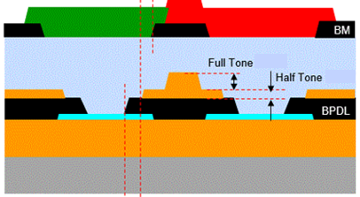

(a)

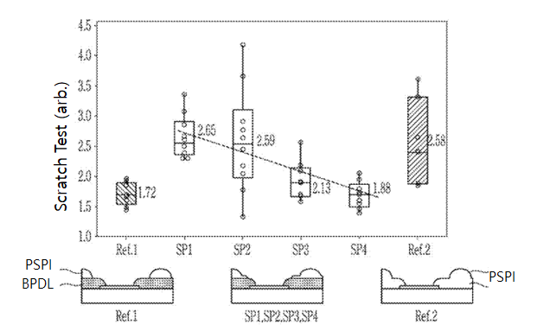

(b)

**Fig. 5. Optimization of hSPC structure: (a) cross-sectional analysis showing layer configuration, (b) Scratch Test result according to cover ratio of the half-tone Spacer on BPDL including reference panel**

The optimization of the hSPC structure, shown in Fig. 5, represents a critical advancement in addressing these challenges. The coverage ratio emerged as a key parameter, with performance metrics showing a clear correlation with structural configuration. Analysis of the data revealed an optimal coverage over 50%, beyond which diminishing returns were observed. This optimization balanced mechanical stability with optical performance requirements.

The relationship between structural parameters and device performance was further investigated through comprehensive stress analysis. FEM simulations correlated well with experimental observations, providing insight into stress distribution patterns during device operation. This understanding proved crucial in optimizing the hSPC configuration for maximum effectiveness in Fig.6.

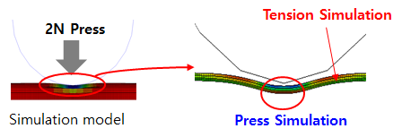

1. Simulation model

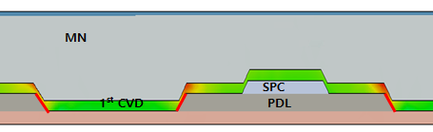

1. Simulation results

Fig. 6. FEM Stress Simulation

The implementation of the optimized structure resulted in substantial improvements in mechanical durability while maintaining essential optical properties. Long-term reliability testing demonstrated stability under various environmental conditions, with minimal degradation in performance metrics. These results validate the effectiveness of our approach in addressing the fundamental challenges of BPDL implementation in flexible displays.

The significance of these findings extends beyond the immediate application. The developed technology establishes a new framework for addressing mechanical-optical trade-offs in flexible display designs. The successful implementation in commercial devices demonstrates not only the technical viability but also the practical manufacturability of the approach.

Future developments of this technology could focus on further optimization of material properties and process parameters. The understanding gained through this study suggests potential pathways for extending the application to larger display formats and more demanding use cases. Additionally, the principles established here may find application in other areas of flexible electronics where mechanical stability and optical performance must be balanced.

# Impact

This study has successfully demonstrated the development and implementation of half-tone spacer (hSPC) technology, effectively addressing the mechanical vulnerability issues associated with BPDL application in foldable OLED displays. Through comprehensive material analysis, we have quantitatively identified the fundamental differences in mechanical properties between BPDL and PSPI, attributable to their distinct molecular structures. Nanoindentation measurements confirmed BPDL's relative softness, while adhesion testing revealed critical correlations between interface characteristics and PAC content.

The developed solution centered on an optimized hSPC structure achieving over 50% coverage, with precise control of PSPI thin film thickness spacing from the BPDL tip. This configuration, combined with optimized specific monomer thickness, effectively suppressed embo mura while maintaining essential optical properties. The mechanical integrity of the display structure showed remarkable improvement, with pressure resistance, representing an approximately 90% enhancement in mechanical strength.

This technological advancement has enabled the world's first implementation of stylus pen functionality in a foldable display, successfully commercialized in the Galaxy Fold 3. The achievement marks a significant milestone in foldable display technology, demonstrating the practical viability of combining advanced mechanical durability with sophisticated user interaction capabilities. [10]

# References

[1] Genggongwo Shi. et al. Side-Chain Polyimides as Binder Polymers for Photolithographic Patterning of a Black Pixel Define Layer for Organic Light Emitting Diode. *International Journal of Polymer Science* vol. 2018, Article ID 3790834, 7 (2018)

[2] Genggongwo Shi. et al. Black Photoresist for Patterning Pixel Define Layer of Organic Light Emitting Diode with Polyimide as Thermal Stabilizer. *Materials Sciences and Applications* vol. 9, 554 (2018)

[3] Chuan X.Xu. et al. FLI Structure for R1 Foldable AMOLED Display. *SID Symposium Digest of Technical Papers Applications* vol. 51, 1811 (2020)

[4] Chuan X.Xu. et al. Foldable AMOLED Display Utilizing Novel COE Structure. *SID Symposium Digest of Technical Papers Applications* vol. 49, 310 (2018)