For every sample, the attributes contain the number, areas, centroids, door number of each room type, they are named like this:

livingroom_number, livingroom_areas, livingroom_centroids, livingroom_door_number, masterroom_number, masterroom_areas, masterroom_centroids, masterroom_door_number, kitchen_..., bathroom_...

Among the four values, “number” is an int, areas, centroids, and door numbers are lists for there might be more than one of this room type.

Attributes also contain the door features:

“door_number” is an int, representing how many doors are there in this sample;

“room_numbers_adjacent_to_door” is a list, representing how many rooms are adjacent to each door;

'room_types_adjacent_to_door' is a list consisting of tuples, representing which room types are adjacent to each door.

About the centroids, calculating is by adapting a stretched x-y coordinate system:

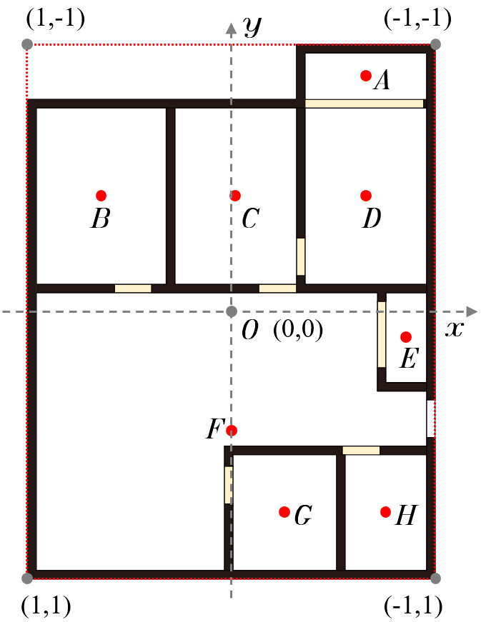

About the areas, the value is the room size as a percentage of the overall size.

For example, feature vector of No. 20 sample is:

{'livingroom_number': 1,

'livingroom_areas': [0.38539353565260304],

'livingroom_centroids': [(0.0, 0.4486486486486487)],

'livingroom_door_number': [5],

'masterroom_number': 1,

'masterroom_areas': [0.10535405872193437],

'masterroom_centroids': [(-0.6595744680851063, -0.43243243243243246)],

'masterroom_door_number': [2],

'kitchen_number': 1,

'kitchen_areas': [0.05921539600296077],

'kitchen_centroids': [(-0.2624113475177305, 0.7513513513513513)],

'kitchen_door_number': [1],

'bathroom_number': 1,

'bathroom_areas': [0.04605641911341393],

'bathroom_centroids': [(-0.7588652482269503, 0.7513513513513513)],

'bathroom_door_number': [1],

'diningroom_number': 0,

'diningroom_areas': [],

'diningroom_centroids': [],

'diningroom_door_number': [],

'childroom_number': 0,

'childroom_areas': [],

'childroom_centroids': [],

'childroom_door_number': [],

'studyroom_number': 0,

'studyroom_areas': [],

'studyroom_centroids': [],

'studyroom_door_number': [],

'secondroom_number': 2,

'secondroom_areas': [0.11287934863064397, 0.10535405872193437],

'secondroom_centroids': [(0.6382978723404256, -0.43243243243243246),

(-0.02127659574468085, -0.43243243243243246)],

'secondroom_door_number': [1, 2],

'guestroom_number': 0,

'guestroom_areas': [],

'guestroom_centroids': [],

'guestroom_door_number': [],

'balcony_number': 1,

'balcony_areas': [0.027633851468048358],

'balcony_centroids': [(-0.6595744680851063, -0.8810810810810811)],

'balcony_door_number': [1],

'entrance_number': 0,

'entrance_areas': [],

'entrance_centroids': [],

'entrance_door_number': [],

'storage_number': 1,

'storage_areas': [0.017846862406447898],

'storage_centroids': [(-0.8581560283687943, 0.0972972972972973)],

'storage_door_number': [1],

'wallin_number': 0,

'wallin_areas': [],

'wallin_centroids': [],

'wallin_door_number': [],

'room_numbers_adjacent_to_door': [2, 2, 2, 2, 2, 2, 2],

'room_types_adjacent_to_door': [('masterroom', 'balcony'),

('masterroom', 'secondroom2'),

('livingroom', 'secondroom1'),

('livingroom', 'secondroom2'),

('livingroom', 'storage'),

('livingroom', 'bathroom'),

('livingroom', 'kitchen')],

'door_number': 7,

'use_area': 0.8597335307179867}